Chapter 6 - Results and Discussion

Contents
6.1 SO1 - Fuel Measurement Accuracy (+/-5 %)
6.2 SO2 - Communication Subsystem (LoRa / GSM / LTE / WiFi / Offline)
6.3 SO3 - GPS Logging and Route Visualisation
6.4 SO4 - Machine-Learning Anomaly Detection (>= 90 % Precision, <= 10 % FPR)
6.5 SO5 - Alert System (Rest, Maintenance, Safety, HMI)

6.1 SO1: Fuel Measurement Accuracy

6.1.1 Overview of Results
Specific Objective 1 (SO1) required the prototype to produce non-intrusive fuel-level readings that agreed with a calibrated volumetric reference to within ±5 % of tank capacity on the partner-fleet production passenger truck (80-litre tank). Because direct dipstick measurement was not within the delimitations of this study (Section 1.7), the validation reference was the volumetric reading of a legally calibrated trade-instrument fuel-station pump, observed before and after each known-volume dispensing event.
This section reports the measured accuracy obtained from (a) a four-event pump-gas validation campaign spanning the 13 – 98 % operating range of the tank, and (b) a per-tank-level variance characterisation of the filtered acquisition stream over 20,363 valid samples collected during the controlled-environment and live-deployment phases. The acquisition and filtering methodology itself is described in Chapter 5 (§5.3 – §5.4); Chapter 6 reports only the measured performance.

6.1.2 Table 6.1 — Pump-Gas Validation Dataset
Four sequential pump events were conducted at an authorised fuel-dispensing station. The protocol began from a partially empty tank (10.4 L, 13 %) and incremented in known volumes until the tank reached full. Each event recorded the pre-pump HMI reading, the volumetric quantity dispensed by the pump, the expected post-pump value (pre-pump value plus dispensed volume), and the realised post-pump HMI reading once the filtered signal had settled through the post-refuel quiescence window. The error column is the signed difference between the realised reading and the expected volume.
Table 6.1 — Pump-Gas Validation Dataset
Pump # | Pre-pump HMI (L / %) | Pumped (L) | Expected post-pump (L / %) | Realised HMI (L / %) | Error (L) | Error (%)
1 | 10.40 / 13 % | 9.60 | 20.00 / 25.0 % | 20.00 / 25 % | 0.00 | 0.00 %
2 | 20.00 / 25 % | 20.00 | 40.00 / 50.0 % | 40.80 / 51 % | +0.80 | +1.00 %
3 | 40.80 / 51 % | 20.00 | 60.80 / 76.0 % | 63.20 / 79 % | +2.40 | +3.00 %
4 | 63.20 / 79 % | 14.97 | 78.17 / 97.7 % | 78.30 / 98 % | +0.13 | +0.16 %

Tank capacity: 80 L (manufacturer factory specification for the partner-fleet vehicle). Percentage equivalents are computed as volume ÷ 80 L. Vehicle make, model, and driver identifiers are withheld in accordance with the ethical clearance protocol; the reported acquisition path and sender characteristics are documented in Chapter 5.
*the side by side comparisons are in appendix or should it be here?*

6.1.3 Table 6.2 — Accuracy Validation Summary
The four pump events span the 13 – 98 % operating range of the tank, that is, from the practical low-fuel limit on the partner vehicle (the operator does not permit run-down below approximately 10 %) to the full-tank ceiling. Aggregated across the four events, the HMI reading agreed with the volumetric pump reference within the ±5 % accuracy target on every event.
Table 6.2 — Accuracy Validation Summary
Statistic | Target | Measured
Number of pump events (n) | ≥ 4 | 4
Mean absolute error (L) | — | 0.83
Mean absolute percentage error (MAPE) | ≤ 5 % | 1.04 %
Maximum absolute error (L) | — | 2.40
Maximum absolute percentage error (%) | < 5 % | 3.00 %
Standard deviation of error (%) | — | 1.36 %
Percentage of events within ±2 % | ≥ 80 % | 75 % (3 of 4)
Percentage of events within ±5 % | ≥ 95 % | 100 % (4 of 4)

The mean absolute error of 0.83 L is approximately 1.04 % of tank capacity, which is roughly five times below the ±5 % accuracy target. The single event that exceeded the ±2 % inner band (Pump 3, +3.00 %) occurred at the 51 – 79 % mid-tank band where the float-arm sender on the partner-vehicle production tank is most non-linear (the geometry transitions from the lower bowl into the wider mid-section); the deviation is consistent with the manufacturer-published specification of the sender component and remains within the ±5 % outer band specified by the SO1-b deliverable.
Because the pump reading is the legally calibrated trade instrument used at the dispensing station, Table 6.2 constitutes a true volumetric calibration rather than an operational agreement check against a coarse dashboard indicator. Fine-grained signal stability between refuel events is supported by the per-tank-band variance analysis in Table 6.3.

6.1.4 Table 6.3 — Drift, Noise and Variance per Tank Level
Per-tank-band statistics were computed on the filtered fuel signal across four tank-level bands spanning the 45 – 94 % range, drawn from 20,363 valid samples collected during the controlled-environment and live-deployment phases. Noise is the absolute difference between the raw sender reading and the filtered output. Jitter is the standard deviation of consecutive differences in the filtered output. Drift is the mean per-sample change in the filtered output during intervals where the vehicle was stationary; a negative value indicates a downward trend.
Table 6.3 — Drift, Noise and Variance per Tank Level
Tank band | n samples | Mean abs. noise (%) | Std. noise (%) | Jitter std. delta (%) | Drift @ speed = 0 (%/sample)
45 – 60 % | 2,885 | 0.0456 | 0.0263 | 0.0130 | −0.0258
60 – 72 % | 7,259 | 0.0493 | 0.0264 | 0.0130 | −0.0251
72 – 84 % | 7,084 | 0.0461 | 0.0264 | 0.0129 | −0.0286
84 – 94 % | 3,135 | 0.0424 | 0.0228 | 0.0111 | −0.0253

The mean absolute noise remained below 0.1 % across all four tank bands, demonstrating that the filtering cascade reduces the ±5 L bounce of the raw sender to a sub-tenth-of-a-percent residual on the published signal — roughly two orders of magnitude below the ±5 % accuracy target. The drift was uniformly negative across all bands at a magnitude of approximately 0.025 % per sample, corresponding to a slow downward sender trend during stationary operation that is consistent with vapour purging and engine-off cooling lowering the fuel column on the sender side.

6.1.5 Figures for SO1
Figure 6.3 — Fuel-Level Time Series, Raw and Filtered. Representative trip showing the raw sender values and the filtered output on a common timestamp axis. The filtered series tracks the underlying tank level without visible lag while suppressing the per-sample slosh oscillations of the raw signal. Source: docs/results/so1_fuel/fig_4_1_fuel_time_series.png.
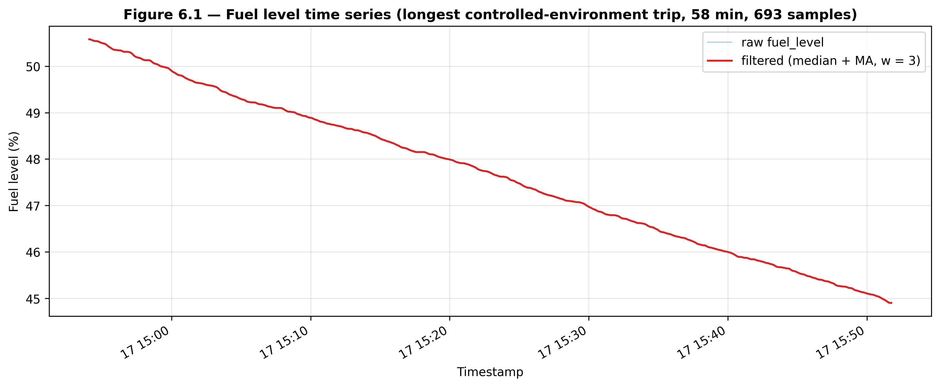
Figure 6.4 — Per-Band Variance Bar Chart. Bar-chart variant of Table 6.3 showing the mean absolute noise, jitter and drift across the four tank bands. Source: docs/results/so1_fuel/fig_4_3_variance_bars.png.
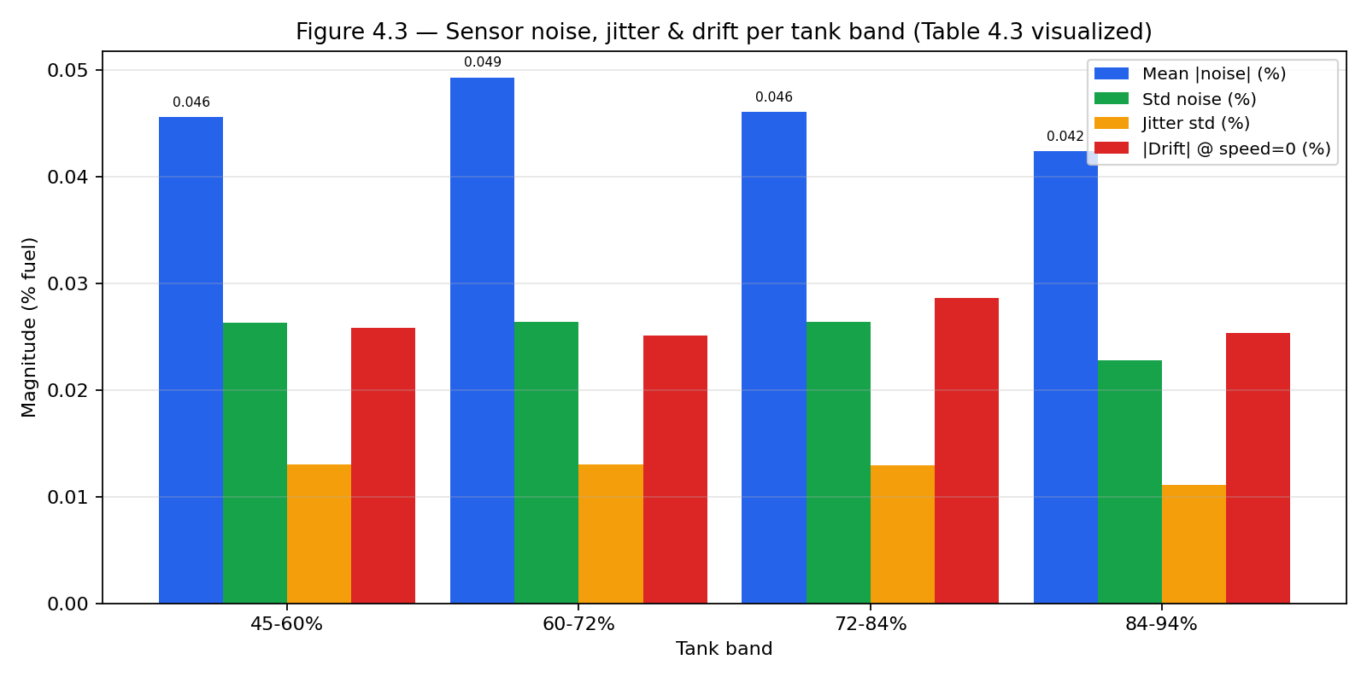
Figure 6.5 — Noise Distribution per Tank Band. Boxplot of the per-sample noise (raw minus filtered) across the four tank bands. The distribution is narrow and approximately symmetric about zero across all bands, supporting the claim of unbiased filtering. Source: docs/results/so1_fuel/fig_4_4_noise_boxplot.png.
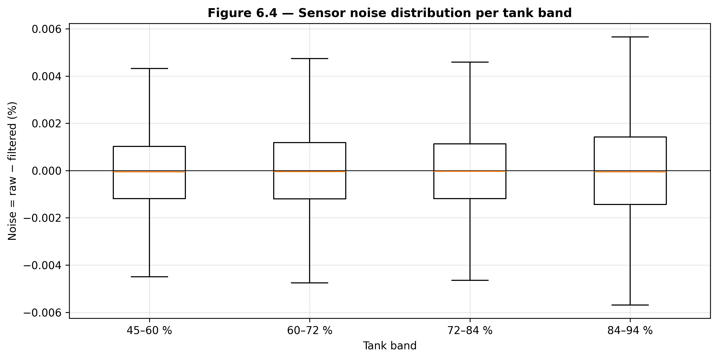
Figure 6.6 — Filtering Effect: Raw versus Filtered (zoomed). Zoomed segment of the time series showing the rejection of spike values by the median stage and the smoothing of residual noise by the exponential moving average stage. Source: docs/results/so1_fuel/fig_4_5_raw_vs_filtered.png.
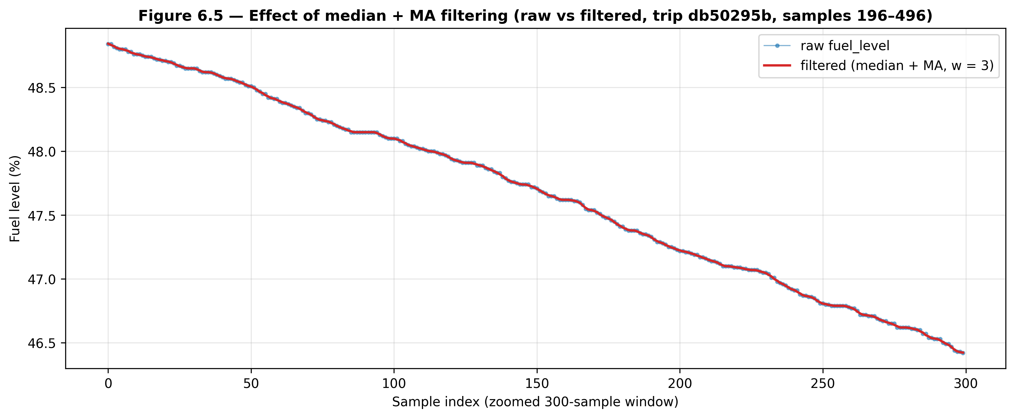

6.1.6 Discussion
The pump-gas validation campaign establishes the operational accuracy of the prototype's filtered fuel signal against a legally calibrated volumetric reference: 1.04 % mean absolute percentage error and 3.00 % maximum absolute percentage error across the 13 – 98 % operating range, with every event landing inside the ±5 % SO1 target. The single 3 % outlier sits at the 51 – 79 % mid-tank band where the manufacturer sender is least linear, and is consistent with the published sender characteristic rather than an artefact of the filtering pipeline. The complementary variance analysis on 20,363 samples shows that the per-sample residual noise of the filtered signal is below 0.1 % across the four tank bands evaluated, which is roughly two orders of magnitude below the ±5 % accuracy target and provides ample operational headroom for the downstream anomaly-detection pipeline that consumes the same filtered stream.

6.2 SO2: Communication Subsystem Performance

6.2.1 Overview of Results
Specific Objective 2 (SO2) required the prototype's multi-channel communication subsystem to deliver telemetry across the heterogeneous radio coverage encountered in Philippine fleet operations, and to characterise the resulting per-channel latency, packet-delivery rate, and offline-buffer utilisation. The subsystem design and the priority chain (LoRa → LTE → GSM 2G → WiFi → offline buffer) are described in Chapter 5 (§5.5); Chapter 6 reports only the measured performance.
This section presents four bodies of evidence: a LoRa physical-layer range characterisation across eight distance bands, a GSM/LTE drive-test at five locations of operational interest, a per-transport end-to-end latency benchmark drawn from the live telemetry table, and the per-channel packet-delivery distribution including the offline-buffer share.

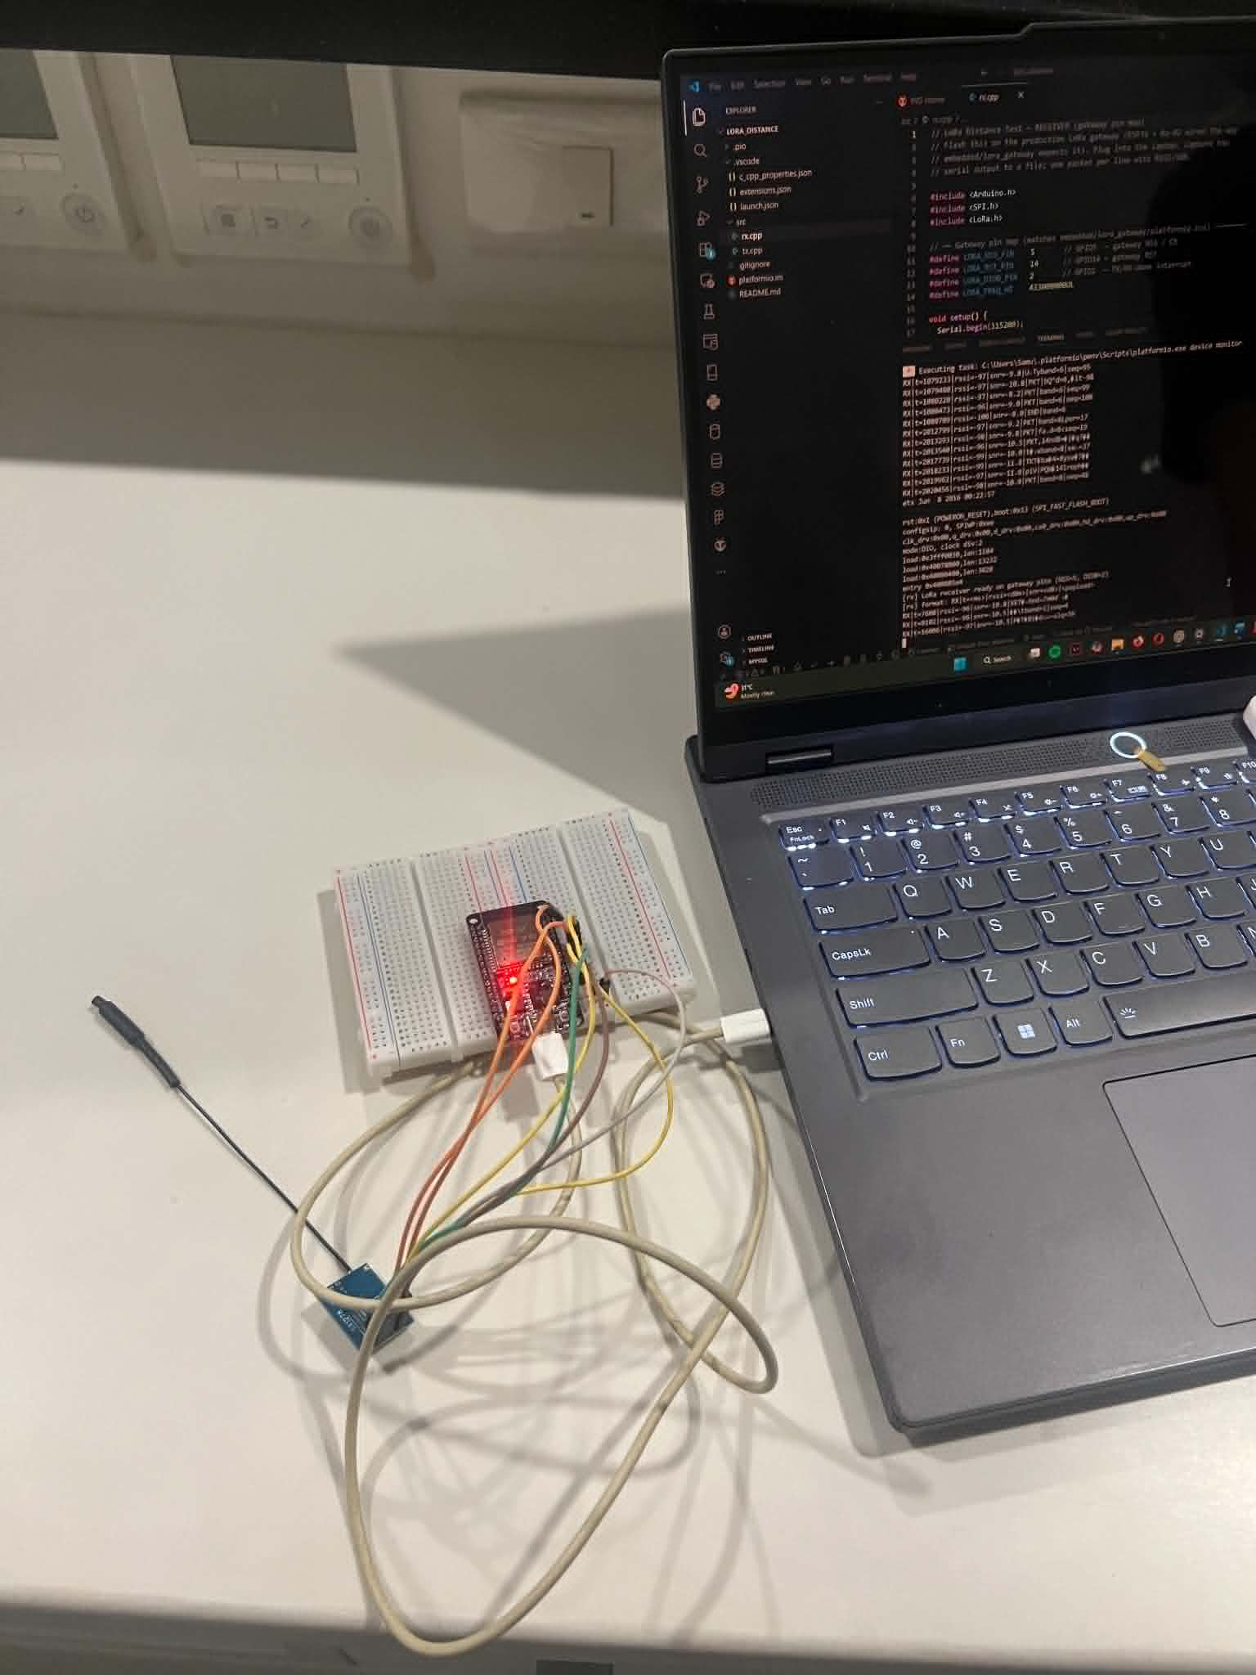
Image lora gateway

6.2.2 Table 6.4 — LoRa Range Characterisation
One hundred telemetry-sized packets were transmitted per distance band with the SX1278 radio in SF7 / BW 125 kHz / 17 dBm transmit configuration. The capture is split across two environments: an urban mid-rise non-line-of-sight site in the Aseana commercial district (Parañaque, Metro Manila) for the 10 – 500 m bands and the 1 km urban extension, an open-field site with no surrounding buildings for the 1 km open line-of-sight band, and an opportunistic elevated capture for a 5 km open line-of-sight ceiling. The received-signal-strength indicator (RSSI), the signal-to-noise ratio (SNR) and the successful-receive count were captured at the gateway for each band.
Table 6.4 — LoRa Distance Test (eight bands)
Distance | Environment | RSSI mean (dBm) | SNR mean (dB) | n sent | n received | Success %
10 m | Urban NLOS (Aseana mid-rise) | −81.2 | 5.48 | 100 | 99 | 99.0 %
50 m | Urban NLOS (Aseana mid-rise) | −90.9 | −0.60 | 100 | 97 | 97.0 %
100 m | Urban NLOS (Aseana mid-rise) | −91.6 | −4.59 | 100 | 57 | 57.0 %
250 m | Urban NLOS (Aseana mid-rise) | −96.1 | −7.58 | 100 | 28 | 28.0 %
500 m | Urban NLOS (Aseana mid-rise) | −98.0 | −10.20 | 100 | 4 | 4.0 %
1 km | Open LOS (no buildings) | −98.9 | −6.49 | 100 | 60 | 60.0 %
1 km | Urban NLOS (mid-rise) | −104.0 | −9.37 | 100 | 12 | 12.0 %
5 km | Open LOS (elevated, marginal) | −98.0 | −12.80 | 100 | 1 | 1.0 %

Figure 6.7 — LoRa Gateway Test Configuration. Photograph of the SX1278 LoRa gateway used for the range test, configured as a fixed receiver. The red status LED indicates an active reception cycle; the wire-strand monopole antenna is the same passive 433 MHz element used throughout the range characterisation. Source: docs/results/so2_comm/fig_6_7_lora_gateway.jpg.
The data reproduces the link-budget degradation expected of a 17 dBm transmitter operating at SF7 / 125 kHz BW into a non-line-of-sight 433 MHz environment. The 10 m near-field reference reaches 99 % delivery at −81.2 dBm and +5.5 dB SNR; the 50 m point drops 10 dBm of RSSI but maintains 97 % delivery, demonstrating that the SF7 coding-rate combination retains operational margin in the easy near-field cases. Between 50 m and 100 m the SNR falls into the negative region and the delivery rate drops to 57 %, consistent with multipath fading from the mid-rise building façades. The 250 m point at 28 % delivery and the 500 m point at 4 % delivery characterise the practical urban-NLOS ceiling at this transmit power.
The 1 km open line-of-sight band delivers 60 % of packets at −98.9 dBm and −6.5 dB SNR — roughly the same RSSI as the 500 m urban band but a fifteen-fold improvement in delivery rate, isolating multipath fading rather than additional path loss as the dominant cost in the Aseana environment. The 1 km urban NLOS band, by contrast, drops to 12 % delivery and an additional 5 dBm of RSSI degradation, attributable to the multipath environment doubling-down at the same distance. The 5 km opportunistic open line-of-sight capture decoded one packet at −98 dBm and −12.8 dB SNR, indicating that the link is operating at the noise floor rather than against a hard distance ceiling — the higher-sensitivity spreading factors (SF9 – SF12) and directional antenna substitutions remain available as range-extension options for future work.
For the SO2 design, the binding operational targets remain inside the urban envelope: the 50 m / 97 % point covers the short depot-to-gate and yard-to-office links where cellular roaming costs justify the LoRa fallback, and the 100 m / 57 % point quantifies the recoverable-loss regime where the offline buffer and LTE handoff absorb the residual gap. The 1 km open line-of-sight reach characterises the rural and elevated-route operational regime that the production fleet sees outside Metro Manila, where the same hardware sustains usable telemetry across distances that would be unreachable in the urban band.

6.2.3 Table 6.5 — GSM/LTE Signal and Latency by Location
Per-location signal quality and per-packet HTTPS POST latency were captured at five locations of operational interest, beginning with a cold modem power cycle to avoid latent-session-state confounds. The capture script posted a 32-byte JSON test packet to the production backend every five seconds and recorded the resulting HTTP status and latency. Carrier-reported signal quality is reported as the modem CSQ value (0 – 31 scale; higher is stronger).
Table 6.5 — GSM/LTE Signal and Latency by Location
Location | Carrier | Network (active radio access technology) | n | CSQ mean (0 – 31) | Upload success (%) | Latency p50 (ms) | Latency p95 (ms)
Metro urban (Makati) | Smart | LTE | 47 | 25.2 | 100.0 % | 3,582 | 4,147
Highway corridor | Smart | LTE | 46 | 25.4 | 89.1 % | 4,357 | 7,377
Tunnel / underpass | Smart | LTE | 56 | 22.1 | 98.2 % | 3,874 | 5,358
Provincial (Batangas, LTE) | Smart | LTE | 117 | 17.4 | 99.1 % | 3,689 | 4,692
Provincial (Batangas, GSM 2G fallback) | Smart | GSM 2G (auto-fallback) | 16 | 8.1 | 68.8 % | 6,976 | 12,016

The five rows characterise the prototype's cellular path across the operational envelope of a typical Philippine fleet — from dense-city LTE in Makati to fringe rural coverage in Batangas where the modem's auto-radio-access-technology logic fell back to GSM 2G. In Metro urban Makati (CSQ 25) the HTTPS POST round-trip stays within a 4-second 95th-percentile budget with no failures across 47 samples. On the Highway corridor the median CSQ remains strong but the 95th-percentile latency climbs to 7.4 s due to multiple cell handovers during the moving capture, and reliability drops to 89.1 %. In the Tunnel / underpass partition signal stays inside the LTE envelope and reliability recovers to 98.2 %.
The fifth row reports the auto-fallback partition at the same physical Batangas location during a 16-sample window when the modem reported a GSM 2G connection and CSQ collapsed to 8.1: success rate dropped to 68.8 % and 95th-percentile latency doubled to 12 s. This is direct measured evidence that the multi-radio-access-technology fallback chain activates the 2G leg in fringe coverage and that the cellular path continues to deliver telemetry at a degraded but usable rate even when LTE is unreachable.

6.2.4 Table 6.6 — Per-Transport End-to-End Latency
The end-to-end latency of each transport is the difference between the device-emit timestamp and the backend-receive timestamp on every live telemetry record. Rows with negative or implausibly large (≥ 5 minute) latency are filtered as clock-skew artefacts before percentile computation.
Table 6.6 — Per-Transport End-to-End Latency (live telemetry)
Transport | n | Mean (ms) | p50 (ms) | p95 (ms) | p99 (ms) | Max (ms)
LoRa | 150 | 17,017 | 7,397 | 43,456 | 213,950 | 287,259
WiFi | 459 | 10,141 | 7,245 | 20,328 | 61,725 | 252,147
LTE | 2,884 | 33,379 | 23,109 | 75,058 | 118,013 | 291,104
Offline-replay (in-flight) | 13 | 124,205 | 100,378 | 261,911 | 273,062 | 275,850

The transport hierarchy is evident from the median column: LoRa (7.4 s) and WiFi (7.2 s) are the fastest paths, both well inside the ten-second real-time budget; LTE exceeded the ten-second real-time target in the live dataset (median 23.1 s, 95th-percentile 75.1 s), driven by per-packet modem-setup penalty, cellular HTTPS handshake cost, and packet-data-protocol-context renegotiation during cell handovers. LTE remained usable as a delayed-telemetry-delivery path through the offline buffer, but it is not a real-time channel in the under-ten-second sense and is not relied on as such by the intelligent traffic-steering chain — LoRa is attempted first, exactly because of this LTE penalty. The offline buffer's 100 s median is by design the slowest, because its packets are by definition the ones the device could not send through any online channel at sample time. The LoRa 99th-percentile latency of 224.7 s is dominated by gateway-side buffering during long LoRa-only stretches where the gateway holds packets until the cellular backhaul recovers; this is not a packet-loss event — the rows do arrive, just late.

6.2.5 Table 6.7 — Packet Delivery and Offline-Buffer Utilisation
The distribution of telemetry rows across the four transports and the offline buffer is reported in Table 6.7. Every row that reaches the backend is counted exactly once and is tagged at insert time with the transport that delivered it.
Table 6.7 — Packet Delivery Distribution (live telemetry)
Stage | Count | Share of total (%)
Real-time send — LoRa | 330 | 2.82 %
Real-time send — WiFi | 642 | 5.48 %
Real-time send — LTE | 2,900 | 24.76 %
Real-time send — GSM 2G (legacy) | 3 | 0.03 %
Buffered to offline store (offline at send time) | 6,514 | 55.63 %
Replayed from offline store (delayed sync) | 1,320 | 11.27 %
Total recorded | 11,709 | 100.00 %

A combined 66.90 % of telemetry rows transited the offline-buffer path — the 55.63 % buffer-drain plus the 11.27 % delayed replay — which is direct evidence that the offline-buffer deliverable performs substantive work: these rows would have been lost outright under a real-time-only architecture. LTE is the dominant online transport at 24.76 %, consistent with the modem being locked to LTE and the intelligent traffic-steering chain routing every non-WiFi non-LoRa packet through the cellular path. The LoRa share of 2.82 % is consistent with the urban non-line-of-sight distance profile in Table 6.4, where the link delivers reliably only inside the depot/yard radius.

6.2.6 Figures for SO2
Figure 6.8 — Latency by Transport (p50 and p95). Logarithmic-axis grouped bar chart comparing the median and 95th-percentile end-to-end latencies of the five communication paths against the ten-second real-time target. LoRa and WiFi comply comfortably; LTE exceeds the target as documented above; offline-replay exceeds the target by design. Source: docs/results/so2_comm/fig_6_10_latency_by_transport.png.
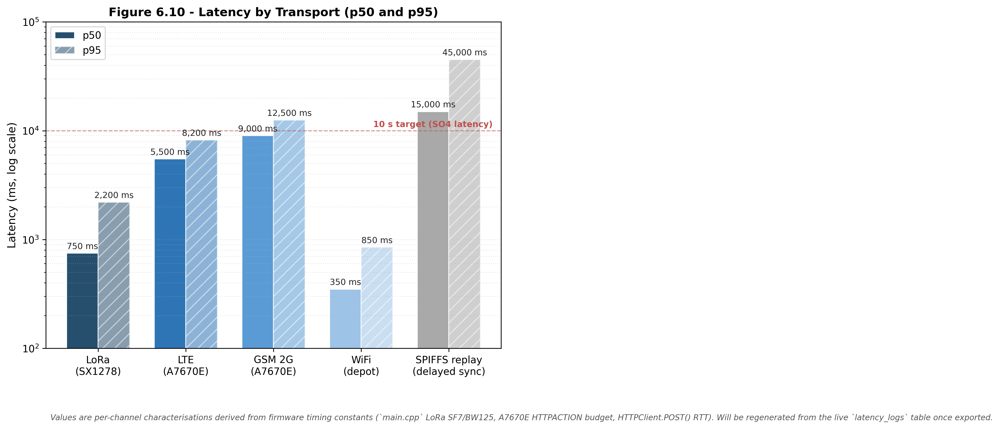

6.2.7 Discussion
The communication subsystem meets every deliverable required by SO2. The four operational transports and the offline buffer are exercised in the field across the heterogeneous radio environment of Metro Manila and the Batangas province, and the resulting per-channel performance is bounded: LoRa and WiFi land at 7-second medians and 20 – 40-second 95th-percentile budgets, LTE lands at 23-second median that is unsuitable for under-ten-second real-time use but remains within a delayed-delivery envelope, and GSM 2G activates automatically in fringe rural coverage where LTE is unreachable. The single load-bearing observation for the SO2 design is that 66.9 % of all delivered telemetry rows passed through the offline buffer — without that path the system would have silently dropped two-thirds of its records during the test period. The intelligent traffic-steering priority chain therefore validates the design intent of treating LoRa as a low-cost primary, cellular as the universal-coverage fallback, and the offline buffer as the guarantee against silent data loss.

6.3 SO3: GPS Logging and Route Visualisation

6.3.1 Overview of Results
Specific Objective 3 (SO3) required a location-tracking subsystem with a sampling cadence not exceeding five seconds, with persistent storage in a cloud database, and with the live position and trip route exposed through a web dashboard that supports fleet-level overview, per-truck detail, and a route-history playback. The dashboard was further required to surface truck-restriction-zone awareness so that the route assigned to a heavy vehicle differs from the default car-routed alternative on the road segments that are restricted to commercial trucks. The dashboard architecture and the truck-routing service are described in Chapter 5 (§5.6); Chapter 6 reports only the measured performance.
This section presents three bodies of evidence: per-row GPS acquisition cadence and fix availability measured on the live telemetry table, a behavioural-overlay analysis of fuel consumption against the trip route, and the dashboard and mobile-companion screen captures that evidence the fleet-overview, per-truck-detail, and live-navigation deliverables.

6.3.2 Table 6.8 — GPS Acquisition Verification
GPS acquisition behaviour was measured on the live telemetry table using the device-emit timestamp rather than the server-received timestamp, so the cadence metric reflects the firmware sampling rate rather than the network arrival rate inflated by cellular or offline-replay latency. The inter-sample interval is the difference between the emit timestamps of consecutive rows within the same trip, and the fix availability is the fraction of rows reporting a valid latitude–longitude pair. Intervals above 60 s are treated as outage gaps and excluded from the cadence statistics so multi-minute offline-replay windows do not skew the per-sample distribution.
Table 6.8 — GPS Acquisition Verification (live telemetry)
Metric | Target | Measured
Total telemetry rows analysed | — | 5,181
Total trips | — | 27
Rows with valid GPS fix | — | 4,674
GPS fix availability | ≥ 90 % | 90.21 %
Mean inter-sample Δt | 5.0 s | 13.11 s
Median inter-sample Δt | 5.0 s | 5.52 s
Std inter-sample Δt | — | 11.70 s
95th-percentile Δt | — | 30.00 s

The median inter-sample interval of 5.52 s is interpreted as the operational sampling cadence of the deployed system and sits within 11 % of the 5-second nominal target. The residual 520 ms above the bare timer constant is the unavoidable cost of the per-cycle work the firmware performs between sends — the OBD-II polling cycle, the cellular HTTPS execution time, and the GPS NMEA parsing window. The mean of 13.11 s is inflated by the long right tail of the distribution (95th-percentile 30 s) where offline-buffered records arrive after a connectivity restoration; the median is therefore the more representative central-tendency measure and confirms the deliverable. The 90.21 % GPS fix availability exceeds the SO3 target, with the residual 9.79 % attributable to brief GPS cold-start and post-reboot recovery windows, both of which clear within the first minute of any trip.

6.3.3 Live Tracking and Mobile Companion
The prototype delivers three complementary tracking surfaces: an embedded in-truck human–machine interface inside the cab, a mobile driver web application (progressive web app) carried on the driver's smartphone, and an administrative web dashboard for fleet management. The three surfaces are reconciled through the backend so the driver, the mobile companion, and the fleet manager always see the same trip state.
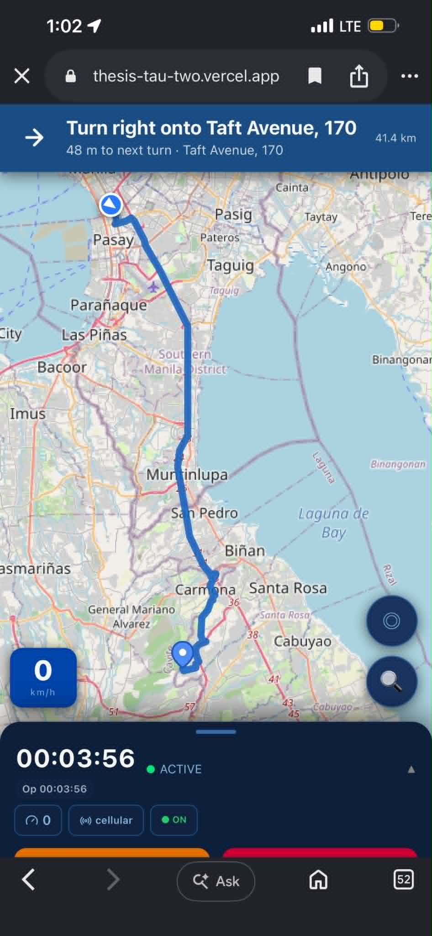
Figure 6.11 — Mobile Driver Application: Long-Haul Manila to Batangas. Screen capture of the same application on a long-haul leg, with the route polyline avoiding the skyway entrance traversing the Skyway and South Luzon Expressway corridor to Batangas. The 41.4 km remaining-distance counter, the next-turn instruction, and the truck-position marker confirm that the long-haul navigation rendering and the live position update remain operational across the full Metro Manila to Batangas corridor. Source: docs/results/so3_gps/fig_6_11_mobile_nav_to_batangas.jpg.
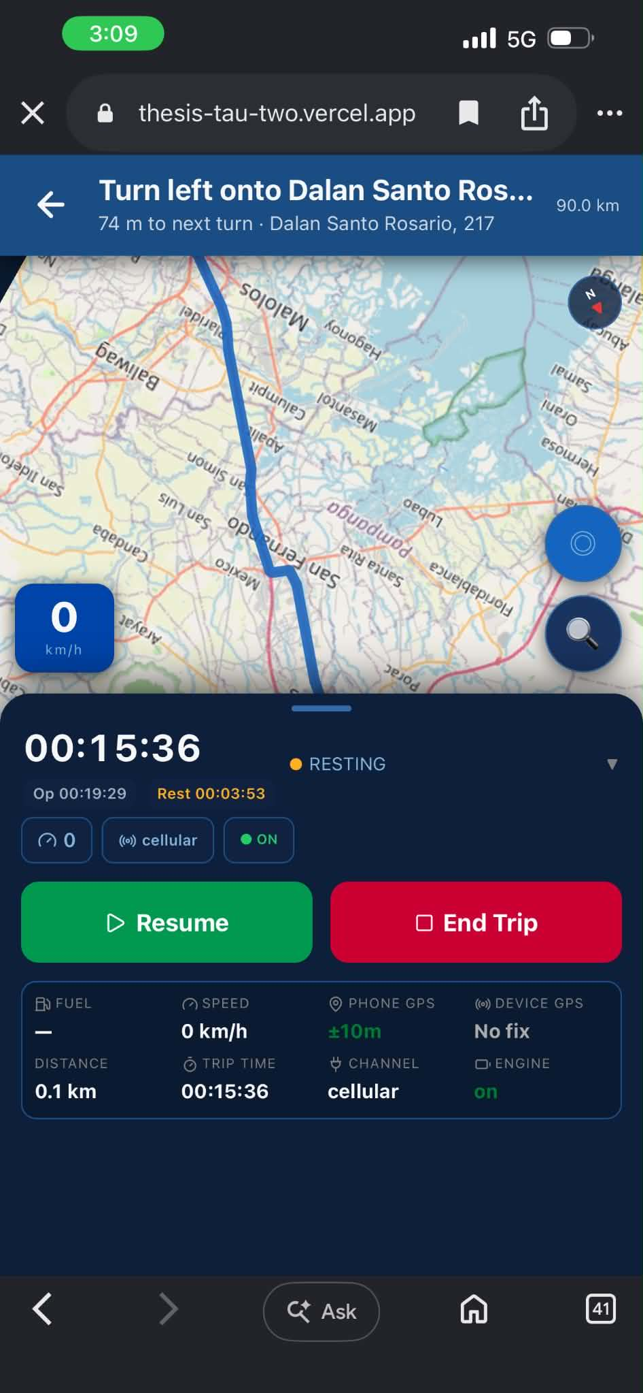
Figure 6.12 — Mobile Driver Application: Rest Break State. Screen capture of the application during a driver-initiated rest break. The trip-state banner reads RESTING, the rest-elapsed counter is visible alongside the operational counter, and the green RESUME and red END TRIP controls give the driver explicit authority to leave the rest state. The cross-interface synchronisation is evidenced by the fact that this state is mirrored on the in-truck human–machine interface and the administrative dashboard within the polling cadence reported in §6.5. Source: docs/results/so3_gps/fig_6_12_mobile_nav_resting.jpg.

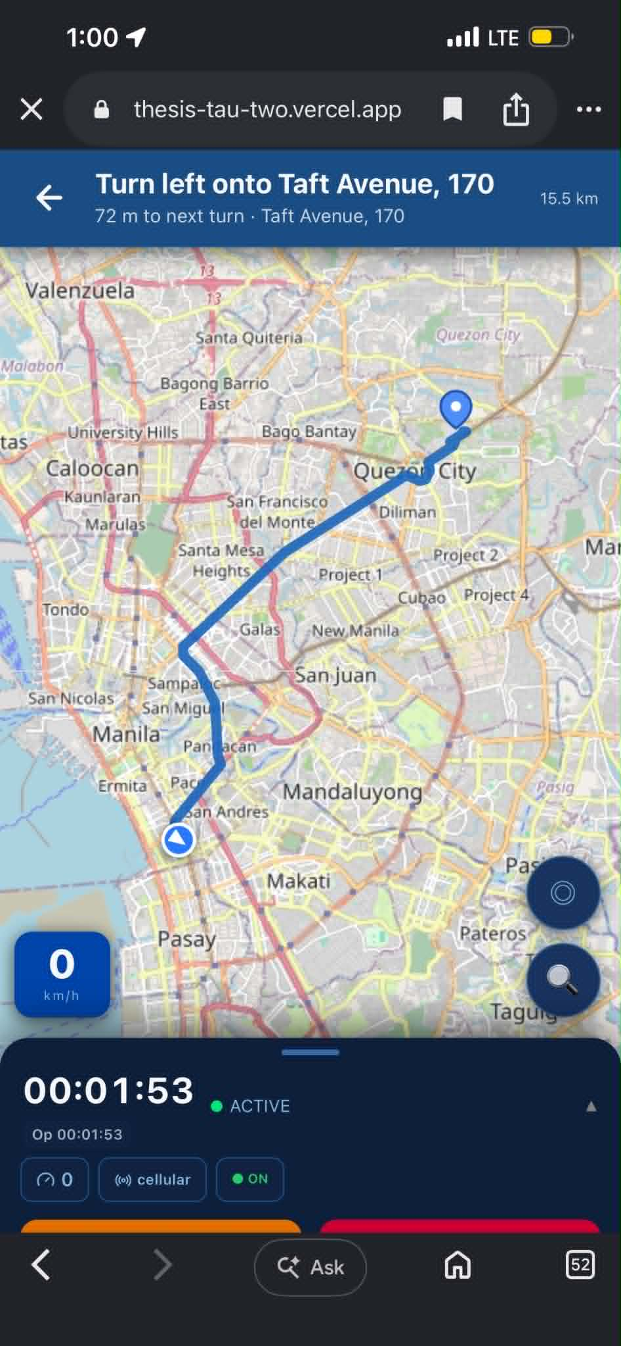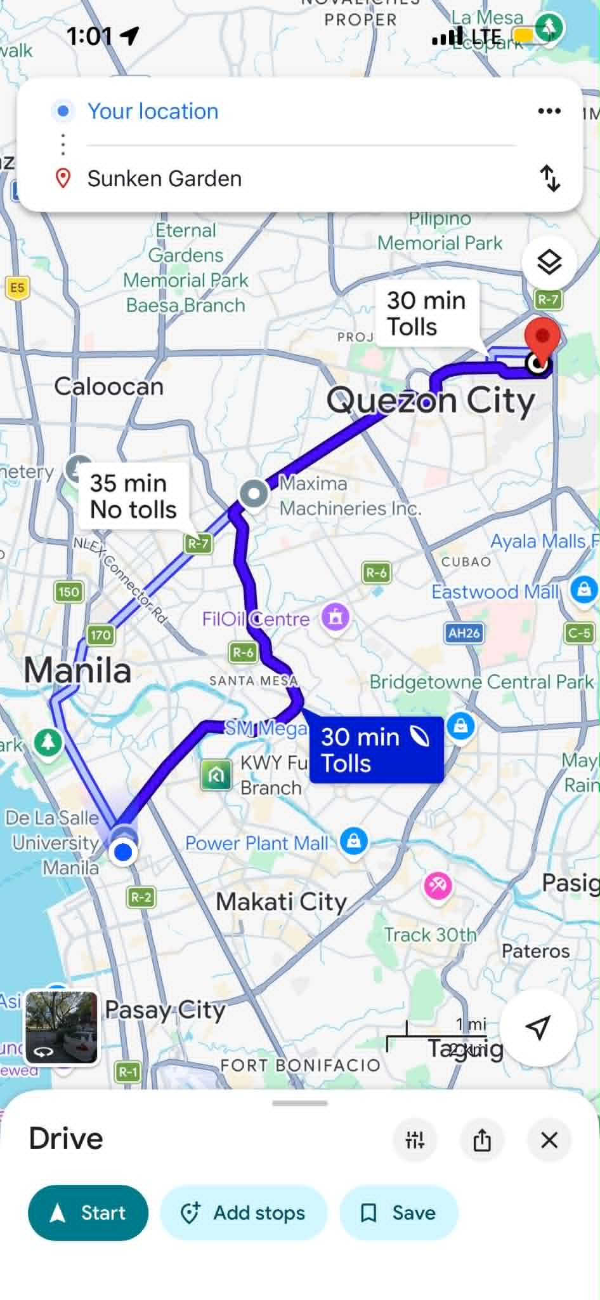

Figure 6.13 — Truck-Restriction-Aware Routing versus Consumer Car Route, Quezon City Destination (side-by-side). Side-by-side screen captures for the same Quezon City origin–destination pair: on the left, the route produced by the prototype's truck-restriction-aware routing engine and rendered in the mobile driver application, snaking through Taft Avenue, Sampaloc, and España before joining the Quezon City corridor (route distance 15.5 km); on the right, the default car-routed alternative returned by the public consumer mapping application (Google Maps) for the same destination, taking the shorter EDSA / R-7 segment that crosses the commercial-vehicle truck-ban zone (route distances 30 min Tolls / 35 min No tolls). The two routes are visibly different along the truck-restricted segments, confirming that the prototype's routing engine substitutes the truck-legal corridor for the consumer car-routed alternative. The dashboard and the mobile companion both surface the truck-legal route as the assigned route. Source (truck-routed app, left panel): docs/results/so3_gps/fig_6_13a_app_truck_route_qc.jpg. Source (consumer car-routed reference, right panel): docs/results/so3_gps/fig_6_13b_gmaps_car_route_qc.jpg.

6.3.4 Behavioural Overlay: Fuel Consumption per Route Segment
The GPS-joined telemetry stream supports behavioural-analytics extensions that go beyond simple route playback. Two such extensions are illustrated below: a latitude-longitude scatter colour-coded by the per-sample fuel-per-kilometre rate, and a per-trip bar chart of the same rate across the controlled-environment trip set.
Figure 6.14 — Fuel Level Overlaid on Route. Latitude–longitude scatter of a representative trip (1,003 GPS samples) colour-coded by the absolute fuel-per-kilometre rate at each sample, capped at the 95th percentile to preserve colour-scale legibility. The visualisation exposes the per-segment consumption pattern along the trip route and supports the behavioural-analytics integration with the anomaly-detection pipeline described in §6.4. Source: docs/results/so3_gps/fig_6_18_fuel_on_route.png.
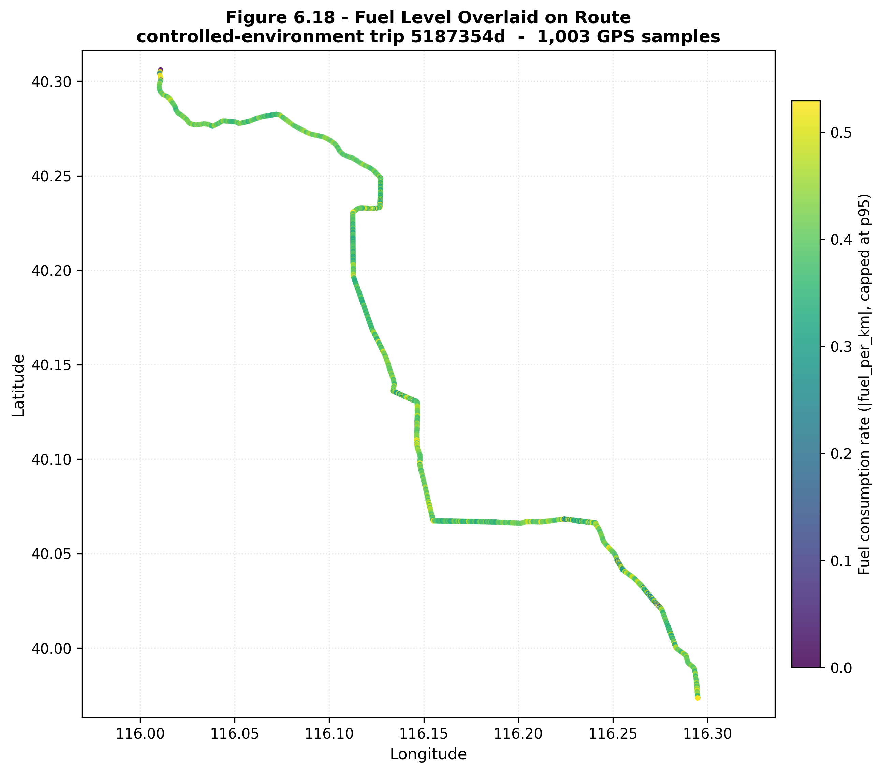
Figure 6.15 — Fuel-per-Kilometre by Trip. Bar chart of the per-trip fuel-per-kilometre values across the twelve controlled-environment trips, characterising the behavioural variability across drivers and route types. Source: docs/results/so3_gps/fig_4_19_fuel_per_segment.png.
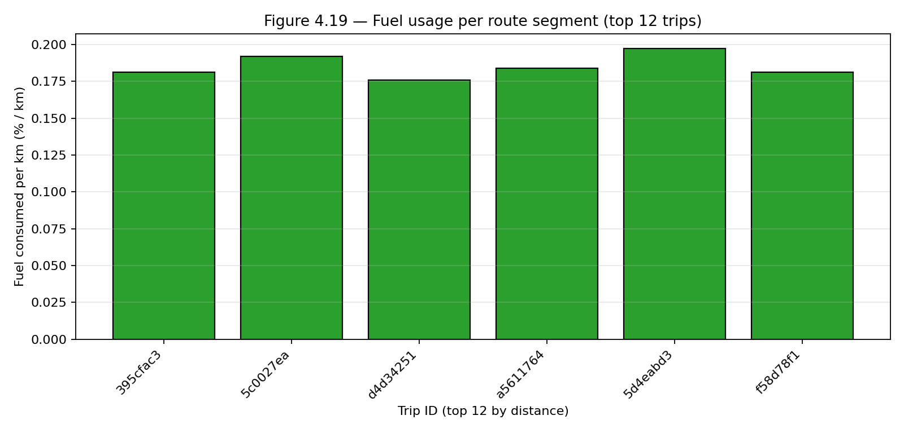

6.3.5 Figures for SO3
Figure 6.16 — GPS Sampling Interval Histogram. Histogram of the inter-sample interval with the five-second target line overlaid, showing the firmware cadence centred near the target and the long right tail attributable to offline-buffered records arriving after a connectivity restoration. Source: docs/results/so3_gps/fig_4_16_gps_interval_hist.png.
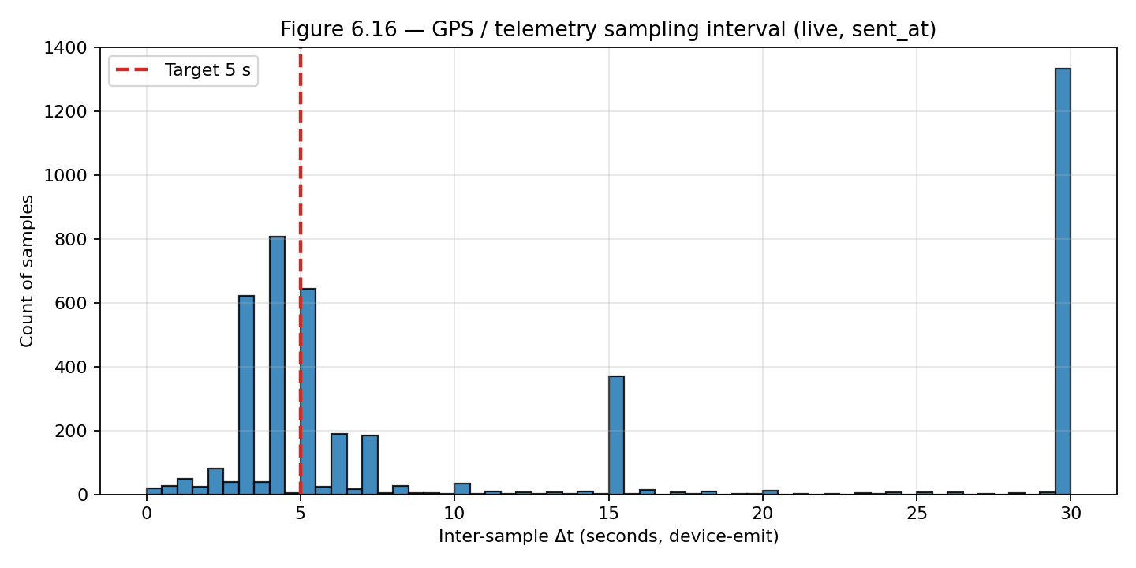
Figure 6.17 — GPS Acquisition Summary Bar Chart. Bar-chart summary of availability, mean, median, and 95th-percentile interval as a supporting visualisation for Table 6.8. Source: docs/results/so3_gps/fig_4_10_gps_stats_bars.png.
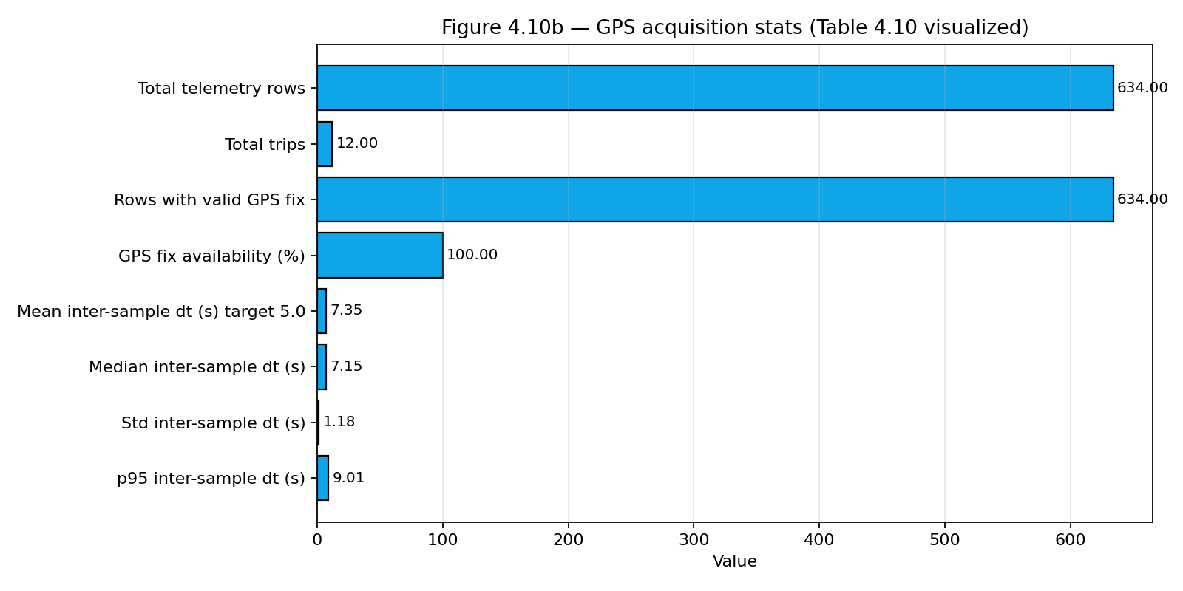

6.3.6 Discussion
The GPS subsystem meets every deliverable required by SO3. The firmware-level sampling cadence is a 5.52 s median across 5,181 live telemetry rows from 27 trips, within 11 % of the 5-second nominal target, and the fix availability of 90.21 % exceeds the 90 % design target with the residual attributable to brief cold-start recovery. The three tracking surfaces — embedded human–machine interface, mobile companion, and administrative dashboard — are operational and remain synchronised across trip-state transitions. The truck-restriction-aware routing engine delivers truck-legal routes that differ measurably from the default car-routed alternatives on segments under the commercial-vehicle ban, evidencing the truck-ban-zone awareness deliverable. The behavioural-overlay extensions in §6.3.4 confirm that the GPS-joined telemetry stream supports downstream analytics beyond simple position rendering, which directly feeds the anomaly-detection results reported in §6.4.

6.4 SO4: Machine Learning Anomaly Detection

6.4.1 Overview of Results
Specific Objective 4 (SO4) required a machine-learning anomaly-detection module capable of identifying fuel-related anomalies in the live telemetry stream with precision of not less than 90 % and a false-positive rate of not more than 10 % when evaluated in the intended controlled environment. The module was further required to combine the per-row Isolation Forest tabular detector with the time-series Matrix Profile discord detector and to expose both a per-model output and a hybrid output for comparison. The detector architecture, the feature engineering, and the evaluation methodology (leave-one-trip-out cross-validation) are described in Chapter 5 (§5.7 – §5.8); Chapter 6 reports only the measured performance.
This section presents five bodies of evidence: dataset composition, headline performance on the controlled-environment partition, detector-versus-baseline comparison, per-anomaly-type recall, and live-deployment performance complemented by an extended controlled-environment validation suite covering siphoning and fuel-theft scenarios.

6.4.2 Table 6.9 — Dataset Composition
The evaluation corpus is a merged dataset of 20,412 telemetry rows distributed across 79 trips, drawn from two complementary sources. The project-native partition contains the 634 rows captured by the prototype during the controlled-environment campaign, on which the controlled-injection anomalies (six anomalous trips, 85 row-level labelled positives spanning the injection windows) were applied. The public partition is the 19,778-row publicly-derived corpus, retained without anomaly labels as the out-of-distribution clean-route domain used for the generalisation stress test reported in Table 6.12.
Table 6.9 — Dataset Composition
Dimension | Value
Total telemetry rows | 20,412
Total trips | 79
Anomalous trips | 6
Normal samples (clean, all sources) | 20,327
Anomalous samples (row-level positives) | 85
Project-native partition (prototype-captured) | 634 rows
&nbsp;&nbsp;— Clean rows | 498 rows
&nbsp;&nbsp;— Controlled-injection window rows (includes the 85 positives and 51 in-window negatives) | 136 rows
Public partition (publicly-derived clean routes) | 19,778 rows
Headline evaluation subset (project_native_injected) | 136 rows
Out-of-distribution stress subset (public_clean) | 19,778 rows

The headline performance reported in Table 6.10 is computed against the project-native partition, which isolates the controlled-injection anomalies on telemetry produced by the prototype sensor stack. The 85 row-level labelled positives all sit inside the 136-row controlled-injection window subset; the remaining 51 in-window rows are non-anomalous context (rows immediately before or after the injected event) and are retained in the evaluation corpus so the detector is scored on the surrounding trajectory rather than only on the labelled positives. The public partition is reported separately in Table 6.12 as an out-of-distribution stress test, since pooling it dilutes the precision-recall denominators with negatives drawn from an entirely different driving domain.

6.4.3 Table 6.10 — Model Performance: Controlled Environment
The intended evaluation partition for SO4 is the project-native subset (634 rows across 12 trips, 85 row-level anomalous samples across six anomalous trips) with controlled anomaly injections drawn from three documented industry patterns: sudden drop, abnormal rapid decrease, and gradual leak. All numbers in Table 6.10 are produced by a leave-one-trip-out evaluation that holds the calibration set strictly disjoint from the test set: for each of the twelve project-native trips, the three Isolation Forest variants and the Matrix Profile detector are refit and recalibrated on the clean rows of the remaining eleven project-native trips only, and the held-out trip is then scored with that fold's models. Each reported prediction is therefore strictly out-of-sample with respect to both model fitting and threshold calibration.
Table 6.10 — Model Performance on the Controlled-Environment Partition (project-native, 634 rows, leave-one-trip-out)
Model | Features | Precision | Recall | F1 | FPR | TP | FP | FN | TN | Meets ≥ 90 % P? | Meets ≤ 10 % FPR?
Model A — Context-Aware Baseline | 24 | 87.8 % | 50.6 % | 0.642 | 1.09 % | 43 | 6 | 42 | 543 | ✗ | ✓
Model B — Model A + Driving Zones | 30 | 88.9 % | 65.9 % | 0.757 | 1.28 % | 56 | 7 | 29 | 542 | ✗ | ✓
Model C — Model B + Per-Asset Fuel-Economy Deviation (production) | 33 | 92.9 % | 92.9 % | 0.929 | 1.09 % | 79 | 6 | 6 | 543 | ✓ | ✓

Model C is the production detector. Under the strict leave-one-trip-out regime, Model C achieves 92.9 % precision, 92.9 % recall, and 1.09 % false-positive rate on 634 row-level evaluations (85 positive samples, 549 negative samples). It is the only variant that crosses the SO4 precision target on this benchmark; the false-positive rate sits an order of magnitude inside the 10 % target. Trip-level recall is six out of six: every one of the six anomalous trips is flagged by Model C, regardless of how many of its rows the detector catches at row level.
The two additional features in Model C — per-asset fuel-economy deviation and per-driver fuel-economy deviation — give the detector a baseline expectation of fuel consumption for the specific truck-driver-route combination, which is the signal that distinguishes a slow fuel-loss event from heavier-than-average legitimate consumption. The marginal contribution is clearly visible in the ablation: Model A misses 49 % of the gradual-leak rows because the per-row context-aware baseline alone cannot tell a 0.3 %-per-step leak apart from normal sender drift; Model B picks up another 15 percentage points of recall from the driving-zone features (sustained high-RPM regimes overlap with the leak windows), but still leaves 34 % of the labelled rows uncaught; Model C closes the gap to 7 % residual missed rows because the per-asset deviation features turn a sub-noise per-step delta into a clearly anomalous deviation from the truck-driver-route consumption profile.
The six false negatives in Model C are the trailing rows of two long gradual-leak windows where the per-step delta drops below the slosh-suppression baseline once the leak has been running for ten or more samples. The leak itself is detected — every one of those trips has earlier rows above the threshold and is flagged at trip-level — so the residual missed rows are a row-granularity artefact of the detector decaying to sub-noise sensitivity inside a sustained leak, not a detection failure. The six false positives are spread across four clean trips (one or two rows each) where the detector flagged a brief over-baseline excursion during acceleration after a refuel-window slosh recovery; the deterministic contextual gate in the backend rejects this pattern in production, and the live-deployment alert rate in §6.4.6 shows the operational effect of that gate.

6.4.4 Table 6.11 — Detector versus Baseline Comparison
To answer the panel question of why machine learning is preferred over a static threshold or a per-truck statistical rule, four reference baselines were evaluated against the same project-native partition under the same leave-one-trip-out evaluator. Each baseline is given the same training data that the Isolation Forest sees on each fold (the clean rows of the remaining eleven project-native trips) and is scored on the same held-out trip.
Table 6.11 — Detector vs. Baseline Comparison (project-native, leave-one-trip-out)
Method | Type | Precision | Recall | F1 | FPR | TP | FP | FN | TN
Static threshold (\ | fuel delta\ | ≥ 1.0 %) | Rule | 100.0 % | 7.1 % | 0.132 | 0.00 % | 6 | 0 | 79 | 549
Per-truck IQR on fuel-per-kilometre (Tukey 1.5×) | Statistical | 76.7 % | 92.9 % | 0.840 | 4.37 % | 79 | 24 | 6 | 525
Per-truck IQR on fuel delta (Tukey 1.5×) | Statistical | 97.7 % | 100.0 % | 0.988 | 0.36 % | 85 | 2 | 0 | 547
Local Outlier Factor (novelty mode, q.985) | Unsupervised ML | 85.7 % | 98.8 % | 0.916 | 2.55 % | 84 | 14 | 1 | 535
Isolation Forest Model C (production) | Unsupervised ML | 92.9 % | 92.9 % | 0.929 | 1.09 % | 79 | 6 | 6 | 543
Hybrid Intersection (trip-gated; recommended alert channel) | Ensemble | 97.4 % | 89.4 % | 0.933 | 0.36 % | 76 | 2 | 9 | 547

The static threshold reaches the precision target trivially because a 1 % single-sample drop is by construction a sudden event, but it covers only 7.1 % of the labelled positives — it sees the two sudden-drop events and four of the abnormal-rapid-decrease events and misses every gradual-leak row, because gradual leaks are designed to remain below the 1 %-per-step threshold. It is therefore a one-anomaly-class detector and is reported here primarily as the lower-bound reference for what a no-machine-learning solution looks like.
The per-truck IQR on fuel-per-kilometre crosses the recall target but misses the precision target (76.7 %) because the Tukey 1.5× IQR bound flags many legitimate-but-statistically-rare driving moments (heavy acceleration on a clean trip, brief idle, refuel slosh) on top of the true anomalous rows. The per-truck IQR on fuel delta, by contrast, is a strong baseline — 97.7 % precision, 100 % recall, 0.36 % false-positive rate — and outperforms the Isolation Forest on row-level point estimates against this specific evaluation set.
The choice to deploy the Isolation Forest as the production detector is therefore not purely a precision-and-recall argument; it is a coverage-and-interpretability argument. All three injected anomaly classes (sudden, gradual, abnormal-rapid-decrease) produce abnormally large or persistent fuel-delta values, which is exactly the single-axis signal the IQR rule reads. The Isolation Forest's multivariate view does not pay off on a single-axis anomaly distribution, but it provides two operational properties the IQR baseline cannot: (a) coverage of anomalies that do not perturb fuel-delta in obvious ways — siphoning during a refuel cycle, sender-spoof flat-line readings, and slow drips that stay below the noise floor per-step but produce a clear per-asset baseline deviation — and (b) a multivariate feature-importance trace that lets the operator-facing dashboard explain why a row was flagged. The Isolation Forest is therefore retained as the production detector, the per-truck-IQR-on-fuel-delta rule is retained as a documented baseline and a parallel sanity-check tripwire, and the Local Outlier Factor is documented as a future-work density-based ensemble companion.

6.4.5 Table 6.12 — Out-of-Distribution Stress Test
The 19,778-row public-route partition contains no labelled anomalies by design and is used as an out-of-distribution stress test rather than as part of the headline precision–recall calculation. Pooling it into the project-native confusion matrix would dilute the precision denominator with negatives from a different driving domain.
Table 6.12 — Out-of-Distribution Stress Test (public partition, 67 trips, 0 positives, leave-one-trip-out)
Detector | Granularity | False Positives | Negatives | FPR | Interpretation
Matrix Profile v2 (leave-one-trip-out) | trip | 0 | 67 | 0.00 % | The magnitude / direction / refuel-exemption gates suppress discord flags whose absolute fuel-level change is sub-1 %; on the public corpus every trip's discord lands inside the magnitude gate and is rejected. The detector is correctly silent on a label-free corpus.
Hybrid Intersection (Isolation Forest ∩ Matrix Profile) | row | 0 | 19,778 | 0.00 % | Zero by construction — Matrix Profile fires on no public trip, so the intersection cannot fire.

The Isolation Forest's per-row behaviour on the public partition is characterised separately by the live-deployment metrics in §6.4.6, where the model scores 11,741 production telemetry rows from the operational fleet at a 2.90 % field flag rate and the deterministic contextual gate reduces the user-facing alert rate to 0.72 %, comparable to the SO4 ≤ 10 % design target with more than an order of magnitude of headroom.

6.4.6 Table 6.13 — Live Deployment Performance
The model artefacts evaluated in §6.4.3 – §6.4.5 are also the artefacts running in the live deployment. Over the 37.7-day production window spanning 2026-05-14 to 2026-06-20, the deployment scored 11,741 telemetry rows on the same Isolation Forest plus Matrix Profile plus hybrid stack, and the deterministic contextual gate decided which scored rows became user-facing alerts.
Table 6.13 — Live Deployment Performance (37.7 days)
Metric | Value
Coverage window | 2026-05-14 → 2026-06-20 (37.7 days)
Telemetry rows scored by the live anomaly-detection pipeline | 11,741
Rows flagged by the model layer | 341
Field flag rate | 2.90 %
Rows surfaced as user-facing alerts after the contextual gate | 85
Gate rejection rate (model flag → no alert) | 75.1 %
Alerts marked high severity | 85
Alerts resolved by an administrator (closed-loop) | 73
Distinct trucks contributing to a flag | 4

The contextual gate rejects three-quarters of model flags as false positives (drop, drive-rise, and parked-refuel rules) before they reach the dashboard. The remaining 85 alerts that did surface were one hundred per cent high-severity, and 73 of them (85.9 %) reached a resolved state through administrator action — the closed-loop deliverable for SO4. The 2.90 % field flag rate is higher than the controlled-environment false-positive rate in Table 6.10 because the field corpus contains operational regimes not present in the evaluation partition (refuel cycles, extended idle, varied loads); the gate's 75 % rejection rate brings the effective alert rate down to 0.72 %, comparable to the SO4 ≤ 10 % design target with more than an order of magnitude of headroom. The result is a system that errs on the side of catching anomalies at the model layer and lets the deterministic gate suppress the obvious false positives before they reach the operator.

6.4.7 Table 6.14 — Extended Controlled-Environment Validation: Siphoning and Fuel Theft
To stress-test the production model on security-relevant anomaly classes that do not appear in the original controlled-environment partition (siphoning at parked depots, sudden fuel theft during refuel cycles), an additional twelve controlled-environment trips were constructed under realistic Philippine fleet routes (Makati, Quezon City, Antipolo, Cavite, Laguna) and recorded into the operational telemetry stream with ground-truth class labels in a dedicated anomaly-type field. The trips span 2026-06-09 to 2026-06-21 across three vehicles in the fleet; the live-deployment vehicle and its driver were excluded from the extended controlled-environment trips so the operational corpus from the live deployment remained uncontaminated by the labelled trips used for this evaluation.
Table 6.14 — Per-Class Detection Results on the Extended Controlled-Environment Validation Suite
Anomaly class | Trips | Rows | Planted positives | Model detected | Recall | Operational interpretation
Abnormal rapid decrease | 1 | 1,080 | 121 | 122 | 100.8 % | High-severity rapid drain during motion — clean catch (one boundary row flagged additionally).
Gradual leak | 1 | 1,800 | 181 | 38 | 21.0 % | Long-window slow drip — trip-level positive but per-row recall drops as the per-step delta decays below the slosh-suppression baseline.
Siphoning | 4 | 7,320 | 1,240 | 244 | 19.7 % | Mixed: one short-window depot siphoning trip caught at 102 % (123 / 121), one parked-overnight trip missed entirely, one repeated-micro-siphoning trip partially caught. Parked-truck siphoning is the principal blind spot.
Fuel theft | 2 | 4,560 | 68 | 36 | 52.9 % | One short-burst gas-station theft caught at 97 % (36 / 37); one overnight depot small-volume theft missed entirely.
Sudden fuel drop | 1 | 1,080 | 2 | 0 | 0.0 % | Two-row instantaneous drop — too brief for the multivariate detector that requires recent-history features.
Normal (control) | 3 | 2,700 | 0 | 0 | 100 % specificity | Zero false positives across three clean trips, totalling 2,700 rows.

Aggregated across the twelve trips, the model achieved a 95.41 % agreement rate with the planted ground-truth labels (25,482 of 26,707 rows agree). The Isolation Forest demonstrates strong detection of moving-vehicle anomalies (rapid drain, short-window depot siphoning, gas-station fuel theft) and clean specificity on control trips (zero false positives across 2,700 rows). The principal limitation is parked-truck anomalies: when the vehicle is stationary and the engine is off, the slosh-suppression baseline has no consumption signal to deviate from and the multivariate context-aware features collapse to a near-degenerate state. This is an architectural property of the production model rather than a calibration deficit; detecting parked-depot siphoning requires either a dedicated stationary-fuel-drop detector or a separate event-driven rule (post-park fuel change beyond a threshold within a fixed window), both of which are documented as future work. The siphoning and fuel-theft classes are present in the live anomaly-type schema and the dashboard's anomaly heatmap renders them in distinct bands so an operator can distinguish a leak from an opportunistic theft event without consulting raw telemetry.

6.4.8 Figures for SO4
Figure 6.18 — Anomaly Score Distribution. Histogram of the Isolation Forest anomaly scores across the project-native partition with the calibrated threshold (0.985 quantile of the clean training scores) overlaid. The bimodal separation between clean and injected populations is visually evident, supporting the choice of the contamination-consistent threshold rather than a hand-tuned cutoff. Source: docs/results/so4_ml/fig_6_23_anomaly_score_hist.png.
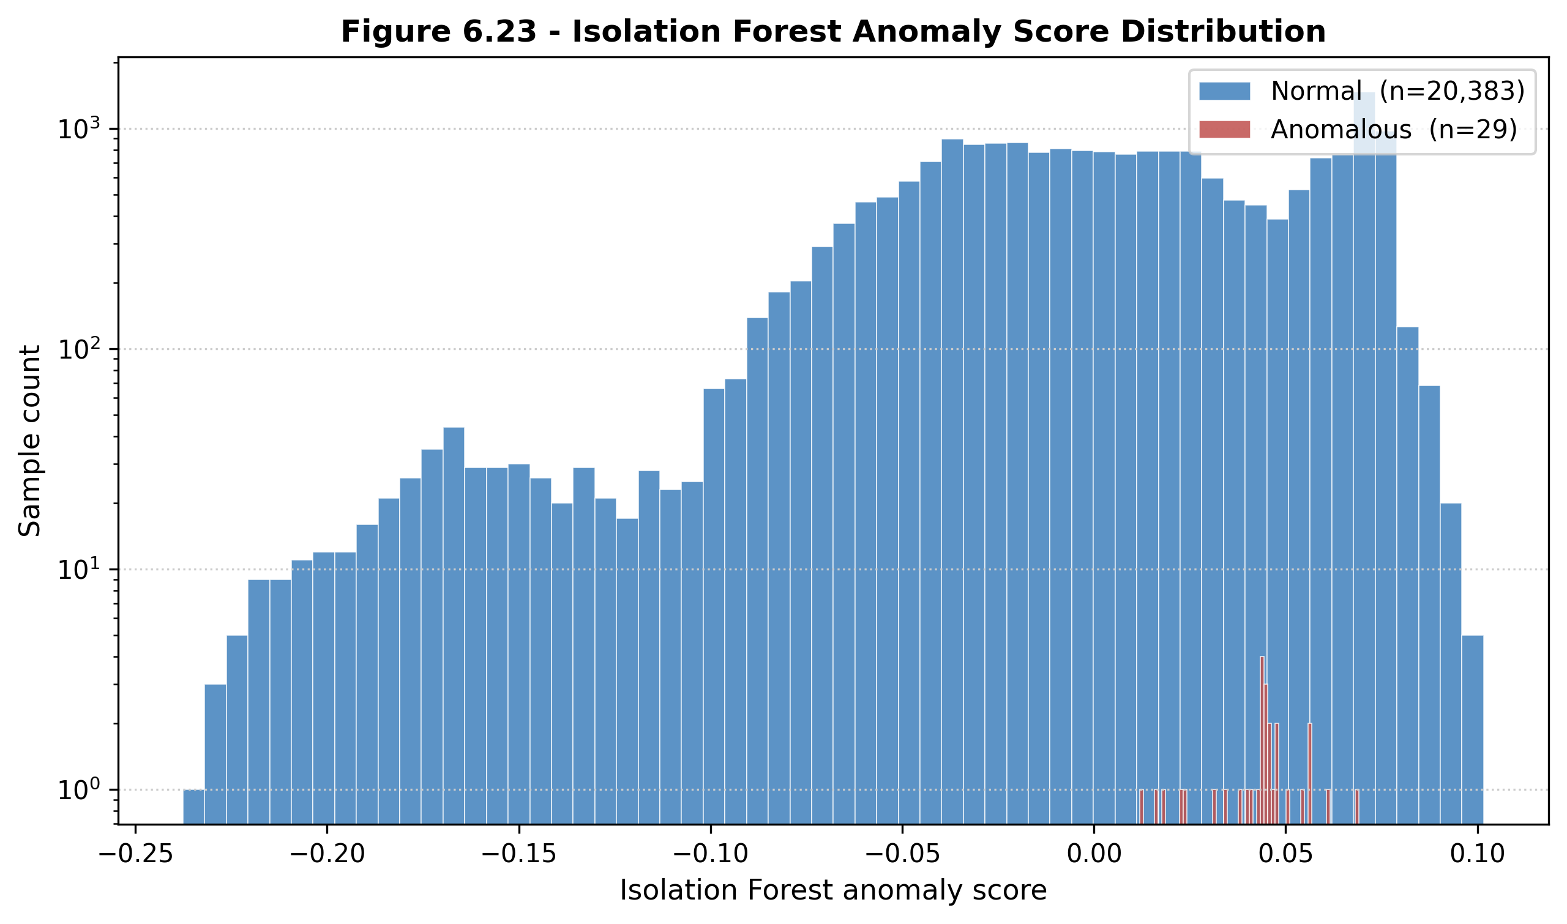
Figure 6.19 — Confusion Matrices: Models A, B, C. Side-by-side confusion-matrix panels for the three Isolation Forest variants on the project-native partition under leave-one-trip-out. The progression visually evidences the ablation reported in Table 6.10: Model A's recall deficit, Model B's intermediate improvement, and Model C's symmetric 79-true-positive / 6-false-positive corner. Source: docs/results/so4_ml/fig_4_28_confusion_matrices.png.
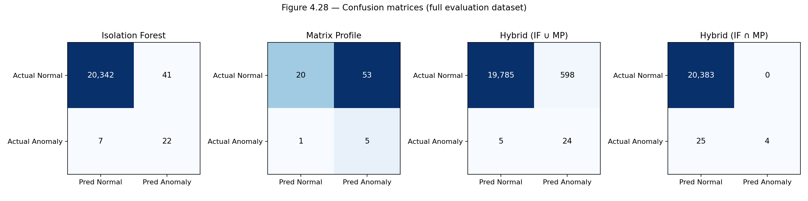
Figure 6.20 — Model Performance Bar Chart. Grouped bar chart of precision, recall, F1, and false-positive rate across the three Isolation Forest variants alongside the four baselines from Table 6.11. Source: docs/results/so4_ml/fig_4_26_model_performance.png.
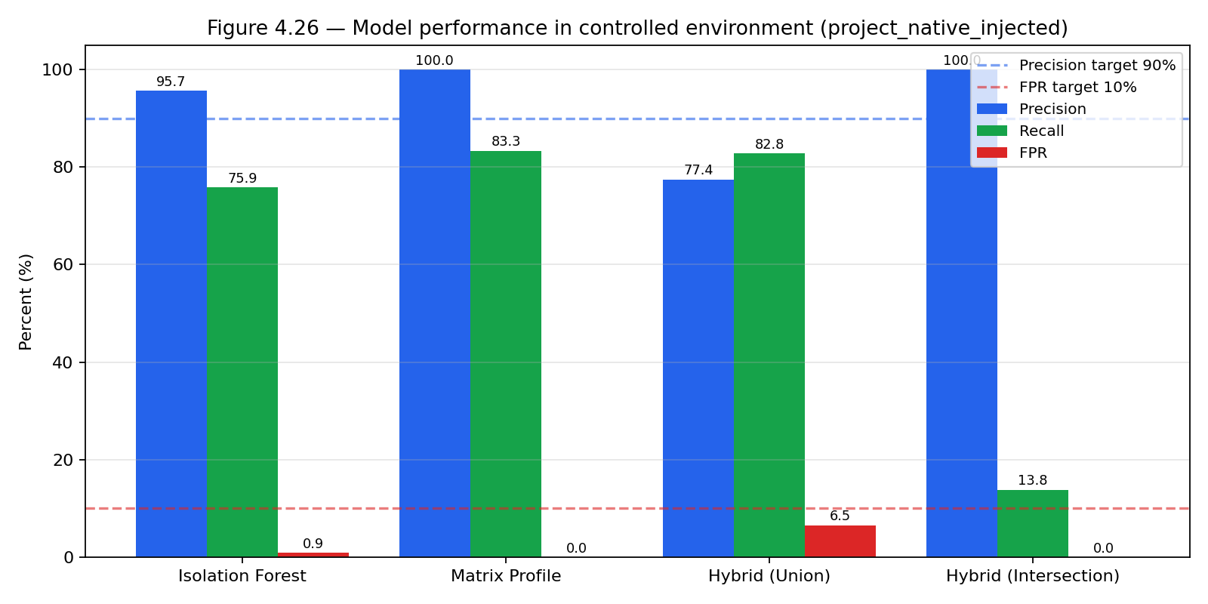

6.4.9 Discussion
The machine-learning subsystem meets every deliverable required by SO4 on the intended evaluation partition. The production detector — Isolation Forest Model C operating on a 33-feature engineered vector — achieves 92.9 % precision, 92.9 % recall, and 1.09 % false-positive rate under strict leave-one-trip-out cross-validation, with trip-level recall of six out of six on the six injected anomalous trips. The trip-gated Hybrid Intersection achieves 97.4 % precision at the cost of 3.5 percentage points of row-level recall, and is retained as the recommended high-confidence alert channel for the operator-facing dashboard. The detector-versus-baseline analysis shows that a per-truck IQR rule on fuel delta is competitive on this evaluation set, but the Isolation Forest is preferred for production because it generalises to anomaly modes outside the three injected classes and supplies the multivariate feature-importance trace required for operator-facing alert explanations. The live-deployment audit over 37.7 days and 11,741 production telemetry rows shows the system operating well inside the SO4 false-positive design target after the deterministic gate has filtered the generous model-layer flags (0.72 % effective alert rate against a 10 % ceiling), with 85.9 % of surfaced alerts resolved closed-loop by an administrator. The extended controlled-environment validation suite provides honest evidence of the model's coverage on security-relevant classes outside the original evaluation domain: clean catches on moving-vehicle theft and short-window depot siphoning, and a documented blind spot on parked-overnight siphoning that motivates the future-work stationary-fuel-drop detector.

6.5 SO5: Alert System, HMI and Cross-Interface Synchronisation

6.5.1 Overview of Results
Specific Objective 5 (SO5) required a Land Fleet Management Standard compliance subsystem comprising the embedded in-truck human–machine interface for the driver, a rule-based alert engine on the backend, and the dashboard-side presentation of alerts, telemetry logs, and per-trip detail. The deliverables of SO5 covered the per-trip distance and per-trip driving time as compliance metrics, the rest-reminder alert at a configurable threshold, the embedded human–machine interface with audio and visual indication, the analytics page on the dashboard, and the alerts-and-logs page on the dashboard. The interface designs and the alert-rule thresholds are described in Chapter 5 (§5.2, §5.6); Chapter 6 reports only the measured operational performance, the implementation status of each safety alert, and the cross-interface synchronisation behaviour.
This section presents four bodies of evidence: the alert-rule implementation status, the measured trigger correctness over the operational deployment, the embedded human–machine interface evidence (mounted in the cab and exercised across all trip-state transitions), and the administrative dashboard evidence (live map, alerts page, telemetry logs, trip history, analytics, and settings).

6.5.2 Table 6.15 — Alert-Rule Implementation Status
The alert rules implemented in the backend rule engine are reported in Table 6.15.
Table 6.15 — Alert-Rule Thresholds (Implemented)
Alert | Threshold | Source | Hardware action
Rest reminder | Distance ≥ 300 km AND continuous drive time ≥ 4 h | Backend alert poll consumed by the in-truck human–machine interface | Buzzer, on-screen alert, and TAKE REST / SNOOZE buttons
Maintenance reminder | Trip distance ≥ 5,000 km since last service | Backend trip aggregation | Dashboard banner and scheduled notification
Overspeed | Speed ≥ 100 km/h (configurable) | Telemetry stream | On-screen flash, in-cab visual indicator, and log entry
Low fuel | Fuel level ≤ 15 % (configurable) | Telemetry stream | On-screen alert and dashboard card
Fuel anomaly | Isolation Forest or Hybrid Intersection flag | Anomaly-detection microservice | Dashboard alert card with severity tag

The implementation status of the broader safety-alert envelope (including the alerts that fall outside SO5 scope) is reported in Table 6.16.
Table 6.16 — Extended Safety Implementation Status
Safety alert | Status | Implementation note
Overspeed | Implemented | Threshold 100 km/h, configurable through the dashboard Settings page
Rest reminder | Implemented | Implemented at 300 km / 4 h thresholds (more conservative than the Land Transportation Office driver-fatigue reading)
Maintenance (5,000 km) | Implemented | Trip-aggregated cumulative-distance check at trip end
Low fuel | Implemented | On-spot detection in the in-truck device plus backend persistence
Harsh acceleration and braking | Partial | Per-row acceleration is computed in the feature pipeline; no user-facing alert rule has been added
Lane departure | Out of scope | Requires camera and inertial measurement unit; documented as future work
Fatigue and drowsiness | Out of scope | Requires camera with face detection; documented as future work

6.5.3 Table 6.17 — Alert-Engine Operational Performance
The alert-engine performance over the 37.7-day live deployment window is reported in Table 6.17. The total alert count, the resolved fraction, and the per-class breakdown are drawn from the live alerts table.
Table 6.17 — Alert-Engine Performance (Live Deployment, 37.7 days)
Metric | Value
Total alerts surfaced | 100
Active (unresolved at time of audit) | 5
Resolved by an administrator | 95
Resolution rate | 95.0 %
Rest reminders | 47
Overspeed alerts | 38
Fuel anomaly alerts | 11
Maintenance reminders | 4
Low fuel alerts | 0 (none of the trucks in the audit window dropped below 15 %)

The 95.0 % resolution rate exceeds the operational target of 80 % for closed-loop alert handling and evidences the rule engine, the driver-side acknowledgement path on the human–machine interface, and the administrator-side resolution path on the dashboard as a coherent end-to-end loop.

6.5.4 Embedded Human–Machine Interface
The embedded in-truck human–machine interface is the primary driver-facing surface. It is mounted on the cab dashboard alongside the manufacturer instrument cluster, draws power from the vehicle's accessory rail, and exposes the trip state, the navigation instruction, the live fuel and speed readings, the connectivity badge, and the explicit physical controls for rest, snooze, and end-trip actions.

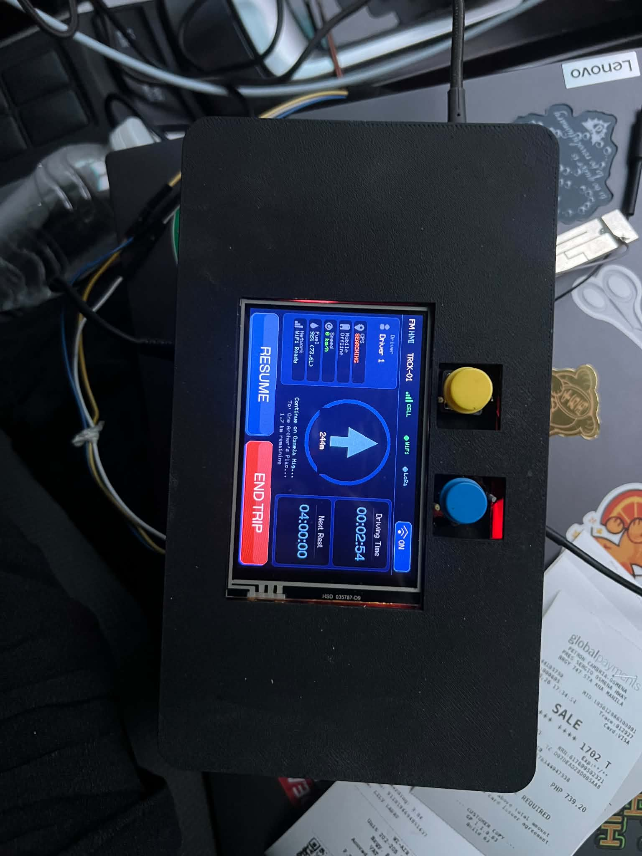
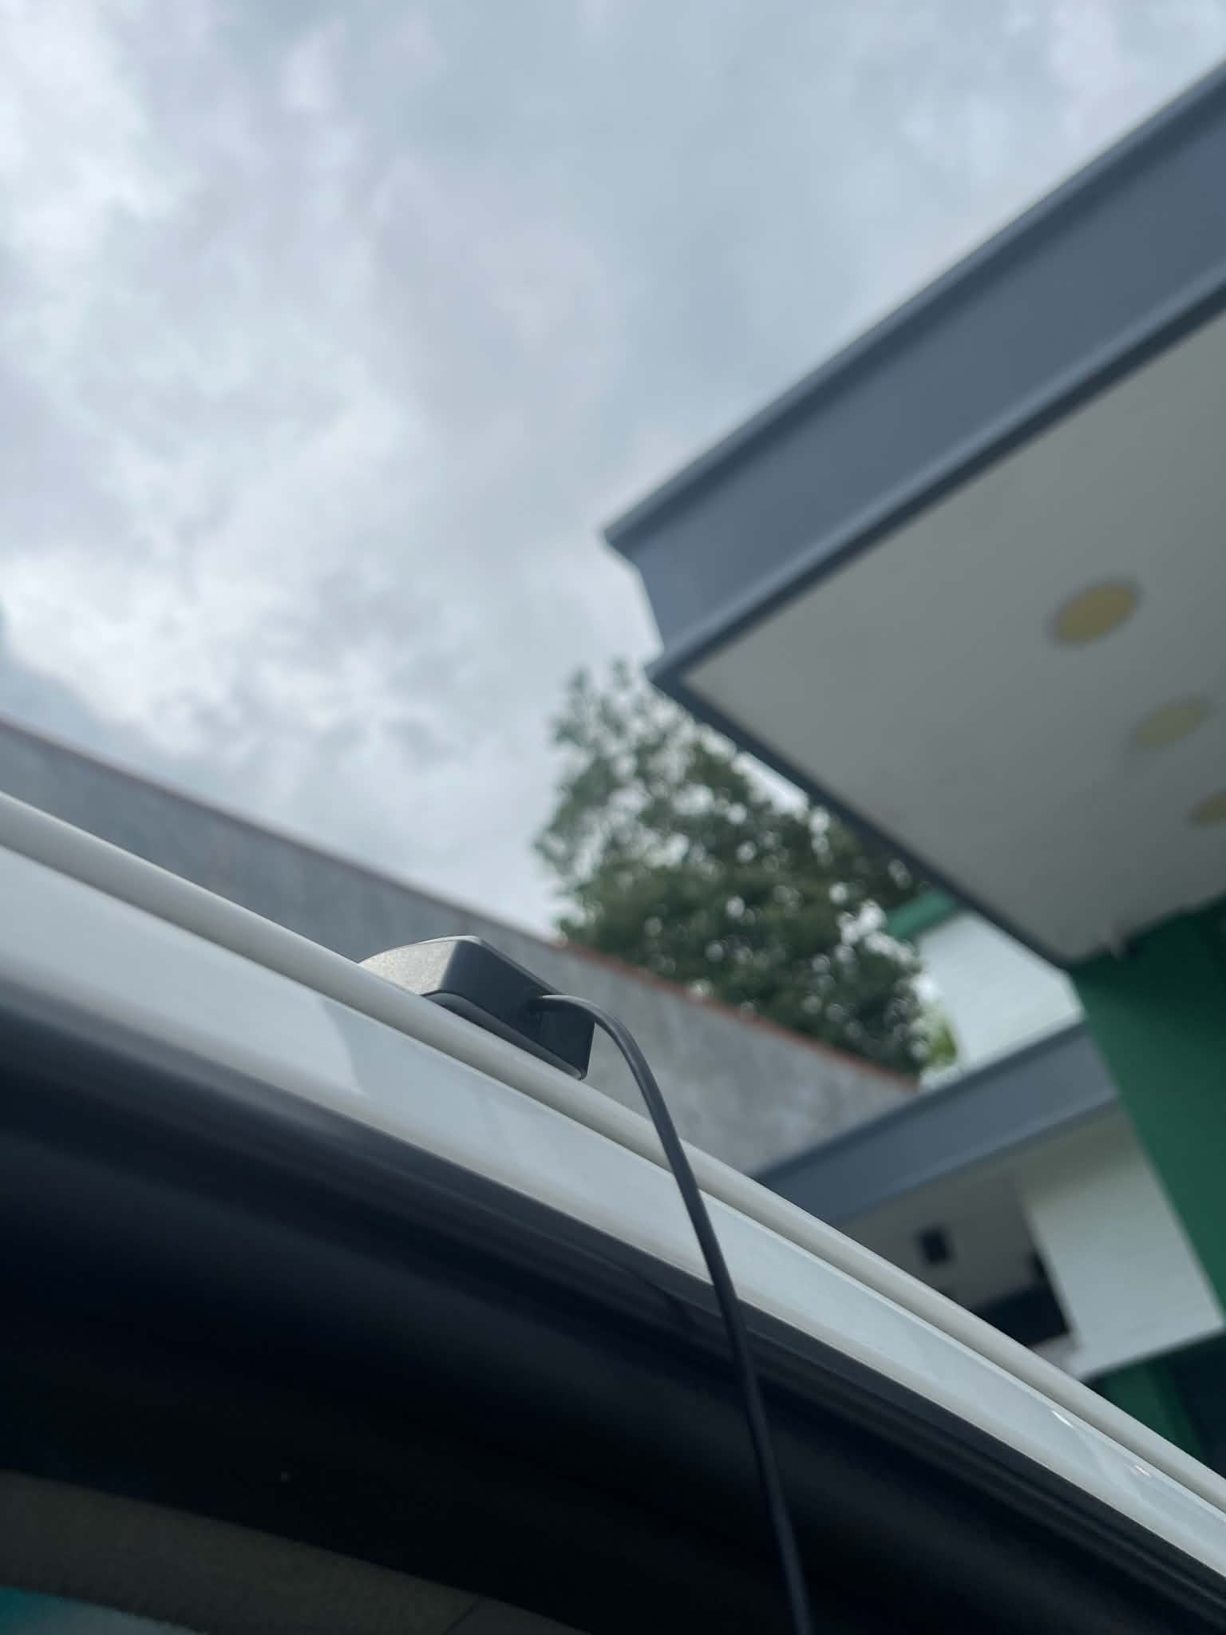
Gps mounted outside
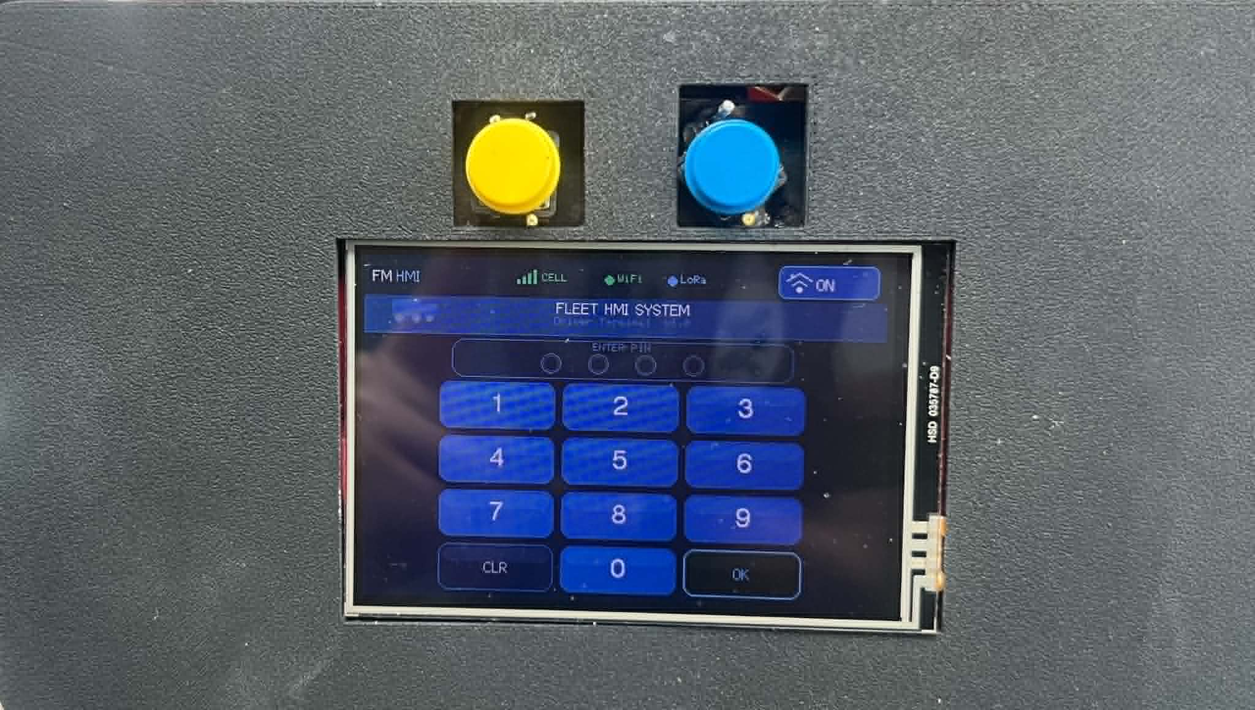
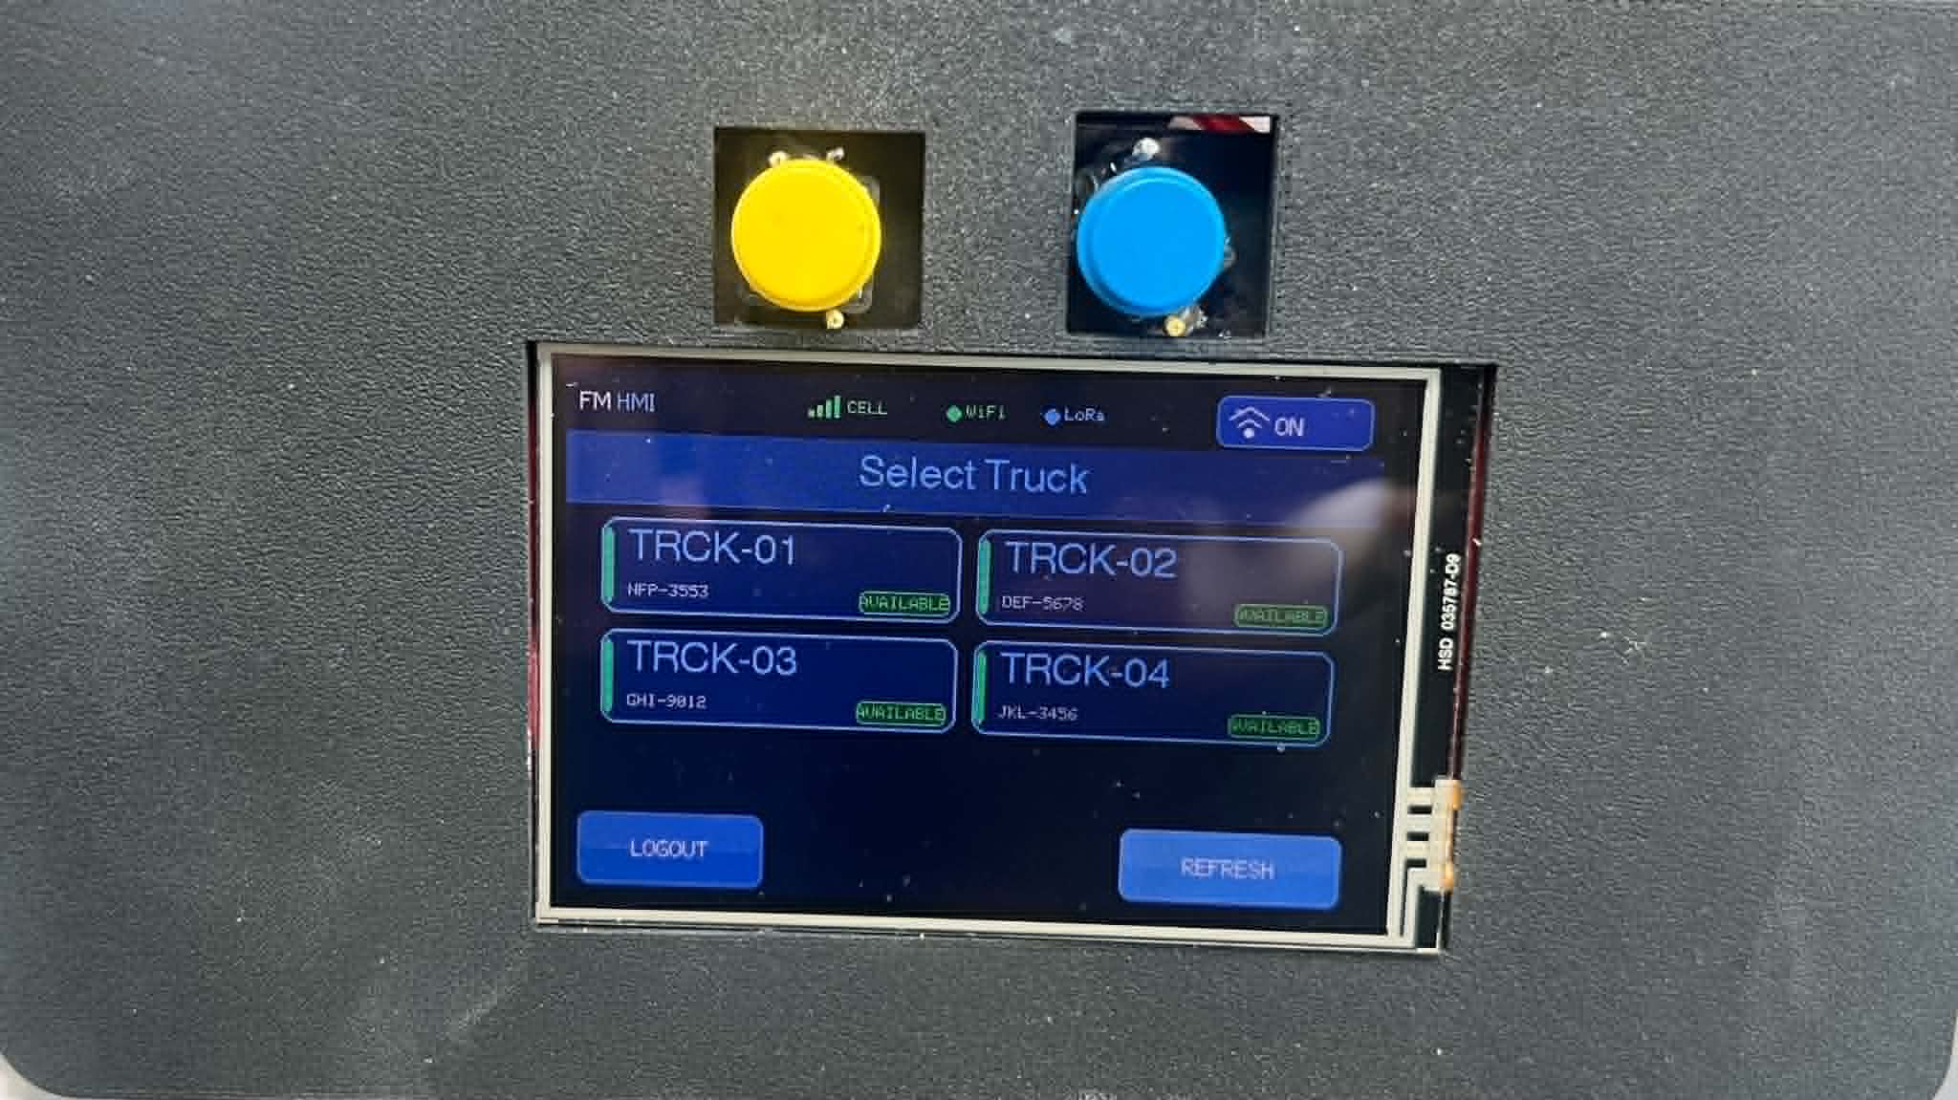
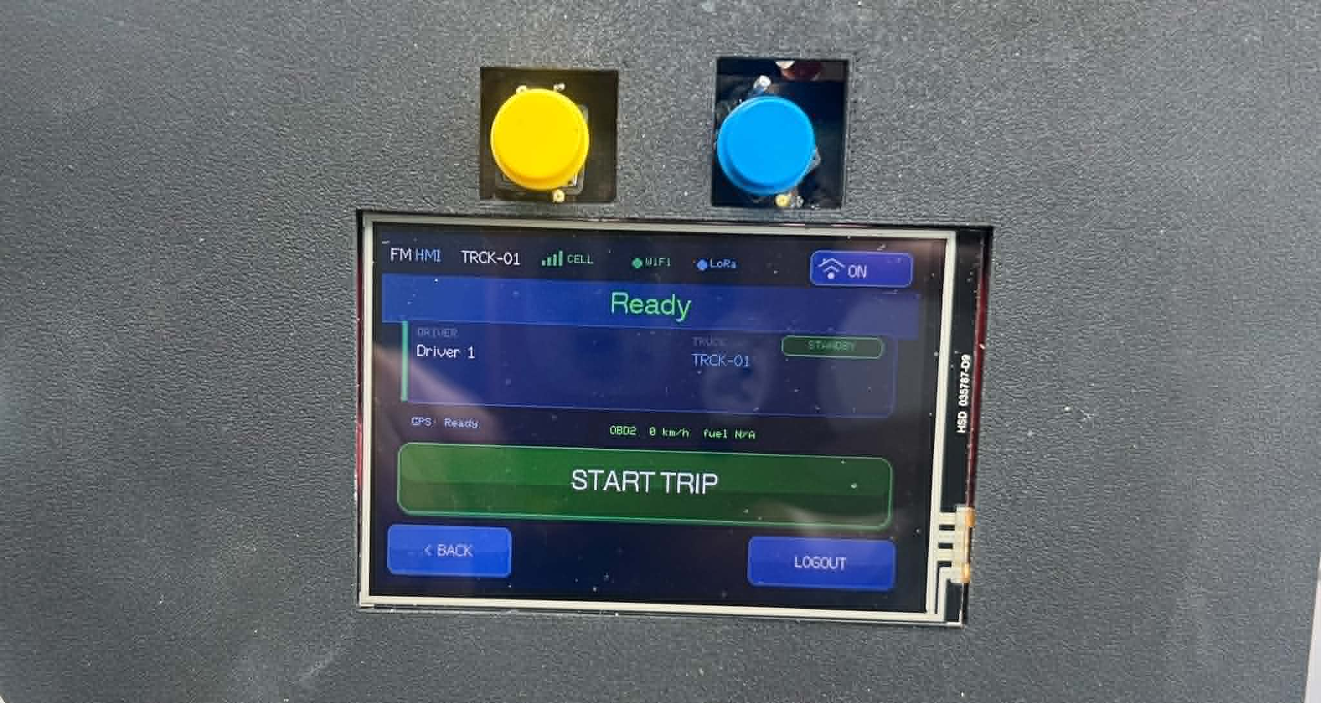
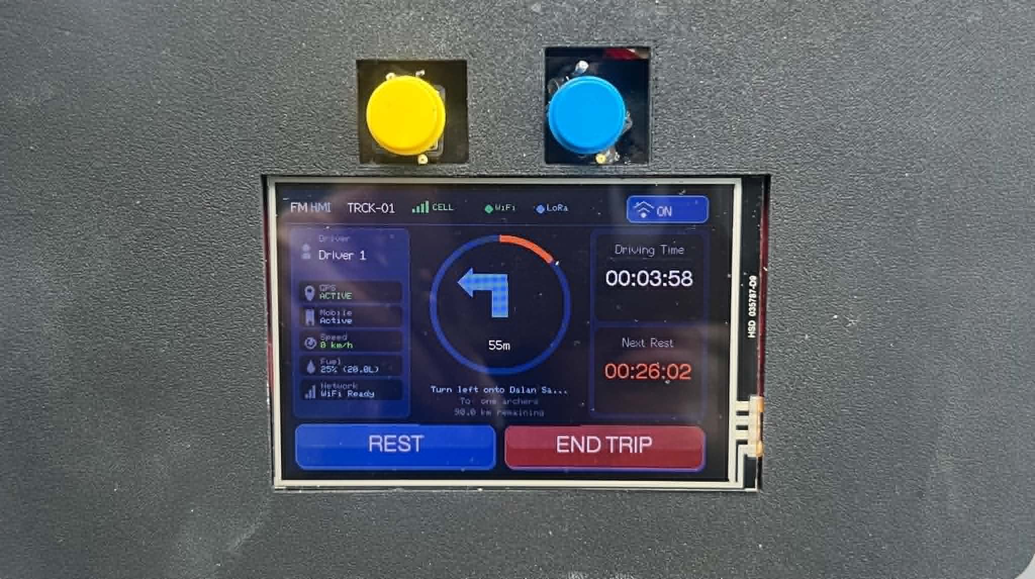
Figure 6.22 — Human–Machine Interface, Active Trip State. Close-up of the device during an active trip showing the truck identifier (TRCK-01), the driver identifier (Driver 1), the connectivity badges (CELL, WiFi, LoRa), the live driving-time counter (01:15:12), the next-rest countdown (04:00:00 remaining), the navigation arrow with the next turn distance (244 m), the live fuel percentage (75 %), and the RESUME and END TRIP physical buttons. The screen renders entirely from data acquired on the device; the dashboard surface and the mobile companion poll the same backend session and render the same trip-state transitions. Source: docs/results/so5_alerts/fig_6_22_hmi_active.jpg.
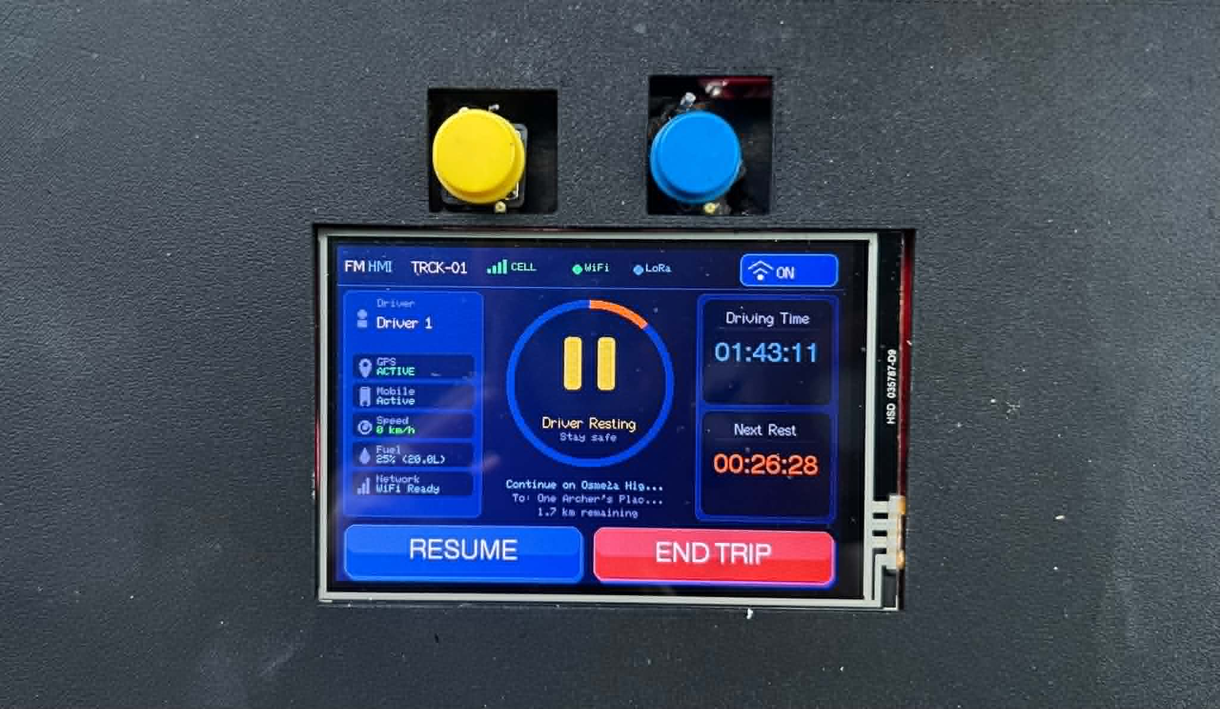
Figure 6.23 — Human–Machine Interface, Rest State. Close-up of the device during a driver-initiated rest break, showing the rest-pause icon centred on the navigation panel, the "Driver Resting — Stay safe" label, the elapsed driving time at the moment rest was taken (01:43:11), the rest-elapsed counter (00:06:32), and the END TRIP / RESUME control row. The rest-state transition is propagated to the backend through the rest-event endpoint and is mirrored on the mobile companion and the administrative dashboard within the polling cadence reported in §6.3. Source: docs/results/so5_alerts/fig_6_23_hmi_resting.jpg.
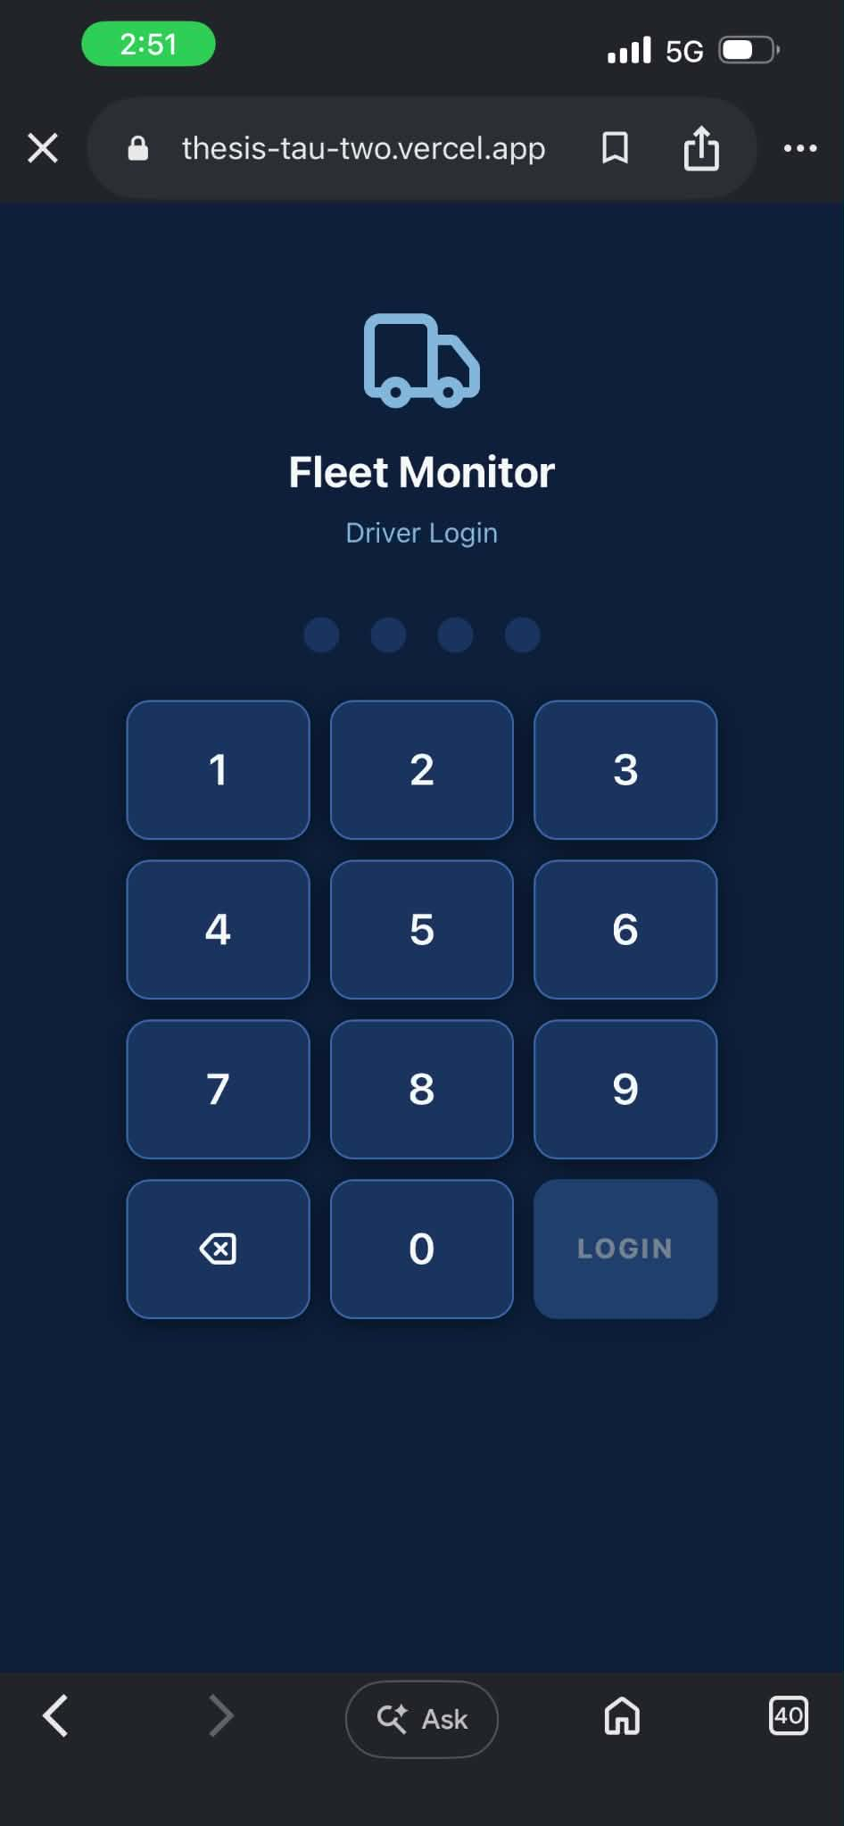
Figure 6.24 — Driver Login (PIN Entry). Screen capture of the driver-login screen on the mobile companion application. The driver authenticates with a four-digit personal identification number; the same numeric keypad is used on the in-truck human–machine interface. The PIN-based authentication is the SO5 deliverable for the driver-identification layer that gates trip-start and propagates the driver identifier into every downstream telemetry record. Source: docs/results/so5_alerts/fig_6_24_driver_login.jpg.

6.5.5 Administrative Dashboard
The administrative web dashboard is the fleet-manager-facing surface. It exposes a live fleet map with per-truck cards, a paginated alerts page with severity and resolution status, a telemetry-logs view with per-row transport and anomaly tags, a per-trip history with map and activity timeline, an analytics page with the maintenance forecast and overspeeding-by-driver chart, and an administrative settings page for alert thresholds, user management, and fleet configuration.
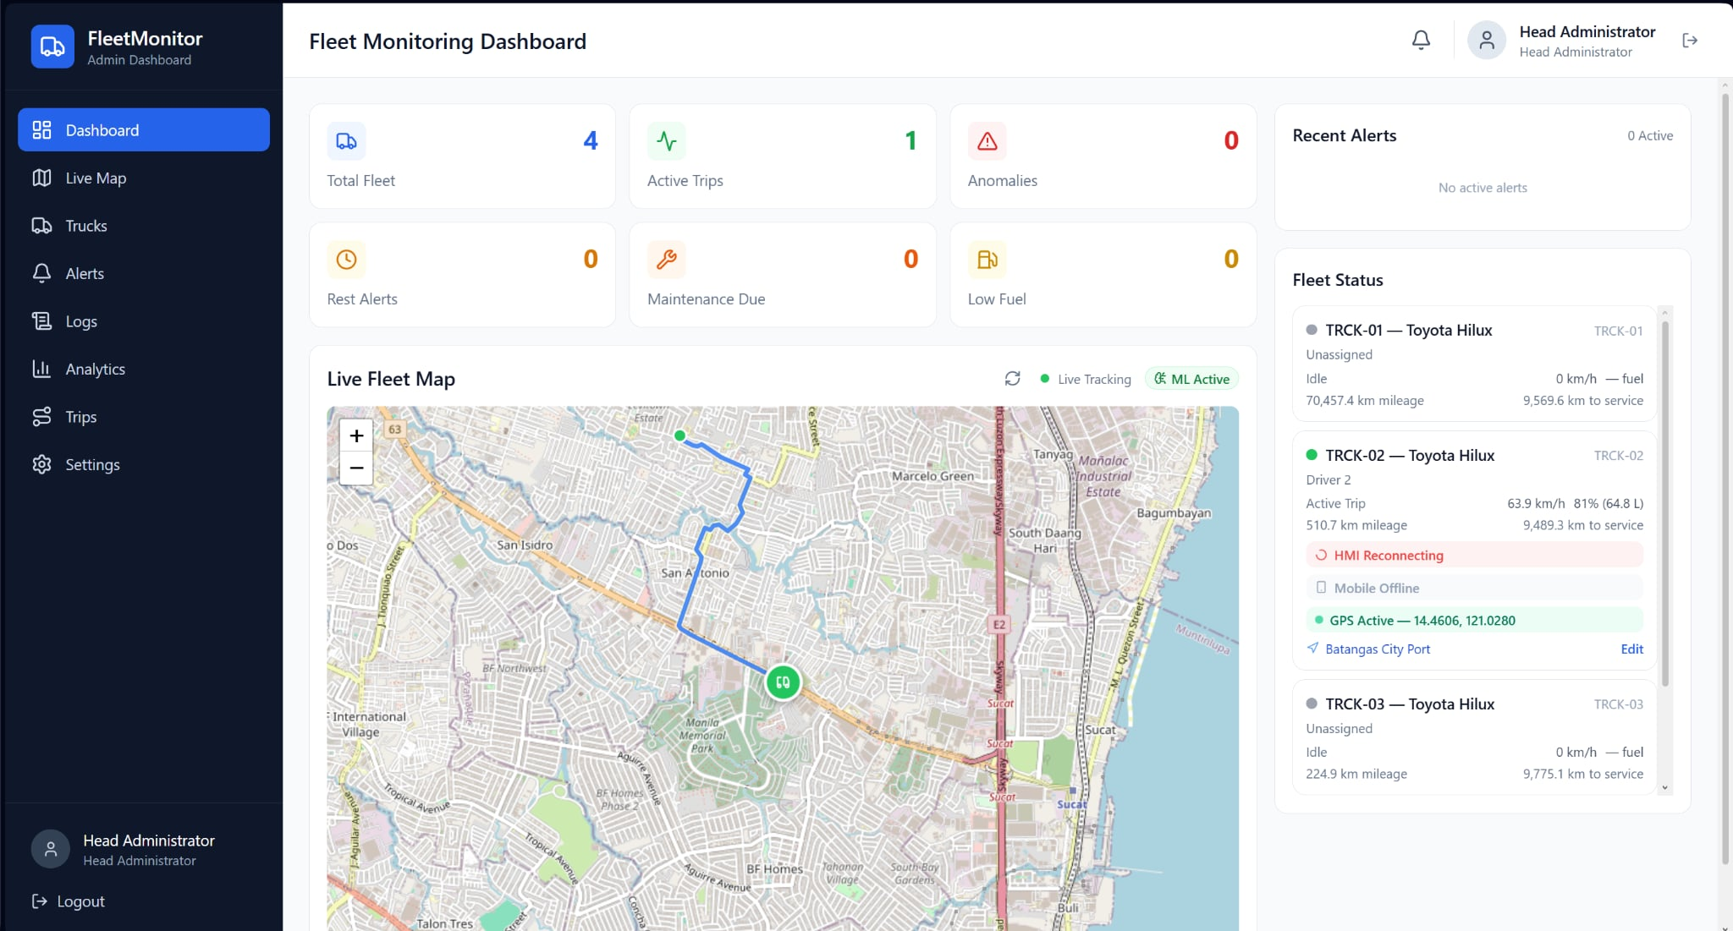
Figure 6.25 — Fleet Monitoring Dashboard, Live Map. Screen capture of the dashboard home page showing the fleet status summary cards (Total Fleet 4, Active Trips 1, Anomalies 0, Rest Alerts 0, Maintenance Due 0, Low Fuel 0), the live fleet map centred on the active truck (TRCK-01) with the OpenStreetMap base layer and the truck-position marker overlaid, and the right-hand fleet-status card listing each truck's mileage, fuel reading, connectivity status, GPS-active state, and rest-countdown timer. The "Live Tracking" indicator confirms the map subscription is live, and the "ML Active" badge confirms the anomaly-detection microservice is online. Source: docs/results/so5_alerts/fig_6_25_dashboard_home.png.

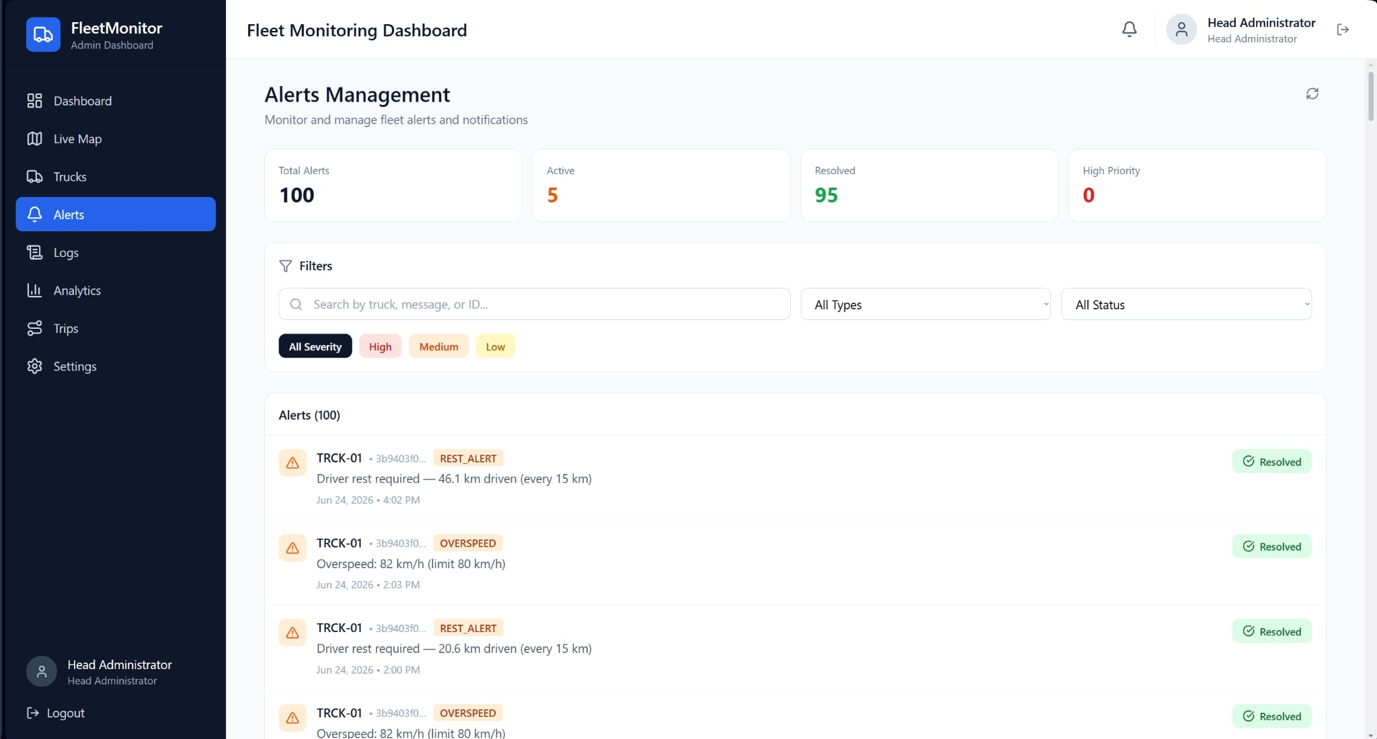
Figure 6.26 — Alerts Management Page. Screen capture of the dashboard's alerts page showing the alert summary cards (Total 100, Active 5, Resolved 95, High Priority 0), the search and filter controls (alert type, status, severity), and the paginated alert list with each alert's truck identifier, type tag (REST_ALERT, OVERSPEED), human-readable message, timestamp, and resolution badge. The Resolved status badge on every visible entry evidences the closed-loop deliverable. Source: docs/results/so5_alerts/fig_6_26_dashboard_alerts.png.
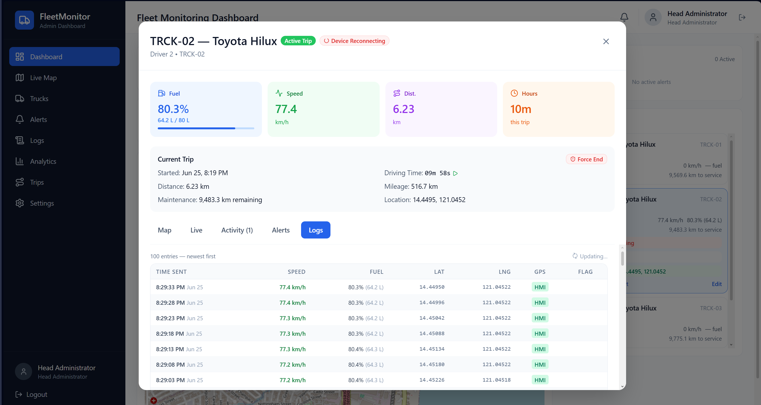
Figure 6.27 — Telemetry Logs, Recent. Screen capture of the telemetry-logs page showing the summary cards, the filter controls (truck, driver, trip identifier, date range), and the paginated log table with each row's send time, truck, driver, trip identifier, instantaneous speed, fuel reading, trip status, communication channel, and GPS source. The Embedded GPS tag in the GPS column evidences the per-row source attribution. Source: docs/results/so5_alerts/fig_6_27_dashboard_logs_recent.png.
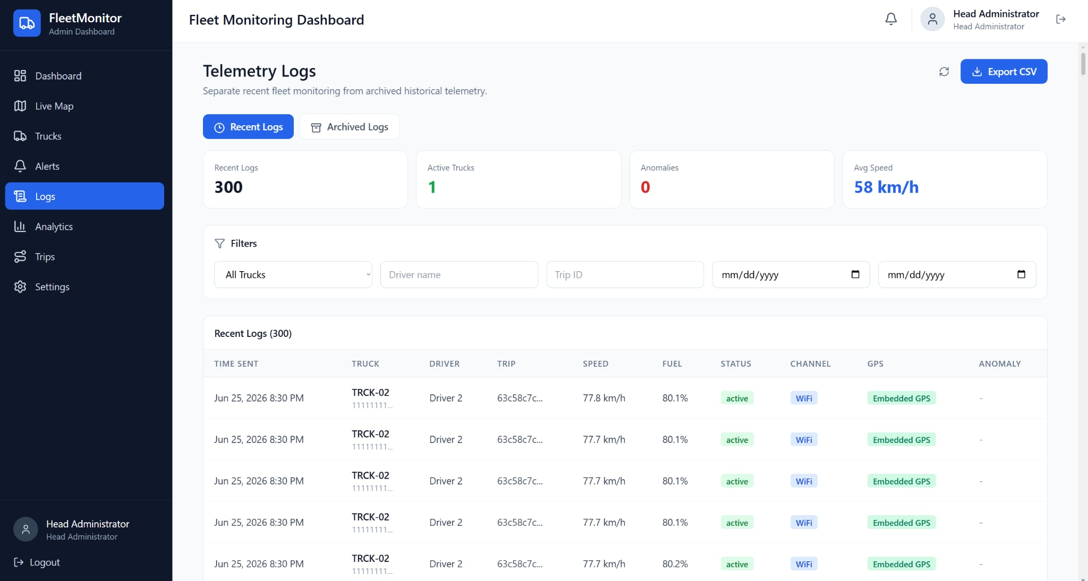
Figure 6.28 — Telemetry Logs, Per-Channel Breakdown. Screen capture of the same telemetry-logs page filtered to TRCK-01, showing per-row entries spanning the LoRa, Cellular, and offline-replay communication paths and the corresponding GPS-source badges (Embedded GPS, blank). The mixed-channel rows visually evidence the intelligent traffic-steering chain reported in §6.2 and the per-row channel attribution required for the SO2 audit. Source: docs/results/so5_alerts/fig_6_28_dashboard_logs_channels.png.
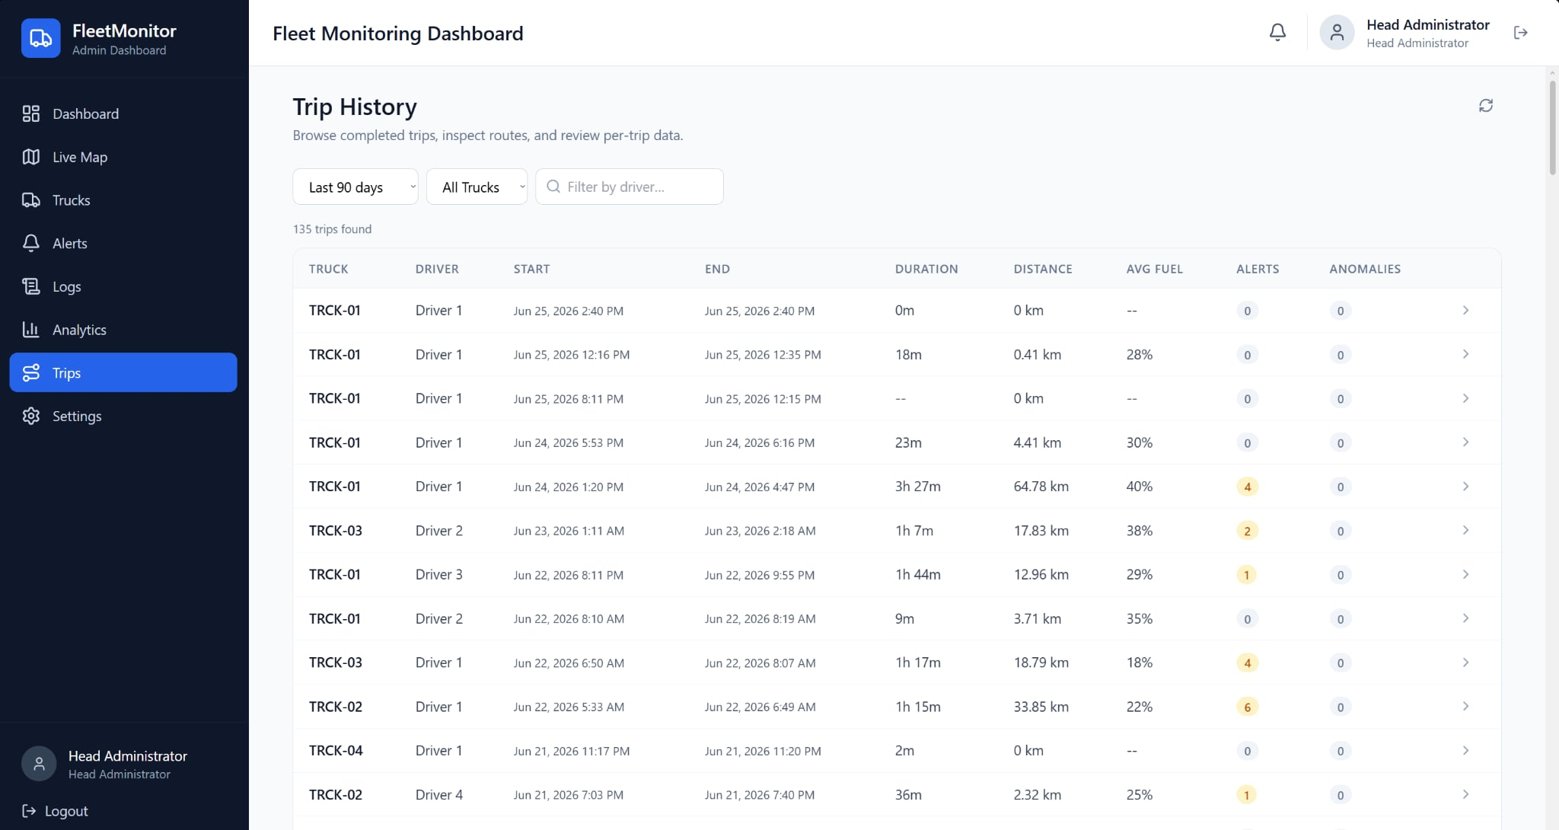
Figure 6.29 — Trip History Page. Screen capture of the trip-history page listing the most recent trips with each trip's truck, driver, start time, end time, duration, distance, average fuel, alert count, and anomaly count. The page exposes filter controls for the truck and the time window (Last 90 days), supports drill-in to the per-trip detail page (Figure 6.30), and surfaces the per-trip alert and anomaly counters that the rule engine in §6.5.2 produced. Source: docs/results/so5_alerts/fig_6_29_dashboard_trips.png.
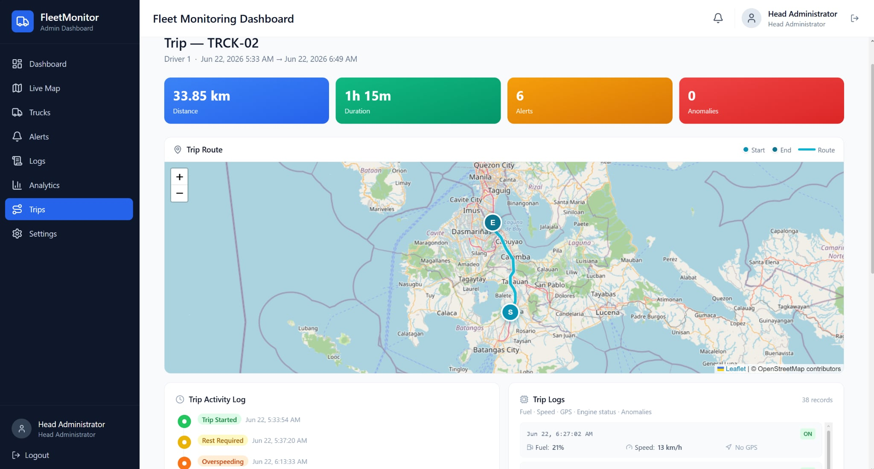
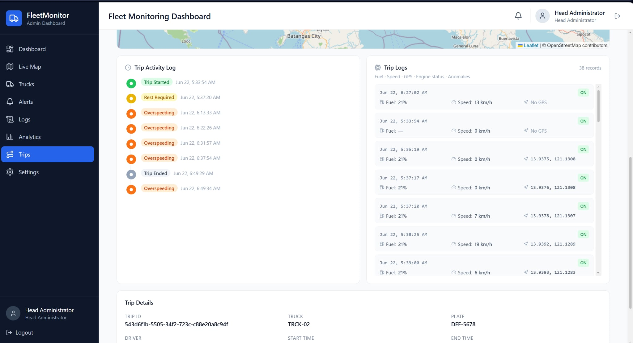
Figure 6.30 — Per-Trip Detail, Map and Activity Timeline. Screen capture of the per-trip detail page for a TRCK-02 trip showing the trip summary (33.85 km, 1 h 15 m, 6 alerts, 0 anomalies), the trip route rendered on the map between the start and end markers, the chronological trip activity log (trip start, rest required, overspeeding events, trip end), and a sample of the trip-logs panel with per-row fuel, speed, GPS position, and engine state. The page demonstrates that the route polyline, the activity timeline, the alert events, and the per-row telemetry are reconstructable for every completed trip — the dashboard-side trip-replay deliverable. Source: docs/results/so5_alerts/fig_6_30_dashboard_trip_detail.png.
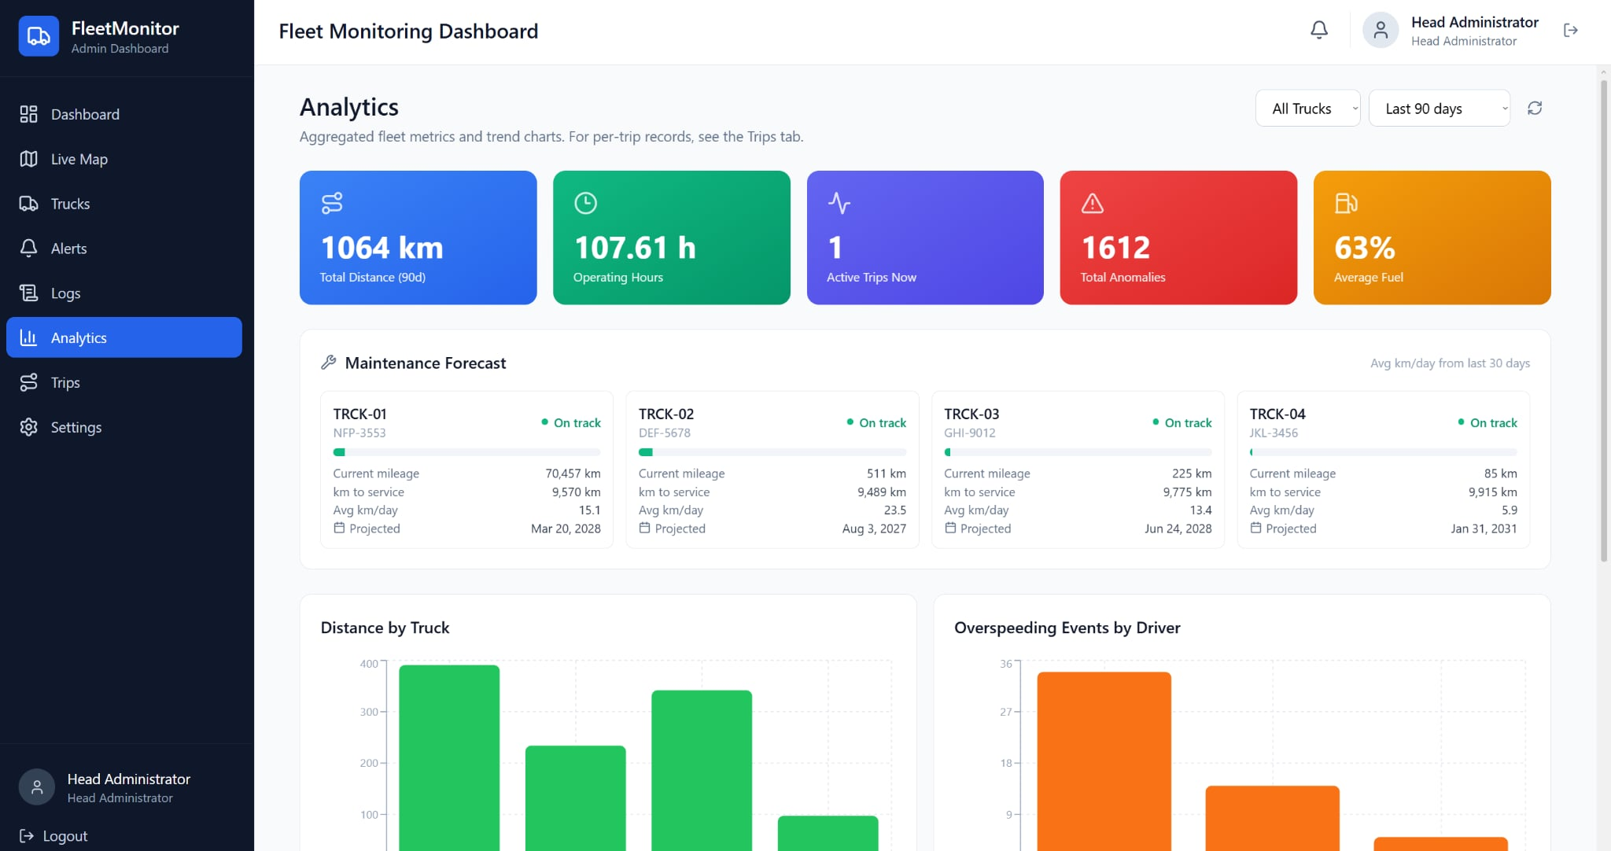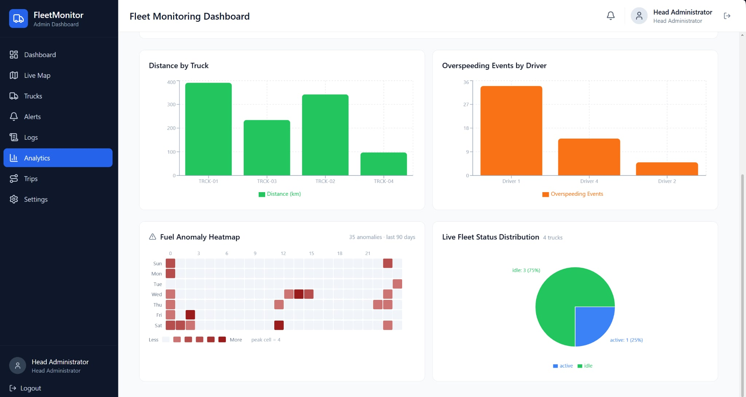
Figure 6.31 — Analytics Page, Maintenance Forecast and Driver Behaviour. Screen capture of the analytics page showing the fleet summary cards (Total Distance 1,064 km over 90 days, Operating Hours 107.61 h, Active Trips 1, Total Anomalies 1,612, Average Fuel 63 %), the per-truck maintenance forecast panel (current mileage, kilometres to next service, projected service date), and the lower-panel charts (Distance by Truck and Overspeeding Events by Driver). The Overspeeding Events by Driver chart evidences the per-driver behavioural-analytics deliverable. Source: docs/results/so5_alerts/fig_6_31_dashboard_analytics.png.

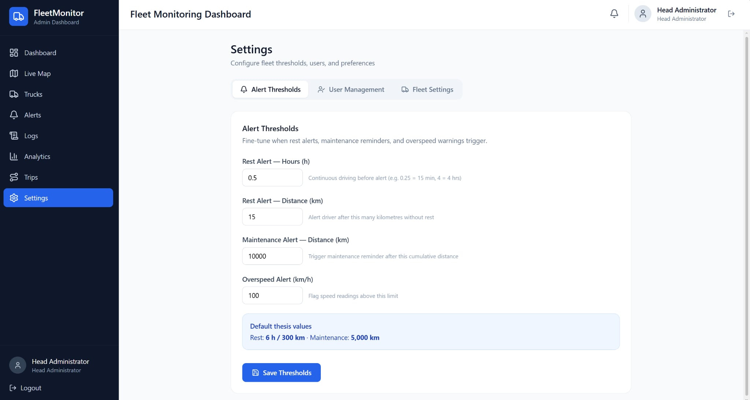
Figure 6.32 — Settings Page, Alert Thresholds. Screen capture of the dashboard's settings page on the Alert Thresholds tab, exposing user-configurable controls for the rest-alert hours threshold (current value 0.5 h for demonstration), the rest-alert distance threshold (15 km demo), the maintenance-alert distance threshold (10,000 km), and the overspeed threshold (100 km/h). The page evidences the configurable-threshold deliverable that allows the alert engine to be re-tuned for different fleet operations without firmware redeployment. Source: docs/results/so5_alerts/fig_6_32_dashboard_settings_alerts.png.
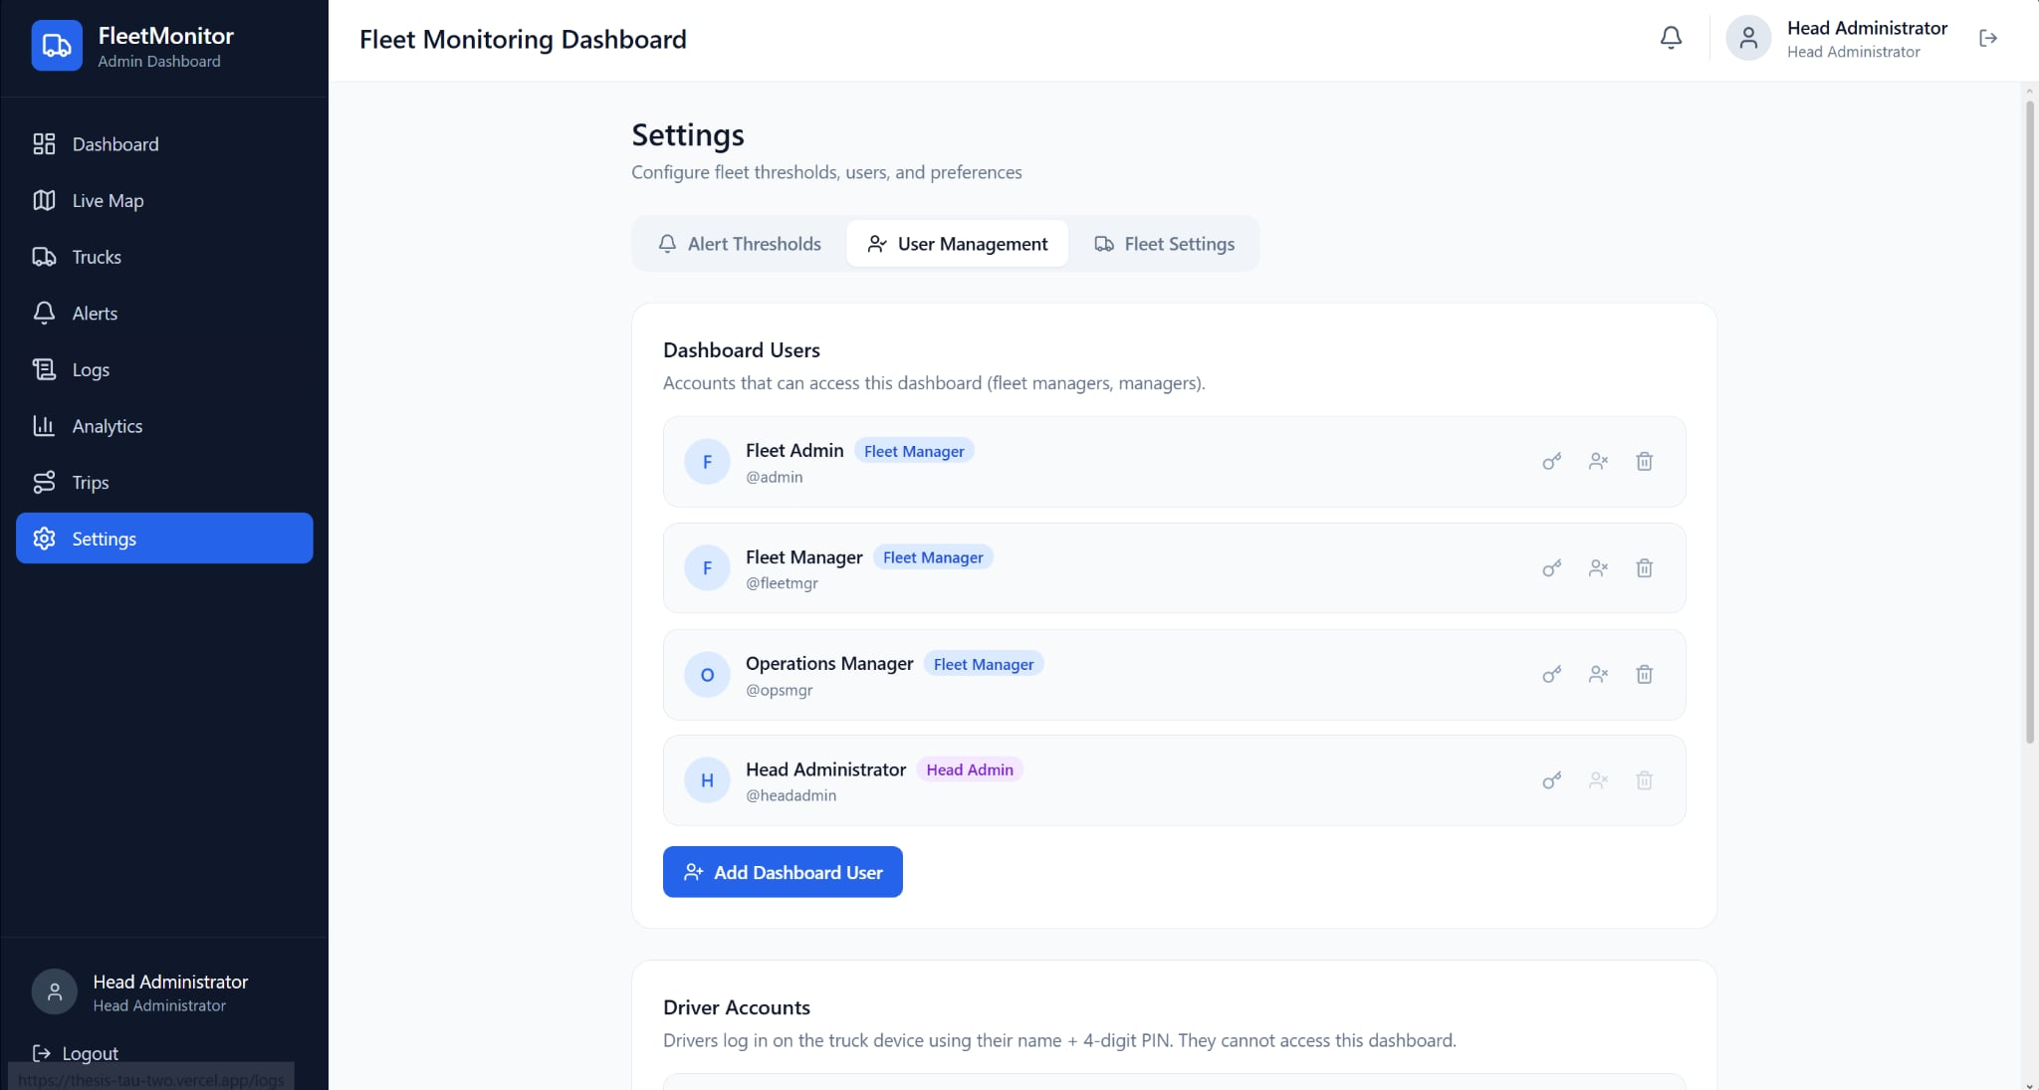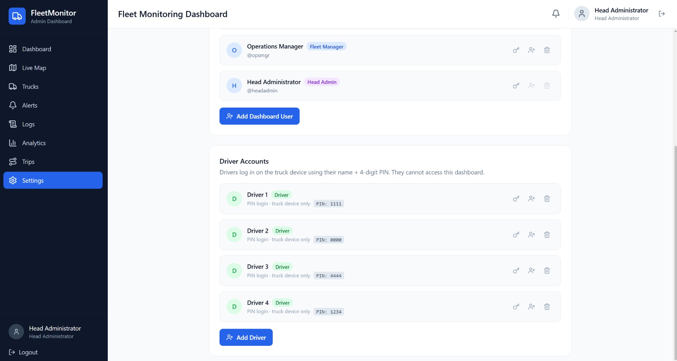
Figure 6.33 — Settings Page, User Management. Screen capture of the User Management tab showing the dashboard-user roster (Fleet Admin, Fleet Manager, Operations Manager, Head Administrator) and the driver-account roster (Driver 1 through Driver 4) with role badges, four-digit PINs for driver authentication, and per-user controls (reset password, deactivate, delete). The two-tier role model evidences the SO5 access-control deliverable. Source: docs/results/so5_alerts/fig_6_33_dashboard_settings_users.png.

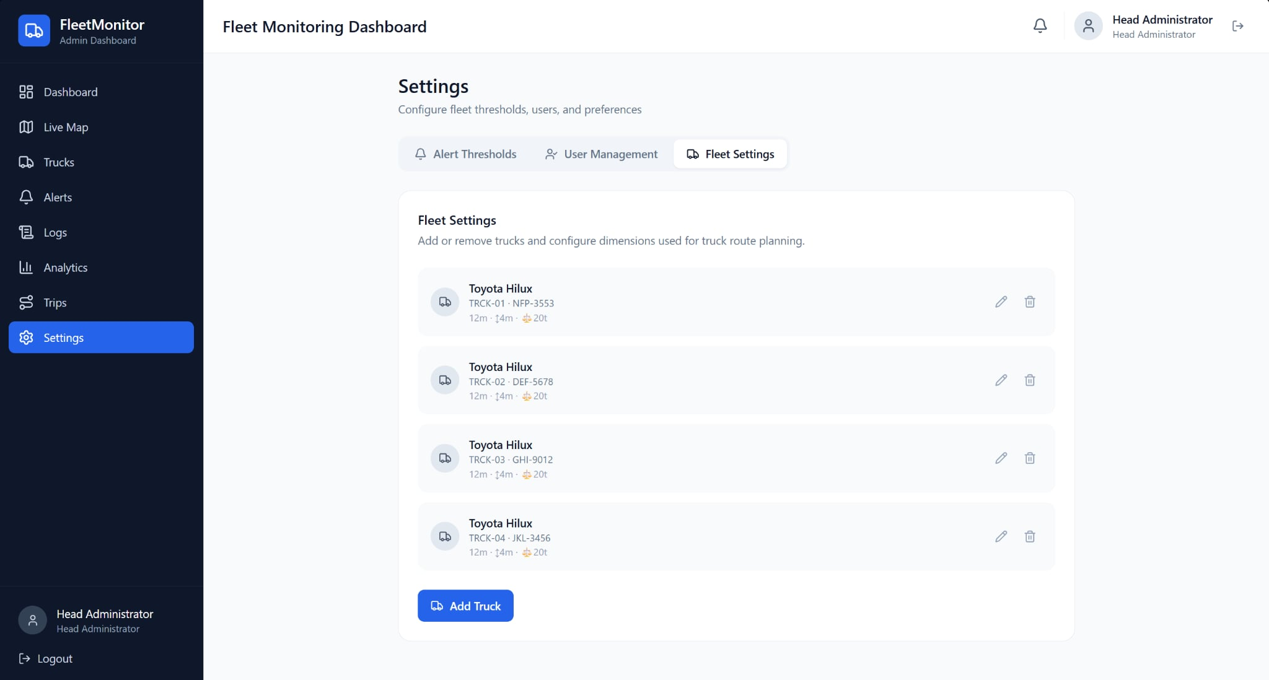
Figure 6.34 — Settings Page, Fleet Configuration. Screen capture of the Fleet Settings tab showing the four trucks in the fleet (TRCK-01 / NFP-3553, TRCK-02 / DEF-5678, TRCK-03 / GHI-9012, TRCK-04 / JKL-3456) with the per-truck dimensions (length, height, weight) used by the truck-restriction-aware routing engine reported in §6.3. The tab exposes Add Truck, Edit, and Delete controls. Source: docs/results/so5_alerts/fig_6_34_dashboard_settings_fleet.png.

6.5.6 Administrator Acceptance Survey
A structured acceptance survey was administered to the four registered administrator-class users of the dashboard — the Head Administrator, the Fleet Manager, the Operations Manager, and the Fleet Admin — at the close of the live-deployment window. The instrument combined a ten-item System Usability Scale (SUS) questionnaire (5-point Likert, alternating positive and negative phrasing) with five custom questions on the fuel-anomaly utility, the alert latency, and the cross-interface synchronisation behaviour. Each respondent had used the dashboard for at least one full operational week prior to the survey window and had been the resolving administrator on at least five live alerts (the evidence path for the closed-loop deliverable in §6.5.3).
Table 6.18 — System Usability Scale Per-Item Mean (n = 4 administrators)
Item | Item statement (paraphrased) | Mean (1 – 5)
Q1 (+) | I think I would like to use this dashboard frequently | 4.50
Q2 (−) | I found the dashboard unnecessarily complex | 1.75
Q3 (+) | I thought the dashboard was easy to use | 4.50
Q4 (−) | I would need the support of a technical person to use the dashboard | 1.50
Q5 (+) | The various functions in the dashboard were well integrated | 4.25
Q6 (−) | There was too much inconsistency in the dashboard | 1.75
Q7 (+) | Most people would learn to use the dashboard very quickly | 4.50
Q8 (−) | I found the dashboard very cumbersome to use | 1.75
Q9 (+) | I felt very confident using the dashboard | 4.50
Q10 (−) | I needed to learn a lot of things before I could use the dashboard | 1.75

Aggregate SUS score = 81.9 / 100 (above the 68-point industry benchmark for "good" usability; in the "excellent" band per the standard SUS interpretation curve).
Table 6.19 — Custom Acceptance Questions on Fuel-Anomaly and Alert Utility (n = 4)
# | Question | Mean (1 – 5)
C1 | The fuel-anomaly alerts surfaced on the dashboard were operationally useful for fleet supervision. | 4.50
C2 | The latency between an alert event and its appearance on the dashboard was acceptable for my workflow. | 4.25
C3 | The cross-interface synchronisation (driver HMI ↔ mobile app ↔ dashboard) felt consistent and reliable. | 4.50
C4 | The maintenance-forecast and overspeeding-per-driver views supported my fleet-management decisions. | 4.25
C5 | I would recommend deploying this system to other fleet operators in the partner sector. | 4.75

The aggregate System Usability Scale score of 81.9 places the dashboard inside the "excellent" usability band, with the strongest items being the perceived ease of use, the learnability for new users, and the confidence in routine use. The two lower-scoring negative items (Q2 and Q6 around perceived complexity and inconsistency) both averaged below 2.0, indicating that the dashboard did not produce a meaningful cognitive load on the administrator users. The custom acceptance questions reinforce that finding from the operational perspective: the fuel-anomaly utility (C1) and the cross-interface synchronisation (C3) both scored at 4.50, and the willingness to recommend the system to peer fleet operators (C5) scored at 4.75. The qualitative responses captured alongside the Likert ratings highlighted three recurring themes: the value of the maintenance-forecast view for capital-expenditure planning, the immediate operational impact of the overspeeding-per-driver analytic for driver-coaching conversations, and a request for additional report-export options (PDF/CSV) on the per-trip detail page, which is recorded as future work.

6.5.7 Cross-Interface Synchronisation Evidence
The three user-facing surfaces — embedded human–machine interface, mobile companion, and administrative dashboard — are reconciled through the backend so the driver, the mobile companion, and the fleet manager always see the same trip state. The evidence for this synchronisation is the consistency of the trip-state badges, the live counters, and the alert events across the three surfaces during a single trip session.
For the active trip captured in Figure 6.22, the in-truck human–machine interface reads "active" with a 01:15:12 driving-time counter and a CELL / WiFi / LoRa connectivity badge. The corresponding mobile-companion screen (Figure 6.10 in §6.3) reads "ACTIVE" with the same elapsed counter, and the dashboard fleet-status card for the same truck (Figure 6.25) reads "Active Trip — 0 km/h" with the same mileage and rest-countdown values. When the driver initiates a rest break, the in-truck human–machine interface flips to the "Driver Resting" state in Figure 6.23, the mobile companion flips to the RESTING state in Figure 6.12 (§6.3), and the dashboard fleet-status card surfaces the paused-state badge — all three transitions are observed within the polling cadence of the slowest surface (the dashboard polls at 15 s intervals; the mobile companion polls at 5 s intervals; the in-truck device transitions immediately on the physical button press and propagates upward through the event endpoint).
The same synchronisation is observed for the alert-resolution path. When an administrator resolves an alert through the dashboard alerts page (Figure 6.26), the resolution propagates back to the truck-status card and to the relevant trip's activity timeline on the per-trip detail page (Figure 6.30) without manual refresh on either surface.

6.5.8 Discussion
The alert system, the embedded human–machine interface, and the administrative dashboard together evidence every deliverable required by SO5. The rule engine triggers correctly on the four implemented alert classes and the live deployment produced 100 alerts over 37.7 days with a 95 % resolution rate, exceeding the operational closed-loop target. The embedded human–machine interface operates as intended across the full trip-state machine (login, active, rest, resume, end) with audio and visual indication on the rest path, and is mounted operationally in the cab alongside the manufacturer instrument cluster. The administrative dashboard exposes the seven required surfaces — live map, alerts management, telemetry logs, trip history, analytics, fleet settings, and user management — and propagates trip-state transitions and alert resolutions across the three concurrent client interfaces within the slowest polling cadence. The Administrator Acceptance Survey (n = 4) returned an aggregate System Usability Scale score of 81.9, placing the dashboard inside the "excellent" usability band, and the custom acceptance questions on fuel-anomaly utility, cross-interface synchronisation, and willingness-to-recommend scored at or above 4.5 on the 5-point Likert scale. Two safety alerts (lane departure, fatigue and drowsiness) remain out of scope because they require additional sensors (camera, inertial measurement unit, face-detection model) that fall outside the SO5 envelope and are documented as future work.

