How to Set Up Android Environment Variable / Path on Windows

After you have installed the Android SDK Environment Kit in Windows, you must set the ***ANDROID_HOME environment variable*** to point to the *Android SDK* installation directory. Let us just set up the Android Environment Variable but to achieve that you are required to have the Android installation path with you. In the last chapter, we did the installation in the following path but choose the right path in case you changed the default location for the installation.

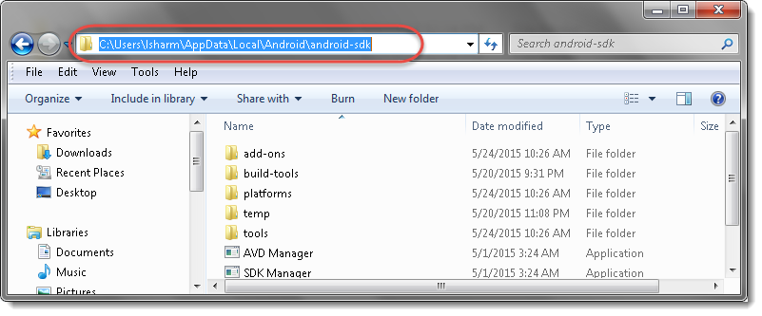

Step 1: Setting the ANDROID_HOME Variable

1) Open the ***Control Panel -> System or Security –> System***; the same thing can be done by *right-clicking* on ‘***MyComputer***’ and choosing ***Properties***.

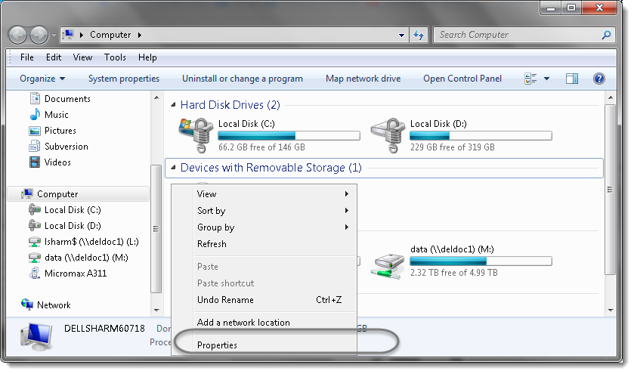

2) Choose ‘***Advanced system settings***‘.

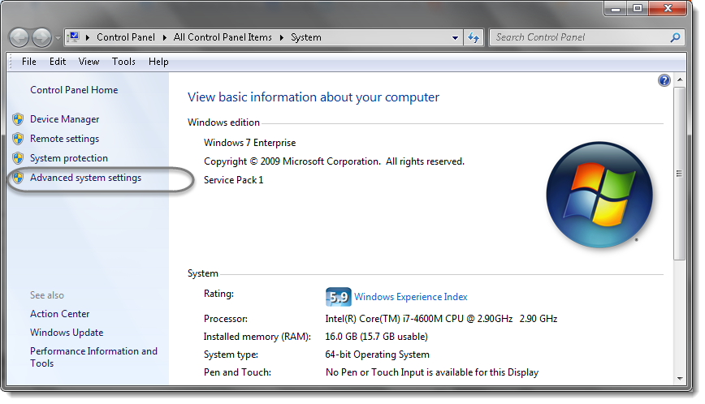

3) Under the ***Advanced*** tab Choose the ‘***Environment Variable…***‘ option.

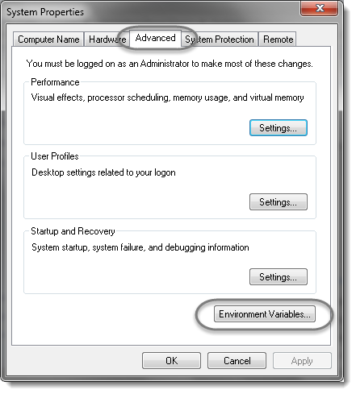

4) Select ***New*** In the ***System variables*.**

**Note: Make sure creating a variable name as “ANDROID_HOME” under System variables.**

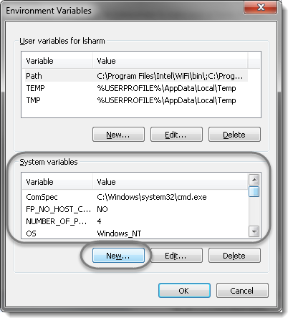

5) Define the *Variable name* as ‘***ANDROID_HOME***‘ and *Variable value* as ‘***C:\Users\lsharm\AppData\Local\Android\android-sdk****‘*.

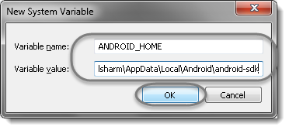

***Note****: if needed, modify this string to reflect the real location of your machine.*

Step 2: Setting PATH Variables for Android SDK

6) Now we need to specify the ‘***tools***‘ folder location in the ***PATH***variable of *android sdk* package. For *PATH*, most probably it will already exists in your machine. So just select it and choose the ***Edit***option.

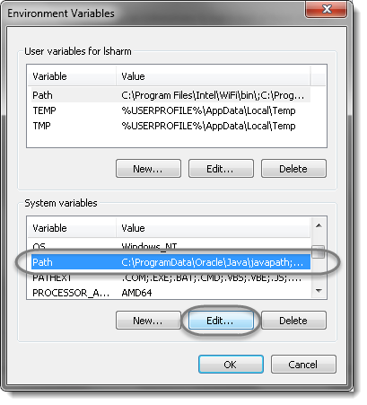

7) In the editor add the value ‘***;%ANDROID_HOME%\tools***‘ or ‘***;C:\Users\lsharm\AppData\Local\Android\android-sdk\tools***‘.

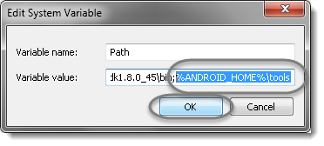

8) Now we need to specify the ‘***platform-tools***‘ folder location in the ***PATH***variable of *android sdk* package. Select the *Path* variable and choose the ***Edit***option.



9) In the editor add the value ‘***;%ANDROID_HOME%\platform-tools***‘ or ‘***;C:\Users\lsharm\AppData\Local\Android\android-sdk\platform-tools***‘.

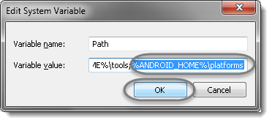

***Note:****This screenshot says****platforms****but it is wrong, please select****ptatform-tools.***

10) Now go to ***Start*** and type ***cmd***in the ***Run*** and hit ***Enter***. It will launch the *Command Prompt*. Type ‘***android***‘.

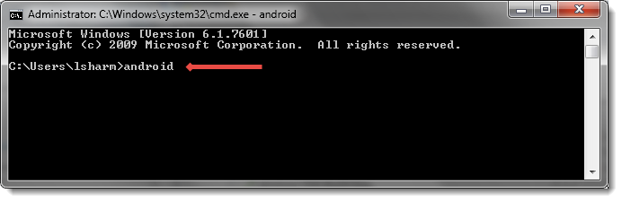

***Note:****If the cmd is already opened, please close it and start it again before typing android.*

11) it will open the ***Android SDK Manager***.