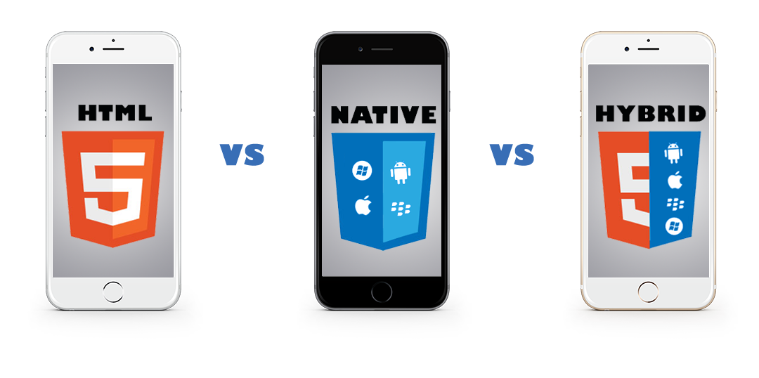

Initial Android installation:

1. JAVA_HOME configured
2. Download ANDROIDSTUDIO

[*http://developer.android.com/sdk/index.html?gclid=CO_QkdPowMwCFdITaAodqrYHPQ*](http://developer.android.com/sdk/index.html?gclid=CO_QkdPowMwCFdITaAodqrYHPQ)

1. Environment variable setup for ANDROID_HOME
   1. VARIABLE NAME: ANDROID_HOME
   2. VARIABLE VALUE: C:\Users\ra016si\AppData\Local\Android\sdk

PATH: %ANDROID_HOME%\tools;%ANDROID_HOME%\platform-tools

* 1. Open CMD and type: android
  2. Inside AVD Manager Select the Tools checkbox.
  3. Select the checkbox for the latest Android SDK, Android 6.0 Android 4.4.2 (API Level 19) as of this writing.
  4. From the Extras folder, select the checkbox for the Android Support Library.
  5. Click the Install packages… button to complete the download and installation.

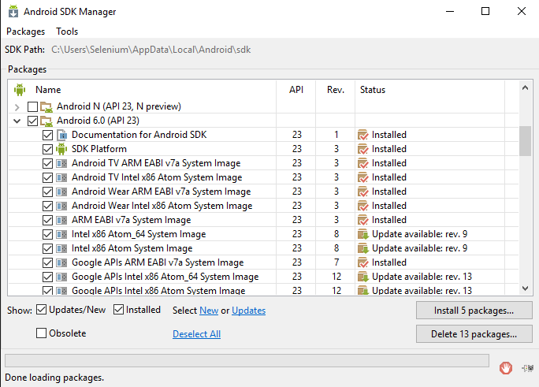

**CONFIGURING ANDROID DEVICE**

Connect the Device to a Genuine USB cable and make sure drivers are installed completely on your Desktop / Laptop

In some cases if the drivers are not fully installed follow these troubleshooting steps:

<http://theunlockr.com/2009/10/06/how-to-set-up-adb-usb-drivers-for-android-devices/>

Once the drivers are fully installed and your machine is able to detect your device

Go to Settings -> General and look for the option “Developer Options”

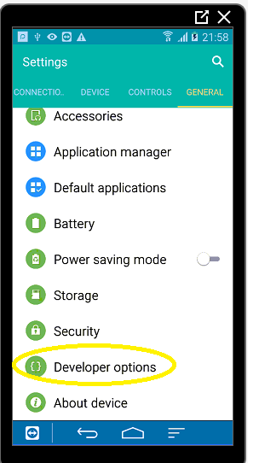

If you don’t see the Developer Option go to About Device and tap 6 times on Build Number

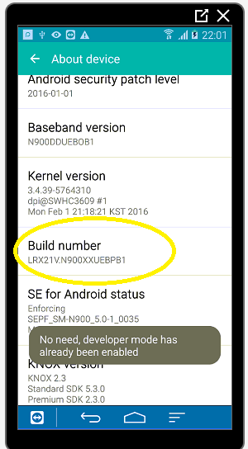

Go to Developer Options and check USB Debugging and Stay awake options (Make sure to turn off “Stay awake” once done with the testing

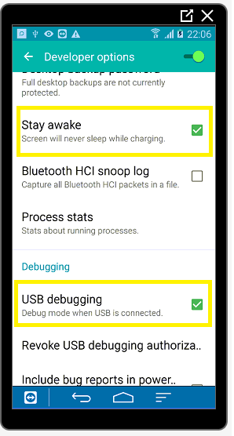

**Go to Command Prompt and type “adb devices” and make sure you see your device id**

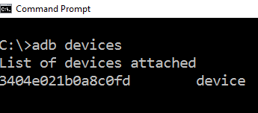

**Installing Emulator – Genymotion**

Emulators are very slow on windows. To get best of the experience with emulators download and install Genymotion Emulator

<https://www.genymotion.com/features/>

**DOWNLOAD APPIUM**

Appium comes in 2 parts

1. **GUI Tool**

<http://appium.io/>

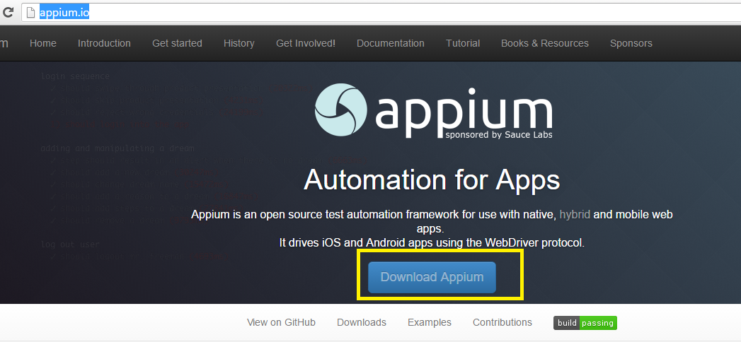

1. **Java client (API)**

<https://search.maven.org/#search%7Cga%7C1%7Cg%3Aio.appium%20a%3Ajava-client>

**Maven Dependency**

<dependencies>

<dependency>

<groupId>org.seleniumhq.selenium</groupId>

<artifactId>selenium-java</artifactId>

<version>LATEST</version>

</dependency>

<dependency>

<groupId>io.appium</groupId>

<artifactId>java-client</artifactId>

<version>LATEST</version>

</dependency>

</dependencies>

**JAVA Document path**

http://appium.github.io/java-client/

**STARTING APPIUM SERVER**

**1: Through Appium App:**

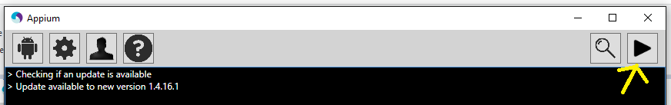

**2: Through Command Prompt:**

**Navigate to the bin folder in command prompt where Appium is** **installed C:\Program Files (x86)\Appium\node_modules\appium\bin**

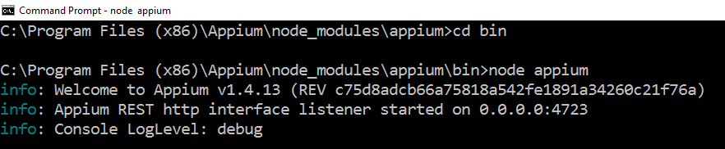

**3: Through Java Code:**

AppiumDriverLocalService service = AppiumDriverLocalService

.*buildService*(**new** AppiumServiceBuilder()

.usingDriverExecutable(**new** File("c:/Program Files/nodejs/node.exe"))

.withAppiumJS(**new** File("C:/Program Files (x86)/Appium/node_modules/appium/bin/appium.js"))

.withLogFile(**new** File("c:/appiumlogs/logs.txt")));

service.start();

//To stop the services

service.stop();

**DEPLOYING APPS**

**1: Through Appium App**

1. Get the capabilities from Android Settings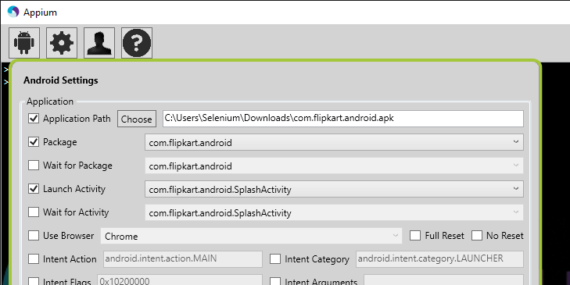
2. Check the Pre-launch under general settings and hit RUN while the device is connected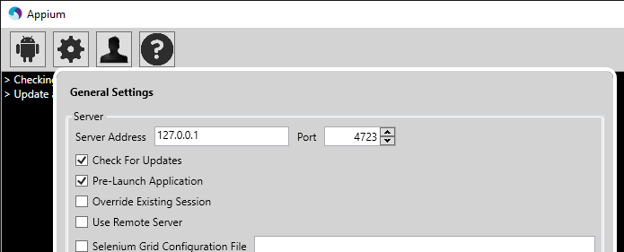

**2: Deploying APK files through code**

File app = **new** File("C:\\Users\\Selenium\\Downloads\\selendroid-test-app-0.17.0.apk");

DesiredCapabilities capabilities = **new** DesiredCapabilities();

capabilities.setCapability(CapabilityType.***BROWSER_NAME***, "");

capabilities.setCapability("device", "Android");

capabilities.setCapability("deviceName", "Galaxy Note3");

capabilities.setCapability("platformVersion", "5.0");

capabilities.setCapability("platformName","Android");

capabilities.setCapability("app", app.getAbsolutePath());

**3: Launching already deployed app through Java code**

DesiredCapabilities capabilities = **new** DesiredCapabilities();

capabilities.setCapability(CapabilityType.***BROWSER_NAME***, "");

capabilities.setCapability("device", "Android");

capabilities.setCapability("deviceName", "Galaxy Note3");

capabilities.setCapability("platformVersion", "5.0");

capabilities.setCapability("platformName","Android");

//Give the App package and Activity info to launch the already //installed app

capabilities.setCapability("appPackage",

"com.whatsapp");

capabilities.setCapability("appActivity",

"com.whatsapp.Main");

chrome://inspect/#devices

**Basic Test for Launching WebApp on Chrome Browser**

**public** **class** BasicWebAppTest {

**public** **static** AndroidDriver<MobileElement> *driver*;

**public** **static** **void** main(String[] args) **throws** MalformedURLException, InterruptedException {

AppiumDriverLocalService service = AppiumDriverLocalService

.*buildService*(**new** AppiumServiceBuilder()

.usingDriverExecutable(**new** File("c:/Program Files/nodejs/node.exe"))

.withAppiumJS(**new** File("C:/Program Files (x86)/Appium/node_modules/appium/bin/appium.js"))

.withLogFile(**new** File("c:/appiumlogs/logs.txt")));

service.start();

DesiredCapabilities capabilities = **new** DesiredCapabilities();

capabilities.setCapability(CapabilityType.***BROWSER_NAME***, "Chrome");

capabilities.setCapability("device", "Android");

capabilities.setCapability("deviceName", "Galaxy Note3");

capabilities.setCapability("platformVersion", "5.0");

capabilities.setCapability("platformName","Android");

*driver* = **new** AndroidDriver<MobileElement>(**new** URL("http://127.0.0.1:4723/wd/hub"), capabilities);

*driver*.manage().timeouts().implicitlyWait(20L, TimeUnit.***SECONDS***);

*driver*.navigate().to("http://way2automation.com");

System.***out***.println(*driver*.getTitle());

Thread.*sleep*(3000);

*driver*.quit();

service.stop();

}

}

**Basic Test for Launching Native / Hybrid App on a Real Device / Emulator when app is already installed**

DesiredCapabilities capabilities = **new** DesiredCapabilities();

capabilities.setCapability(CapabilityType.***BROWSER_NAME***, "");

capabilities.setCapability("device", "Android");

capabilities.setCapability("deviceName", "Galaxy Note3");

capabilities.setCapability("platformVersion", "5.0");

capabilities.setCapability("platformName","Android");

//Give Package Name and Launchable Activity of the APK file

capabilities.setCapability("appPackage",

"com.whatsapp");

capabilities.setCapability("appActivity",

"com.whatsapp.Main");

*driver* = **new** AndroidDriver<MobileElement>(**new** URL("http://127.0.0.1:4723/wd/hub"), capabilities);

*driver*.manage().timeouts().implicitlyWait(20L, TimeUnit.***SECONDS***);

**Native methods from Android Driver class**

***Unlocking the device:***

**if**(*driver*.isLocked()){

*driver*.unlockDevice();

}

*driver*.unlockDevice();

***Locking the device:***

*driver*.lockDevice();

***Get Current running activity:***

System.***out***.println(*driver*.currentActivity());

***Android Key Codes:***

[***http://developer.android.com/reference/android/view/KeyEvent.html***](http://developer.android.com/reference/android/view/KeyEvent.html)

*driver*.pressKeyCode(153);

*driver*.pressKeyCode(151);

*driver*.pressKeyCode(145);

This will enter the number as 971

**Open Notifications:**

*driver*.openNotifications();

**Installing, Removing and Switching Apks**

//Verify if app exists

**if**(!*driver*.isAppInstalled("io.selendroid.testapp")){

//Installing the App

*driver*.installApp("C:\\Users\\Selenium\\Downloads\\selendroid-test-app-0.17.0.apk");

System.***out***.println("App installed successfully");

//Switching between Apks

*driver*.startActivity("io.selendroid.testapp", ".HomeScreenActivity");

}**else**{

//Removing the App

*driver*.removeApp("io.selendroid.testapp");

System.***out***.println("App removed successfully");

}

**More Native commands:**

driver.pressKeyCode(AndroidKeyCode.BACK);

driver.rotate(ScreenOrientation.LANDSCAPE)

driver.runAppInBackground(10)

**Native Test – Dialing a Number**

DesiredCapabilities capabilities = **new** DesiredCapabilities();

capabilities.setCapability(CapabilityType.***BROWSER_NAME***, "");

capabilities.setCapability("device", "Android");

capabilities.setCapability("deviceName", "Galaxy Note3");

capabilities.setCapability("platformVersion", "5.0");

capabilities.setCapability("platformName","Android");

capabilities.setCapability("appPackage",

"com.android.contacts");

capabilities.setCapability("appActivity",

"com.android.contacts.activities.PeopleActivity");

*driver* = **new** AndroidDriver<MobileElement>(**new** URL("http://127.0.0.1:4723/wd/hub"), capabilities);

*driver*.manage().timeouts().implicitlyWait(20L, TimeUnit.***SECONDS***);

Thread.*sleep*(3000);

*driver*.findElement(By.*xpath*("//android.widget.TextView[contains(@text,'Keypad')]")).click();

*driver*.findElement(By.*id*("com.android.contacts:id/nine")).click();

*driver*.findElement(By.*id*("com.android.contacts:id/seven")).click();

*driver*.findElement(By.*id*("com.android.contacts:id/one")).click();

*driver*.findElement(By.*id*("com.android.contacts:id/one")).click();

*driver*.findElement(By.*id*("com.android.contacts:id/one")).click();

*driver*.findElement(By.*id*("com.android.contacts:id/one")).click();

*driver*.findElement(By.*id*("com.android.contacts:id/one")).click();

*driver*.findElement(By.*id*("com.android.contacts:id/five")).click();

*driver*.findElement(By.*id*("com.android.contacts:id/five")).click();

*driver*.findElement(By.*id*("com.android.contacts:id/eight")).click();

*driver*.findElement(By.*id*("com.android.contacts:id/dialButton")).click();

**Native Test – Scroll to a contact (UIAutomation)**

**public** **static** AndroidDriver<MobileElement> *driver*;

**public** **static** **void** main(String[] args) **throws** IOException, InterruptedException {

DesiredCapabilities capabilities = **new** DesiredCapabilities();

capabilities.setCapability(CapabilityType.***BROWSER_NAME***, "");

capabilities.setCapability("device", "Android");

capabilities.setCapability("deviceName", "Galaxy Note3");

capabilities.setCapability("platformVersion", "5.0");

capabilities.setCapability("platformName","Android");

capabilities.setCapability("appPackage",

"com.android.contacts");

capabilities.setCapability("appActivity",

"com.android.contacts.activities.PeopleActivity");

*driver* = **new** AndroidDriver<MobileElement>(**new** URL("http://127.0.0.1:4723/wd/hub"), capabilities);

*driver*.manage().timeouts().implicitlyWait(20L, TimeUnit.***SECONDS***);

System.***out***.println(*driver*.findElements(By.*id*("com.android.contacts:id/tab_custom_layout")).size());

*driver*.findElements(By.*id*("com.android.contacts:id/tab_custom_layout")).get(3).click();

//First Way

//driver.scrollTo("Akash").click();

//Scrolling

*driver*.findElementByAndroidUIAutomator("new UiScrollable(new UiSelector().scrollable(true).instance(0)).scrollIntoView(new UiSelector().text(\""+str+"\").instance(0))").click();

We will talk more on UIAutomation after Selendroid Test App Example

**Native – Android UI Automation**

File app = **new** File(System.*getProperty*("user.dir")+"\\apk\\selendroid-test-app-0.17.0.apk");

DesiredCapabilities capabilities = **new** DesiredCapabilities();

capabilities.setCapability(CapabilityType.***BROWSER_NAME***, "");

capabilities.setCapability("device", "Android");

capabilities.setCapability("deviceName", "Galaxy Note3");

capabilities.setCapability("platformVersion", "5.0");

capabilities.setCapability("platformName","Android");

capabilities.setCapability("app", app.getAbsolutePath());

*driver* = **new** AndroidDriver<MobileElement>(**new** URL("http://127.0.0.1:4723/wd/hub"), capabilities);

*driver*.manage().timeouts().implicitlyWait(20L, TimeUnit.***SECONDS***);

*driver*.findElementByAndroidUIAutomator("UiSelector().resourceId(\"io.selendroid.testapp:id/my_text_field\")").sendKeys("Hello Appium !!!");

//UIAutomation - checkable

System.***out***.println(*driver*.findElementsByAndroidUIAutomator("UiSelector().checkable(true)").size());

//UIAutomation - instance

*driver*.findElementByAndroidUIAutomator("UiSelector().className(\"android.widget.CheckBox\").instance(0)").click();

**Selendroid Test App – Creating Xpaths from XML**

**GESTURES**

1. Drag and Drop
2. Swipe and scroll
3. LongPress
4. Multitouch

**Capturing Screenshots**

**Notifications Test**

**Switching Apps Test**

1. Native App
2. Hybrid App

**Chrome Browser WebApp Testing**

chrome://inspect#devices