- Introduction

  - What is the LearnITy Framework?

1.2 Basic Concepts

* Interface (The 'xml' file.)
User Defined

* JS Function
Framework Defined

User Defined

* POJO (Plain Old Java Object)
Framework Defined

* Interface :

In LearnITy Framework it's not mandatory always that we need to write a new 'interface' for creating a new page. We can also use existing JSP/Servlet pages.

* JS Function :

i) User Defined : User can write various JS(Java Script) functions in a separate js file & can call those functions from the interface.

ii) Framework Defined : There are lots of Framework defined js functions which invoked automatically when we create a JQ Grid, call some value etc.

* POJO (Plain Old Java Object) :

Scope of POJO -

    - Application : Objects in this scope are initialized during DWR servlet initialization, and Closeable objects in this scope are closed during DWR servlet destruction.
    - Global : Objects in this scope are not initialized and Closeable objects in this scope are closed during servlet context destruction (not during DWR servlet destruction).
    - Request : Object in this scope initialized when the request comes, and objects in this scope are closed once the request is completed.
    - Session : Object in this scope is destroyed once the session is expired.

1.3 Component of an Interface -

* manifest.xml :

In the 'manifest.xml' file we need to specify the mapping of the interface.

Eg. - <?xml version="1.0" encoding="UTF-8"?>
<manifest id="LearnITy7 Interface" title="Interface Collection Framework">
<interface id="Course" title="Course" type="Interface" zip="Course.zip"/>
</manifest>

* interface.xml :
In an “interface.xml” file there are the following six sections -

* Interface
A) <interface id=” ” title=” “ type”Interface”>

B) <structure>

C) <layout id=” ”>

D) <content id=” “>

E) <style id=” ”>

F) <behaviour id=” “>

G) <resource>

A) <interface> :

Under this section we need to define the id, name & the type of the interface. All other sections come under this part only.

Eg. - <interface id="LearnityPortal" title="LearnityPortal" type="Interface">

B) <structure> :

Under the 'structure' section we need to define the classes (like – lable, textlink etc.) that we need to use in the page which we are designing. All class should have one unique id by which these classes will be recognized in other sections.

Eg. - <structure>
<part id="MainScreen" class="label"></part>
</structure>

C) <layout> :

Under the 'layout' section we need to define the position of all the parts, which we have defined under the 'structure' section.

Eg. -
<layout id="Portallayout">
<part id="MainScreen" height="600px" width="1000px" left="1px" top="1px" position="absolute"></part>
</layout>

D) <content> :

Under the 'content' section we need to define what should be the content of the above defined parts.

Eg. - <content id="Portalcontent">
<part id="appname" value="Learnity Portal" valuetype="inline"></part>
</content>

E) <style> :

Under the 'style' section we need to define the style for the above defined classes. We can directly define the style of a class here or we can also embed an existing 'css' file with the part.

Eg. - <style id="Portalstyle">
<part id="MainScreen" value="maincss" valuetype="reference"></part>
<part id="appname" value="[CDATA[color: #D4D4C5;font: 16px arial;font-weight:bold;]]" valuetype="inline"></part>
</style>

** In the 1st example we have embedded an existing 'css' file with the class, but is the 2nd example we have defined the style for that class inside the tag only.

F) <behaviour> :

If we want a part to perform some task that we can define under the 'behaviour' tag. Say we want the 'Submit' button to perform a task when the user clicks it, then we need to define how it will perform the task under this 'behaviour' section.

Eg. - <behaviour id="Portalbehaviour">
<part id="root">
<event name="onload_click()" type="simple" function="" callback="" javaclass="" target="" valuetype="jsevent" resourceid="accmainjs"></event>
</part>
</behaviour>

G) <resource> :

Under the 'resource' section we need to define all the file resource associated to the page.

Eg. - <resource>
<resourceitem id="logoutimg" href="h_logout.png" valuetype="image"></resourceitem>
</resource>

1.4 interfacerole.xml :

In this file we need to define the roles & the work of that role. We need to define which interface will be accessible under which role. Also, since a single interface may have multiple interface components ((layout, content, behaviour, etc.) of the same type; for each accessible interface, we need to specify the id of the interface components that are accessible for that particular role.

Eg. -
<?xml version="1.0" encoding="UTF-8"?>
<roles>
<role id="ADMIN">
<interface id="BatchMgmt">
<layout id="BatchMgmtLayout"/>
<content id="BatchCreationContent"/>
<behaviour id="BatchCreationBehaviour"/>

</interface>
</role>
</roles>

In the above example we have defined a role called 'Admin', and the admin will get the access of “BatchMgmt” interface. We also need to mention the “layout id”, “content id” , “styleid”, “behaviour id”.

1.5 How it works :

Installation of the Framework -

For installing LearnITy Framework first of all you need to create the following folders -

The folder path for LearnITy Framework -

Context
- coreadmin
- css (This folder contains all the 'css' files.)
- images (This folder contains all the image files for 'Core Administration')
- js (In contains all the Java Script files for LearnITy Framework)
- schema (Here the sql scheme is being kept)
- servlets (It contains all the js, css & html files for core admin pages.)
- themes (It hold all the themes for JQGrid)
- login.html (This is the login page for 'core admin')
- META-INF
- context.xml (This file holds all the DB informations)
- MANIFEST.MF
- WEB-INF
- classes (This folder contains all the class files for 'Core Admin')
-portal.properties
- lib (In this folder we keeps all the 'jar' files required for framework)
- dwr.xml
- web.xml

- coreadmin

- META-INF :
context.xml :
In this file the user need to specify the DB details for the framework.

Eg. -

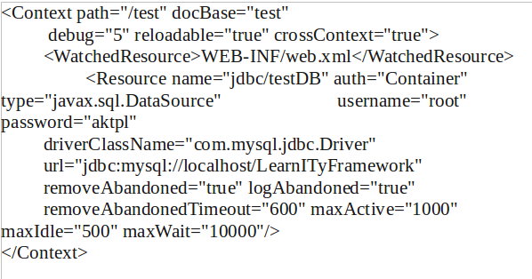

Above is an example of 'context.xml'.
The following things need to specify in this file -

- Context path
- Resource name
- username (for MySql)
- password (for MySql)
- driverClassName
- url (Here we need to specify the DB name for the framework)
- removeAbandonedTimeout (The time you specify here, after that much of time a connection will be removed autometically.)
- maxActive (Here you can specify, at a time a maximum of how many connections can be active together.)
- maxIdle (Here you need to specify the duration for session timeout.)

WEB-INF:

dwr.xml :

web.xml :
In this xml file we need to define all the servlets that we are using.

Eg. -

<?xml version="1.0" encoding="ISO-8859-1"?>

<!DOCTYPE web-app
PUBLIC "-//Sun Microsystems, Inc.//DTD Web Application 2.2//EN"
"http://java.sun.com/j2se/1.5.0/docs/guide/management/agent.html">
<!-- "http://java.sun.com/j2ee/dtds/web-app_2_2.dtd">-->

<web-app>

<display-name>/test</display-name>

<!-- for JNDI -->
<welcome-file-list>
<welcome-file>login.html</welcome-file>
</welcome-file-list>
<resource-ref>
<description>
Resource reference to a factory for java.sql.Connection
instances that may be used for talking to a particular
database that is configured in the context.xml file.
</description>
Here we need to specify the 'Resource name'
for the database. If required more than one
DB can be used.
<res-ref-name>
jdbc/testDB
</res-ref-name>
<res-type>
javax.sql.DataSource
</res-type>
<res-auth>
Container
</res-auth>
Here we are
declaring the
Servlet.
</resource-ref>
<servlet>
<servlet-name>coreadministrationv2.Login</servlet-name>
<servlet-class>coreadministrationv2.Login</servlet-class>
</servlet>

<servlet-mapping>
Here we are
mapping the
Servlet.
<servlet-name>coreadministrationv2.Login</servlet-name>
<url-pattern>/servlet/coreadministrationv2.Login</url-pattern>
</servlet-mapping>
<session-config>
<session-timeout>300</session-timeout>
</session-config>
</web-app >

WEB-INF
classes
portal.properties :

Followoing is an exampl of the 'portal.properties' file -

xml=/opt/jakarta-tomcat-5.5.9/webapps/indiafirstold/xmlzip/
dwrxmlpath=/opt/jakarta-tomcat-5.5.9/webapps/indiafirstold/WEB-INF/
downloadzip=/opt/jakarta-tomcat-5.5.9/webapps/indiafirstold/downloadzip/
reportpath=/opt/jakarta-tomcat-5.5.9/webapps/indiafirstold/report/

When we uplad a zip file in coreadmin it first store the zip file some where in the hard-drive & then it extracts the file from there, under the 'xml' we have defined that path only.

We also need to specify the path of the 'dwr.xml' file under 'dwrxmlpath'.

When we download some zip file from the coreadmin side, that time also the sytem store those files some where in the hard-drive, so we need to specify that path under 'downloadzip'.

Under the 'reportpath' we need to specify the path where all the reports should be stored.

How to deploy a xml in LearnITy Framework -

Step 1 – Create the xml file & save it as 'interface.xml'.

Step 2 – Keep the xml file inside a folder with a meaningful name.

Step 3 – Keep all the 'css' & 'js' files releted to that 'interface' inside the same directory.

Step 4 – Create a zip of that directory.

Step 5 – Now login to the 'coreadmin' & download following files -

1. manifest.xml
2. interfacerole.xml

Step 6 – Now you need to make entry of your file in the above mention two files.

In 'manifest.xml' file you need to make follwing entries -

<interface id="MyFirstInterface" title="MyFirstInterface" type="Interface" zip="MyFirstInterface .zip"/>

in 'interfacerole.xml' file you need to make following entries under the role to whom you want to give access of your page(For learning purpose initially we will assign it to the 'Default' role) -

<interface id="MyFirstInterface">
<layout id="MyFirstInterfaceLayout"/>
<content id="MyFirstInterfaceContent"/>
<behaviour id="MyFirstInterfaceBehaviour"/>
</interface>

Step 7 – Now you need to upload the following two file to the 'coreadmin' -

1. manifest.xml
2. interfacerole.xml

Step 8 – Now in the 'coreadmin' you need to find out your interface from the list, then select your interface & browse the zip file you have created, then click on the 'Upload' button.

2. Tutorial -

2.1 My first interface -

Here is a sample of a simple interface.xml

Part - 1
<interface id="MyFirstInterface" title="MyFirstInterface" type="Interface">
Part - 2
<configuration createsession="true" checkrole="false" ></configuration>

<structure>
<part id="MyFirstInterfaceback" class="label"></part>
Part - 3
<part id="MyFirstInterfacelabel" class="label"></part>
<part id="MyFirstInterfacelogo" class="image"></part>
</structure>

<layout id="MyFirstInterfacelayout">
Part - 4
<part id="MyFirstInterfaceback" height="500px" width="824px" left="18%" top="50px" position="absolute"></part>
<part id="MyFirstInterfacelabel" height="60px" width="210px" left="336px" top="15px" position="absolute" parent_id="accloginback"></part>
<part id="MyFirstInterfacelogo" height="120px" width="120px" left="360px" top="150px" position="absolute" parent_id="accloginback"></part>
</layout>

<content id="MyFirstInterfacecontent">
<part id="MyFirstInterfaceback" value="" valuetype=""></part>
Part - 5
<part id="MyFirstInterfacelabel" value="My First Interface" valuetype=""></part>
<part id="MyFirstInterfacelogo" value="aunweshalogo" valuetype="reference"></part>
</content>

<style id="MyFirstInterfacestyle">
<part id="MyFirstInterfaceback" value="[CDATA[background-color: #F6F6F6;]]" valuetype="inline"></part>
<part id="MyFirstInterfacelabel" value="" valuetype=""></part>
Part - 6
<part id="MyFirstInterfacelogo" value="" valuetype=""></part>
</style>

<behaviour id="MyFirstInterfacebehaviour">
<part id="MyFirstInterfaceback">
<event name="" type="simple" function="" callback="" javaclass="" target="" valuetype="" resourceid=""></event>
Part - 7
</part>
<part id="MyFirstInterfacelabel">
<event name="" type="simple" function="" callback="" javaclass="" target="" valuetype="" resourceid=""></event>
</part>
<part id="MyFirstInterfacelogo">
<event name="" type="simple" function="" callback="" javaclass="" target="" valuetype="" resourceid=""></event>
</part>
</behaviour>
Part - 8
<resource>
<resourceitem id="MyFirstInterfacelogo" href="logo.gif" valuetype="image"></resourceitem>
</resource>
</interface>

Part – 1:
Under the part – 1 we have defined the id, name and the type of the 'xml' file.

Part – 2:
Under the part – 2 we have defined the configuration for the xml file. Like in the example we have given <createsession="true"> which mean it will create a session when the page will be loaded, <checkrole="false"> it option is given if we want to add the session checking and role checking option to the application, which mean before loading the page it will check for the session validity and the role of the user.

Part – 3:
Under part – 3 we have declared the all the classes which we need to implement our application. Each of the class should have an unique id for further reference.

Part – 4:
Under part – 4 we need to define the position for all the classes. Other than define the position here, we can also include the position in a separate 'css' file and import that file to the interface.

Part – 5:
Under section – 5 we can define a value for any class if we want.
Eg. -
<part id="MyFirstInterfacelabel" value="My First Interface" valuetype=""></part> in this example we have assign a value directly for the class.
<part id="MyFirstInterfacelogo" value="aunweshalogo" valuetype="reference"></part> but in this example we have given <valuetype="reference"> which mean we will export some external file or image to this 'class' which we need to mention under the <resource> section.

Part – 6:
Under part – 6 we can define the style like – color, font-style, behaviour etc for the classes.

Part – 7:
Under part – 7 we need to define the POJO, JS name if we want to use. We can use the method of some outside java class, which we need to mention under this section.

Part – 8:
Under part – 8 we need to mention the resource of the file which we want export.

* The output of the above interface is -

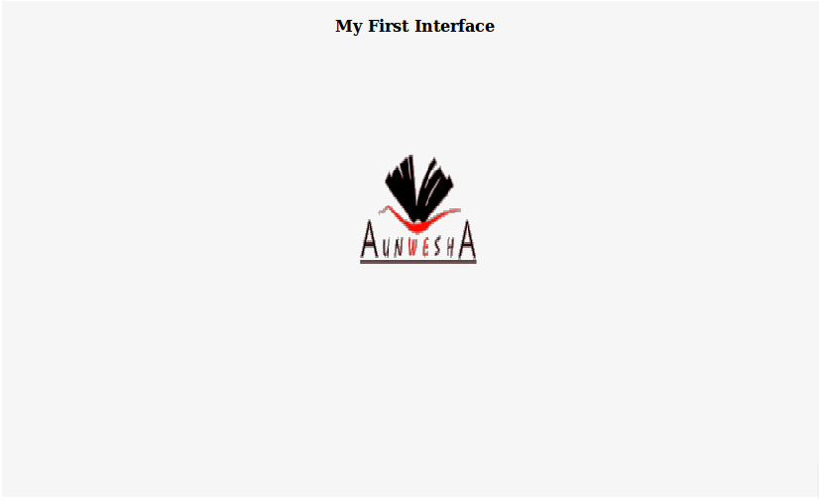

  - Using a simple DBGrid:

The next example will tell us how to use a simple DBGrid in an interface -

<interface id="MyFirstGrid" title="MyFirstGrid" type="Interface">
<structure>
<part id="main" class="label" > </part>
<part id="MyFirstGridgrid" class="Conditionalgrid" loadurl="" editurl="" caption=" Currently Defined User(s)" sortname="student_id" sortorder="desc">
<selector id="lqualifier" class="combo" contentid="MyFirstGridcontent" behaviourid="MyFirstGridbehaviour" domaintype="query" value="select lqualifier,lqualifier from learning_qualifier" ></selector>

<column head="User Id" name="student_id" index="1" width="105" editable="true" hidden="false" key="true" required="true" minval="" maxval="">
<edit type="text" size="30" rows="" cols="" editdomaintype="" value="" > </edit>
</column>
<column head="First Name" name="a.first_name" index="2" width="125" editable="true" hidden="false" key="false" required="true" minval="" maxval="">
<edit type="text" size="30" rows="" cols="" editdomaintype="" value="" > </edit>
</column>
<column head="Middle Name" name="a.middle_name" index="3" width="125" editable="true" hidden="false" key="false" required="false" minval="" maxval="">
<edit type="text" size="30" rows="" cols="" editdomaintype="" value="" > </edit>
</column>
<column head="Last Name" name="a.sname" index="4" width="125" editable="true" hidden="false" key="false" required="true" minval="" maxval="">
<edit type="text" size="30" rows="" cols="" editdomaintype="" value="" > </edit>
</column>
<column head="Age" name="a.age" index="5" width="55" editable="true" hidden="false" key="false" required="false" minval="" maxval="">
<edit type="text" size="10" rows="" cols="" editdomaintype="" value="" > </edit>
</column>

<loadquery value="select student_id,first_name,middle_name,sname,age from student_details"></loadquery>
</part>
</structure>

<layout id="MyFirstGridlayout">
<part id="main" height="100%" width="100%" left="0px" top="0px" position="absolute"></part>
<part id="MyFirstGridgrid" height="" width="" left="2%" top="opx" position="absolute" parent_id="main"></part>

</layout>

<content id="MyFirstGridcontent">

</content>

<style id="MyFirstGridStyle">

</style>

<behaviour id="MyFirstGridbehaviour">

</behaviour>

</interface>

* Under the part id “MyFirstGridgrid” all the codes for the grid has been writtent. We need to take the class as 'Conditionalgrid' for useing a grid in our page.

<part id="MyFirstGridgrid" class="Conditionalgrid" loadurl="" editurl="" caption=" Currently Defined User(s)" sortname="student_id" sortorder="desc">

In the above part we have defined an id for our grid, we have defined the class as 'Conditionalgrid', if you want to add some heading for the grid you need to mention under the 'caption', under 'sortname' you can define the field name by which you want to do the sorting for the grid, you can also specify the order of the sorting uder 'sortorder' as “asc” or “desc”.

How to define a column of a grid -

<column head="User Id" name="student_id" index="1" width="105" editable="true" hidden="false" key="true" required="true" minval="" maxval="">
<edit type="text" size="30" rows="" cols="" editdomaintype="" value="" > </edit>
</column>

In the above example the following thing we have defined -

* column head="User Id" (The display name for the column).
* name="student_id" (You can specify any name for the column).
* index="1" (Index defines the serial no of the column).
* width="105" (width of the column).
* editable="true" (Making this option true means, while you edit a row you can edit the data of this coulmn. Making the option 'false' means, you can not edit this column after you add it.)
* hidden="false" (This option determines whether the column to be displayed or not. Making this option 'true' you can hide the coulm).
* key="true" (Making this true means, this could will act like a primery key.)

Where to write the sql query for the grid -

Eg -

<loadquery value="select student_id,first_name,middle_name,sname,age from student_details"> </loadquery>

Under the <loadquery> section you need to write the query for your grid.

The output for the above given example is -

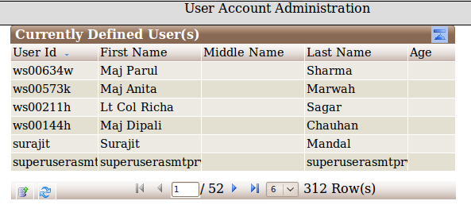
2.3 Including a report :

The following code show how to add a report in LearnITy Framework -

<interface id="ReportLink" title="ReportLink" type="Interface">
<configuration createsession="true" checkrole="true" />
<structure>
<part id="reportlinkmain" class="label" />
<part id="reporttypelabel" class="label" />
<part id="reporttype" class="combo" />
<part id="reportframe" class="report" />

</structure>
<layout id="ReportLinkLayout">
<part id="reportlinkmain" height="500px" width="768px" left="0px" top="0px" position="absolute" />
<part id="reporttypelabel" height="30px" width="130px" left="10px" top="20px" position="absolute" parent_id="reportlinkmain" />
<part id="reporttype" height="30px" width="150px" left="140px" top="20px" position="absolute" parent_id="reportlinkmain" />
<part id="reportframe" height="380px" width="750px" left="1px" top="50px" position="absolute" parent_id="reportlinkmain" />
</layout>
<content id="ReportLinkContent">
<part id="reporttypelabel" value="Select Report Type" valuetype="inline" />
<part id="reporttype" valuetype="fixed">
<combooption name="product_inventory.rptdesign" value="Product Inventory"></combooption>
<combooption name="product_details.rptdesign" value="Product Details"></combooption>
</part>
<part id="reportframe" viewer_type="html" report_chooser="reporttype">

</part>
</content>
<style id="ReportLinkStyle">
<part id="reportlinkmain" value="reportlinkcss" valuetype="reference"></part>
</style>
<behaviour id="ReportLinkBehaviour">

</behaviour>
<resource>

</resource>
</interface>

* In the above interface we have taken one 'combo' class and 'report' class along with two 'label' under the <structure>. Under the <content> what we have done is, we have mentioned the report names and the value under the combo options. Selecting on that particular option it will show the report which has mentioned under the 'name' of the <combooption>. Now we also need to mention the details of the 'report' class under <content>. Here we have mentioned the “viewer_type” report as 'html' and the “report_chooser” as 'reporttype', which means it will display the report based on the selection of the 'combo'.

* The output of the above interface is -

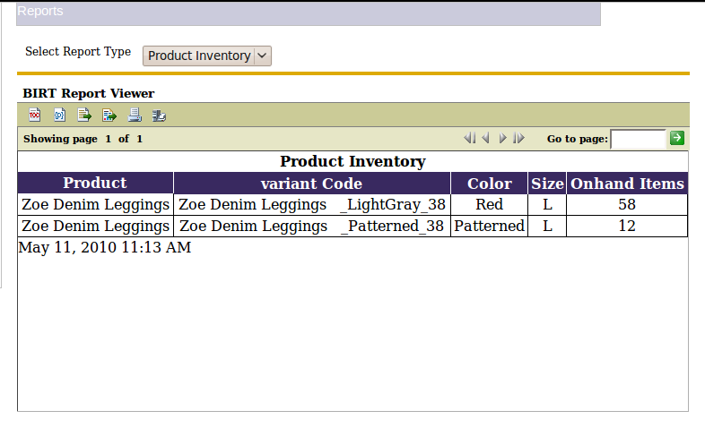

2.3.1 Including a report without parameter :

The following is the code for including a report which have no parameter -

interface.xml -

<interface id="BatchReport" title="BatchReport" type="Interface">
<configuration createsession="true" checkrole="true" />
<structure>
<part id="reportlinkmain" class="label" />
<part id="showreport" class="button" />
<part id="reportframe" class="report" />

</structure>
<layout id="ReportLinkLayout">
<part id="reportlinkmain" height="500px" width="768px" left="0px" top="0px" position="absolute" />
<part id="showreport" height="30px" width="150px" left="140px" top="20px" position="absolute" parent_id="reportlinkmain" />
<part id="reportframe" height="380px" width="750px" left="1px" top="50px" position="absolute" parent_id="reportlinkmain" />
</layout>
<content id="ReportLinkContent">
<part id="reportframe" viewer_type="html" rpt_file="batchdetails_report.rptdesign" />
<part id="showreport" value="Show Batch Report" valuetype="inline" />
</content>
<style id="ReportLinkStyle">

</style>
<behaviour id="ReportLinkBehaviour">
<part id="root">
<event name="" type="simple" function="" callback="" javaclass="" target="" valuetype="reference" resourceid="reportsjs"/>
</part>
<part id="showreport">
<event name="onclick" type="simple" function="run_report" callback="" javaclass="" target="" valuetype="jsevent" resourceid="" />
</part>
</behaviour>
<resource>
<resourceitem id="reportsjs" href="batch_report.js" valuetype="js"/>
</resource>
</interface>

filename.js -

function run_report()
{
LoadReport();
}

Output of the above report -

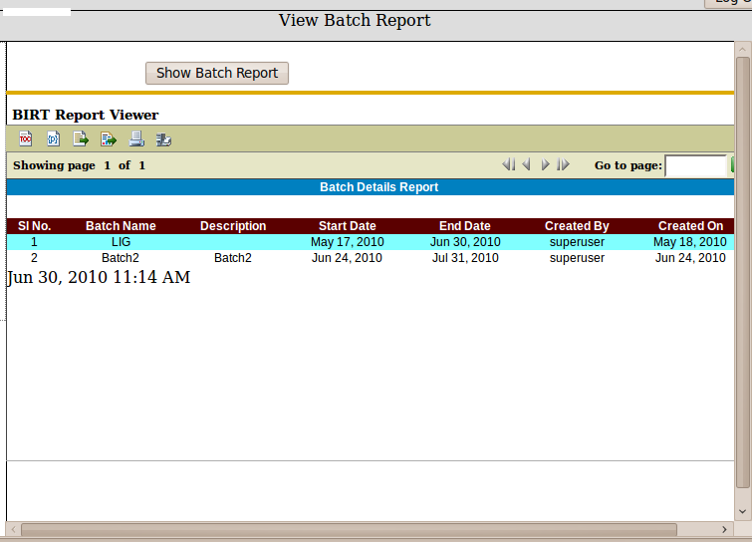

2.3.1 Including a report without parameter :

The following is the code for including a report which have no parameter -

interface.xml -

<interface id="BatchUserAssoReport" title="BatchUserAssoReport" type="Interface">
<configuration createsession="true" checkrole="true" />
<structure>
<part id="reportlinkmain" class="label" />
<part id="reporttypelabel" class="label" />
<part id="batchReportLabelCombo" class="combo"></part>
<part id="showreport" class="button" />
<part id="reportframe" class="report" />

</structure>
<layout id="ReportLinkLayout">
<part id="reportlinkmain" height="500px" width="768px" left="0px" top="0px" position="absolute" />
<part id="reporttypelabel" height="30px" width="130px" left="10px" top="20px" position="absolute" parent_id="reportlinkmain" />
<part id="batchReportLabelCombo" height="30px" width="130px" left="150px" top="20px" position="absolute" parent_id="reportlinkmain" />
<part id="showreport" height="30px" width="150px" left="300px" top="20px" position="absolute" parent_id="reportlinkmain" />
<part id="reportframe" height="380px" width="750px" left="1px" top="50px" position="absolute" parent_id="reportlinkmain" />
</layout>
<content id="ReportLinkContent">
<part id="reporttypelabel" value="Select Batch" valuetype="inline" />
<part id="batchReportLabelCombo" valuetype="query" value="select batch_id,title from batchmanagement"></part>
<part id="reportframe" viewer_type="html" rpt_file="batch_user_asso_report.rptdesign">
<report_parameters>

<report_parameter name="batch_id" value="batch_user_rpt()" value_type="function"></report_parameter>

</report_parameters>
</part>
<part id="showreport" value="Show Report" valuetype="inline" />

</content>
<style id="ReportLinkStyle">

</style>
<behaviour id="ReportLinkBehaviour">
<part id="root">
<event name="" type="simple" function="" callback="" javaclass="" target="" valuetype="reference" resourceid="reportsjs"/>
</part>
<part id="showreport">
<event name="onclick" type="simple" function="run_report" callback="" javaclass="" target="" valuetype="jsevent" resourceid="" />
</part>
</behaviour>
<resource>
<resourceitem id="reportsjs" href="batch_report.js" valuetype="js"/>
</resource>
</interface>

filename.js -

function batch_user_rpt()
{
var batch_id=getValue('batchReportLabelCombo');
return batch_id;
}

function run_report()
{
LoadReport();
}

Output of the above report -

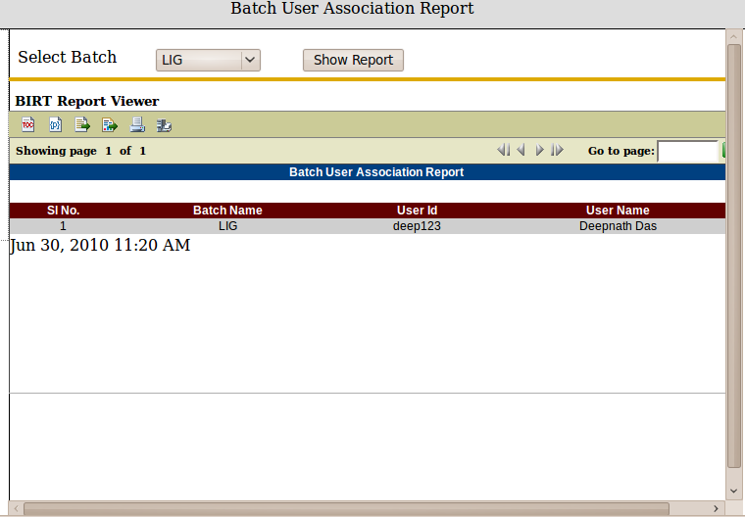

2.4 Including a chart :

The following code show how to add a chart in LearnITy Framework -

<interface id="userChart" title="userChart" type="Interface">
<structure>
<part id="mainpage" class="label"></part>
<part id="chart1" class="chart"></part>
<part id="Chartajaxcomp" class="ajaxcomponent"></part>
</structure>
<layout id="userChartLay">
<part id="mainpage" height="100%" width="100%" left="0px" top="0px" position="absolute" > </part>
<part id="chart1" height="96%" width="96%" left="5px" top="10px" position="absolute" parent_id="mainpage"></part>
<part id="Passajaxcomp" height="" width="" left="" top="" position="" parent_id="mainpage"></part>
</layout>
<content id="userChartCont">
<part id="mainpage" value="" valuetype=""></part>
<part id="chart1">
<chartstructure>
<matric_title>Active User</matric_title>
<description>Active User</description>
<X_axis_query>select account_status from student_details group by account_status</X_axis_query>
<series1_query>select count(account_status) from student_details group by account_status</series1_query>
<series2_query></series2_query>
<series3_query></series3_query>
<legenddata1>User Type</legenddata1>
<legenddata2></legenddata2>
<legenddata3></legenddata3>
<chart_type>pie</chart_type>
<subtype>0</subtype>
<width>700</width>
<height>700</height>
<yaxis_label>Active User</yaxis_label>
<color>3</color>
<transpose></transpose>
<stacked></stacked>
<chart_dimension>TwoDimensionalwithdepth</chart_dimension>
<xaxis_label>Active User</xaxis_label>
</chartstructure>
</part>
</content>
</interface>

* The output of the above interface -

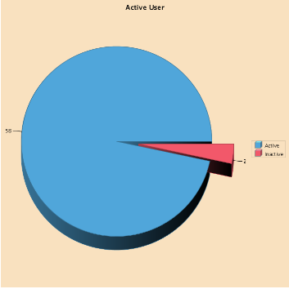

2.4 Including a Conditionalgrid :

<part id="unitImportExportGrid" class="Conditionalgrid" loadurl="" editurl="" caption="Currently Associated Units" sortname="instance_id" sortorder="asc" gridnavbar="true">

<selector id="unit_id" class="combo" contentid="unitImportExportPrimeContent" behaviourid="unitImportExportPrimeBehaviour" domaintype="query" value="select unit_id,unit_name from unit_details order by unit_name" gridrefresh="true" influence=""></selector>

<column head="Instance" name="instance_id" index="1" width="150" editable="false" hidden="false" key="true" required="false" minval="" maxval="">
<edit type="text" size="20" rows="" cols="" editdomaintype="" value=""> </edit>
</column>
<column head="Remarks" name="remarks" index="2" width="350" editable="true" hidden="false" key="false" required="false" minval="" maxval="">
<edit type="textarea" size="20" rows="6" cols="15" editdomaintype="query" value="select courseid,name from coursemanagement order by name"> </edit>
</column>

<loadquery value="select instance_id,remarks from unit_instance_management where unit_id=%unit_id%"></loadquery>

<delete>
<queries>
<query id="1" sql="[CDATA[delete from unit_instance_management where unit_id=%unit_id% and instance_id=%instance_id%]]" parameter="unit_id,instance_id"></query>
</queries>
<!--<action sequence="before" actionname="learnityasmtserver.assessmentadmin.standaloneasmt.SendMailAsmtUserReg"></action>-->

</delete>

<add>
<queries>

<query id="1" sql="[CDATA[insert into unit_instance_management(unit_id,remarks) values(%unit_id%,%remarks%)]]" parameter="unit_id,remarks"></query>
</queries>
<!--<action sequence="before" actionname="learnityasmtserver.assessmentadmin.standaloneasmt.SendMailAsmtUserReg"></action>-->
</add>
<modify>
<queries>
<query id="1" sql="[CDATA[update unit_instance_management set remarks=%remarks% where unit_id=%unit_id% and instance_id=%instance_id%]]" parameter="unit_id,instance_id"></query>
</queries>
</modify>
</part>

2.5 Including a JSP :

A JSP page can be included by two ways
      - Using CDATA
In the Content portion of interface copy the JSP file content inside <![CDATA[ ]]> of a label part.
<content id=”JSPInterfaceContent”>
<part id="jspcontent" valuetype="cdata"><![CDATA[ <html>
<head><title>Hello, User</title></head>
<body bgcolor="#ffffff" background="background.gif">
<table border="0" width="700">
<tr>
<td width="150"> &nbsp; </td>
<td width="550">
<h1>My name is Duke. What is yours?</h1>
</td>
</tr>
<tr>
<td width="150" &nbsp; </td>
<td width="550">
<form method="get">
<input type="text" name="username" size="25">
<br>
<input type="submit" value="Submit">
<input type="reset" value="Reset">
</td>
</tr>
</form>
</table>
</body>
</html> ]]>
</part>
</content>

In this process we can add simple jsp files (without directives).

Screenshot
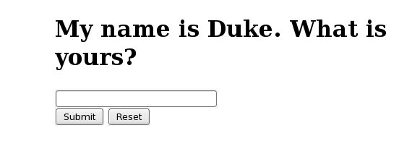

      - Using InvokeURL
In the Behaviour portion of interface event name will be invokeurl and write jsp filename in the function attribute of a iframe part.
<behaviour id=" JSPInterfaceBehaviour">
<part id="left_frame">
<event name="invokeurl" type="simple" function="http://localhost:8080/learnity/MyJSP.jsp" callback="" javaclass="" target="left_frame" valuetype="inline" resourceid=""></event>
</part>
</behavior>
In this process we can add any jsp files.

MyJSP.jsp file

<%@page language="java" session="true" contentType="text/html;charset=ISO-8859-1" %>

<!DOCTYPE html PUBLIC "-//W3C//DTD XHTML 1.0 Transitional//EN" "http://www.w3.org/TR/xhtml1/DTD/xhtml1-transitional.dtd">
<html xmlns="http://www.w3.org/1999/xhtml">

<font color="blue">Please Enter User Name and Password </font><br><br>

<head>
<meta http-equiv="Content-Type" content="text/html; charset=iso-8859-1">
<title>Implementing css and javascript</title>

<style>
body{
background-color: #CCCCCC;
border: 2px solid #009900;
height: 130px;
width: 300px;
margin-left: 15px;
padding-left:5px;
padding-right:5px;
}

.inputbox {
background-color:#FFFFFF;
color: #333333;
width:150px;
border-width:1px;
border-style:solid;
border-color:#808080;

}

.inputbox:hover {
border-width:1px;
border-style:solid;
border-color:#11A3EA;
}

.inputbox:focus {

border-width:1px;
border-style:solid;
border-color:#11A3EA;
color: #0F4987;
}

.submitButton {
background-color: #ffffff;
color: #000000;
background: #ffffff;
border: 1px solid #cccccc;
text-align: center;
width: auto;
padding: 2px 3px 2px 3px;
}
</style>
<script language="JavaScript" type="text/JavaScript">
function validate(theForm){
if(theForm.user.value.length==0){
alert("UserId can't be blank");
theForm.user.focus();
return false;
}else if(theForm.pass.value.length==0){
alert("Password can't be blank");
theForm.pass.focus();
return false;
}else if(theForm.pass.value.length<6){
alert("Password length can't be less than 6 char");
theForm.pass.focus();
return false;
}
}

</script>
</head>

<form enctype="multipart/form-data" onSubmit="return validate(this)" method="post" action="Welcome.html">
<table border = "0">
<tr align="left" valign="top">
<td>User Name:</td>
<td><input type="text" name ="user" class="inputbox"/></td>
</tr>
<tr align="left" valign="top">
<td>Password:</td>
<td><input type="password" name ="pass" class="inputbox"/></td>
</tr>
<tr align="left" valign="top">
<td></td>
<td><input type="submit" name="submit" value="submit" class="submitButton"/></td>
</tr>
</table>
</form>

Screenshot
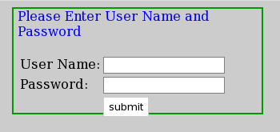

Cache Management -

One need to login to the core-admin for managing the cache.
Following are the pages for managing the cache -

1. Cache Definition
2. Cache Management

1. Cache Definition -

Following are the attributes for “Cache Definition” -

a) Cache Name
b) Select Type
c) Max Element
d) Overflow to disk
e) Eviction Policy
f) Eternal
g) Disk Persistent
h) Time to Live(seconds)
i) Time to Idle(seconds)
j) Expiry Thread Interval(seconds)
k) Disk Store Path

a) Cache Name -
The name of the cache.

b) Select Type -
The type of the cache.

c) Max Element -
Sets the maximum number elements in memory.

d) Overflow to disk -
Sets whether elements can overflow to disk when the in-memory cache has reached the set limit.

e) Eviction Policy -
The policy used to evict elements from the MemoryStore. The default memory store eviction policy is LRU.

f) Eternal -
Sets whether elements are eternal. If eternal, timeouts are ignored and the element is never expired.

g) Disk Persistent -
Default value for diskPersistent.

h) Time to Live(seconds) -
Sets the time to idle for an element before it expires. Is only used if the element is not eternal. This attribute is optional in the configuration. A value of 0 means do not check time to live.

i) Time to Idle(seconds) -
Sets the time to idle for an element before it expires. Is only used if the element is not eternal. This can be overidden in Element. This property can be modified dynamically while the cache is operating.

j) Expiry Thread Interval(seconds) -
Sets the interval in seconds between runs of the disk expiry thread. 2 minutes is the default. This is not the same thing as time to live or time to idle. When the thread runs it checks these things. So this value is how often we check for expiry.
k) Disk Store Path -
The path where the disk store is located

2. Cache Management -

Following are the attributes of this page -

a) No of Entries
b) No. of Hits
c) Hits in Memory
d) Hits on Disk
e) No. of Miss

a) No of Entries -
No of pages stored in the cache.

b) No. of Hits -
The number of times a requested item was found in the cache.

c) Hits in Memory -
Number of times a requested item was found in the Memory Store.

d) Hits on Disk -
Number of times a requested item was found in the Disk Store.

e) No. of Miss -
The number of times a requested element was not found in the cache.

Button on this page -

i) Clear Cache – This button will clear all the cache history from the server.
ii) Shut Down Cache – This button will stop caching.

