**Solution**

1. In previous case study we already created empty repository “edureka-transaction-api”.

**Stage 1 Solution**

1. Create a maven project.
2. Add swagger parser dependency
3. Create one Service which will accept swagger JSON as an input file.
4. Use parser to parser JSON and print End Points

**GIT Commands**

1. **List Modified Files**

**$ git status**

warning: LF will be replaced by CRLF in src/main/java/com/edureka/github/exceptions/InvalidSwaggerFileException.java.

The file will have its original line endings in your working directory.

On branch feature/swagger_endpoints

Changes to be committed:

(use "git reset HEAD <file>..." to unstage)

modified: pom.xml

new file: src/main/java/com/edureka/github/SwaggerParserService.java

new file: src/main/java/com/edureka/github/exceptions/InvalidSwaggerFileException.java

new file: src/main/resources/logback.xml

new file: swagger.json

Untracked files:

(use "git add <file>..." to include in what will be committed)

.classpath

.gitignore

.project

.settings/

1. Create Feature Branch
   1. **git checkout -b feature/swagger_endpoints**
   2. **git branch**

* feature/swagger_endpoints

Master

1. **git add src/ swagger.json pom.xml**

warning: LF will be replaced by CRLF in src/main/java/com/edureka/github/exceptions/InvalidSwaggerFileException.java.

The file will have its original line endings in your working directory.

1. **git status**

warning: LF will be replaced by CRLF in src/main/java/com/edureka/github/exceptions/InvalidSwaggerFileException.java.

The file will have its original line endings in your working directory.

On branch feature/swagger_endpoints

Changes to be committed:

(use "git reset HEAD <file>..." to unstage)

new file: Problem.docx

modified: pom.xml

new file: src/main/java/com/edureka/github/SwaggerParserService.java

new file: src/main/java/com/edureka/github/exceptions/InvalidSwaggerFileException.java

new file: src/main/resources/logback.xml

new file: swagger.json

Untracked files:

(use "git add <file>..." to include in what will be committed)

.classpath

.gitignore

.project

1. **git commit -m "Stage 1 feature solved."**

[feature/swagger_endpoints warning: LF will be replaced by CRLF in src/main/java/com/edureka/github/exceptions/InvalidSwaggerFileException.java.

The file will have its original line endings in your working directory.

699d5d3] Stage 1 feature solved.

Committer: root <raghugupta@dbs.com>

Your name and email address were configured automatically based

on your username and hostname. Please check that they are accurate.

You can suppress this message by setting them explicitly:

git config --global user.name "Your Name"

git config --global user.email you@example.com

1. **git push origin feature/swagger_endpoints**

Fatal: HttpRequestException encountered.

Username for 'https://github.com': learnkarts

Counting objects: 16, done.

Delta compression using up to 4 threads.

Compressing objects: 100% (11/11), done.

Writing objects: 100% (16/16), 15.93 KiB | 0 bytes/s, done.

Total 16 (delta 1), reused 0 (delta 0)

remote: Resolving deltas: 100% (1/1), completed with 1 local object.

To http://github.com/learnkarts/edureka-transaction-api.git

* [new branch] feature/swagger_endpoints -> feature/swagger_endpoints

1. **git log**

commit 699d5d30326a8736a3b541314a812248daf101f0

Author: root <raghugupta@dbs.com>

Date: Tue May 29 15:11:27 2018 +0800

Stage 1 feature solved.

commit f715450aa817706660118a9733ffbb638114e64b

Author: root <raghugupta@dbs.com>

Date: Tue May 29 14:27:22 2018 +0800

Initial code added.

commit 746d655bbd185ce2b9e4e2e4ee41c6c139861c88

Author: learnkarts <raghugupta@dbs.com>

Date: Mon May 28 14:10:32 2018 +0800

Code added

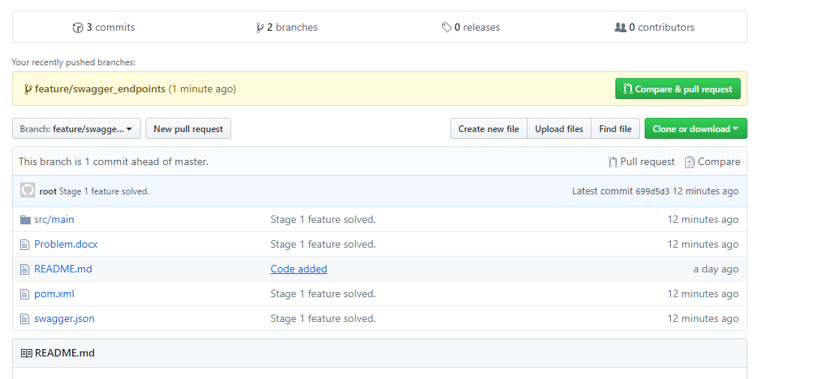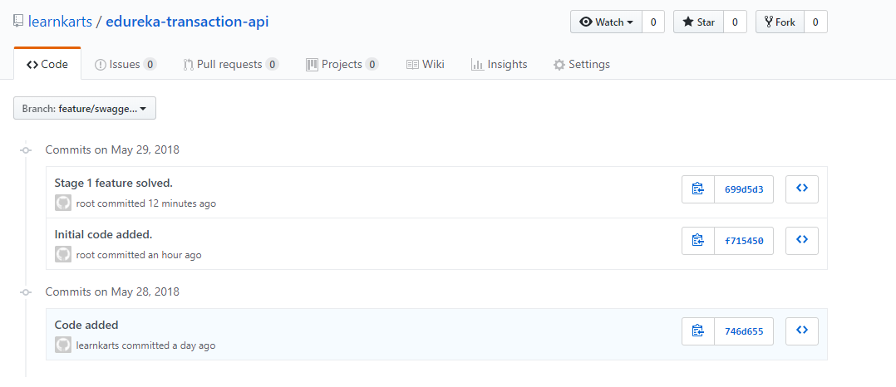

**Create Branch from Git HUB**

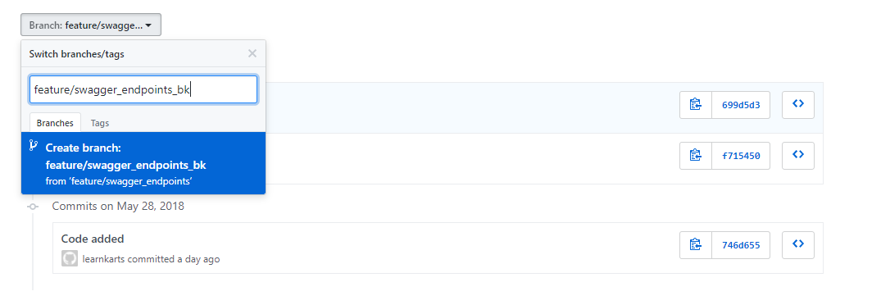

**Pre and Post Branch Creation**

**git branch -a**

* feature/swagger_endpoints

master

remotes/origin/HEAD -> origin/master

remotes/origin/feature/swagger_endpoints

remotes/origin/master

**Post Branch Creation and fetch command**

$ **git fetch**

From http://github.com/learnkarts/edureka-transaction-api

* [new branch] feature/swagger_endpoints_bk -> origin/feature/swagger_endpoints_bk

$ **git branch -a**

* feature/swagger_endpoints

master

remotes/origin/HEAD -> origin/master

remotes/origin/feature/swagger_endpoints

remotes/origin/feature/swagger_endpoints_bk

remotes/origin/master

**Tagging**

$ git tag release1.1 -a

$ git push origin --tags

Fatal: HttpRequestException encountered.

Username for 'https://github.com': learnkarts

Counting objects: 1, done.

Writing objects: 100% (1/1), 182 bytes | 0 bytes/s, done.

Total 1 (delta 0), reused 0 (delta 0)

To http://github.com/learnkarts/edureka-transaction-api.git

* [new tag] release1.1 -> release1.1

$ git tag release1.2 -a

$ git push origin --tags

Fatal: AggregateException encountered.

Username for 'https://github.com': learnkarts

Counting objects: 1, done.

Writing objects: 100% (1/1), 165 bytes | 0 bytes/s, done.

Total 1 (delta 0), reused 0 (delta 0)

To http://github.com/learnkarts/edureka-transaction-api.git

* [new tag] release1.2 -> release1.2

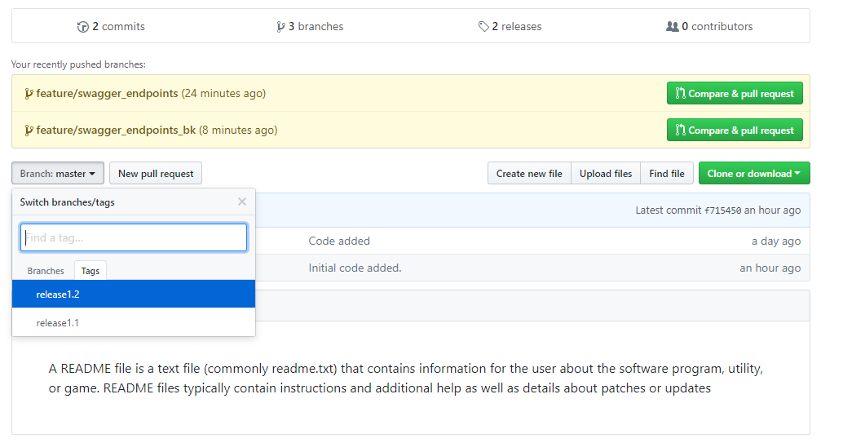

$ git tag

release1.1

release1.2

$ git push --delete origin release1.1

Fatal: HttpRequestException encountered.

Username for 'https://github.com': learnkarts

To http://github.com/learnkarts/edureka-transaction-api.git

- [deleted] release1.1

$ git tag

release1.1

release1.2

$ git tag --delete release1.1

Deleted tag 'release1.1' (was 651d0f7)

$ git tag

release1.2

