Playwright Automation Implementation Guide (Beginner Friendly, End-to-End)

Who this document is for
This guide is written for a fresher who is learning automation testing with Playwright for the first time.
You will understand: - What each file in this project does. - Why the project is split into layers. - How execution happens from start to end. - How UI code and automation code connect. - How to extend this project safely.

1. Big Picture: What this project actually is
This repository has two parts working together:
- Application under test (AUT)
  - Built using Flask (app.py) and HTML templates (templates/)
  - This app runs on http://localhost:5000
  - It has login, register, products, forms, and components pages
- Automation framework
  - Built using Pytest + Playwright (tests/)
  - It opens a real browser, interacts with the app, and verifies behavior
Think of it this way: - templates/ + app.py = the website you are testing - tests/ = the test engineers’ code that checks if the website works correctly

2. Learning roadmap for a fresher
If you are new, follow this order:
- Read requirements.txt and pytest.ini to understand dependencies and test rules.
- Read app.py to understand what backend routes and APIs exist.
- Open templates/base.html to understand shared page structure and common data-testids.
- Read tests/specs/auth/test_authentication.py to see the style of tests.
- Read tests/pages/app_pages.py to learn Page Object Model usage.
- Read tests/locators/app_locators.py to understand locator centralization.
- Read tests/fixtures/base_fixtures.py to understand fixture lifecycle.
- Move to advanced tests in tests/specs/forms/ and tests/specs/components/.

3. Setup and run (with explanation)

3.1 Install Python dependencies
Command:
pip install -r requirements.txt
What happens: - Installs Flask (web app runtime) - Installs Pytest (test runner) - Installs Playwright + plugin (browser automation)

3.2 Install browser binaries
Command:
playwright install
What happens: - Downloads Chromium/WebKit/Firefox binaries used by Playwright - Without this, tests cannot launch browser

3.3 Start application
Command:
python app.py
What happens: - Flask starts local server at http://localhost:5000 - Pages and APIs become available

3.4 Run tests
Command:
pytest tests/
What happens: - Pytest discovers test files by rules in pytest.ini - Loads fixtures from tests/conftest.py - Launches browser and executes tests

4. End-to-end execution sequence (deep dive)
This is the most important section for freshers.

Phase A: Pytest bootstraps
- You run pytest tests/
- Pytest reads pytest.ini
- Pytest starts test collection from tests/
- Pytest imports tests/conftest.py
- conftest.py registers plugin: tests.fixtures.base_fixtures

Phase B: Fixtures prepare runtime
For every test session: 1. browser fixture (scope=session) starts Playwright + Chromium
For every test function: 1. page fixture creates a fresh browser context and page 2. Optional fixtures create objects like LoginPage, ProductsPage, NavigationComponent 3. autouse cleanup fixture (clear_local_storage) is ready to run after the test

Phase C: Test function logic runs
Example test: - test_successful_login_with_test_ids(login_page, page)
Execution path: 1. Pytest injects login_page object 2. login_page.navigate() opens /login 3. login_page.login(...) fills form and clicks submit 4. Page JS calls /api/login in backend 5. Backend validates and responds 6. Browser redirects to /dashboard 7. Test asserts URL

Phase D: Teardown and cleanup
After each test: 1. clear_local_storage runs cleanup logic 2. page context closes
After all tests: 1. browser closes 2. Process exits with report summary

5. Why this architecture is used

5.1 Locator Contract Layer
File: tests/locators/app_locators.py
Why: - If data-testid changes in UI, update in one place - Avoid repeating raw strings in many files

5.2 Page Object Model (POM)
File: tests/pages/app_pages.py
Why: - Tests should say what business action to do, not low-level selector details - Example: login_page.login("user", "pass") is easier to read than multiple fill/click lines in every test

5.3 Component Object Model
File: tests/components/common_components.py
Why: - Some UI pieces are reused across pages (navbar, modal, alerts) - Encapsulate once, use everywhere

5.4 Fixtures as dependency injection
File: tests/fixtures/base_fixtures.py
Why: - Reusable setup/teardown - Cleaner tests with fewer boilerplate lines - Consistent browser lifecycle

5.5 Specs layer
Files: tests/specs/**
Why: - Keep test intent readable - Organize by feature area (auth/products/forms/components)

6. Full file-by-file explanation
Every file in this repository is explained below.

6.1 Root files

app.py
What it is: - Main Flask application file.
What it contains: - App initialization and secret key. - In-memory mock data: - users_db - products_db - Page routes: - /, /login, /register, /products, /product/<id>, /cart, /checkout, /dashboard, /profile, /forms, /components - API routes: - /api/login - /api/register - /api/products - /api/place-order - /api/update-profile - Session handling (session['user'], session['role'])
Why this matters to automation: - Tests need a predictable backend to validate UI workflows. - Login/registration/product APIs drive UI behavior used in tests. - Role-based dashboard rendering allows admin vs user assertions.
Execution context: - Runs when you start app with python app.py. - Flask serves templates and API responses consumed by browser automation.

pytest.ini
What it is: - Central Pytest config file.
Key settings in this project: - testpaths = tests - Naming conventions for test files/classes/functions - Default options: - -v - --tb=short - --strict-markers - Marker definitions (smoke, auth, products, etc.)
Why this matters: - Standardizes how tests are discovered and reported. - Prevents marker mistakes when --strict-markers is enabled.
Execution context: - Read automatically on pytest command.

requirements.txt
What it is: - Python package dependency list.
Packages used: - flask==3.0.0 - pytest==7.4.3 - pytest-playwright==0.4.3 - playwright==1.40.0
Why this matters: - Ensures reproducible environment. - Avoids “works on my machine” issues.

README.md
What it is: - Project overview document.
Why this matters: - Explains intent, architecture patterns, and usage commands. - Good orientation before code-level learning.

QUICKSTART.md
What it is: - Rapid setup/run guide.
Why this matters: - Helps fresher run app and tests quickly before deep code study.

6.2 Static files

static/js/main.js
What it does: - Logs app load message. - On DOMContentLoaded, reads cart from localStorage and updates data-testid="cart-count".
Why this matters for tests: - Cart count is validated in product/cart scenarios. - Gives consistent cart indicator state across pages.

static/css/style.css
What it does: - Provides styles for layout, navbar, hero, forms, cards, components.
Why this matters for tests: - UI visibility/hide-show behavior often depends on CSS state. - Components like modal, dropdown, toast rely on style changes that tests assert.

6.3 Templates folder (application UI under test)

templates/base.html
Purpose: - Base template inherited by all pages.
Key elements: - Navbar with test IDs: - logo-link - nav-home, nav-products, nav-forms, nav-components - cart-link, cart-count, login-button - Footer test hooks - Includes global CSS/JS
Why this helps automation: - Navigation component tests rely on stable shared locators. - ARIA roles (navigation, menubar, menuitem) support role-based locator strategies.

templates/home.html
Purpose: - Home/landing page.
Key elements: - Hero section (hero-section) - CTA buttons (shop-now-button, register-button) - Feature cards - Newsletter form and message (newsletter-email-input, newsletter-subscribe-button, newsletter-message)
Script behavior: - Newsletter form shows success text locally.
Automation value: - Good beginner page for button clicks, text assertions, and simple form submission.

templates/login.html
Purpose: - User login page.
Key form fields: - username-input - password-input - remember-checkbox - submit-login-button - error-message
Script behavior: - Submits credentials to /api/login. - On success redirects to /dashboard. - On failure shows error message.
Automation value: - Core for happy-path and negative-path authentication tests. - Demonstrates label-, role-, and test-id-based locators.

templates/register.html
Purpose: - New user registration.
Key elements: - Username, email, password, confirm fields - Terms checkbox - Error and success messages
Script behavior: - Client-side checks: - Password match - Terms accepted - API call to /api/register - Success message + delayed redirect to /login
Automation value: - Demonstrates multi-field input automation and validation-path testing.

templates/products.html
Purpose: - Product listing page with dynamic rendering.
Key controls: - Category filter dropdown (category-filter) - Search input (search-input) with debounce - Clear filters button (clear-filters-button) - Product grid (products-grid) - Loading indicator (loading-indicator) - Empty state (no-products-message)
Dynamic behavior: - Calls /api/products with query params. - Creates product cards dynamically with IDs like: - product-1 - product-name-1 - add-to-cart-1 - view-details-1 - Updates localStorage cart and cart count.
Automation value: - Teaches async waits, dynamic locators, list assertions, and state reset.

templates/product_detail.html
Purpose: - Single product detail page.
Key elements: - product-detail-name, product-detail-category, product-detail-price, product-detail-stock - add-to-cart-detail
Script behavior: - Adds selected product to cart and updates count.
Automation value: - Supports navigation and detail verification scenarios.

templates/cart.html
Purpose: - Shopping cart display.
Behavior: - Reads cart from localStorage. - Shows empty state or summary state.
Automation value: - Useful for verifying cart persistence and conditional rendering.

templates/checkout.html
Purpose: - Checkout form flow.
Key fields: - shipping-address-input - shipping-city-input - accept-terms-checkbox - place-order-button - checkout-message
Script behavior: - Validates terms accepted. - Calls /api/place-order. - On success shows order ID and clears cart.
Automation value: - Good example of end-to-end transaction-like flow.

templates/dashboard.html
Purpose: - Post-login dashboard.
Key points: - Shows username. - Shows admin-badge only if role is admin. - Includes profile link and logout button.
Automation value: - Enables role-based UI assertions.

templates/profile.html
Purpose: - Profile update page.
Behavior: - Email update form posts to /api/update-profile. - Shows status messages.
Automation value: - Demonstrates authenticated API-backed UI update testing.

templates/forms_demo.html
Purpose: - Comprehensive form controls demo page.
Sections include: - Text inputs (with labels/placeholders) - Select dropdown - Radio buttons - Checkboxes - Date and time inputs - Textarea - File inputs - Validation form - Multi-step form
Script behavior: - Validation form submit shows success message. - Multi-step logic toggles active step and success state.
Automation value: - Best page to practice many locator strategies and input interactions.

templates/components_demo.html
Purpose: - Interactive component demo page.
Components included: - Modal dialog - Dropdown menu - Tabs - Alerts - Accordion - Data table - Progress bar - Toast notifications
Script behavior: - Contains JS for open/close/toggle/animate behaviors.
Automation value: - Teaches testing dynamic UI states, ARIA roles, temporary elements, and timing-sensitive behavior.

6.4 Tests package marker files
These files are intentionally empty but important for Python import behavior.

tests/__init__.py
- Marks tests as a package.

tests/components/__init__.py
- Marks tests.components as a package.

tests/fixtures/__init__.py
- Marks tests.fixtures as a package.

tests/locators/__init__.py
- Marks tests.locators as a package.

tests/pages/__init__.py
- Marks tests.pages as a package.

tests/specs/__init__.py
- Marks tests.specs as a package.
Why these help: - Prevent import path issues as project grows.

6.5 Core test framework files

tests/conftest.py
Purpose: - Global Pytest configuration hook.
Current behavior: - Registers fixture plugin module: tests.fixtures.base_fixtures.
Why this helps: - All tests can use shared fixtures without extra imports.

tests/locators/app_locators.py
Purpose: - Centralized locator constants grouped by feature.
Classes present: - HomeLocators - LoginLocators - RegisterLocators - ProductsLocators - CheckoutLocators - NavigationLocators - DashboardLocators - FormsLocators - ComponentsLocators
Why this helps: - Single source of truth for locator names. - Reduces typo risk and maintenance cost.
How fresher should use it: - Never hardcode test IDs in tests if a locator constant exists.

tests/components/common_components.py
Purpose: - Reusable component-level wrappers.
Classes and intent: - NavigationComponent - Shared nav actions and cart count retrieval. - ModalComponent - Generic modal operations (visible/close/confirm/cancel). - AlertComponent - Alert presence and text checks. - FormValidationComponent - Common validation message checks.
Why this helps: - DRY principle: one implementation for shared widgets.
Execution context: - Used directly in tests or injected by fixture (navigation).

tests/pages/app_pages.py
Purpose: - Page Object Model abstraction.
Classes: - BasePage - Common page utilities (goto, wait_for_load_state) - HomePage - Home actions like newsletter subscription - LoginPage - Login workflows and error retrieval - RegisterPage - Registration workflow and feedback methods - ProductsPage - Filter/search/add-to-cart/detail navigation/count checks - CheckoutPage - Shipping form + terms + place order - DashboardPage - Admin badge check, profile navigation, logout
Why this helps: - Tests remain readable and intent-focused. - Selector changes handled in one layer.
Beginner note: - Page objects should represent user actions and outcomes, not raw low-level steps everywhere.

tests/fixtures/base_fixtures.py
Purpose: - Test object lifecycle and dependency injection.
Important fixtures: - browser (session scope) - Starts Chromium once for entire run. - page (function scope) - Creates new context/page for each test. - Page fixtures (home_page, login_page, etc.) - Return corresponding page object classes. - navigation - Returns NavigationComponent instance. - authenticated_page - Logs in standard user before returning page. - admin_authenticated_page - Logs in admin user. - clear_local_storage (autouse) - Clears localStorage post-test to reduce cross-test contamination.
Why this helps fresher learning: - Shows practical fixture scopes and isolation strategy. - Demonstrates reusable login-state setup.

6.6 Spec files (actual tests)

tests/specs/auth/test_authentication.py
Focus: authentication and registration.
Covers: - Successful login - Invalid login handling - Role-based locator usage - New user registration - Registration mismatch validation - Remember-me checkbox - Admin badge visibility - Login-to-register navigation
Learning outcomes: - Difference between positive and negative scenarios. - URL assertions and message assertions. - Real usage of POM + direct locators.

tests/specs/products/test_products.py
Focus: product catalog behavior.
Covers: - Initial product load - Category filtering - Search by name - Clearing filters - Add-to-cart count update - Product detail navigation - Empty result message - Product card data presence - ARIA role semantics for list/listitem
Learning outcomes: - Handling asynchronous UI updates. - Working with dynamic IDs and list content.

tests/specs/forms/test_forms.py
Focus: broad form controls and validation.
Covers: - Text inputs via labels - Dropdown selection - Radio/checkbox interactions - Date and textarea inputs - Validation submission checks - Multi-step form forward/backward navigation - Placeholder locator usage - ARIA describedby validation - File input existence
Learning outcomes: - Most complete locator-strategy practice file for beginners.

tests/specs/components/test_components.py
Focus: advanced UI components.
Covers: - Modal open/close - Dropdown interaction - Tabs (test-id and role-based) - Dynamic alerts - Accordion expand/collapse - Data table structure/actions/filtering - Progress bar animation change - Toast temporary notification
Learning outcomes: - Dealing with temporary/transient DOM elements. - Assertions for visibility, roles, and dynamic states.

7. How frontend code and tests connect (important)

Example 1: Login flow connection
- Test: login_page.login("testuser", "password123")
- Page object fills username-input, password-input, clicks submit-login-button
- templates/login.html JS submits to /api/login
- app.py validates credentials and sets session
- Browser redirects to /dashboard
- Test asserts URL/dashboard visibility

Example 2: Product filtering connection
- Test selects category via category-filter
- templates/products.html triggers loadProducts()
- JS calls /api/products?category=Electronics
- app.py returns filtered JSON
- JS rerenders product cards
- Test checks count reduced

Example 3: Admin badge connection
- Test logs in as admin
- Backend stores role admin in session
- /dashboard template conditionally renders admin-badge
- Test asserts admin badge is visible

8. Locator strategies used in this project

get_by_test_id(...)
- Most common in this codebase.
- Stable and explicit.
- Used heavily with data-testid in templates.

get_by_role(...)
- Accessibility-friendly strategy.
- Used in tabs, buttons, radios, checkboxes, table structures.

get_by_label(...)
- Great for form inputs with <label for=...>.
- Used in forms and login tests.

get_by_placeholder(...)
- Useful fallback for placeholder-based identification.

Chained locators
- Example in product card checks: find card first, then child elements.
- Useful for structured and repeated DOM blocks.

9. Test reliability concepts for freshers

9.1 Synchronization
- Dynamic UI often needs waits.
- This project uses:
  - wait_for_url
  - wait_for(state="hidden")
  - expect(...) assertions with auto-wait
  - occasional wait_for_timeout for demo behavior

9.2 Isolation
- Each test gets a fresh browser context from page fixture.
- Local storage cleanup reduces cross-test side effects.

9.3 Stable selectors
- data-testid values are explicit and consistent.
- Central locator file avoids magic strings everywhere.

9.4 Readability
- Specs express user intent.
- Page/component layers hide implementation details.

10. Typical request-to-assertion trace (single test walkthrough)
Take test_add_product_to_cart from products specs:
- products_page.navigate() -> opens /products
- Wait for loading-indicator hidden
- navigation.get_cart_count() -> reads nav count text
- products_page.add_product_to_cart(1) -> clicks dynamic button
- JS in products page updates localStorage and cart-count
- test reads new cart count
- assertion checks new count = old count + 1
What this teaches: - Page object + component object cooperation. - UI JavaScript side effect verification. - End-user visible behavior assertion.

11. How to extend this framework correctly
If you add a new feature (example: Wishlist):
- Add data-testid in template for new UI controls.
- Add constants in tests/locators/app_locators.py.
- Add/extend page object methods in tests/pages/app_pages.py.
- If shared UI piece, add component class/method in tests/components/common_components.py.
- Add fixture if commonly reused setup is needed.
- Write spec tests in tests/specs/<feature>/.
- Keep assertions business-focused.

12. Common beginner mistakes (and how this project avoids them)
- Hardcoding locators in tests everywhere.
- Avoided by locator contract + POM.
- Repeating login flow in every test.
- Avoided by fixtures like authenticated_page.
- Overusing sleep.
- Mostly avoided via role/state waits and expect.
- Not isolating tests.
- Avoided with new context per test + storage cleanup.
- Mixing test logic and selector details.
- Avoided by page/component layers.

13. Command cheat sheet with when to use

Run all tests
pytest tests/
Use when: full regression check.

Run auth tests only
pytest tests/specs/auth/
Use when: authentication changes.

Run one exact test
pytest tests/specs/auth/test_authentication.py::test_successful_login_with_test_ids -v
Use when: debug a specific failure quickly.

Start app
python app.py
Use when: local manual exploration or UI + automation runs.

14. Final summary for fresher
This project is a complete starter architecture for Playwright automation: - It gives a real app to test. - It shows professional test design patterns. - It demonstrates how backend, frontend, and automation code interact. - It teaches maintainability through locator/page/component/fixture layering.
If you understand this repository deeply, you can implement scalable automation in real-world projects, not just simple demo scripts.

15. Diagram-Style Execution Flows

15.1 Full runtime flow (App + Pytest + Playwright)
User runs command: pytest tests/
|
v
Pytest starts
-> reads pytest.ini
-> discovers tests under tests/
-> imports tests/conftest.py
-> loads tests.fixtures.base_fixtures
|
v
Session fixtures
-> sync_playwright() starts
-> chromium.launch(...) opens browser process
|
v
For each test function
-> new browser context
-> new page/tab
-> inject fixtures (page object/component object)
-> run test steps
|
v
Browser interacts with UI (templates/*.html)
-> click/fill/assert elements by test-id/role/label
-> page JS triggers API calls where needed
|
v
Flask app.py receives API/page requests
-> reads/writes mock DB + session
-> responds with HTML/JSON
|
v
Playwright assertions validate result
-> URL, text, visibility, attributes, values
|
v
Per-test teardown
-> clear localStorage (autouse fixture)
-> close page context
|
v
Session teardown
-> close browser
-> pytest summary report

15.2 Login flow sequence
test_authentication.py::test_successful_login_with_test_ids
|
+--> LoginPage.navigate() -> GET /login
|
+--> LoginPage.login(user, pass)
|
+--> fill username/password
+--> click submit-login-button
|
+--> login.html JS fetch('/api/login', POST)
|
+--> app.py /api/login validates users_db
+--> sets session user + role
+--> returns { success: true }
|
+--> JS redirects browser to /dashboard
|
+--> test waits for URL and asserts dashboard URL

15.3 Products filtering flow
test_products.py::test_filter_products_by_category
|
+--> ProductsPage.navigate() -> GET /products
|
+--> select category-filter = Electronics
|
+--> products.html JS loadProducts()
|
+--> fetch('/api/products?category=Electronics')
|
+--> app.py filters products_db
+--> returns filtered JSON
|
+--> JS re-renders products-grid cards
|
+--> test waits loading-indicator hidden
+--> asserts filtered count < initial count

15.4 Checkout flow sequence
Test navigates to /checkout
|
+--> fill shipping address + city
+--> check accept-terms-checkbox
+--> click place-order-button
|
+--> checkout.html JS fetch('/api/place-order', POST)
|
+--> app.py checks session auth
+--> returns success + order_id
|
+--> JS shows checkout-message
+--> JS clears localStorage cart
+--> JS updates cart-count = 0
|
+--> test asserts success message

15.5 Fixture lifecycle diagram
[Scope: session]
browser fixture
start once -----------------------------> close once
[Scope: function]
page fixture
create context/page -> run test -> close context
[Autouse fixture]
clear_local_storage
(after each test) page.evaluate(localStorage.clear())
[Object fixtures]
login_page/products_page/etc
simple wrappers around current function-scoped page

16. Per-Test Walkthrough Tables (Given/When/Then + File Mapping)
Legend: - Spec File = where test case is written - Primary Support = page/component/fixture files mostly used - Target UI/API = main route or behavior touched

16.1 Authentication Suite Walkthroughs
Test Case | Given | When | Then | Primary Support | Target UI/API
test_successful_login_with_test_ids | User on login page | Fill valid credentials and submit | Redirects to /dashboard | tests/pages/app_pages.py (LoginPage) | templates/login.html, /api/login, templates/dashboard.html
test_login_with_invalid_credentials | User on login page | Submit invalid credentials | Error message visible | tests/pages/app_pages.py | templates/login.html, /api/login
test_login_with_role_based_locators | User opens login page directly | Uses label/role locators to login | URL changes to dashboard | direct Playwright API in spec | templates/login.html, /api/login
test_register_new_user | User on register page | Fills all fields with unique username and submits | Registration success message shown | tests/pages/app_pages.py (RegisterPage) | templates/register.html, /api/register
test_register_with_mismatched_passwords | User on register page | Enters different password + confirm | Client-side mismatch error shown | tests/pages/app_pages.py | templates/register.html client validation
test_login_remember_me_checkbox | User on login page | Checks remember checkbox | Checkbox is checked | direct locator in spec | templates/login.html
test_admin_login_shows_admin_badge | Admin user logs in | Navigates into dashboard context | admin-badge is visible | LoginPage, DashboardPage | /api/login, templates/dashboard.html conditional block
test_navigation_links_on_login_page | User on login page | Clicks register link | Navigates to /register | direct locator in spec | templates/login.html -> route /register

16.2 Products Suite Walkthroughs
Test Case | Given | When | Then | Primary Support | Target UI/API
test_products_page_loads_successfully | User on products page | Wait for loading to finish | Product count > 0 | ProductsPage | templates/products.html, /api/products
test_filter_products_by_category | Products loaded | Select category Electronics | Result count reduces | ProductsPage | category-filter, /api/products?category=...
test_search_products_by_name | Products loaded | Search laptop | Matching product(s) shown | ProductsPage | search-input, debounced /api/products?search=...
test_clear_filters_resets_products | Filter already applied | Click clear filters | Original product count restored | ProductsPage | clear-filters-button + reload
test_add_product_to_cart | Products loaded + cart count known | Click add-to-cart-1 | Cart count increments by 1 | ProductsPage + NavigationComponent | localStorage cart + cart-count
test_view_product_details | Products loaded | Click view-details-1 | URL matches /product/1, detail name visible | ProductsPage | templates/product_detail.html
test_no_products_message_when_no_matches | Products page open | Search non-existent text | no-products-message shown | ProductsPage | dynamic empty state in products JS
test_product_card_displays_correct_info | Product cards rendered | Inspect first card | Name/price/stock/category fields visible | direct locator chaining | dynamic card HTML in products JS
test_products_grid_uses_role_list | Products rendered | Inspect grid and first card roles | role=list and role=listitem exist | direct role assertions | accessibility structure in products page

16.3 Forms Suite Walkthroughs
Test Case | Given | When | Then | Primary Support | Target UI/API
test_text_inputs_with_labels | User on forms page | Fill first/last/email via labels | Values are present | direct role/label locators | templates/forms_demo.html text input section
test_select_dropdown | User on forms page | Select us in country dropdown | Value is us | direct test-id locator | country-select
test_radio_buttons_with_roles | User on forms page | Check medium radio | Medium checked; others unchecked | direct role locator | radio group section
test_checkboxes_multiple_selection | User on forms page | Check newsletter and promotions | Both checked, updates unchecked | direct role locator | checkbox section
test_date_input | User on forms page | Fill date input | Date value saved | direct test-id locator | date input section
test_textarea | User on forms page | Fill multiline comment | Textarea value matches | direct test-id locator | textarea section
test_form_validation_required_field | User on forms page | Fill required fields and submit | Validation success message shown | direct test-id locator | validation form + inline JS handler
test_multi_step_form_navigation | Step 1 visible | Navigate 1->2->3 and submit | Multistep success shown | direct test-id + class checks | multistep JS (showStep)
test_multi_step_form_backward_navigation | User reaches step 2 | Click previous | Step 1 shown again | direct test-id locator | multistep backward path
test_placeholder_locators | User on forms page | Use placeholder selector on email input | Input value matches expected | get_by_placeholder | email placeholder user@example.com
test_aria_described_by_for_help_text | Email input available | Read ARIA attribute | aria-describedby=email-help | direct attribute assert | accessibility help-text mapping
test_file_upload_input | User on forms page | Locate file input | Input is visible and type=file | direct locator | file upload section

16.4 Components Suite Walkthroughs
Test Case | Given | When | Then | Primary Support | Target UI/API
test_modal_open_and_close | Components page loaded, modal hidden | Open then close modal | Modal visibility toggles correctly | direct locators | modal section + JS open/close
test_modal_confirm_action | Modal opened | (Confirm action currently commented in spec) | Demonstration placeholder test | direct locators | modal confirm behavior (not fully asserted)
test_dropdown_menu_interaction | Dropdown hidden | Toggle menu, choose option 1 | Selected text updates | direct locators | dropdown JS + selected label
test_tabs_navigation | Profile tab active | Click settings then notifications | Proper tab panel visibility switch | direct locators | tabs JS with aria-controls
test_tabs_with_role_locators | Components page open | Use role locators to activate Settings tab | Settings tabpanel visible | role-based locators | tab/tablist/tabpanel accessibility
test_alert_notifications | Components page open | Trigger success and error alerts | Both alerts appear | direct locators | alert creation JS (alert-success, alert-error)
test_accordion_expand_collapse | Accordion content hidden | Click header twice | Content shows then hides | direct locators | accordion toggle JS
test_data_table_structure | Table visible | Validate header/row/cell roles | Semantic table structure confirmed | direct role locators | data table markup
test_data_table_row_actions | Table row 1 visible | Locate edit and delete controls | Action buttons visible | direct locators | row action buttons
test_progress_bar | Progress starts at 0 | Click start and wait | Progress text/value advances | direct locators + timeout | progress interval JS
test_toast_notification | Components page open | Trigger toast | Temporary toast becomes visible | direct locators + timeout | toast creation and animation
test_table_filtering_by_status | Components table loaded | Filter rows with text Active | At least 2 active rows found | chained locators | table content filter pattern
test_dropdown_with_role_menu | Components page open | Open dropdown menu | (Spec currently incomplete after this step) | direct locators | menu/menuitem accessibility demo

17. Cross-Reference Matrix (Quick Index)
Layer | Main Files | Responsibility
App backend | app.py | Routes, API logic, session state
UI markup | templates/*.html | DOM structure, test IDs, ARIA roles
UI behavior | Inline JS in templates + static/js/main.js | Dynamic rendering, fetch calls, localStorage updates
UI style | static/css/style.css | Visibility/layout states used by assertions
Locator contracts | tests/locators/app_locators.py | Stable selector constants
Page APIs | tests/pages/app_pages.py | Business actions over raw locators
Reusable components | tests/components/common_components.py | Shared UI interactions
Test setup/DI | tests/fixtures/base_fixtures.py, tests/conftest.py | Browser/page lifecycle and object injection
Test scenarios | tests/specs/**/*.py | Feature-level validations

18. Fresher Practice Exercises (Optional)
- Add a new test for profile email update success.
- Spec file: create in tests/specs/auth/ or a new tests/specs/profile/.
- Use existing login fixture then navigate to /profile.
- Convert one direct-locator test into Page Object style.
- Example: migrate a forms spec step into a new method in tests/pages/app_pages.py.
- Add one new component test-id and its locator constant.
- Update templates/components_demo.html.
- Add constant in tests/locators/app_locators.py.
- Write a test assertion in tests/specs/components/test_components.py.
- Create a marker strategy in pytest.ini.
- Add marker (example ui_components) and tag related tests.
- Run only that marker.

19. Visual Flowcharts (Embedded PNG)

19.1 Full runtime flow
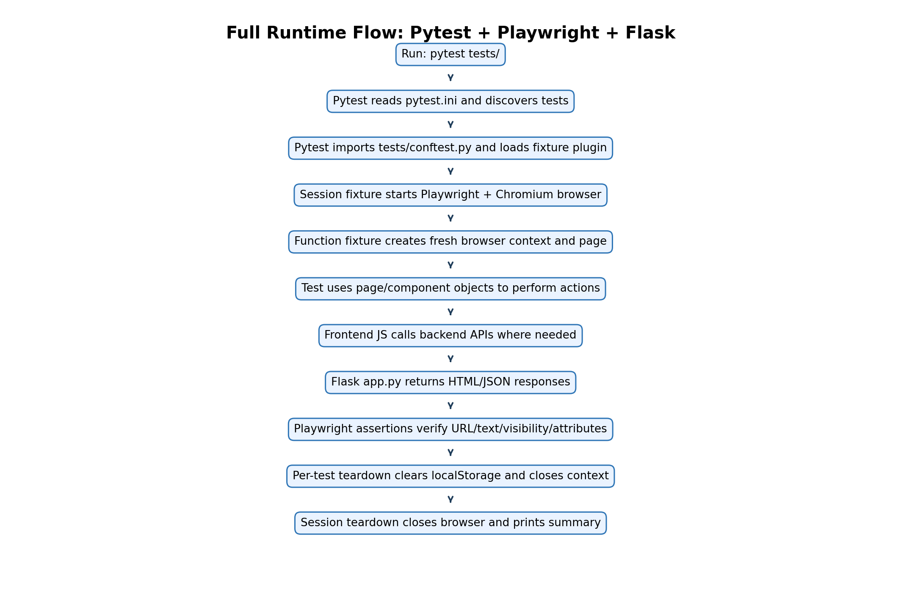
Full Runtime Flow

19.2 Login sequence flow
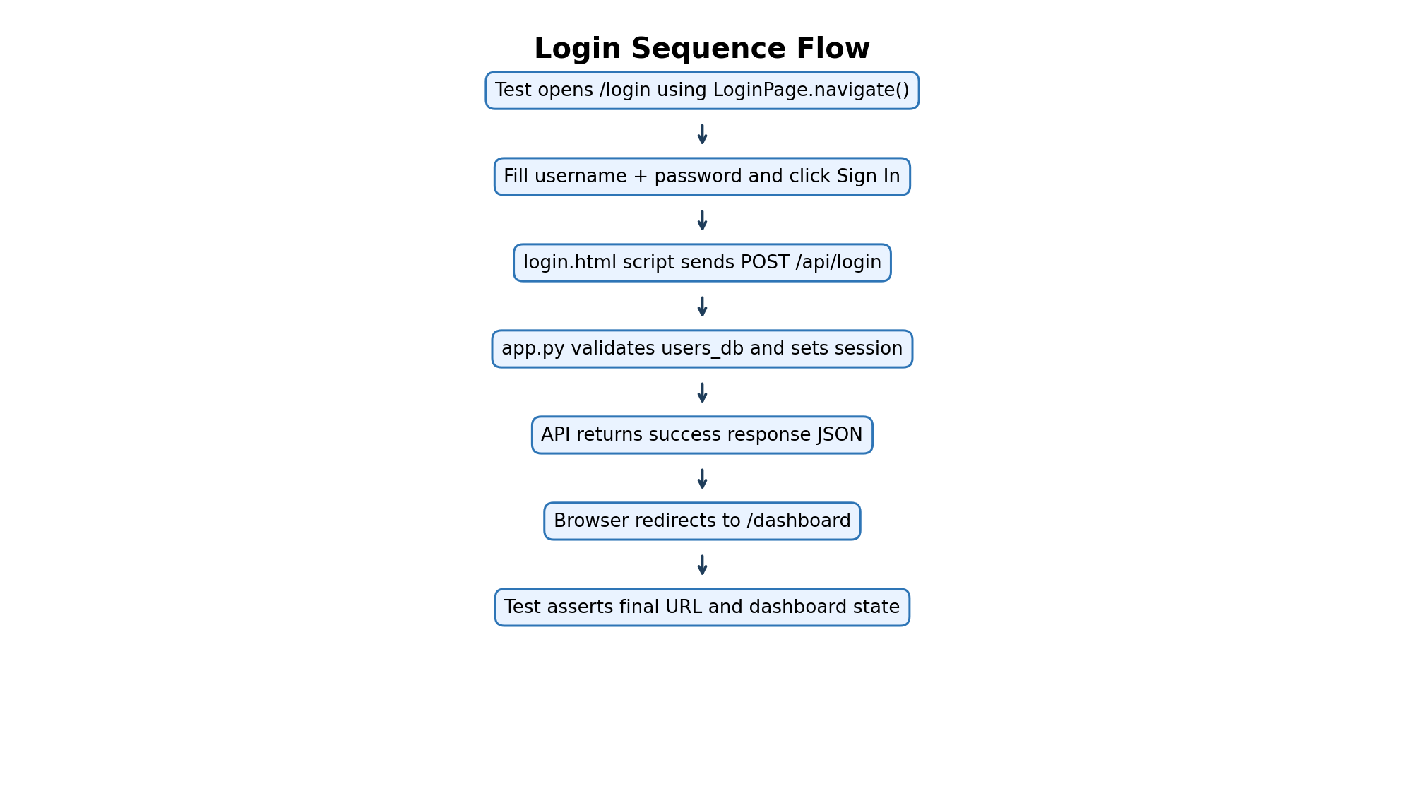
Login Sequence Flow

19.3 Products filter/search flow
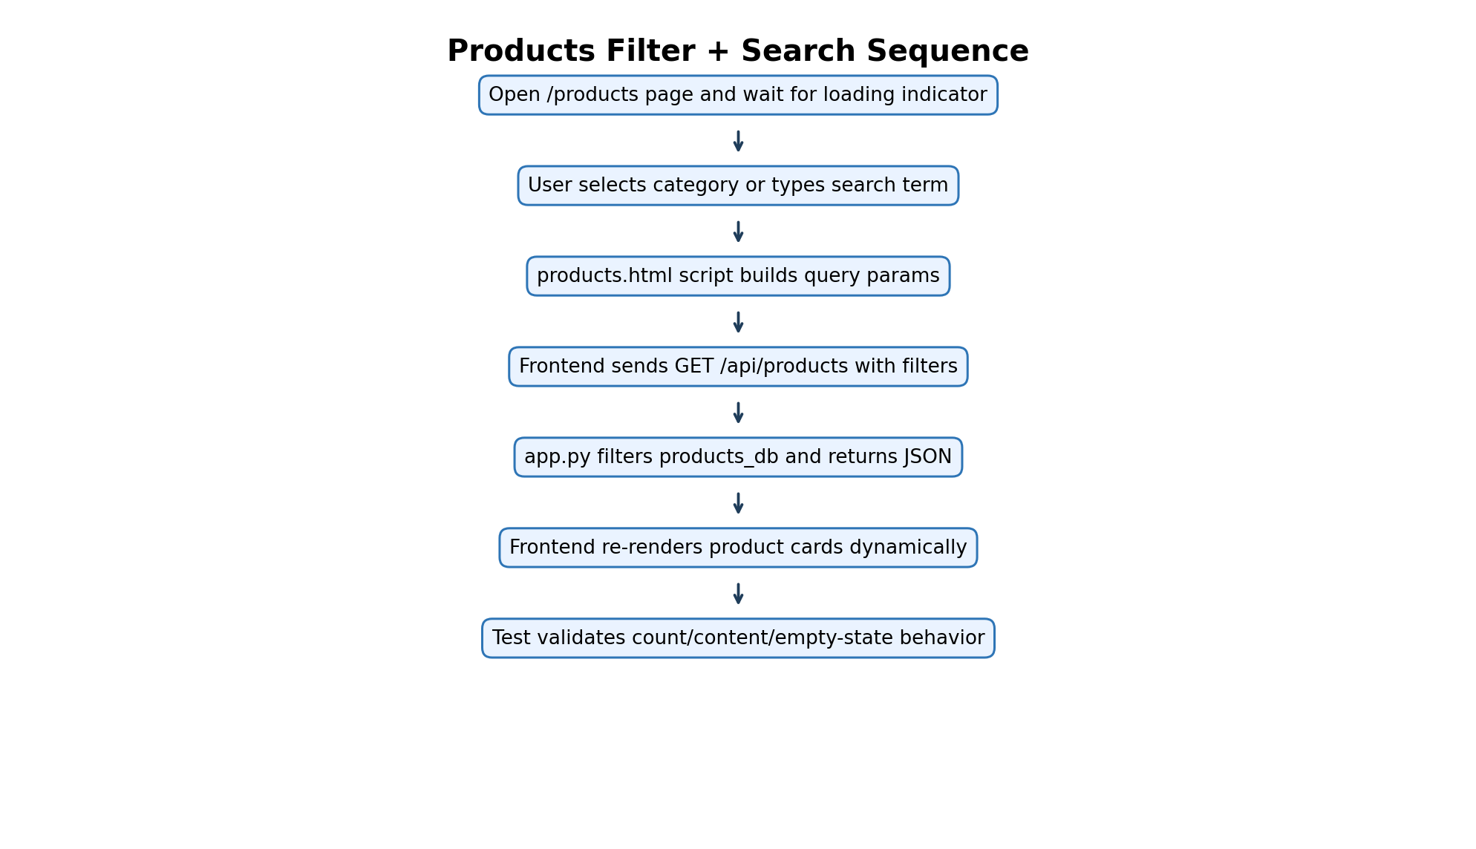
Products Flow

19.4 Checkout sequence flow
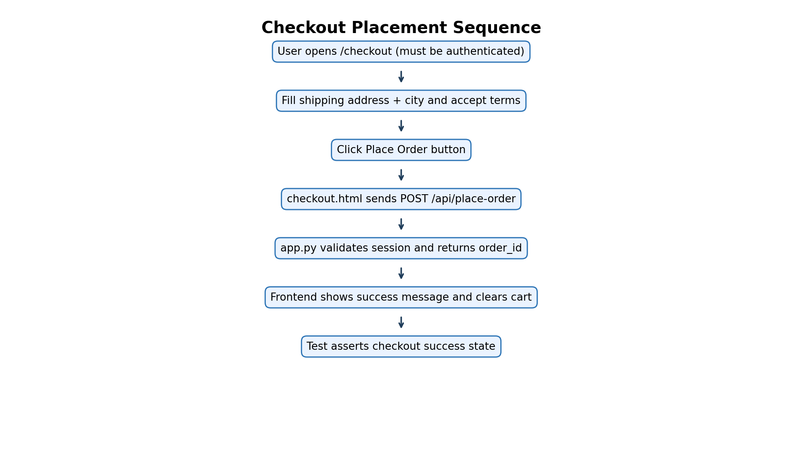
Checkout Flow

19.5 Fixture lifecycle flow
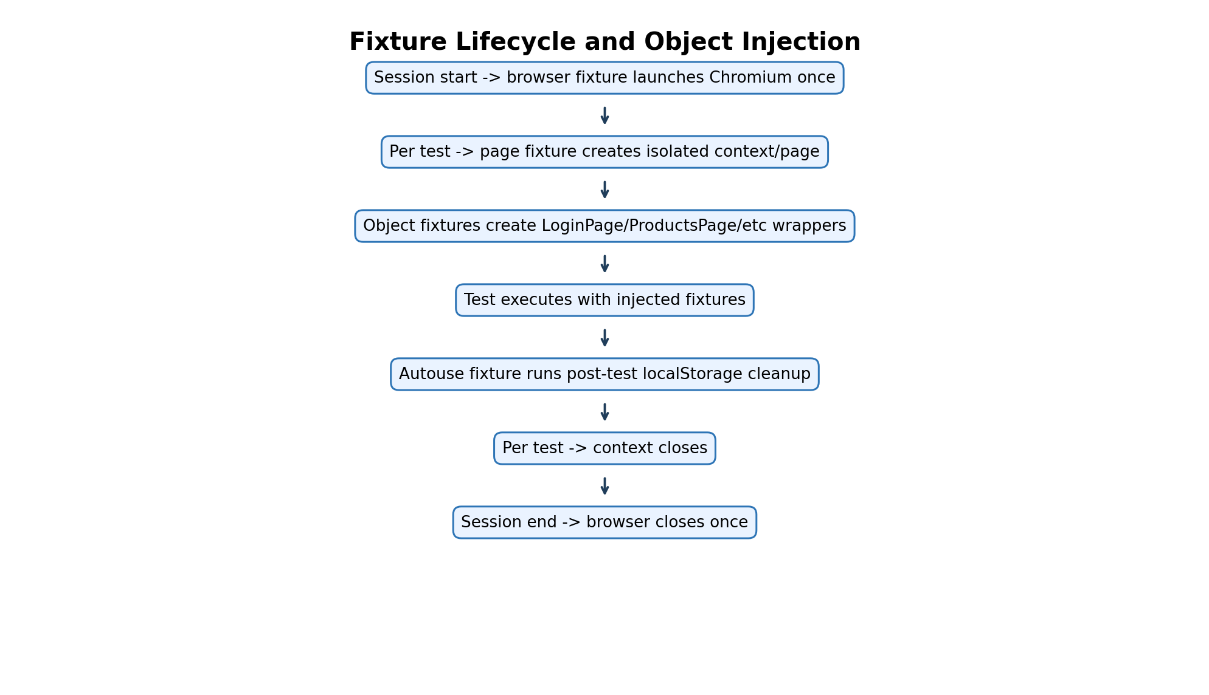
Fixture Lifecycle Flow

How to read these diagrams
- Start at the top box and follow arrows downward.
- Blue boxes represent execution phases.
- Browser, frontend JS, and backend API transitions are shown in the middle steps.
- Last boxes always represent assertions and teardown.

