1. **Develop a Django app that displays current date and time in server**

**views.py**

import datetime

from django.http import HttpResponse

from django.shortcuts import render

# Create your views here.

def current_date_time(request):

    now=datetime.datetime.now()

    result="<html><body><h1>Current Date and time is %s" %(now)

    return HttpResponse(result)

**urls.py**

from django.contrib import admin

from django.urls import path

from ap1.views import current_date_time,four_hours_ahead,four_hours_before

from ap2.views import showlist

urlpatterns = [

    path('admin/', admin.site.urls),

    path('cdt/', current_date_time ),

**OUTPUT:**

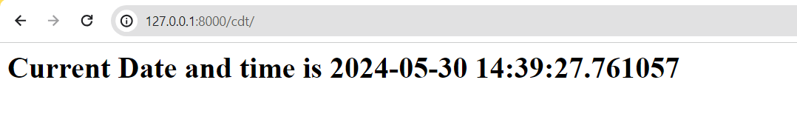

**2) Develop a Django app that displays date and time four hours ahead and four hours before as an offset of current date and time in server.**

*Views.py*

import datetime

from django.http import HttpResponse

from django.shortcuts import render

# Create your views here.

def current_date_time(request):

    now=datetime.datetime.now()

    result="<html><body><h1>Current Date and time is %s" %(now)

    return HttpResponse(result)

def four_hours_ahead(request):

     dt = datetime.datetime.now() + datetime.timedelta(hours=4)

     html = "<html><body><h1>After 4hour(s), it will be %s.</h1>"% (dt,)

     return HttpResponse(html)

def four_hours_before(request):

     dt = datetime.datetime.now() + datetime.timedelta(hours=-4)

     html = "<html><body><h1>Before 4 hour(s), it was %s.</h1>"% (dt,)

     return HttpResponse(html)

*urls.py*

from django.contrib import admin

from django.urls import path

from ap1.views import current_date_time,four_hours_ahead,four_hours_before

urlpatterns = [

    path('admin/', admin.site.urls),

    path('cdt/', current_date_time ),y

    path('fhrsa/',four_hours_ahead),

    path('fhrsb/',four_hours_before),

]

**OUTPUT:**

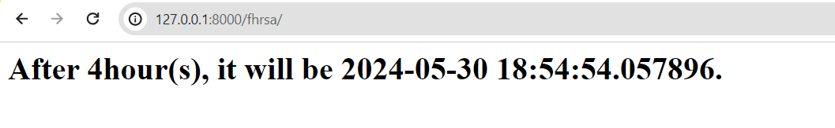

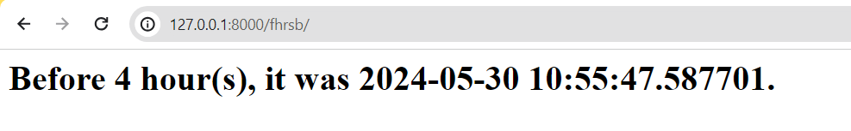

**3) Develop a simple Django app that displays an unordered list of fruits and ordered list of selected students for an event**

*Create an another ap folder:*

python manage.py startapp ap2

***Create a folder “templates” in ap2***

***Create a file “****showlist.html****” as mentioned below in templates folder***

*ap2/templates/showlist.html*

**<html>**

**<style type="text/css">**

**#i1 {background-color: lightgreen;color:brown;display:table}**

**#i2 {background-color: black;color:yellow;display:table}**

**</style>**

**<body>**

**<h1 id="i1">Unordered list of fruits</h1>**

**<ul>**

**{% for fruit in fruits %}**

**<li>{{ fruit }}</li>**

**{% endfor %}**

**</ul>**

**<h1 id="i2">Ordered list of Students</h1>**

**<ol>**

**{% for student in student_names %}**

**<li>{{ student }}</li>**

**{% endfor %}**

**</ol>**

**</body>**

**</html>**

*views.py*

**from django.shortcuts import render**

**# Create your views here.**

**def showlist(request):**

**fruits=["Mango","Apple","Banana","Jackfruits"]**

**student_names=["Tony","Mony","Sony","Bob"]**

**return render(request,'showlist.html',{"fruits":fruits,"student_names":student_names})**

*urls.py*

**from django.contrib import admin**

**from django.urls import path**

**from ap1.views import current_date_time,four_hours_ahead,four_hours_before**

**from ap2.views import showlist**

**urlpatterns = [**

**path('admin/', admin.site.urls),**

**path('cdt/', current_date_time ),**

**path('fhrsa/',four_hours_ahead),**

**path('fhrsb/',four_hours_before),**

**path('showlist/', showlist),**

**]**

*Lab/settings.py*

**TEMPLATES = [**

**{**

**'BACKEND': 'django.template.backends.django.DjangoTemplates',**

**'DIRS': [os.path.join(BASE_DIR,'ap2/templates'),],**

**'APP_DIRS': True,**

**'OPTIONS': {**

**'context_processors': [**

**'django.template.context_processors.debug',**

**'django.template.context_processors.request',**

**'django.contrib.auth.context_processors.auth',**

**'django.contrib.messages.context_processors.messages',**

**],**

**},**

**},**

**]**

*OUTPUT:*

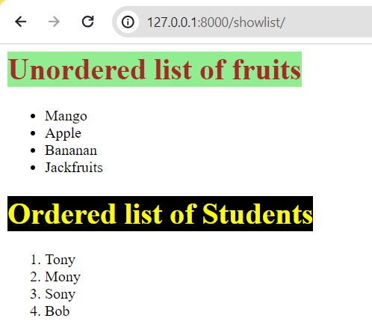

**4) Develop a layout.html with a suitable header (containing navigation menu) and footer with copyright and developer information. Inherit this layout.html and create 3 additional pages: contact us, About Us and Home page of any website.**

*views.py*

from django.shortcuts import render

def home(request):

     return render(request,'home.html')

def aboutus(request):

     return render(request,'aboutus.html')

def contactus(request):

     return render(request,'contactus.html')

*urls.py*

from django.urls import path

from ap2.views import aboutus,home,contactus

urlpatterns = [

    path('aboutus/', aboutus),

    path('home/', home),

    path('contactus/', contactus),

]

*Template files*

*layout.html*

<html>

     <title>{% block title %} {% endblock %} </title>

     <style type="text/css">

        nav {background-color: lightblue;padding:10px}

     </style>

     <body>

        <nav>

            <a href="/home/">Home</a>|

            <a href="/aboutus/">About Us</a>|

            <a href="/contactus/">Contact Us</a>|

        </nav>

        <section>

            {% block content %}{% endblock %}

        </section>

        <footer>

            <hr>

            &copy; Developed by Sir MVIT, Bengaluru

        </footer>

     </body>

</html>

*home.html*

{% extends 'layout.html' %}

{% block title %}

Home

{% endblock %}

{% block content %}

<h2>This is the home page</h2>

{% endblock %}

*aboutus.html*

{% extends 'layout.html' %}

{% block title %}

About Us

{% endblock %}

{% block content %}

<h2>We are DJango developers</h2>

{% endblock %}

*contactus.html*

{% extends 'layout.html' %}

{% block title %}

Contact us

{% endblock %}

{% block content %}

<h2> phone: 9900556688 <br> Address: Sir MVIT,Bengaluru</h2>

{% endblock %}

*OUTPUT:*

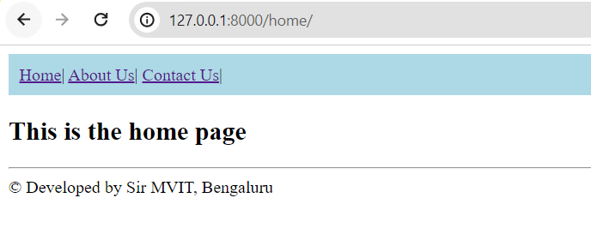

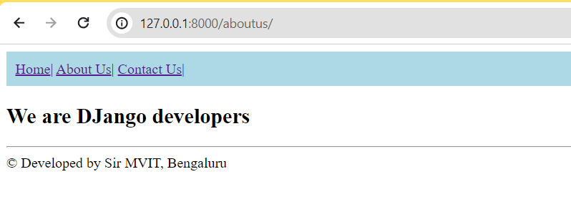

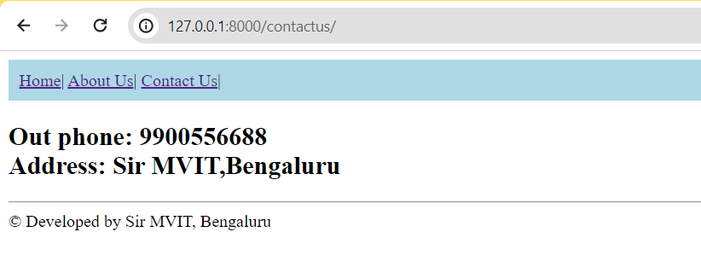

**5) Develop a Django app that performs student registration to a course. It should also display list of students registered for any selected course. Create students and course as models with enrolment as ManyToMany field.**

***WAMP Server link***

[**https://sourceforge.net/projects/wampserver/files/latest/download**](https://sourceforge.net/projects/wampserver/files/latest/download)

During installation process, many files will be missing and system asks to install it. Hence download the files from this website:

[**https://wampserver.aviatechno.net/**](https://wampserver.aviatechno.net/)

After successful installation of WAMP server, start it and then go to [**http://localhost/phpmyadmin**](http://localhost/phpmyadmin)

**Usename: root**

**Password- empty**

***Use phpMyAdmin***

Create a new database “studentreg”

**PS D:\SirMVIT\MY_SUBJECTS\FullStackDevelopment> python manage.py startapp ap3**

**Install mysqlclient from VS Code terminal:**

**pip install mysqlclient**

**static and template folder creation and 3 files inside this folder**

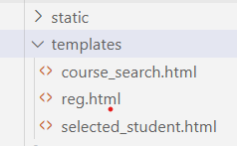

***course_search.html***

<html>

    <body>

        <form method="POST" action="">

            Courses

            {% csrf_token %}

            <select name="cname">

                {%for course in courses %}

                <option value="{{course.id}}">{{course.course_name}}</option>

                {% endfor %}

            </select>

            <input type="submit" value="Search">

        </form>

    </body>

</html>

***reg.html***

<html>

    <body>

        <form method="post" action="">

            {% csrf_token %}

            Student Name

            <select name="sname">

            {%for student in students %}

            <option value="{{student.id}}">{{student.student_name}}</option>

            {% endfor %}

            </select><br>

            Course Name

            <select name="cname">

            {%for course in courses %}

            <option value="{{course.id}}">{{course.course_name}}</option>

            {% endfor %}

            </select><br>

            <input type="submit" value="Enroll">

        </form>

    </body>

</html>

***selected_student.html***

<html>

    <body>

        <table border>

            <tr>

                <th>Student Name</th>

                <th>Student USN</th>

                <th>Sem</th>

            </tr>

            {% for student in student_list %}

            <tr>

                <td>{{student.student_name}}</td>

                <td>{{student.student_usn}}</td>

                <td>{{student.student_sem}}</td>

            </tr>

            {% endfor %}

        </table>

    </body>

</html>

***models.py***

from django.db import models

# Create your models here.

class Course(models.Model):

    course_code=models.CharField(max_length=40)

    course_name=models.CharField(max_length=100)

    course_credits=models.IntegerField()

class Student(models.Model):

    student_usn=models.CharField(max_length=20)

    student_name=models.CharField(max_length=100)

    student_sem=models.IntegerField()

    enrolment=models.ManyToManyField(Course)

***views.py***

from django.http import HttpResponse

from django.shortcuts import render

from ap3.models import Course, Student

# Create your views here.

def reg(request):

    if request.method == "POST":

        sid=request.POST.get("sname")

        cid=request.POST.get("cname")

        student=Student.objects.get(id=sid)

        course=Course.objects.get(id=cid)

        res=student.enrolment.filter(id=cid)

        if res:

            return HttpResponse("<h1>Student already enrolled</h1>")

        student.enrolment.add(course)

        return HttpResponse("<h1>Student enrolled successfully</h1>")

    else:

        students=Student.objects.all()

        courses=Course.objects.all()

        return render(request,"reg.html",{"students":students, "courses":courses})

def course_search(request):

    if request.method=="POST":

        cid=request.POST.get("cname")

        s=Student.objects.all()

        student_list=list()

        for student in s:

            if student.enrolment.filter(id=cid):

                student_list.append(student)

        if len(student_list)==0:

            return HttpResponse("<h1>No Students enrolled</h1>")

        return render(request,"selected_student.html",{"student_list":student_list})

    else:

        courses=Course.objects.all()

        return render(request,"course_search.html",{"courses":courses})

***urls.py***

from ap3.views import reg, course_search

urlpatterns = [

    path('admin/', admin.site.urls),

    path('cdt/', current_date_time ),

    path('fhrsa/',four_hours_ahead),

    path('fhrsb/',four_hours_before),

    path('showlist/', showlist),

    path('aboutus/', aboutus),

    path('home/', home),

    path('contactus/', contactus),

    path('reg/', reg),

    path('course_search/',course_search),

]

***settings.py***

INSTALLED_APPS = [

    'django.contrib.admin',

    'django.contrib.auth',

    'django.contrib.contenttypes',

    'django.contrib.sessions',

    'django.contrib.messages',

    'django.contrib.staticfiles',

    'ap3'

]

TEMPLATES = [

    {

        'BACKEND': 'django.template.backends.django.DjangoTemplates',

        'DIRS': [os.path.join(BASE_DIR,'ap3/templates'),],

        'APP_DIRS': True,

        'OPTIONS': {

            'context_processors': [

                'django.template.context_processors.debug',

                'django.template.context_processors.request',

                'django.contrib.auth.context_processors.auth',

                'django.contrib.messages.context_processors.messages',

            ],

        },

    },

]

DATABASES = {

    'default': {

        'ENGINE': 'django.db.backends.mysql',

        'NAME': 'studentreg',

        'USER': 'root',

        'PASSWORD': '',

        'HOST':'localhost',

        'PORT':'3306',

    }

}

STATIC_URL = 'static/'

STATICFILES_DIRS=[os.path.join(BASE_DIR, 'ap3/static')]

***Perform Migrations***

**python manage.py makemigrations ap3**

**python manage.py migrate**

**python manage.py runserver**

***Note: migration should be done every time as models.py change or any database table changes*.**

***Insert into tables in phpmyadmin***

[**http://localhost/phpmyadmin**](http://localhost/phpmyadmin)

OR

[**http://localhost/phpmyadmin/index.php?route=/sql&pos=0&db=studentreg&table=ap3_course**](http://localhost/phpmyadmin/index.php?route=/sql&pos=0&db=studentreg&table=ap3_course)

[**http://localhost/phpmyadmin/index.php?route=/sql&pos=0&db=studentreg&table=ap3_student**](http://localhost/phpmyadmin/index.php?route=/sql&pos=0&db=studentreg&table=ap3_student)

**ap3_student and ap3_course**

***OUTPUT***

***Run the url***

[**http://127.0.0.1:8000/reg/**](http://127.0.0.1:8000/reg/)

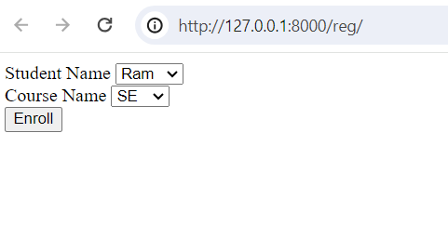

[**http://127.0.0.1:8000/course_search/**](http://127.0.0.1:8000/course_search/)

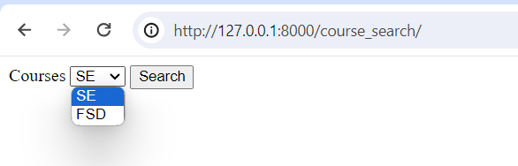

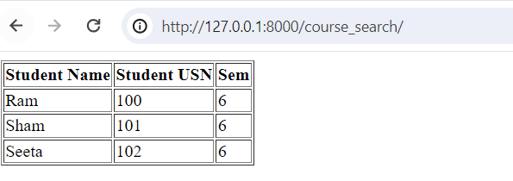

**Module 3:**

**6. For student and course models created in Lab experiment for Module2, register admin interfaces, perform migrations and illustrate data entry through admin forms.**

1)admin.py

from django.contrib import admin

from ap3.models import Course, Student

# Register your models here.

admin.site.register(Student)

admin.site.register(Course)

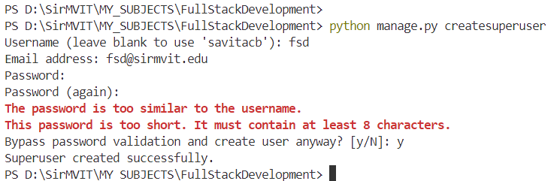

PS D:\SirMVIT\MY_SUBJECTS\FullStackDevelopment> python manage.py runserver

* Login with your superuser credentials

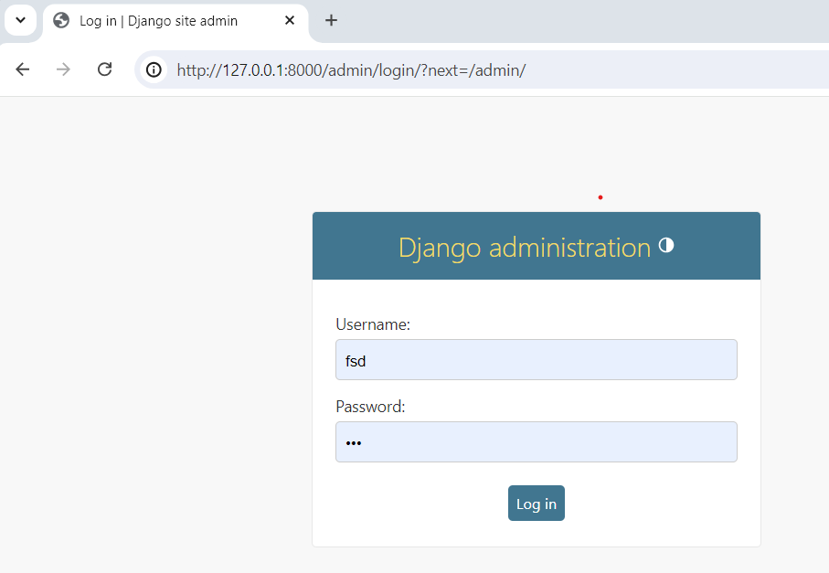

* Index page should be visible

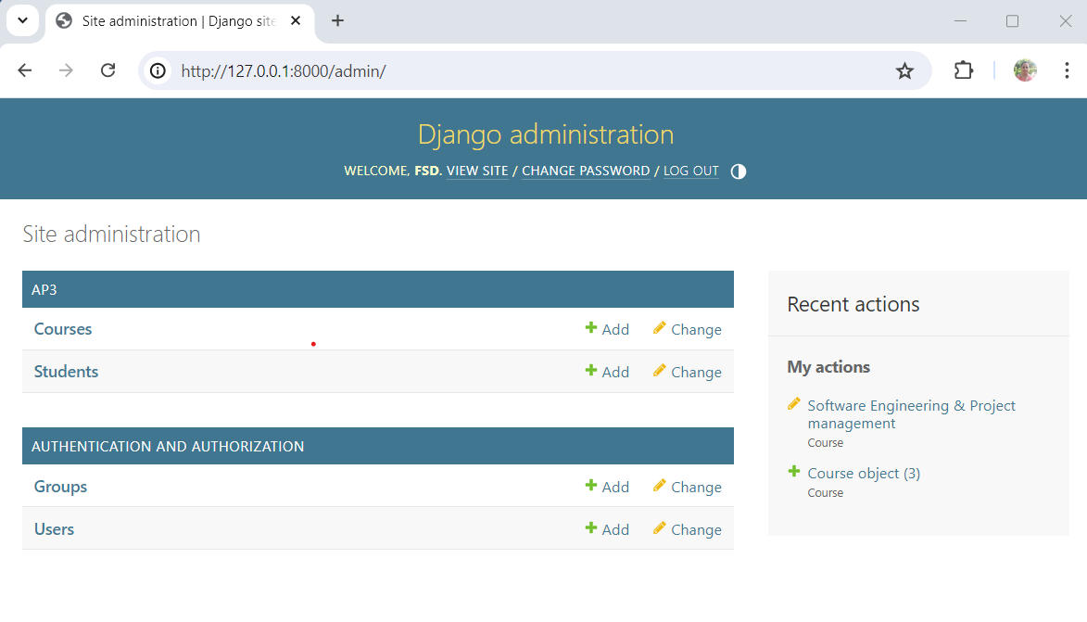

* Go to Courses

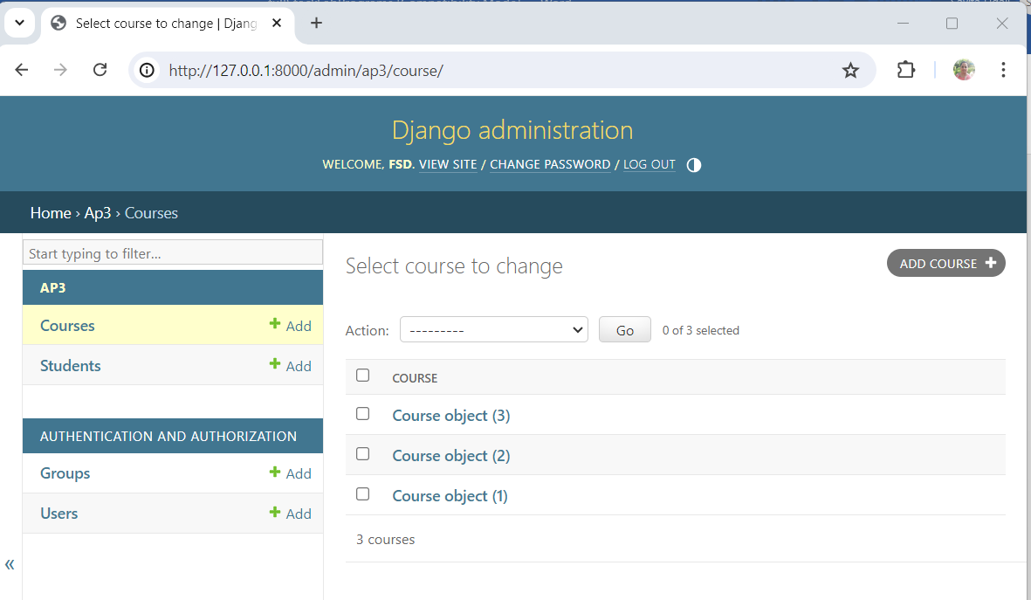

* Add course

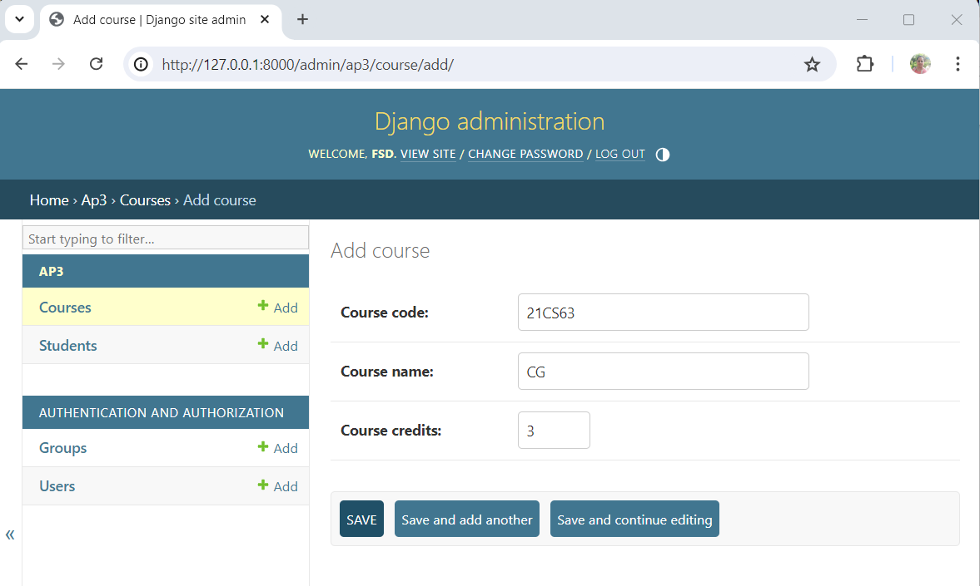

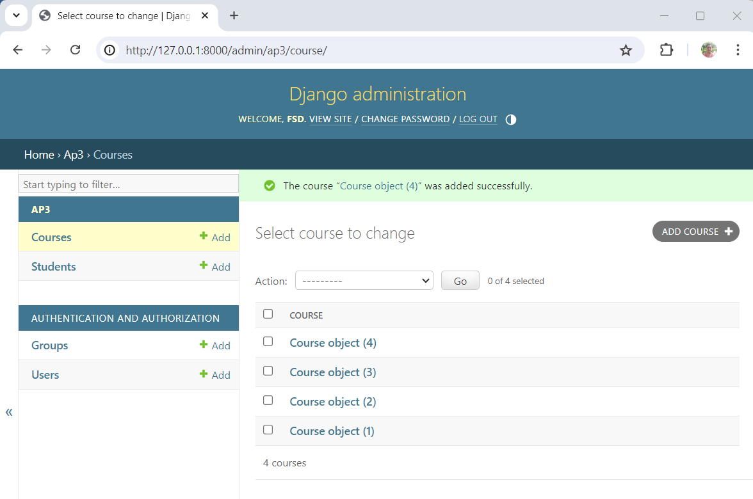

* We see a very vague display of objects. To fix it, make the following changes in models.py

**models.py**

from django.db import models

# Create your models here.

class Course(models.Model):

    course_code=models.CharField(max_length=40)

    course_name=models.CharField(max_length=100)

    course_credits=models.IntegerField()

    def __str__(self):

        return self.course_name

class Student(models.Model):

    student_usn=models.CharField(max_length=20)

    student_name=models.CharField(max_length=100)

    student_sem=models.IntegerField()

    enrolment=models.ManyToManyField(Course)

    def __str__(self):

        return self.student_name+"("+self.student_usn+")"

Run the code:

PS D:\SirMVIT\MY_SUBJECTS\FullStackDevelopment> python manage.py runserver

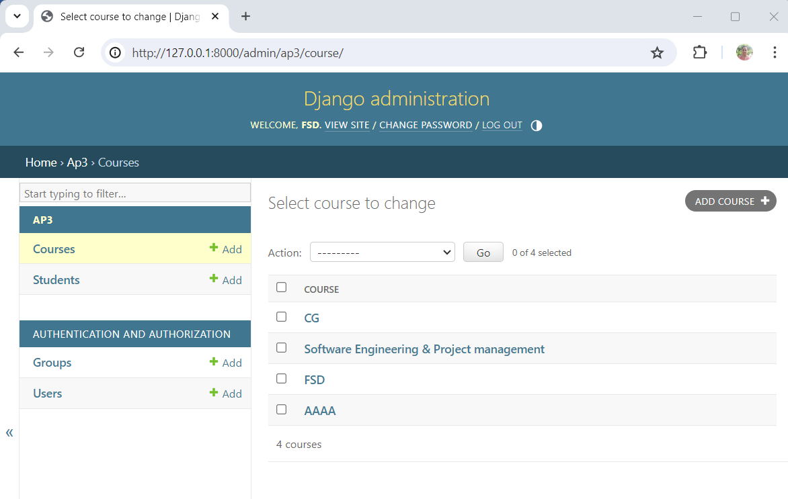

**Updating urls.py**

from ap3.views import reg, course_search

admin.site.site_header="My Site Header"

admin.site.site_title="My Site Title"

admin.site.index_title="My Site Index"

PS D:\SirMVIT\MY_SUBJECTS\FullStackDevelopment> python manage.py runserver

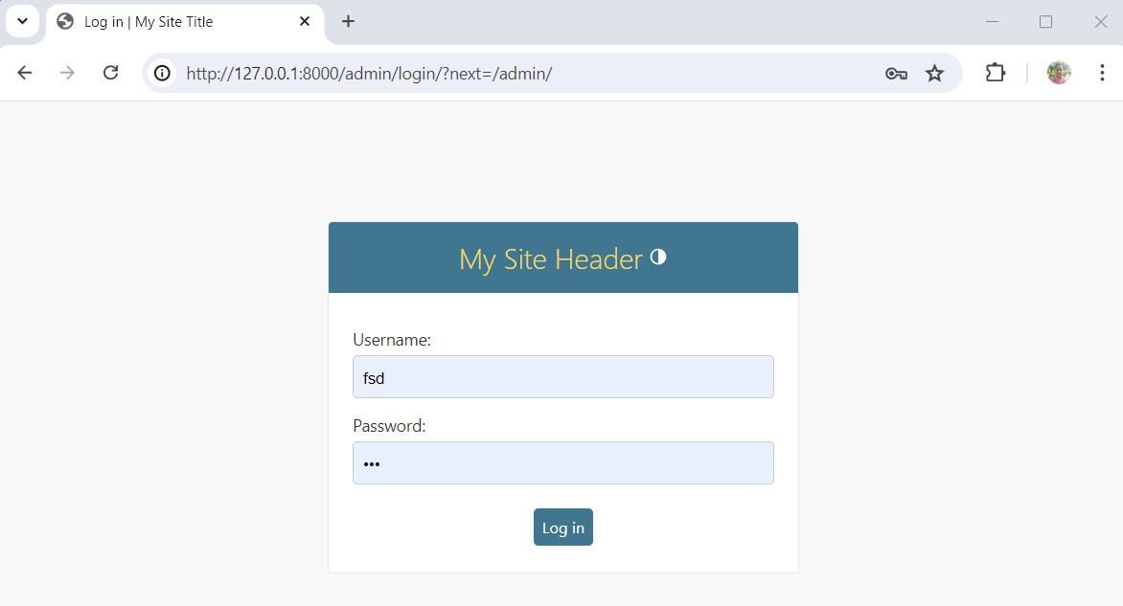

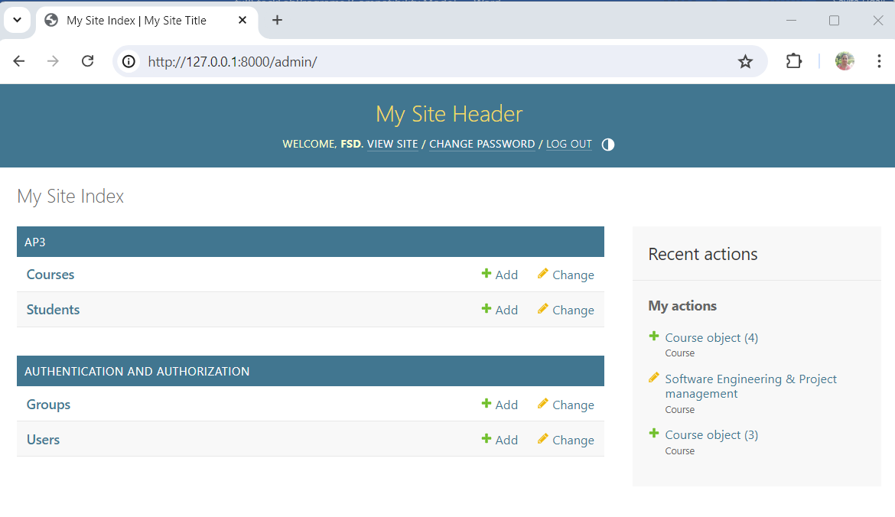

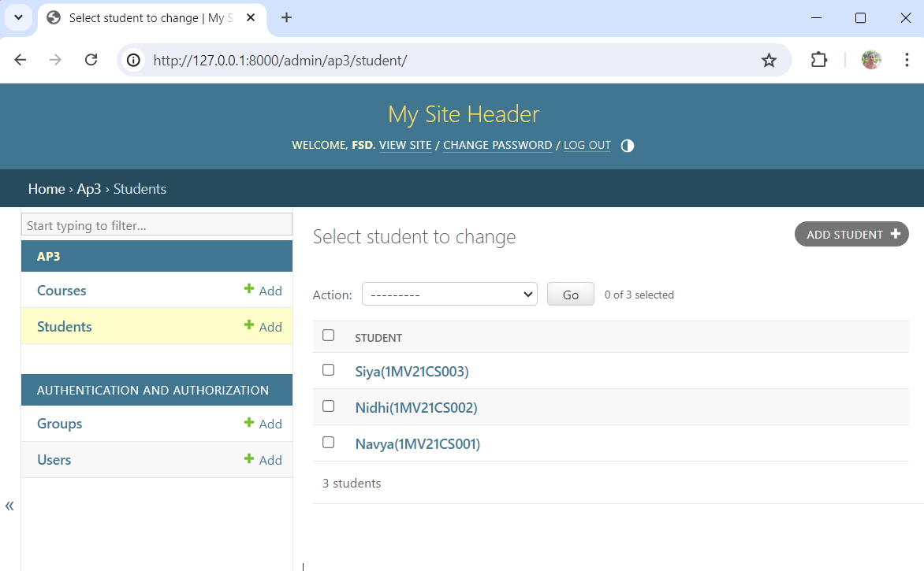

**Updating models.py (removing compulsory field )**

**In course**

course_credits=models.IntegerField(blank=True, null=True)

**and run the migration commands**

python manage.py makemigrations ap3

python manage.py migrate

**customizing admin**

**in admin.py**

#admin.site.register(Student)

@admin.register(Student)

class StudentAdmin(admin.ModelAdmin):

    list_display = ('student_name','student_usn','student_sem')

    ordering=('student_name',)

    search_fields = ('student_name',)

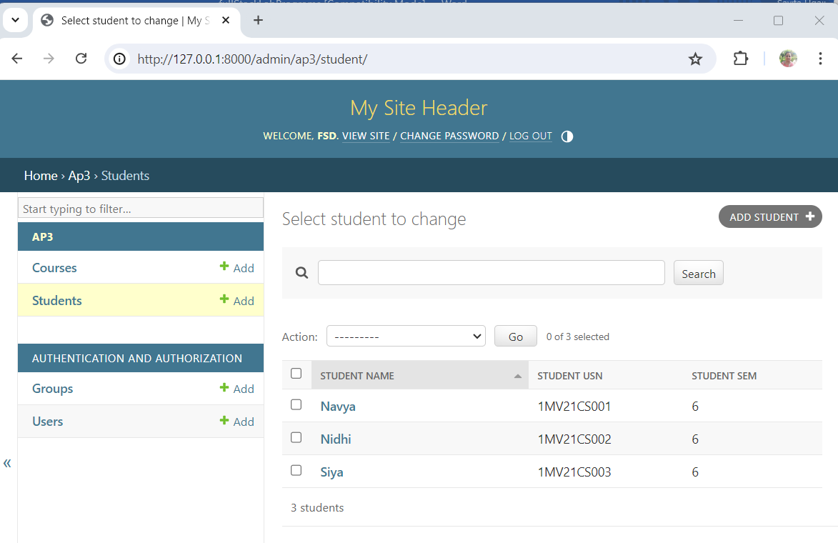

**Search Operation:**

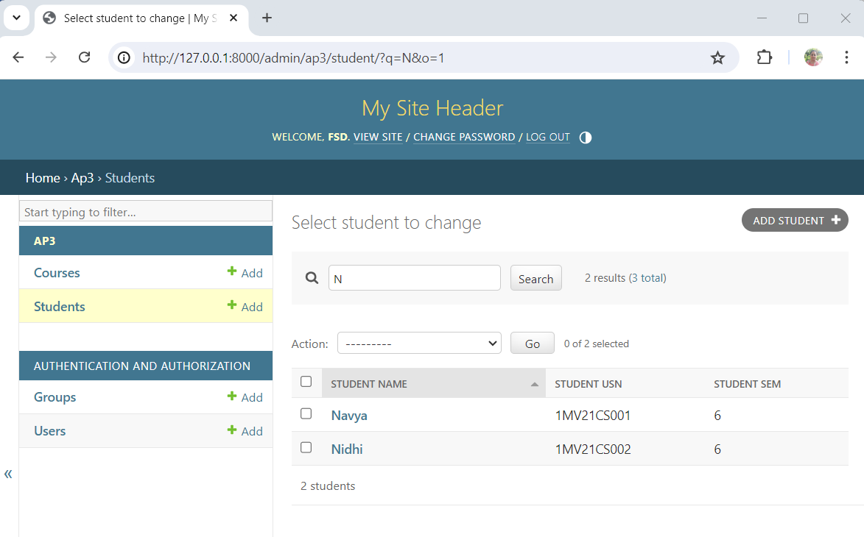

**7) Develop a Model form for student that contains his topic chosen for project, languages used and duration with a model called project.**

**models.py**

from Django.db import models

from django.forms import ModelForm

class Project(models.Model):

    student=models.ForeignKey(Student,on_delete=models.CASCADE)

    ptopic=models.CharField(max_length=200)

    plangauges=models.CharField(max_length=200)

    pduration=models.IntegerField()

class ProjectReg(ModelForm):

    required_css_class="required"

    class Meta:

        model=Project

        fields=['student','ptopic','plangauges','pduration']

**views.py**

from ap3.models import Course, Student, ProjectReg

def add_project(request):

    if request.method=="POST":

        form=ProjectReg(request.POST)

        if form.is_valid():

            form.save()

            return HttpResponse("<h1>Record inserted successfully</h1>")

        else:

            return HttpResponse("<h1>Record not inserted</h1>")

    else:

        form=ProjectReg()

        return render(request,"add_project.html",{"form":form})

**add_project.html (need to be created in templates folder)**

<html>

    <form method="post" action="">

        {% csrf_token %}

        <table>

            {{ form.as_table}}

            <tr>

                <td>

                    <input type="submit" value="Submit">

                </td>

            </tr>

        </table>

    </form>

</html>

**urls.py**

from ap3.views import reg, course_search, add_project

urlpatterns = [

    path('admin/', admin.site.urls),

    path('cdt/', current_date_time ),

    path('fhrsa/',four_hours_ahead),

    path('fhrsb/',four_hours_before),

    path('showlist/', showlist),

    path('aboutus/', aboutus),

    path('home/', home),

    path('contactus/', contactus),

    path('reg/', reg),

    path('course_search/',course_search),

    path('add_project/', add_project)

]

Perform remigrations before running:

python manage.py makemigrations ap3

python manage.py migrate

python manage.py runserver

OUTPUT:

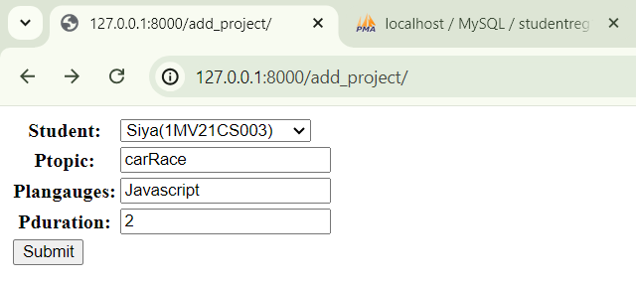

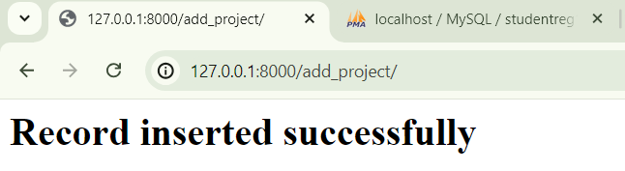

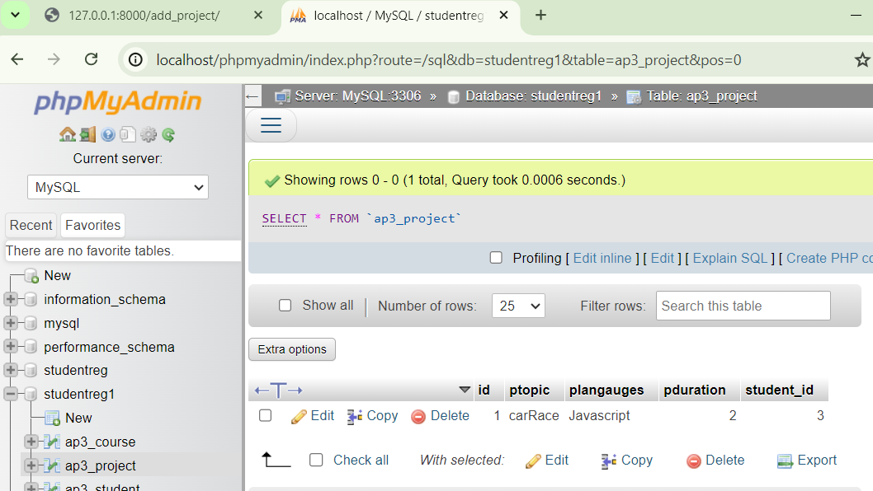

**8) For students enrolment developed in Module 2, create a generic class view which displays list of students and detailview that displays student details for any selected student in the list.**

**views.py**

from django.views import generic

class StudentListView(generic.ListView):

    model=Student

    template_name="student_list.html"

class StudentDetailView(generic.DetailView):

    model=Student

    template_name="student_detail.html"

**student_list.html**

<html>

    <body>

        {% if student_list %}

        <table border>

            <tr>

                <th>USN</th>

                <th>Courses Enrolled</th>

            </tr>

            {% for student in student_list %}

            <tr>

                <td><a href="/student_detail/{{student.pk}}">{{ student.student_usn }}</a></td>

                <td>{% for course in student.enrolment.all %}

                    <span>{{ course.course_name }}</span>

                    {% endfor %}

                </td>

            </tr>

            {% endfor %}

        </table>

        {% else %}

            <h1>No Students Enrolled</h1>

        {% endif %}

    </body>

</html>

**student_detail.html**

<h1>Student Name: {{ student.student_name }}</h1>

<h1>Student USN: {{ student.student_usn }}</h1>

<h1>Student Sem: {{ student.student_sem }}</h1>

**urls.py**

from ap3.views import StudentListView,StudentDetailView

urlpatterns = [

    path('add_project/', add_project),

    path('student_list/', StudentListView.as_view()),

    path('student_detail/<int:pk>/', StudentDetailView.as_view()),

]

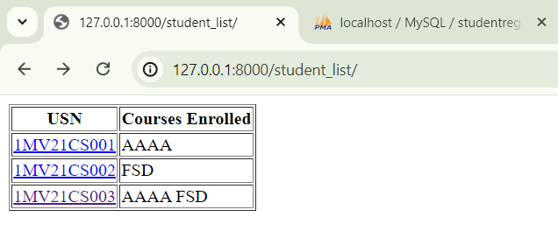

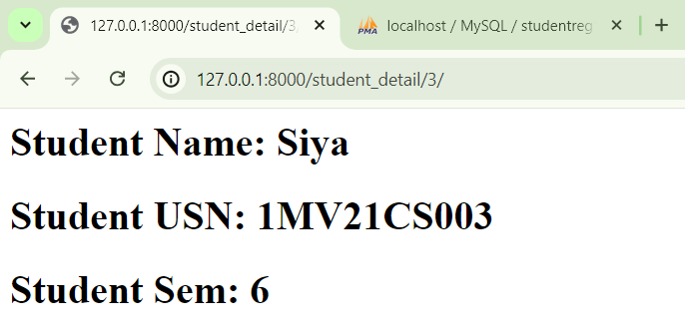

**9) Develop example Django app that performs CSV and PDF generation for any models created in previous laboratory component.**

In the terminal:

**pip install reportlab**

**views.py**

def construct_csv_from_model(request):

    courses=Course.objects.all()

    response=HttpResponse(content_type="text/csv")

    response['Content-Disposition'] = 'attachment;filename="courses_data.csv"'

    writer=csv.writer(response)

    writer.writerow(["Course Name","Course Code","Credits"])

    for course in courses:

    writer.writerow([course.course_name,course.course_code, course.course_credits])

    return response

def construct_pdf_from_model2(request):

    courses=Course.objects.all()

    response=HttpResponse(content_type="application/pdf")

    response['Content-Disposition'] = 'attachment; filename="courses_data.pdf"'

    c=canvas.Canvas(response)

    c.drawString(70,720,"Course Name")

    c.drawString(170,720,"Course Code")

    c.drawString(270,720,"Credits")

    y=660

    for course in courses:

        c.drawString(70,y,course.course_name)

        c.drawString(170,y,course.course_code)

        c.drawString(270,y,str(course.course_credits))

        y=y-60

    c.showPage()

    c.save()

    return response

urls.py

from ap3.views import construct_csv_from_model, construct_pdf_from_model2

urlpatterns = [

    path('construct_course/', construct_csv_from_model),

    path('construct_pdf_from_model2/', construct_pdf_from_model2),

]

CSV file downloaded

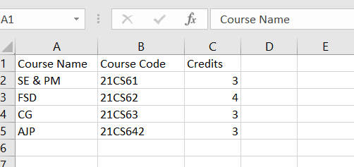

PDF file downloaded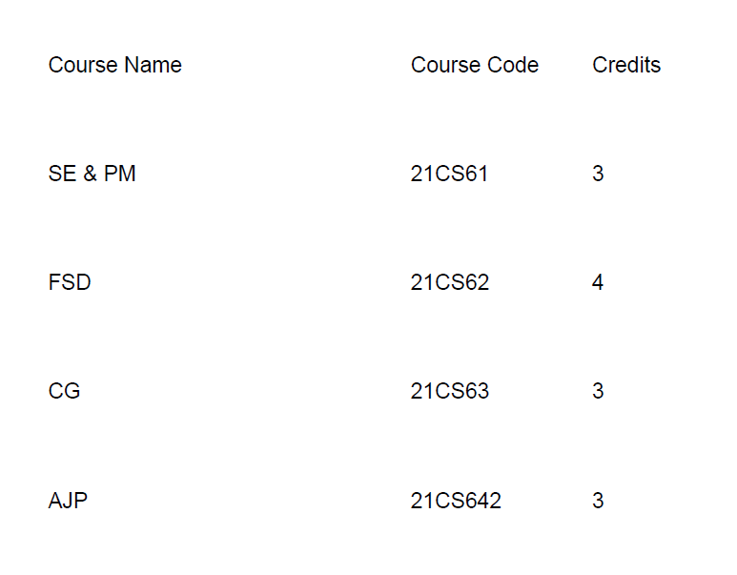

**10) Develop a registration page for student enrolment as done in Module 2 but without page refresh using AJAX.**

**views.py**

def regaj(request):

    if request.method == "POST":

        sid=request.POST.get("sname")

        cid=request.POST.get("cname")

        student=Student.objects.get(id=sid)

        course=Course.objects.get(id=cid)

        res=student.enrolment.filter(id=cid)

        if res:

            return HttpResponse("<h1>Student already enrolled</h1>")

        student.enrolment.add(course)

        return HttpResponse("<h1>Student enrolled successfully</h1>")

    else: students=Student.objects.all()

    courses=Course.objects.all()

    return render(request,"regaj.html",{"students":students, "courses":courses})

**regaj.html**

{% load static %}

<html>

    <body>

        <form method="post" action="">

            {% csrf_token %}

            Student Name

            <select name="sname" id="sname">

                {% for student in students %}

                <option value="{{ student.id }}">{{ student.student_name }}</option>

                {% endfor %}

            </select>

            <br>

            Course Name

            <select name="cname" id="cname">

                {% for course in courses %}

                <option value="{{ course.id }}">{{ course.course_name }}</option>

                {% endfor %}

            </select>

            <br>

            <span id="ans"></span>

            <input type="button" value="Enroll" id="ebtn">

        </form>

        <script src="{% static 'jquery.min.js' %}"></script>

        <script>

            $(document).ready(function(){

                $("#ebtn").click(function(){

                    var sname = $("#sname").val();

                    var cname = $("#cname").val();

                    $.ajax({

                        type: "POST",

                        url: "/regaj/",

                        data: {

                            sname: sname,

                            cname: cname,

                            csrfmiddlewaretoken: "{{ csrf_token }}"

                        },

                        success: function(response){

                            $("#ans").html(response);

                        }

                    });

                });

            });

        </script>

    </body>

</html>

**urls.py**

from ap3.views import regaj

urlpatterns = [

    path('regaj/',regaj),

]

**OUTPUT**

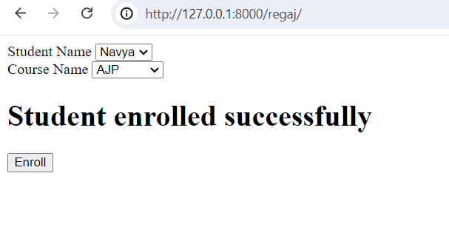

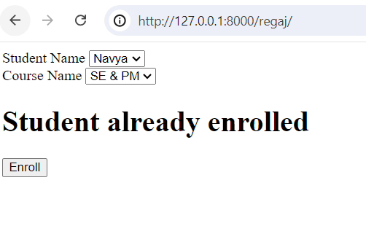

**11) Develop a search application in Django using AJAX that displays courses enrolled by a student being searched.**

**views.py**

def course_search_ajax(request):

    if request.method=="POST":

        cid=request.POST.get("cname")

        s=Student.objects.all()

        student_list=list()

        for student in s:

            if student.enrolment.filter(id=cid):

                student_list.append(student)

        if len(student_list)==0:

            return HttpResponse("<h1>No Students enrolled</h1>")

        return render(request,"selected_students.html",{"student_list":student_list})

    else:

        courses=Course.objects.all()

        return render(request,"course_search_aj.html",{"courses":courses})

**course_search_aj.html**

{% load static %}

<html>

    <body>

        <form method="POST" action="">

            Courses

            {% csrf_token %}

            <select name="cname" id="cname">

                {% for course in courses %}

                <option value="{{ course.id }}">{{ course.course_name }}</option>

                {% endfor %}

            </select>

            <input type="button" value="Search" id="serbtn">

            <span id="result"></span>

        </form>

    </body>

    <script src="{% static 'jquery.min.js' %}"></script>

    <script>

    $(document).ready(function(){

        $("#serbtn").click(function(){

            var cname = $("#cname").val();

            $.ajax({

                url: "/course_search/",

                type: "POST",

                data: { cname: cname, csrfmiddlewaretoken: "{{ csrf_token }}"},

                success: function(response){$("#result").html(response);}

            });

        });

    });

    </script>

</html>

**urls.py**

from ap3.views import regaj, course_search_ajax

urlpatterns = [

    path('course_seacrh_ajax/',course_search_ajax),

]

**OUTPUT**

