**PGP in AI/ML**

**Classification - Assignment 2**

**Submission Date: 2359 hrs on 03-09-2019**

**Total Marks: 25**

The following questions are to enhance your understanding of basic concepts and definitions. You are expected to answer these questions on your own without referring to internet.

1. In a particular pain clinic, 15% of patients are prescribed narcotic pain killers. Overall, six percent of the clinic’s patients are addicted to narcotics (including pain killers and illegal substances). Out of all the people prescribed pain pills, 9% are addicts. If a patient is an addict, what is the probability that they will be prescribed pain pills ? (Hint: Use Bayes Theorem) **[3M**]
2. Given below is the classification data set of a few mammals/non-mammals, based on a few attributes (Give Birth, Can Fly, Lives In Water, Have Legs).

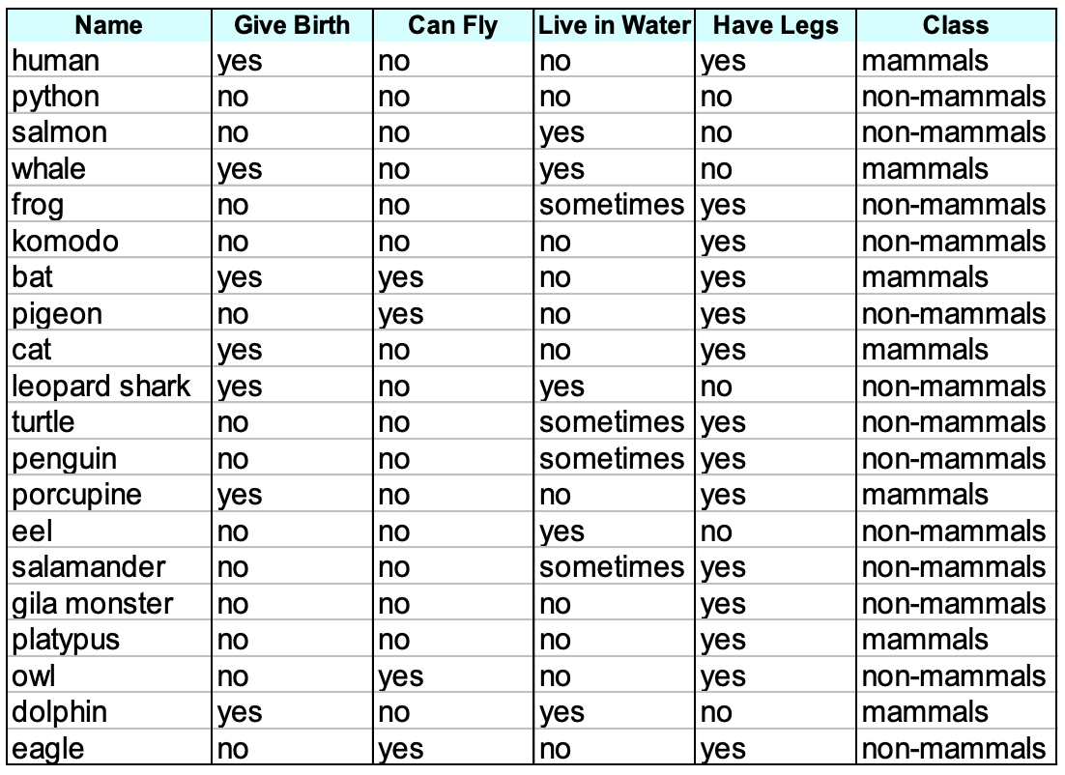

For the input set given below, please determine the Class of the creature using Naïve Bayes classifier **[7M]**

**Give Birth – Yes, Can fly – No, Live in water – Sometimes, Have legs – Yes**

1. For the dataset -2 (liver disease dataset), implement Naïve Bayes classifier using Python. **[15M**]

Please follow the following steps.

1. Import the libraries [1M]
2. Load the dataset [1M]
3. Remove/replace missing values (if any) [2M]
4. Split features and labels [1M]
5. Split train and test data [1M}
6. Implement Naïve Bayes Classifier [2M]
7. Calculate accuracy measures [2M]

Submission Details

Text answers – id_classification_assignment2.doc

Code - id_NB.ipynb

Contact Details

(You should put up queries in the discussion forum of the corresponding assignment folder only)

1. Himanshu - himanshuchawla437@gmail.com
2. Mohit - mohitrathore15@gmail.com
3. Parthasarathy - pdparthasarathy.03@gmail.com