WebAPI 2 - Learning Materials

Gokul Gopalsamy

Author Note

Beginners note for WEB API 2 learning

Contents

**Introduction** 4

Getting Started with JQuery 6

How JQuery can help with HTML DOM manipulations 9

Abstract 23

JQuery - Learning Materials 24

**Session I: Introduction - Create Web API for CRUD Operations**

* Source: <https://www.tutorialsteacher.com/webapi/create-web-api-for-crud-operation>
* We will create a Web API project and implement GE, POST, PUT and DELETE for CURD operations using EF
* Create new Project - “ASP.Net Web application”

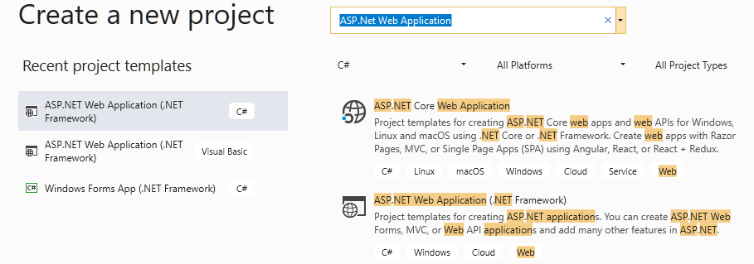

* Enter name for the project and save the project name as PP.POD (Purchase Order)

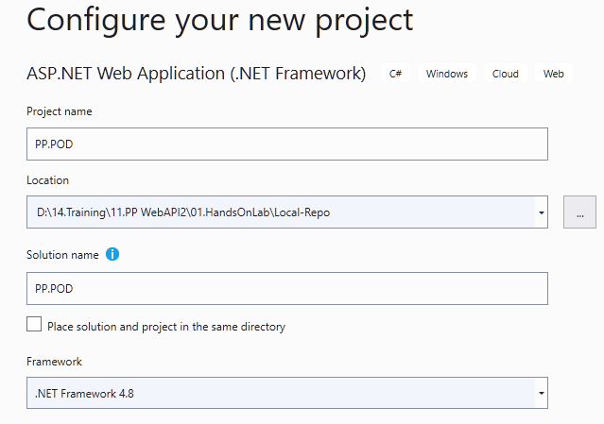

* From project template select the template name as “Web API” and click Create button

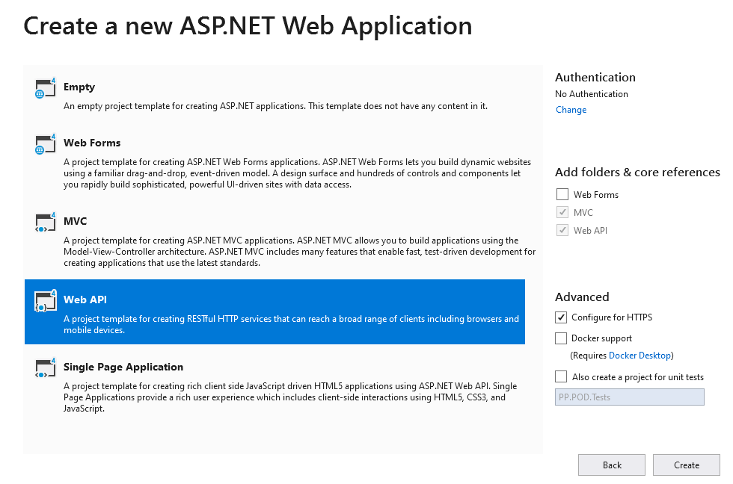

* We could see that a new WebAPI project is created with necessary project files. Important files:

App_Start 🡪 WebApiConfig.cs and

Controller 🡪 ValuesController.cs

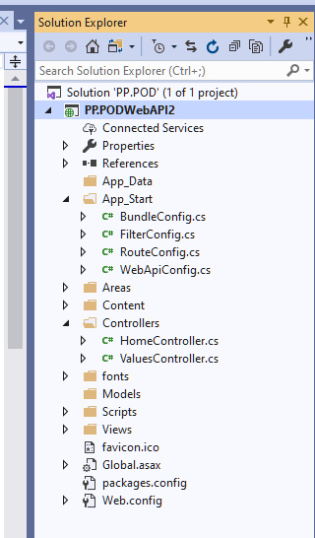

* ValueController.cs was added by default and it inherits from : **ApiController**

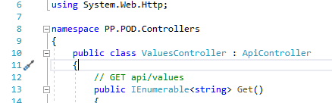

* As we will be adding the new ApiController for web API we will delete the default ApiController
* We will use Entity Framework Database First approach (EF-DBF)

### Adding EF Data Model

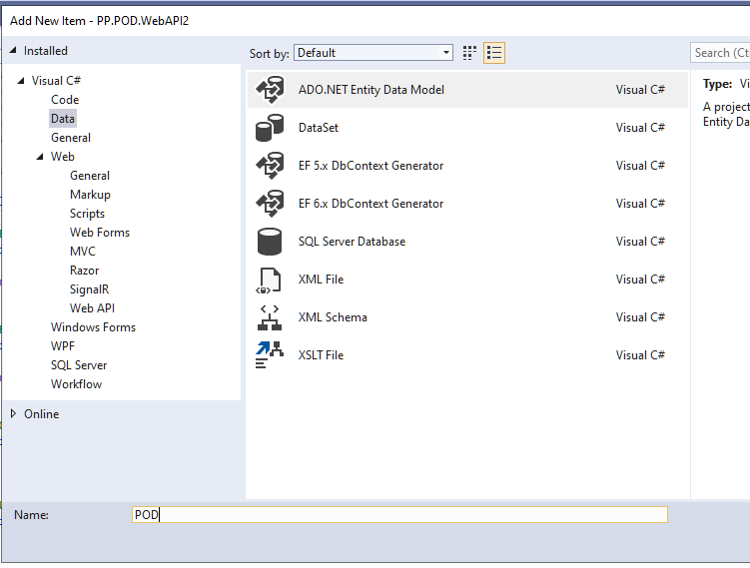

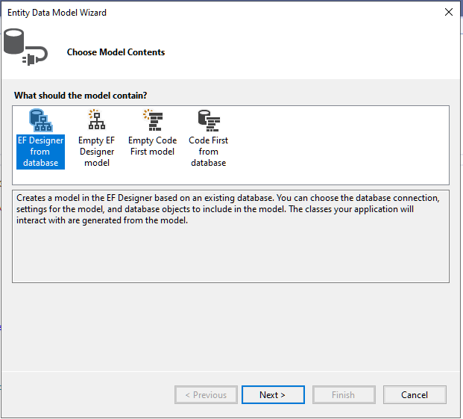

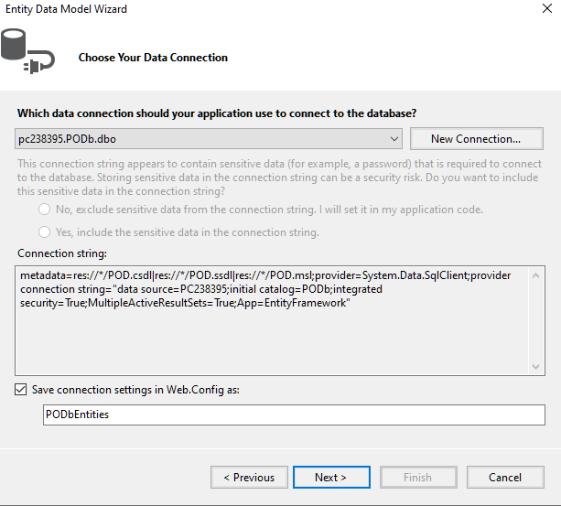

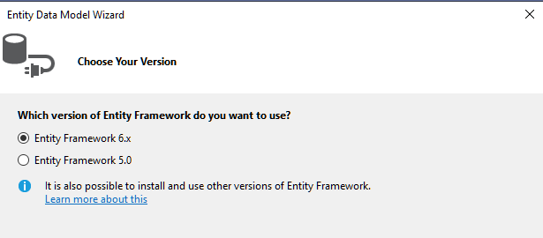

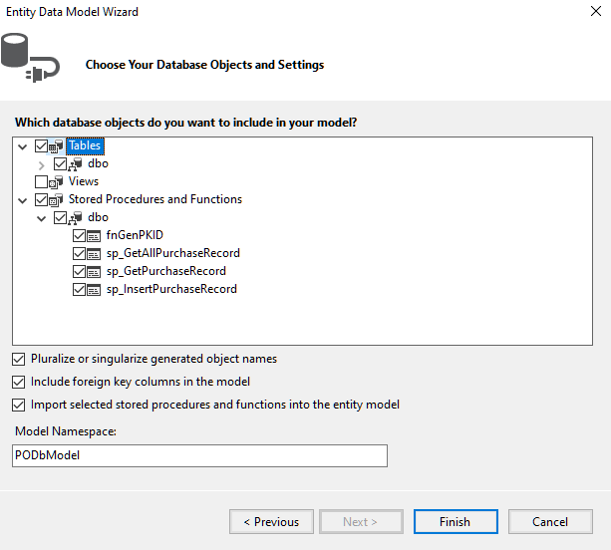

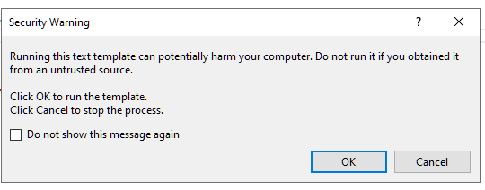

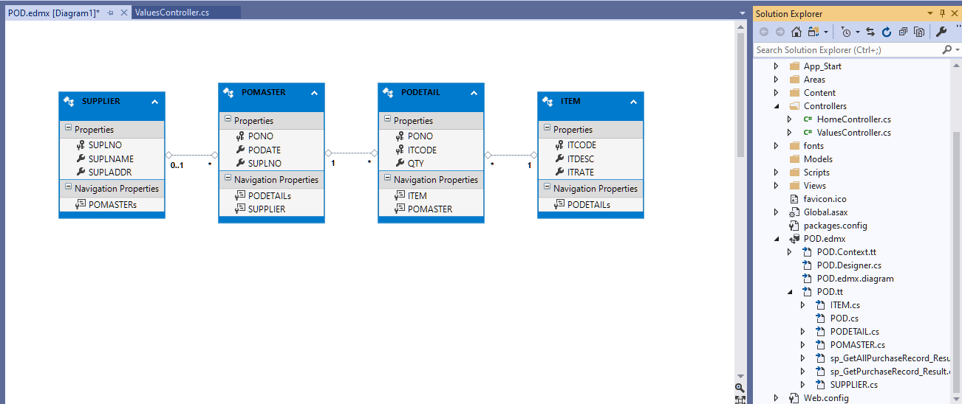

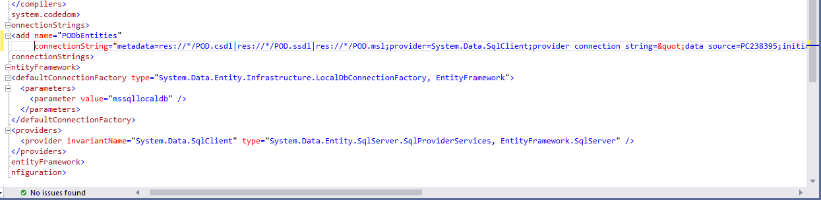

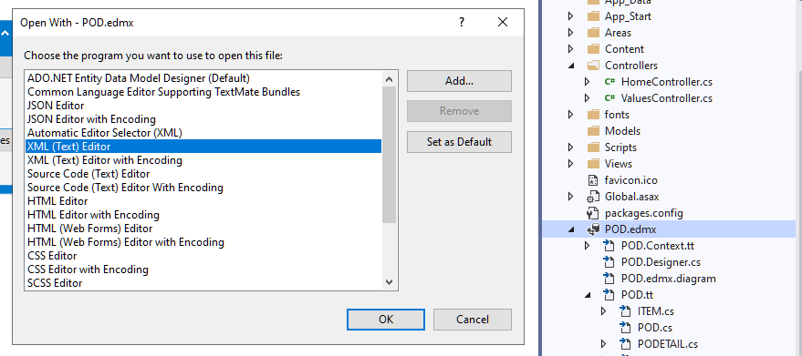

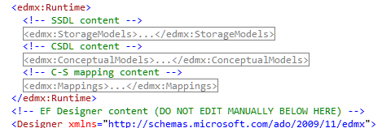

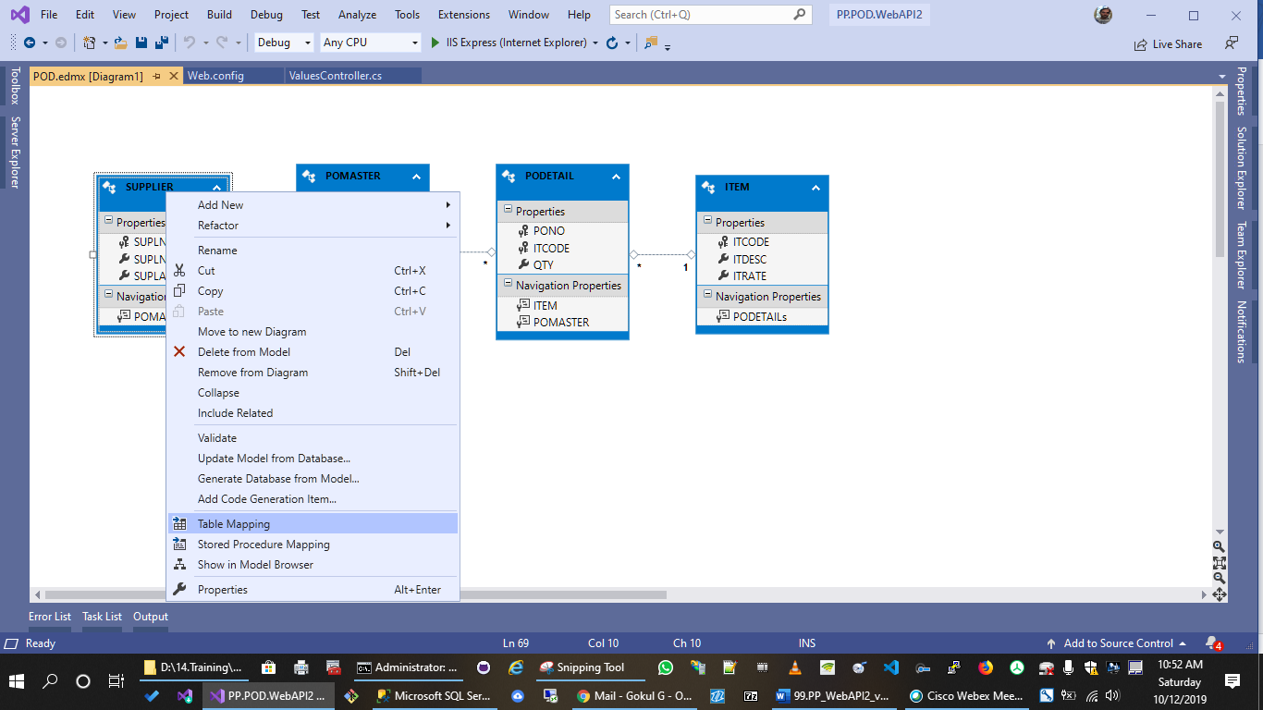

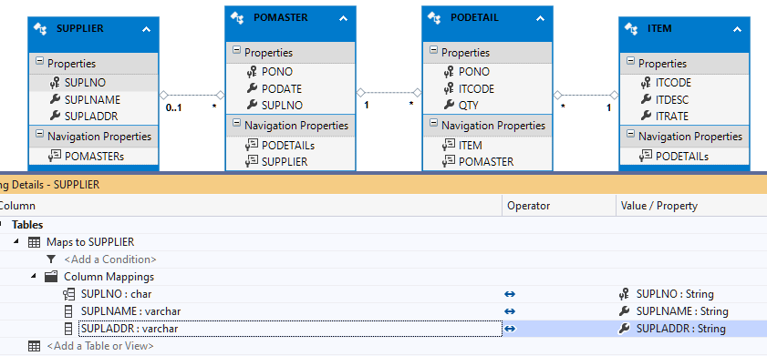

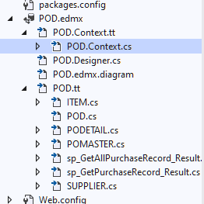

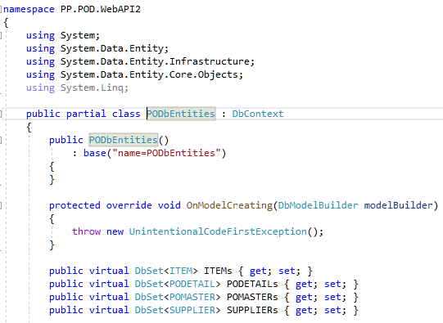

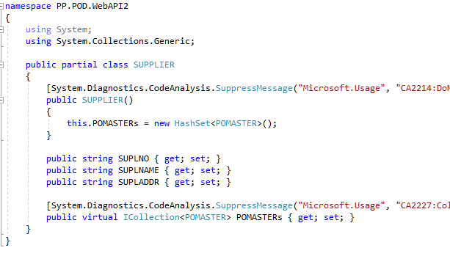

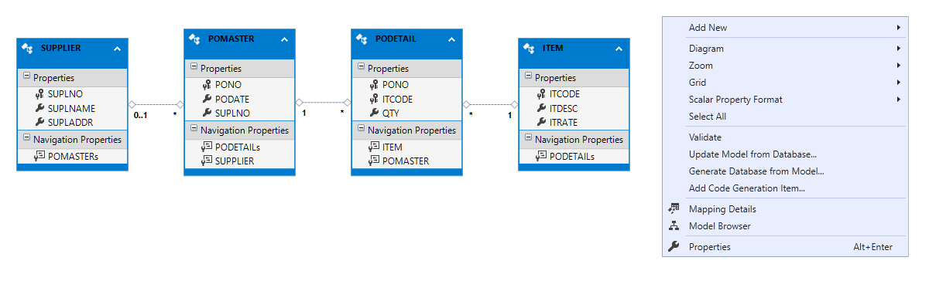

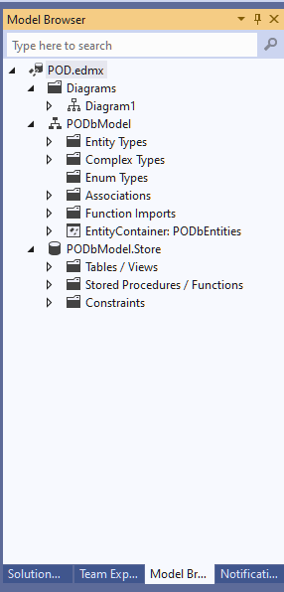

EF will be continued in next chapter

Back to CRUD ..

