Serialization and Deserialization:

The process of converting python object to file/network format is known as Serialization.

Converting the file/network format is Deserialization.

To convert into file object and vice versa, we use pickle Module.

Pickle module has 2 methods.

1)dump(obj,file) – To convert into file format and 2)load(file) – To convert file format to python object

Attaching the code for reference: (Employee.py is a python object,test.txt is an output file)



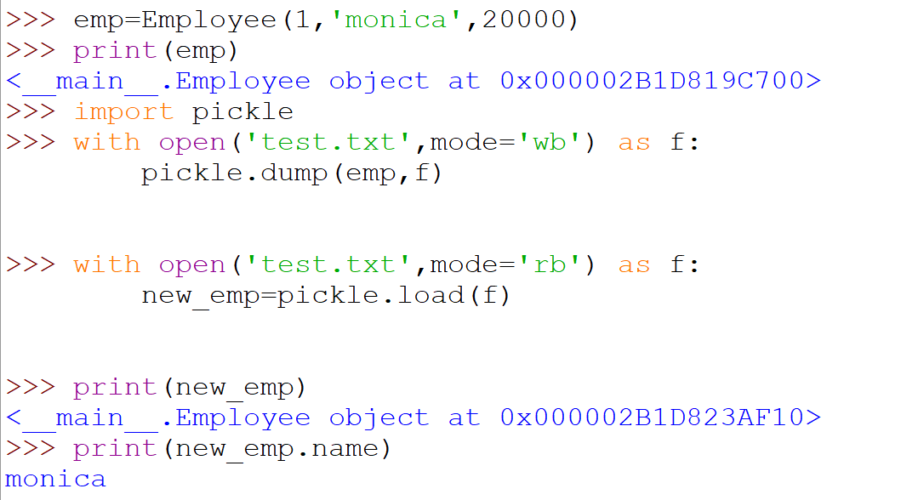

To convert into n/w object(json) and vice versa, we use json Module.

It has 4 methods.

1. dumps() -> To convert into jsonstring
2. loads() ->To convert into python dictionary object from json string
3. dump() -To convert into .json file
4. load() - To convert into python dictionary object from .json file

