Copyright © This course contains materials from "Survivability and Information Assurance" (copyright 2005 Carnegie Mellon University) with special permission of the Software Engineering Institute at Carnegie Mellon University.

Table of Contents
1. Principle 3: Not All Data Is of Equal Value to the Enterprise-Risk Must Be Managed
2. Reading Assignments
3. Principle 3: Not all data is of equal value to the enterprise - risk must be managed.
4. Learning Outcomes
5. Topics
6. Topics
7. The need for information security and management risk
8. Anticipate Failures and Intrusions
9. Risk
10. Information Security Risk
11. Risk Impact
12. Risk Management
13. Risk Management Options
14. Risk Mitigation by Transfer
15. Organizational Gap
16. Identifying and Managing Risk
17. Topics
18. Assets
19. IA Regulations and Standards
20. Threats, Vulnerabilities, and Controls
21. Process of Risk Management
22. Summary
23. Exam

1. Principle 3: Not All Data Is of Equal Value to the Enterprise-Risk Must Be Managed
This module introduces the topic of risk management within the context of information assets. Not all data is of equal value to an enterprise. A key concept is being able to evaluate the relative importance of specific data (information assets) to fulfilling the mission and to prioritize security resources in accordance with an asset's criticality. To make effective asset protection choices, one must understand information assets, threats against these assets, vulnerabilities that can be exploited, impacts of vulnerability exploitation, and loss outcomes. There are risk evaluation and management approaches that system administrators need to understand, participate in, use to obtain risk mitigation strategies, and use to determine work priorities.
The SIA course was developed using the OCTAVE® methodology of risk management but I have decided to use the NIST 800-37 Risk Management Framework. Much of the material will be kept in this lesson that was originally developed but will be supplemented with material from the NIST 800-37 rev 1 framework. You will notice that much of the information from OCTAVE® is similar to the NIST Risk Management Framework. Also, the NIST Risk Management Framework was designed for the federal government. I've used direct quotes from the NIST 800-37 rev 1 publication and modified the terminology to try to make it independent of the industry where you may work. This framework is based on input from the government, private industry, universities, and researchers and has undergone thorough review. In many organizations, knowing where to start managing risk or how to manage risk may not by known byt the system administrators or security administrators. There is no need to start creating your own risk management processes when there are ones like OCTAVE® and the NIST Risk Management Framework that already exist and is based on peer-review of its processes and procedures.
Terminology note: The NIST documents uses some terminology that are most commonly used within the federal government. Some terms were changed to appeal to a broader audience and to help students understand that "risk" affects any organization and that the publication doesn't apply to just the federal government. Below are two terms used throughout this document and its non-federal equivalent.
- Authorizing Official = Chief Executive Officer (CEO). This is the person that authorizes an information system to operate and the person that accepts any risk within the information system.
- Authorizing Official Designated Representative (AODR) = Chief Information Officer (CIO). Within an organization, the CIO or Directory of IT is the technical representative for the CIO. The CIO may have Director of IT and/or Director of IT Security or a security officer that reports to him/her that carries out the technical implementations of security controls (however, if there is a Director of IT under the CIO, he or she usually has security officer or system administrators that carry out the technical work while they perform the oversight). However, the ultimate responsibilty of the security of the system is the CEO because he or she will be the one that has to answer to lawyers, regulatory commissions, etc. when they there is a compromise.
The CIO should always keep the CEO abreast of all risks to the system by being able to clearly explain what exactly the risks are and what mitigating controls are in place to minimize the impact.
This module should take 8 hours.

2. Reading Assignments
Required readings:
- Guide for Applying the Risk Management Framework to Federal Information Systems - National Institute of Standards & technology 2010.
Recommended readings:
- None.
[1]

3. Principle 3: Not all data is of equal value to the enterprise - risk must be managed.

Not all data is of equal value to an enterprise. A key concept is being able to evaluate the relative importance of specific data (information assets) to fulfilling the mission and to prioritize security resources in accordance with an asset's criticality. To make effective asset protection choices, one must understand information assets, threats against these assets, vulnerabilities that can be exploited, impacts of vulnerability exploitation, and loss outcomes. There is risk evaluation and management approaches that system administrators need to understand, participate in, use to obtain risk mitigation strategies, and use to determine work priorities.

4. Learning Outcomes
Define the concepts of risk and risk management
Understand the importance of identifying and prioritizing assets
Describe an approach to risk evaluation and its results
Understand an administrator's role in risk management
At the conclusion of this module, you should be able to be conversant in key terms and topics related to risk management and understand the responsibility to identify and protect the most critical assets first. You will be able to use risk evaluation as a means for informing their work and making choices in the face of limited resources.

5. Topics
Define terminology and concepts
- Risk, risk impacts, and risk management
- Assets, requirements, threats, vulnerabilities, and controls
Risk evaluation
- Threat/asset specific
- NIST Risk Management Framework
Administrator responsibilities
The purpose of this lecture is to familiarize you with risk and asset management. One of the key concepts is the determination and valuation of assets. In most organizations, identifying and prioritizing assets based on their value, cost, or importance constitute this valuation and determination process. This lecture focuses on an organization's ability to select and prioritize assets based on the asset's importance or relevance in fulfilling the mission and objectives, as well as impacts to the organization if the asset is compromised.
This lecture explains risk, risk impact, assets, asset categories, risk evaluation, and the risk management process. It covers one recommended risk evaluation method, NIST Risk Management Framework, the potential impacts of risk events, and how to determine mitigation strategies for managing and reducing risk, as well as the administrator's role in these activities.

6. Topics
Define terminology and concepts
- Risk, risk impacts, and risk management
- Assets, requirements, threats, vulnerabilities, and controls
Risk evaluation
- Threat/asset specific
- Process of Risk Management
Administrator responsibilities
First we establish terminology, definitions, and concepts that are used throughout the lecture.

7. The need for information security and management risk
"Organizations depend on information technology and the information systems that are developed from that technology to successfully carry out their missions and business functions. Information systems can include as constituent components, a range of diverse computing platforms from high-end supercomputers to personal digital assistants and cellular telephones. Information systems can also include very specialized systems and devices (e.g., telecommunications systems, industrial/process control systems, testing and calibration devices, weapons systems, command and control systems, and environmental control systems). Federal information and information systems are subject to serious threats that can have adverse impacts on organizational operations (including mission, functions, image, and reputation), organizational assets, individuals, other organizations, and the Nation by compromising the confidentiality, integrity, or availability of information being processed, stored, or transmitted by those systems. Threats to information and information systems include environmental disruptions, human or machine errors, and purposeful attacks. Cyber attacks on information systems today are often aggressive, disciplined, well-organized, well-funded, and in a growing number of documented cases, very sophisticated. Successful attacks on public and private sector information systems can result in serious or grave damage to the national and economic security interests of the United States. Given the significant and growing danger of these threats, it is imperative that leaders at all levels of an organization understand their responsibilities for achieving adequate information security and for managing information system-related security risks" (National Institute of Standards and Technology [NIST], 2010).
"NIST in partnership with the Department of Defense (DoD), the Office of the Director of National Intelligence (ODNI), and the Committee on National Security Systems (CNSS), has developed a common information security framework for the federal government and its contractors" (NIST, 2010) Even though this publication was designed for the federal government as the primary audience, the principles and processes outlined in this publication can be applied to many sectors besides the goverment. "The intent of this common framework is to improve information security, strengthen risk management processes.... This publication, developed by the Joint Task Force Transformation Initiative Working Group, [have developed a] six-step Risk Management Framework (RMF). The revised process emphasizes: (i) building information security capabilities into...information systems through the application of state-of-the-practice management, operational, and technical security controls; (ii) maintaining awareness of the security state of information systems on an ongoing basis though enhanced monitoring processes; and (iii) providing essential information to senior leaders to facilitate decisions regarding the acceptance of risk to organizational operations and assets, individuals, other organizations, and the Nation arising from the operation and use of information systems" (NIST, 2010).
The RMF has the following characteristics:
- Promotes the concept of near real-time risk management and ongoing information system authorization through the implementation of robust continuous monitoring processes;
- Encourages the use of automation to provide senior leaders the necessary information to make cost-effective, risk-based decisions with regard to the organizational information systems supporting their core missions and business functions;
- Integrates information security into the enterprise architecture and system development life cycle;
- Provides emphasis on the selection, implementation, assessment, and monitoring of security controls, and the authorization of information systems;
- Links risk management processes at the information system level to risk management processes at the organization level through a risk executive (function); and
- Establishes responsibility and accountability for security controls deployed within organizational information systems and inherited by those systems (i.e., common controls).
The risk management process described in this publication...[defines] a more dynamic approach that provides the capability to more effectively manage information system-related security risks in highly diverse environments of complex and sophisticated cyber threats, ever-increasing system vulnerabilities, and rapidly changing missions" (NIST, 2010)

8. Anticipate Failures and Intrusions
You won't necessarily have warning

Failures and Intrusions
Many organizations have contingency plans for dealing with business interruptions caused by natural disasters or accidents. Although impacts resulting from the majority of cyberattacks are manageable, a cyberattack on an organization's critical networked information systems has the potential to cause severe and prolonged business disruption. This can occur whether the business has been targeted specifically or is a random victim of a broad-based attack. If a cyberattack disrupts critical business functions and interrupts the essential services that customers depend upon, then the survival of the business may be at risk. One example is the Web services offered by major banks. If a bank's home page is defaced as part of a cyberattack, it likely decreases the confidence that patrons have in the bank's ability to safeguard their money. These patrons may decide to move their money elsewhere. Therefore, relatively benign attacks (from an operational standpoint) can cause significant damage to the overall business survivability of an organization.
One significant difference between disruptions caused by natural disasters and those caused by cyberattacks is that with a natural disaster a customer expects diminished service. A business disruption caused by a cyberattack likely is seen by enterprise customers as a sign of incompetence. Unless the cyberattack is widespread and well publicized, little customer sympathy is forthcoming [Lipson 99].
It is essential that survivability be treated holistically when managing IT systems and information assets. Sustaining the mission of the organization is, after all, the primary motivation for investing in survivability components-not just protecting systems from intruders.

This lecture describes how asset prioritization, risk identification, and risk management can be employed to minimize business disruption in the face of failures and intrusions.

9. Risk
Risk is the possibility of suffering loss, destruction, modification, or denial of availability of an asset.

Risk is the possibility of suffering harm or loss. With respect to information, risk is the possibility of suffering a loss (or impact) due to disclosure, destruction, modification, or denial of access to the information. Risk comprises an event (a threat scenario), a consequence (impact on the organization), and uncertainty (whether the threat scenario will occur). These risk impacts can directly affect security requirements-confidentiality, integrity, and availability-of the information as well as enterprise survivability and security.
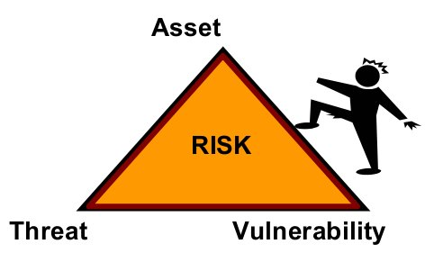
For a risk to exist, the following must be present:
Assets of value to an organization or individual that must be protected (critical assets)
Threats to these critical assets (possibility of disclosure, modification, destruction, or interruption)
Vulnerabilities that may provide an opportunity for threats to be realized in a manner that discloses, modifies, destroys, or interrupts access to an asset
Before risks can be managed, they must be identified. One way to examine for potential risk is to list the components of risk in an asset-driven scenario and gauge the risk's likelihood of occurrence.
Example of Risk
For example, let's consider a home user making a consumer purchase over the Internet. In this situation, the user must submit customer information to the web site (i.e., item, quantity, name of customer, address of customer, payment type, credit card number, etc.) to complete the purchase. Therefore from the user's point of view, risk certainly exists, even if the user is not explicitly aware of the risk or is seemingly unconcerned. The asset at risk is the customer's information, the threat is anyone on the Internet with malicious intent, and the vulnerability is any technology weakness that allows the information to be observed and captured.
How to Think About Risk Qualitatively
Risks can be measured both qualitatively and quantitatively. First, let's discuss the more straightforward and more commonly used qualitative approach. Qualitative measures of high, medium, and low provide the simplest means of assigning values to risk impacts. These measures provide enough of a benchmark to compare impacts across all critical assets. Qualifying risk means understanding the negative impact to the asset as well as the likelihood of the threat. This impact occurs when the asset is disclosed, modified, destroyed, or access to the asset is interrupted. To the home user in the scenario above, qualifying the risk means looking at the result and impact of having their personal information disclosed. Users are probably most concerned with their financial exposure and liability, identity loss, and laws and regulations to which they may be subjected. Users can rate these concerns as high, medium, or low.
Quantifying the risk means determining the likelihood that the risk will occur. Here the home user needs to consider the probability of someone performing several different attacks retrieve a user's personal information. This determination takes into account questions such as the following:
How likely is it that someone may observe the information in transit between the home user and the Web site (and possibly decode any encrypted network traffic)?
How likely is it that the software handling personal information is vulnerable to attack?
How likely is it that this user will be singled out over all of the other web commerce transactions happening at the seller's web site?
How likely is it that an attacker might gain access to the information once it has arrived at the seller's Web site?
These are a small sample of the potential risks in this simple transaction. For the home user to understand these risks, he or she must appreciate the potential impact. This rests on an understanding of potential threat sources (humans, system problems, viruses, etc.) that may exploit vulnerabilities manifest. This potential is a continuum ranging from negligible to actual, over the life of the information being transmitted, stored, and processed.

10. Information Security Risk
Information security risk is a type of organizational risk that needs to be managed.
Managing information security risks requires a partnership among
- all levels of staff
- business units and the IT department
- partners
- contractors
- service providers
- end users
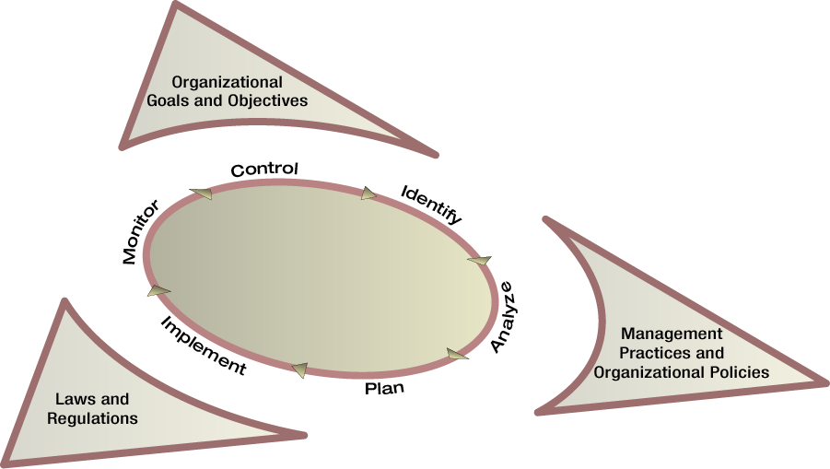
Managing risks is already a part of the corporate world. Managing information security risks is just an extension of that. What tends to be forgotten is that information security risks exist at all levels of the enterprise, and cannot be relegated to just the IT department. Improperly designed security controls can make employees' work so difficult that they begin bypassing security controls just to do their jobs.
Effectively managing information security risks requires cooperation and input from everyone. Do not forget all of your customers, partners, suppliers, end users, service providers, and anyone else who accesses, processes, or in any way interacts with your systems and critical information.
"Risk management can be viewed as a holistic activity that is fully integrated into every aspect of the organization. [The illustration below depicts] a three-tiered approach to risk management that addresses risk-related concerns at: (i) the organization level; (ii) the mission and business process level; and (iii) the information system level" (NIST, 2010)
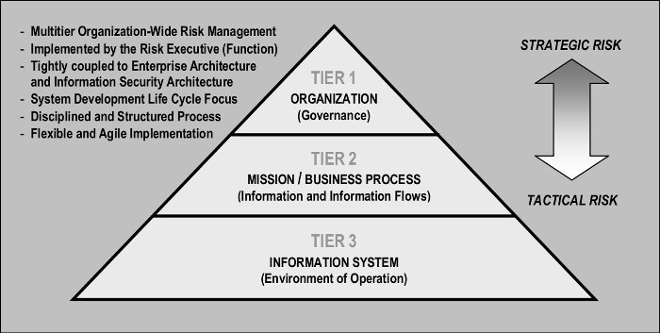
Figure 1. Image from NIST Publication 800-37 rev 1 page 5
"Tier 1 addresses risk from an organizational perspective with the development of a comprehensive governance structure and organization-wide risk management strategy that includes: (i) the techniques and methodologies the organization plans to employ to assess information system-related security risks and other types of risk of concern to the organization;16 (ii) the methods and procedures the organization plans to use to evaluate the significance of the risks identified during the risk assessment; (iii) the types and extent of risk mitigation measures the organization plans to employ to address identified risks; (iv) the level of risk the organization plans to accept (i.e., risk tolerance); (v) how the organization plans to monitor risk on an ongoing basis given the inevitable changes to organizational information systems and their environments of operation; and (vi) the degree and type of oversight the organization plans to use to ensure that the risk management strategy is being effectively carried out. As part of the overall governance structure established by the organization, the risk management strategy is propagated to organizational officials and contractors with programmatic, planning, developmental, acquisition, operational, and oversight responsibilities, including for example: (i) authorizing officials; (ii) chief information officers; (iii) senior information security officers; (iv) enterprise/information security architects; (v) information system owners/program managers; (vi) information owners/stewards; (vii) information system security officers; (viii) information system security engineers; (ix) information system developers and integrators; (x) system administrators; (xi) contracting officers; and (xii) users.
Tier 2 addresses risk from a mission and business process perspective and is guided by the risk decisions at Tier 1. Tier 2 activities are closely associated with enterprise architecture17 and include: (i) defining the core missions and business processes for the organization (including any derivative or related missions and business processes carried out by subordinate organizations); (ii) prioritizing missions and business processes with respect to the goals and objectives of the organization; (iii) defining the types of information that the organization needs to successfully execute the stated missions and business processes and the information flows both internal and external to the organization; (iv) developing an organization-wide information protection strategy and incorporating high-level information security requirements18 into the core missions and business processes; and (v) specifying the degree of autonomy for subordinate organizations (i.e., organizations within the parent organization) that the parent organization permits for assessing, evaluating, mitigating, accepting, and monitoring risk.
Because subordinate organizations responsible for carrying out derivative or related missions and business processes may have already invested in their own methods of assessing, evaluating, mitigating, accepting and monitoring risk, parent organizations may allow a greater degree of autonomy within parts of the organization or across the entire organization in order to minimize costs. When a diversity of risk assessment methods is allowed, organizations may choose to employ when feasible, some means of translation and/or synthesis of the risk-related information to ensure that the output of the different risk assessment activities can be correlated in a meaningful manner.
Tier 3 addresses risk from an information system perspective and is guided by the risk decisions at Tiers 1 and 2. Risk decisions at Tiers 1 and 2 impact the ultimate selection and deployment of needed safeguards and countermeasures (i.e., security controls) at the information system level. Information security requirements are satisfied by the selection of appropriate management, operational, and technical security controls.... The security controls are subsequently allocated to the various components of the information system...in accordance with the information security architecture developed by the organization. Security controls are typically traceable to the security requirements established by the organization to ensure that the requirements are fully addressed during design, development, and implementation of the information system. Security controls can be provided by the organization or by an external provider. Relationships with external providers are established in a variety of ways, for example, through joint ventures, business partnerships, outsourcing arrangements (i.e., through contracts, interagency agreements, lines of business arrangements), licensing agreements, and/or supply chain arrangements. Risk management tasks begin early in the system development life cycle and are important in shaping the security capabilities of the information system. If these tasks are not adequately performed during the initiation, development, and acquisition phases of the system development life cycle, the tasks will, by necessity, be undertaken later in the life cycle and be more costly to implement. In either situation, all tasks are completed prior to placing the information system into operation or continuing its operation to ensure that: (i) information system-related security risks are being adequately addressed on an ongoing basis; and (ii) the authorizing official explicitly understands and accepts the risk to organizational operations and assets, individuals, other organizations, and the Nation based on the implementation of a defined set of security controls and the current security state of the information system.
The Risk Management Framework (RMF), illustrated [below], provides a disciplined and structured process that integrates information security and risk management activities into the system development life cycle. The RMF operates primarily at Tier 3 in the risk management hierarchy but can also have interactions at Tiers 1 and 2 (e.g., providing feedback from ongoing authorization decisions to the risk executive [function], dissemination of updated threat and risk information to authorizing officials and information system owners). The RMF steps include:
- Categorize the information system and the information processed, stored, and transmitted by that system based on an impact analysis.
- Select an initial set of baseline security controls for the information system based on the security categorization; tailoring and supplementing the security control baseline as needed based on an organizational assessment of risk and local conditions.
- Implement the security controls and describe how the controls are employed within the information system and its environment of operation.
- Assess the security controls using appropriate assessment procedures to determine the extent to which the controls are implemented correctly, operating as intended, and producing the desired outcome with respect to meeting the security requirements for the system.
- Authorize information system operation based on a determination of the risk to organizational operations and assets, individuals, other organizations, and the Nation resulting from the operation of the information system and the decision that this risk is acceptable.
- Monitor the security controls in the information system on an ongoing basis including assessing control effectiveness, documenting changes to the system or its environment of operation, conducting security impact analyses of the associated changes, and reporting the security state of the system to designated organizational officials.
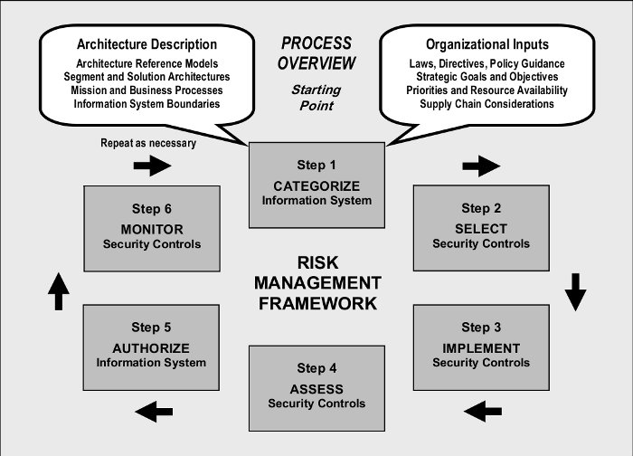
Image from NIST 800-53 rev1 page 19.
In summary, there is a significant degree of flexibility in how organizations employ the risk management processes described above. While it is convenient to portray the risk management approach in Figure 1 as hierarchical, the reality of project and organization dynamics can be much more complex. The organizational management style may be at one or more points on the continuum from top-down command to consensus among peers. For risk management to succeed at all levels of the organization, the organization must have a consistent and effective approach to risk management that is applied to all risk management processes and procedures. Organizational officials identify the resources necessary to complete the risk management tasks described in this publication and ensure that those resources are made available to appropriate personnel. Resource allocation includes both funding to carry out the risk management tasks and assigning qualified personnel needed to accomplish the tasks" (NIST, 2010).
System Development Life Cycle
"All...information systems, including operational systems, systems under development, and systems undergoing modification or upgrade, are in some phase of a system development life cycle. Requirements definition is a critical part of any system development process and begins very early in the life cycle, typically in the initiation phase. Security requirements are a subset of the overall functional and nonfunctional (e.g., quality, assurance) requirements levied on an information system and are incorporated into the system development life cycle simultaneously with the functional and nonfunctional requirements. Without the early integration of security requirements, significant expense may be incurred by the organization later in the life cycle to address security considerations that could have been included in the initial design. When security requirements are considered as an integral subset of other information system requirements, the resulting system has fewer weaknesses and deficiencies, and therefore, fewer vulnerabilities that can be exploited in the future.
Early integration of information security requirements into the system development life cycle is the most cost-effective and efficient method for an organization to ensure that its protection strategy is implemented. It also ensures that information security processes are not isolated from the other routine management processes employed by the organization to develop, implement, operate, and maintain information systems supporting ongoing missions and business functions. In addition to incorporating information security requirements into the system development life cycle, security requirements are also integrated into the program, planning, and budgeting activities within the organization to ensure that resources are available when needed and program/project milestones are completed. The enterprise architecture provides a central record of this integration within an organization.
Ensuring that information security requirements are integrated into the organization's system development life cycle processes regardless of the type of life cycle processes employed, helps facilitate development and implementation of more resilient information systems to reduce risk to organizational operations and assets, individuals, other organizations, and the Nation. This can be accomplished using the well-established concept of integrated project teams. [Iotegrated project teams are multidisciplinary entities consisting of a number of individuals with a range of skills and roles to help facilitate the development of information systems that meet the requirements of the organization.] A responsible organizational official (e.g., agency head, mission or business owner, integrated project team leader, program manager, information system owner, authorizing official) ensures that security professionals are an integral part of any information system development activities from the initial definition of information security requirements at Tier 1 and Tier 2 to the selection of security controls at Tier 3. Such consideration is used to foster close cooperation among personnel responsible for the design, development, implementation, operation, maintenance, and disposition of information systems and the information security professionals advising the senior leadership on appropriate security controls needed to adequately mitigate risk and protect critical missions and business functions.
Finally, organizations maximize the use of security-relevant information (e.g., assessment results, information system documentation, and other artifacts) generated during the system development life cycle to satisfy requirements for similar information needed for information security-related purposes. Similar security-relevant information concerning common controls, including security controls provided by external providers, is factored into the organization's risk management process. The judicious reuse of security-relevant information by organizations is an effective method to help eliminate duplication of effort, reduce documentation, promote reciprocity, and avoid unnecessary costs that may result when security activities are conducted independently of system development life cycle processes. In addition, reuse promotes greater consistency of information used in the design, development, implementation, operation, maintenance, and disposition of an information system including security-related considerations" (NIST, 2010).
Information System Boundaries
"One of the most challenging problems for information system owners, authorizing officials, chief information officers, senior information security officers, and information security architects is identifying appropriate boundaries for organizational information systems. Well-defined boundaries establish the scope of protection for organizational information systems (i.e., what the organization agrees to protect under its direct management control or within the scope of its responsibilities) and include the people, processes, and information technologies that are part of the systems supporting the organization's missions and business processes. Information system boundaries are established in coordination with the security categorization process and before the development of security plans. Information system boundaries that are too expansive (i.e., too many system components and/or unnecessary architectural complexity) make the risk management process extremely unwieldy and complex. Boundaries that are too limited increase the number of information systems that must be separately managed and as a consequence, unnecessarily inflate the total information security costs for the organization. The following sections provide general guidelines to assist organizations in establishing appropriate system boundaries to achieve cost-effective solutions for managing information security-related risks from the operation and use of information systems" (NIST, 2010)
Establishing Information System Boundaries
"The set of information resources allocated to an information system defines the boundary for that system. Organizations have significant flexibility in determining what constitutes an information system and its associated boundary. If a set of information resources is identified as an information system, the resources are generally under the same direct management control. Direct management control does not necessarily imply that there is no intervening management. It is also possible for multiple information systems to be considered as independent subsystems of a more complex information system. This situation may arise in many organizations when smaller information systems are coalesced for purposes of risk management into a larger, more comprehensive system. On a larger scale, an organization may develop a system of systems involving multiple independent information systems (possibly distributed across a widespread geographic area) supporting a set of common missions and/or business functions. In addition to consideration of direct management control, it may also be helpful for organizations to determine if the information resources being identified as an information system:
- Support the same mission/business objectives or functions and essentially the same operating characteristics and information security requirements; and
- Reside in the same general operating environment (or in the case of a distributed information system, reside in various locations with similar operating environments).
Since commonality can change over time, this determination is revisited periodically as part of a continuous monitoring process carried out by the organization. While the above considerations may be useful to organizations in determining information system boundaries for purposes of risk management, they are not viewed as limiting the organization's flexibility in establishing commonsense boundaries that promote effective information security within the available resources of the organization. Information system owners consult with authorizing officials, chief information officers, senior information security officers, information security architects, and the risk executive (function) when establishing or changing system boundaries. The process of establishing information system boundaries and the associated risk management implications is an organization-wide activity that includes careful negotiation among all key participants-taking into account mission and business requirements, technical considerations with respect to information security, and programmatic costs to the organization. Software applications (e.g., database applications, Web applications) hosted by an information system are included in the risk management process since application security is critical to the overall security of the system. Software applications depend on the resources provided by the hosting information system and as such, can take advantage of (i.e., leverage) the security controls provided by the system to help provide a foundational level of protection for the hosted applications, when this type of inheritance is applicable. Additional application-level security controls are provided by the respective software applications, as needed. Organizations ensure that all security controls, including application-level controls employed in separate software applications, are managed and tracked on an ongoing basis. Application owners coordinate with information system owners to ensure that information security and risk management activities are carried out as seamlessly as possible among applications and hosting systems. This coordination includes, for example, consideration for: (i) the selection, implementation, assessment, and monitoring of security controls for hosted applications; (ii) the effects of changes to hosted applications on the overall security state of the information system and the missions and business processes supported by that system; and (iii) the effects of changes to the information system on hosted applications. Employing strong configuration management and control processes within software applications and the hosting information system, and reusing security control assessment results helps to provide the necessary protection for applications.
Security controls provided by the hosted software application are documented in the security plan for the hosting information system and assessed for effectiveness during the risk management process (i.e., during the initial authorization of the information system and subsequently, during the continuous monitoring process). Application-level security controls are also assessed for effectiveness if the applications are added after the hosting information system is authorized to operate. Information system owners take appropriate measures to ensure that hosted applications do not affect the security state of the hosting system and obtain the necessary information from application owners to conduct security impact analyses, when needed" (NIST, 2010)
Changing Technologies and the Effect on Information System Boundaries
"Changes to current information technologies and computing paradigms add complications to the traditional tasks of establishing information system boundaries and protecting the missions and business processes supported by organizational information systems. In particular, net-centric architectures (e.g., service-oriented architectures [SOAs], cloud computing) introduce two important concepts: (i) dynamic subsystems; and (ii) external subsystems. While the concepts of dynamic subsystems and external subsystems (described in the following sections) are not new, the pervasiveness and frequency of their invocation in net-centric architectures can present organizations with significant new challenges.
Dynamic Subsystems
For many information systems, the determination of subsystems is established at system initiation and maintained throughout the life cycle of the system. However, there are some instances, most notably in net-centric architectures, where the subsystems that compose the system may not be present at all stages of the life cycle. Some subsystems may not become part of an information system until sometime after system initiation, while other subsystems may leave the system sometime prior to system termination. Generally, this will not impact the external boundary of the information system if the dynamic subsystems are in the system design and the appropriate security controls are reflected in the security plan. But it does impact the subsystems that exist within the boundary at any given point in time.
Dynamic subsystems that become part of an organizational information system at various points in time may or may not be under the direct control of the organization. These subsystems may be provided by external providers (e.g., through contracts, interagency agreements, lines of business arrangements, licensing agreements, and/or supply chain arrangements). Regardless of whether the subsystem is or is not controlled by the organization, the expectations of its capabilities have to be considered. The dynamic inclusion or exclusion of the subsystems may or may not require reassessment of the information system as a whole. This is determined based on constraints and assumptions (e.g., functions the subsystems perform, connections to other subsystems and other information systems) imposed upon the subsystems at system design and incorporated in the security plan. So long as the subsystems conform to the identified constraints and assumptions, they can be dynamically added or removed from the information system without requiring reassessments of the entire system.
As noted above, the assumptions and constraints on the dynamic subsystems are reflected in the information system design and the security plan. The determination as to whether the subsystems conform to the assumptions and constraints is addressed during the continuous monitoring phase of the risk management process. Depending upon the nature of the subsystems (including the functions, connections, and relative trust relationships established with the subsystem providers), the determination of conformance may be performed in a manual or automated manner, and may occur prior to, or during the subsystem connecting/disconnecting to the information system" (NIST, 2010).
External Subsystems
"Another characteristic often apparent in net-centric architectures is that some of the subsystems (or components of subsystems) are outside of the direct control of the organization that owns the information system and authorizes its operation. The nature of such external subsystems can vary from organizations employing external cloud computing services to process, store, and transmit information to organizations allowing platforms under their control to host applications/services developed by some external entity" (NIST, 2010).
"An organization should require that an external provider demonstrate proof of strong information security practices that will handle any data that the organizations owns. In the event of a compromise or data breach that affects that organizations data, the authorizing official is held responsible for the data. This should apply to any "external subsystems storing, processing, or transmitting [the organization's] information and any services provided by or associated with the subsystem. [T]he assurance or confidence that the risk from using external services is at an acceptable level depends on the trust that the organization places in the external service provider. In some cases, the level of trust is based on the amount of direct control the organization is able to exert on the external service provider with regard to employment of security controls necessary for the protection of the service and the evidence brought forth as to the effectiveness of those controls. In other instances, trust may be based on other factors, such as the experience the organization has with the external service provider, and the confidence (trust) the organization has in the provider taking the correct actions. There are a variety of factors that can complicate the level of trust issue in the case of net-centric architectures to include:
- The delineation between what is owned by the external entity and the organization may be somewhat blurred (e.g., organization-owned platform executing external entity- developed service/application software or firmware);
- The degree of control the organization has over the external entity providing/supporting the subsystems/services may be very limited;
- The nature and content of the subsystems may be subject to rapid change; and
- The subsystems/services may be of such critical nature that they need to be incorporated into organizational information systems very rapidly.
The consequence of the factors above is that some of the more traditional means of verifying the correct functioning of a subsystem and the effectiveness of security controls (e.g., clearly defined requirements, design analysis, testing and evaluation before deployment) may not be feasible for a net-centric subsystem/service. As a result, organizations may be left to depend upon the nature of the trust relationships with the suppliers of the net-centric subsystems/services as the basis for determining whether or not to allow/include the subsystems/services (e.g., use of GSA list of approved providers). Alternatively, organizations may allow such subsystems/services to be used only in those instances where they have constrained the nature of information or process flow such that the organization believes that any potential adverse impact is manageable. Ultimately, when the level of trust in the external provider of subsystems/services is below expectations, the organization: (i) employs compensating controls; (ii) accepts a greater degree of risk; or (iii) does not obtain the service (i.e., performs its core missions and business operations with reduced levels of functionality or possibly no functionality at all)" (NIST, 2010).

11. Risk Impact
Realized security risks may result in the following:
- Loss of reputation and competitive position  - Loss of customers  - Increase in operating costs and staff hours  - Loss of revenue  - Loss of life or property  - Loss due to monetary fine,aw suit, or regulatory penalty  - Loss or compromise of critical information and key technologies  - Loss of trust in the organization'systems and networks | 
Understanding a risk's impact forms the basis for evaluating outcomes of risk: loss, destruction, modification, and interruption. Impact is the realization of a risk. To evaluate the outcome of a risk, we start by developing evaluation criteria for risk scenarios.
Let's consider a home user who sets up a personal web server to display his or her resume. To manage risk, our home user identifies his or her assets, considers the possible negative outcomes, and characterizes the impact of an asset being compromised. Here, our home user recognizes that one asset is the web server while another is the resume file. Selecting the resume, the possible negative outcomes to this information asset include the following:
- Destruction of the resume file
- Modification of the resume content
- Pirating the resume data
- Interruption of its presentation to the Internet
- Our home user should be able to define potential failure conditions, such as the following:
- Destruction, causing an expenditure of effort to recover or recreate the information
- Modification, causing a prospective employer to consider the candidate either adequate or inadequate for the position, depending on what information was changed
- Theft, causing a loss of creative and competitive marketing of the individual's skills or background
- Interruption, denying potential employers access to the candidate's information
Finally, the home user must evaluate the impacts, deciding whether he or she really cares about the potential impacts to the assets involved. If yes, then mitigation strategies should be implemented; if no, then the potential risk impacts are accepted in addition to the consequences of loss or harm should the risk be realized.
From the perspective of the insurance industry (as reported by The Fidelity and Deposit Companies), risk is categorized as shown below. This is meaningful given that the insurance industry sells "risk transfer" services:
- electronic publishing liability
- property damage
- business interruption
- damage to reputation
- restoration costs
- intellectual property loss
- business income loss
- extortion

12. Risk Management
Risk management is a process used to identify, analyze, and mitigate the risk (comprised of assets, threats, vulnerabilities, and controls); and provide strategies for sustaining the security requirements of an information asset.
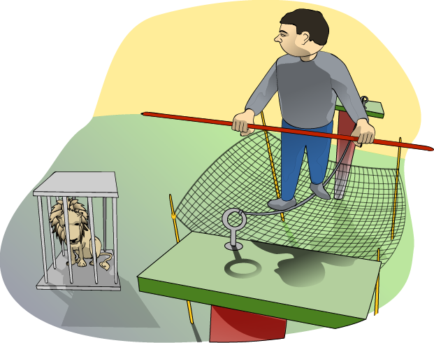
Risk management should be a well-defined and established process. Effective risk management can save resources, reduce mishaps, and even save lives.

13. Risk Management Options
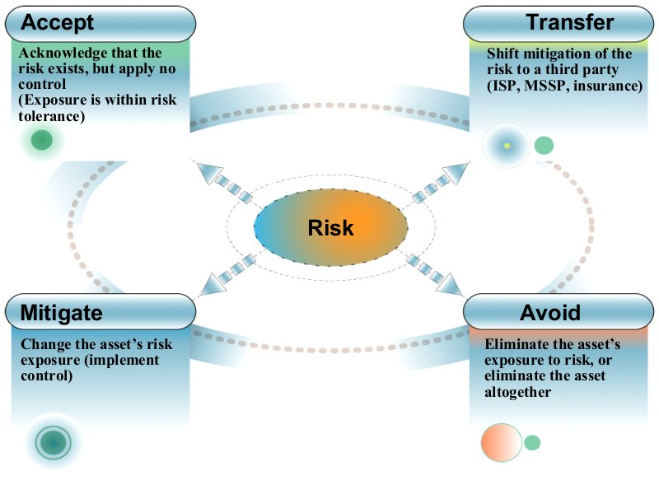
Organizations have four options when deciding how to manage risks:
Accept
If an organization chooses to accept risk, it does so with full knowledge of the potential threats and vulnerabilities to the asset. It may be that the asset's exposure is acceptable or within some level tolerance. For example, an organization recognizes the threat that usernames and passwords could be compromised by administering systems remotely with Telnet, a text-in-the-clear protocol. However, the organization decides that the risk is not great enough to warrant a control (such as encrypted sessions with SSH or IPsec).
Mitigate
Mitigating risk is actively applying controls to reduce the asset's level of exposure. In the above Telnet example, the organization could mitigate the risk by (a) denying all administrative traffic to the remote systems that is not encrypted and authenticated, and (b) writing an organizational policy that acts as a deterrent (such as any attempt to compromise access controls on enterprise systems will be met with severe disciplinary action).
Transfer
Transferring risk occurs when an organization decides to contract with a third party to mitigate the risk. However, keep in mind that the organization continues to own the risk. For example, an organization can transfer the risk of losing data (and support the goal of mission survivability) by contracting with a service provider who maintains an offsite data backup and recovery capability. Although risk transference does not change probability or severity of a threat, it may decrease the probability or severity of the organization's risk exposure. At a minimum, the organization's risk exposure is greatly decreased or eliminated because the possible losses or costs are shifted to another entity.
Avoid
Avoiding risk means that the organization eliminates the asset's exposure or even the asset itself. An example might be the replacement of historically vulnerable platforms (like Internet Information Server) with hardened platforms like Bastille/Apache Web server.

14. Risk Mitigation by Transfer

Outsourcing risk mitigation
Trust dilemma
Residual risk
Risk Transfer
Because you cannot identify, let alone mitigate, all risks, at some point you have to trust someone or something to take the appropriate action or to function as designed. For example, you may have to trust people, systems, or programs to handle and operate on information in a manner that meets its security requirements.
If an organization has transferred risk mitigation to another party such as a managed security service provider (MSSP), the risk has not been completely removed. The client organization must trust in the effectiveness of the MSSP. As a result, there is still a residual risk that the MSSP may not be able to meet the expectations of the client all of the time. The responsibility (and consequences) of transferred risks are still retained by the organization.
Historically, programming and computer science have been taught in an environment that assumes that trust exists. As a result, most systems and software currently deployed are not designed to sufficiently guard against breaches of trust that threaten information survivability.
Do not place blind trust in the individuals and technology that protects information assets. Implement monitoring controls for the risk you have accepted as well as the risk that you currently mitigate. In fact, monitoring accepted or transferred risks works in the same fashion as monitoring known, mitigated risks. For monitoring to be effective, risks that are managed or accepted must again be documented and understood by the organization and its employees.

15. Organizational Gap
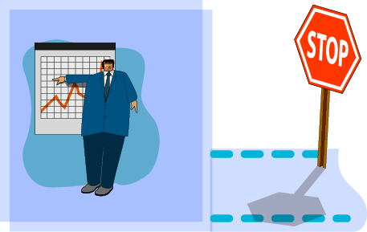 | 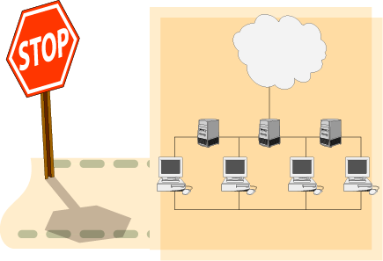
Enterprise Management  - Business  - Planning  - Budget | Network  - Hack Points  - Communication  - Systems Administration  - Network Support
There is a gap in understanding and communication between enterprise management and IT management regarding security.
Risk evaluation and management help in achieving some degree of institutional learning, such that an organization is able to continue to improve its security posture following a risk evaluation.
Risk evaluation helps managers to select security solutions within the context of their own business goals and resource and funding constraints.

16. Identifying and Managing Risk
Requires:
- Identifying and prioritizing assets
- Relating threats and vulnerabilities
- Performing risk evaluation
- Recognizing risk must be managed
Risk can be mitigated, but cannot be eliminated.
Identifying assets involves a discussion within the organization to determine what categories of assets exist, who owns each asset, and what level of protection is necessary for each asset. This exchange of information should happen between the managers, staff, and IT personnel on a periodic basis and as part of the organization's review of its information security policy. These events enable the organization to identify its current protection strategy for each asset and any changes to the asset's priority as seen by different levels of the organization. Assets may be mission critical, non-critical but sensitive, or general in nature. This discussion aids in prioritizing assets and it should be documented and reflected in organizational policy, procedures, standards, and guidelines (see Principle 4: Information assurance policy governs actions).
Identifying asset threats and vulnerabilities is part of a risk evaluation activity and requires that those who are responsible for protecting the information assets have an appreciation of the range of threats and vulnerabilities. Once the range is understood, the likelihood of any one threat acting adversely on an asset must be identified.
The results of a risk evaluation include protection strategies (plans, policies, technological mechanisms) that will help to mitigate identified risks. For example, an identified risk for a medical organization may be that "modification of paper medical records by unauthorized individuals can lead to loss of life, financial or punitive penalties, or loss of customer confidence." This risk is stated as a risk scenario that identifies the critical assets (paper medical records), threats to the asset (personnel exceeding their privileges or unauthorized outsiders), outcome (modification of the records), and impact (public safety, financial, customer confidence, legal). Risk evaluation determines which risks need to be considered and a qualitative measure of their impact (high, medium, low).

17. Topics
Define terminology and concepts
- Risk, risk impacts, and risk management
- Assets, requirements, threats, vulnerabilities, and controls
Risk evaluation
- Threat/asset specific
- NIST Risk Management Framework

18. Assets
Asset: something of value to the enterprise  - Categories  - Information Assets  - Technology Assets  - Critical Assets  - Other Supporting Assets | 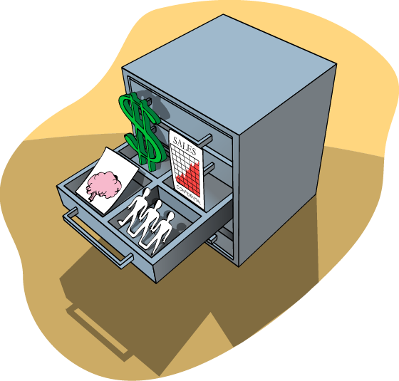
An asset is anything of value to an organization. Assets can be categorized as information assets (for example, business and customer data), technology assets (hardware, software), and supporting assets (facilities, utilities, services). Assets in any of these categories may be identified as critical, that is, most important.
Your organization may choose to categorize assets according to sensitivity or function. Asset definitions can be highly subjective and asset value even more so. Therefore, another way to approach assets and asset value is to consider the worth of the asset in both quantitative and qualitative terms. By examining an asset's value (qualities of the asset's presence and absence), you may discover a more meaningful categorization approach.
Information Assets
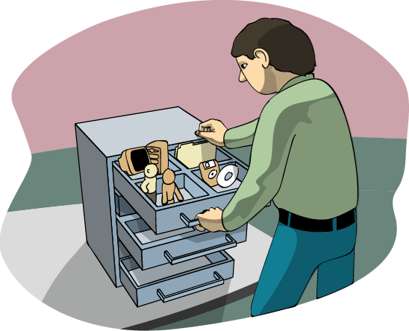
Information and data repositories
- Business strategies
- Product information
- Customer data
- Business partner data
Processes
Key staff knowledge
Information assets include the following:  - Business short term and long term competitive strategies  - Sensitive product development and release information  - Customer contract and purchasing histories  - Data being processed on, stored on, or transmitted between systems  - Backup and archive data (on-site and off-site storage volumes and locations)  - Paper documents  - Escrowed encryption keys  - Software distribution media  Processes that are assets include the following:  - Strategic and operational planning  - Market analysis | - Product selection and development  - Personnel processes (hiring, termination, compensation)  - IT processes (configuration management, change control, release management)  Key staff members whose knowledge can be described as an asset include the following:  - Senior and middle management  - Technical and non-technical staff  - Public relations  - Help desk, facilities, security, CSIRTs  - Contractors, vendors, suppliers, partners  - Government, police, fire fighters
Technology Assets (aka Containers
Hardware
- Desktops
- Laptops
- Mobile devices
- Servers
- Routers
Software
- Operating systems
- Other system software
- System configurations
- Services
- Applications and tools (COTS, custom)

Technology Assets (aka Containers)  Hardware assets include the following:  - Desktop and laptop computers  - Mobile devices (PDAs, cell phones)  - Servers  - Mainframes  - Network equipment (routers, switches, firewalls)  - Wiring infrastructure  - Wireless support infrastructure | Software assets include the following:  - Commercial off-the-shelf (COTS) software  - Operating systems  - Desktop software  - Mainframe applications  - Custom software  - In-house development  - Outsourced development  - Ad hoc scripts  - Undocumented tools used by employees
Supporting Assets
Facilities  Utilities  Outsourced Services | 

Facilities include the following:  - Physical space  - Heating/ventilation/air conditioning (HVAC) support  - Power  - Water  - Telephone  - Security  Utilities include the following:  - Power  - Water  - Telephone  - Leased lines (T1, T3, ISDN)  - Voice lines  - Cell phones | - Pager services  - Service level agreements  - Hardware maintenance  - HVAC support  - Outsourced services include the following:  - Off-site IT services  - Information storage  - Web services  - Consultants  - Utilities  - Legal services  - Public relations  - Managed or monitored security  - Physical  - Network
Critical Assets
A large, adverse impact occurs if the asset is  - Disclosed to unauthorized people  - Modified without authorization  - Lost  - Destroyed  - Inaccessible  Require the greatest level of protection and investment  Critical assets are assets that have an integral relationship with the mission of the organization. This means that loss or damage to a critical asset would cause disruption to the operational or functional mission of the organization to a point where the mission could fail. Each organization defines a unique set of critical assets that align with mission success or failure. | 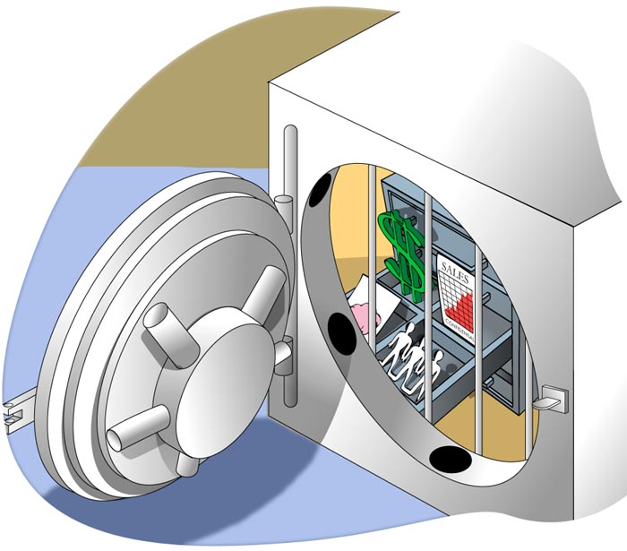

Examples of critical assets include the following:  - Intellectual property  - Patents, copyrights  - Software under development  - Systems acquisition or development projects  - Corporate financial data  - Payroll information by employee, department, organization  - Financial earnings, revenue, and loss statements  - Stock dividend information  - Customer sales information  - -Names, addresses, credit card/account numbers, purchase histories, demographic information  - Human resource information  -Names of employees, departments, salaries | - Hiring, administrative punishment, and disability information  - Network architecture information  - Network topology diagrams  - Desktop or systems replacement plans  - Strategic infrastructure plans  - Vulnerability assessment reports  - Types and locations of infrastructure (general purpose, storage, server, networking, and security devices)  U.S. Government or military classified information  - Compartmentalized information  - Deployment and strategic plans  - Intelligence information, logistic movements/support  - Technical specifications on equipment, weapons, projects
Security Requirements
Each asset has requirements for confidentiality, integrity, and availability that should be  - Communicated  - Detailed  - Documented | 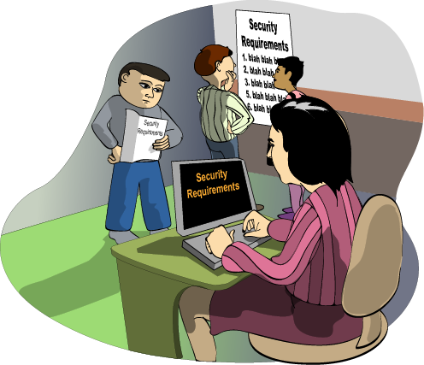
Each asset has requirements for confidentiality, integrity, and availability that should be
- Communicated throughout the organization, especially from the owner of the asset to the person(s) responsible for its safety and security
- Detailed, explaining under what conditions and to what degree the requirements must be enforced
- Documented, describing the requirements, the responsible owner(s), and party charged with its protection
Security requirements should be understood at all levels of the organization and by all roles involved in the asset's protection. They should be described with enough detail for a specific requirement to be allocated to the responsible owner (manager, user, system/security administrator, etc.) or the technology protecting the asset. They should be documented in security policies, plans, and procedures. Refer to Principle 10: Communication skill is critical to reach all constituencies.
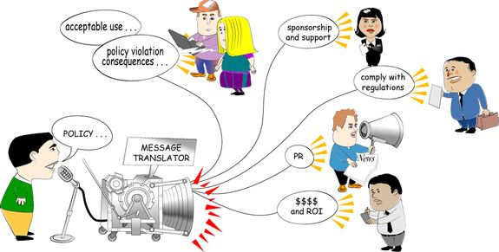

19. IA Regulations and Standards

Additional Sources of Security Requirements
- National legislation
- Insurance industry requirements
- Customer demand
- E-torts and e-pacts
The following are examples of legislation that influence security requirements:
The Information Technology Management Reform Act (ITMRA) of 1996 is also known as the Clinger Cohen Act and primarily affects federal government agencies.
The Health Insurance Portability and Accountability Act (HIPAA) of 1997 addresses the handling of patient information. Many academic institutions have associated medical facilities and student health centers so are subject to HIPAA.
The Child Online Privacy Protection Act (COPPA) of 1998 requires certain commercial Web sites to obtain parental consent before collecting, using, or disclosing personal information from children under 13.
The Gramm-Leach-Bliley Act of 1999 applies to financial institutions and protects customer data and privacy.
The Sarbanes-Oxley Act of 2002 was created in response to accounting improprieties such as Enron's. CEOs and CFOs are required to inform their directors of significant internal control deficiencies that could adversely affect their ability to report financial data. "Major accounting firms now recommend that clients disclose their security plans in much the same way they disclose financial performance" [Leibs 03]
Payment Card Industry requirements of 2006 requires that all merchants that accept VISA, Mastercard, American Express, Discover and JCB International credit cards meet specificy security requirements.
E-torts: non-contractual and non-statutory claims for injuries arising from any one or more e-risks E-pacts: contractual terms used to define contractual rights to property and limited rights or remedies
Having to meet emerging IA regulations and standards will affect your organization and its ability to conduct ongoing business operations if it isn't already. Your security standard of due care/due diligence will affect your insurance rates.

20. Threats, Vulnerabilities, and Controls
Controls
A control is a safeguard or countermeasure employed to reduce the risk associated with a specific threat or group of threats as in the following examples:
Access Control technologies  Firewalls  Access Control Lists on files and directories  Physical security systems like locks and card scanners  Encryption technologies | Redundancy in Systems  Clustered servers  Redundant sources of power and HVAC  Cross-utilization and training of IT personnel
Threats
A threat is any event that will cause an undesirable impact or loss to an organization if it occurs. Examples of threats include the following:
Intrusions and disruptions to information systems  Viruses, Worms, and Trojan Horses  Denials of Service  Sniffing network traffic  Stealing data assets | Loss of assets that are single points of failure  Critical data that is not backed up  Single, critical piece of network infrastructure (i.e. a core router)  Keys that are used to encrypt critical data
Vulnerabilities
A vulnerability is the absence or weakness of a safeguard. It can also be described as a weakness in an asset or the methods of ensuring that the asset is survivable. Examples of vulnerabilities include the following:
Software and hardware flaws  Buffer overflows  Weak default configurations  Under-engineered hardware (i.e., not enough memory, disk space, etc.) | Lack of policies and procedures  Undefined access controls  Lack of documentation  Users unaware of survivability issues
For system and network administrators, the most readily identifiable sources of risk are threat and vulnerability. The loss or impact of an event (caused by inappropriate, accidental, negligent, or intentional acts) result from threats exploiting vulnerabilities, creating and outcome of disclosure, modification, destruction, or interruption of access to an asset.

21. Process of Risk Management
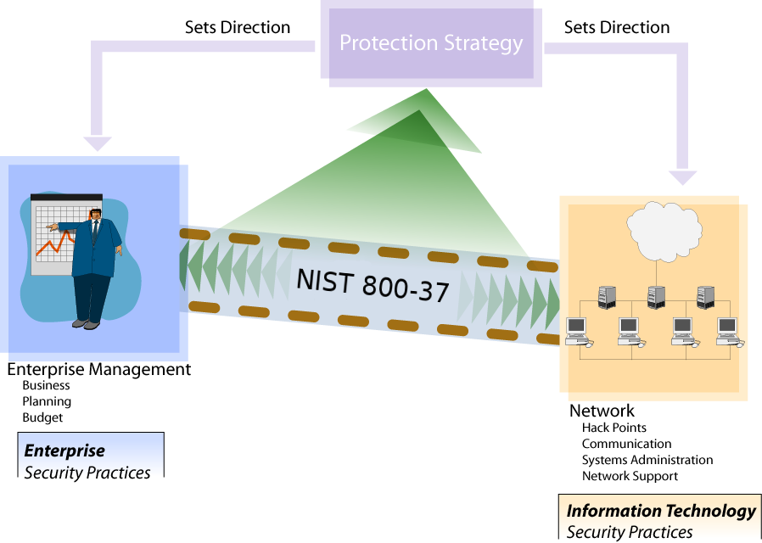
"The process includes a set of well-defined risk-related tasks that are to be carried out by selected individuals or groups within well-defined organizational roles (e.g., risk executive [function], authorizing official, authorizing official designated representative, chief information officer, senior information security officer, enterprise architect, information security architect, information owner/steward, information system owner, common control provider, information system security officer, and security control assessor). Many risk management roles defined in this publication have counterpart roles defined in the routine system development life cycle processes carried out by organizations. Whenever possible and consistent with core missions/business processes, organizations align risk management roles with similar (or complementary) roles defined for the system development life cycle. RMF tasks are executed concurrently with or as part of system development life cycle processes, taking into account appropriate dependencies. This helps to ensure that organizations are effectively integrating the process of managing information system-related security risks with system development life cycle processes.
Each RMF task description includes the individual or group with the primary responsibility for carrying out the task, the supporting roles that may be called upon to assist in completing the task, the system development life cycle phase most closely associated with the task, supplemental guidance to help explain how the task is executed, and appropriate references for publications or Web sites with information related to the task.46 To summarize the key risk management-related activities to be carried out by the organization, a milestone checkpoint is provided for each step in the RMF. The milestone checkpoints contain a series of questions for the organization to help ensure that important activities described in a particular step in the RMF have been completed prior to proceeding to the next step.
The process of implementing the RMF tasks (i.e., the order and manner in which the tasks occur and are executed, the names of primary/supporting roles, the names and format of artifacts) may vary from organization to organization. The RMF tasks can be applied at appropriate phases in the system development life cycle. While the tasks appear in sequential order, there can be many points in the risk management process that require divergence from the sequential order including the need for iterative cycles between tasks and revisiting tasks. For example, the results from security control assessments can trigger remediation actions on the part of an information system owner, which can in turn require the reassessment of selected controls. Monitoring the security controls in an information system can also generate a potential cycle of tracking changes to the system and its environment of operation, conducting security impact analyses, taking remediation actions, reassessing security controls, and reporting the security status of the system. There may also be other opportunities to diverge from the sequential nature of the tasks when it is more efficient or cost-effective to do so. For example, while the security control assessment tasks are listed after the security control implementation tasks, some organizations may choose to begin the assessment of certain controls as soon as they are implemented but prior to the complete implementation of all controls described in the security plan. This may result in the organization assessing the physical and environmental protection controls within a facility prior to assessing the security controls employed in the hardware and software components of the information system (which may be implemented at a later time). Regardless of the task ordering, the last step before an information system is placed into operation is the explicit acceptance of risk by the authorizing official.
RMF steps and associated tasks can be applied to both new development and legacy information systems. For legacy systems, organizations can use RMF Steps 1 through 3 to confirm that the security categorization has been completed and is appropriate and that the requisite security controls have been selected and allocated. Applying the first three steps in the RMF to legacy systems can be viewed as a gap analysis to determine if the necessary and sufficient security controls (i.e., system-specific, hybrid, and common controls) have been appropriately selected and allocated. Security control weaknesses and deficiencies, if discovered, can be subsequently addressed in RMF Steps 3 through 6 similar to new development systems. If no weaknesses or deficiencies are discovered in the security controls during the gap analysis and there is a current security authorization in effect, the organization can move directly to the last step in the RMF, continuous monitoring. If a current security authorization is not in place, the organization continues with RMF Steps 4 through 6.
The security categorization process influences the level of effort expended when implementing the RMF tasks. Information systems supporting the most critical and/or sensitive operations and assets within the organization as indicated by the security categorization, demand the greatest level of attention and effort to ensure that appropriate information security and risk mitigation are achieved. Most RMF tasks can be carried out by external providers with appropriate contractual agreements or other arrangements in place (see Appendix I of the NIST 800-37 Rev 1).
NOTE: Since the tasks in the RMF are described in a sequential manner, organizations may choose to deviate from that sequential structure in order to be consistent with their established management and system development life cycle processes or to achieve more cost-effective and efficient solutions with regard to the execution of the tasks. Regardless of the task ordering, the last step before an information system is placed into operation is the explicit acceptance of risk by the authorizing official. Organizations may also execute certain RMF tasks in an iterative manner or in different phases of the system development life cycle. For example, security control assessments may be carried out during system development, system implementation, and system operation/maintenance (as part of continuous monitoring).
Organizations may also choose to expend a greater level of effort on certain RMF tasks and commit fewer resources to other tasks based on the level of maturity of selected processes and activities within the organization. Since the RMF is life cycle-based, there will be a need to revisit various tasks over time depending on how the organization manages changes to the information systems and the environments in which those systems operate. Managing information security-related risks for an information system is viewed as part of a larger organization-wide risk management activity carried out by senior leaders. The RMF must simultaneously provide a disciplined and structured approach to mitigating risks from the operation and use of organizational information systems and the flexibility and agility to support the core missions and business operations of the organization in highly dynamic environments of operation" (NIST, 2010).
In the discussion below, you will see references to NIST 800-53 (currently rev 3). The document outlines security controls that are the minimum that must be implemented within federal organizations depending on their security categorization (Low, Moderate, or High). You don't have to use the NIST 800-53 controls selction within your organization. The point is you should use some existing benchmark or methodology that has been tested and known to work. You can use the SANS Top 20 as your methodology to secure your system. Just know that there is more to it than the Top 20, but these will help ensure your systems are quite resistant to attacks. That is, as long as you implement the controls correctly and that you continously monitor the controls to ensure each one remains implemented. The NIST 800-53 publication covers much more than just technical controls for an organization. The industry alternative to NIST 800-53 is the ISO27001 certification - which NIST provides a mapping to their controls in NIST 800-53.
The sections below are taken from the NIST Special Publication 800-37 rev 1:
RMF STEP 1 - CATEGORIZE INFORMATION SYSTEM
SECURITY CATEGORIZATION
TASK 1-1: Categorize the information system and document the results of the security categorization in the security plan.
Primary Responsibility: Information System Owner; Information Owner/Steward.
Supporting Roles: Risk Executive (Function); Authorizing Official or Designated Representative; Chief Information Officer; Senior Information Security Officer; Information System Security Officer.
System Development Life Cycle Phase: Initiation (concept/requirements definition).
Supplemental Guidance: The security categorization process is carried out by the information system owner and information owner/steward in cooperation and collaboration with appropriate organizational officials (i.e., senior leaders with mission/business function and/or risk management responsibilities). The security categorization process is conducted as an organization-wide activity taking into consideration the enterprise architecture and the information security architecture. This helps to ensure that individual information systems are categorized based on the mission and business objectives of the organization. The results of the security categorization process influence the selection of appropriate security controls for the information system and also, where applicable, the minimum assurance requirements for that system. The organization may consider decomposing the information system into multiple subsystems to more efficiently and effectively allocate security controls to the system. One approach is to categorize each identified subsystem (including dynamic subsystems). Separately categorizing each subsystem does not change the overall categorization of the information system. Rather, it allows the constituent subsystems to receive a separate allocation of security controls from NIST Special Publication 800-53 instead of deploying higher-impact controls across every subsystem. Another approach is to bundle smaller subsystems into larger subsystems within the information system, categorize each of the aggregated subsystems, and allocate security controls to the subsystems, as appropriate. Security categorization information is documented in the system identification section of the security plan or included as an attachment to the plan. The risk executive (function) provides guidance and relevant information to authorizing officials concerning the risk management strategy for the organization (e.g., risk assessment methodologies employed by the organization, evaluation of risks determined, risk mitigation approaches, organizational risk tolerance, approaches for monitoring risk over time, known existing aggregated risks from current information systems, and other sources of risk). Security categorization determinations consider potential adverse impacts to organizational operations, organizational assets, individuals, other organizations, and the Nation.
References: FIPS Publication 199; NIST Special Publications 800-30, 800-39, 800-59, 800-60; CNSS Instruction 1253.
INFORMATION SYSTEM DESCRIPTION
TASK 1-2: Describe the information system (including system boundary) and document the description in the security plan.
Primary Responsibility: Information System Owner.
Supporting Roles: Authorizing Official or Designated Representative; Senior Information Security Officer; Information Owner/Steward; Information System Security Officer.
System Development Life Cycle Phase: Initiation (concept/requirements definition).
Supplemental Guidance: Descriptive information about the information system is documented in the system identification section of the security plan, included in attachments to the plan, or referenced in other standard sources for information generated as part of the system development life cycle. Duplication of information is avoided, whenever possible. The level of detail provided in the security plan is determined by the organization and is typically commensurate with the security categorization of the information system. Information may be added to the system description as it becomes available during the system development life cycle and execution of the RMF tasks. A system description may include, for example: - Full descriptive name of the information system including associated acronym;
- Unique information system identifier (typically a number or code);
- Information system owner and authorizing official including contact information;
- Parent or governing organization that manages, owns, and/or controls the information system;
- Location of the information system and environment in which the system operates;
- Version or release number of the information system;
- Purpose, functions, and capabilities of the information system and missions/business processes supported;
- How the information system is integrated into the enterprise architecture and information security architecture;
- Status of the information system with respect to acquisition and/or system development life cycle;
- Results of the security categorization process for the information and information system;
- Types of information processed, stored, and transmitted by the information system;
- Boundary of the information system for risk management and security authorization purposes;
- Applicable laws, directives, policies, regulations, or standards affecting the security of the information system;
- Architectural description of the information system including network topology;
- Hardware and firmware devices included within the information system;
- System and applications software resident on the information system;
- Hardware, software, and system interfaces (internal and external);
- Subsystems (static and dynamic) associated with the information system;
- Information flows and paths (including inputs and outputs) within the information system;
- Cross domain devices/requirements;
- Network connection rules for communicating with external information systems;
- Interconnected information systems and identifiers for those systems;
- Encryption techniques used for information processing, transmission, and storage;
- Cryptographic key management information (public key infrastructures, certificate authorities, etc.);
- Information system users (including organizational affiliations, access rights, privileges, citizenship, if applicable);
- Ownership/operation of information system (e.g., government-owned, government-operated; government-owned, contractor-operated; contractor-owned, contractor-operated; nonfederal [state and local governments, grantees]);
- Security authorization date and authorization termination date;
- Incident response points of contact; and
- Other information as required by the organization.
References: None.
INFORMATION SYSTEM REGISTRATION
TASK 1-3: Register the information system with appropriate organizational program/management offices.
Primary Responsibility: Information System Owner.
Supporting Roles: Information System Security Officer.
System Development Life Cycle Phase: Initiation (concept/requirements definition).
Supplemental Guidance: The registration process begins by identifying the information system (and subsystems, if appropriate) in the system inventory and establishes a relationship between the information system and the parent or governing organization that owns, manages, and/or controls the system. Information system registration, in accordance with organizational policy, uses information in the system identification section of the security plan to inform the parent or governing organization of: (i) the existence of the information system; (ii) the key characteristics of the system; and (iii) any security implications for the organization due to the ongoing operation of the system. Information system registration provides organizations with an effective management/tracking tool that is necessary for security status reporting in accordance with applicable laws, Executive Orders, directives, policies, standards, guidance, or regulations. Those subsystems that are more dynamic in nature (e.g., subsystems in net-centric architectures) may not be present throughout all phases of the system development life cycle. Such subsystems are registered either as a subset of a well-defined information system or a method of registration for dynamic subsystems is implemented that includes as much information as feasible. Some information about dynamic subsystems is known prior to the subsystem manifesting itself in the information system (e.g., assumptions and constraints specified in the security plan). However, more detailed information may not be known until the subsystem manifests itself.
References: None.
Milestone Checkpoint #1
- Has the organization completed a security categorization of the information system including the information to be processed, stored, and transmitted by the system?
- Are the results of the security categorization process for the information system consistent with the organization's enterprise architecture and commitment to protecting organizational mission/business processes?
- Do the results of the security categorization process reflect the organization's risk management strategy?
- Has the organization adequately described the characteristics of the information system?
- Has the organization registered the information system for purposes of management, accountability, coordination, and oversight?
STEP 2 - SELECT SECURITY CONTROLS
The common control identification below is applicable to organizations that may have many subsystems or information system that are geographically distributed. In those cases, the organization would have required controls that all locations must adhere to. Most likely, those common controls will be policies and legal requirements (federal/state/local/foreign) but may also include technical security controls.
COMMON CONTROL IDENTIFICATION
TASK 2-1: Identify the security controls that are provided by the organization as common controls for organizational information systems and document the controls in a security plan (or equivalent document).
Primary Responsibility: Chief Information Officer or Senior Information Security Officer; Information Security Architect; Common Control Provider.
Supporting Roles: Risk Executive (Function); Authorizing Official or Designated Representative; Information System Owner; Information System Security Engineer.
System Development Life Cycle Phase: Initiation (concept/requirements definition).
Supplemental Guidance: Common controls are security controls that are inherited by one or more organizational information systems. Common controls are identified by the chief information officer and/or senior information security officer in collaboration with the information security architect and assigned to specific organizational entities (designated as common control providers) for development, implementation, assessment, and monitoring. Common control providers may also be information system owners when the common controls are resident within an information system. The organization consults information system owners when identifying common controls to ensure that the security capability provided by the inherited controls is sufficient to deliver adequate protection. When the common controls provided by the organization are not sufficient for information systems inheriting the controls, the system owners supplement the common controls with system-specific or hybrid controls to achieve the required protection for the system and/or accept greater risk. Information system owners inheriting common controls can either document the implementation of the controls in their respective security plans or reference the controls contained in the security plans of the common control providers. Organizations may choose to defer common control identification and security control selection until a later phase in the system development life cycle. When common controls are not resident within an information system (e.g., physical and environmental protection controls, personnel security controls), the organization selects one or more senior organizational officials or executives to serve as authorizing officials for those controls. These authorizing officials are responsible for accepting the risk to organizational operations and assets, individuals, other organizations, and the Nation resulting from the deployment of the security controls provided by common control providers and inherited by organizational information systems. Common control providers are responsible for: (i) documenting common controls in a security plan (or equivalent document prescribed by the organization); (ii) ensuring that common controls are developed, implemented, and assessed for effectiveness by qualified assessors with a level of independence required by the organization; (iii) documenting assessment findings in a security assessment report; (iv) producing a plan of action and milestones for all common controls deemed less than effective (i.e., having unacceptable weaknesses or deficiencies in the controls); (v) receiving authorization for the common controls from the designated authorizing official; and (vi) monitoring common control effectiveness on an ongoing basis.
Security plans, security assessment reports, and plans of action and milestones for common controls (or a summary of such information) are made available to information system owners (whose systems are inheriting the controls) after the information is reviewed and approved by the senior official or executive responsible and accountable for the controls. The organization ensures that common control providers keep this information current since the controls typically support multiple organizational information systems. Security plans, security assessment reports, and plans of action and milestones for common controls are used by authorizing officials within the organization to make risk-based decisions in the security authorization process for their information systems. The use of common controls is documented within the security plans for information systems inheriting those controls. Organizations ensure that common control providers have the capability to rapidly broadcast changes in the status of common controls that adversely affect the protections being provided by and expected of the common controls. Common control providers are able to quickly inform information system owners when problems arise in the inherited common controls (e.g., when an assessment or reassessment of a common control indicates the control is flawed in some manner, when a new threat or attack method arises that renders the common control less than effective in protecting against the new threat or attack method). Organizations are encouraged, when feasible, to employ automated management systems to maintain records of the specific common controls used in each organizational information system to enhance the ability of common control providers to rapidly communicate with information system owners. If common controls are provided to the organization (and its information systems) by entities external to the organization (e.g., shared and/or external service providers), arrangements are made with the external/shared service providers by the organization to obtain information on the effectiveness of the deployed controls. Information obtained from external organizations regarding the effectiveness of common controls is factored into authorization decisions.
References: FIPS Publications 199, 200; NIST Special Publications 800-30, 800-53; CNSS Instruction 1253.
SECURITY CONTROL SELECTION
TASK 2-2: Select the security controls for the information system and document the controls in the security plan.
Primary Responsibility: Information Security Architect; Information System Owner.
Supporting Roles: Authorizing Official or Designated Representative; Information Owner/Steward; Information System Security Officer; Information System Security Engineer.
System Development Life Cycle Phase: Initiation (concept/requirements definition).
Supplemental Guidance: The security controls are selected based on the security categorization of the information system. The security control selection process includes, as appropriate: (i) choosing a set of baseline security controls; (ii) tailoring the baseline security controls by applying scoping, parameterization, and compensating control guidance; (iii) supplementing the tailored baseline security controls, if necessary, with additional controls and/or control enhancements to address unique organizational needs based on a risk assessment (either formal or informal) and local conditions including environment of operation, organization-specific security requirements, specific threat information, cost-benefit analyses, or special circumstances; and (iv) specifying minimum assurance requirements, as appropriate. Organizations document in the security plan, the decisions (e.g., tailoring, supplementation, etc.) taken during the security control selection process, providing a sound rationale for those decisions. The security plan contains an overview of the security requirements for the information system in sufficient detail to determine that the security controls selected would meet those requirements. The security plan, in addition to the list of security controls to be implemented, describes the intended application of each control in the context of the information system with sufficient detail to enable a compliant implementation of the control. During the security control selection process organizations may begin planning for the continuous monitoring process by developing a monitoring strategy. The strategy can include, for example, monitoring criteria such as the volatility of specific security controls and the appropriate frequency of monitoring specific controls. Organizations may choose to address security control volatility and frequency of monitoring during control selection as inputs to the continuous monitoring process. The monitoring strategy can be included in the security plan to support the concept of near real-time risk management and ongoing authorization (see Task 2-3). Information system owners inheriting common controls can either document the implementation of the controls in their respective security plans or reference the controls contained in the security plans of the common control providers (see Task 2-1). Information system owners can refer to the security authorization packages prepared by common control providers when making determinations regarding the adequacy of common controls inherited by their respective systems.
For net-centric architectures where subsystems may be added or removed from an information system dynamically, the organization includes in the security plan for the system: (i) descriptions of the functions of the dynamic subsystems; (ii) the security controls employed in the subsystems; (iii) constraints/assumptions regarding the functions of the dynamic subsystems and the associated security controls in the subsystems; (iv) dependencies of other subsystems on the proper functioning of the security controls of the dynamic subsystems; (v) procedures for determining that the dynamic subsystems conform to the security plan, assumptions, and constraints; and (vi) the impact of the dynamic subsystems and associated security controls on existing security controls in the information system. While inclusion of a dynamic subsystem may impact the information system or some of the currently identified subsystems, it does not necessarily mean the subsystem will impact the security of the system or other subsystems. That is, not all subsystems are security relevant. Changes in the net-centric architectures that exceed the anticipated limits of the security plan may not be allowed or may require reassessment prior to being approved. When security controls are designated as common controls, the organization ensures that sufficient information is available to information system owners and authorizing officials to support the risk management process. When security services are provided by external providers (e.g., through contracts, interagency agreements, lines of business arrangements, licensing agreements, and/or supply chain arrangements), the organization: (i) defines the external services provided to the organization; (ii) describes how the external services are protected in accordance with the security requirements of the organization; and (iii) obtains the necessary assurances that the risk to organizational operations and assets, individuals, other organizations, and the Nation arising from the use of the external services is acceptable. The organization also considers that replicated subsystems within a complex information system may exhibit common vulnerabilities that can be exploited by a common threat source, thereby negating the redundancy that might be relied upon as a risk mitigation measure. The impact due to a security incident against one constituent subsystem might cascade and impact many subsystems at the same time.
References: FIPS Publications 199, 200; NIST Special Publications 800-30, 800-53; CNSS Instruction 1253.
MONITORING STRATEGY
TASK 2-3: Develop a strategy for the continuous monitoring of security control effectiveness and any proposed or actual changes to the information system and its environment of operation.
Primary Responsibility: Information System Owner or Common Control Provider.
Supporting Roles: Risk Executive (Function); Authorizing Official or Designated Representative; Chief Information Officer; Senior Information Security Officer; Information Owner/Steward; Information System Security Officer.
System Development Life Cycle Phase: Initiation (concept/requirements definition).
Supplemental Guidance: A critical aspect of risk management is the ongoing monitoring of security controls employed within or inherited by the information system. An effective monitoring strategy is developed early in the system development life cycle (i.e., during system design or COTS procurement decision) and can be included in the security plan. The implementation of a robust continuous monitoring program allows an organization to understand the security state of the information system over time and maintain the initial security authorization in a highly dynamic environment of operation with changing threats, vulnerabilities, technologies, and missions/business functions. The ongoing monitoring of security controls using automated tools and supporting databases facilitates near real-time risk management for the information system. An effective monitoring program includes: (i) configuration management and control processes; (ii) security impact analyses on proposed or actual changes to the information system and its environment of operation; (iii) assessment of selected security controls employed within and inherited by the information system (including controls in dynamic subsystems); and (iv) security status reporting to appropriate organizational officials. The continuous monitoring strategy for the information system identifies the security controls to be monitored, the frequency of monitoring, and the control assessment approach. The strategy defines how changes to the information system will be monitored, how security impact analyses will be conducted, and the security status reporting requirements including recipients of the status reports.
The criteria for selecting security controls to be monitored post deployment and for determining the frequency of such monitoring is established by the information system owner or common control provider in collaboration with selected organizational officials including, for example, the authorizing official or designated representative, chief information officer, senior information security officer, and risk executive (function). The selection criteria reflect the priorities and importance of the information system to organizational operations and assets, individuals, other organizations, and the Nation. Security controls that are volatile (i.e., most likely to change over time), critical to certain aspects of the organization's protection strategy, or identified in current plans of action and milestones are assessed as frequently as necessary consistent with the criticality of the function and capability of the monitoring tools. The use of automation facilitates a greater frequency and volume of security control assessments. Determining the frequency for assessing security controls inherited by the information system (i.e., common controls) includes the organization's determination of the trustworthiness of the common control provider. An organizational assessment of risk (either formal or informal) can also be used to guide the selection of specific security controls to be monitored and the frequency of such monitoring. The approach to security control assessments during continuous monitoring may include detection of the status of information system components and analysis of historical, operational data, as well as the reuse of assessment procedures and results that supported the initial authorization decision. The authorizing official or designated representative approve the monitoring strategy including the set of security controls that are to be monitored on an ongoing basis as well as the frequency of the monitoring activities. The approval of the monitoring strategy can be obtained in conjunction with the security plan approval. The monitoring of security controls continues throughout the system development life cycle. For security controls employed in information systems with dynamic subsystems, the monitoring strategy accounts for subsystems that did not exist at the beginning of the system development life cycle. An effective monitoring strategy for dynamic subsystems achieves an appropriate balance with regard to risk by: (i) not placing unnecessary or unrealistic burdens on the organization by requiring reauthorization of the information system each time a new subsystem is added or removed; and (ii) not compromising the accepted security posture of the overall system.
References: NIST Special Publications 800-30, 800-39, 800-53; 800-53A; CNSS Instruction 1253.
SECURITY PLAN APPROVAL
TASK 2-4: Review and approve the security plan.
Primary Responsibility: Authorizing Official or Designated Representative.
Supporting Roles: Risk Executive (Function); Chief Information Officer; Senior Information Security Officer.
System Development Life Cycle Phase: Development/Acquisition.
Supplemental Guidance: The independent review of the security plan by the authorizing official or designated representative with support from the senior information security officer, chief information officer, and risk executive (function), helps determine if the plan is complete, consistent, and satisfies the stated security requirements for the information system. The security plan review also helps to determine, to the greatest extent possible with available planning or operational documents, if the security plan correctly and effectively identifies the potential risk to organizational operations and assets, individuals, other organizations, and the Nation, that would be incurred if the controls identified in the plan were implemented as intended. Based on the results of this independent review and analysis, the authorizing official or designated representative, chief information officer, senior information security officer, or risk executive (function) may recommend changes to the security plan. If the security plan is deemed unacceptable, the authorizing official or designated representative sends the plan back to the information system owner (or common control provider) for appropriate action. If the security plan is deemed acceptable, the authorizing official or designated representative approves the plan. The acceptance of the security plan represents an important milestone in both the risk management process and the system development life cycle. The authorizing official or designated representative, by approving the security plan, agrees to the set of security controls (system-specific, hybrid, and/or common controls) proposed to meet the security requirements for the information system. This approval allows the risk management process to advance to the next step in the RMF (i.e., the implementation of the security controls). The approval of the security plan also establishes the level of effort required to successfully complete the remainder of the steps in the RMF and provides the basis of the security specification for the acquisition of the information system, subsystems, or components.
References: NIST Special Publications 800-30, 800-53; CNSS Instruction 1253.
Milestone Checkpoint #2
- Has the organization allocated all security controls to the information system as system-specific, hybrid, or common controls?
- Has the organization used its risk assessment (either formal or informal) to inform and guide the security control selection process?
- Has the organization identified authorizing officials for the information system and all common controls inherited by the system?
- Has the organization tailored and supplemented the baseline security controls to ensure that the controls, if implemented, adequately mitigate risks to organizational operations and assets, individuals, other organizations, and the Nation?
- Has the organization addressed minimum assurance requirements for the security controls employed within and inherited by the information system?
- Has the organization consulted information system owners when identifying common controls to ensure that the security capability provided by the inherited controls is sufficient to deliver adequate protection?
- Has the organization supplemented the common controls with system-specific or hybrid controls when the security control baselines of the common controls are less than those of the information system inheriting the controls?
- Has the organization documented the common controls inherited from external providers?
- Has the organization developed a continuous monitoring strategy for the information system (including monitoring of security control effectiveness for system-specific, hybrid, and common controls) that reflects the organizational risk management strategy and organizational commitment to protecting critical missions and business functions?
- Have appropriate organizational officials approved security plans containing system-specific, hybrid, and common controls?
RMF STEP 3 - IMPLEMENT SECURITY CONTROLS
SECURITY CONTROL IMPLEMENTATION
TASK 3-1: Implement the security controls specified in the security plan.
Primary Responsibility: Information System Owner or Common Control Provider.
Supporting Roles: Information Owner/Steward; Information System Security Officer; Information System Security Engineer.
System Development Life Cycle Phase: Development/Acquisition; Implementation.
Supplemental Guidance: Security control implementation is consistent with the organization's enterprise architecture and information security architecture. The information security architecture serves as a resource to allocate security controls (including, for example, security mechanisms and services) to an information system and any organization-defined subsystems. Security controls targeted for deployment within the information system (including subsystems) are allocated to specific system components responsible for providing a particular security capability. Not all security controls need to be allocated to every subsystem. Categorization of subsystems, information security architecture, and allocation of security controls work together to help achieve a suitable balance. Allocating some security controls as common controls or hybrid controls is part of this architectural process. Organizations use best practices when implementing the security controls within the information system including system and software engineering methodologies, security engineering principles, and secure coding techniques. In addition, organizations ensure that mandatory configuration settings are established and implemented on information technology products in accordance with [...] organizational policies ([i.e., Federal Desktop Core Configuration, CIS benchmarks). Information system security engineers with support from information system security officers employ a sound security engineering process that captures and refines information security requirements and ensures the integration of those requirements into information technology products and systems through purposeful security design or configuration. When available, organizations consider the use of information technology products that have been tested, evaluated, or validated by approved, independent, third-party assessment facilities. In addition, organizations satisfy, where applicable, minimum assurance requirements when implementing security controls. Assurance requirements are directed at the activities and actions that security control developers and implementers define and apply to increase the level of confidence that the controls are implemented correctly, operating as intended, and producing the desired outcome with respect to meeting the security requirements for the information system. Assurance requirements address the quality of the design, development, and implementation of the security functions in the information system. For higher-impact systems (i.e., potential high-value targets) in situations where specific and credible threat information indicates the likelihood of advanced cyber attacks, additional assurance measures are considered. Organizations consider any implementation-related issues associated with the integration and/or interfaces among common controls and system-specific controls.
For the identified common controls inherited by the information system, information system security engineers with support from information system security officers coordinate with the common control provider to determine the most appropriate way to apply the common controls to the organizational information systems. For certain management and operational controls, formal integration into information technology products, services, and systems may not be required. For certain types of operational and/or technical controls, implementation may require additional components, products, or services to enable the information system to utilize the previously selected common controls to the fullest extent. If selection of common controls previously had been deferred, identification of common controls inherited by the information system is revisited to determine if better determinations can be made at this point in the system development life cycle. Information system owners can refer to the authorization packages prepared by common control providers when making determinations regarding the adequacy of the implementations of common controls for their respective systems. For common controls that do not meet the protection needs of the information systems inheriting the controls or that have unacceptable weaknesses or deficiencies, the system owners identify compensating or supplementary controls to be implemented. To the maximum extent and consistent with the flexibility allowed in applying the tasks in the RMF, organizations and their contractors conduct initial security control assessments (also referred to as developmental testing and evaluation) during information system development and implementation. Conducting security control assessments in parallel with the development and implementation phases of the system development life cycle facilitates the early identification of weaknesses and deficiencies and provides the most cost-effective method for initiating corrective actions. Issues found during these assessments can be referred to authorizing officials for early resolution, as appropriate. The results of the initial security control assessments can also be used during the security authorization process to avoid delays or costly repetition of assessments. Assessment results that are subsequently reused in other phases of the system development life cycle meet the reuse requirements (including independence) established by the organization.
References: FIPS Publication 200; NIST Special Publications 800-30, 800-53, 800-53A; CNSS Instruction 1253; Web: SCAP.NIST.GOV.
SECURITY CONTROL DOCUMENTATION
TASK 3-2: Document the security control implementation, as appropriate, in the security plan, providing a functional description of the control implementation (including planned inputs, expected behavior, and expected outputs).
Primary Responsibility: Information System Owner or Common Control Provider.
Supporting Roles: Information Owner/Steward; Information System Security Officer; Information System Security Engineer.
System Development Life Cycle Phase: Development/Acquisition; Implementation.
Supplemental Guidance: Security control documentation describes how system-specific, hybrid, and common controls are implemented. The documentation formalizes plans and expectations regarding the overall functionality of the information system. The functional description of the security control implementation includes planned inputs, expected behavior, and expected outputs where appropriate, typically for those technical controls that are employed in the hardware, software, or firmware components of the information system. Documentation of security control implementation allows for traceability of decisions prior to and after deployment of the information system. The level of effort expended on documentation of the information system is commensurate with the purpose, scope, and impact of the system with respect to organizational missions, business functions, and operations. To the extent possible, organizations reference existing documentation (either by vendors or other organizations that have employed the same or similar information systems), use automated support tools, and maximize communications to increase the overall efficiency and cost effectiveness of security control implementation. The documentation also addresses platform dependencies and includes any additional information necessary to describe how the security capability required by the security control is achieved at the level of detail sufficient to support control assessment. Documentation for security control implementation follows best practices for hardware and software development as well as for system/security engineering disciplines and is consistent with established organizational policies and procedures for documenting system development life cycle activities. Whenever possible and practicable for technical security controls that are mechanism-based, organizations take maximum advantage of functional specifications provided by or obtainable from hardware and software vendors and/or systems integrators including security-relevant documentation that may assist the organization during the assessment and monitoring of the controls. Similarly, for management and operational controls, organizations obtain security control implementation information from appropriate organizational entities (e.g., facilities offices, human resource offices, physical security offices). Since the enterprise architecture and information security architecture established by the organization significantly influence the approach used to implement security controls, providing documentation of this process helps to ensure traceability with regard to meeting the organization's information security requirements.
References: NIST Special Publication 800-53; CNSS Instruction 1253.
Milestone Checkpoint #3
- Has the organization allocated security controls as system-specific, hybrid, or common controls consistent with the enterprise architecture and information security architecture?
- Has the organization demonstrated the use of sound information system and security engineering methodologies in integrating information technology products into the information system and in implementing the security controls contained in the security plan?
- Has the organization documented how common controls inherited by organizational information systems have been implemented?
- Has the organization documented how system-specific and hybrid security controls have been implemented within the information system taking into account specific technologies and platform dependencies?
- Has the organization taken into account the minimum assurance requirements when implementing security controls?
RMF STEP 4 - ASSESS SECURITY CONTROLS
ASSESSMENT PREPARATION
TASK 4-1: Develop, review, and approve a plan to assess the security controls.
Primary Responsibility: Security Control Assessor.
Supporting Roles: Authorizing Official or Designated Representative; Chief Information Officer; Senior Information Security Officer; Information System Owner or Common Control Provider; Information Owner/Steward; Information System Security Officer.
System Development Life Cycle Phase: Development/Acquisition; Implementation.
Supplemental Guidance: The security assessment plan provides the objectives for the security control assessment, a detailed roadmap of how to conduct such an assessment, and assessment procedures. The assessment plan reflects the type of assessment the organization is conducting (e.g., developmental testing and evaluation, independent verification and validation, assessments supporting security authorizations or reauthorizations, audits, continuous monitoring, assessments subsequent to remediation actions). Conducting security control assessments in parallel with the development/acquisition and implementation phases of the life cycle permits the identification of weaknesses and deficiencies early and provides the most cost-effective method for initiating corrective actions. Issues found during these assessments can be referred to authorizing officials for early resolution, as appropriate. The results of security control assessments carried out during system development and implementation can also be used (consistent with reuse criteria) during the security authorization process to avoid system fielding delays or costly repetition of assessments. The security assessment plan is reviewed and approved by appropriate organizational officials to ensure that the plan is consistent with the security objectives of the organization, employs state-of-the practice tools, techniques, procedures, and automation to support the concept of continuous monitoring and near real-time risk management, and is cost-effective with regard to the resources allocated for the assessment. The purpose of the security assessment plan approval is two-fold: (i) to establish the appropriate expectations for the security control assessment; and (ii) to bound the level of effort for the security control assessment. An approved security assessment plan helps to ensure that an appropriate level of resources is applied toward determining security control effectiveness. When security controls are provided to an organization by an external provider (e.g., through contracts, interagency agreements, lines of business arrangements, licensing agreements, and/or supply chain arrangements), the organization obtains a security assessment plan from the provider.
Organizations consider both the technical expertise and level of independence required in selecting security control assessors. Organizations also ensure that security control assessors possess the required skills and technical expertise to successfully carry out assessments of system-specific, hybrid, and common controls. This includes knowledge of and experience with the specific hardware, software, and firmware components employed by the organization. An independent assessor is any individual or group capable of conducting an impartial assessment of security controls employed within or inherited by an information system. Impartiality implies that assessors are free from any perceived or actual conflicts of interest with respect to the development, operation, and/or management of the information system or the determination of security control effectiveness. Independent security control assessment services can be obtained from other elements within the organization or can be contracted to a public or private sector entity outside of the organization. Contracted assessment services are considered independent if the information system owner is not directly involved in the contracting process or cannot unduly influence the independence of the assessor(s) conducting the assessment of the security controls. The authorizing official or designated representative determines the required level of independence for security control assessors based on the results of the security categorization process for the information system and the ultimate risk to organizational operations and assets, individuals, other organizations, and the Nation. The authorizing official determines if the level of assessor independence is sufficient to provide confidence that the assessment results produced are sound and can be used to make a risk-based decision on whether to place the information system into operation or continue its operation. In special situations, for example when the organization that owns the information system is small or the organizational structure requires that the security control assessment be accomplished by individuals that are in the developmental, operational, and/or management chain of the system owner, independence in the assessment process can be achieved by ensuring that the assessment results are carefully reviewed and analyzed by an independent team of experts to validate the completeness, consistency, and veracity of the results. The authorizing official consults with the Office of the Inspector General, the senior information security officer, and the chief information officer to discuss the implications of any decisions on assessor independence in the types of special circumstances described above. This discussion may occur prior to each security assessment or only once if an organization is establishing an organizational policy and approach for specific special circumstances that will be applied to all information systems meeting the specific special circumstance criteria. Security control assessments in support of initial and subsequent security authorizations are conducted by independent assessors.
References: NIST Special Publication 800-53A.
SECURITY CONTROL ASSESSMENT
TASK 4-2: Assess the security controls in accordance with the assessment procedures defined in the security assessment plan.
Primary Responsibility: Security Control Assessor.
Supporting Roles: Information System Owner or Common Control Provider; Information Owner/Steward; Information System Security Officer.
System Development Life Cycle Phase: Development/Acquisition; Implementation.
Supplemental Guidance: Security control assessments determine the extent to which the controls are implemented correctly, operating as intended, and producing the desired outcome with respect to meeting the security requirements for the information system. Security control assessments occur as early as practicable in the system development life cycle, preferably during the development phase of the information system. These types of assessments are referred to as developmental testing and evaluation and are intended to validate that the required security controls are implemented correctly and consistent with the established information security architecture. Developmental testing and evaluation activities include, for example, design and code reviews, application scanning, and regression testing. Security weaknesses and deficiencies identified early in the system development life cycle can be resolved more quickly and in a much more cost-effective manner before proceeding to subsequent phases in the life cycle. The objective is to identify the information security architecture and security controls up front and to ensure that the system design and testing validate the implementation of these controls.
The information system owner relies on the technical expertise and judgment of assessors to: (i) assess the security controls employed within or inherited by the information system using assessment procedures specified in the security assessment plan; and (ii) provide specific recommendations on how to correct weaknesses or deficiencies in the controls and reduce or eliminate identified vulnerabilities. The assessor findings are an unbiased, factual reporting of the weaknesses and deficiencies discovered during the security control assessment. Organizations are encouraged to maximize the use of automation to conduct security control assessments to help: (i) increase the speed and overall effectiveness and efficiency of the assessments; and (ii) support the concept of ongoing monitoring of the security state of organizational information systems. When iterative development processes such as agile development are employed, this typically results in an iterative assessment as each cycle is conducted. A similar process is used for assessing security controls in COTS information technology products employed within the information system. Even when iterative development is not employed, organizations may choose to begin assessing security controls prior to the complete implementation of all security controls listed in the security plan. This type of incremental assessment is appropriate if it is more efficient or cost-effective to do so. For example, policy, procedures, and plans may be assessed prior to the assessment of the technical security controls in the hardware and software. In many cases, common controls (i.e., security controls inherited by the information system) may be assessed prior to the security controls employed within the system.
The organization ensures that assessors have access to: (i) the information system and environment of operation where the security controls are employed; and (ii) the appropriate documentation, records, artifacts, test results, and other materials needed to assess the security controls. In addition, assessors have the required degree of independence as determined by the authorizing official (see Appendix D.13 and Appendix F.4 see Appendix I of the NIST 800-37 Rev 1). Security control assessments in support of initial and subsequent security authorizations are conducted by independent assessors. Assessor independence during continuous monitoring, although not mandated, facilitates reuse of assessment results when reauthorization is required. When security controls are provided to an organization by an external provider (e.g., through contracts, interagency agreements, lines of business arrangements, licensing agreements, and/or supply chain arrangements), the organization ensures that assessors have access to the information system/environment of operation where the controls are employed as well as appropriate information needed to carry out the assessment. The organization also obtains any information related to existing assessments that may have been conducted by the external provider and reuses such assessment information whenever possible in accordance with the reuse criteria established by the organization. Descriptive information about the information system is typically documented in the system identification section of the security plan or included by reference or as attachments to the plan. Supporting materials such as procedures, reports, logs, and records showing evidence of security control implementation are identified as well. In order to make the risk management process as timely and cost-effective as possible, the reuse of previous assessment results, when reasonable and appropriate, is strongly recommended. For example, a recent audit of an information system may have produced information about the effectiveness of selected security controls. Another opportunity to reuse previous assessment results comes from programs that test and evaluate the security features of commercial information technology products. Additionally, if prior assessment results from the system developer are available, the security control assessor, under appropriate circumstances, may incorporate those results into the assessment. And finally, assessment results are reused to support reciprocity where possible.
References: NIST Special Publication 800-53A.
SECURITY ASSESSMENT REPORT
TASK 4-3: Prepare the security assessment report documenting the issues, findings, and recommendations from the security control assessment.
Primary Responsibility: Security Control Assessor.
Supporting Roles: Information System Owner or Common Control Provider; Information System Security Officer.
System Development Life Cycle Phase: Development/Acquisition; Implementation.
Supplemental Guidance: The results of the security control assessment, including recommendations for correcting any weaknesses or deficiencies in the controls, are documented in the security assessment report. The security assessment report is one of three key documents in the security authorization package developed for authorizing officials. The assessment report includes information from the assessor necessary to determine the effectiveness of the security controls employed within or inherited by the information system based upon the assessor's findings. The securityassessment report is an important factor in an authorizing official's determination of risk to organizational operations and assets, individuals, other organizations, and the Nation. Security control assessment results are documented at a level of detail appropriate for the assessment in accordance with the reporting format prescribed by organizational [...] policies. The reporting format is also appropriate for the type of security control assessment conducted (e.g., developmental testing and evaluation, self-assessments, independent verification and validation, independent assessments supporting the security authorization process or subsequent reauthorizations, assessments during continuous monitoring, assessments subsequent to remediation actions, independent audits/evaluations). Security control assessment results obtained during system development are brought forward in an interim report and included in the final security assessment report. This supports the concept that the security assessment report is an evolving document that includes assessment results from all relevant phases of the system development life cycle including the results generated during continuous monitoring. Organizations may choose to develop an executive summary from the detailed findings that are generated during a security control assessment. An executive summary provides an authorizing official with an abbreviated version of the assessment report focusing on the highlights of the assessment, synopsis of key findings, and/or recommendations for addressing weaknesses and deficiencies in the security controls.
References: NIST Special Publication 800-53A.
REMEDIATION ACTIONS
TASK 4-4: Conduct initial remediation actions on security controls based on the findings and recommendations of the security assessment report and reassess remediated control(s), as appropriate.
Primary Responsibility: Information System Owner or Common Control Provider; Security Control Assessor.
Supporting Roles: Authorizing Official or Designated Representative; Chief Information Officer; Senior Information Security Officer; Information Owner/Steward; Information System Security Officer; Information System Security Engineer; Security Control Assessor.
System Development Life Cycle Phase: Development/Acquisition; Implementation.
Supplemental Guidance: The security assessment report provides visibility into specific weaknesses and deficiencies in the security controls employed within or inherited by the information system that could not reasonably be resolved during system development. The findings generated during the security control assessment facilitate a disciplined and structured approach to mitigating risks in accordance with organizational priorities. Information system owners and common control providers, in collaboration with selected organizational officials (e.g., information system security engineer, authorizing official designated representative, chief information officer, senior information security officer, information owner/steward), may decide that certain findings are inconsequential and present no significant risk to the organization. Alternatively, the organizational officials may decide that certain findings are in fact, significant, requiring immediate remediation actions. In all cases, organizations review assessor findings and determine the severity or seriousness of the findings (i.e., the potential adverse impact on organizational operations and assets, individuals, other organizations, or the Nation) and whether the findings are sufficiently significant to be worthy of further investigation or remediation. An updated assessment of risk (either formal or informal) based on the results of the findings produced during the security control assessment and any inputs from the risk executive (function), helps to determine the initial remediation actions and the prioritization of such actions. Senior leadership involvement in the mitigation process may be necessary in order to ensure that the organization's resources are effectively allocated in accordance with organizational priorities, providing resources first to the information systems that are supporting the most critical and sensitive missions and business functions for the organization or correcting the deficiencies that pose the greatest degree of risk. If weaknesses or deficiencies in security controls are corrected, the remediated controls are reassessed for effectiveness. Security control reassessments determine the extent to which the remediated controls are implemented correctly, operating as intended, and producing the desired outcome with respect to meeting the security requirements for the information system. Exercising caution not to change the original assessment results, assessors update the security assessment report with the findings from the reassessment. The security plan is updated based on the findings of the security control assessment and any remediation actions taken. The updated security plan reflects the actual state of the security controls after the initial assessment and any modifications by the information system owner or common control provider in addressing recommendations for corrective actions. At the completion of the assessment, the security plan contains an accurate list and description of the security controls implemented (including compensating controls) and a list of residual vulnerabilities.
Organizations can prepare an optional addendum to the security assessment report that is transmitted to the authorizing official. The optional addendum provides information system owners and common control providers an opportunity to respond to the initial findings of assessors. The addendum may include, for example, information regarding initial remediation actions taken by information system owners or common control providers in response to assessor findings, or provide an owner's perspective on the findings (e.g., including additional explanatory material, rebutting certain findings, and correcting the record). The addendum to the security assessment report does not change or influence in any manner, the initial assessor findings provided in the original report. Information provided in the addendum is considered by authorizing officials in their risk-based authorization decisions. Organizations may choose to employ an issue resolution process to help determine the appropriate actions to take with regard to the security control weaknesses and deficiencies identified during the assessment. Issue resolution can help address vulnerabilities and associated risk, false positives, and other factors that may provide useful information to authorizing officials regarding the security state of the information system including the ongoing effectiveness of system-specific, hybrid, and common controls. The issue resolution process can also help to ensure that only substantive items are identified and transferred to the plan of actions and milestones.
References: NIST Special Publications 800-30, 800-53A.
Milestone Checkpoint #4
- Has the organization developed a comprehensive plan to assess the security controls employed within or inherited by the information system?
- Was the assessment plan reviewed and approved by appropriate organizational officials?
- Has the organization considered the appropriate level of assessor independence for the security control assessment?
- Has the organization provided all of the essential supporting assessment-related materials needed by the assessor(s) to conduct an effective security control assessment?
- Has the organization examined opportunities for reusing assessment results from previous assessments or from other sources?
- Did the assessor(s) complete the security control assessment in accordance with the stated assessment plan?
- Did the organization receive the completed security assessment report with appropriate findings and recommendations from the assessor(s)?
- Did the organization take the necessary remediation actions to address the most important weaknesses and deficiencies in the information system and its environment of operation based on the findings and recommendations in the security assessment report?
- Did the organization update appropriate security plans based on the findings and recommendations in the security assessment report and any subsequent changes to the information system and its environment of operation?
RMF STEP 5 - AUTHORIZE INFORMATION SYSTEM
PLAN OF ACTION AND MILESTONES
TASK 5-1: Prepare the plan of action and milestones based on the findings and recommendations of the security assessment report excluding any remediation actions taken.
Primary Responsibility: Information System Owner or Common Control Provider.
Supporting Roles: Information Owner/Steward; Information System Security Officer.
System Development Life Cycle Phase: Implementation.
Supplemental Guidance: The plan of action and milestones, prepared for the authorizing official by the information system owner or the common control provider, is one of three key documents in the security authorization package and describes the specific tasks that are planned: (i) to correct any weaknesses or deficiencies in the security controls noted during the assessment; and (ii) to address the residual vulnerabilities in the information system. The plan of action and milestones identifies: (i) the tasks to be accomplished with a recommendation for completion either before or after information system implementation; (ii) the resources required to accomplish the tasks; (iii) any milestones in meeting the tasks; and (iv) the scheduled completion dates for the milestones. The plan of action and milestones is used by the authorizing official to monitor progress in correcting weaknesses or deficiencies noted during the security control assessment. All security weaknesses and deficiencies identified during the security control assessment are documented in the security assessment report to maintain an effective audit trail. Organizations develop specific plans of action and milestones based on the results of the security control assessment and in accordance with applicable laws, Executive Orders, directives, policies, standards, guidance, or regulations. Plan of action and milestones entries are not required when weaknesses or deficiencies are remediated during the assessment or prior to the submission of the authorization package to the authorizing official.
Organizations define a strategy for developing plans of action and milestones that facilitates a prioritized approach to risk mitigation that is consistent across the organization. The strategy helps to ensure that organizational plans of action and milestones are based on: (i) the security categorization of the information system; (ii) the specific weaknesses or deficiencies in the security controls; (iii) the importance of the identified security control weaknesses or deficiencies (i.e., the direct or indirect effect the weaknesses or deficiencies may have on the overall security state of the information system, and hence on the risk exposure of the organization, or ability of the organization to perform its mission or business functions); and (iv) the organization's proposed risk mitigation approach to address the identified weaknesses or deficiencies in the security controls (e.g., prioritization of risk mitigation actions, allocation of risk mitigation resources). A risk assessment guides the prioritization process for items included in the plan of action and milestones.
References: OMB Memorandum 02-01; NIST Special Publications 800-30, 800-53A.
SECURITY AUTHORIZATION PACKAGE
TASK 5-2: Assemble the security authorization package and submit the package to the authorizing official for adjudication.
Primary Responsibility: Information System Owner or Common Control Provider.
Supporting Roles: Information System Security Officer; Security Control Assessor.
System Development Life Cycle Phase: Implementation.
Supplemental Guidance: The security authorization package contains: (i) the security plan; (ii) the security assessment report; and (iii) the plan of action and milestones. The information in these key documents is used by authorizing officials to make risk-based authorization decisions. For information systems inheriting common controls for specific security capabilities, the security authorization package for the common controls or a reference to such documentation is also included in the authorization package. When security controls are provided to an organization by an external provider (e.g., through contracts, interagency agreements, lines of business arrangements, licensing agreements, and/or supply chain arrangements), the organization ensures that the information needed for authorizing officials to make risk-based decisions, is made available by the provider.
Additional information can be included in the security authorization package at the request of the authorizing official carrying out the authorization action. The contents of the security authorization package are protected appropriately in accordance with [...] organizational policies. Organizations are strongly encouraged to use automated support tools in preparing and managing the content of the security authorization package to help provide an effective vehicle for maintaining and updating information for authorizing officials regarding the ongoing security status of information systems within the organization. Providing orderly, disciplined, and timely updates to the security plan, security assessment report, and plan of action and milestones on an ongoing basis, supports the concept of near real-time risk management and ongoing authorization. It also facilitates more cost-effective and meaningful reauthorization actions, if required. Organizations maintain strict version control as key documents in the authorization package are updated. With the use of automated tools and supporting databases, authorizing officials and other senior leaders within the organization are able to maintain awareness with regard to the security state of the information system including the ongoing effectiveness of system-specific, hybrid, and common controls.
References: None.
RISK DETERMINATION
TASK 5-3: Determine the risk to organizational operations (including mission, functions, image, or reputation), organizational assets, individuals, other organizations, or the Nation.
Primary Responsibility: Authorizing Official or Designated Representative.
Supporting Roles: Risk Executive (Function); Senior Information Security Officer.
System Development Life Cycle Phase: Implementation.
Supplemental Guidance: The authorizing official or designated representative, in collaboration with the senior information security officer, assesses the information provided by the information system owner or common control provider regarding the current security state of the system or the common controls inherited by the system and the recommendations for addressing any residual risks. Risk assessments (either formal or informal) are employed at the discretion of the organization to provide needed information on threats, vulnerabilities, and potential impacts as well as the analyses for the risk mitigation recommendations. The risk executive (function) also provides information to the authorizing official that is considered in the final determination of risk to organizational operations and assets, individuals, other organizations, and the Nation resulting from the operation and use of the information system. Risk-related information includes the criticality of organizational missions and/or business functions supported by the information system and the risk management strategy for the organization. The risk management strategy typically describes: (i) how risk is assessed within the organization (i.e., tools, techniques, procedures, and methodologies); (ii) how assessed risks are evaluated with regard to severity or criticality; (iii) known existing aggregated risks from organizational information systems and other sources; (iv) risk mitigation approaches; (v) organizational risk tolerance; and (vi) how risk is monitored over time. When making the final risk determination, the authorizing official or designated representative considers information obtained from the risk executive (function) and the information provided by the information system owner or common control provider in the security authorization package (i.e., security plan, security assessment report, and plan of action and milestones). Conversely, information system-related security risk information derived from the execution of the RMF is available to the risk executive (function) for use in formulating and updating the organization-wide risk management strategy.
References: NIST Special Publications 800-30, 800-39.
RISK ACCEPTANCE
TASK 5-4: Determine if the risk to organizational operations, organizational assets, individuals, other organizations, or the Nation is acceptable.
Primary Responsibility: Authorizing Official.
Supporting Roles: Risk Executive (Function); Authorizing Official Designated Representative; Senior Information Security Officer.
System Development Life Cycle Phase: Implementation.
Supplemental Guidance: The explicit acceptance of risk is the responsibility of the authorizing official and cannot be delegated to other officials within the organization. The authorizing official considers many factors when deciding if the risk to organizational operations (including mission, function, image, or reputation), organizational assets, individuals, other organizations, and the Nation, is acceptable. Balancing security considerations with mission and operational needs is paramount to achieving an acceptable authorization decision. The authorizing official issues an authorization decision for the information system and the common controls inherited by the system after reviewing all of the relevant information and, where appropriate, consulting with other organizational officials, including the organization's risk executive (function). Security authorization decisions are based on the content of the security authorization package and, where appropriate, any inputs received from key organizational officials, including the risk executive (function). The authorization package provides relevant information on the security state of the information system including the ongoing effectiveness of the security controls employed within or inherited by the system. Inputs from the risk executive (function), including previously established overarching risk guidance to authorizing officials, provide additional organization-wide information to the authorizing official that may be relevant and affect the authorization decision (e.g., organizational risk tolerance, specific mission and business requirements, dependencies among information systems, and other types of risks not directly associated with the information system). Risk executive (function) inputs are documented and become part of the security authorization decision. Security authorization decisions, including inputs from the risk executive (function), are conveyed to information system owners and common control providers and made available to interested parties within the organization (e.g., information system owners and authorizing officials for interconnected systems, chief information officers, information owners/stewards, senior managers).
The authorization decision document conveys the final security authorization decision from the authorizing official to the information system owner or common control provider, and other organizational officials, as appropriate. The authorization decision document contains the following information: (i) authorization decision; (ii) terms and conditions for the authorization; and (iii) authorization termination date. The security authorization decision indicates to the information system owner whether the system is: (i) authorized to operate; or (ii) not authorized to operate. The terms and conditions for the authorization provide a description of any specific limitations or restrictions placed on the operation of the information system or inherited controls that must be followed by the system owner or common control provider. The authorization termination date, established by the authorizing official, indicates when the security authorization expires. Organizations may choose to eliminate the authorization termination date if the continuous monitoring program is sufficiently robust to provide the authorizing official with the needed information to conduct ongoing risk determination and risk acceptance activities with regard to the security state of the information system and the ongoing effectiveness of security controls employed within and inherited by the system.
Authorization termination dates are influenced by [...] organizational policies which may establish maximum authorization periods. For example, if the maximum authorization period for an information system is three years, then an organization establishes a continuous monitoring strategy for assessing a subset of the security controls employed within and inherited by the system during the authorization period. This strategy allows all security controls designated in the respective security plans to be assessed at least one time by the end of the three-year period. This also includes any common controls deployed external to organizational information systems. If the security control assessments are conducted by qualified assessors with the required degree of independence based on [...] organizational policies, appropriate security standards and guidelines, and the needs of the authorizing official, the assessment results can be cumulatively applied to the reauthorization, thus supporting the concept of ongoing authorization. Organizational policies regarding ongoing authorization and formal reauthorization, if/when required, are consistent with federal directives, regulations, and/or policies.
The authorization decision document is attached to the original security authorization package containing the supporting documentation and transmitted to the information system owner or common control provider. Upon receipt of the authorization decision document and original authorization package, the information system owner or common control provider acknowledges and implements the terms and conditions of the authorization and notifies the authorizing official. The organization ensures that authorization documents for both information systems and for common controls are made available to appropriate organizational officials (e.g., information system owners inheriting common controls, risk executive (function), chief information officers, senior information security officers, information system security officers). Authorization documents, especially information dealing with information system vulnerabilities, are: (i) marked and appropriately protected in accordance with federal and organizational policies; and (ii) retained in accordance with the organization's record retention policy. The authorizing official verifies, on an ongoing basis, that the terms and conditions established as part of the authorization are being followed by the information system owner or common control provider.
References: NIST Special Publication 800-39.
Milestone Checkpoint #5
- Did the organization develop a plan of action and milestones reflecting organizational priorities for addressing the remaining weaknesses and deficiencies in the information system and its environment of operation?
- Did the organization develop an appropriate authorization package with all key documents including the security plan, security assessment report, and plan of action and milestones (if applicable)?
- Did the final risk determination and risk acceptance by the authorizing official reflect the risk management strategy developed by the organization and conveyed by the risk executive (function)?
- Was the authorization decision conveyed to appropriate organizational personnel including information system owners and common control providers?
RMF STEP 6 - MONITOR SECURITY CONTROLS
INFORMATION SYSTEM AND ENVIRONMENT CHANGES
TASK 6-1: Determine the security impact of proposed or actual changes to the information system and its environment of operation.
Primary Responsibility: Information System Owner or Common Control Provider.
Supporting Roles: Risk Executive (Function); Authorizing Official or Designated Representative; Senior Information Security Officer; Information Owner/Steward; Information System Security Officer.
System Development Life Cycle Phase: Operation/Maintenance.
Supplemental Guidance: Information systems are in a constant state of change with upgrades to hardware, software, or firmware and modifications to the surrounding environments where the systems reside and operate. A disciplined and structured approach to managing, controlling, and documenting changes to an information system or its environment of operation is an essential element of an effective security control monitoring program. Strict configuration management and control processes are established by the organization to support such monitoring activities. It is important to record any relevant information about specific changes to hardware, software, or firmware such as version or release numbers, descriptions of new or modified features/capabilities, and security implementation guidance. It is also important to record any changes to the environment of operation for the information system (e.g., modifications to hosting networks and facilities, mission/business use of the system, threats), or changes to the organizational risk management strategy.
The information system owner and common control provider use this information in assessing the potential security impact of the changes. Documenting proposed or actual changes to an information system or its environment of operation and subsequently assessing the potential impact those changes may have on the security state of the system or the organization is an important aspect of security control monitoring and maintaining the security authorization over time. Information system changes are generally not undertaken prior to assessing the security impact of such changes. Organizations are encouraged to maximize the use of automation when managing changes to the information system or its environment of operation.
Security impact analysis conducted by the organization, determines the extent to which proposed or actual changes to the information system or its environment of operation can affect or have affected the security state of the system. Changes to the information system or its environment of operation may affect the security controls currently in place (including system-specific, hybrid, and common controls), produce new vulnerabilities in the system, or generate requirements for new security controls that were not needed previously. If the results of the security impact analysis indicate that the proposed or actual changes can affect or have affected the security state of the system, corrective actions are initiated and appropriate documents revised and updated (e.g., the security plan, security assessment report, and plan of action and milestones). The information system owner or common control provider consults with appropriate organizational officials/entities (e.g., configuration control board, senior information security officer, information system security officer) prior to implementing any security-related changes to the information system or its environment of operation. The authorizing official or designated representative uses the revised and updated security assessment report in collaboration with the senior information security officer and risk executive (function) to determine if a formal reauthorization action is necessary. Most routine changes to an information system or its environment of operation can be handled by the organization's continuous monitoring program, thus supporting the concept of ongoing authorization and near real-time risk management. Conducting security impact analyses is part of an ongoing assessment of risk. The authorizing official or designated representative, in collaboration with the risk executive (function), confirms as needed, determinations of residual risk. The risk executive (function) notifies the authorizing official of any significant changes in the organizational risk posture.
References: NIST Special Publications 800-30, 800-53A.
ONGOING SECURITY CONTROL ASSESSMENTS
TASK 6-2: Assess a selected subset of the technical, management, and operational security controls employed within and inherited by the information system in accordance with the organization-defined monitoring strategy.
Primary Responsibility: Security Control Assessor.
Supporting Roles: Authorizing Official or Designated Representative; Information System Owner or Common Control Provider; Information Owner/Steward; Information System Security Officer.
System Development Life Cycle Phase: Operation/Maintenance.
Supplemental Guidance: Organizations assess all security controls employed within and inherited by the information system during the initial security authorization. Subsequent to the initial authorization, the organization assesses a subset of the security controls (including management, operational, and technical controls) on an ongoing basis during continuous monitoring. The selection of appropriate security controls to monitor and the frequency of monitoring are based on the monitoring strategy developed by the information system owner or common control provider and approved by the authorizing official and senior information security officer. For ongoing security control assessments, assessors have the required degree of independence as determined by the authorizing official (see Appendix D.13 and Appendix F.4 see Appendix I of the NIST 800-37 Rev 1). Security control assessments in support of initial and subsequent security authorizations are conducted by independent assessors. Assessor independence during continuous monitoring, although not mandated, introduces efficiencies into the process and allows for reuse of assessment results when reauthorization is required. Organizations can use the current year's assessment results to meet the annual FISMA security control assessment requirement. To satisfy this requirement, organizations can draw upon the assessment results from any of the following sources, including but not limited to: (i) security control assessments conducted as part of an information system authorization, ongoing authorization, or formal reauthorization, if required; (ii) continuous monitoring activities; or (iii) testing and evaluation of the information system as part of the system development life cycle process or audit (provided that the testing, evaluation, or audit results are current, relevant to the determination of security control effectiveness, and obtained by assessors with the required degree of independence). Existing security assessment results are reused to the extent that they are still valid and are supplemented with additional assessments as needed. Reuse of assessment information is critical in achieving a cost-effective, fully integrated security program capable of producing the needed evidence to determine the security status of the information system. The use of automation to support security control assessments facilitates a greater frequency and volume of assessments that is consistent with the monitoring strategy established by the organization.
References: NIST Special Publication 800-53A.
ONGOING REMEDIATION ACTIONS
TASK 6-3: Conduct remediation actions based on the results of ongoing monitoring activities, assessment of risk, and outstanding items in the plan of action and milestones.
Primary Responsibility: Information System Owner or Common Control Provider.
Supporting Roles: Authorizing Official or Designated Representative; Information Owner/Steward; Information System Security Officer; Information System Security Engineer; Security Control Assessor.
System Development Life Cycle Phase: Operation/Maintenance.
Supplemental Guidance: The assessment information produced by an assessor during continuous monitoring is provided to the information system owner and common control provider in an updated security assessment report. The information system owner and common control provider initiate remediation actions on outstanding items listed in the plan of actions and milestones and findings produced during the ongoing monitoring of security controls. The security control assessor may provide recommendations as to appropriate remediation actions. An assessment of risk (either formal or informal) informs organizational decisions with regard to conducting ongoing remediation actions. Security controls that are modified, enhanced, or added during the continuous monitoring process are reassessed by the assessor to ensure that appropriate corrective actions are taken to eliminate weaknesses or deficiencies or to mitigate the identified risk.
References: NIST Special Publications 800-30, 800-53, 800-53A; CNSS Instruction 1253.
KEY UPDATES
TASK 6-4: Update the security plan, security assessment report, and plan of action and milestones based on the results of the continuous monitoring process.
Primary Responsibility: Information System Owner or Common Control Provider.
Supporting Roles: Information Owner/Steward; Information System Security Officer.
System Development Life Cycle Phase: Operation/Maintenance.
Supplemental Guidance: To facilitate the near real-time management of risk associated with the operation and use of the information system, the organization updates the security plan, security assessment report, and plan of action and milestones on an ongoing basis. The updated security plan reflects any modifications to security controls based on risk mitigation activities carried out by the information system owner or common control provider. The updated security assessment report reflects additional assessment activities carried out to determine security control effectiveness based on modifications to the security plan and deployed controls. The updated plan of action and milestones: (i) reports progress made on the current outstanding items listed in the plan; (ii) addresses vulnerabilities discovered during the security impact analysis or security control monitoring; and (iii) describes how the information system owner or common control provider intends to address those vulnerabilities. The information provided by these key updates helps to raise awareness of the current security state of the information system (and the common controls inherited by the system) thereby supporting the process of ongoing authorization and near real-time risk management.
The frequency of updates to risk management-related information is at the discretion of the information system owner, common control provider, and authorizing officials in accordance with federal and organizational policies. Updates to information regarding the security state of the information system (and common controls inherited by the system) are accurate and timely since the information provided influences ongoing security-related actions and decisions by authorizing officials and other senior leaders within the organization. With the use of automated support tools and effective organization-wide security program management practices, authorizing officials are able to readily access the current security state of the information system including the ongoing effectiveness of system-specific, hybrid, and common controls. This facilitates near real-time management of risk to organizational operations and assets, individuals, other organizations, and the Nation, and provides essential information for continuous monitoring and ongoing authorization. When updating key information in security plans, security assessment reports, and plans of action and milestones, organizations ensure that the original information needed for oversight, management, and auditing purposes is not modified or destroyed. Providing an effective method of tracking changes to information over time through strict configuration management and control procedures (including version control) is necessary to: (i) achieve transparency in the information security activities of the organization; (ii) obtain individual accountability for security-related actions; and (iii) better understand emerging trends in the organization's information security program.
References: NIST Special Publication 800-53A.
SECURITY STATUS REPORTING
TASK 6-5: Report the security status of the information system (including the effectiveness of security controls employed within and inherited by the system) to the authorizing official and other appropriate organizational officials on an ongoing basis in accordance with the monitoring strategy.
Primary Responsibility: Information System Owner or Common Control Provider.
Supporting Roles: Information System Security Officer.
System Development Life Cycle Phase: Operation/Maintenance.
Supplemental Guidance: The results of monitoring activities are recorded and reported to the authorizing official on an ongoing basis in accordance with the monitoring strategy. Security status reporting can be: (i) event-driven (e.g., when the information system or its environment of operation changes or the system is compromised or breached); (ii) time-driven (e.g., weekly, monthly, quarterly); or (iii) both (event- and time-driven). Security status reports provide the authorizing official and other senior leaders within the organization, essential information with regard to the security state of the information system including the effectiveness of deployed security controls. Security status reports describe the ongoing monitoring activities employed by the information system owner or common control provider. Security status reports also address vulnerabilities in the information system and its environment of operation discovered during the security control assessment, security impact analysis, and security control monitoring and how the information system owner or common control provider intends to address those vulnerabilities. Organizations have significant latitude and flexibility in the breadth, depth, and formality of security status reports. Security status reports can take whatever form the organization deems most appropriate. The goal is cost-effective and efficient ongoing communication with senior leaders conveying the current security state of the information system and its environment of operation with regard to organizational missions and business functions. At a minimum, security status reports summarize key changes to security plans, security assessment reports, and plans of action and milestones. Use of automated management tools facilitates the effectiveness and timeliness of security status reporting. The frequency of security status reports is at the discretion of the organization and in accordance with federal and organizational policies. Status reports occur at appropriate intervals to transmit significant security-related information about the information system (including information regarding the ongoing effectiveness of security controls employed within and inherited by the system), but not so frequently as to generate unnecessary work. The authorizing official uses the security status reports in collaboration with the senior information security officer and risk executive (function) to determine if a formal reauthorization action is necessary. Security status reports are appropriately marked, protected, and handled in accordance with federal and organizational policies. At the discretion of the organization, security status reports can be used to help satisfy FISMA reporting requirements for documenting remedial actions for any security-related weaknesses or deficiencies. Note that this status reporting is intended to be ongoing, not to be interpreted as requiring the time, expense, and formality associated with the information provided for the initial approval to operate. Rather, the reporting is conducted in the most cost-effective manner consistent with achieving the reporting objectives.
References: NIST Special Publication 800-53A.
ONGOING RISK DETERMINATION AND ACCEPTANCE
TASK 6-6: Review the reported security status of the information system (including the effectiveness of security controls employed within and inherited by the system) on an ongoing basis in accordance with the monitoring strategy to determine whether the risk to organizational operations, organizational assets, individuals, other organizations, or the Nation remains acceptable.
Primary Responsibility: Authorizing Official.
Supporting Roles: Risk Executive (Function); Authorizing Official Designated Representative; Senior Information Security Officer.
System Development Life Cycle Phase: Operation/Maintenance.
Supplemental Guidance: The authorizing official or designated representative reviews the reported security status of the information system (including the effectiveness of deployed security controls) on an ongoing basis, to determine the current risk to organizational operations and assets, individuals, other organizations, or the Nation. The authorizing official determines, with inputs as appropriate from the authorizing official designated representative, senior information security officer, and the risk executive (function), whether the current risk is acceptable and forwards appropriate direction to the information system owner or common control provider. The use of automated support tools to capture, organize, quantify, visually display, and maintain security status information promotes the concept of near real-time risk management regarding the overall risk posture of the organization. The use of metrics and dashboards increases an organization's ability to make risk-based decisions by consolidating data from automated tools and providing it to decision makers at different levels within the organization in an easy-to-understand format. The risks being incurred may change over time based on the information provided in the security status reports. Determining how the changing conditions affect the mission or business risks associated with the information system is essential for maintaining adequate security. By carrying out ongoing risk determination and risk acceptance, authorizing officials can maintain the security authorization over time. Formal reauthorization actions, if required, occur only in accordance with federal or organizational policies. The authorizing official conveys updated risk determination and acceptance results to the risk executive (function).
References: NIST Special Publications 800-30, 800-39.
INFORMATION SYSTEM REMOVAL AND DECOMMISSIONING
TASK 6-7: Implement an information system decommissioning strategy, when needed, which executes required actions when a system is removed from service.
Primary Responsibility: Information System Owner.
Supporting Roles: Risk Executive (Function); Authorizing Official Designated Representative; Senior Information Security Officer; Information Owner/Steward; Information System Security Officer.
System Development Life Cycle Phase: Disposal.
Supplemental Guidance: When a federal information system is removed from operation, a number of risk management-related actions are required. Organizations ensure that all security controls addressing information system removal and decommissioning (e.g., media sanitization, configuration management and control) are implemented. Organizational tracking and management systems (including inventory systems) are updated to indicate the specific information system components that are being removed from service. Security status reports reflect the new status of the information system. Users and application owners hosted on the decommissioned information system are notified as appropriate, and any security control inheritance relationships are reviewed and assessed for impact. This task also applies to subsystems that are removed from information systems or decommissioned. The effects of the subsystem removal or decommissioning are assessed with respect to the overall operation of the information system where the subsystem resided, or in the case of dynamic subsystems, the information systems where the subsystems were actively employed.
References: NIST Special Publications 800-30, 800-53A.
Milestone Checkpoint #6
- Is the organization effectively monitoring changes to the information system and its environment of operation including the effectiveness of deployed security controls in accordance with the continuous monitoring strategy?
- Is the organization effectively analyzing the security impacts of identified changes to the information system and its environment of operation?
- Is the organization conducting ongoing assessments of security controls in accordance with the monitoring strategy?
- Is the organization taking the necessary remediation actions on an ongoing basis to address identified weaknesses and deficiencies in the information system and its environment of operation?
- Does the organization have an effective process in place to report the security status of the information system and its environment of operation to the authorizing officials and other designated senior leaders within the organization on an ongoing basis?
- Is the organization updating critical risk management documents based on ongoing monitoring activities?
- Are authorizing officials conducting ongoing security authorizations by employing effective continuous monitoring activities and communicating updated risk determination and acceptance decisions to information system owners and common control providers?

22. Summary

Understand why risk is important
Be able to use risk terminology and concepts
Be able to describe what actions an organization takes to identify and manage risk
Define assets, security requirements, threats, vulnerabilities, and controls
Describe an approach to risk evaluation and its results
Understand an administrator's role in risk management

23. Exam

Notes
[1] | ® - OCTAVE is registered in the U.S. Patent and Trademark Office by Carnegie Mellon University.  SM - Operationally Critical Threat, Asset, and Vulnerability Evaluation is a service mark of Carnegie Mellon University.

