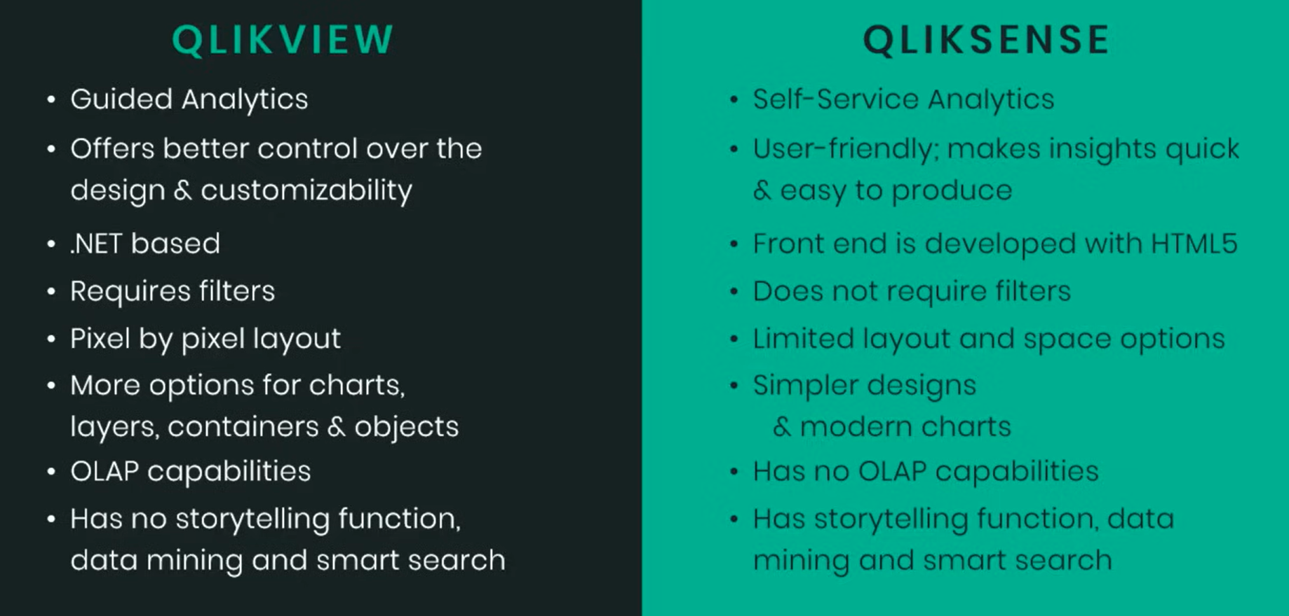

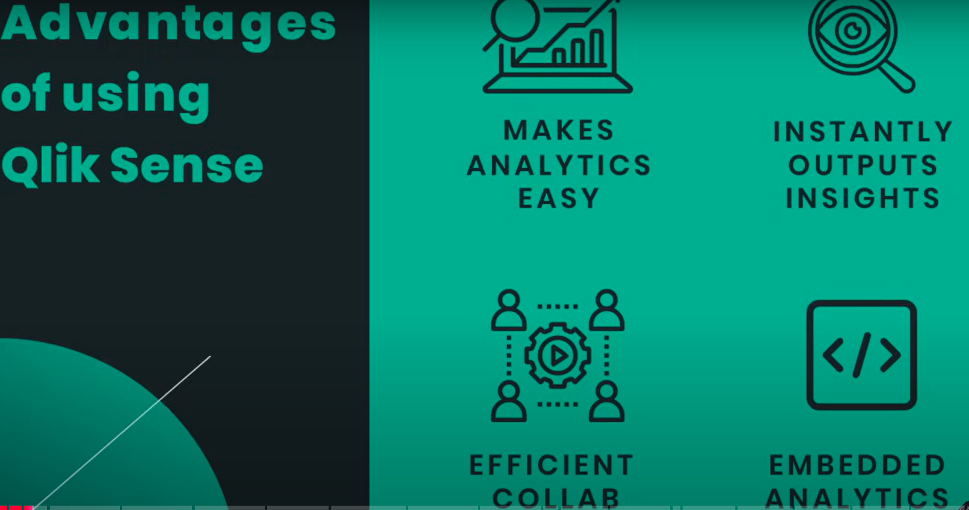

| **Parameter** | **Qlik Sense** | **Power BI** |
| --- | --- | --- |
| **Data Engine** | Associative-based data engine | SQL Database based data engine |
| **Environment** | Workbooks can be created in the cloud so that all can work together | Creates an individual workbook and then shares on the cloud |
| **User Interface** | Somewhat difficult to adopt and are less interactive | Easy to understand and is more interactive as compared to Qlik Sense |
| **Cost & Plans** | Need to purchase a plan to start or need to take a free trial  Plans:   * Business: $ 30 per user/month * Enterprise SaaS: need to connect the Sales team | The desktop version is free to play with  Plans:   * Pro: $ 13.70 per user/month * Premium: $ 27.50 per user/month |
| **Starting-up** | Requires the knowledge of scripting | One can go with the excel knowledge |
| **Key Features** | * Associative model to directly link tables * Storytelling * Qlik Indexing Engine (QIX) | * Seamless integration with Office 365 * More customization options * Data Analysis Expression (DAX) |
| **Platform** | Self-service business intelligence platform | Cloud-based platform |
| **Similarities** | Features like dashboard, reports, and visualization | Features like dashboard, reports, and visualization |
| **Language** | Proprietary scripting language i.e. Qlik Script | Language like SQL, Python, and R. |

[**https://github.com/learntech210/Qlikdata1.git**](https://github.com/learntech210/Qlikdata1.git)

[**https://github.com/learntech210/loanapp99.git**](https://github.com/learntech210/loanapp99.git)

**lt1.csv**

[**https://github.com/learntech210/customer.git**](https://github.com/learntech210/customer.git)

**LinkTable:**

**[Invoice]:**

**LOAD**

**AutoNumber([Product_ID]&[Supplier_ID]&[Material_ID]) as %key,**

**// [Product_ID],**

**// [Supplier_ID],**

**// [Material_ID],**

**[Invoice_ID],**

**[Invoice_Qty],**

**[Spend],**

**[Invoice_Date]**

**FROM [lib://DataFiles/invoice.xlsx]**

**(ooxml, embedded labels, table is Invoice);**

**[purchase_order]:**

**LOAD**

**AutoNumber([Product_ID]&[Supplier_ID]&[Material_ID]) as %key,**

**// [Product_ID],**

**// [Supplier_ID] AS [purchase_order.Supplier_ID],**

**// [Material_ID] AS [purchase_order.Material_ID],**

**[PurchaseOrder_ID],**

**[PO_quantity],**

**[Order_date]**

**FROM [lib://DataFiles/invoice.xlsx]**

**(ooxml, embedded labels, table is purchase_order);**