POWER APPS REPORT

An Industrial Internship Report

submitted by

PRIKSHIT SHARMA
19BCI0230

in partial fulfilment for the award of the degree of

CSE WITH SPECIALIZATION IN INFORMATION SECURITY

in

COMPUTER SCIENCE






SCHOOL OF COMPUTER SCIENCE AND ENGINEERING

JULY TO AUGUST 2023

DECLARATION BY THE CANDIDATE

I hereby declare that the Industrial Internship report entitled “POWER APPS” submitted by me to Vellore Institute of Technology, Vellore in partial fulfilment of the requirement for the award of the degree of B TECH IN COMPUTER SCIENCE WITH SPECIALIZATION IN INFORMATION SECURITY in COMPUTER SCIENCE is a record of bonafide industrial training undertaken by me under the supervision of SAURABH SIR, CEO OF CIS IT SOLUTIONS PVT LTD. I further declare that the work reported in this report has not been submitted and will not be submitted, either in part or in full, for the award of any other degree or diploma in this institute or any other institute or university.

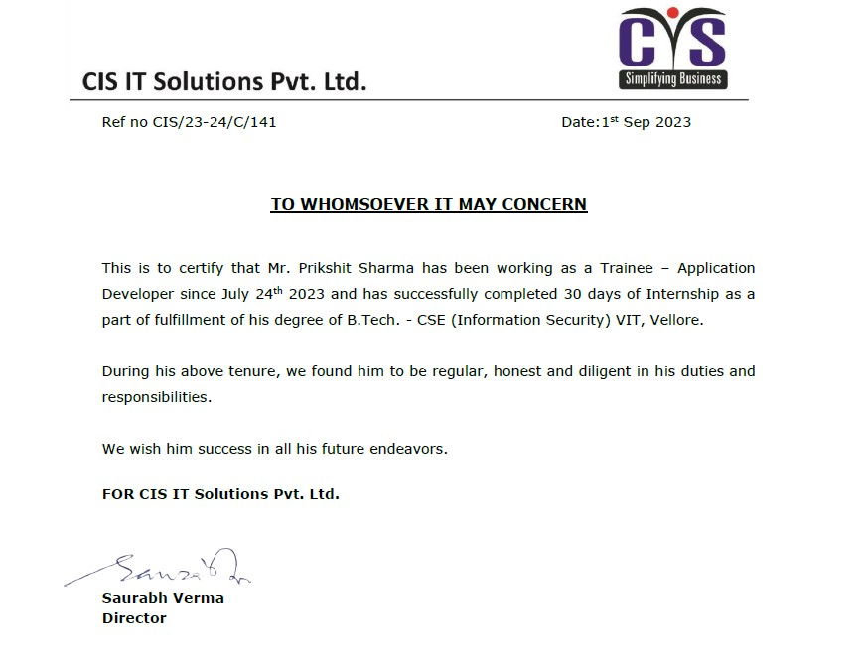

POWER APPS INDUSTRIAL INTERNSHIP

INTRODUCTION

Power apps is the service provided by microsoft to create applications inside organizations in a very simple and efficient manner. It helps to create the applications with minimal efforts as it is a low code platform.

It provides security features also like whether person is authentic or not and which person is authorized to do which task.

It provides us to merge with many services called connectors like Ms Excel,azure cloud services and with git etc.

METHODOLOGY OF CREATING APPLICATIONS

CANVAS APPLICATIONS
It helps us to create user applications with a custom or good user interface.

MODEL DRIVEN APPLICATIONS
It helps us to create applications in scenarios like where data is complex and important and user interface is comparitively less important.

LEARNINGS FROM THE INTERNSHIP

REAL TIME SCENARIOS
I learned about how to convert the users idea practically into the application.

TEAM WORK
I learned about how to work in a team and also learned from them important values like honesty, punctual and hard work.

