**Pabna University of Science and Technology**

***Department of Information and Communication Engineering***

***B.Sc. (Engineering) 3rd Year 2nd Semester Examination-2021***



**Session:** **2018-2019** **Course Code**: **ICE-3208**

**Title:** **Digital Image and Speech Processing Sessional.**

**Project Report On**

**Face Recognition System without Machine Learning or Convolutional Neural Network (CNN).**

**Submitted by**

|  |  |
| --- | --- |
|  | **Name: MD RAHATUL RABBI**  **Roll: 190609**  **Reg. No: 1065334**  **Session: 2018-19**  **Department of ICE,**  **Pabna University of Science and Technology** |

**Submitted to**

**Dr. Md. Imran Hossain**

**Associate Professor**

**Dept. of Information and Communication Engineering**

**Pabna University of Science and Technology,**

**Pabna-6600, Bangladesh.**

**Project Name:** Face Recognition System without Machine Learning or Convolutional Neural Network (CNN).

**Objectives:**

1. To identify individuals by comparing their facial features against a database of known faces.
2. To verify or authenticate individuals by comparing their facial features against a stored template or biometric data to grant access to secure systems or facilities
3. To monitor public spaces, airports, banks, and other high-security areas to identify potential threats or track suspicious individuals.
4. To restricted areas and to ensure only authorized personnel can gain access.

Here we will look at to identify and verify individuals based on their facial features and unique characteristics.

**Theory:** Face Recognition refers to the technology capable of identifying or verifying a subject through an image, video, or any audiovisual element of his face. Generally, this identification is used to access an application, system, or service and it works like a face scanner.

Because computerized facial recognition involves the measurement of a human's physiological characteristics, facial recognition systems are categorized as biometrics. Although the accuracy of facial recognition systems as a biometric technology is lower than iris recognition, fingerprint image acquisition, palm recognition or voice recognition, it is widely adopted due to its contactless process

**Procedure:** To implement the Face Recognition System using MATLAB, we need to do three things. These are –

Setp-1: Preparing dataset,

Step-2: Loading the dataset

Step-3: Recognizing the face

**Setp-1: Preparing dataset**

I have prepared a dataset of 40 people. Each of these people has 10 images with different poses. That means in total there are 40 x 10 = 400 images. For every individual, there is separate folders. Explaining it in this way will create confusion. That is why I have prepared figure Fig 1.1. I hope it will help you to understand how to prepare the dataset.

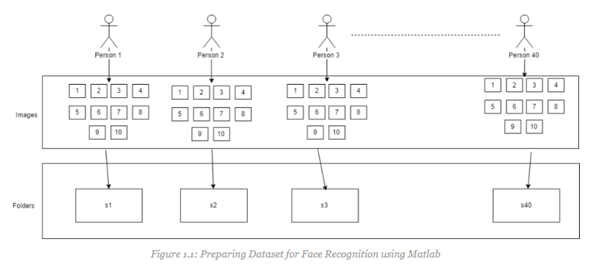

**Step-2: Loading the dataset**

After preparing the dataset, next task is loading the dataset. We will implement a function in MATLAB to load the dataset. We can use this function to load other dataset as well. Let’s name it ‘load_database.m’

**MATLAB Code-1:**

|  |
| --- |
| %program to load the dataset  function output_value = load_database();  persistent loaded;  persistent numeric_Image;  if(isempty(loaded))  all_Images = zeros(10304,40);  for i=1:40  cd(strcat('s',num2str(i)));  for j=1:10  image_Container = imread(strcat(num2str(j),'.pgm'));  all_Images(:,(i-1)*10+j)=reshape(image_Container,size(image_Container,1)*size(image_Container,2),1);  end  display('Loading Database');  cd ..  end  numeric_Image = uint8(all_Images);  end  loaded = 1;  output_value = numeric_Image; |

**Step-3: Recognizing the face**

To recognize the faces, I loaded the dataset first. After that using random function I generated a random index. Using the sequence of random index, I loaded the image which will be recognized later. Rest of the images are also loaded into a separate variable.

After that, I calculated the mean of all of the images and subtracted the mean from them. The eigenvectors were calculated on these images. Upon having the eigenvalues I created matrix where each row contains the signature of individual images. That means now we have the eigenvalues and the signature of the image to identify them.

In the last section, I subtracted the mean value from the image which we want to recognize. Then multiplied it with the eigenvector. Finally based on the difference between current image signatures with the signature I have mentioned above, I have predicted the recognized face.

**MATLAB Code-2:**

|  |
| --- |
| %Main File for Face_Recognition  loaded_Image=load_database();  random_Index=round(400*rand(1,1));  random_Image=loaded_Image(:,random_Index);  rest_of_the_images=loaded_Image(:,[1:random_Index-1 random_Index+1:end]);  image_Signature=20;    white_Image=uint8(ones(1,size(rest_of_the_images,2)));  mean_value=uint8(mean(rest_of_the_images,2));  mean_Removed=rest_of_the_images-uint8(single(mean_value)*single(white_Image));  L=single(mean_Removed)'*single(mean_Removed);  [V,D]=eig(L);  V=single(mean_Removed)*V;  V=V(:,end:-1:end-(image_Signature-1));  all_image_Signatire=zeros(size(rest_of_the_images,2),image_Signature);  for i=1:size(rest_of_the_images,2);  all_image_Signatire(i,:)=single(mean_Removed(:,i))'*V;  end  subplot(121);  imshow(reshape(random_Image,112,92));  title('Looking for this Face','FontWeight','bold','Fontsize',16,'color','red');  subplot(122);  p=random_Image-mean_value;  s=single(p)'*V;  z=[];  for i=1:size(rest_of_the_images,2)  z=[z,norm(all_image_Signatire(i,:)-s,2)];  if(rem(i,20)==0),imshow(reshape(rest_of_the_images(:,i),112,92)),end;  drawnow;  end  [a,i]=min(z);  subplot(122);  imshow(reshape(rest_of_the_images(:,i),112,92));  title('Recognition Completed','FontWeight','bold','Fontsize',16,'color','red'); |

**Output:**

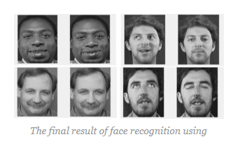

**Result and Discussion:**

In Face Recognition System if we look at them carefully, the accuracy of this method is around 94%. That means out of 100 trial, it may make four mistakes.