Car Price Prediction Using Machine Learning
Project Report
Prepared by: Joy Chandra Shill ,Ksh Chinglamba Singha

1. Abstract
This project uses a supplied car dataset to develop a regression-based car price prediction prototype. The workflow includes dataset inspection, exploratory data analysis, preprocessing, model comparison, test-set evaluation, and a Streamlit dashboard for interactive predictions. The dataset does not specify the price currency or source, so outputs should be interpreted only in the dataset's price units.

2. Problem Statement
Vehicle prices are influenced by factors such as brand, model year, engine size, fuel type, transmission, mileage, doors, owner count and horsepower. The project investigates whether a regression model can learn relationships between these features and the target Price column.

3. Dataset Description
The CSV contains 2000 records and 11 columns. The target is Price. The supplied file contains 0 missing values. Car_ID is an identifier and is excluded from model inputs. The currency and provenance of the dataset are not specified.
Column | Role | Meaning
Car_ID | Excluded identifier | Car identifier
Brand | Input feature | Vehicle characteristic
Model_Year | Input feature | Vehicle characteristic
Engine_Size | Input feature | Vehicle characteristic
Fuel_Type | Input feature | Vehicle characteristic
Transmission | Input feature | Vehicle characteristic
Mileage | Input feature | Vehicle characteristic
Doors | Input feature | Vehicle characteristic
Owner_Count | Input feature | Vehicle characteristic
Horsepower | Input feature | Vehicle characteristic
Price | Target variable | Value to predict

4. Methodology
- Inspect data types, missing values and feature ranges.
- Separate the target Price from the input features and exclude Car_ID.
- Split the data into 80% training and 20% testing using random_state=42.
- Impute missing numeric values using the median and categorical values using the most frequent category.
- One-hot encode categorical features and use a pipeline to keep preprocessing consistent at prediction time.
- Compare Random Forest, Extra Trees and Gradient Boosting regressors.
- Select the model with the lowest MAE on the held-out test set.
- Deploy the saved pipeline through a Streamlit dashboard.

5. Exploratory Data Analysis
The price distribution chart summarizes the target values in the supplied dataset.
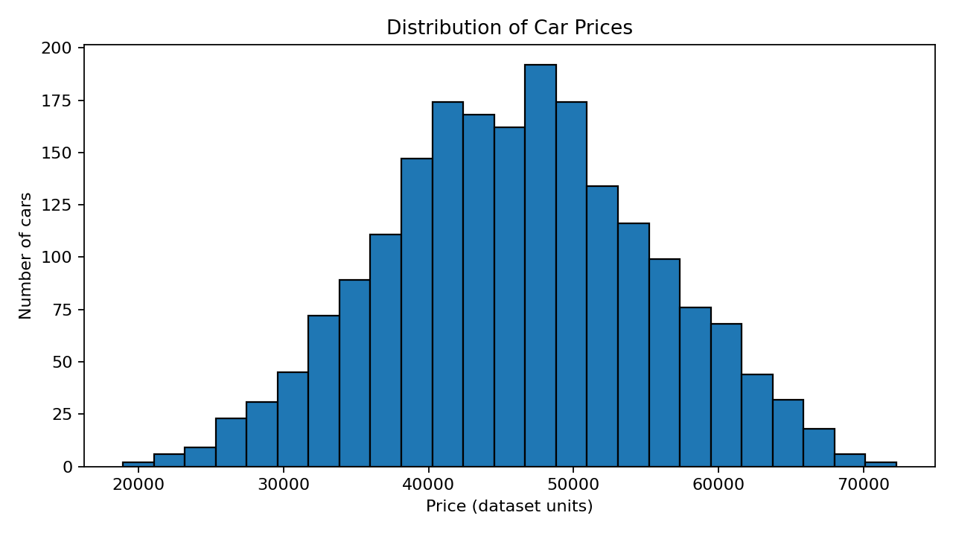
The following chart compares median prices by brand within this dataset.
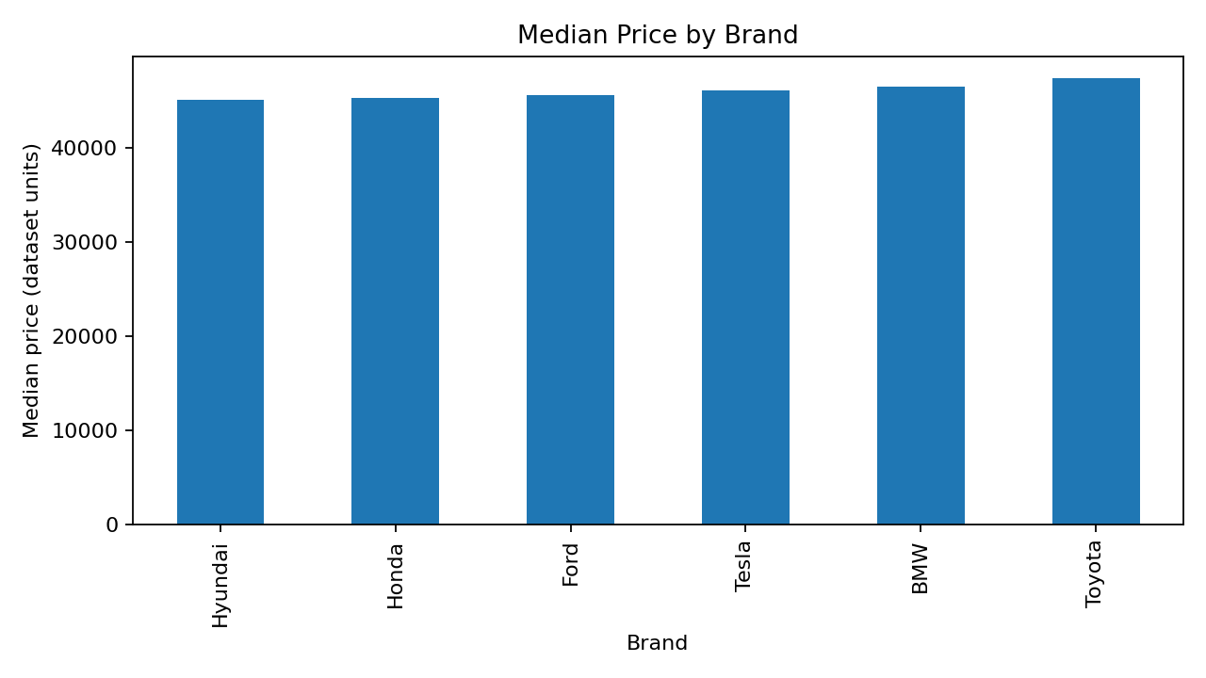

6. Model Evaluation
The selected model was Gradient Boosting, chosen by the lowest MAE among the evaluated candidates.
MAE: 1,962.1309
RMSE: 2,430.6927
R2: 0.9284
MAE is the average absolute prediction error. RMSE penalizes larger errors more heavily. R² describes how much variation is explained relative to a mean baseline; it can be negative on weak predictions. All metrics are specific to the chosen split and the dataset's unspecified price units.
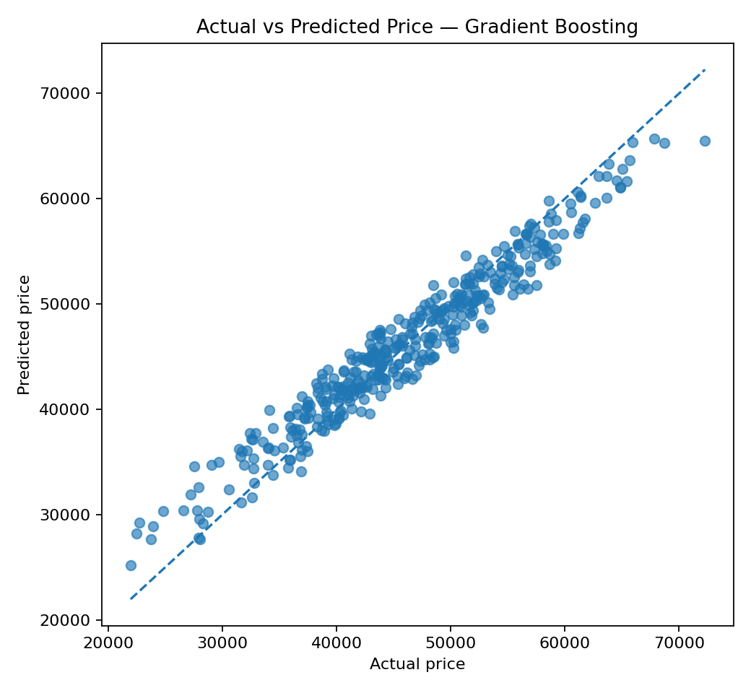

7. Dashboard
The Streamlit dashboard contains four sections: Predict Price, Data Insights, Model Performance and Dataset. Users select vehicle features and request a prediction. The dashboard also displays charts, summary metrics, model comparison results and a dataset preview.

8. Limitations
- The dataset's origin, collection method and currency are not provided.
- The model is an educational prototype and not a professional market valuation tool.
- A single train-test split gives only one estimate of generalization performance.
- The dataset may not represent current real-world vehicle prices.
- Predictions should not be used for financial or purchasing decisions without independent validation.

9. Future Improvements
Future work may include cross-validation, hyperparameter optimization, validation on an external real-world dataset, adding vehicle condition and location features, and adding model explainability with feature importance or SHAP after checking compatibility and interpretation.

10. Conclusion
The project demonstrates an end-to-end data science workflow: data inspection, analysis, model training, evaluation, model serialization and interactive deployment. It is suitable as a learning prototype, provided the limitations of the source dataset are clearly communicated.

References / Tools
Python, Pandas, NumPy, Matplotlib, Scikit-learn, Joblib and Streamlit documentation.
Download from: Kaggle
Authors: upcodder
Dataset link: https://www.kaggle.com/datasets/upcoderr/car-specifications-dataset

