Use Gmail Built-in Encryption (Confidential Mode)
This is the easiest method. It protects your email with a passcode and prevents forwarding, copying, downloading.

Steps:
- Open Gmail → click Compose
- At the bottom of the compose window, click the Lock + Clock icon
(This is Confidential Mode)
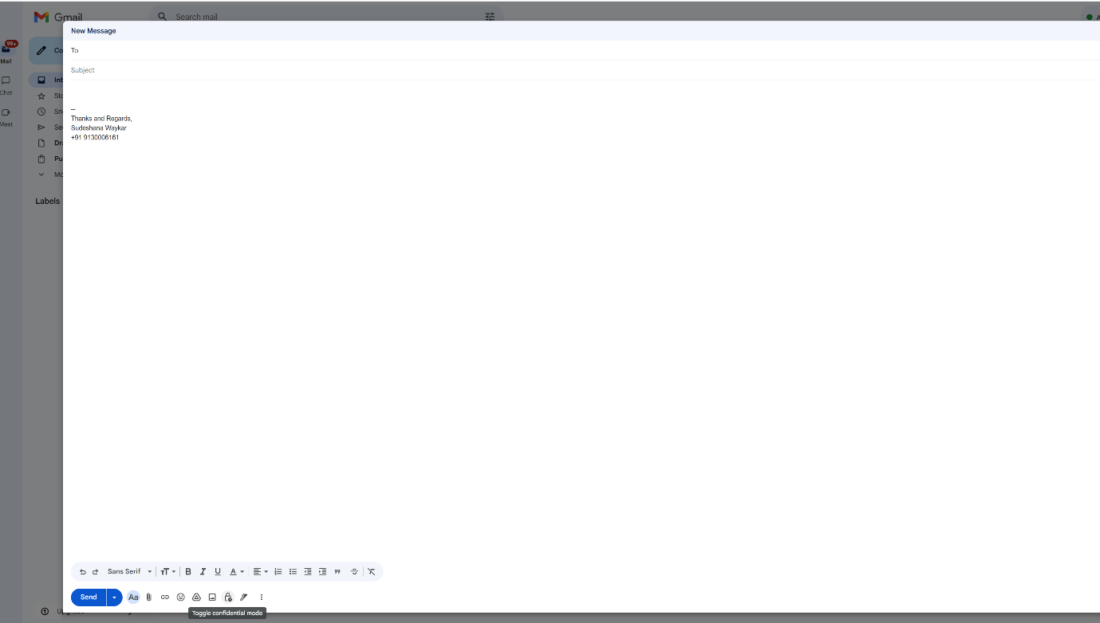
- Set:
  - Expiration date
  - Passcode requirement
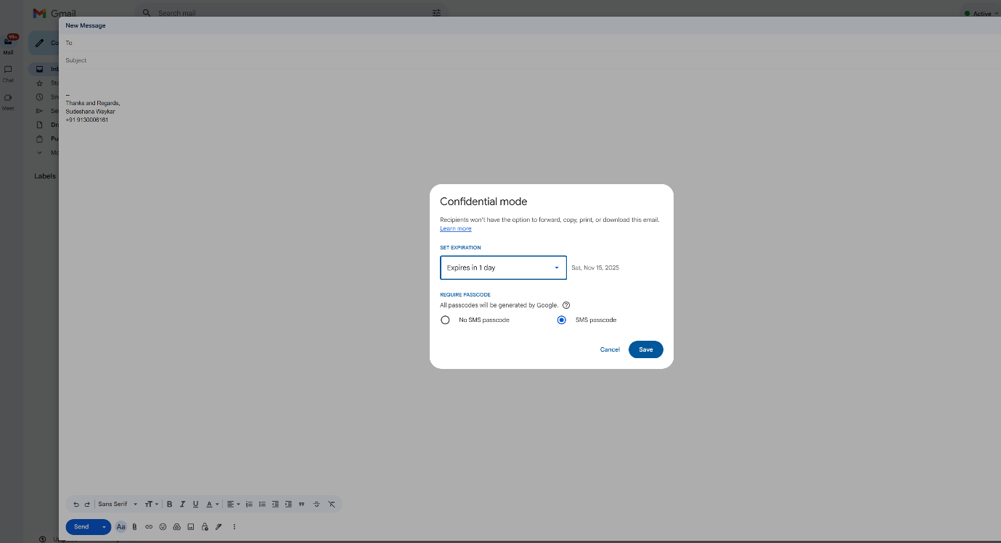

- Choose SMS Passcode (recommended)
  - Enter recipient’s phone number
  - They will get a code on SMS to open email
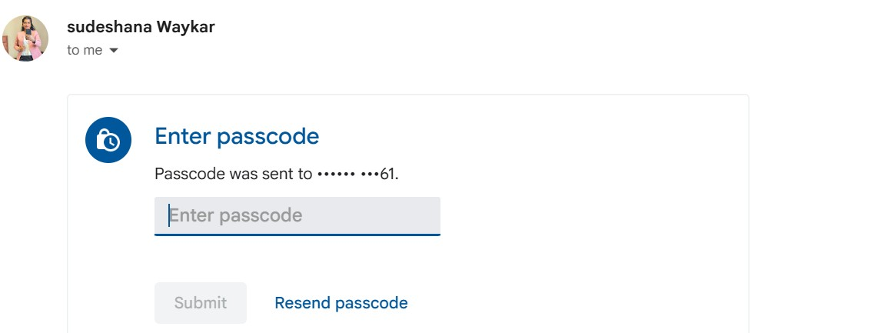
- Click Save, then send the email
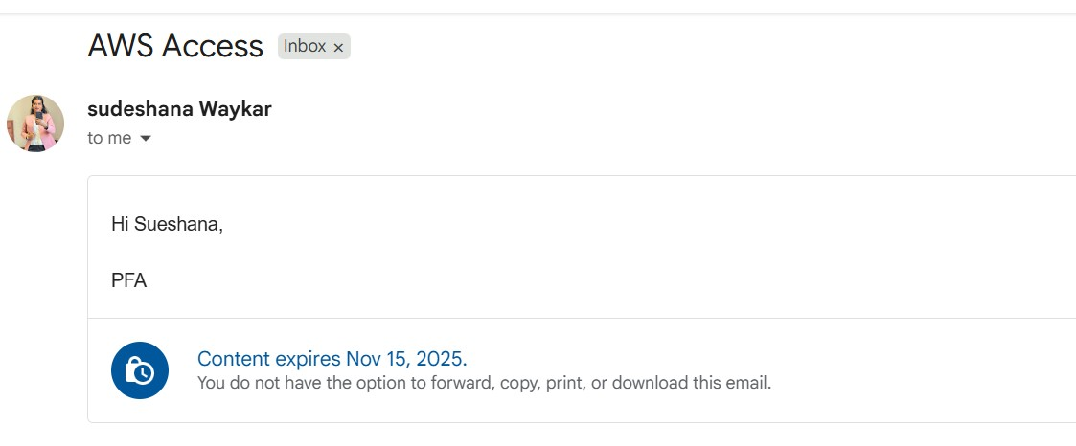

What happens?
✔ Email content is protected
✔ Recipient needs a passcode to open
✔ Content cannot be copied/forwarded

