**Program-3: Write a JavaScript code that displays text “TEXT-GROWING” with increasing font size in the interval of 100ms in RED COLOR, when the font size reaches 50pt it displays “TEXTSHRINKING” in BLUE color. Then the font size decreases to 5pt.**

**Steps:**

1. **Open a text editor or sublime text-3 file and save it as “yourname_program3.html”**
2. **Type the below code and save it.**

<!DOCTYPE HTML>

<html>

<head>

<title>Text Shrink</title>

<style>

p {

position: absolute;

top: 50%;

left: 50%;

transform: translate(-50%, -50%);

}

</style>

</head>

<body>

<p id="demo"></p>

<script>

var var1 = setInterval(inTimer, 500);

var fs = 5; //font size

var ids = document.getElementById("demo");

function inTimer()

{

ids.innerHTML = 'TEXT GROWING';

ids.setAttribute('style', "font-size: " + fs + "px; color: red");

fs += 5;

if (fs >= 50)

{

clearInterval(var1); //paused

var2 = setInterval(deTimer, 500);

}

}

function deTimer() //fs = 50px

{

fs -= 5;

ids.innerHTML = 'TEXT SHRINKING';

ids.setAttribute('style', "font-size: " + fs + "px; color: blue");

if (fs == 5)

{

clearInterval(var2); //paused

var1 = setInterval(inTimer, 500);

}

}

</script>

</body>

</html>

**Output:**

**“Text Growing” in red colors.**

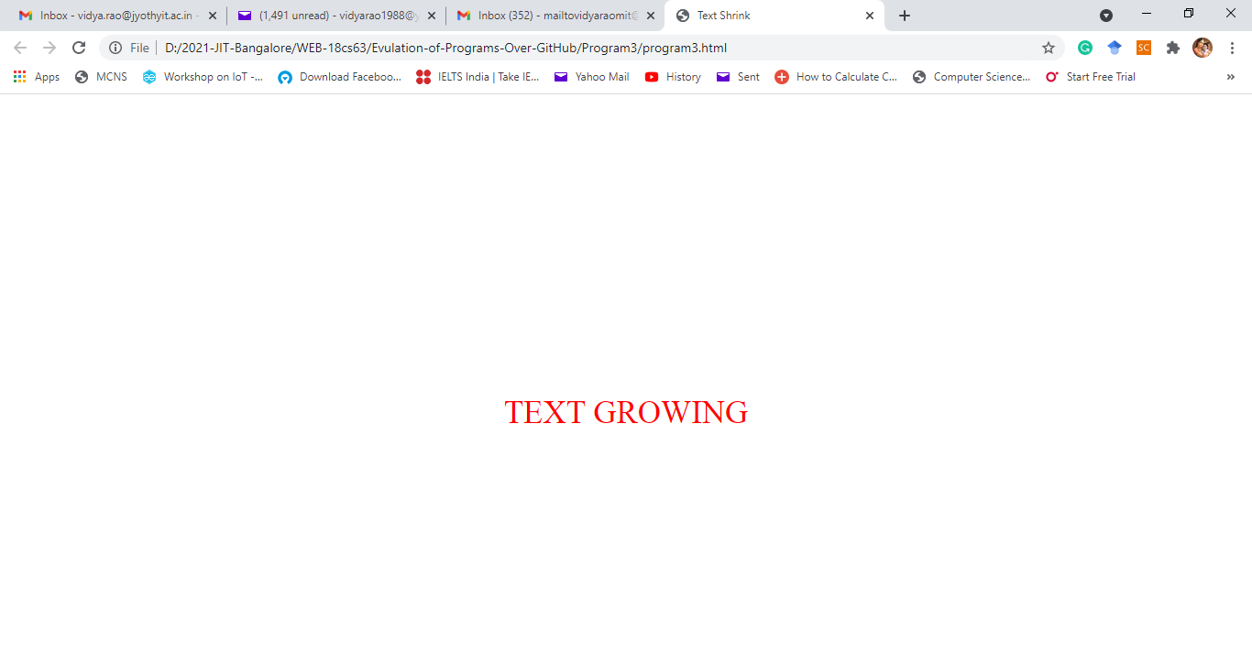

**“Text Shrinking” in blue colors.**

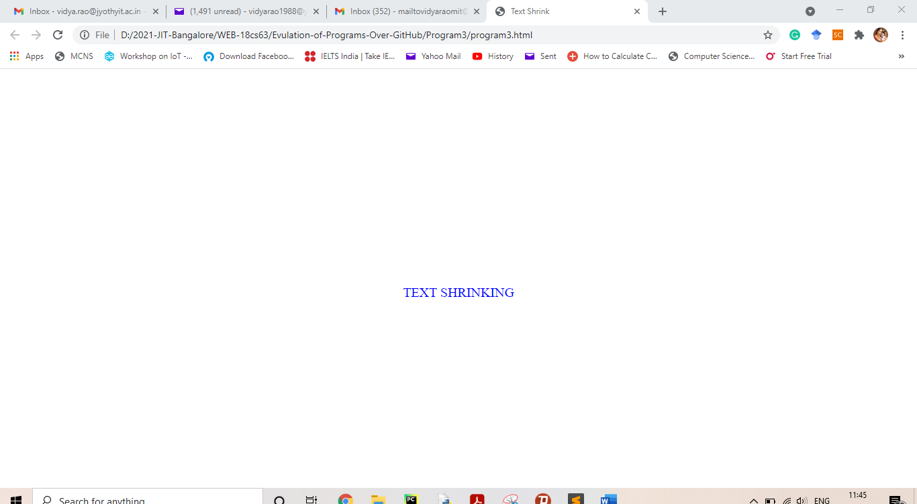

1. Your challenge is as followed.
2. Save the file as yourname_challeneg3.html
   1. Add above code of text growing and shrinking.
   2. Use following tags
      1. Header
      2. Footer
      3. Heading tags
      4. Paragraphs
      5. Sections – date and time of photo clicked.
      6. Figure – for images
      7. Article – for description of images
      8. Breaks
      9. Basic tags, etc
   3. For review stars, a sample code is given below.

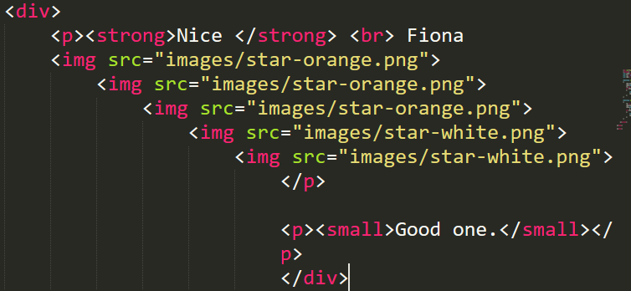

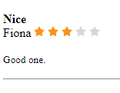

* 1. You can download or create orange and white stars

1. 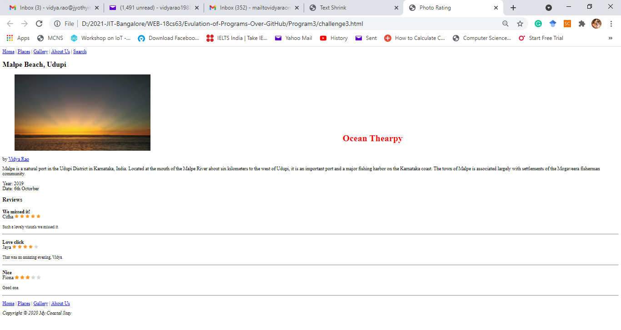Output expected is shown below

This text shall grown and shrink as previous example

In case above web page is not legible, I have divided and attached below.

Top part.

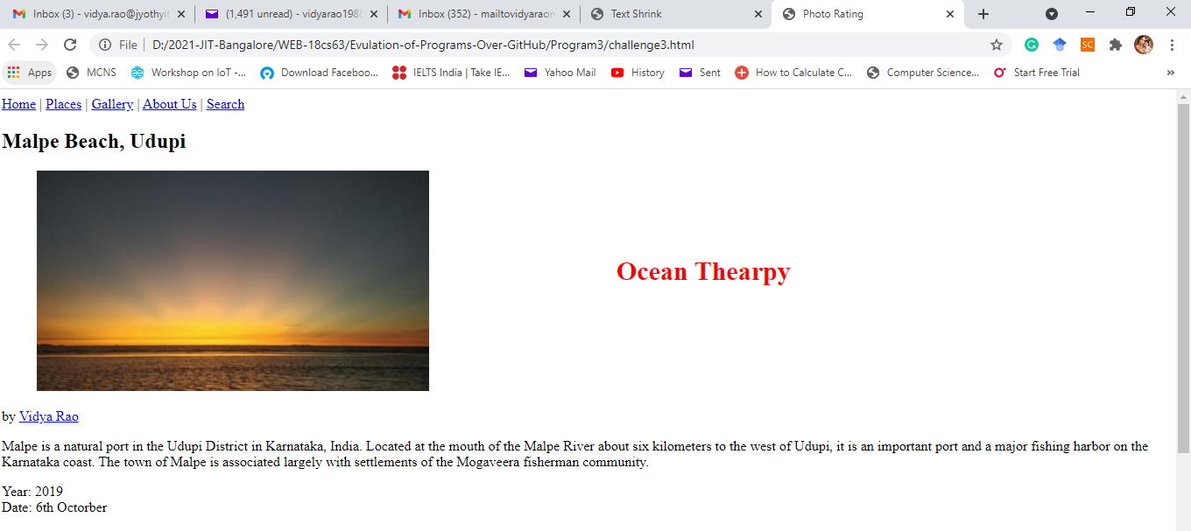

Part 1

Below part

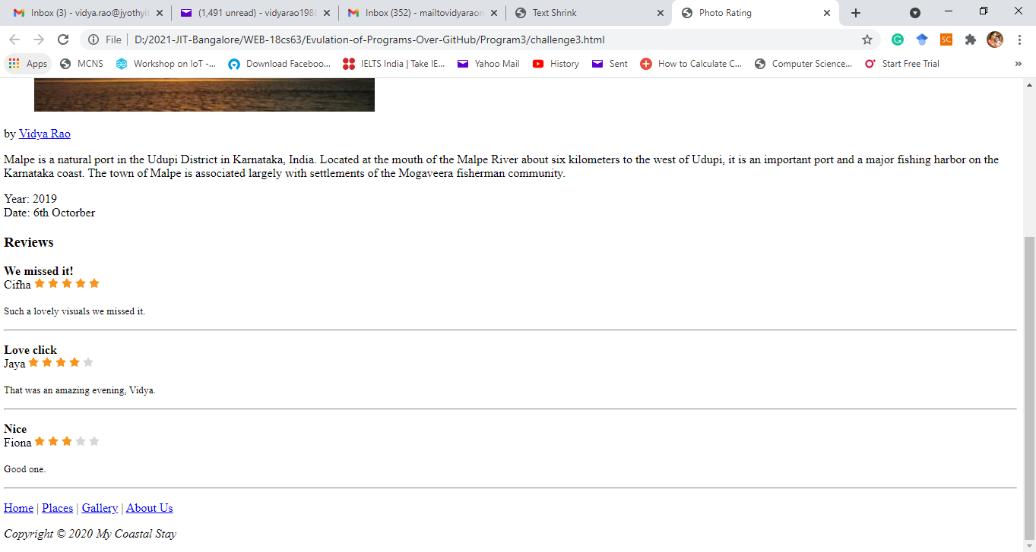

Part 2

1. Submission of assignment.
   1. Save all your code and outputs under a word file, convert to PDF and upload-to: Google class.
   2. You can upload video file if needed.
   3. Push all your files into your GitHub account as explained in the class with screen shot of output. Don’t put video and all in GitHub.