**Program-4: Develop and demonstrate a HTML5 file that includes JavaScript script that uses functions for the following problems:**

**a. Parameter: A string**

**b. Output: The position in the string of the left-most vowel**

**c. Parameter: A number**

**d. Output: The number with its digits in the reverse order**

**Steps:**

1. **Open a text editor or sublime text-3 file and save it as “yourname_program4.html”**
2. **Type the below code and save it.**

<!DOCTYPE HTML>

<html>

<head><title>Program-4</title></head>

<body>

<script type="text/javascript">

var str = prompt("Enter the Input", "");

if (!(isNaN(str))) //isNaN means is Not a Number

{

var num, rev = 0,remainder;

num = parseInt(str);

while (num != 0)

{

remainder = num % 10;

num = parseInt(num / 10);

rev = rev * 10 + remainder;

}

alert("Reverse of " + str + " is " + rev);

}

else

{

str = str.toUpperCase();

for (var i = 0; i < str.length; i++) //0,1,2,3

{

var chr = str.charAt(i);

if (chr == 'A' || chr == 'E' || chr == 'I' || chr == 'O' || chr == 'U')

break;

}

if (i < str.length)

alert("The position of the left most vowel is " + (i + 1));

else

alert("No vowel found in the entered string");

}

</script>

</body>

</html>

**Output 1: Integer Value test**

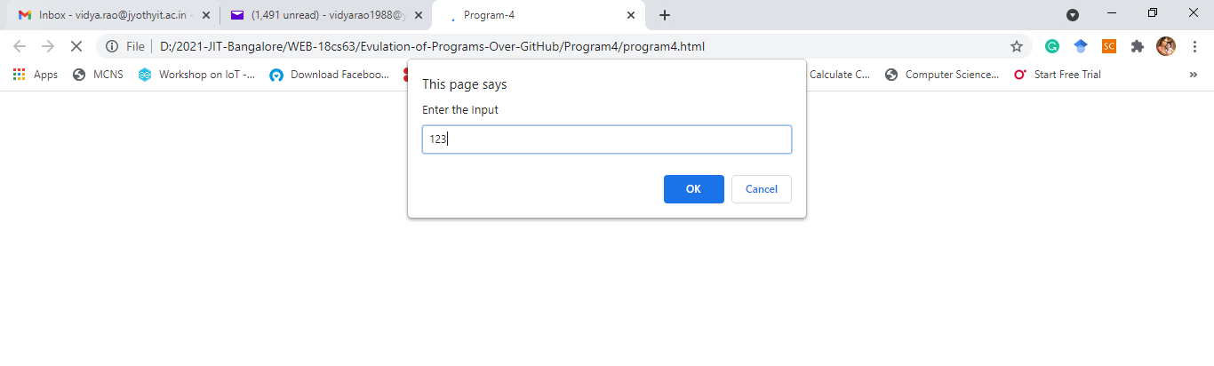

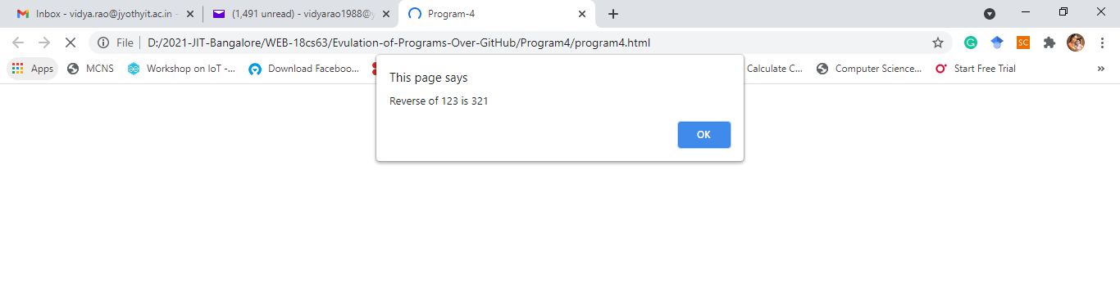

**Output 2: String Value test**

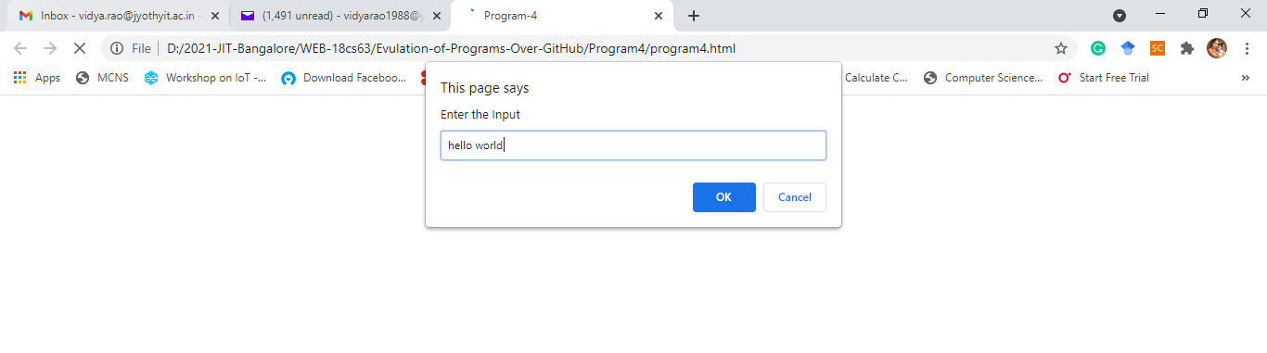

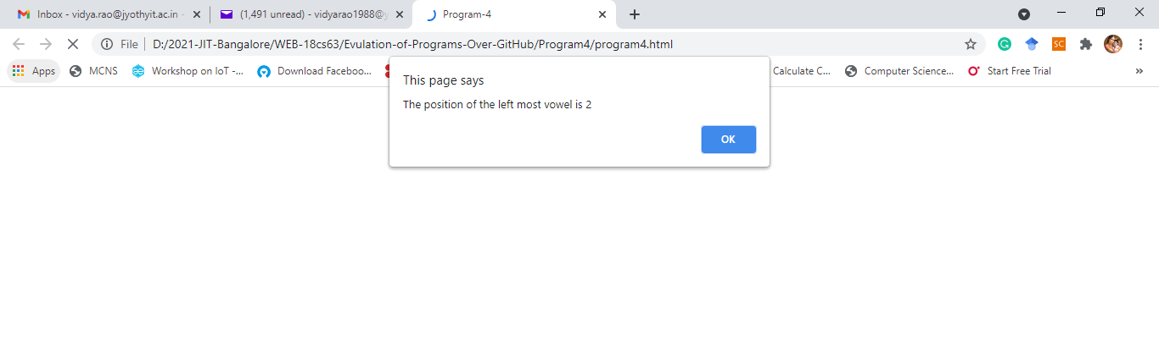

1. Test Cases

|  |  |  |  |
| --- | --- | --- | --- |
| Test No. | Test Case | Expected Output | Output Obtained |
| 1 | Integer Value:  Text Value: |  |  |
| 2 | Negative Integer value:  Text Value: |  |  |
| 3 | Integer Value:  Alpha numerical value: |  |  |
| 4 | Integer Value:  Non vowel string: |  |  |
| 5 | Test case of choice |  |  |

1. Your challenge is as followed. Save the file as yourname_challeneg4.html
2. 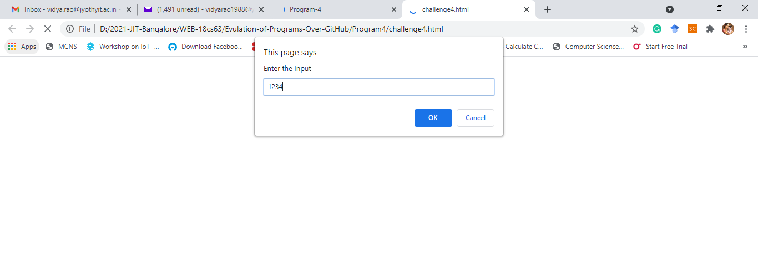Same as above program by in place of displaying only reverse of string under Integer Value, display the product of actual Integer Entered and Reversed Integer.

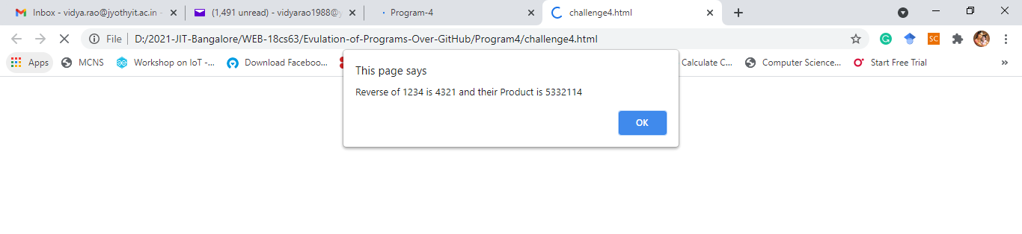

1. For character string, every vowel needs to be counted and the count should be displayed on the screen as shown bellow:

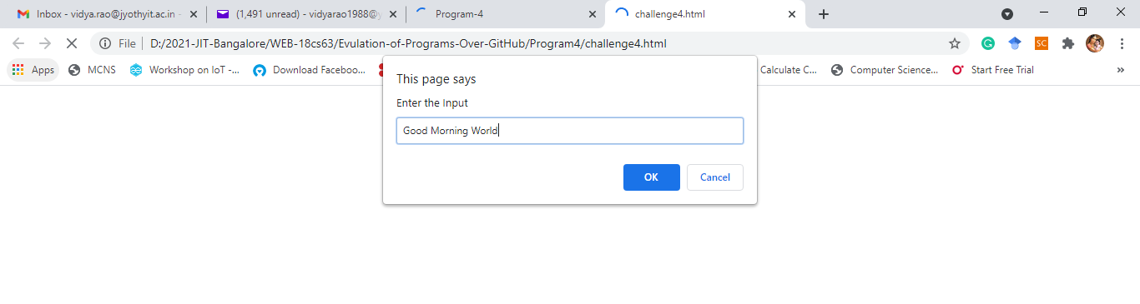

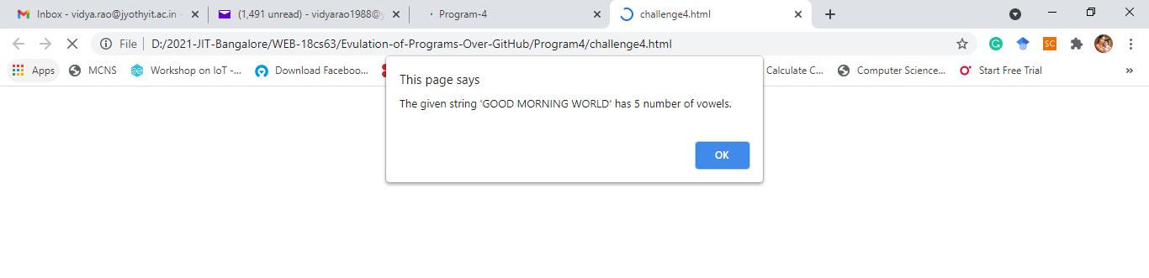

1. Test case should as before with more number test cases.
2. Submission of assignment.
   1. Save all your code and outputs under a word file, convert to PDF and upload-to: Google class.
   2. You can upload video file if needed.
   3. Push all your files into your GitHub account as explained in the class with screen shot of output. Don’t put video and all in GitHub.