**Assignment 5: Program 5, 6 and 7**

**\*\*\*\*\*\*\*\*\*\*\*\*\*\*\*\*\*\*\*\*\*\*\*\*Program-5\*\*\*\*\*\*\*\*\*\*\*\*\*\*\*\*\*\*\*\*\*\*\*\*\***

**Design an XML document to store information about a student in an engineering college affiliated to VTU. The information must include USN, Name, and Name of the College, Program, Year of Joining, and email id. Make up sample data for 3 students. Create a CSS style sheet and use it to display the document.**

**\*\*\*\*\*\*\*\*\*\*\*\*\*\*\*\*\*\*\*Steps before we start\*\*\*\*\*\*\*\*\*\*\*\*\*\*\*\*\*\*\***

1. **Install XAMPP Server using:** [**https://www.apachefriends.org/download.html**](https://www.apachefriends.org/download.html)
2. **Open SubLimeText -> create a new file.**
3. **Save file as prog5.xml in the path XAMPP -> htdoc -> create folder as "WebLab" and save the file (C:\xampp\htdocs\WebLab)**
4. **Type below XML program.**

**prog5.xml**

|  |
| --- |
| **<?xml-stylesheet type="text/css" href="prog5.css"?>** |
| **<!DOCTYPE HTML>** |
| **<html>** |
| **<head>** |
| **<h1> STUDENTS DESCRIPTION </h1>** |
| **</head>** |
| **<students>** |
| **<student>** |
| **<USN> ID : 1JT21IS001</USN>** |
| **<name>Name : AJAY</name>** |
| **<college>COLLEGE : JIT</college>** |
| **<branch>BRANCH : Information Science and Engineering</branch>** |
| **<year>YEAR : 2021</year>** |
| **<e-mail>E-Mail : ajay@gmail.com</e-mail>** |
| **</student>** |
| **<student>** |
| **<USN>USN : 1JT21IS034 </USN>** |
| **<name>NAME : Ramya </name>** |
| **<college>COLLEGE : JIT</college>** |
| **<branch>BRANCH : Information Science and Engineering</branch>** |
| **<year>YEAR : 2021</year>** |
| **<e-mail>E-Mail : ramya@gmail.com</e-mail>** |
| **</student>** |
| **<student>** |
| **<USN>USN : 1JT21IS055</USN>** |
| **<name>NAME : Thanu </name>** |
| **<college>COLLEGE : JIT</college>** |
| **<branch>BRANCH : Information Science and Engineering</branch>** |
| **<year>YEAR : 2021</year>** |
| **<e-mail>E-Mail : tanu@gmail.com</e-mail>** |
| **</student>** |
| **</students>** |
| **</html>** |

1. **Open one more new file in same path and type the CSS style sheet (prog5.css)**

**prog5.css**

|  |
| --- |
| **student {** |
| **display: block;** |
| **margin-top: 10px;** |
| **color: Navy;** |
| **}** |
|  |
| **USN {** |
| **display: block;** |
| **margin-left: 10px;** |
| **font-size: 14pt;** |
| **color: Red;** |
| **}** |
|  |
| **name {** |
| **display: block;** |
| **margin-left: 20px;** |
| **font-size: 14pt;** |
| **color: Blue;** |
| **}** |
|  |
| **college {** |
| **display: block;** |
| **margin-left: 20px;** |
| **font-size: 12pt;** |
| **color: Maroon;** |
| **}** |
|  |
| **branch {** |
| **display: block;** |
| **margin-left: 20px;** |
| **font-size: 12pt;** |
| **color: Purple;** |
| **}** |
|  |
| **year {** |
| **display: block;** |
| **margin-left: 20px;** |
| **font-size: 14pt;** |
| **color: Green;** |
| **}** |
|  |
| **e-mail {** |
| **display: block;** |
| **margin-left: 20px;** |
| **font-size: 12pt;** |
| **color: Blue;** |
| **}** |

1. **To execute the program, run the XAMP server app and start Apache server.**

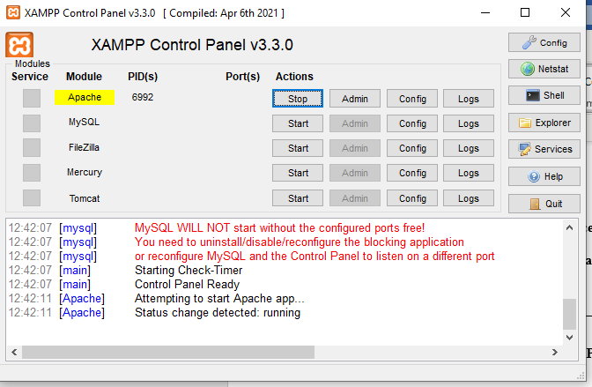

1. **Open a web browser and type the following line in URL box** [**http://localhost/WebLab/prog5.xml**](http://localhost/WebLab/prog5.xml)
2. **Then you can see your output on the web page as below.**

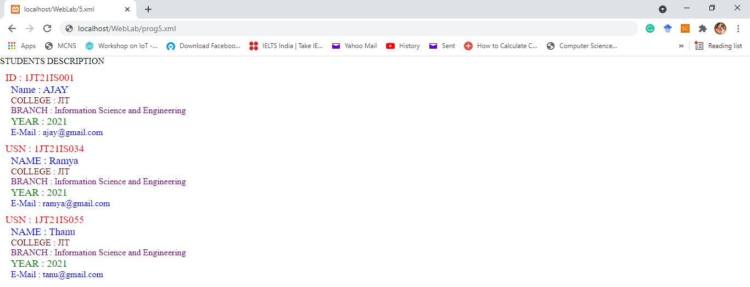

1. **Write your data within the TAGs created and show the output.**
2. **Submission of assignment.**
   1. **Save all your code and outputs under a word file, convert to PDF and upload-to: Google class.**
   2. **You can upload video file if needed.**
   3. **Push all your files into your GitHub account as explained in the class with screen shot of output. Don’t put video and all in GitHub.**

**\*\*\*\*\*\*\*\*\*\*\*\*\*\*\*\*\*\*\*\*\*\*\*\*Program-6\*\*\*\*\*\*\*\*\*\*\*\*\*\*\*\*\*\*\*\*\*\*\*\*\***

**Write a PHP program to keep track of the number of visitors visiting the web page and to display this count of visitors, with proper headings.**

**\*\*\*\*\*\*\*\*\*\*\*\*\*\*\*\*\*\*\*Steps before we start\*\*\*\*\*\*\*\*\*\*\*\*\*\*\*\*\*\*\***

1. **Install XAMPP Server using:** [**https://www.apachefriends.org/download.html**](https://www.apachefriends.org/download.html)
2. **Open SubLimeText -> create a new file.**
3. **Save file as prog6.php in the path XAMPP -> htdoc -> create folder as "WebLab" and save the file (C:\xampp\htdocs\WebLab)**
4. **Create one more file as counter.txt in the folder.**
5. **Type below php program.**

**prog6.php**

|  |
| --- |
| **<?php** |
| **$user = "YourName";** |
| **?>** |
| **<!DOCTYPE html>** |
| **<html>** |
| **<head> <title> program 6 </title></head>** |
| **<body>** |
| **<h2> <?php echo $user; ?>,Welcome to Sample PHP Script </h2>** |
| **<?php** |
| **print "<h3> REFRESH PAGE </h3>";** |
| **$name="counter.txt";** |
|  |
| **$file = fopen($name,"r");** |
| **$hits = fscanf($file,"%d");** |
| **fclose($file);** |
| **$hits[0]++;** |
|  |
| **$file = fopen($name,"w");** |
| **fprintf($file,"%d",$hits[0]);** |
| **fclose($file);** |
|  |
| **print "Total number of views: ".$hits[0];** |
| **?>** |
| **</body>** |
| **</html>** |

1. **To execute the program, run the XAMP server app and start Apache server.**



1. **Open a web browser and type the following line in URL box** [**http://localhost/WebLab/prog6.php**](http://localhost/WebLab/prog6.php)
2. **Then you can see your output on the web page as below.**

|  |
| --- |
|  |

1. **your challenge output should look like below:**

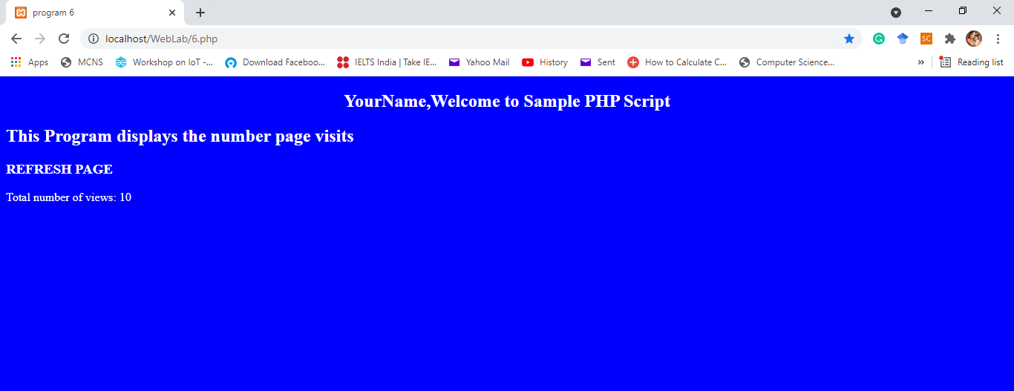

1. **Submission of assignment.**
   1. **Save all your code and outputs under a word file, convert to PDF and upload-to: Google class.**
   2. **You can upload video file if needed.**
   3. **Push all your files into your GitHub account as explained in the class with screen shot of output. Don’t put video and all in GitHub.**

**\*\*\*\*\*\*\*\*\*\*\*\*\*\*\*\*\*\*\*\*\*\*\*\*Program-7\*\*\*\*\*\*\*\*\*\*\*\*\*\*\*\*\*\*\*\*\*\*\*\*\***

**Write a PHP program to display a digital clock which displays the current time of the server.**

**\*\*\*\*\*\*\*\*\*\*\*\*\*\*\*\*\*\*\*Steps before we start\*\*\*\*\*\*\*\*\*\*\*\*\*\*\*\*\*\*\***

1. **Install XAMPP Server using:** [**https://www.apachefriends.org/download.html**](https://www.apachefriends.org/download.html)
2. **Open SubLimeText -> create a new file.**
3. **Save file as prog7.php in the path XAMPP -> htdoc -> create folder as "WebLab" and save the file (C:\xampp\htdocs\WebLab)**
4. **Type below php program.**

**prog7.php**

|  |
| --- |
| **<!DOCTYPE HTML>** |
| **<html>** |
|  |
| **<head>** |
| **<meta http-equiv="refresh" content="1" />** |
| **<style>** |
| **p {** |
| **color: white;** |
| **font-size: 90px;** |
| **position: absolute;** |
| **top: 50%;** |
| **left: 50%;** |
| **transform: translate(-50%, -50%);** |
| **}** |
|  |
| **body {** |
| **background-color: black;** |
| **}** |
|  |
| **</style>** |
| **<p> <?php echo date(" h: i : s A");?> </p>** |
| **</head>** |
|  |
| **</html>** |

1. **To execute the program, run the XAMP server app and start Apache server.**



1. **Open a web browser and type the following line in URL box** [**http://localhost/WebLab/prog7.php**](http://localhost/WebLab/prog7.php)
2. **Then you can see your output on the web page as below.**

|  |
| --- |
|  |

1. **your challenge output should look like below with different date format:**

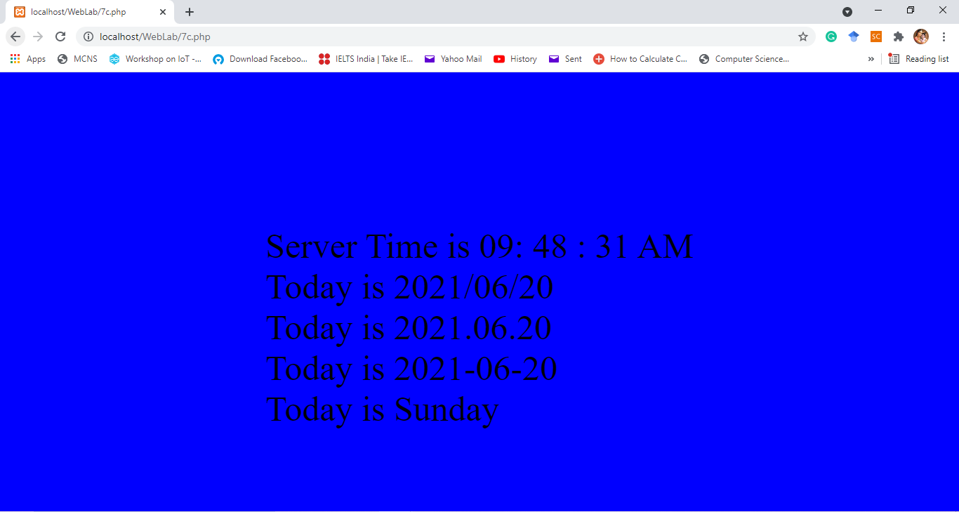

1. **Submission of assignment.**
   1. **Save all your code and outputs under a word file, convert to PDF and upload-to: Google class.**
   2. **You can upload video file if needed.**
   3. **Push all your files into your GitHub account as explained in the class with screen shot of output. Don’t put video and all in GitHub.**

|  |
| --- |
| **Note:** |
| 1. **In a single PDF Save all your codes and outputs under a word file, convert to PDF and upload-to: Google class. (all three programs in single PDF)** |
| 1. **Write all codes and scan to PDF and upload to Google Class.** |
| 1. **Upload the programs to GitHub and provide the link.** |