Project outline: Road proximity and soil quality at Campus Irchel

ESS841
This project will investigate whether soil metal concentrations and selected indicators of soil quality vary with distance from a road at Campus Irchel.

Research questions and hypotheses
- Do soil pollutant concentrations (P₂O₅, PbO, SO₃, ZnO ) decrease with increasing distance from the road?
Hypothesis: Pollutant concentrations are highest near the road and decline with distance, consistent with roadside deposition.

- How do soil quality indicators vary with distance from the road?
Hypothesis: Soil farther from the road has lower pollutant concentrations and higher organic matter and nitrogen contents.
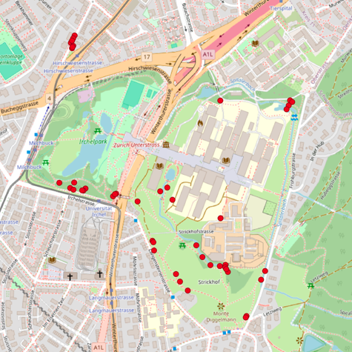
Figure 1: Trees around Campus Irchel
Sampling design
Four spatially separated transects will be established perpendicular to a comparable stretch of road located within the vicinity of a chosen group of trees, identified as red dots (Figure 1). Each transect will include five locally appropriate and accessible sampling distances. Sampling depth will remain consistent at 5 cm. Vegetation, recent disturbance, location, soil moisture, and temperature will be recorded.

Laboratory analyses
Samples will be prepared according to laboratory protocols. X-ray fluorescence (XRF) will quantify P₂O₅, PbO (air pollution), SO₃, ZnO (tire rubber particulates), Ca (concrete/asphalt) as well as other pollutants. Soil pH will provide context for metal retention and potential mobility. Elemental analysis (EA) will determine total nitrogen and carbon; total nitrogen will be treated as a nutrient-status indicator rather than a direct measure of nutrient availability. Additionally, SoliTOC could be useful as it determines exact TOC (Total Organic Carbon) and TIC (Total Inorganic Carbon), and the ROC (Residual Oxidized Carbon) pool (based on older bitumen rubber).

Depending on equipment availability, X-ray diffraction (XRD) will identify crystalline mineral phases, while DRIFT spectroscopy in addition to SOliTOC will investigate differences in OM and carbonates.

Data analysis and scope
Metal concentrations and soil quality indicators will be plotted against distance. Analyses will examine distance trends and relationships between metals and pH, accounting for transect grouping. The study will assess soil quality indicators; demonstrating changes in productivity would require an additional measure, such as soil respiration.

