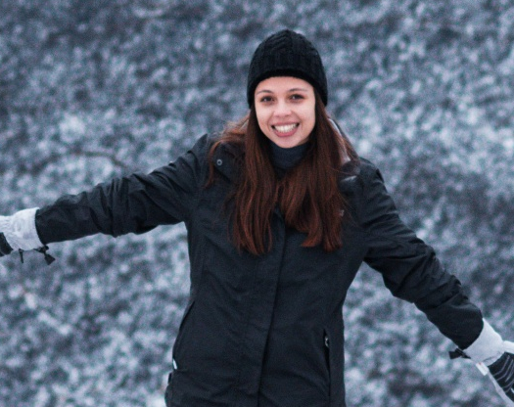
Lea Smit

Address: 94 Onrus Close, Vermont Avenue, Hermanus
Telephone: +27 71 492 3588
Email: lea.smit1@gmail.com
Date of Birth: 14th February 2001
Nationality: South African
Language Skills: Fluent English, Fluent Afrikaans

Professional profile
I am a passionate marine mammal scientist and PhD candidate with hands-on experience in field research, data analysis, and conservation initiatives. Currently conducting research at the University of Pretoria’s Mammal Research Institute Whale Unit, I specialise in humpback whale population structure and behaviour. My expertise includes advanced molecular laboratory techniques, CATS and satellite tagging, and bioinformatics pipelines. I am a dedicated researcher, bringing a strong blend of scientific expertise, creativity, and commitment to environmental stewardship, and committed to bridging the gap between genetic data and marine conservation policy.

Key skills
- Fieldwork & data collection: Experienced in biopsy sampling, processing, and managing marine mammal field data, photo-identification data, and collection of prey and faecal samples.
- Statistical & analytical tools: Proficient in R for statistical analyses, MATLAB for data processing, working knowledge of Bash and Perl; experienced with QGIS mapping, Cervus, and CLC software.
- Laboratory techniques: Skilled in molecular methods, including DNA extraction, polymerase chain reaction (PCR), gel electrophoresis, microsatellite genotyping, and mitochondrial DNA sequencing.
- Communication & outreach: Strong written and verbal communication skills developed through presenting complex data to international audiences, public engagement, and mentoring undergraduate students.
- Technical & computer proficiency: Competent in Microsoft Office Suite (Word, Excel, PowerPoint) for reporting, data management, and presentations.
- Stakeholder engagement: Proven ability to collaborate with multidisciplinary teams (DFFE, Whale and Climate Program) and engage in public conservation outreach.

Education and Research
2026 – present Doctor of Philosophy specialising in Zoology
Mammal Research Institute Whale Unit, University of Pretoria, South Africa
2024 – 2025 Master of Science specialising in Zoology (Cum Laude)
Mammal Research Institute Whale Unit, University of Pretoria, South Africa
2023 Bachelor of Science Honours – Genetics (Cum Laude)
University of Pretoria, South Africa
2019 – 2022 Bachelor of Science – Zoology (extended program)
University of Pretoria, South Africa
2014 – 2018 Point High School – Mossel Bay
Matriculated in 2018 with 4 distinctions
2012 – 2013 Milkwood Primary School – Mossel Bay
2006 – 2012 Al Mawakeb School – Dubai

Research outputs
2024 Presenter at the Whales and Climate Program symposium
2025 Oral presentation, 41st Zoological Society of Southern Africa (ZSSA) Conference
2025 Oral presentation, Southern African Marine Science Symposium (SAMSS) 2025
2026 Poster presentation, Society for Marine Mammalogy (SMM) 26th Biennial Conference on
the Biology of Marine Mammals

Teaching and research experience
2023-2024 University tutor – University of Pretoria
Tutored first- and third-year students in an introductory genetics module and a genome evolution and phylogenetics module.
Key responsibilities:
    - Prepared and delivered coursework materials
    - Explained basic scientific concepts
    - Marked semester tests and examinations
2025 Research scientist – (Whale Cruise 2025 – Voyage 306)
RV: Algoa; Department of Fisheries, Forestry, and the Environment (DFFE)

Academic service & leadership
2026 – present Local Organising Committee member, Zoological Society of Southern Africa (ZSSA)
    - Co-organising the biennial ZSSA Conference (Swakopmund, Namibia, July 2027)
2024 – present Student representative, Zoological Society of Southern Africa (ZSSA)
    - Representing student interests on the society council, fostering engagement and supporting student initiatives

Project work and internships
Dec 2019 – Ocean’s Research – Mossel Bay, Intern for Marine Field Research
Jan 2020 Completed the competitive Marine Field Research Internship program with Oceans Research, working alongside students from international universities.
Key activities and contributions:
    - Participated in multiple ongoing research projects, including shark behaviour, dolphin monitoring, and estuary ecology studies
    - Collected, processed and managed field data following scientific protocols
    - Assisted with community outreach and conservation-related initiatives

Grants and awards
2025 3rd place for “Best Master’s student presentation” at the 41st Zoological Society of Southern Africa (ZSSA) Conference
2025 IMarEST Student Bursary for travel to the Southern African Marine Science Symposium
2026 The Society for Marine Mammalogy: Student travel grant to the 26th Biennial Conference on
the Biology of Marine Mammals

Accomplishments and certificates
2013, 2016, 2017 Mossel Bay Eisteddfod (guitar)
2016 SA Taalbond
2014 – 2017 First aid level 3
2017 Bio-Science Global Olympiad
2017 Represented South Africa in the Open World Championships for Yachting in Thessalonica, Greece
2018 Assistant Instructor (South African Sailing)
2019 Advanced Open Water Scuba Diver
2019 Marine Mammal Medic
2020 Dive Against Debris
2024 Pipetting Workshop
2025 Personal Survival Techniques training course (exp. 2030)
2025 South African Maritime Safety Authority (SAMSA) Medical Fitness certificate (exp. 2027)

Special interests and experience
2010 – present Horseback riding (outrides, jumping, horsemanship)
2023 – present Padel tennis/jogging/cycling

References
Els Vermeulen – Senior Lecturer and Research Manager at the Mammal Research Institute Whale Unit – University of Pretoria
Tel: +27 60 971 4301 Email: els.vermeulen@up.ac.za

Arrie Klopper – Academic Co-ordinator – University of Pretoria
Tel: +27 83 460 7336 Email: arrie.klopper@up.ac.za

Anri van Wyk – Postdoctoral Fellow – University of Pretoria
Tel: +27 82 488 6239 Email: anri.vanwyk@up.ac.za

