**3. How to structure and present a piece of academic writing**

What is academic writing?[2]

When comprising a piece of academic writing, one needs to follow structural and style conventions to ensure that the information they provide is credible, precise and lain out in a concise manner. This ensures optimal understanding of reader, especially when exploring more difficult concepts and is important for both lecturers and students for example, when writing assignments or writing on topics. Your piece must have a natural flow, that builds upon topics already mentioned.

How must we structure academic writing?

The structure of academic writing is key and it is essential that you include the following sections in any piece of academic writing, Introduction, Body, Conclusion, References[1](see table 3.1). What each should contain is outlined below.

-Introduction, include the learning goals/ aims of the document, basically outlining the content that will follow

-Body, should contain sub-sections of the topic(when required), it should clearly explain your original statements in the introduction and cover any topics outlined there, if making an argument it should be accordingly backed up by empirical data, any images or diagrams related to the text would also be placed here

-Conclusion, ties up any loose ends, makes final concluding points and directs the reader to any references

-References, outlines any sources of data, concepts or research that was used to create the document, should be labelled clearly

Presentation[3]

Any sections and topics should be numbered chronologically. It is good practice to label any sub-sections with the first digit being the label of the section it is subsequent to( e.g section 1.1, 1.2, 1.2.1, etc ), this is most commonly used when writing mathematical documentation when cross referencing information is common. In a similar way when images/diagrams/tables are shown they should be prefixed with the main sections label and the number and its index( e.g image 5.14, table 5.2 ). Likewise it is important to caption images with a simple description following there number.

Table 3.1 *basic structure of document*

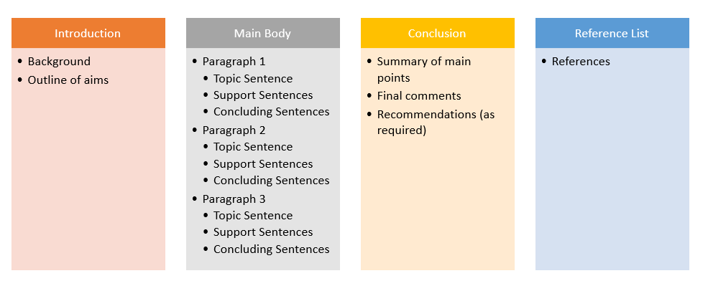

Reference list

[1] ETBI FET digital library- *Academic writing:structure.* Available at:

<https://library.etbi.ie/writing/structure>

[2]University of Reading- *Academic writing.* Available at:

<https://libguides.reading.ac.uk/writing/style>

[3]University of Notre Dame Library - *APA referencing 7th edition.* Available at:

<https://library.nd.edu.au/instruction/referencing/apa7/images>