

Group Assessment Coversheet

To be attached to the front of the assessment.

**Campus: Pretoria and Bedfordview**

**Faculty: Information Technology**

**Module Code: ITEHA3-B33**

**Group: 2**

**Lecturer’s Name:** **Ms. Magongo. N.**

|  |  |  |
| --- | --- | --- |
| **Indicate** | **Yes** | **No** |
| Plagiarism report attached |  |  |

**Declaration:**

I declare that this assessment is my own original work except for source material explicitly acknowledged. I also declare that this assessment or any other of my original work related to it has not been previously, or is not being simultaneously, submitted for this or any other course. I also acknowledge that I am aware of the Institution’s policy and regulations on honesty in academic work as set out in the Eduvos Conditions of Enrolment, and of the disciplinary guidelines applicable to breaches of such policy and regulations.

Eduvos (Pty) Ltd. (formerly Pearson Institute of Higher Education) is registered with the Department of Higher Education and institution under the Higher Education Act, 101, of 1997. Registration Certificate number: 2001/HE07/008Training as a private higher education

|  |  |  |  |
| --- | --- | --- | --- |
|  | |  | **% Participated** |
| **1** | **Student Full Name** | **Lea Thumbiran** | **50%** |
| **Student Number** | **LMTPQFTH6** |
| **Contact Number** | **079 898 2004** |
| **Signature** |  |
| **2** | **Student Full Name** | **Arno Moller** | **50%** |
| **Student Number** | **CC96ZRRS5** |
| **Contact Number** | **071 641 1562** |
| **Signature** |  |

**Lecturer’s Comments:**

|  |  |  |  |
| --- | --- | --- | --- |
| **Marks Awarded:** |  |  | **%** |

|  |  |
| --- | --- |
| **Signature** | **Date** |

Group Assignment Coversheet 2021 | V1.1 Page 2 of 2

**Eduvos**

**Enterprise Programming in C#**

**(ITEHA3-B33)**

**Group Assignment**

**Ms. Magongo. N**

**Lea Thumbiran LMTPQFTH6**

**8 August 2023**

Table of Contents

Question 1: 1

1.1) 1

1.2) 3

1.3) 3

Bibliography 4

# Question 1:

## 1.1)

The user flow diagram showing the login and registration process for the chatting application is shown below:

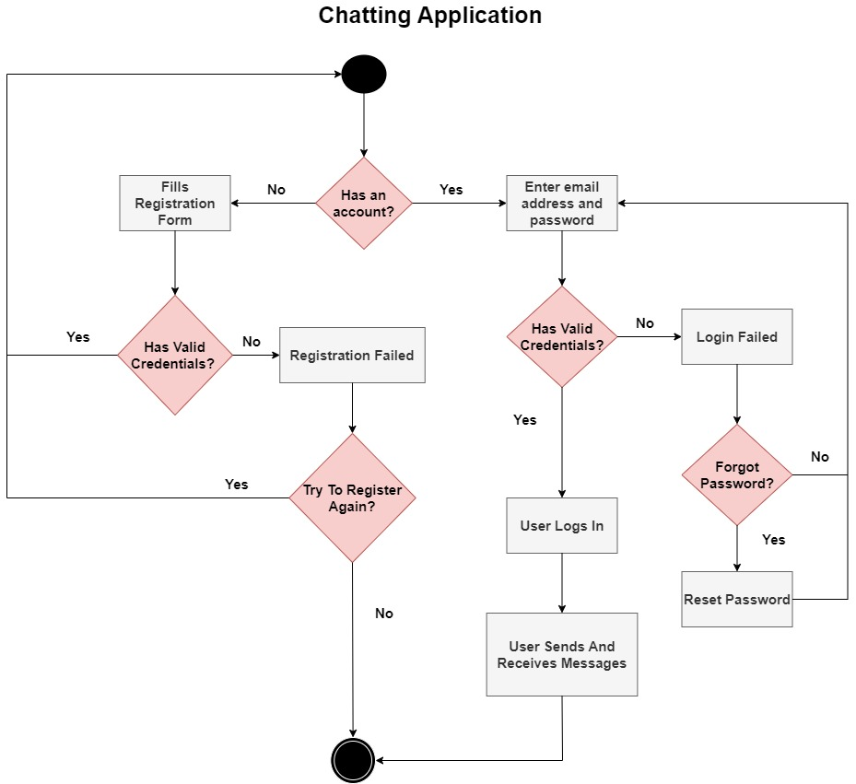

Figure 1 – User flow diagram of a login and registration process for a chatting application (Ivonna, 2022).

The diagram above does the following:

* The chatting application starts and checks if the user has an account:
  + If the user does not have an account, they are directed to the registration page, here the user will fill out their account details, if the details are valid then they are redirected to the login page and can then log in with their account details. If the account details are invalid (such as their email address does not exist or their password and confirm password do not match) the registration will fail, the user can then try to register again or close the chatting application.
  + If the user does have an account, then they can enter their email address and password, if their details are valid, then they can log in and send and receive messages on the chatting application. If their details are invalid, the login will fail, the user can then request to reset their password or try to log in again.

The system architecture diagram for the chatting application is shown below:

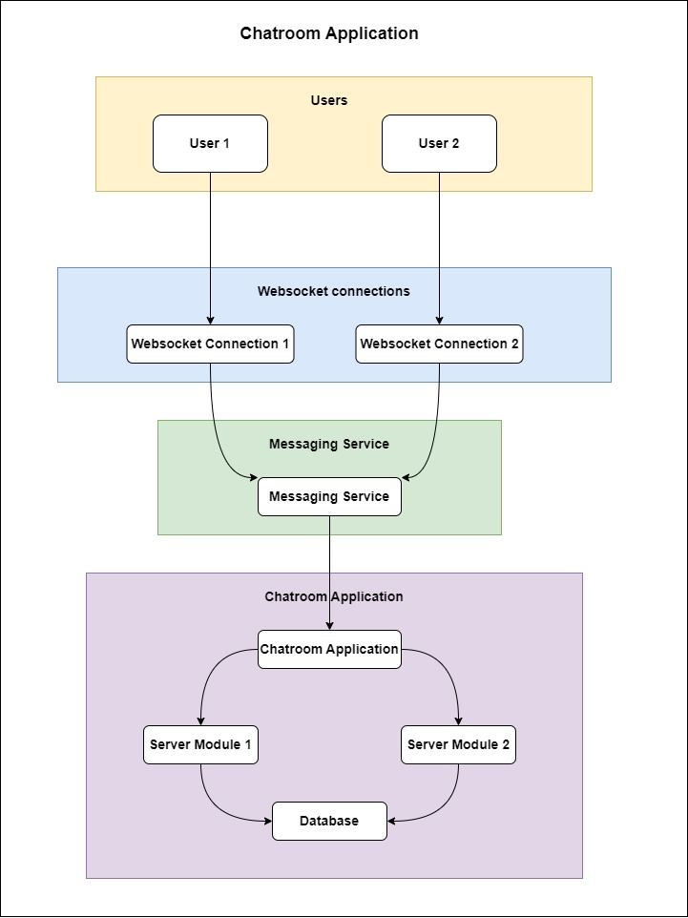

Figure 2 - System architecture diagram of a chatting application (Pareek, 2023).

The diagram above does the following:

## 1.2)

## 1.3)

# Bibliography

edrawsoft, 2023. *System Architecture Diagram: A Complete Tutorial.* [Online]   
Available at: https://www.edrawsoft.com/article/system-architecture-diagram.html  
[Accessed 13 August 2023].

InterviewBit, 2023. *System Architecture – Detailed Explanation.* [Online]   
Available at: https://www.interviewbit.com/blog/system-architecture/  
[Accessed 13 August 2023].

Ivonna, C., 2022. *What is a User Flow Diagram and How to Create One?.* [Online]   
Available at: https://venngage.com/blog/user-flow-diagram/  
[Accessed 13 August 2023].

Pareek, K., 2023. *Architecture of a System.* [Online]   
Available at: https://www.geeksforgeeks.org/architecture-of-a-system/  
[Accessed 13 August 2023].