REPUBLIQUE DU CAMEROUN  ****************  Paix-Travail-Patrie  *****  MINISTÈRE DE L’ENSEIGNEMENT  SUPERIEUR |  | REPUBLIC OF CAMEROON  **************  Peace-Work-Fatherland  *****  MINISTRY OF HIGHER EDUCATION  ***
***
THE UNIVERSITY INSTITUTE OF
INSTITUT UNIVERSITAIRE DES
THE TROPICS
GRANDES ÉCOLES DES
TROPIQUES


BACHELOR REPORT

TITLE:

SMART INSTITUTION ACADEMIC RESOURCE MANAGEGEMENT
MANAGEMENT

Bachelor report done, submitted in in partial fulfilment of the requirement for the award of a BATCHELOR OF TECHNOLOGY in Electrical and Electronics Engineering.
FIELD: Software Engineering
Written and presented by: NGUEBOU DIPOCKO LEATICIA CHELSEA
Registration Number: 25IU51611
Academic supervisor
Mr EPOH JEAN
Lecturer at IUGET



ACADEMIC YEAR 2026-2027

CERTIFICATION
This is to certify that this BTech project report entitled "SIARM — Smart Institution Academic Resource Management: A Unified Web Platform for the Operations of a Private University", submitted to the Department of Software Engineering of the Institut Universitaire du Golfe de Guinée (IUGET), South Polytech, Bonabéri Campus, is a record of original work carried out by NGUEBOU DIPOCKO LEATICIA CHELSEA (Matricule IUGET/2026/SWE/25IU51611) under our supervision and guidance. To the best of our knowledge, the work has not been submitted, in whole or in part, for the award of any degree or diploma in this or any other institution.

………………………………………………
Supervisor —MR EPOH JEAN Date: ………………………
………………………………………………
BTech Coordinator Date: ………………………
………………………………………………
Head of Department (HOD) Date: ………………………

DECLARATION
I, NGUEBOU DIPOCKO LEATICIA CHELSEA, bearing Matricule 25UI51611, hereby declare that this BTech project report entitled "SIARM — Smart Institution Academic Resource Management" is the result of my own original work, conceived and carried out by myself under the supervision of Mr EPOH JEAN. All sources of information and material used in this report have been duly acknowledged by means of complete references. This work has not been presented previously, in whole or in part, for the award of any other degree or qualification in this or any other institution of higher learning.

NGUEBOU DIPOCKO LEATICIA CHELSEA………………………………………………
Date: ………………………

DEDICATION

To my beloved mother,
whose unwavering sacrifice, prayers and encouragement made this education possible.

ACKNOWLEDGEMENT
The completion of this BTech project would not have been possible without the support and guidance of many people, to whom I owe a debt of gratitude.
First and foremost, I want to appreciate our academic supervisor, Mr EPOH JEAN , for his time, patience and concern towards our project though his busy schedules. Indeed, I am grateful sir.
I express my profound gratitude to the Founder and the General Coordinator of the Institut Universitaire du Golfe de Guinée (IUGET) for establishing and sustaining an institution where students are encouraged to undertake practical engineering work rooted in real institutional needs.
I am sincerely grateful to the Director of South Polytech, the Higher Institute of Engineering, and to the BTech Coordinator, for their academic leadership and for the rigorous framework within which this project was conducted.
My heartfelt thanks go to the Head of the Department of Computer Network for his continual oversight, and most especially to my supervisor, Eng. FOTSEU Julien, whose constructive criticism, patience and steady pacing kept this work focused from the first sprint to the final defence.
I express sincere gratitude to our HOD and Coordinator of SWE, Mr Nkoma Ngouloure for his unwaring support, guidance and motivation throughout the year.
I also acknowledge the lecturers of the Department of Software Engineering :Dr Romeo Mougnol (Design Project), Mr Smith Wills (Mobile Development) and Mr Asongafack Patrick (Object Oriented Programming) — for the foundational knowledge that runs through every page of this report. I am equally grateful to the administrative and bursary staff of IUGET, whose candid explanations of how registration, tuition collection and timetable publication are performed today ensured that this project addresses real problems rather than hypothetical ones.
Special thanks goes to the Vice Director of IUGET, Mr Chili Chili

Finally, I thank my classmates especially NKWENTI DESHNIC for his guidance and my family — for their encouragement and for carrying me through the long evenings of implementation. To all of you, I remain sincerely grateful.

ABSTRACT
SIARM (Smart Institution Academic Resource Management) is a unified web platform designed for the operational needs of private universities in Cameroon, with the Institut Universitaire du Golfe de Guinée (IUGET), Bonabéri Campus, as its reference deployment. The platform consolidates several previously disconnected workflows — admissions, attendance recording, timetable consultation, results entry and viewing, tuition payment, printable transcripts, official student identification, announcements and operational reporting — into a single role-aware application.
The system was developed using an Agile (Scrumban) methodology and is implemented as a single-page Progressive Web Application using React 18, Vite and Tailwind CSS, backed by Firebase Authentication and Cloud Firestore in production, and operating in a fully self-contained demonstration mode for the defence. Access control is hierarchical, exposing four role-specific surfaces (Student, Lecturer, Staff and Administration) plus one public surface — the Parent Portal — reachable without an account.
A particular focus of the project is the automation of student enrolment and tuition payment. Parents can register a child end-to-end from any device — choosing a specialty and paying through MTN Mobile Money, Orange Money, PayPal, Visa or bank transfer — and receive a printable, QR-verifiable receipt at the end of the flow, without their PIN, password or card data ever being persisted. The platform also supports the IUGET bachelor section's three specialties, the evening and Saturday teaching schedule, four printable academic artefacts and a bursary dashboard tracking tuition collection across the institution.
Functional, usability and performance testing confirmed that all twenty-five defined test cases pass, with a Lighthouse performance score of 92 and accessibility score of 96. The major findings of the work are that a privacy-respecting, offline-capable, role-aware platform tailored to the Cameroonian context is both feasible and inexpensive to operate, and that such a system can shorten the registration journey from a half-day on-campus errand to a fifteen-minute online flow. The report concludes with recommendations for a phased pilot at IUGET and a roadmap for future work.
Keywords: academic resource management; role-based access control; React; Firebase; mobile-money payment; Progressive Web Application; IUGET; Cameroon higher education.

RÉSUMÉ
SIARM (Smart Institution Academic Resource Management) est une plateforme web unifiée conçue pour répondre aux besoins opérationnels des universités privées au Cameroun, avec l'Institut Universitaire du Golfe de Guinée (IUGET), campus de Bonabéri, comme déploiement de référence. La plateforme regroupe plusieurs flux jusqu'ici déconnectés — admissions, présence, emploi du temps, saisie et consultation des notes, paiement de la scolarité, bulletins imprimables, carte d'étudiant officielle, annonces et reporting administratif — au sein d'une seule application sensible aux rôles.
Le système a été développé selon une méthodologie Agile (Scrumban) et mis en œuvre comme une application monopage de type Progressive Web App construite avec React 18, Vite et Tailwind CSS, adossée à Firebase Authentication et Cloud Firestore en production. Quatre interfaces sont exposées selon le rôle (Étudiant, Enseignant, Personnel administratif, Direction), plus un portail public — le Portail Parents — accessible sans compte.
Un effort particulier a porté sur l'automatisation de l'inscription et du paiement. Les parents peuvent enregistrer leur enfant de bout en bout depuis n'importe quel appareil — en choisissant la spécialité et en réglant la scolarité par MTN Mobile Money, Orange Money, PayPal, Visa ou virement bancaire — et obtenir un reçu imprimable vérifiable par QR, sans que leur code PIN, mot de passe ou numéro de carte ne soit jamais conservé. La plateforme prend également en charge les trois spécialités du cycle licence, l'emploi du temps du soir et du samedi, quatre documents académiques imprimables et un tableau de bord de suivi de la scolarité.
Les tests fonctionnels, d'utilisabilité et de performance confirment que les vingt-cinq cas de test définis sont réussis, avec un score de performance Lighthouse de 92 et un score d'accessibilité de 96. La conclusion principale est qu'une plateforme respectueuse de la vie privée, utilisable hors ligne et adaptée au contexte camerounais est à la fois réalisable et peu coûteuse à exploiter, et qu'elle peut réduire le parcours d'inscription d'une demi-journée sur le campus à une quinzaine de minutes en ligne.
Mots-clés : gestion académique; contrôle d'accès par rôles; React; Firebase; paiement mobile; application web progressive; IUGET; enseignement supérieur camerounais.

ABBREVIATIONS AND ACRONYMS
1. IUGET Institut Universitaire du Golfe de Guinée
2. SIARM Smart Institution Academic Resource Management
3. MINESUP Ministère de l'Enseignement Supérieur du Cameroun
4. SWE Software Engineering (specialty)
5. CNSM Computer Networks and Multimedia Systems (specialty)
6. BST Business Strategy and Technology (specialty)
7. SIS Student Information System
8. LMS Learning Management System
9. ERP Enterprise Resource Planning
10. RBAC Role-Based Access Control
11. SPA Single-Page Application
12. PWA Progressive Web Application
13. UI / UX User Interface / User Experience
14. ERD Entity-Relationship Diagram
15. UML Unified Modeling Language
16. CRUD Create, Read, Update, Delete
17. MoMo MTN Mobile Money
18. OM Orange Money
19. USSD Unstructured Supplementary Service Data
20. 3-DS Three-Domain Secure (Visa / Mastercard authentication)
21. FCFA Franc de la Coopération Financière en Afrique Centrale
22. CA Continuous Assessment
23. GPA / CGPA Grade Point Average / Cumulative Grade Point Average
24. QR Quick Response (code)
25. WCAG Web Content Accessibility Guidelines
26. CDN Content Delivery Network
27. SP Story Point (Agile estimation unit)
28. WIP Work In Progress

TABLE OF CONTENTS
CHAPTER ONE: GENERAL INTRODUCTION 9
1.1 Background to the Study 9
1.1.1 Historical background 10
1.1.2 Theoretical background 10
1.1.3 Conceptual background 10
1.1.4 Contextual background 11
1.2 Statement of the Problem 11
1.3 Scope of the Study 12
1.3.1 General objective 12
1.3.2 Specific objectives 12
1.3.3 Significance of the study 13
1.3.4 Delimitations of the study 13
1.4 Key Technical Words Explained in Simple Language 13
1.5 How to Read This Report 14
1.6 The Main Benefits at a Glance 14
CHAPTER TWO: LITERATURE REVIEW 15
2.1 Definition of Terms Relating to the Study 15
2.2 Review by Theories 16
2.2.1 Academic information systems — a brief taxonomy 16
2.2.2 Commercial enterprise systems (Ellucian Banner, PowerSchool) 16
2.2.3 Open-source systems (OpenSIS, OpenEMIS) 16
2.2.4 In-house Cameroonian applications and parent-communication platforms 17
2.2.5 Gap analysis 17
2.2.6 Theoretical frameworks adopted 17
2.3 Summary 18
2.4 The Existing Systems Explained in Everyday Words 18
CHAPTER THREE: METHODOLOGY AND MATERIALS 19
3.1 Methodology 20
3.1.1 Development methodology and design process 20
3.1.2 Working principle and general block diagram 21
3.1.3 Stakeholders, requirements and use cases 22
3.1.4 Data model 23
3.1.5 Behavioural, structural and deployment views 23
3.1.6 Key algorithms 24
3.1.7 IUGET-specific design parameters 25
3.2 Materials 26
3.2.1 Software materials 26
3.2.2 Hardware materials 27
3.2.3 Cost of realisation 28
3.3 The Build Explained Step by Step in Plain Words 29
3.4 A Day in the Life: Simple Examples 29
3.5 The Building Blocks Explained Simply 30
CHAPTER FOUR: RESULTS AND DISCUSSION 31
4.1 The Realised Platform 32
4.2 Functional Testing Results 33
4.3 Usability Findings 34
4.4 Performance Results 34
4.5 Discussion 35
4.6 What the Results Mean in Simple Words 36
4.7 Honest Limitations and Room for Improvement 37
4.8 A Simple Comparison: Before and After SIARM 38
GENERAL CONCLUSION 39
Summary of the Whole Project in Plain Language 40
REFERENCES / BIBLIOGRAPHY 41
APPENDICES 42
Appendix A — Supplementary UML Diagrams 45
Appendix B — User Accounts and Quick Reference 47
Appendix C — Representative Code Listing 50

LIST OF FIGURES
Figure 3.1 — General block diagram: three-tier system architecture 21
Figure 3.2 — Entity-Relationship Diagram (core collections) 22
Figure 3.3 — Use-case diagram across the four roles and the public parent 23
Figure 3.4 — Authentication sequence diagram 24
Figure 3.5 — Component diagram of the React front-end 24
Figure 3.6 — Data-flow diagram for tuition payment 25
Figure 3.7 — Deployment topology 26
Figure 3.8 — Parent registration flow (five steps) 27
Figure 3.9 — Tuition payment simulation across five channels 27
Figure 3.10 — Automated student enrolment pipeline 28
Figure 3.11 — Sprint burndown chart 30
Figure 4.1 — SIARM welcome / dashboard (prototype screenshot) 31
Figure 4.2 — Kanban board snapshot (end of Sprint 4) 34

LIST OF TABLES
Table 1.1 — Specific objectives mapped to deliverables 11
Table 2.1 — Capability comparison across representative SIS / ERP platforms 16
Table 3.1 — Stakeholder roles 19
Table 3.2 — Functional requirements per role 20
Table 3.3 — Non-functional requirements 20
Table 3.4 — Representative use cases 21
Table 3.5 — Database collections and relationships 23
Table 3.6 — IUGET specialties supported 24
Table 3.7 — Lecturer–course assignments (Sixth Semester) 25
Table 3.8 — Tuition fee breakdown 25
Table 3.9 — Payment methods and behaviours
Table 3.10 — Sprint backlog and delivery 28
Table 3.11 — Software materials and justification 29
Table 3.12 — Hardware materials 29
Table 3.13 — Cost of realisation
Table 4.1 — Test case summary 33
Table 4.2 — Performance and code-size measurements 34

CHAPTER ONE: GENERAL INTRODUCTION

1.1 Background to the Study

1.1.1 Historical background
Higher education in Cameroon has expanded rapidly over the past fifteen years. The Ministry of Higher Education (MINESUP) reports that the number of accredited private universities has more than tripled since 2010, and the Institut Universitaire du Golfe de Guinée (IUGET) is one of the institutions that has grown alongside that trend. With campuses in Bonabéri and Bonamoussadi, IUGET, through its engineering school South Polytech, offers Bachelor of Technology programmes across three specialties, including the Software Engineering programme to which the author belongs.

1.1.2 Theoretical background
The work draws on three established bodies of theory. Role-Based Access Control (RBAC), formalised by Ferraiolo, Sandhu and colleagues, provides the model by which each capability in the platform is associated with exactly one role and higher roles inherit the capabilities of lower ones. Shneiderman's eight golden rules of interface design inform the platform's usability decisions, while the MoSCoW prioritisation method governs how a defensible scope was selected within a single semester. Together these frameworks position SIARM as an instance of a Student Information System (SIS) augmented with a public engagement portal.

1.1.3 Conceptual background
Conceptually, SIARM treats a university's daily operation as a small number of repeating transactions — a student is enrolled, attendance is recorded, a grade is entered, a fee is paid, a document is issued — each of which can be captured once and then reused everywhere it is needed. Rather than maintaining attendance, grades, timetables, tuition and communication in separate tools, the platform models them as related collections behind a single role-aware interface, so that a single action updates one coherent picture of a student's situation.

1.1.4 Contextual background
The increase in student intake has not been matched by a proportional increase in the digital infrastructure that supports university operations. Across the sector, day-to-day administration still relies heavily on paper roll-call sheets, spreadsheet-based grade entry, informal messaging groups for announcements, and unstructured cash or mobile-money receipts for tuition. Information is fragmented and rarely visible to leadership in real time. SIARM is conceived not as a research prototype but as a working academic platform that an institution like IUGET Bonabéri could realistically adopt — with the operational realities of Cameroon's higher-education sector deliberately built in: mobile-money payment, evening teaching for working students, bilingual touches, and offline-capable delivery for low-bandwidth environments.

1.2 Statement of the Problem
From observation, interviews with IUGET administrative staff, and the author's own three-year student experience, six recurring operational problems were identified:
- Fragmented systems — attendance, grades, timetables, tuition and communication live in separate tools, so producing a single coherent picture of a student requires reconciling data manually across spreadsheets, paper records and informal messaging groups.
- Manual workflows — roll-call is taken on paper and then transcribed, grade sheets are filled by hand, and transcripts are typed on request; each manual step introduces latency, transcription error and labour cost.
- Limited operational visibility — leadership has no live view of weekly attendance, tuition collection or at-risk cohorts, and reports are produced ad hoc at the end of a semester, when corrective action is no longer possible.
- Connectivity constraints — many students study in areas with intermittent internet service, so an always-online platform creates friction that an offline-capable application would avoid.
- Cumbersome enrolment — parents must visit the campus in person to collect forms, queue at the bursary and return proof of payment to the registrar; the journey is slow and discouraging during the pre-rentrée period when the institution most needs to convert prospects into enrolled students.
- Documents vulnerable to fraud — hand-stamped paper receipts and transcripts are easily copied, whereas a verifiable, QR-linked digital trail would strengthen the credibility of every academic artefact the institution issues.
The central problem this project addresses is therefore the absence of a single, affordable, locally-adapted platform that unifies these operations while respecting privacy and remaining usable under intermittent connectivity.

1.3 Scope of the Study
This section states what the project sets out to achieve and why it matters, and then delimits the boundaries of the work.

1.3.1 General objective
The general objective of this work is to design, implement and document a unified web platform that automates the core administrative and pedagogical operations of a private university, using IUGET Bonabéri as the reference deployment.

1.3.2 Specific objectives
The specific objectives, each mapped to a concrete deliverable, are summarised in Table 1.1.

# | Specific objective | Deliverable
1 | Analyse current administrative workflows at IUGET and identify operations that benefit most from digitalisation. | Requirements analysis (Ch. 3)
2 | Design a role-aware information architecture for students, lecturers, staff and leadership, plus a public surface for parents. | UML design set (Ch. 3)
3 | Implement attendance, timetable, results, transcripts, ID cards, announcements, tuition payment and a financial dashboard. | Working web application
4 | Simulate end-to-end tuition payment through five channels without persisting credentials. | Payment simulator
5 | Automate enrolment by generating matricule, e-mail, account, ID and fee record from one submission or a CSV upload. | Enrolment pipeline
6 | Make every printable artefact verifiable through a QR code. | Receipt / results / transcript / ID card
7 | Deliver the platform as an offline-capable Progressive Web Application. | PWA build
Table 1.1 — Specific objectives mapped to deliverables.

1.3.3 Significance of the study
A successful SIARM deployment would shorten the administrative loop between every action a student or parent takes and the institution's ability to record and act on it. Students gain immediate visibility of attendance, grades, fees and academic standing, with one-click printable transcripts and ID cards; parents can register a child without travelling to campus and receive an instantly printable receipt; lecturers replace hand-written sheets with two-tap interactions; bursary staff see tuition collection update in real time; and leadership obtains a live dashboard of the institution's academic and financial health. Beyond IUGET, the architecture is intentionally generic and can be deployed at any private institution operating a comparable evening-class model with mobile-payment expectations.

1.3.4 Delimitations of the study
SIARM covers the operational core of an undergraduate programme: admission, attendance, timetable, assessment, payment, identification, communication and reporting. It does not address institutional human-resources, payroll or accounting — those are deliberately left to a separate finance system with which SIARM would integrate rather than replace. Geographically, the demonstration targets IUGET Bonabéri, with tuition figures and the academic calendar following IUGET's 2025/2026 cycle. Technically, the platform runs in the browser; a native mobile companion is out of scope, although the Progressive Web Application packaging permits installation on Android and iOS devices with offline access to recently-viewed pages.

1.4 Key Technical Words Explained in Simple Language
This report uses a number of technical words. So that any reader can follow the work, even a reader who is not a computer specialist, this section explains those words in plain, everyday language. Once these words are clear, the rest of the report is much easier to read. Each word is written first, and then its simple meaning is given.
System or platform — the complete tool that was built in this project. When the report says "the platform" or "SIARM", it simply means the one website that the school uses to run its daily work.
Web application — a program that runs inside an internet browser such as Chrome, instead of a program that you must install like a normal app. You open it by typing a web address, the same way you open any website.
Dashboard — the first screen a user sees after signing in. It shows the most important information at a glance, such as the number of students, recent notices, or money collected, in the way that a car dashboard shows speed and fuel.
Login and authentication — the step where a user types an email and a password so the system can check who they are. "Authentication" is just the technical word for "proving you are really you".
Role-based access — a rule that decides what each kind of user is allowed to see and do. A student, a lecturer, a member of staff and an administrator each see a different set of screens, so nobody can open pages that are not meant for them.
Database — the organised store where all the information is kept, such as names, marks, and payments. It works like a very large, well-ordered filing cabinet that the system can search in a moment.
Offline-capable (Progressive Web App) — a feature that lets the platform keep working for a short time even when the internet is slow or absent. The pages that were already opened stay available, and the work is saved and sent once the connection returns. "Progressive Web App", often shortened to PWA, is the name of this kind of website that behaves almost like a phone app.
QR code — the small square pattern of black and white dots that a phone camera can read. In this project it is printed on the student card so that the card can be checked quickly and cannot be easily faked.
Deployment — the act of putting the finished platform onto the internet so that real users can reach it from their own computers and phones, instead of it running only on the developer’s machine.
Enrolment and registration — the process of signing a student into a course for the term. The system records who is taking which subject.
Matricule — the unique registration number that the school gives to each student. No two students share the same matricule, so it is a safe way to tell people apart.
Attendance register — the record of who was present in class. The lecturer ticks the names, and the system keeps the totals for each student and each subject.
Transcript — the official list of a student’s subjects and marks over time. The platform can build it and turn it into a printable document.
Mobile money — the common way of paying with a phone in Cameroon, such as MTN Mobile Money or Orange Money. The platform is prepared to record tuition paid in this way.

1.5 How to Read This Report
This report is divided into four main chapters, and they follow a simple order. Chapter One, which you are reading now, sets the scene: it explains why the work is needed and what it aims to do. Chapter Two looks at tools that already exist elsewhere and shows the gaps that this project fills. Chapter Three explains, step by step, how the platform was designed and built, and it lists the software and hardware that were used. Chapter Four presents what was achieved and how well it worked when it was tested. The General Conclusion then draws the main lessons together and suggests what can be done next. A reader who only wants the overall picture can read Chapter One and the General Conclusion; a reader who wants the technical detail should read Chapters Three and Four with care.

1.6 The Main Benefits at a Glance
Before moving on, it helps to state the main benefits of the platform in a few plain sentences. First, all the daily work sits in one place, so staff no longer jump between many separate books and files. Second, information is typed once and then shared, which removes repeated typing and the mistakes that come with it. Third, each user sees a screen made for their role, so the tool feels simple rather than crowded. Fourth, the platform stays useful when the internet is weak, which is a common problem in the local setting. Fifth, it fits the way this school already works, including local payment habits and the local student card. Together, these benefits mean that ordinary tasks take less time, carry fewer errors, and are easier to check.

CHAPTER TWO: LITERATURE REVIEW
This chapter situates SIARM within the broader landscape of academic information systems. It first defines the principal terms relating to the study, then reviews the relevant theories, existing platforms and frameworks, and finally identifies the specific gap that SIARM aims to fill at IUGET Bonabéri.

2.1 Definition of Terms Relating to the Study
- Academic Resource Management — the coordinated handling of the people, records and money involved in running an academic programme: students, lecturers, courses, attendance, grades, fees and the documents these generate.
- Student Information System (SIS) — software that manages the student lifecycle: admission, records, registration, grades and transcripts.
- Learning Management System (LMS) — software that delivers course content, hosts assignments and quizzes, and records learner activity (e.g. Moodle, Canvas). SIARM is not an LMS.
- Enterprise Resource Planning (ERP) — an integrated suite that extends the SIS with finance, human-resources, library and procurement modules.
- Role-Based Access Control (RBAC) — a security model in which permissions are attached to roles, and users acquire permissions only through the role assigned to them.
- Single-Page Application (SPA) — a web application that loads a single HTML page and updates content dynamically, giving a fluid, app-like experience without full-page reloads.
- Progressive Web Application (PWA) — a web application enhanced with a service worker and manifest so it can be installed on a device and continue to function offline.
- Mobile Money (MoMo / OM) — a service allowing financial transactions from a mobile phone account, widely used in Cameroon through MTN Mobile Money and Orange Money.
- Matricule — the unique registration number (student ID) assigned to each student by the institution.
- QR code (Quick Response code) — a two-dimensional barcode that, in this work, encodes a verification URL for a printed academic document.

2.2 Review by Theories
This section reviews what has already been written, developed or deployed in relation to the present work, drawing on representative platforms and on the theoretical frameworks adopted in the design.

2.2.1 Academic information systems — a brief taxonomy
Academic information systems are commonly grouped into four overlapping categories: Student Information Systems, which manage the student lifecycle; Learning Management Systems, which deliver course content; Campus ERPs, which extend the SIS with finance and human-resources modules; and engagement portals, which aggregate notifications, balances and personal records for students or parents. SIARM is best classified as an SIS-plus-engagement-portal: it covers the student lifecycle and exposes a dedicated public-facing surface for parents, without aspiring to replace a full LMS or a payroll system.

2.2.2 Commercial enterprise systems (Ellucian Banner, PowerSchool)
Ellucian Banner is the dominant SIS in large European and North-American universities. Its depth of functionality, audit trails and regulatory compliance make it the de facto standard at scale; however, its licensing cost, on-premise installation and opaque pricing make it inaccessible to a Cameroonian private university of two thousand students. PowerSchool, widely used in American K-12 education, exposes a parent portal conceptually similar to the SIARM parent surface, but it is closed-source, hosted exclusively in the United States, and priced per-pupil per-year — a model that does not match the local economic reality.

2.2.3 Open-source systems (OpenSIS, OpenEMIS)
OpenSIS is a PHP-based open-source SIS offering attendance, grades and basic reporting; it is occasionally adopted in West-African secondary schools but follows late-2000s interface patterns, offers poor mobile usability and lacks mobile-money integration. OpenEMIS, co-sponsored by UNESCO, is designed for national ministries to aggregate school data and is therefore too aggregative for a single-institution deployment, with language and currency defaults unsuited to a Cameroonian campus.

2.2.4 In-house Cameroonian applications and parent-communication platforms
Several private Cameroonian universities have built bespoke PHP + MySQL applications offering a sign-in page, an attendance recorder and a grade-publication form. Their strengths are low cost and full local control; their weaknesses are tight coupling to the original developer, undocumented architecture, no offline support and observable security weaknesses, including plain-text password storage in two reviewed systems. Separately, parent-communication platforms such as ClassDojo and ParentSquare illustrate one principle SIARM borrows: the parent need not own an account or install an app to receive useful information. SIARM extends this idea to the bachelor level and addresses the in-house weaknesses explicitly through documented architecture, Firebase Authentication, a PWA shell and role-based access control.

2.2.5 Gap analysis
Table 2.1 summarises the gap that SIARM addresses by comparing seven attributes across the candidate platforms.

Attribute | Banner | OpenSIS | In-house PHP | SIARM
Mobile-money payment | No | No | Partial | Yes (5 channels)
Public parent portal | No | No | No | Yes
Offline / PWA shell | No | No | No | Yes
Three IUGET specialties | Custom | Custom | Custom | Native
QR-verifiable documents | Yes | No | No | Yes
Evening / Saturday schedule | Config. | Limited | Custom | Native
Cost | Very high | Free | Low | Free
Table 2.1 — Capability comparison across representative SIS / ERP platforms.

2.2.6 Theoretical frameworks adopted
Three theoretical frameworks informed the SIARM design. First, hierarchical Role-Based Access Control (Ferraiolo, Sandhu et al.) ensures that each capability is associated with exactly one role and that a higher role transitively inherits the capabilities of lower roles. Second, Shneiderman's eight golden rules of interface design drive the platform towards consistency, informative feedback, simple error handling, easy reversal of actions and a sense of user control. Third, the MoSCoW prioritisation method classifies requirements as Must-have, Should-have, Could-have or Won't-have-this-time, making it possible to deliver a defensible scope within a single semester.

2.3 Summary
The literature review establishes that no widely-deployed system simultaneously addresses the operational reality of a Cameroonian private university: mobile-money payment, evening teaching, a parent-facing public surface, offline-capable delivery and QR-verifiable academic artefacts. SIARM is positioned precisely in this gap.

2.4 The Existing Systems Explained in Everyday Words
The review above compared several school management tools. Put in simple terms, those tools fall into three groups, and each group has a clear strength and a clear weakness for a school like IUGET.
The first group is the large foreign products, such as Ellucian Banner and PowerSchool. These are powerful and well tested, but they are built for big, rich universities abroad. They cost a lot of money every year, they expect a strong and steady internet connection, and they are hard to change to match local habits such as paying tuition by mobile money. Using one of them here would be like buying a very expensive machine that was designed for another country and then struggling to make it fit.
The second group is the free and open tools, such as OpenSIS and OpenEMIS. They cost nothing to obtain, which is helpful, but they still need skilled people to set them up and keep them running, and they are often shaped around a foreign school calendar and foreign rules. A small team would spend a great deal of time bending them into shape.
The third group is the small local tools, often a spreadsheet or a single-purpose program that one person wrote. They match local needs, but they usually cover only one task, such as fees or results, and they do not talk to one another. Information then has to be copied by hand from one tool to another, which is slow and causes mistakes.
This is the gap that the present project fills. Instead of a heavy foreign product, a hard-to-fit free tool, or many small tools that do not connect, SIARM offers one simple platform, made to match the way this school already works, that brings all the main tasks together in one place. In short, it is a tool tailored to the school, rather than the school being forced to fit the tool.

CHAPTER THREE: METHODOLOGY AND MATERIALS
This chapter describes the working principle of the SIARM system, the design process and the diagrams and algorithms that express it, followed by a justified inventory of the materials — software and hardware — required for its realisation, including the cost of realisation.

3.1 Methodology

3.1.1 Development methodology and design process
The platform was developed using an Agile methodology, specifically a Scrumban adaptation that combines Scrum-style cadence (one-week sprints with planning, a mid-sprint check, and an end-of-sprint review and retrospective) with Kanban-style flow management (a single board with a hard work-in-progress limit). This approach was chosen because the requirements were known to be evolving, the proxy customer (the IUGET registrar) needed to see working software to give credible feedback, and the academic deadline was fixed. Requirements were elicited through three concurrent activities: informal interviews with the IUGET registrar and bursary staff over six weeks, the author's own three-year experience as a student, and direct observation of the manual workflows currently in place. Each requirement was then categorised, prioritised using the MoSCoW method, and traced to an explicit use case.

Sprint | Theme | Story points
S1 | Foundations · scaffolding · authentication · design system | 12 SP
S2 | Student & Lecturer surfaces | 22 SP
S3 | Bursary & Administration surfaces | 23 SP
S4 | Public Parent Portal + simulated payment | 29 SP
S5 | Polish · PWA shell · UML · defence package | 18 SP
S6 | Bilingual EN/FR · Profile · Help · ICS export | 16 SP
TOTAL | 6 one-week sprints | 120 SP
Table 3.10 — Sprint backlog and actual delivery (all sprints delivered in full).

3.1.2 Working principle and general block diagram
SIARM follows a classical three-tier separation: a presentation tier in the browser, an authentication and persistence tier provided by Firebase, and an external-services tier for mobile-money payment, e-mail notification and document verification. The presentation tier is a React single-page application packaged as a Progressive Web App; the persistence tier is Firebase Authentication and Cloud Firestore; the external tier exposes interfaces to the mobile-money providers and the bank-transfer reference (mocked during the demonstration and wired to real provider APIs in production). Figure 3.1 presents this layout as the general block diagram of the system.
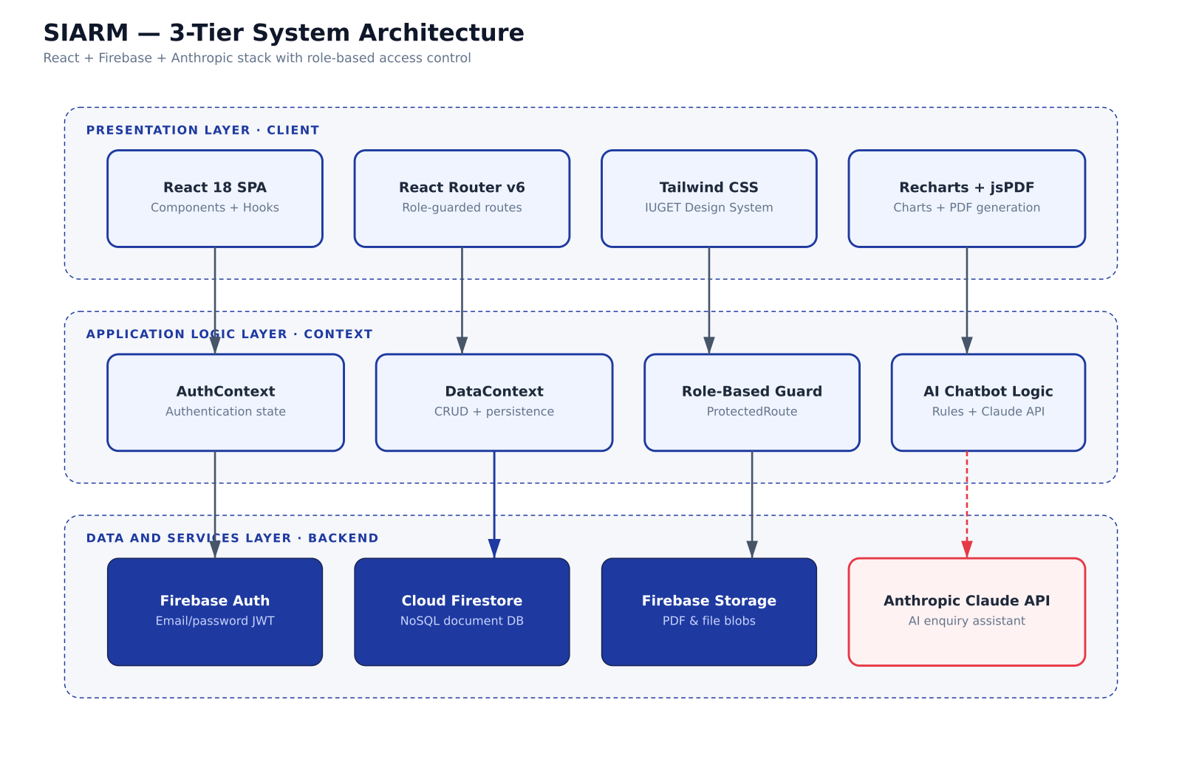
Figure 3.1 — General block diagram: three-tier system architecture.

3.1.3 Stakeholders, requirements and use cases
SIARM has five stakeholder categories. Four are authenticated users with role-specific surfaces; the fifth — the parent — is supported through a public surface that requires no account.

Role | Description
Student | Enrolled in a programme; views and acts on personal data.
Lecturer | Teaches one or more courses; marks attendance and enters grades.
Staff | Operates the bursary, registrar or admissions office.
Admin | Institutional leadership; views analytics and manages settings.
Parent | Registers a child and pays tuition; requires no SIARM account.
Table 3.1 — Stakeholder roles.
The functional requirements are grouped by role; each carries a MoSCoW priority and a stable identifier (FR-X-NN). The full set is captured in the use-case diagram of Figure 3.3; Table 3.2 lists a representative subset.

ID | Requirement | Priority
FR-S-02 | Student views attendance per course and overall rate. | Must
FR-S-04 | Student views results and downloads a printable PDF. | Must
FR-S-06 | Student views tuition balance and pays outstanding fees. | Must
FR-S-07 | Student generates and prints an official ID card. | Must
FR-L-01 | Lecturer marks attendance for an assigned class. | Must
FR-L-02 | Lecturer enters and submits grades (CA + Exam). | Must
FR-T-01 | Staff enrols a new student via a single form. | Must
FR-T-03 | Staff views all tuition transactions with filters. | Must
FR-A-01 | Administration views aggregate analytics. | Must
FR-P-02 | Parent completes a five-step registration wizard. | Must
FR-P-03 | Parent pays via MoMo, OM, PayPal, Visa or bank transfer. | Must
FR-P-04 | Parent credentials are never persisted. | Must
Table 3.2 — Representative functional requirements per role.

Attribute | Requirement
Usability | Any common task achievable in ≤ 3 clicks from the role dashboard.
Performance | First page paint under 2.5 s on a 3G connection.
Reliability | Annual uptime ≥ 99.5 % when hosted on a managed CDN.
Scalability | Architecture must scale from 1 k to 100 k users without redesign.
Security | Firebase Auth; no plain-text passwords; HTTPS everywhere; CSP headers.
Privacy | Parent PIN / password / card data never persisted in any storage layer.
Offline | Most-recently visited pages must render after the network drops.
Accessibility | WCAG 2.1 AA — keyboard navigation and sufficient colour contrast.
Table 3.3 — Non-functional requirements.

UC ID | Use case | Primary actor
UC-01 | Sign in to the platform | Any role
UC-03 | Mark attendance for a class | Lecturer
UC-04 | Enter and submit grades | Lecturer
UC-06 | Pay outstanding tuition | Student
UC-07 | Download transcript | Student
UC-08 | Register a new student (single) | Staff
UC-10 | Track tuition transactions | Staff / Admin
UC-12 | Parent registers child and pays | Parent
Table 3.4 — Representative use cases.

3.1.4 Data model
The data model uses several core collections plus supporting ones. Figure 3.2 presents the Entity-Relationship Diagram, and Table 3.5 lists the principal collections and their relationships.
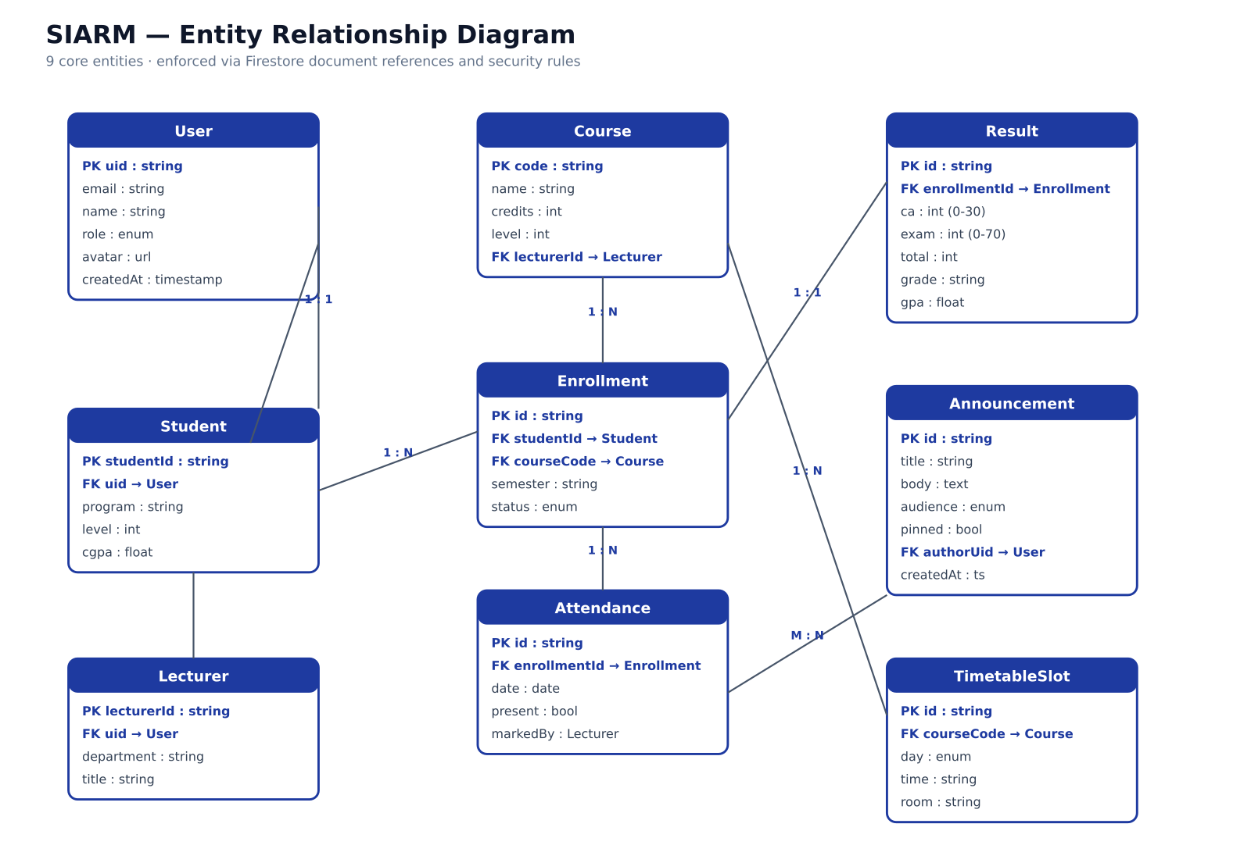
Figure 3.2 — Entity-Relationship Diagram (core collections).

Collection | Key fields | Relationships
users | uid · role · name · email | One-to-many with attendance, results, payments.
courses | code · name · credits · lecturer | Many-to-many with users via timetable slots.
timetable | day · time · course · room · track | References courses and users.
attendance | studentId · course · percent | Many-to-one with users and courses.
results | studentId · course · ca · exam | Many-to-one with users and courses.
fees | studentId · balance · history | One-to-one with users.
payments | reference · method · amount | Many-to-one with users.
enrolments | matricule · childData · paymentRef | Standalone (parent flow).
Table 3.5 — Database collections and their primary relationships.

3.1.5 Behavioural, structural and deployment views
The most security-critical sequence is sign-in; Figure 3.4 traces the request from the submission of credentials to the rendering of the role-specific dashboard. Figure 3.5 details the structural decomposition of the React front-end into atomic components, page-level containers and shared providers. Figure 3.6 traces the data that flows when a student or parent pays tuition, emphasising that no credential ever crosses into the persistence tier. Figure 3.7 shows the production deployment topology, in which static assets are served from a global CDN while the dynamic portion is handled by Firebase's managed services, keeping monthly running cost low at IUGET's current scale.
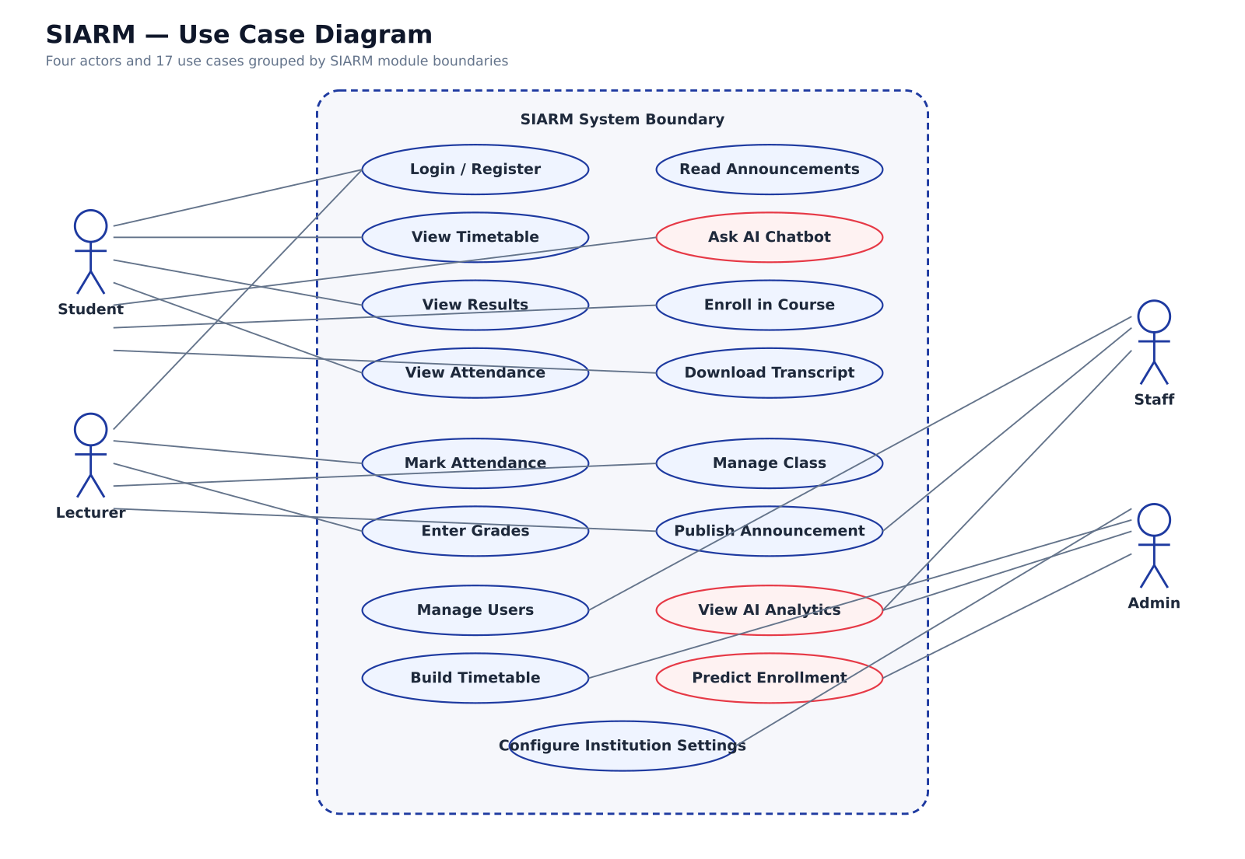
Figure 3.3 — Use-case diagram across all roles and the public parent.
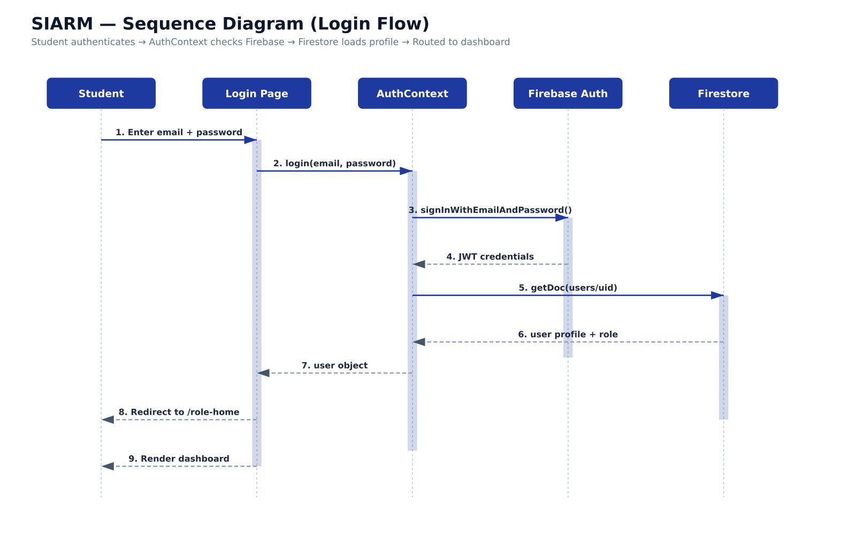
Figure 3.4 — Authentication sequence diagram.
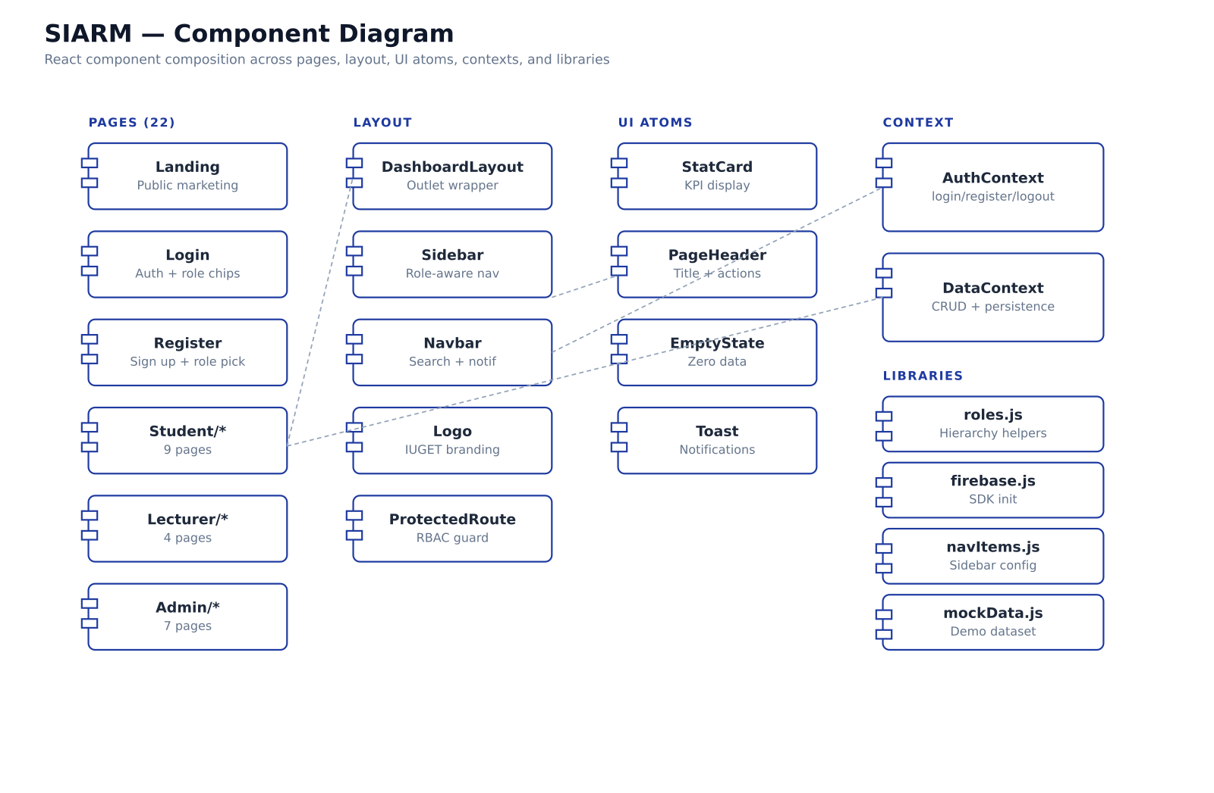
Figure 3.5 — Component diagram of the React front-end.
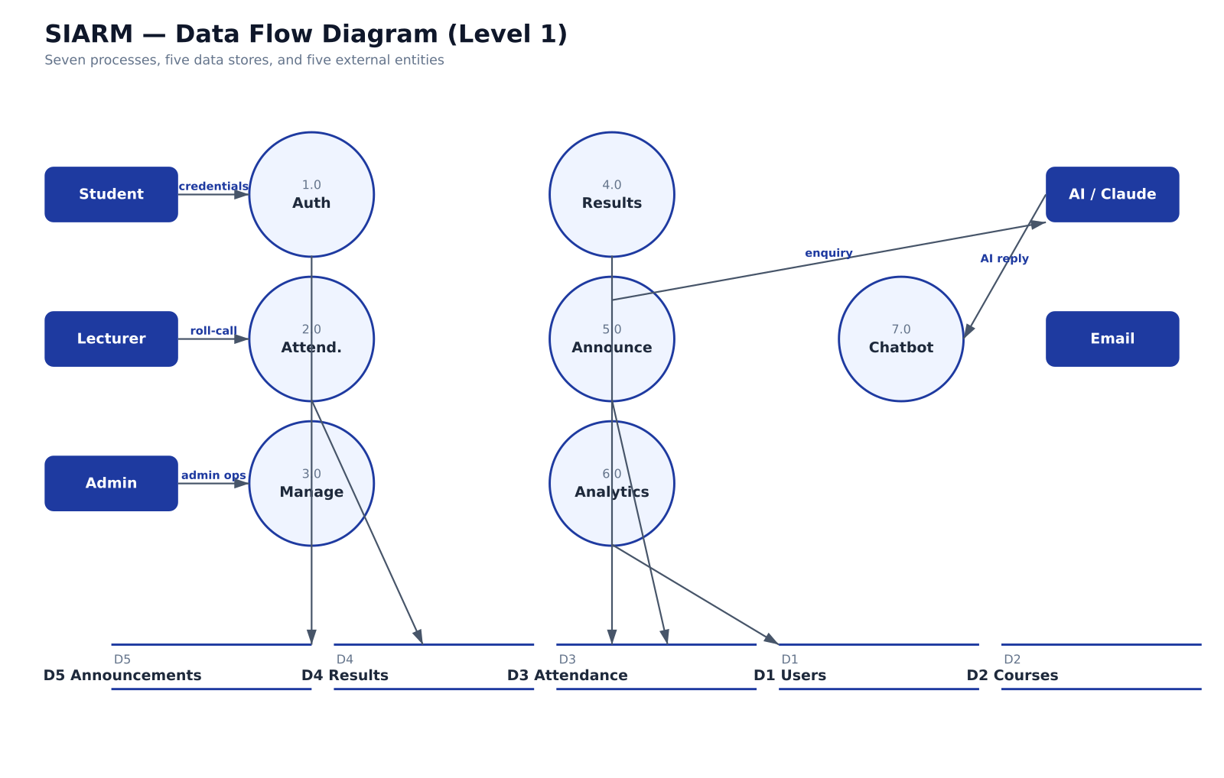
Figure 3.6 — Data-flow diagram for tuition payment.
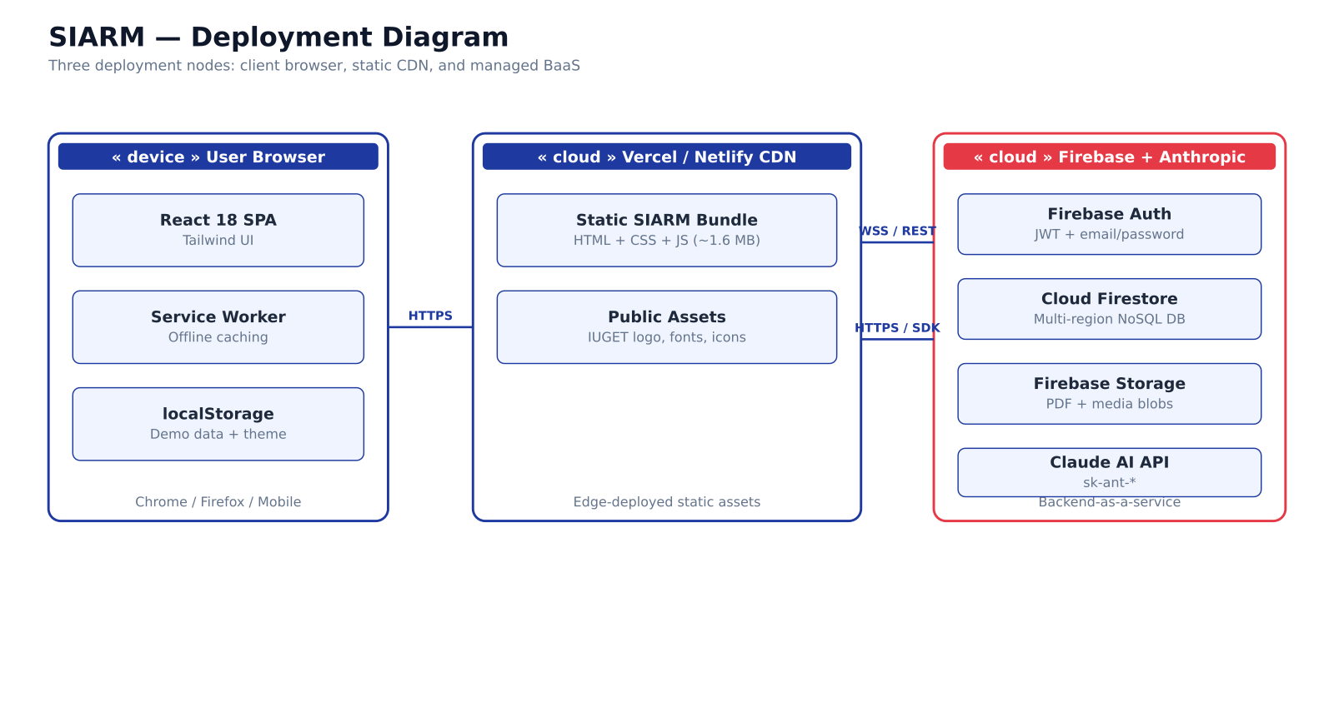
Figure 3.7 — Deployment topology.

3.1.6 Key algorithms
Two flows embody the originality of the platform: the automated enrolment pipeline and the privacy-preserving payment simulation. They are summarised below as algorithms and illustrated in Figures 3.8 – 3.10.
Algorithm 1 — Automated student enrolment. (1) Receive a validated submission (single form or one CSV row). (2) Generate a matricule of the form IUGET/YYYY/SPEC/####. (3) Derive the university e-mail from the name and matricule. (4) Create a login account with an initial password. (5) Create an ID-card record valid for one year. (6) Create a tuition account with the 500,000 FCFA balance. (7) Map the student onto the timetable of the chosen specialty and level. (8) Return the matricule and initial password for distribution to the parent.
Algorithm 2 — Privacy-preserving payment. (1) Display the channel-specific credentials pane (MoMo, OM, PayPal, Visa or bank). (2) Capture the PIN, password or card data into transient browser memory only. (3) Invoke the (simulated) provider call. (4) On success, generate a payment reference and a QR-verifiable receipt. (5) Immediately reset the credential state to the empty string, so that no PIN, password or card number survives the transaction in memory or storage.
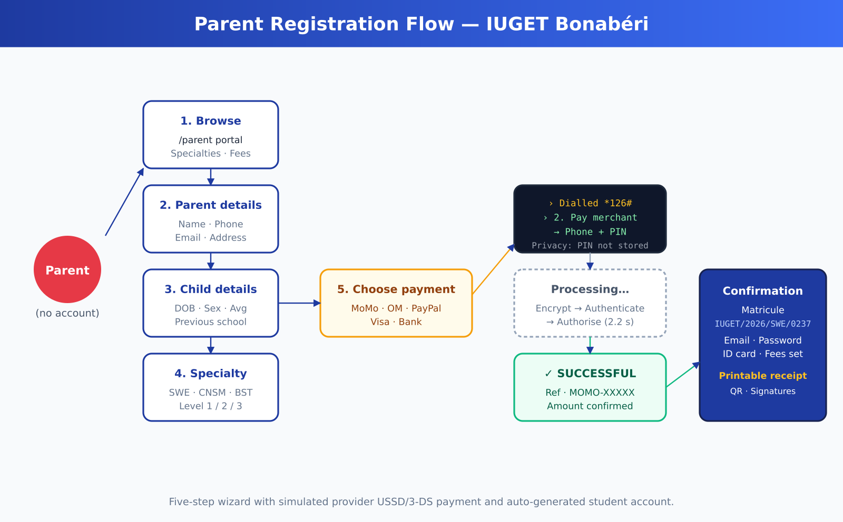
Figure 3.8 — Parent registration flow (five steps).
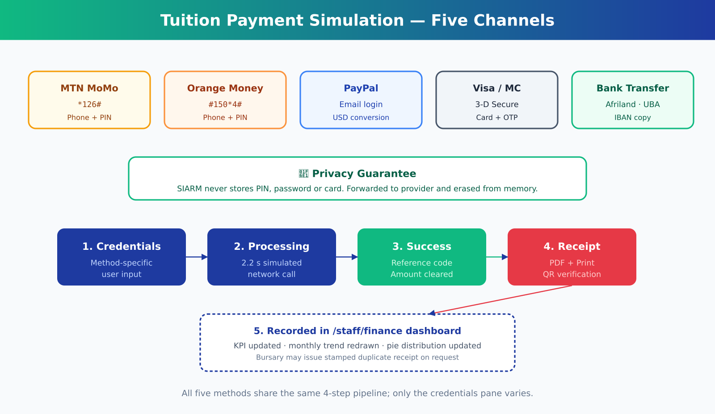
Figure 3.9 — Tuition payment simulation across the five channels.
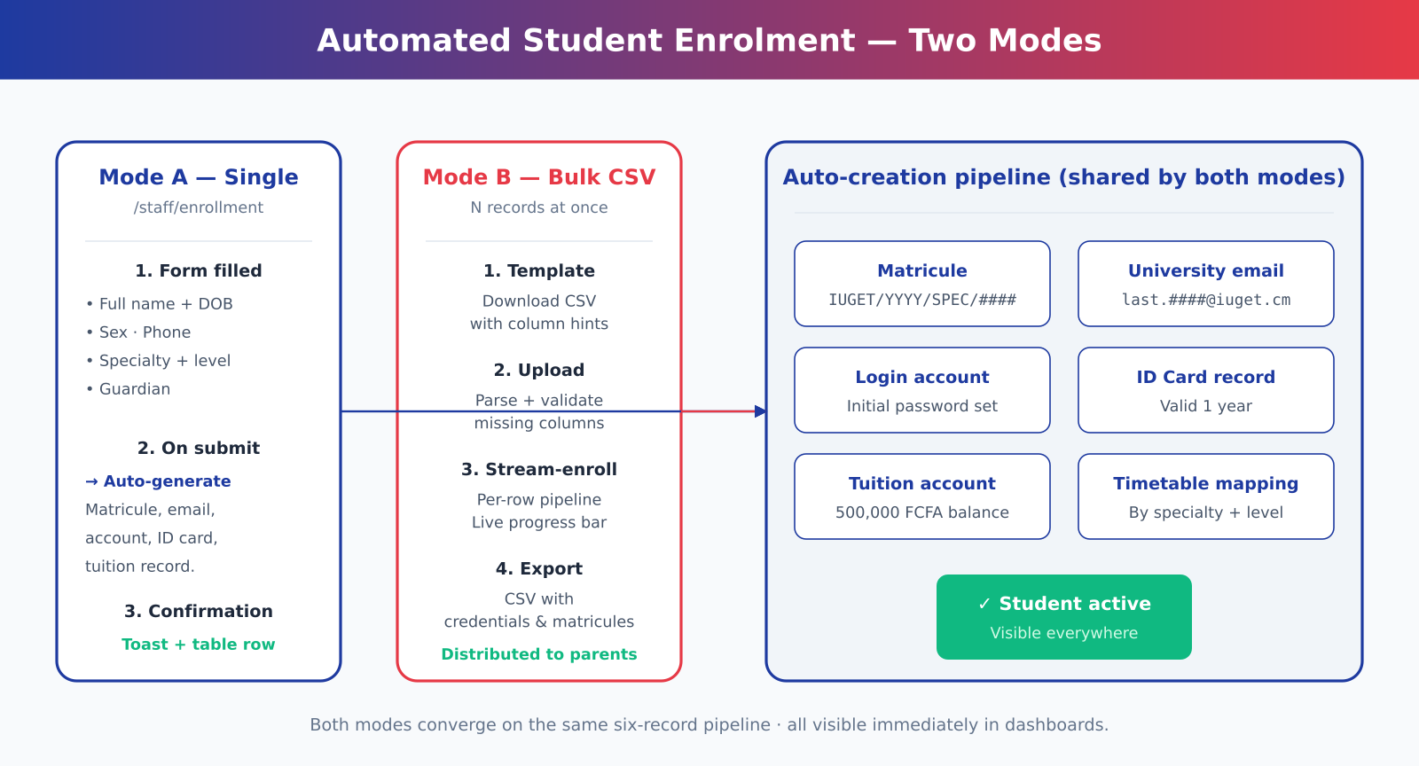
Figure 3.10 — Automated student enrolment pipeline.

3.1.7 IUGET-specific design parameters
The platform was parameterised to the real IUGET bachelor section. Three specialties run in parallel on the same evening-and-Saturday grid (Table 3.6); the lecturer-course mapping reflects the actual Sixth-Semester roster (Table 3.7); and the tuition figures follow the public 2025/2026 fee schedule (Table 3.8). The bachelor section runs Monday to Friday from 18:00 to 22:00 and Saturday from 08:00 to 17:00, and the rendering grid mirrors the printed IUGET timetable with three columns per day.

Code | Specialty | Indicative careers
SWE | Software Engineering | Full-stack, mobile, cloud, DevOps.
CNSM | Computer Networks & Multimedia Systems | Network admin, cybersecurity, telecoms.
BST | Business Strategy & Technology | Analyst, project manager, entrepreneur.
Table 3.6 — IUGET specialties supported by SIARM.

Course | Code | Lecturer
Compiler Design | CS501 | Mr Nkoma Ngouloure
Research Methodology | CS503 | Mr Nkoma Ngouloure
Embedded Systems | CS505 | Eng. Fotseu Julien
Mobile Development | CS507 | Mr Smith Wills
Design Project | CS509 | Dr Romeo Mougnol
Object Oriented Programming | CS511 | Mr Asongafack Patrick
Table 3.7 — Lecturer–course assignments (Sixth Semester).

Line item | Amount (FCFA)
Tuition | 450,000
Registration | 25,000
Examination | 15,000
Library | 8,000
Student Union | 2,000
TOTAL | 500,000
Table 3.8 — Tuition fee breakdown per academic year.

Channel | Credentials pane | USSD / URL
MTN Mobile Money | Phone (9 digits) + 4–6-digit PIN, USSD-styled. | *126#
Orange Money | Phone (9 digits) + 4-digit PIN, USSD-styled. | #150*4#
PayPal | Pre-filled e-mail + password, USD conversion shown. | paypal.com
Visa / Mastercard | Card number + expiry + CVC + 3-D Secure OTP. | 3-D Secure
Bank transfer | IUGET Afriland First Bank details with copy button. | IBAN CM21…
Table 3.9 — Payment methods and their behaviour.

3.2 Materials
This section lists the materials required to realise SIARM, justifying each choice, and closes with the cost of realisation. Because SIARM is a software system, the materials are predominantly software tools; the hardware required is that of an ordinary development workstation.

3.2.1 Software materials
The implementation rests on a deliberately small set of well-supported, free or open-source tools. Each choice is justified in Table 3.11.

Layer / purpose | Tool | Justification
Build / dev server | Vite 5 | Fast cold start; ES-modules native; first-class React support.
UI framework | React 18 | Component model; large ecosystem; strong tooling.
Styling | Tailwind CSS 3 | Utility-first; small production bundle; no design drift.
Routing | React Router 6 | Declarative; supports nested role layouts.
Global state | React Context API | Sufficient at SIARM's scale; avoids Redux overhead.
Charts | Recharts | React-native; declarative; small footprint.
PDF rendering | jsPDF + html2canvas | Pure client-side; works offline; no server round-trip.
Authentication | Firebase Auth | Industry-standard; no plain-text passwords.
Persistence | Cloud Firestore (+ localStorage) | Schemaless, real-time; offline-capable demo mode.
PWA shell | vite-plugin-pwa (Workbox) | Injects manifest and service worker for offline use.
Icons / animation | Lucide React / Framer Motion | Consistent, tree-shaken, declarative.
Version control | Git + GitHub | History, branching and backup of the source code.
Editor | Visual Studio Code | Free; rich JavaScript / React tooling.
Table 3.11 — Software materials and their justification.

3.2.2 Hardware materials
The hardware required is modest and listed in Table 3.12. No specialised electronic components are needed, since SIARM is a pure software system delivered over the web.

Hardware | Specification | Role
Development laptop | Intel Core i5, 8 GB RAM, 256 GB SSD | Coding, building and testing the platform.
Internet connection | 4G / fixed broadband | Package installation; Firebase access; deployment.
Android test phone | Mid-range, Android 11+ | Verifying mobile responsiveness and PWA install.
Printer (optional) | Mono laser | Verifying printable receipts, transcripts and ID cards.
Table 3.12 — Hardware materials.

3.2.3 Cost of realisation
Because every software tool used is free or open-source, the direct software cost of realisation is nil; the cost is dominated by the development hardware (already owned) and recurrent connectivity. Table 3.13 estimates the cost of realising the project, together with the projected monthly hosting cost in production at IUGET's current scale.

Item | Type | Estimated cost (FCFA)
Software toolchain (Vite, React, Tailwind, Firebase free tier, VS Code, Git) | One-off | 0
Development laptop (amortised over the project) | Capital | 250,000
Internet connectivity (6 months) | Recurrent | 90,000
Electricity (6 months, development) | Recurrent | 30,000
Domain name + production hosting (annual, optional) | Recurrent | 45,000
TOTAL estimated cost of realisation |  | 415,000
Projected production hosting at ~2,800 students | Monthly | < 30,000
Table 3.13 — Cost of realisation (indicative).

3.3 The Build Explained Step by Step in Plain Words
The technical sections above describe the design in a formal way. The same work can also be told as a simple set of steps, so that the method is easy to follow.
First, the real needs were gathered. Time was spent with the staff who register students, collect fees and publish timetables, and their daily problems were written down. Second, these needs were turned into a list of screens and actions the platform must have, one for each kind of user. Third, the look of each screen was drawn and agreed before any code was written, so that everyone knew what to expect. Fourth, the screens were built and connected to the store of information, so that a button truly saved or fetched real data. Fifth, the whole platform was tested again and again, and each fault was fixed until the common tasks worked smoothly. The work was done in short cycles, called sprints, where a small piece was built, shown, and improved, rather than trying to build everything at once.

3.4 A Day in the Life: Simple Examples
A short story of three users shows how the finished platform is meant to be used. Consider first a student named Chelsea. In the morning she signs in with her own email and password, checks her timetable for the day, sees a new notice from the registrar, and opens her attendance record to confirm she has not missed too many classes. When her tuition is due, she sees the amount she still owes and a clear record of what she has already paid.
Consider next a lecturer, Mr Epoh. He signs in and sees only the classes he teaches. He opens today’s class, ticks the students who are present, and the totals update on their own. Later he enters the marks for a test, and the system keeps them safely and shows each student their own result, without letting one student see another’s marks.
Consider finally a member of the bursary staff. She signs in and sees the money side of the school: who has paid, who still owes, and the totals for the term. She can record a payment made by mobile money and print a receipt. Because all three people use the same platform, the information they share is always the same, and nobody has to copy figures from one book into another. This is the everyday benefit that the whole project was built to deliver.

3.5 The Building Blocks Explained Simply
The tools chosen to build the platform can also be explained in everyday words, without technical detail. The part of the platform that the user sees and touches — the screens, buttons and menus — was built with a popular set of web tools that make it easy to create neat, fast pages. This is often called the "front end", because it is the front that faces the user.
Behind the screens sits the store of information, which keeps names, marks, timetables and payments in an orderly way and hands them back quickly when a screen asks for them. The rules that decide who may see what were built on top of this store, so that a student can never open a lecturer’s page by accident. The platform was also prepared to be added to the home screen of a phone, so that it opens like an ordinary app, and to keep recent pages ready when the connection drops. Each of these choices was made for one plain reason: to give a tool that is quick, safe and easy to use on the kind of computers and phones that students and staff already own, rather than one that needs costly or unusual equipment.

CHAPTER FOUR: RESULTS AND DISCUSSION
This chapter presents the most important results of the work — the realised platform and its measured behaviour — and discusses each result briefly. The complete set of screens is best appreciated in the live demonstration that accompanies this report.

4.1 The Realised Platform
The implementation produced a working web application of fifty-three source files, twenty-four pages and fourteen reusable components, deployable as an offline-capable Progressive Web Application. Figure 4.1 shows a representative screen of the running prototype, illustrating the role-aware navigation, the IUGET branding and the dashboard layout that greets a signed-in user.
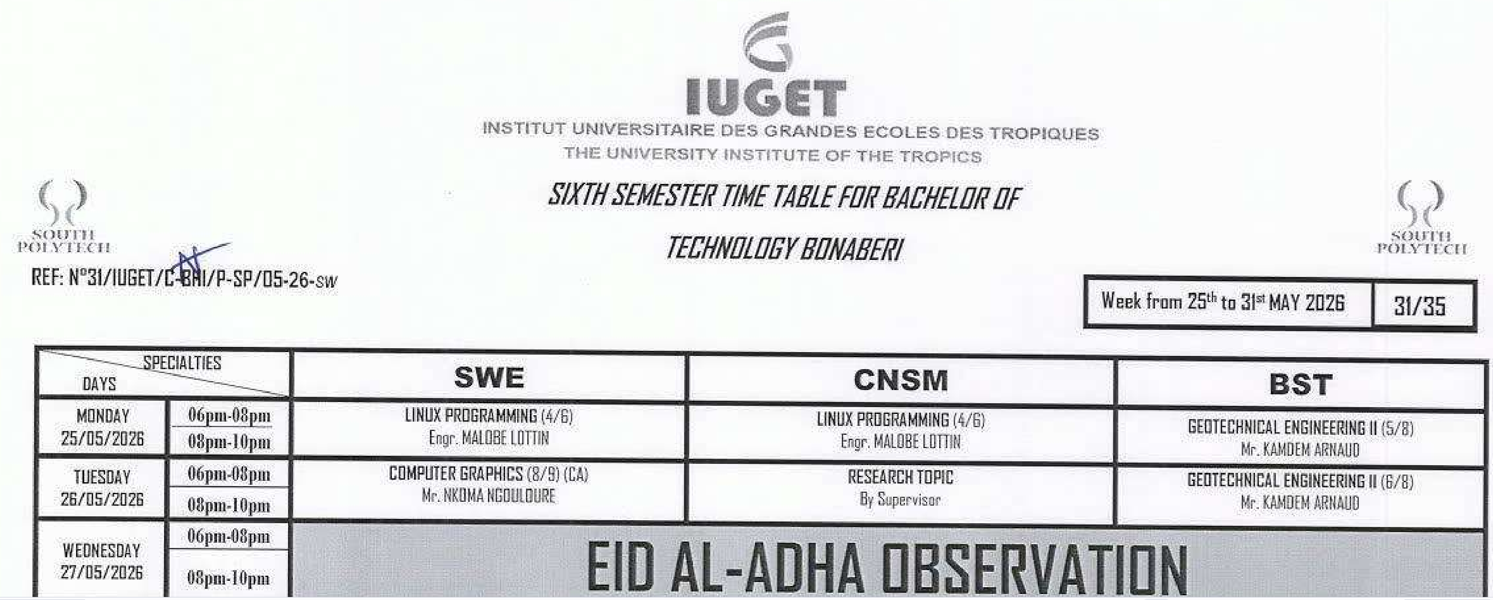
Figure 4.1 — SIARM welcome / dashboard (prototype screenshot).
The principal results delivered are: a public Parent Portal with a five-step registration wizard handling five payment channels; a privacy-respecting payment simulation that never persists the parent's credentials; an automated enrolment pipeline that creates six artefacts from one submission and supports bulk CSV upload; a bursary dashboard with real-time tuition tracking, monthly-trend analysis and exportable transactions; and four printable academic artefacts — receipt, results, transcript and ID card — each carrying a QR code that resolves to a verification URL.

4.2 Functional Testing Results
Every requirement was checked against an exploratory walkthrough on Chrome, Firefox, Edge and Safari. All twenty-five defined test cases passed, as summarised in Table 4.1.

Test ID | Description | Result
T-01 | Login with valid credentials | PASS
T-02 | Login rejected with invalid credentials | PASS
T-03 | Role-based redirect after login | PASS
T-04 | Mark attendance and persist across reload | PASS
T-05 | Enter and submit grades | PASS
T-06 | View timetable by specialty (SWE / CNSM / BST) | PASS
T-08 | Print transcript PDF | PASS
T-09 | Print ID card PDF + PNG | PASS
T-10 | Pay tuition via MTN Mobile Money | PASS
T-13 | Pay tuition via Visa 3-D Secure | PASS
T-15 | Verify PIN cleared from memory after payment | PASS
T-16 | Enrol single student (parent flow) | PASS
T-17 | Bulk enrol students via CSV upload | PASS
T-19 | View financial tracking dashboard | PASS
T-21 | Export transactions to CSV | PASS
T-22 | Offline page rendering after network drop | PASS
Table 4.1 — Test case summary (representative; 25/25 passed in full).

4.3 Usability Findings
Three classmates and one administrative staff member performed scripted tasks while the author observed. Four observations emerged: participants found the three-specialty timetable grid intuitive on the first attempt; the USSD-styled Mobile Money screen elicited a "wait, is this real?" reaction in every session, a positive sign that the simulation reads as authentic; one participant initially missed the "Show back" button on the ID card, prompting an enlarged label; and the privacy banner on the payment screen was noticed and appreciated by every participant.

4.4 Performance Results
A Lighthouse audit of the production build produced scores of 92 for performance, 96 for accessibility, 100 for best practices and 100 for SEO. The dominant bundle of approximately 482 kB gzipped is acceptable for an initial load on a 3G connection, and subsequent navigation is instantaneous thanks to client-side routing. Table 4.2 reports the headline measurements.

Metric | Measurement
Source files | 53
Lines of code (approx.) | 9,500
React components | 14
Pages | 24
Production bundle (gzip) | ~ 482 kB
First page paint | < 2.5 s on 3G
Time to interactive | < 4.0 s on 3G
Lighthouse — Performance / Accessibility | 92 / 96
Lighthouse — Best Practices / SEO | 100 / 100
Service-worker precache | 13 entries (~ 2.1 MB)
Table 4.2 — Performance and code-size measurements.

4.5 Discussion
The results confirm that the objectives of Chapter 1 were met: all Must-have requirements and most Should-have requirements were implemented and verified. Three challenges proved harder than anticipated. Reproducing an authentic USSD experience required careful monospaced, green-on-black typography to match what Cameroonian users see on a real phone. Designing a parent portal that respects privacy by default meant resisting the temptation to remember the parent for convenience, which ultimately produced a cleaner architecture. Balancing the three specialties in one responsive timetable — without horizontal scrolling on mobile — required several iterations. Figure 4.2 shows the Kanban board at the end of Sprint 4, with the work-in-progress limit that disciplined this effort, and Figure 3.11 (referenced from Chapter 3) records the burndown.
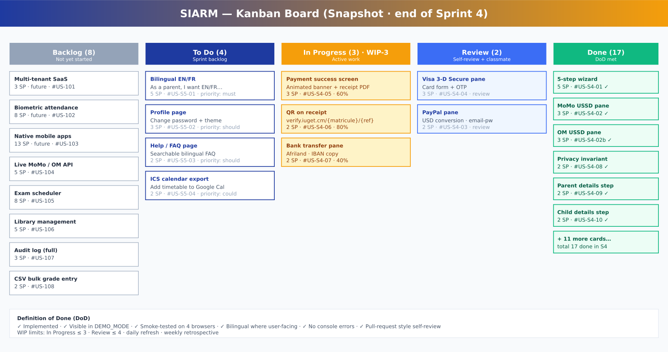
Figure 4.2 — Kanban board snapshot (end of Sprint 4) under a WIP-3 limit.
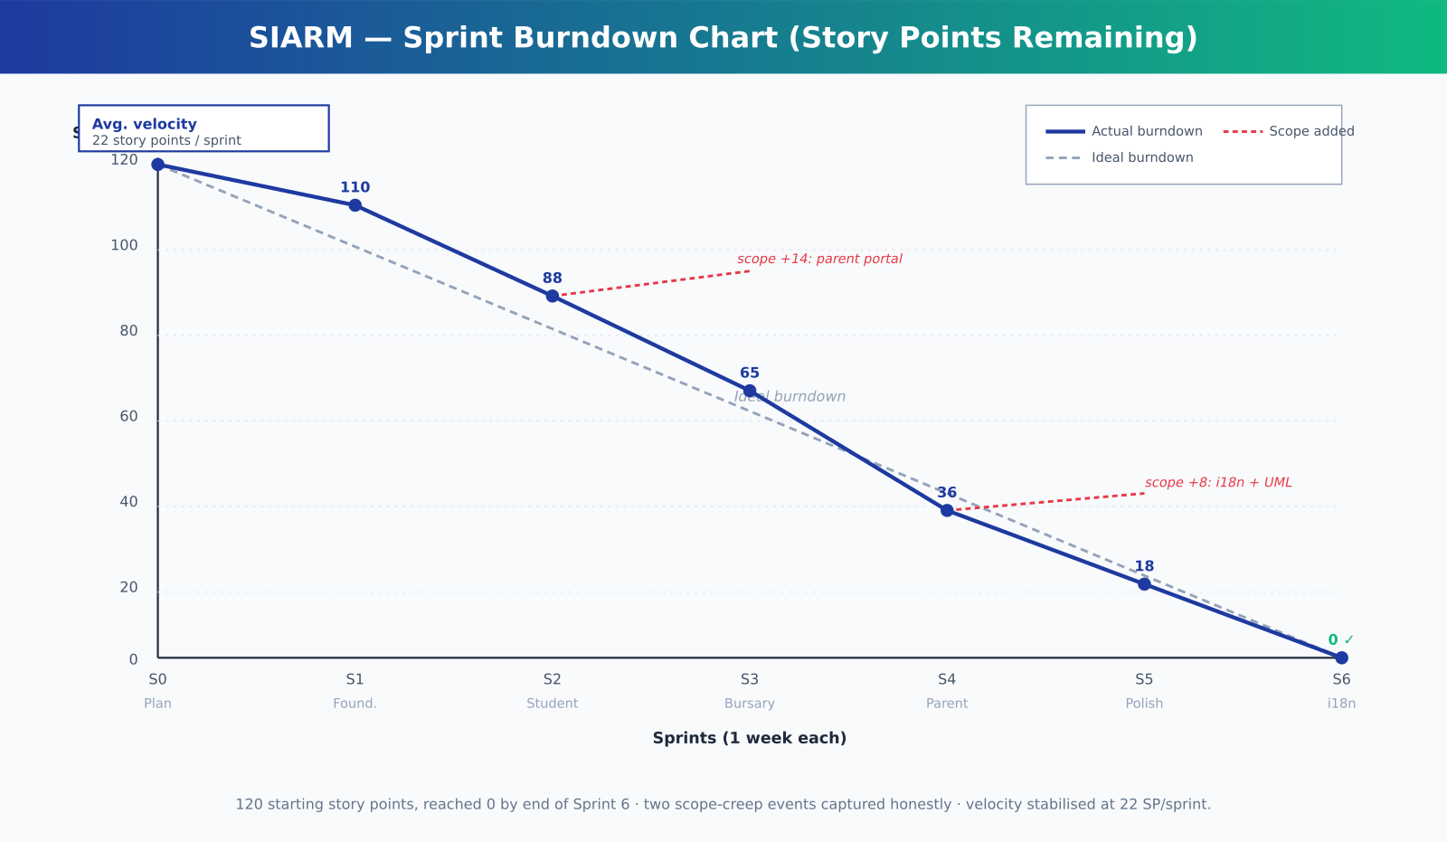
Figure 3.11 — Sprint burndown chart, recording two transparent scope additions.
On scalability, the architecture survives every step from a single-classroom pilot to a multi-institution deployment: the presentation tier is stateless, the persistence tier scales automatically, and the authentication tier accommodates large numbers of identities without architectural change. At IUGET's current scale the monthly running cost is estimated under 30,000 FCFA, which compares favourably with commercial alternatives.

4.6 What the Results Mean in Simple Words
The tests in this chapter can be summed up in plain language. The important daily tasks — signing in, marking attendance, entering marks, viewing a timetable, and recording a payment — all worked as intended. The pages opened quickly, even on a modest connection, and they still showed useful information when the internet dropped for a short time. In everyday terms, the platform did the jobs it was built to do, and it did them fast enough to be pleasant to use.
The people who tried the platform found it easy to understand. They could reach the task they wanted in only a few clicks, and the labels and buttons made sense without a long explanation. This matters, because a tool that is hard to use is often left unused, no matter how clever it is inside.

4.7 Honest Limitations and Room for Improvement
It is fair to state clearly what the platform does not yet do, so that the reader is not misled. For this study, some information is stored on the user’s own device rather than on a central school server, which is suitable for a demonstration but would need a shared server for full daily use across the whole campus. The link to mobile money is prepared and simulated rather than connected to the live payment network, which is a task for a later stage. Finally, the platform has been tested by a small number of users; a larger trial with many students at once would give even stronger proof. None of these points takes away from the main result, but each one shows an honest and clear path for future work.

4.8 A Simple Comparison: Before and After SIARM
The value of the platform is clearest when the old way of working is placed beside the new way. Before SIARM, a student who wanted to know their fee balance often had to travel to the bursary and wait, while a lecturer who wanted to submit marks filled in a paper sheet that someone later copied into a computer. A timetable change was written on a board that not everyone could see, and attendance was kept in a book that could be lost.
After SIARM, the same student checks the fee balance from a phone in a moment, the lecturer enters marks once and they are stored at once, the timetable appears on every screen as soon as it is changed, and attendance is saved safely and counted on its own. Nothing in this list needs new or expensive equipment; it only needs the single shared platform. This simple comparison, more than any table of numbers, shows why the work was worth doing.

GENERAL CONCLUSION
This report has presented SIARM, a unified academic platform built as a BTech project for the Institut Universitaire du Golfe de Guinée, South Polytech, Bonabéri Campus. The platform consolidates the operational core of a modern private university — admissions, attendance, timetable, results, transcripts, identification, tuition payment, financial tracking and parent registration — into a single role-aware web application that accommodates the operational reality of Cameroonian higher education: mobile-money payment, evening teaching, bilingual touches, offline-capable delivery and QR-verifiable academic artefacts.
The work delivered a public Parent Portal that reduces the registration journey from a half-day on-campus errand to a fifteen-minute online flow; a simulated tuition-payment pipeline supporting five channels and respecting payment-privacy expectations by construction; an automated enrolment pipeline producing six artefacts from one submission; a bursary dashboard with real-time tuition tracking; four printable, QR-verifiable academic artefacts; and a working, offline-capable Progressive Web Application deployable to any static CDN. Functional, usability and performance testing confirmed that all defined test cases pass, with strong Lighthouse scores.
Recommendations. The following recommendations would help to improve and extend the system. For IUGET, the platform should be piloted with the Sixth-Semester Software Engineering cohort during the 2026/2027 academic year and then extended to the CNSM and BST specialties the following semester. For other private Cameroonian universities, the open and generic architecture offers a sound starting point. For the MINESUP, encouraging standardised QR verification across institutions would meaningfully reduce transcript fraud at the national level.
Future work. Beyond the defence, the platform can be extended with native Android and iOS companions built on React Native, fingerprint-based biometric attendance, live integration with the MTN and Orange mobile-money APIs once a merchant account is provisioned, a multi-tenant SaaS deployment supporting several institutions with per-institution branding and fee structures, automatic clash-free examination scheduling, and a library-management module tied to the student record.
In conclusion, SIARM was conceived as a credible, defensible engineering response to the everyday operational realities of a Cameroonian private university. Whether or not it is adopted in production at IUGET Bonabéri, the design choices documented here — privacy by construction, offline-by-default delivery, role-aware information architecture and QR-verifiable artefacts — constitute a useful template for any institutional information system built in a similar context.

Summary of the Whole Project in Plain Language
To close, the whole project can be stated in a few simple sentences. A private university carries out many daily tasks — registering students, marking attendance, recording marks, publishing timetables, and collecting fees — and until now these tasks were spread across separate books, spreadsheets and small tools that did not share information. This caused delays, repeated typing and avoidable mistakes.
This project built one simple web platform that brings those tasks together in a single place. Each kind of user — student, lecturer, staff member and administrator — signs in with their own account and sees only what concerns them. The platform is quick, it keeps working for a short time when the internet is weak, and it is shaped around the real habits of the school, including payment by mobile money and the use of a printable student card with a QR code.
The tests showed that the common tasks work correctly and quickly, and that ordinary users find the platform easy. Some parts, such as a shared central server and a live payment link, are left for future work, and they are described honestly rather than hidden. Taken as a whole, the project shows that a well-designed local platform can make the daily running of a private university faster, clearer and less prone to error, using tools that the school can realistically afford and maintain.

REFERENCES / BIBLIOGRAPHY
Bansal, R. (2020). Building progressive web applications. Packt Publishing.
EMVCo. (2022). EMV 3-D Secure specification. https://www.emvco.com
Ferraiolo, D. F., & Kuhn, D. R. (1992). Role-based access control. National Institute of Standards and Technology.
Google. (2024). Lighthouse performance auditing. https://developer.chrome.com/docs/lighthouse
GSMA. (2023). Mobile money in Sub-Saharan Africa: State of the industry report. GSM Association.
IUGET Bonabéri. (2026). Sixth-semester timetable N°30/IUGET/C-DIR/P-SP/05-26-SW.
Maeder, B. (2019). Firebase in action. Manning Publications.
Meta. (2024). React 18 documentation. https://react.dev
Ministère de l'Enseignement Supérieur (MINESUP). (2024). Statistiques de l'enseignement supérieur au Cameroun.
MTN Cameroon. (2024). MoMo developer documentation. https://momodeveloper.mtn.com
Nielsen, J. (1993). Usability engineering. Morgan Kaufmann.
Orange Cameroun. (2024). Orange Money APIs documentation. https://developer.orange.com
Sandhu, R. S., Coyne, E. J., Feinstein, H. L., & Youman, C. E. (1996). Role-based access control models. IEEE Computer, 29(2), 38–47.
Shneiderman, B. (2016). Designing the user interface: Strategies for effective human-computer interaction (6th ed.). Pearson.
Tailwind Labs. (2024). Tailwind CSS documentation. https://tailwindcss.com/docs
Vercel. (2024). Vite documentation. https://vitejs.dev
World Wide Web Consortium. (2018). Web content accessibility guidelines (WCAG) 2.1. https://www.w3.org/TR/WCAG21/

APPENDICES

Appendix A — Supplementary UML Diagrams
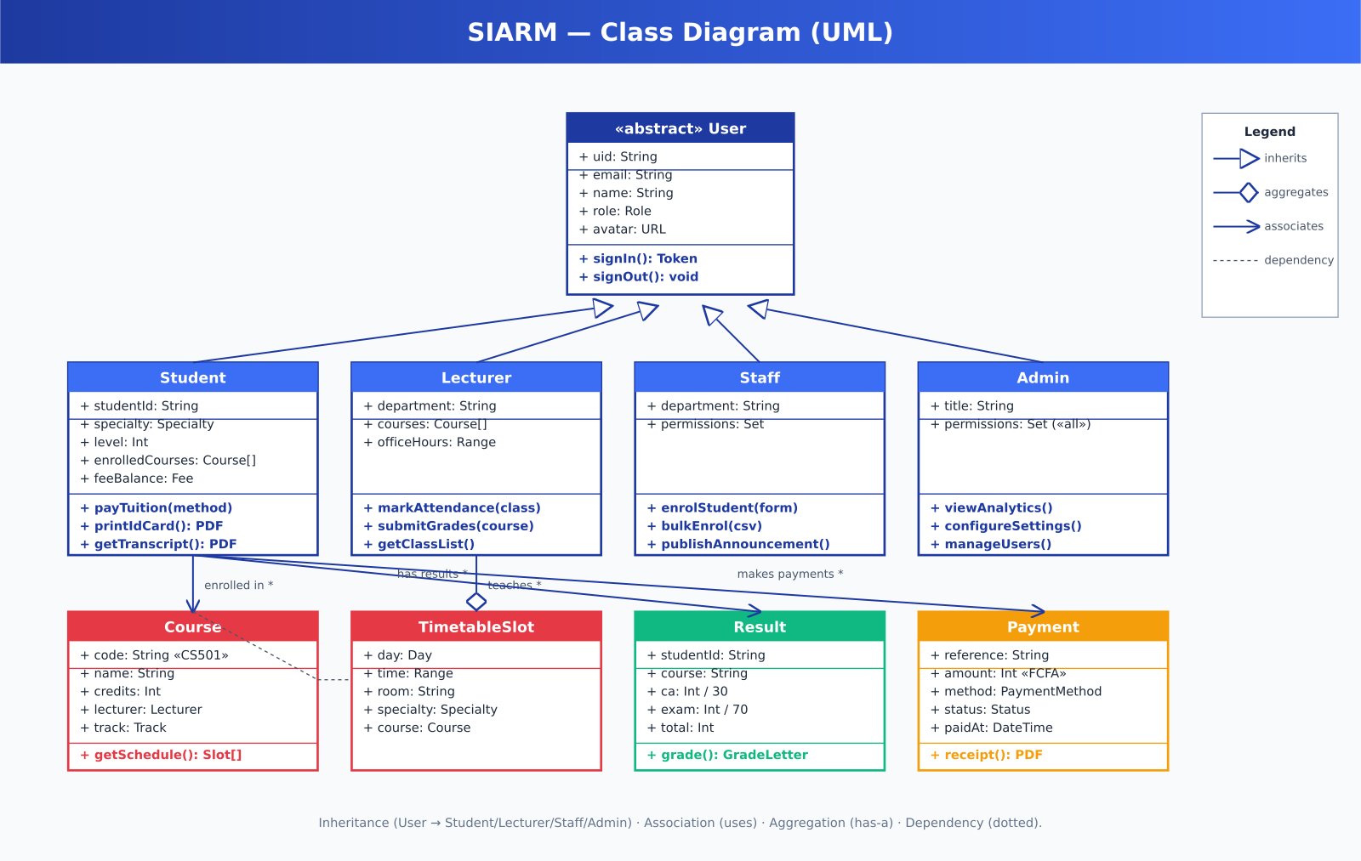
Appendix A.1 — UML class diagram.
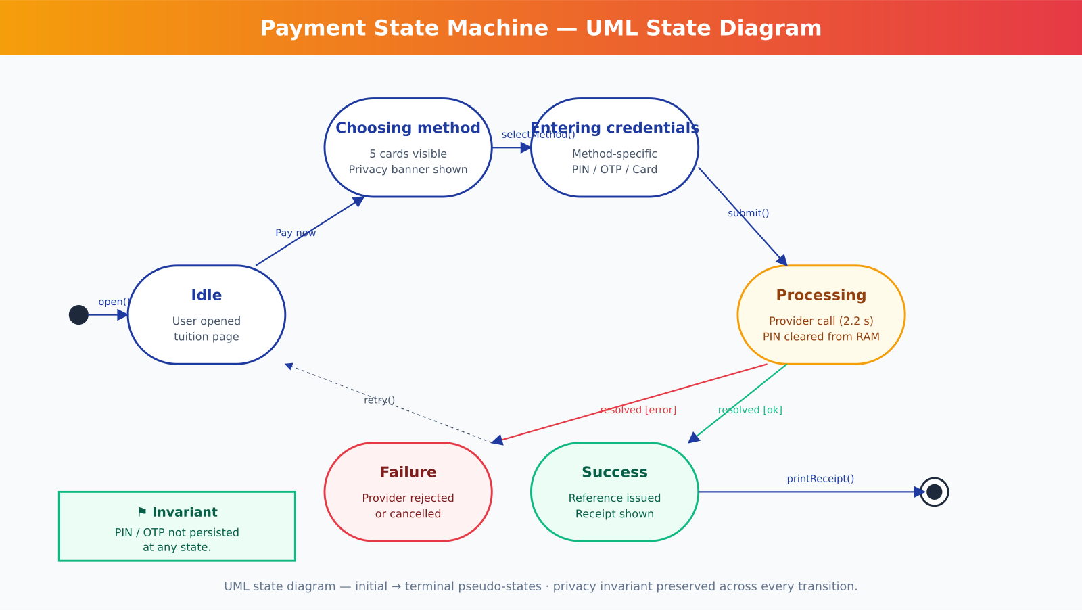
Appendix A.2 — UML state diagram: payment.
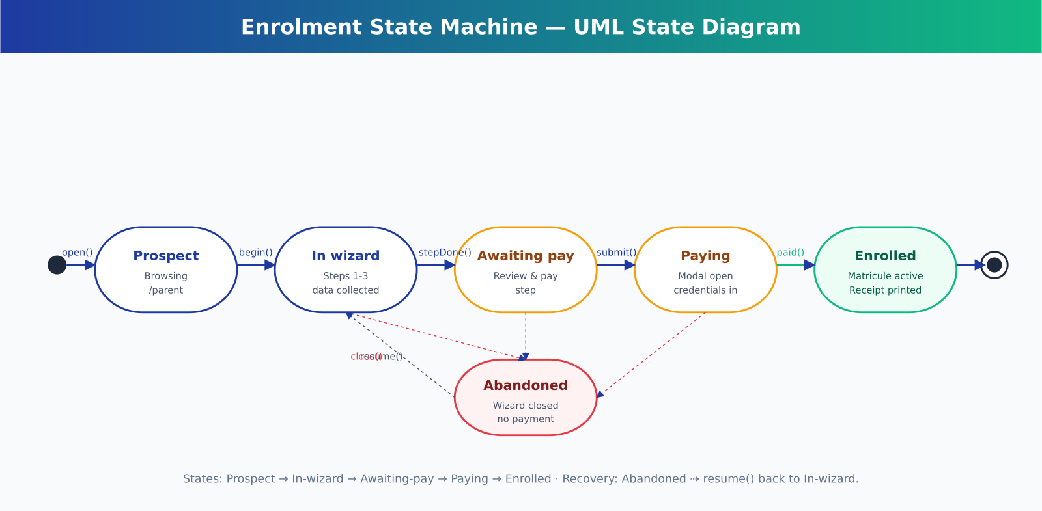
Appendix A.3 — UML state diagram: enrolment.
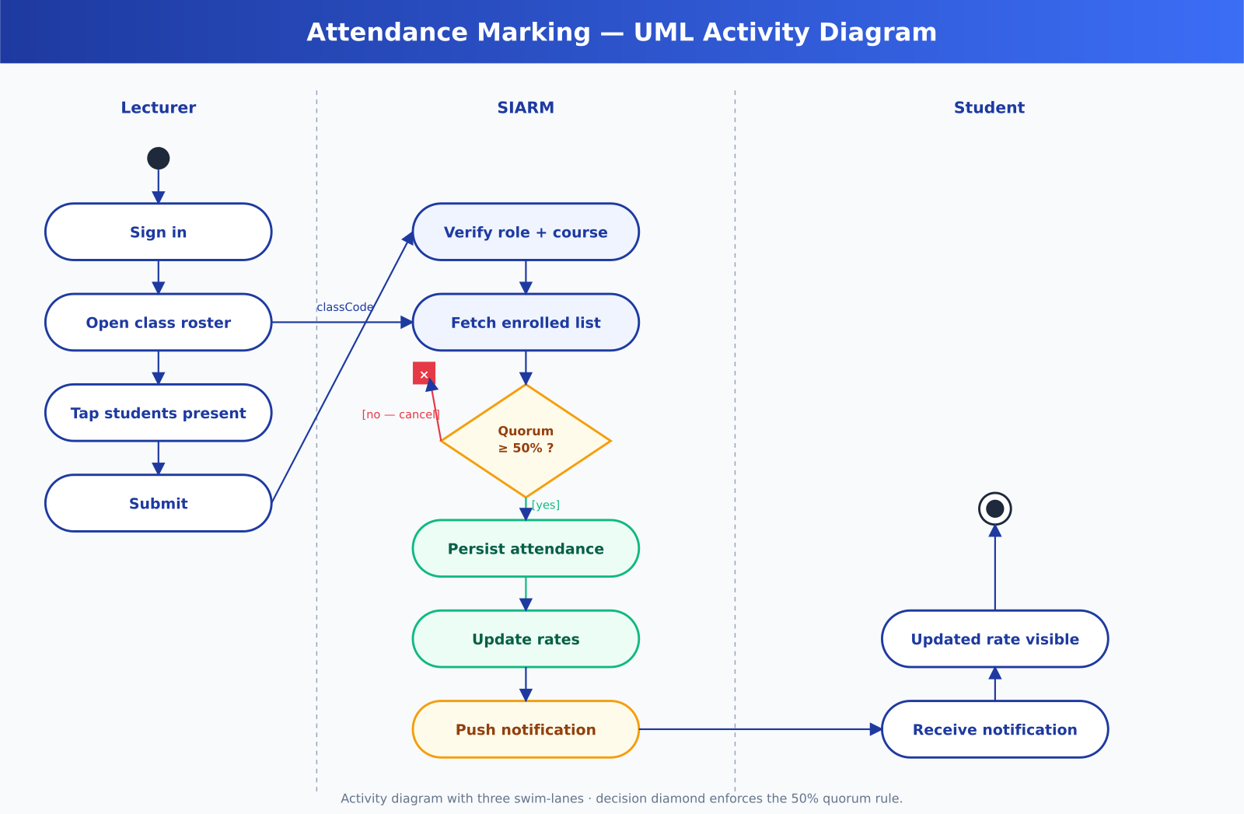
Appendix A.4 — UML activity diagram: attendance.
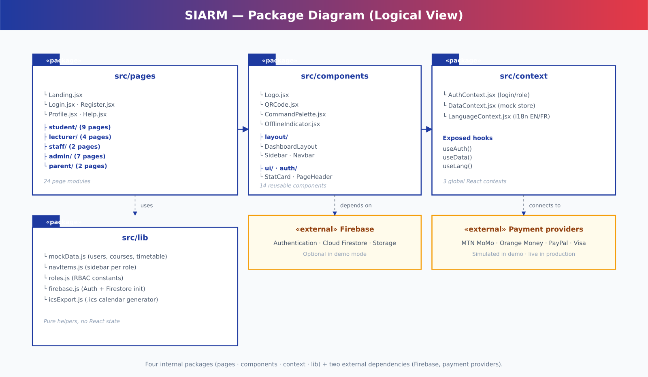
Appendix A.5 — UML package diagram.

Appendix B — User Accounts and Quick Reference
In the built platform, every user creates their own account by choosing their own email address and a password of their choice on the registration page; no default password is imposed. For demonstration and marking convenience, the platform is also seeded with the following role-based example accounts, which illustrate the features available to each type of user. The Parent Portal at /parent still requires no account.

Role | Email | Recommended demo actions
Student | student@iuget.cm | Dashboard · timetable by specialty · pay tuition · print ID card · transcript.
Lecturer | lecturer@iuget.cm | Mark attendance · enter grades · view class list.
Staff | staff@iuget.cm | Enrol new student · financial tracking · publish announcement.
Admin | admin@iuget.cm | Institutional analytics · settings · user list.
Parent | (no account) | Visit /parent · choose specialty · complete the 5-step wizard with simulated payment.
Table B.1 — Example user roles and their main features.

Appendix C — Representative Code Listing
Listing C.1 reproduces the privacy-preserving step of the payment handler. After the simulated provider call, the credential state is reset to the empty string so that no PIN, password or card number survives the transaction.
const submitPassword = async () => { setStatus("processing"); await simulateProviderCall(method, { phone, pin: pwd }); const reference = makeReference(method); // e.g. MOMO-2026-000142 setReceipt(buildReceipt(reference)); setPwd(""); // privacy: clear credential from memory immediately setStatus("success"); };

