# Documentation

## Vision

My vision for this website is a page where amateur astronomers can see current cosmological events and find information about observing at home. I am envisioning a site that the Astronomy Club could use to educate new members of the club who have not had a lot of experience. As the president of the Astronomy Club, I have a lot of interest in astronomy, and I think it would be a great idea to have a location where they can learn more. It would save time for me, and the current Astronomy Club website is kind of terrible. It is missing a lot of elements that would make it an actual useful site that people would go visit.

## Tree Diagram

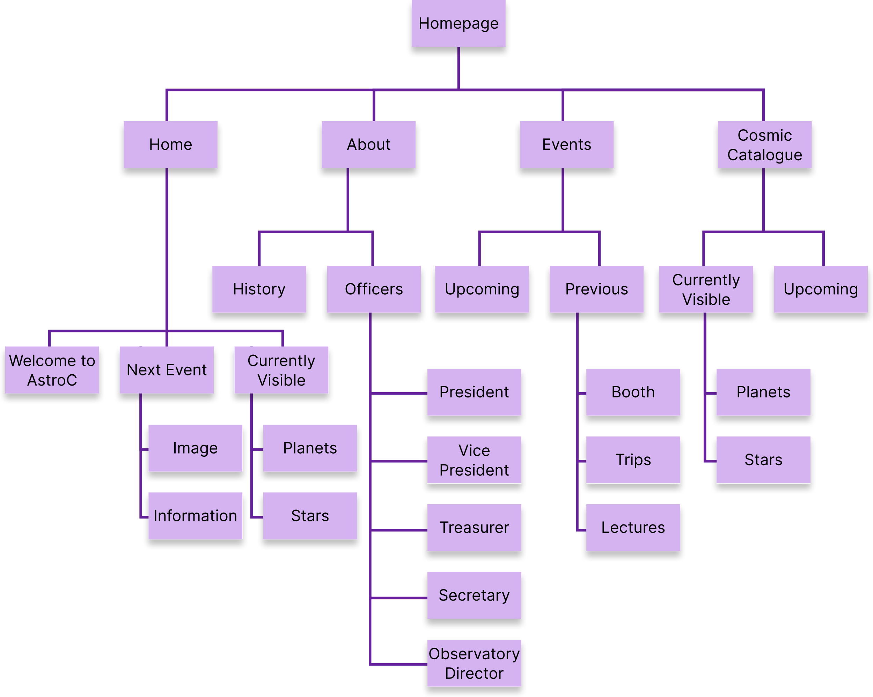

## References

<https://3ap.org/> : rather than being an amazingly designed website, the inspiration I got from this site came from the fact that it is an Astronomy site and it gave me some ideas about the information hierarchy for my own site.

<https://www.vox.com/> : I thought the way this news site handled columns was very smart. Each section is split up into a certain number of columns. Some sections are single column, but most have either two or three columns. The side columns are stacked into one column as the screen size gets smaller. I think it is a smart way to handle it.

<https://www.microsoft.com/en-us/> : I also used this site as inspiration because I liked the fact that it was much shorter than Vox. Whereas I had to scroll a lot on that site, the Microsoft site is a lot more condensed. It made a smart use of the carousel, and that helped give me some ideas of how to handle my own site.

## Transition Design Choice

Column drop!

## Wireframes

### Tablet

### 

### Laptop

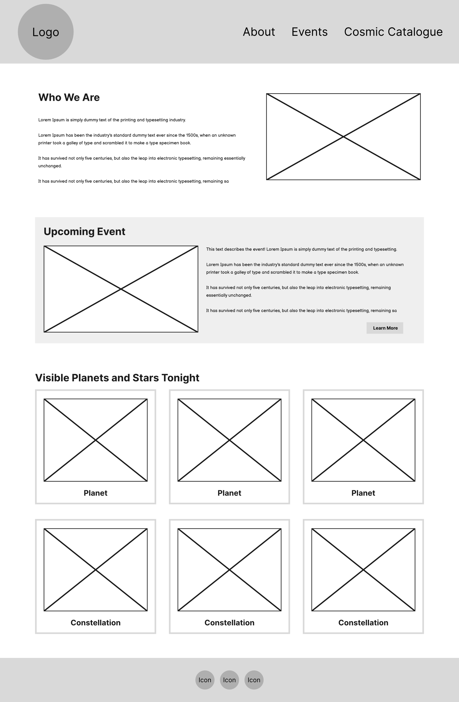

### Phone

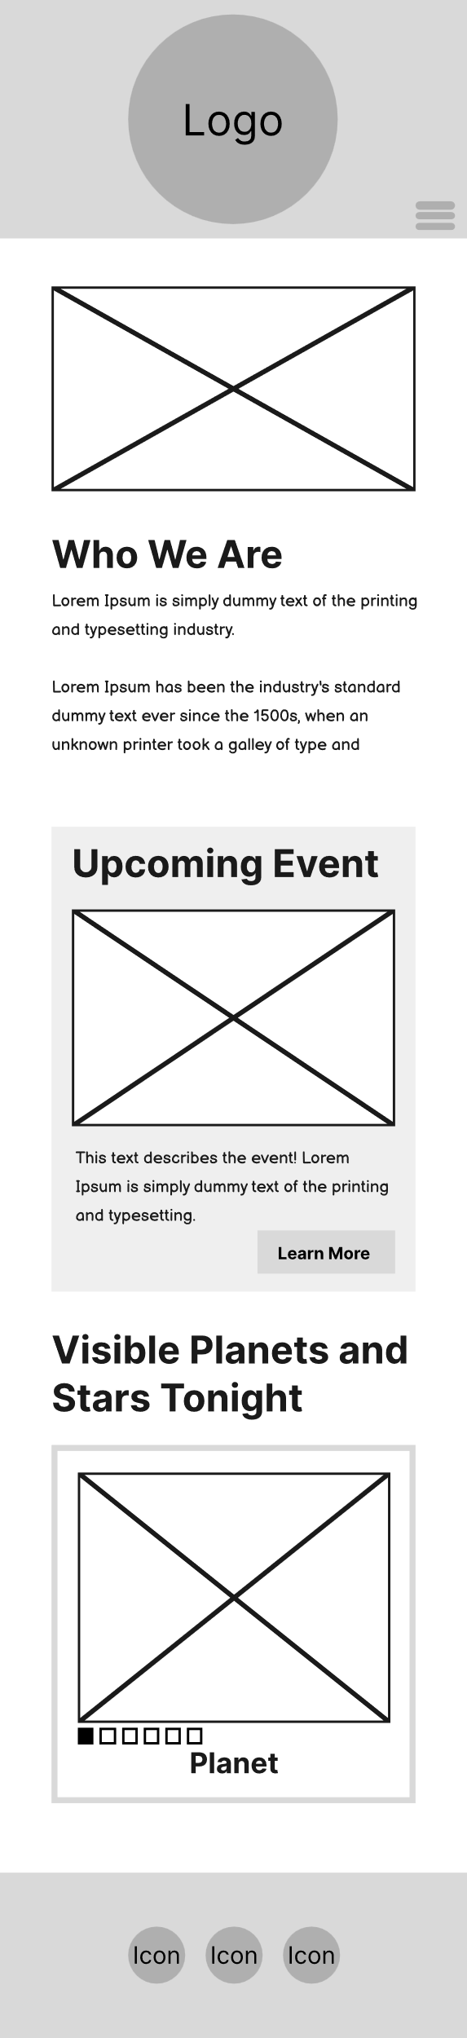

## Reasoning

When turning the wireframes into an actual website, I had to make some changes because we had not yet learned how to do some of the things I wanted to and I could not figure it out by myself.

### Font

I chose a Merriweather / Cabin font pairing. The Merriweather font is primarily used for the headers. I chose the two fonts because there is contrast between the two. Merriweather is serif and Cabin is sans-serif. I wanted the headers to have an academic feel to it since this is a CMU academic club website. However, I wanted the body font to be more casual and easier to read. Based on the site shared on the assignment page, this font combination is “adventurous,” which is something I want. I want potential club members to think of observing and astronomy as a fun and exciting journey/experience.

### Color

I chose a monochromatic purple color scheme. Monochromatic color schemes are appealing and keep things simple. The color – white pairing makes it easy to guide the user’s eyes to what is important. I chose the color purple because it is apparently the color of “mystery.” Considering how mysterious space is, I think the color is fitting. It is even more fitting since space is sort of a purply-blue color.