Introduction

The Nepalese cinema business is expanding at very high rates; nevertheless, most of the available movie halls continue to experience numerous issues regarding their operations and their customers. The problems that are common are poor handling of tickets, ineffective automation, ineffective interdepartmental communication, unreliable pricing, lack of transparency in transparency of seat availability, and poor general customer experience. These issues have led to a requirement of a more centralized, integrated and modernized cinema management system.

The proposed solution to these challenges is the adoption of a powerful and advanced digital system by Kumari Cinemas that will create a modern chain of cinemas in Nepal. The company will design well-developed cinema halls that optimize on seating capacity, halls per location and a centralized platform that is effective in booking, selling and canceling of tickets. It is aimed at increasing the efficiency of operations and customer satisfaction as well as decreasing the high operational cost.

The suggested system enables registered users to easily make a reservation or buy one or more tickets to a movie, hall and show of their choice. To guarantee fair seat usage, the system is equipped with automatic cancellation policy under which all booked ticket that is not bought within one hour of the showtime are automatically cancelled and the seat is made available to other customers. The system also allows dynamic pricing of tickets enabling theaters to attract varied prices on the public holidays or the first week of the release of new movies. Kumari Cinemas aims to transform the movie watching experience in Nepal by providing a smooth, consistent and customer-friendly ticketing system to the customers, which fulfills the modern standard of the movie industry.

Business Rules

Normalization

ERD
An Entity Relationship Diagram is a type of flowchart that illustrates how “things” in a system relate to one another. It includes the models involved (users, movies, tickets) and their attributes. ERD also shows the link between these objects. It is a concept that is widely by the database designers to better understand and categorization of data over time before implementation.
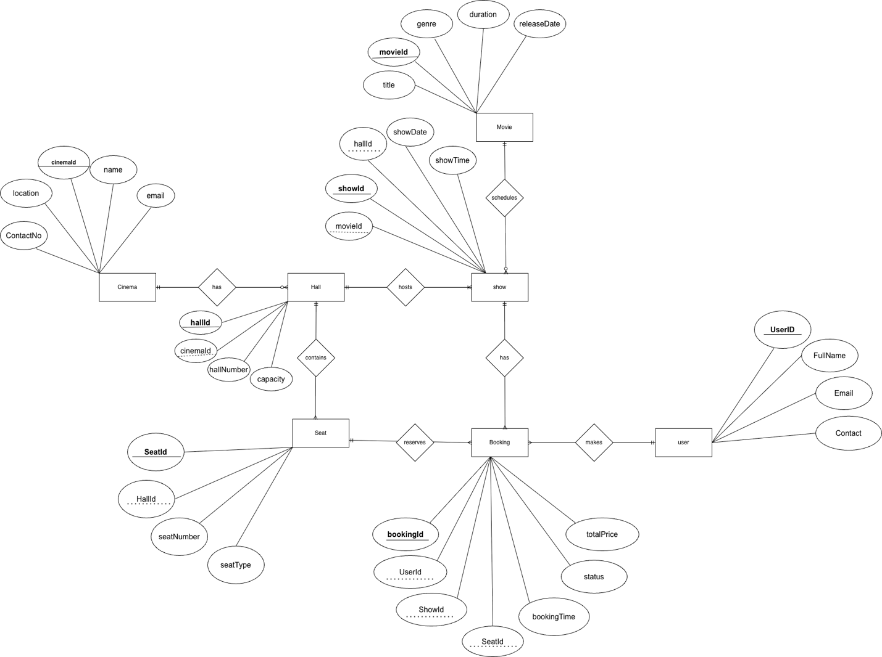

Final ERD
