设置APP

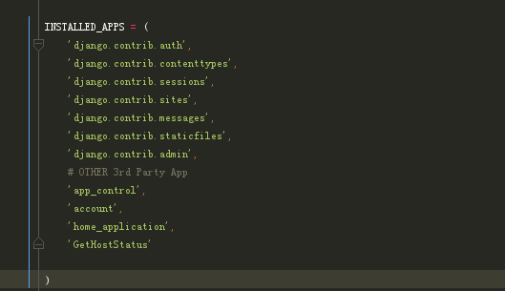

设置url

url(r'^GetHostStatus/', include('GetHostStatus.urls')),