Blood Donation Management System Design Document

Author: Le Ba Phi
Version 0.0.1

1. System Design:
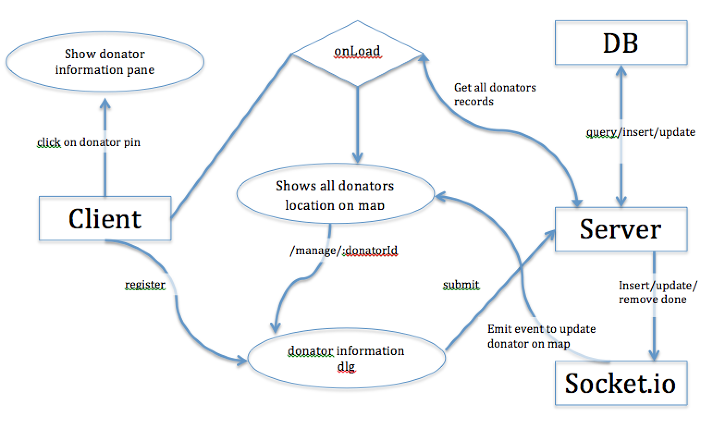

Design
Backend
Single collection Donator. Simple CRUD REST API as Express controller. After create, update and delete Socket.io emits event for all. Find query allow bound rect conditions.
Client controller deliver static files (js, css), and index.html at any other requests.

Frontend
Map is a directive, because I need element access for Google Maps API. Displaing pins on map idle after bounds change inside map directive.
All UI switching using ngRoute. It best for having no cost permanent links for all app points, e.g. `/register`, `/view/:donatorId`, `/manage/:donatorId`.
Single data-service `DonatorService` works with REST API and using ngResource. It has two templates: form mode and view mode.

2. Technologies, libraries: AngularJs, NodeJs, MongoDB, Bootstrap, Socket.io, RestAP, HTTP, Javascript, jQuery, express, jasmine-node and node-rest-client for testing.
3. Rest API:
Base path: /api/donators
- app.get('/', DonatorsController.findLocation): get all donators
- app.post('/', DonatorsController.createDonator): create donator from form register
- app.param('donatorId', DonatorsController.paramsDonator): on sending get request with parameter“donator id”the DonatorsController.paramsDonator will be called to get the donator record from database, then store it to req.donator
- app.get('/:donatorId', DonatorsController.getDonatorById): get donator record by donator id, just return req.donator (look at c)
- app.put('/:donatorId', DonatorsController.updateDonatorById): update donator information by donator id
- app.delete('/:donatorId', DonatorsController.deleteDonatorById): delete donator by donator id

