**SUPPLEMENTARY MATERIAL**

**Table S1.** Hierarchical capture-mark-recapture models used to describe mortality patterns of snowy plovers at Bahía de Ceuta, Mexico, between 2006 and 2020. *k:* number of modelled parameters; Δ*DIC:* difference in deviance information criterion (*DIC*) between a given model and the top model. *DIC* value of top model was 5279.1.

**Table S2.** Relationship between the average egg volume of a clutch and the average chick weight at hatching. See Appendix S2 for methods.

**Table S3.** Sources of egg size variation.

**Table S4.** Relationship between the lay date of an individual’s first nest and their likelihood of polyandry each year. Fixed effect size of ‘first nest lay date’ is the standardized estimate on the logit scale.

**Table S5.** Relationship between the lay date of an individual’s first nest and their likelihood of re-nesting following breeding failure in a given year. Fixed effect size of ‘first nest lay date’ is the standardized estimate on the logit scale.

**Table S6.** Sources of lay date variation.

**Figure S1.** Egg size variation for snowy plovers breeding in Bahía de Ceuta, Mexico between 2006 and 2020. Egg volume was estimated using an allometric equation combining length (A) and width (B) measurements collected in the field (see *Methods*). C) Average egg volume of a clutch was highly correlated with the clutch’s average chick weight at hatch (*β* [95% CIs]: 0.628 [0.552–0.704]; R2*marginal* = 0.370 [0.310–0.436]). Ribbon shows the 95% CI of the model prediction, vertical and horizontal error bars visualize within clutch variation in egg volume and chick hatch weight (1 SD); see Appendix S2 for modelling methods.

**Figure S2.** Bayesian model diagnostics of the Logistic bathtub shaped survival model. a) Serial autocorrelation of iterations within chains, b) chain convergence (*R-hat*) of model, and c) trace plots of chain dynamics.

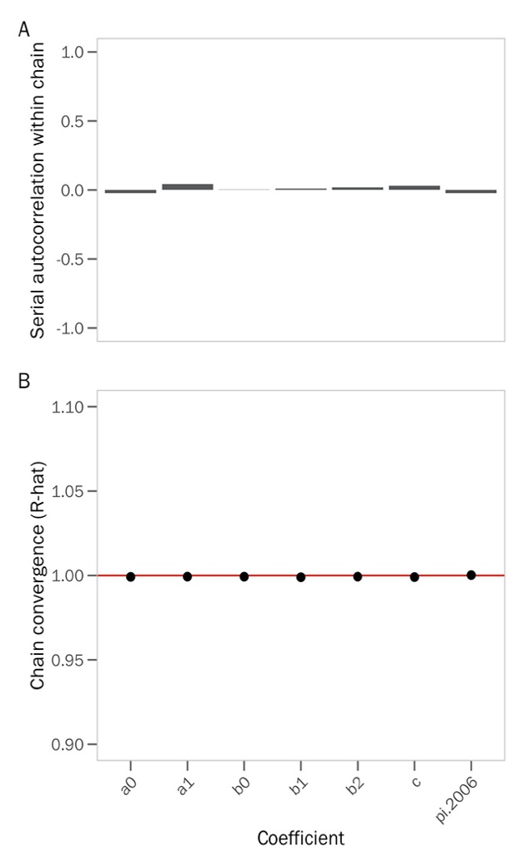

**Figure S3.** Sources of variation in the average hatch weight of chicks.**Figure S5.** Sources of variation in a female’s probability of re-nesting after a failed attempt each year.

**Figure S6.** Homoscedastic spread of residuals from the A) ‘egg volume’ and B) ‘lay date’ models.

**Figure S7.** Relationship between a female’s structural size (i.e., her tarsus length) and A) the lay date of her first nest of the season, and B) the volume of her eggs.

**Figure S8.** Visualization of the effect of uncertainty in the age estimate provided by BaSTA on age-dependent trends in egg volume (top row) and lay date (bottom row) dynamics. Black trends show the model predictions for the 1000 bootstraps of the BaSTA age estimate posteriors (see *Methods*).Panels A and D show the within-individual trends of the ‘age-deviation’ score – as expected, these measures are not impacted by uncertainty in the BaSTA age estimate because they are centered for each individual (i.e., the absolute age is irrelevant). Panels B and E show the between-individual trend of the ‘age at first breeding’ (i.e., selective appearance), and panels C and F show the between-individual trend of the ‘age at last breeding’ (i.e., selective disappearance). Yellow trends and grey ribbons visualize the 95% CI of the model predictions when using the mean age estimate provided by BaSTA (i.e., the effect sizes of the ‘egg volume’ and ‘lay date’ models shown in Fig. 3).

**File S1.** Commented RMarkdown vignette detailing the analytical steps needed to reproduce all our models and results. Click here to view on your internet browser:

<https://raw.githack.com/leberhartphillips/snowy_plover_eggs/main/Seasonal--and-age-related-egg-size-variation-in-a-long-lived-polyandrous-shorebird.html#data-import-and-wrangle>

**Appendix S1.**

To explain how mortality risk is associated with age, we compared four commonly used survival functions: exponential, Gompertz, logistic, and Weibull models. The exponential function keeps survival constant across age

(Cox & Oakes, 1984), whereas the other functions allow for age-dependent variation in survival: the Gompertz model is an exponential function in which age-specific mortality is scaled by baseline mortality (Gompertz, 1812; Pletcher, 1999) and the Weibull model is a power function which assumes that baseline and age-specific mortality rates are independent (Pinder *et al.*, 1978). In addition to the stand-alone versions of these functions, we considered two alternative forms of the Gompertz, logistic, and Weibull functions – “Makeham” and “bathtub” shapes. The Makeham shape constrains the survival function to converge to a constant, rather than zero, as age increases(Pletcher, 1999), whereas the bathtub shape enables concavity in the function, such that mortality could decrease at early ages, but increase later in life (Siler, 1979).

We used four parallel simulations to run the Markov chain Monte Carlo (MCMC) optimization procedure in BaSTA with 800,000 iterations, a 100,000 burn-in period, and a thinning interval of 2000 to minimize serial autocorrelation in the chain (see Fig. S1 for simulation diagnostics). We ranked the survival models according to their deviance information criterion (*DIC*) and determined that the logistic model with a bathtub shape fitted our data best (i.e., lowest *DIC*, (Spiegelhalter *et al.*, 2002); Table S1). This logistic model revealed that female mortality rate increased until age 5 years, after which it became constant (Fig. 1b). Using the top model, we extracted the point estimate and 95% credible interval birth year for each individual in the capture-mark-recapture sample.

**Appendix S2.**

In theory, the selective benefits of larger eggs is that the subsequent hatchlings will be larger and have higher survival owing to more intrinsic reserves provided by the mother (Blomqvist *et al.*, 1997). To link egg size variation to potential fitness consequences of subsequent offspring we evaluated the predicted positive relationship between egg volume and chick weight using the egg dataset described above but reduced observations to the nest level and filtered to only include nests that had chicks measured within one day of hatching, resulting in 456 nests from 276 females. As it was unclear which chick came from which egg, each datum represented the nest-level average of chick weights and egg volumes. We included random intercepts for mother identity and year, and assumed a Gaussian error distribution of egg volume.