**Seasonal- and age-related egg size variation in a long-lived polyandrous shorebird**

*Abstract (284 words):*

Anisogamy is a central component of sex role evolution, however the effect of female-female scramble competition on between-individual egg size variation in polyandrous species is unclear. Moreover, polygamy, which is often positively associated with age, may lead to within-individual variation in egg size due to age-dependent trade-offs between reproductive investments and somatic maintenance. Here we investigate how mating behaviour and senescence are associated with reproductive trade-offs of female snowy plovers (*Charadrius nivosus*). Snowy plovers are long-lived shorebirds (longevity record: 19 years) that produce several nests each year, with females either being polyandrous and sequentially changing partners between breeding attempts or remaining monogamous between attempts. We examined how age, seasonality, and mating tactics affect within- and between-female variation in egg volume using repeated measures collected over a 15-year period. Surprisingly, we found no evidence of reproductive senescence in snowy plover females. Rather, egg volume and polyandry were strongly linked to breeding phenology: early breeding females had a higher likelihood of being polyandrous but laid smaller eggs due to a mismatch with local peak resource availability – suggesting a trade-off between current maternal investment and future breeding opportunities. Initial lay date was also strongly linked to age and origin, with older individuals and local recruits securing the earliest breeding opportunities in the season: indicating that prior experience gives a competitive advantage in the female-female scramble for mates. We suggest that individual female reproductive performance is regulated by flexible mating tactics and age- and season-dependent effects. Our findings highlight the existence of multiple trade-offs for female reproductive investments that likely shape individual variation in lifetime reproductive success. We encourage future research investigating reproductive senescence of wild populations to incorporate age-dependent reproductive investments in light of mating system dynamics.

*Main text (total word count = 6257)*

INTRODUCTION (1131 words)

The divergent gamete sizes of males and females (anisogamy) is a fundamental principle in sex role evolution, however, the effect of female-female competition on egg size variation in sex role reversed species remains unclear. Comparative analysis of birds has shown that a lineage’s egg size tends to decrease following the evolution of polyandry (Liker *et al.*, 2001) – supposedly due to the selective advantages that laying smaller eggs has on minimizing remating time and, hence, maximizing a female’s reproductive output given temporal constraints to her breeding schedule (Andersson, 2004).

A female’s breeding schedule depends, in part, on her local resource availability to commence a breeding attempt – resources that include vacant space to conduct reproductive activities (e.g., courting, nesting, etc.), obtainable food to launch the physiological investments of egg production, and accessible males to seek copulations from and form pair bonds (Emlen & Oring, 1977). In sequentially polyandrous species, females scramble competitively over these breeding resources to maximize their opportunity for multiple breeding attempts, often resulting in high inter-female variation in reproductive success and breeding schedule (e.g., Colwell & Oring, 1988; Schamel *et al.*, 2004). Females able to reproduce early during the season have more time to renest following failure of the first attempt and/or to pursue sequential breeding attempts. In environments with limited or seasonally dependent resources, breeding early gives offspring favourable conditions to outcompete conspecifics – ultimately reducing the amount of parental care required and maximizing offspring survival prospects. However, breeding early may come with the cost of physiological stress to females, or may result in an increased likelihood of failure due to the higher environmental stochasticity, such as low food availability, inclement weather, or frequency-dependent predation risk, associated with the early season (Borgmann *et al.*, 2013; Ockendon *et al.*, 2013). Taken together, a seasonal trade-off between quality and quantity exists for females: early nesters may need to compromise resource investment into their first clutches in order to maximize their re-mating opportunities for multiple breeding attempts (Andersson, 2004).

In many organisms, reproductive productivity is age-dependent (Bouwhuis *et al.*, 2009; Hammers *et al.*, 2012; Lemaître *et al.*, 2015; Zhang *et al.*, 2015; Salguero-Gómez *et al.*, 2016; Jankowiak *et al.*, 2018; Dingemanse *et al.*, 2020): an individual’s performance increases over early life to a maximum and is followed by a decline in older ages. The increase in breeding performance in early life is thought to be an indication of physiological or competitive inferiority of inexperienced breeders compared to their older conspecifics (Curio, 1983), whereas the decline in reproductive performance at old age is considered a sign of senescence – a within-individual age-specific decline in reproductive performance paired with an increase in the probability of death caused by the loss of physiological and cellular function (Medawar, 1952; Williams, 1957). A prominent hypothesis explaining the occurrence of senescence is the disposable soma theory (*sensu* Kirkwood, 1977), which states that individuals are constrained by the amount of resources they have to invest in survival and reproduction (Kirkwood & Austad, 2000). Therefore, senescence is the consequence of age-dependent trade-offs between energy investments in reproduction at the expense of somatic repair (Kirkwood & Rose, 1991; Kirkwood & Austad, 2000; Drenos & Kirkwood, 2005). Thus, an individual’s investment in current reproduction may exacerbate physiological and cellular damage, which might have knock-on effects on their capability for future reproductive investments at older ages – ultimately impairing performance.

A key issue for studying senescence in wild populations is that stochastic extrinsic mortality reduces the frequency of observable individuals in older age classes, hence making it challenging to disentangle among- vs. within-individual age-dependent variation – a phenomenon known as “selective disappearance” (van de Pol & Verhulst, 2006; Nussey *et al.*, 2008). Investigations using longitudinal data to test for senescence are particularly powerful as they can quantitatively control for the confounding effects of selective disappearance through repeated measures of individuals as they age (van de Pol & Verhulst, 2006; Nussey *et al.*, 2008; Dingemanse *et al.*, 2020).

In oviparous organisms, egg size represents a fundamental measure of female reproductive investment (Kaplan, 1980; Fox, 1994; Williams, 1994; Starck & Ricklefs, 1998; Moran & Emlet, 2001; Xu *et al.*, 2019) and is shown to be related to inter- and intra-specific variation in several life history traits. For example, egg size is associated with developmental mode with precocial species typically producing larger eggs than altricial species (Deeming & Reynolds, 2015). Within individuals, variation in egg size is shown to be highly repeatable (Christians, 2002), and age-dependent changes in egg or clutch size are often consistent with senescence although complicated by considerable among-individual variation (Beamonte-Barrientos *et al.*, 2010; Dingemanse *et al.*, 2020).

Among oviparous animals, shorebirds (part of the order Charadriiformes) produce some of the largest eggs in relation to body mass due to the needs of their precocial nidifugous young (Lack, 1968; Rahn *et al.*, 1975). As a clade, shorebirds also exhibit a disproportionately high prevalence of polyandry (Oring, 1986; Andersson, 2005; Colwell, 2010). Sexual and natural selection presumably act divergently on egg size with natural selection on offspring viability favouring larger eggs with more nutrients to enhance offspring survival (Blomqvist *et al.*, 1997; Starck & Ricklefs, 1998; Williams, 2012) whereas sexual selection on polyandry favours smaller eggs that can be produced prior to peak seasonal food availability in order to maximize multiple nesting attempts (Liker *et al.*, 2001; Andersson, 2004).

Here, we investigate seasonal- and age-dependent egg size variation using a 15-year longitudinal mark-recapture dataset of snowy plovers (*Charadrius nivosus*) breeding at Bahía de Ceuta – a wild sub-tropical population in western Mexico. The snowy plover is a long-lived shorebird (Colwell *et al.*, 2017) exhibiting a rare breeding behaviour characterized by sex-role reversal including facultative sequential polyandry whereby females regularly desert their broods after hatching to start a new breeding attempt with another male (Eberhart-Phillips *et al.*, 2017; Kupán *et al.*, 2021). Desertion rates and re-mating rates decline with season in polyandrous plovers (Amat *et al.*, 1999; Székely *et al.*, 1999; Cruz-López *et al.*, 2017a; Kupán *et al.*, 2021) suggesting a prominent role for scramble competition between females over mates. Our aims were to 1) examine whether age-related dynamics in mating strategy, egg size, and breeding schedule are age related and follow a pattern typical for senescence and 2) assess the seasonal relationship between egg size and polyandry potential in regard to reproductive trade-offs associated with female-female scramble competition. Following others (i.e., Bouwhuis *et al.*, 2009; Jankowiak *et al.*, 2018), we hypothesized that a pattern of early-life increase in egg size and advance in lay date, followed by a peak maximum, and a decline thereafter, would be indicative of age-related changes associated with senescence. Furthermore, we hypothesized that the likelihood of polyandry and egg size would be inversely associated with lay date: early breeding females would have the highest rates of seasonal polyandry and would also lay the smallest eggs.

MATERIALS AND METHODS (2335 words)

*Data collection*

We studied the reproductive effort and breeding schedules of female snowy plovers (Fig. 1a) at Bahía de Ceuta – an important breeding site located on the coast of Sinaloa, northwest Mexico (23o54’N, 106o57’W). Details on the study site and population are provided elsewhere (e.g., Cruz-López *et al.*, 2017b; Eberhart-Phillips *et al.*, 2020a). In brief, we annually monitored breeding birds from mid-April until early July, and collected mark-recapture data following the methods described in (Székely *et al.*, 2011). We exhaustively searched for nests using telescopes and mobile hides to minimize disturbance. Upon finding a nest, we measured each eggs’ length and width to the nearest tenth of a mm to determine egg size (Figs. 1a, b). Using these egg dimensions, we calculated egg volume (Fig. 1c) following (Hoyt, 1979) as:

Eq. 1 ,

where *K* is 0.486, a volume-index constant for snowy plovers determined by (Székely *et al.*, 1994) through the use of an egg volumeter (Hanson, 1954). The modal clutch size of snowy plovers is three (87%) and is the maximum number of eggs we have observed in this population (Eberhart-Phillips *et al.*, 2020b). We regularly checked incomplete nests until the clutch was completed and assigned the age of these nests according to the lay date of the last egg laid (Plaschke *et al.*, 2019). If the clutch was complete upon discovery and had not been incubated longer than 10 days, we determined its lay date by floating the egg and estimating the stage of embryonic development (Nosály & Székely, 1993). For successful clutches found after 10 days we assumed an incubation period of 25 days and back-calculated the laying date based on the hatching date (Plaschke *et al.*, 2019). In the rare case that the nest did not hatch and we discovered it after day 10 of embryonic development, we simply assumed that the nest was 17 days old upon discovery (i.e., the midpoint between the minimum age of 11 days and the 25 day incubation period).

We identified previously marked nesting adults based on their unique colour ring combination. We captured unmarked adults on their nests during incubation using funnel traps and assigned a unique colour combination for subsequent recognition (Hall & Cavitt, 2012). Because snowy plovers have circadian sex roles during incubation (Vincze *et al.*, 2017), we generally targeted females for captures during the day and males during the night. In the rare circumstance when we were unable to identify parents before hatching, we attempted capturing parents whilst they tended chicks. As snowy plovers only show a small degree of sexual dimorphism (Küpper *et al.*, 2009), we determined sex of all captured plovers in the field through a combination of plumage characteristics (Argüelles-Tico *et al.*, 2015), time of capture, and other behavioural cues (e.g., sex-specific brood care; Kupán *et al.*, 2021). Furthermore, we confirmed sex molecularly from DNA extracted from blood samples through PCR amplification of Z and W specific DNA regions with two sex-typing markers: P2/P8 and Calex-31 (Griffiths *et al.*, 1998; Küpper *et al.*, 2007; Remedios *et al.*, 2010).

We visited known active nests every four or five days to determine the status of the nest (e.g., active, abandoned, predated) until the 20th day and thereafter daily until the eggs hatched or the nest failed. We weighed chicks as soon as possible after hatching and marked them with an alphanumeric metal and a single colour ring for subsequent identification in the chance that these individuals recruited into the breeding population as adults in future years.

For the years 2006 to 2016 all longitudinal data collected has been compiled as part of the *CeutaOPEN* project – an open-access database for individual-based field studies in evolutionary ecology and conservation biology (Eberhart-Phillips *et al.*, 2020a). We accessed these data directly from the open source repository (Eberhart-Phillips *et al.*, 2020b) and supplemented them with data from four additional field seasons: 2017, 2018, 2019, and 2020. The *CeutaOPEN* database is composed of five tables that correspond to our routine data collection in the field (Székely & Kosztolányi, 2006). Here we used the “Captures”, “Resights”, and “Nests” tables. The “Captures” and “Resights” tables contain information about all the individuals captured and observed, whereas the “Nests” table contains the morphometric and spatiotemporal information related to each nest monitored. Please refer to our RMarkdown vignette that connects to *CeutaOPEN* and reproduces all analytical methods and results discussed below (Supplementary File 1).

*Statistical Analyses*

*Age estimation of individuals with unknown origin*—Investigating age-dependent processes of marked populations in the wild is challenging as they are often composed of a mix of individuals that are of known or unknown age (Colchero *et al.*, 2012) – with the former being individuals initially marked at birth (i.e., ‘uncensored’), and the latter being immigrants of unknown age or those that were born before the study’s first marking occasion (i.e., ‘left-truncated’). To estimate the ages of unknown individuals in our marked population we employed a capture-mark-recapture analysis using the ‘Bayesian Survival Trajectory Analysis’ (BaSTA) package in R (v1.9.4, Colchero *et al.*, 2012), which uses a Bayesian hierarchical framework to fit parametric survival functions of the marked population while accounting for imperfect detection. BaSTA derives birth year estimates of left-truncated individuals from the population mean of the projected survival function. As snowy plovers show prominent sex differences in survival (Eberhart-Phillips *et al.*, 2017; 2018), we estimated female-specific survival functions for this study. Due to high natal dispersal we could not confidently determine the fate of juveniles marked in our population. To acknowledge this uncertainty, our capture-mark-recapture sample only included individuals that survived to their first breeding season, i.e. we constrained first-year survival probability to 1.

In total, our capture-mark-recapture data comprised of 450 uniquely marked females, of which 45 hatched locally and subsequently recruited into the adult population as known-age individuals (Fig. 1a), and the remaining 405 individuals were adults of unknown age and origin. Over the 14-year study period we monitored the presence or absence of marked individuals annually by recapturing or observing them in the field, amounting to a total of 916 post-birth detections of the 450 females in our sample (median detections per adult = 2; mean = 2.04 *±* 1.45 SD). A logistic bathtub-shaped mortality model had the best fit to our data – revealing that female mortality rate increased until age 5 years, after which it became constant (Fig. 1a; see Appendix S1 for detailed methods). Using this model, we extracted the birth year estimate posteriors for each unknown-age individual in the capture-mark-recapture sample. Note that three individuals (one first encountered as an adult [CA1579] and two local recruits [CA2036 and CA1526]; Fig. 2) had been already marked two years prior to the start of our monitoring period (i.e., pre-2006) and were thus added to our sample after running BaSTA on the 2006–2020 capture-mark-recapture data.

*Modelling individual variation in egg volume (“Egg volume model”)*—Our sample for studying egg volume dynamics included 2391 eggs from 840 nests of 425 females. 56 (13.2%) females had three or more years of repeated measures, 83 (19.5%) had two years of repeated measures, and 286 (67.3%) were measured in a single year. Furthermore, 43 (10.1%) individuals in our sample were marked as hatchlings but later recruited as breeding adults in subsequent years (i.e., known age; Fig. 2a), with the remaining 382 (89.9%) individuals being initially marked as adults (i.e., unknown age; Fig. 2b). We followed common statistical approaches to investigate senescence in birds (e.g., Bouwhuis *et al.*, 2009; 2010; Schroeder *et al.*, 2012; Herborn *et al.*, 2016; Graham *et al.*, 2019; Dingemanse *et al.*, 2020) by fitting a quadratic function of age to model age-specific trends in egg volume. We controlled for selective appearance and disappearance of females differing in average egg volume by fitting ‘first observed age’ and ‘last observed age’ as fixed effects – a method that estimates between-individual age effects introduced by selective disappearance and appearance (van de Pol & Verhulst, 2006; Dingemanse *et al.*, 2020).

We modelled within-individual age effects on egg volume by fitting a univariate mixed-effect model, that included linear and quadratic forms of a within-group deviation score for age (henceforth ‘age-deviance’), calculated for individual *i* at age *j* as: *ageij* – [*first observed age*]*i* (van de Pol & Verhulst, 2006; Snijders & Bosker, 2011). Tarsus length was also included as a fixed effect to control for female structural size, and was averaged over an individual’s measurements (i.e., our *a priori* expectation was that tarsus length is static throughout adult life and that any variation in this trait was due to measurement error) – grand average 24.5 mm (±0.96 SD), grand average within-individual standard deviation 0.66 mm (±1.14 SD). In addition to these fixed covariates, we included a quadratic function of lay date to assess seasonal variation in egg volume as several shorebird studies report seasonal increases (Skrade & Dinsmore, 2013; Kwon *et al.*, 2018) or decreases in egg volume (Dittmann & Hötker, 2001; Skrade & Dinsmore, 2013; Kwon et al., 2018; Kubelka et al., 2020; Verhoeven et al., 2020). To disentangle within- from between-individual effects in lay date, we used the same logic as with age above: first lay dates of all individuals each year represented the between-individual seasonal effect, whereas the deviation in lay dates of an individual relative to its first nest of the season represented the within-individual seasonal effect. We included random intercepts for nest, individual, and year, and assumed a Gaussian error distribution of egg volume.

In theory, the selective benefits of larger eggs is that the subsequent hatchlings will be larger and have higher survival owing to more intrinsic reserves provided by the mother (Blomqvist *et al.*, 1997). To link egg size variation to potential fitness consequences of subsequent offspring we evaluated the predicted positive relationship between egg volume and chick weight using the egg dataset described above but reduced observations to the nest level and filtered to only include nests that had chicks measured within one day of hatching, resulting in 456 nests from 276 females. As it was unclear which chick came from which egg, each datum represented the nest-level average of chick weights and egg volumes. We included random intercepts for mother identity and year, and assumed a Gaussian error distribution of egg volume.

*Modelling seasonal variation in polyandry potential (“Polyandry model”)*—Our sample for studying seasonal polyandry dynamics included 425 females for which the identity of their mates had been verified through observation. We defined observed polyandry as a binomial variable that scored an individual as being monogamous or polyandrous each year based on our observations of them having one or multiple breeding partners, respectively (see Fig. 2 for an example of the sampling distribution). By definition, all polyandrous cases bred at least twice within a season, but also 12.4% of monogamous females were observed breeding more than once. Monogamous females remained with the same partner for another breeding attempt only after their initial attempt had failed. To assess the relationship between the likelihood of polyandry and lay date and age, we fitted a binomial linear mixed effects model that tested the likelihood of polyandry predicted by the fixed effects of lay date (i.e., of an individual’s first nest of the season), age-deviance (see above), and first observed age. We included individual and year as random effects.

*Modelling individual variation in lay dat*e *(“Lay date model”)*— Modelling the age effects of first nest lay date followed the same logic as the above egg model, with a univariate mixed-effect structure that included age-deviance, age-deviance-squared, first observed age, last observed age, and average tarsus length as fixed covariates, and individual and year as random intercepts. Furthermore, recruitment status was also fitted as a two-level fixed effect describing if a breeding female hatched locally (“local recruit”) or was first encountered as an adult (“immigrant”). Our sample for studying lay date dynamics used the same nest-level sample as the model of polyandry potential above, however, as we were interested in how the recruitment status of an individual influenced breeding phenology, we excluded data from 2006 as this was the first year of our study when all birds were first individually marked – resulting in 567 nests from 375 females. We visualized the distribution of lay dates to confirm normality and to assess the population-level variance in breeding schedule – an indication of inter-female breeding asynchrony and the intensity of scramble competition (Andersson, 2004).

*Evaluating effect sizes and uncertainty*—We used the “lme4” (Bates et al., 2015), “rptR” (Stoffel *et al.*, 2017) and “partR2” (Stoffel *et al.*, 2020) packages in R (R Core Team, 2013) to conduct our statistical modelling and assessed homoscedasticity by visually examining the residuals (see Fig. S4). For each of the three mixed-effect models above, we evaluated uncertainty in our parameter estimates by simulating 1000 parametric bootstraps via the “partR2::partR2” function (Stoffel *et al.*, 2020). Likewise we derived nest-, individual-, and year-level repeatabilities (i.e., intra-class correlation) by simulating 1000 parametric bootstraps of the three mixed-effect models using “rptR::rpt”. We report fixed effects as standardized regression coefficients (i.e., beta weights) and repeatability as the ‘adjusted repeatability’ – interpreted as the repeatability of a given hierarchical group after controlling for fixed effects (Nakagawa & Schielzeth, 2010).

To ensure that intercepts of our age-dependent models represented the reproductive performance for the earliest age at reproduction (i.e., age 1 in snowy plovers, Page et al., 2009), we fitted age as ‘*age* – 1’ – otherwise it would represent reproduction as age 0, which is an empirically meaningless estimate. For the “Egg volume model” and “Lay date model” we ran an additional simulation that acknowledged uncertainty in the BaSTA age estimate of a given individual: we bootstrapped each model 1000 times, with every iteration randomly drawing a birth year estimate for unknown aged individuals from their posterior distributions provided by BaSTA. For both simulations, we evaluated the influence of birth year uncertainty by examining the effect size distribution of the 1000 bootstraps in relation to the 95% confidence interval for effect sizes of the original model that used the median birth year estimate from BaSTA.

RESULTS(887 words)

We collected measurements from 2391 eggs, originating from 840 clutches of 425 females. Modal clutch size was 3 eggs (724 nests, 86%; 2-eggs: 103 nests, 12.3%, 1-egg: 13 nests, 1.5%). Average egg length was 3.095 cm (±0.100 cm SD, Fig. 3a) and width was 2.245 cm (±0.053 cm SD, Fig. 3b), which translated into an average egg volume of 7.585 cm3 (± 0.464 cm3 SD). We were able to determine the lay date for 832 (98%) of clutches using a combination of egg floating and hatch date information – the remaining 17 nests were assumed to be 17 days old upon discovery (see *Methods*). The average egg volume of a clutch strongly predicted the average hatch weight of the subsequent brood (*β* [95% CIs]: 0.628 [0.552–0.704]; R2*marginal* = 0.370 [0.310–0.436]; Figs. 3c and S2, Table S2). Based on BaSTA’s estimated birth year, 184 of the 382 unknown-age females in our sample were first observed nesting at age 1 (48.1%), 120 at age two (31.4%), 72 at age three (18.8%), five at age 4 (1.3%), and one at age 5 (0.3%). Of the 42 locally hatched females in our sample, 29 first nested at age one (67.4%), six were first observed nesting at age two (14.0%), two at age 3 (4.7%), three at age 4 (7.0%), three at ages 5, 7, and 8, respectively (6.9%). The average tenure of all females in the sample was 1.57 years (± 2.16 SD) with an average age span of 3.12 years (±2.03 SD, median: 3, range: 1 to 14 years) and an average of 1.56 years of observed ages per female (±1.04 SD, median: 1, range: 1 to 8 age-specific observations). Females in our sample were typically observed nesting every consecutive year since their first observation, however, some individuals skipped years (Fig. 2, average yearly interval between nesting attempts = 1.07 ±0.29 SD).

*Individual variation in egg volume*

Overall, mixed effects accounted for 71.4% of variation in egg volume, with fixed effects explaining 8% of this variation (Table S3). Females were highly repeatable in their egg volumes between clutches: *r* = 0.48 ([0.41, 0.53] 95%CIs; Fig. 6, Table S3). Furthermore, eggs within the same clutch were moderately repeatable in volume (*r* = 0.18 [0.14, 0.22]; Fig. 6, Table S3). Senescence in egg volume was not supported (*βage* [95% CIs]: 0.00 [-0.06, 0.6], *βage2*: -0.05 [-0.09, 0.00]; semi-partial R2 of quadratic senescence function = 0.003 [0, 0.05]; Fig. 6, Table S3). Furthermore, we found no support for selective (dis)appearance of individuals according to egg volume, as the 95% CIs for first and last observed ages of reproduction overlapped zero (Fig. 6, Table S3). The bootstrap analysis incorporating the individual birth-year posteriors estimated from BaSTA (Fig. S6a–c) confirmed these results. The strongest fixed effect explaining egg volume variation was the between-individual quadratic season function: eggs were smallest at the start of the season (model prediction: 7.154 *cm*3 [6.941, 7.368] 95%CI, Fig. 4c) and largest shortly after the middle of the season (model prediction: 7.68 *cm*3 [7.599, 7.767] 95%CI, Fig. 4c). Average egg volume also increased between sequential clutches within individuals but with smaller magnitude than the population-level trend (*βwithin*: 0.10 [0.06, 0.14]). As expected, larger females laid larger eggs than smaller females (*βtarsus* [95% CI]: 0.23 [0.16, 0.3]; semi-partial R2 of female tarsus = 0.05 [0.02, 0.1]; Fig. 6, Fig. S3).

*Seasonal variation in polyandry potential*

A female’s likelihood of being polyandrous was strongly dependent on the lay date of their first nest (*β* [95% CIs]: -2.24 [-3.09, -1.77]; R2*marginal* = 0.367 [0.244, 0.493]; Figs. 4a and S3, Table S4). On average, females made 1.43 (±0.56 SD) nesting attempts per season (median = 1, range 1 to 3) and, as expected, polyandrous females laid more nests per year than monogamous ones (Fig. S4). The lay date distribution of polyandrous females was bimodal, with peaks in the first and second nests occurring 11.8 days before and 29.3 days after the unimodal seasonal peak for monogamous females (Fig. 4b). Females had low repeatability in polyandry among years (adjusted individual cross-year repeatability (*r* [95% CIs] = 0.011 [0, 0.144]; Table S3, Fig. S3) and we found no evidence of age-dependent polyandry (Fig. S4). In at least one breeding season, 76 (17.9%) females were polyandrous and 127 (30.0%) females laid multiple clutches throughout the observation period.

*Individual variation in lay date*

Females had moderate repeatability in the lay date of their first nest among years (*r* = 0.18 [0.05, 0.31] 95%CI; Fig. 7, Table S5). We found modest support for the linear term of the age function predicting the lay date of a female’s first nest in the season: young individuals laid later nests compared to their older conspecifics with lay date advancing by ~2.09 days per year of age (95% CI: [1.31, 2.88]). However, the uncertainty in this trend became unwieldly in the oldest age classes of our sample (Fig. 5a). The next strongest effect explaining first nest lay date was origin: females that locally hatched and later recruited into the breeding population initiated nests 6.48 days earlier (95% CI: [3.70, 9.23]) on average compared to conspecifics that had unknown origin (Fig. 5b). Notably, female size did not affect lay date (Fig. 7 and S5), nor did between-individual effects of first or last age at breeding (Fig. 7).

DISCUSSION(1904 words)

Identifying trade-offs between reproductive effort and survival in wild organisms is central for understanding of the evolutionary mechanisms of senescence (Lemaître *et al.*, 2015). Here we show that egg size variation in snowy plovers is not a senescent trait – but is rather a seasonally dynamic trait likely driven by female-female scramble competition to breed early and increase success of a polyandrous mating strategy. Consistent with previous work (Christians, 2002), we found that egg size was highly repeatable for individual females, even after controlling for their structural size. The distribution of lay dates in this snowy plover population extended over a 127-day period, indicating high phenological asynchrony within the breeding population, a pre-cursor for intra-sexual competition (Andersson, 2004). Early nesting females had a much higher likelihood of being sequentially polyandrous than late nesters, likely because early nesting females can have multiple successful nesting attempts and a higher chance to re-mate. Early season nesters had smaller eggs than females starting to breed at a later date suggesting a trade-off between mating strategy and gamete investment (Andersson et al. 2004). This was supported by the observed within-individual effect: females generally increased egg volume between sequential nesting attempts, albeit the effect size was small (Figs. 6 a, b). A seasonal increase in egg volume at both between- and within-individual levels may indicate that maternal investment during early breeding attempts is constrained by restricted food availability, whereas late breeders can take advantage of higher food availability when producing eggs.

Despite being long-lived and investing substantially in reproduction year-after-year, we found no evidence of age-dependent trade-offs in egg size or mating strategy in this snowy plover population. However, older females tended to initiate nesting earlier in the season compared to their younger conspecifics – indicating age-dependent competitive abilities that could reflect local experience. This age-dependent variation in lay date followed a non-linear pattern indicative of senescence in competitive ability: lay date advanced with each year of age until a peak at age 6, however limited sampling in older age classes makes this non-linear trend hard to robustly interpret thereafter. Moreover, locally recruited females (i.e., hatched locally) bred earlier than immigrant females, further suggesting a competitive advantage for individuals with prior experience at the breeding site, which would also apply to older females that bred at the study site before. Importantly, polyandry was not repeatable within individuals – likely due to stochastic socio-ecological dynamics, such as local mate availability and breeding success, which are known to influence mating tactics in plovers (Carmona-Isunza *et al.*, 2017; Halimubieke *et al.*, 2020).

Several studies of oviparous organisms have observed age-dependent variation in egg size, with some studies finding a positive relationship (Cooch *et al.*, 1992; Flint & Sedinger, 1992; Robertson *et al.*, 1994; Warner *et al.*, 2016; Verhoeven *et al.*, 2020) and others observing a negative relationship (Reid, 1988; Potti, 1993; Ito, 1997). However, earlier studies often failed to account for selective disappearance (e.g., Cooch *et al.*, 1992; Flint & Sedinger, 1992; Potti, 1993) and thus complicate the interpretation of individual- vs. population-level effects. Recent longitudinal studies document an increase in egg size in early life, followed by peak and then a late-life decline (Bouwhuis *et al.*, 2009; Jankowiak *et al.*, 2018). The early-life increase in egg size may indicate individual improvement through more efficient foraging abilities, better mate choice, or improved predator avoidance (Forslund & Pärt, 1995). Although we did not find statistical support for a relationship between age and egg volume, we did find evidence that females tended to nest earlier as they aged. We suspect that this early-life delay in lay date is related to the inferior competitive abilities and lack of experience that young females have when faced with the seasonal scramble for early breeding opportunities especially when they are immigrants and arrive later then local residents.

Snowy Plover females may be engaging in reproduction before they have fully matured or built-up reserves to sustain them during incubation duty when feeding time is limited. In snowy plovers, a completed clutch equals approximately 60% of a female’s body mass (Page *et al.*, 2009) representing a substantial investment. We recorded females first breeding as early as 10 months after hatching (Eberhart-Phillips *et al.*, 2020b) – an age at which females may be unable to invest heavily into reproduction. Remarkably, we observed some of these young females to be already polyandrous meaning that they are competitive in the scramble competition over mates. Given that we have observed females still breeding at an age of 13 years (Fig. 2), it is remarkable that we find no evidence of senescence. Such within-individual consistency over life becomes relevant when considering the developmental mode of snowy plovers. For plovers with their nidifugous chicks, small egg volume differences may have significant ramifications for chick survival (Starck & Ricklefs, 1998), as chicks are not fed by the parents but rather must forage for themselves immediately after hatching. Larger chicks that hatch from larger eggs typically survive better than smaller chicks (Blomqvist et al. 1997). Moreover, chicks of polyandrous females are typically cared for solely by their father, forcing them to rely more on their intrinsic reserves than the added benefits of biparental care. Consequently, comparatively small differences in egg size could have large knock-on effects for chick survival (Williams, 1994; Starck & Ricklefs, 1998) –meaning that a females’ potential to save resources by reducing egg volume is limited.

Most studies conducted on temperate or high latitude breeding shorebirds have found a negative association between time of the season and egg size (Byrkjedal & Kalas, 1985; Sandercock *et al.*, 1999; Kubelka *et al.*, 2020) although in polyandrous red-necked phalaropes (*Phalaropus lobatus*)egg size increased across the breeding season (Kwon *et al.*, 2018). However, most investigations of seasonal egg size dynamics did not disentangle whether the observed changes were due to within- or among-individual effects. For example, laying schedules associated with female quality and/or age could be responsible for much of the observed seasonal variation in egg size. A study including 15 arctic shorebirds suggested that indeed among-individual variation may account for more of the seasonal variation in egg size than within-individual variation (Weiser *et al.*, 2018). We observed a between-individual quadratic effect of time of season on egg size: early and late season clutches had smaller eggs than those nesting at the middle of the season. The within-individual effect complemented the population-level trend, with eggs of sequential nests being larger than those of first clutches.

Past studies have linked polyandry and sex-role reversal to reduced female gamete size (Slotow, 1996; Andersson, 2004, Goymann *et al.*, 2015), as smaller eggs would permit females to produce several clutches in rapid succession (Liker *et al.*, 2001). Although it is tempting to interpret our results as support for polyandrous females limiting their reproductive investment into the first clutch by producing small eggs to enable them to quickly produce a second clutch, we believe that this is an unlikely explanation for the observed seasonal variation in egg size. Rather, we argue that the observed seasonal variation in egg size is a result of mating strategy and environmental conditions that both favour early breeders. Clutches produced early and late during the season generally contained smaller eggs (Fig. 4). Although early breeding by females is constrained by obtaining adequate energy reserves for egg production, it provides a head start in the scramble competition for mates and allows these females to exploit sequential mating opportunities later in the season. Note that nest failures may put early females on a monogamous trajectory as re-nesting after nest loss always happens with the same mate (Halimubieke *et al.*, 2019). However, if the clutch is successful, early breeding females almost always desert broods within a few days of hatching (Kupán et al. 2021) and will become polyandrous. The reduced egg size at the end of the season can be explained by late nesting females being under a tight schedule to complete nesting before impending high tides and precipitation flood the breeding grounds (Plaschke *et al.*, 2019), however it should be noted that the late season effect size is small and within our margin of measurement error. Females that initiating their first clutch late rarely have the opportunity to breed a second time successfully and therefore may rather invest more into the current clutch.

Egg size may also be tied to the survival prospects of the young. Notably, chick survival is especially high for nests laid at the beginning of the season despite the smaller egg volumes of early clutches – suggesting a higher resource availability and lower predation rate for chicks hatching from early clutches (Cruz-López *et al.*, 2017b; Kupán *et al.*, 2021). As the season progresses chick survival declines and many chicks originating from late nesting attempts die from starvation as the local water bodies that sustain invertebrate prey communities dry out. At the time of laying, late nesting females undergo oogenesis during the local peak in resource availability, likely producing the larger eggs found in the latter half of the season – a maternal effect that may offset reduced chick survival when conditions deteriorate 25 days later after hatch. Taken together, we think that the seasonal constraints of resource availability for breeding plovers are a better explanation for the differences in reproductive investment by females than the mating strategy *per se*.

One limitation of our study is that some snowy plover females show high breeding dispersal and can produce sequential nests hundreds of kilometres apart (Stenzel *et al.*, 1994; D'Urban Jackson *et al.*, 2020). As our population is open to immigration and emigration, we have likely missed documenting polyandrous breeding attempts at unmonitored neighbouring nesting sites – meaning that we underestimate the true extent of polyandry. Yet, our observed clutch laying distribution (Fig. 5) suggests that this unavoidable limitation is not a major concern because we would have otherwise expected a larger share of seemingly monogamous females breeding at the beginning and end of the breeding season – instead we see that monogamous breeders tend to nest in the middle of the season. Furthermore, we acknowledge that our relatively small sample of known-age individuals presents a limitation to our study, however this simply reflects the challenge of studying an open population in the wild that exhibits high natal dispersal (jackdaw *Corvus monedula*, *N* = 30, (Boonekamp *et al.*, 2014); white-throated sparrow *Zonotrichia albicollis*, *N* = 59, (Grunst *et al.*, 2018)). Nonetheless, we believe our study provides important insights that are robust to our sample size.

In conclusion, we show that egg size variation in snowy plovers is highly repeatable within individuals and remains stable over life despite a substantial cumulative maternal investment. Rather, egg size variation seems to be driven by seasonal fluctuations in resource availability which, in combination with female-female scramble competition over early nesting opportunities, creates a trade-off between current and future reproductive investments. Our results suggest that senescence is not a major driver of age-dependent dynamics of egg size – a surprising result that is inconsistent with the disposable soma theory. Yet, we do show that the prior experience gives older and local females a competitive advantage over younger and naïve conspecifics scrambling for early breeding opportunities that are at the heart of the polyandrous mating strategy (Andersson 2004). We suggest that future research should explore whether and how polygamy and senescence interact to affect reproductive output and what consequences these factors have on offspring survival. Studying patterns of senescence in wild populations with flexible mating systems may help shed light on how variation in mating strategies shape individual life history trajectories and lifetime reproductive success.

**FIGURES**

**Figure 1.** Logistic-bathtub mortality function for snowy plover females: a) frequency distribution of age-specific observations of 41 known-aged females and b) age-dependent mortality hazard.

**Figure 2 (previous page).** Mating strategy and clutch number of female snowy plovers according to age. Each row shows an individual female in the population for which we have at least three years of observations (note that our analysis also includes females with one or two years of observation, but for clarity only individuals with a minimum of three years are plotted in this graph). Panel a) shows known-aged females which were born locally, whereas b) shows females that were initially captured as adults and are therefore of unknown age. Points illustrate the age at which we collected observations of egg volume, with the size of the point corresponding to the number of clutches measured at a given age, and the colour indicating if we observed the female mating with one or two distinct males (i.e., in case of multiple clutches at a given age). The light grey buffer around unknown-age females indicates the 95% CI of the ages for an individuals’ observed period (i.e., lower limit indicates the minimum age the individual could have entered the population and the upper limit indicates the maximum age of an individual’s last observation). The dark grey lines indicate the period for which an individual was observed alive (i.e., in some cases we encountered an individual in the field and confirmed its survival, but we did not observe its nest to be able to measure the eggs. Note also that the age at first encounter of all known-aged individuals is 0).

**Figure 3.** Egg size variation for snowy plovers breeding in Bahía de Ceuta, Mexico between 2006 and 2020. Egg volume was estimated using an allometric equation combining length (A) and width (B) measurements collected in the field (see *Methods*). C) Average egg volume of a clutch was highly correlated with the clutch’s average chick weight at hatch (*β* [95% CIs]: 0.628 [0.552–0.704]; R2*marginal* = 0.370 [0.310–0.436]). Ribbon shows the 95% CI of the model prediction, vertical and horizontal error bars visualize within clutch variation in egg volume and chick hatch weight (1 SD).

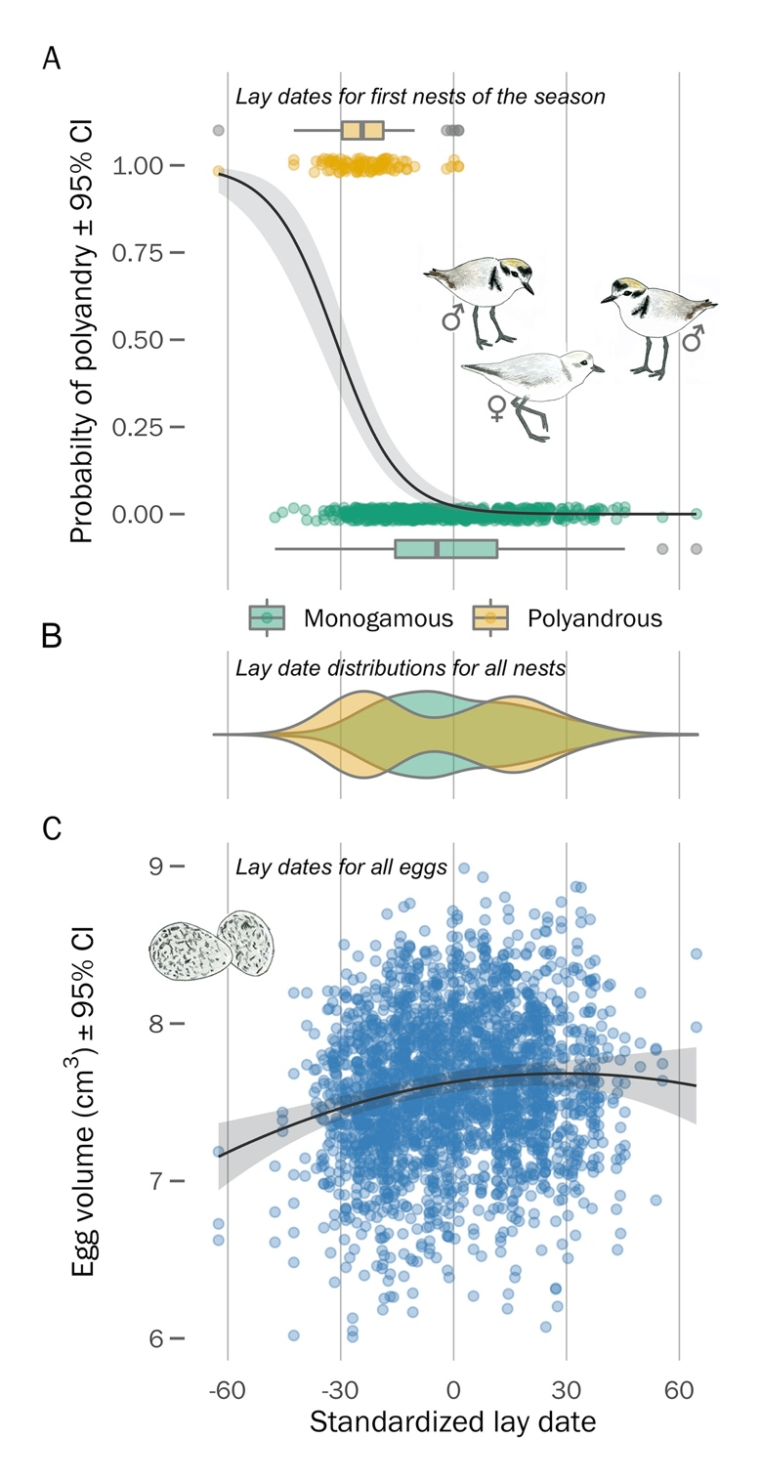**Figure 4.** Phenology of mating strategy, egg laying, and egg size in 425 female snowy plovers breeding at Bahía de Ceuta. A) Relationship between polyandry potential and lay date of a female’s first nest of the season. Each datum is the lay date of an individual’s first nest and their observed local mating behaviour of each year. B) Lay date distributions of all nests for females that were polyandrous (yellow) or monogamous (green). C) Seasonal variation in egg volume – trend shows the between individual polynomial function of the model prediction. Each datum is an egg’s volume (cm3) and lay date. Lay date is standardized for each year.

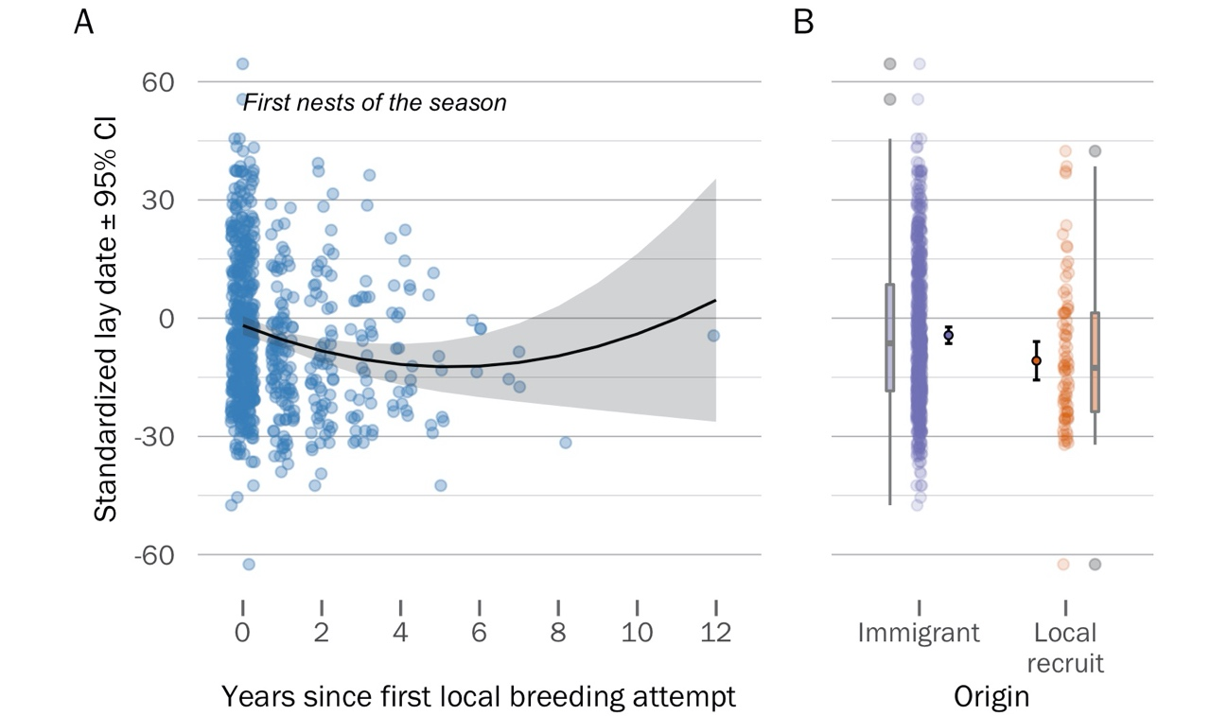

**Figure 5.** Age- and origin-dependent breeding phenology of female snowy plovers. A) Within-individual variation in age-specific nest initiation date – as females gained more experience in the local population, they started nesting earlier, however this trend reversed at older ages. Each datum represents an individual’s ‘age-deviance’ (i.e., a within-group centred measure of the number of years since the individual’s first observed local breeding attempt, see *Methods* for more details) and the lay date of its first nest each year. B) Origin-specific variation in nest initiation date – females that hatched locally and recruited into the breeding population tended to nest earlier than birds originating from elsewhere. Inner-most distributions show the model estimates and 95% CI, outer-most box plots show the inter-quartile ranges of the raw data (point-cloud).

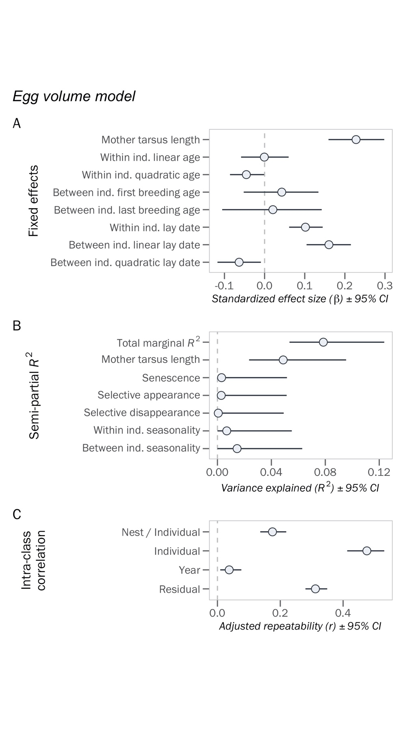**Figure 6.** Sources of egg volume variation.

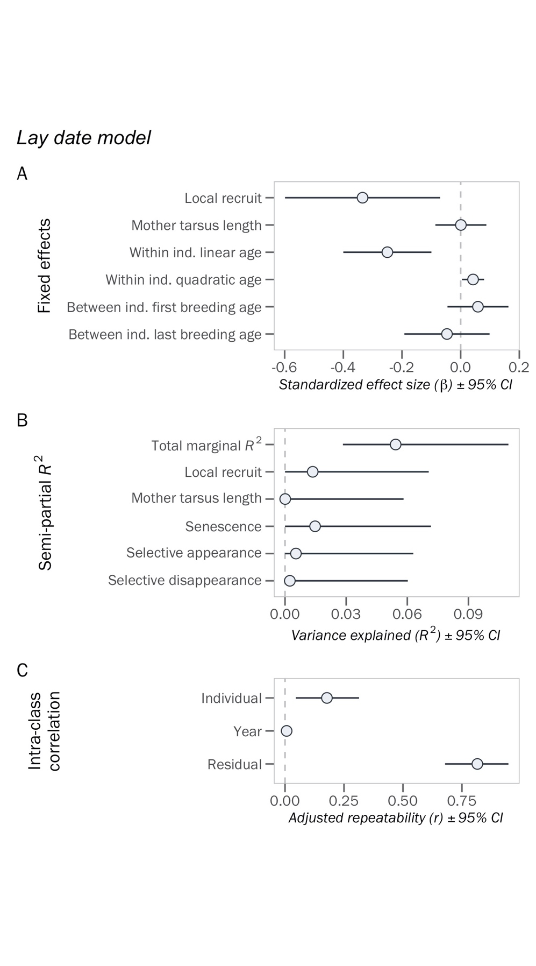**Figure 7.** Sources of lay date variation.

**SUPPLEMENTARY MATERIAL**

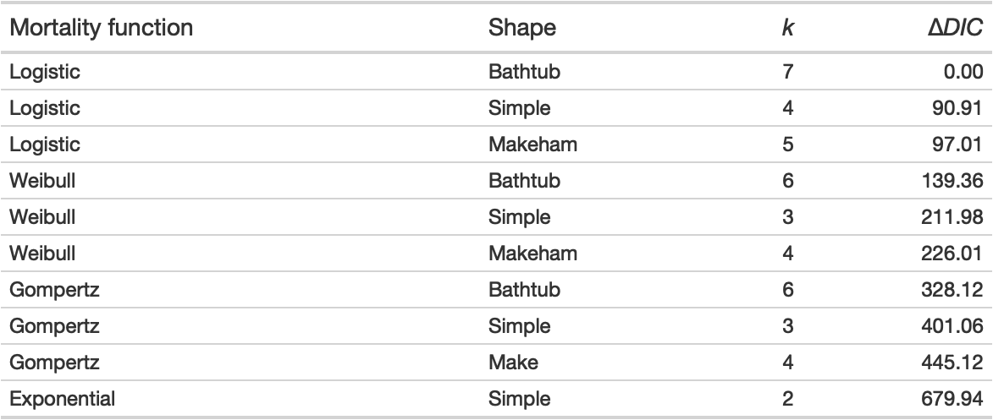**Table S1.** Hierarchical capture-mark-recapture models used to describe mortality patterns of snowy plovers at Bahía de Ceuta, Mexico, between 2006 and 2020. *k:* number of modelled parameters; Δ*DIC:* difference in deviance information criterion (*DIC*) between a given model and the top model. *DIC* value of top model was 5279.1.

**Table S2.** Relationship between the average egg volume of a clutch and the average chick weight at hatching.

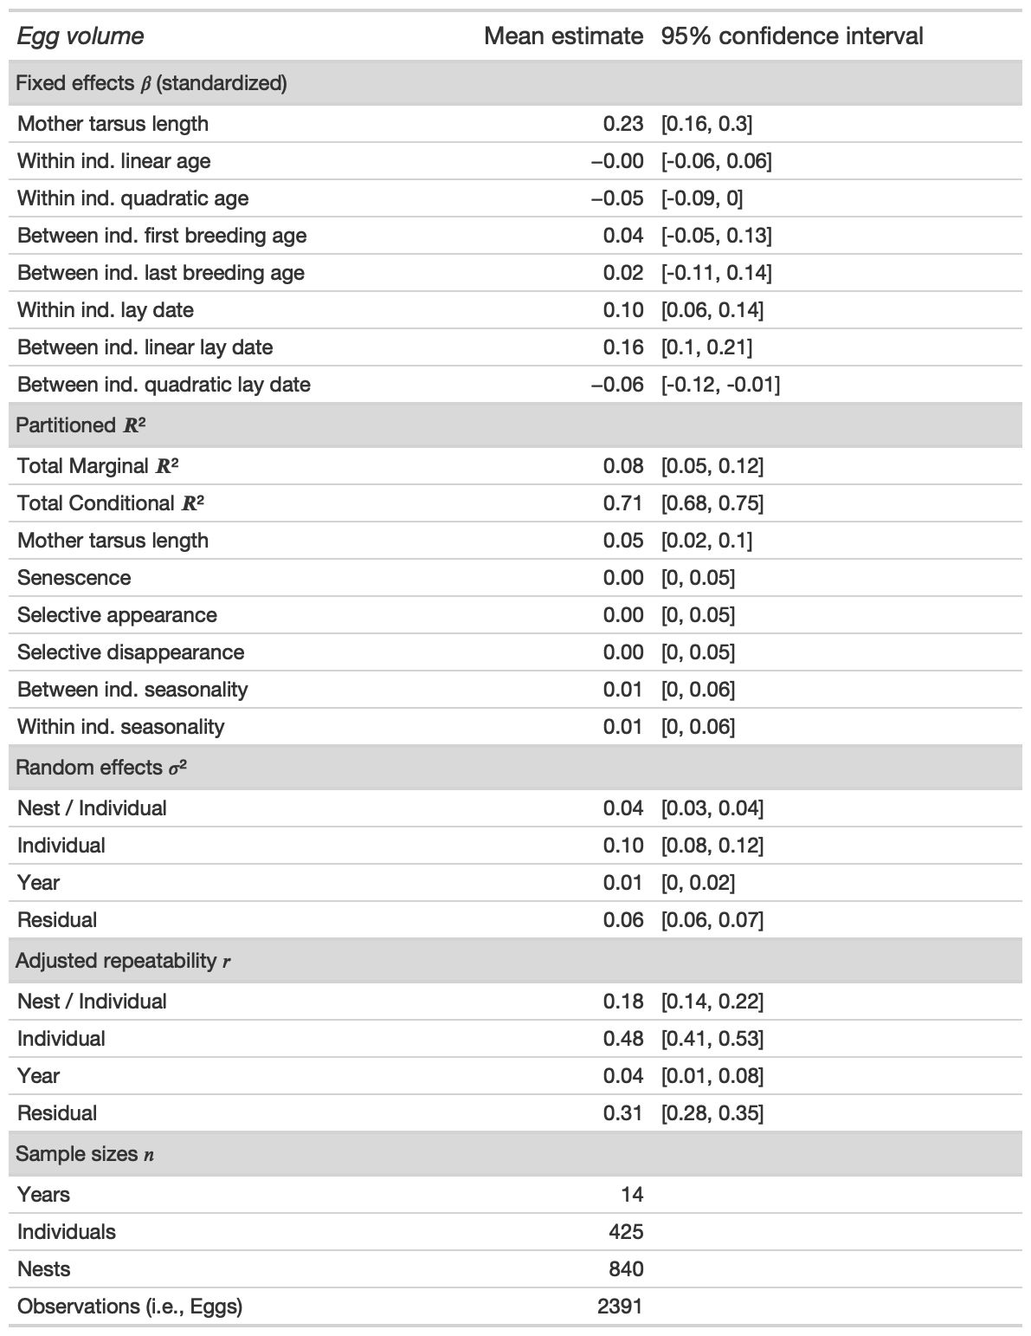**Table S3.** Sources of egg size variation.

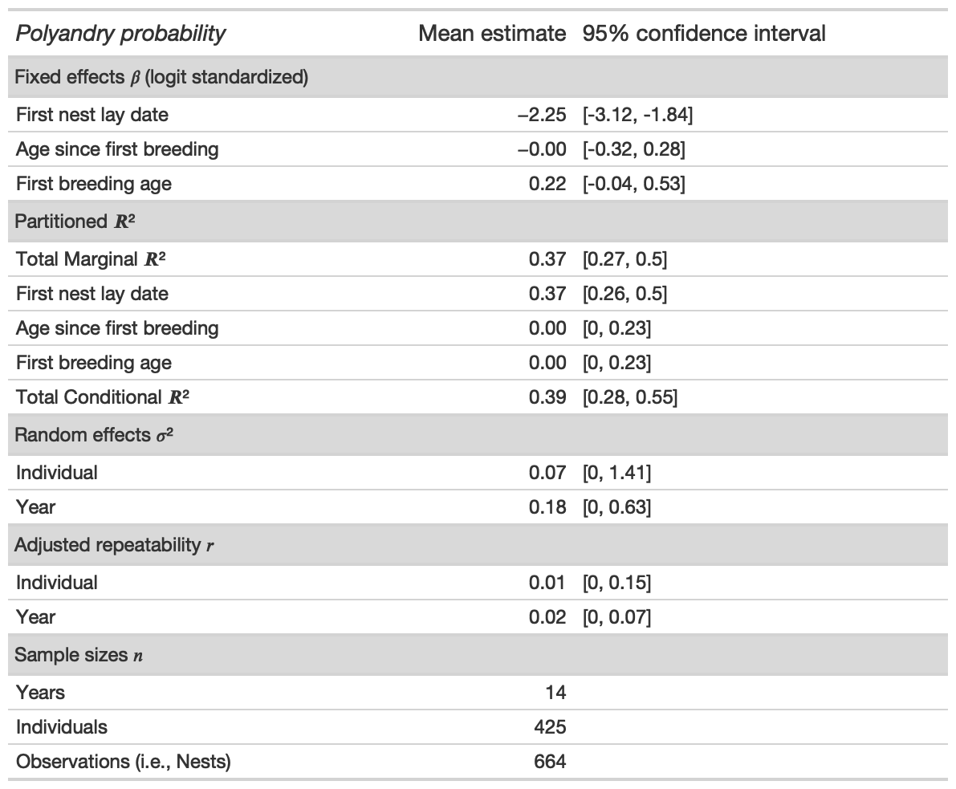**Table S4.** Relationship between the lay date of an individual’s first nest and their likelihood of polyandry each year. Fixed effect size of ‘first nest lay date’ is the standardized estimate on the logit scale.

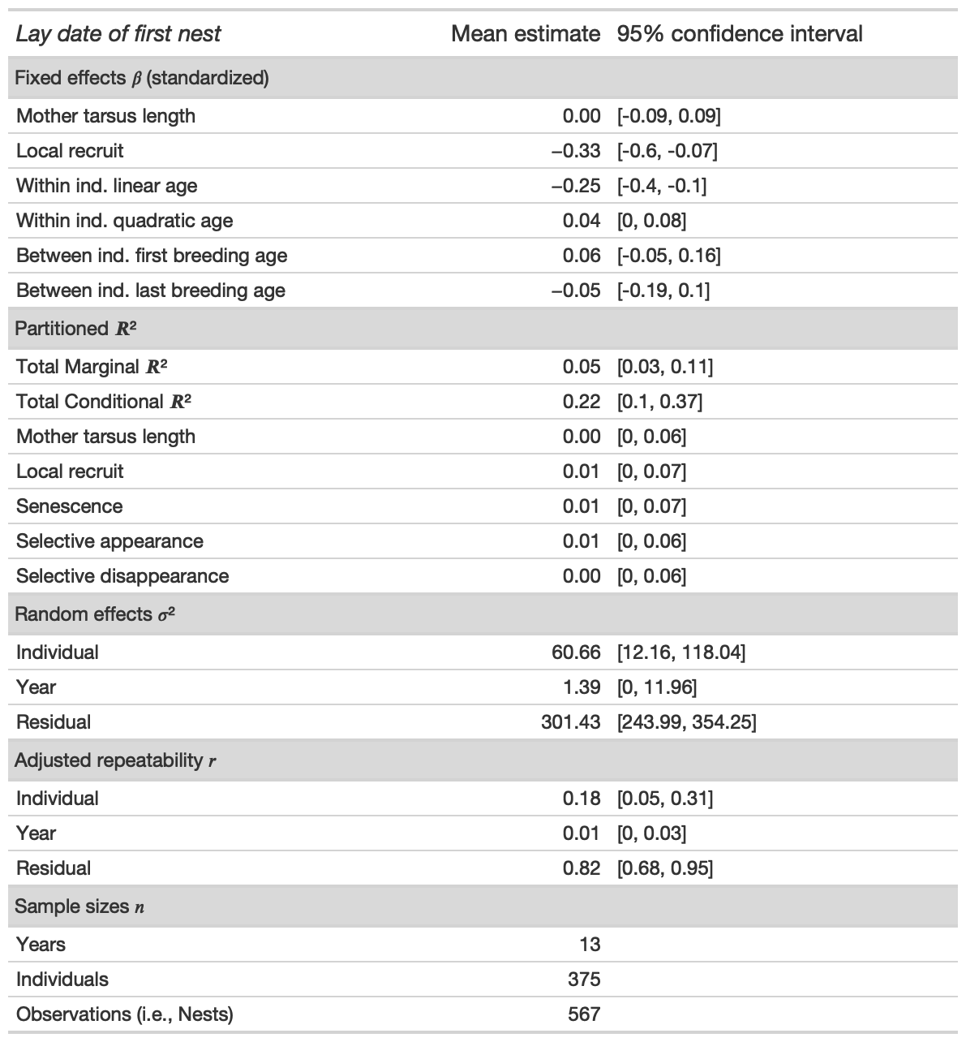**Table S5.** Sources of lay date variation.

**Figure S1.** Bayesian model diagnostics of the Logistic bathtub shaped survival model. a) Serial autocorrelation of iterations within chains, b) chain convergence (*R-hat*) of model, and c) trace plots of chain dynamics.

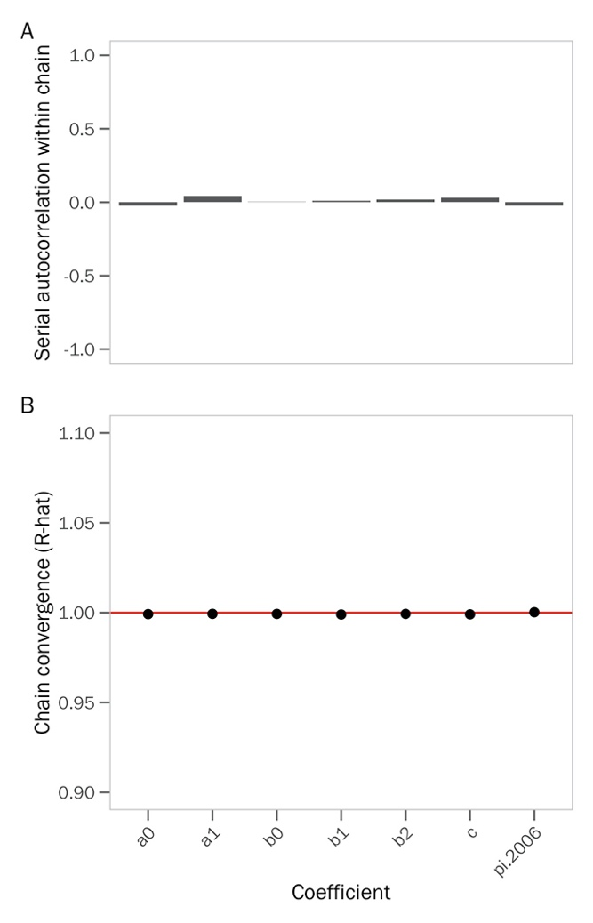

**Figure S2.** Sources of variation the average hatch weight of chicks.

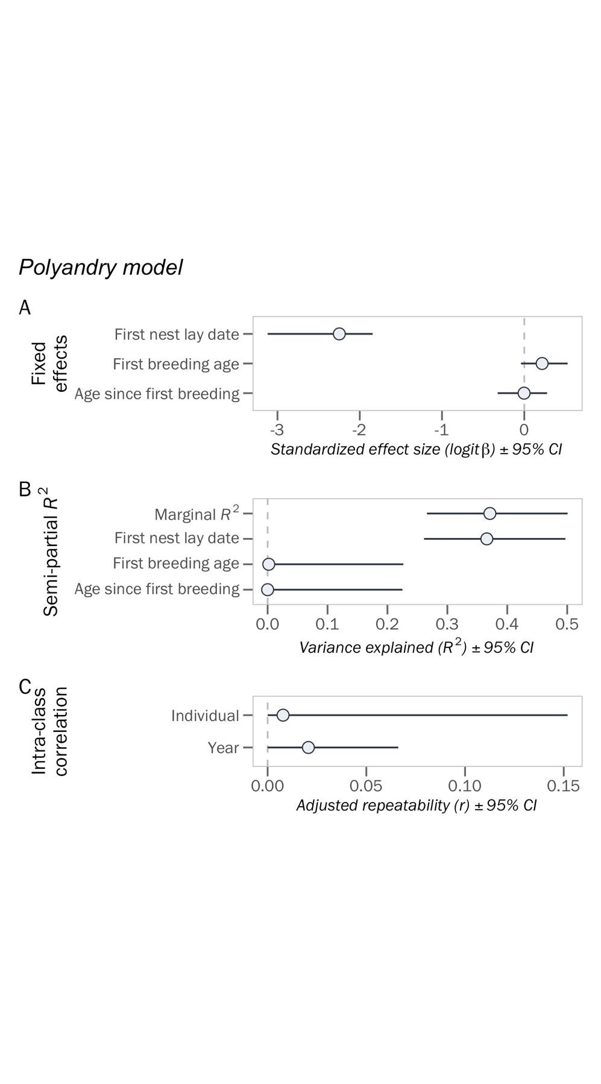**Figure S3.** Sources of variation in a female’s probability of being polyandrous each year.

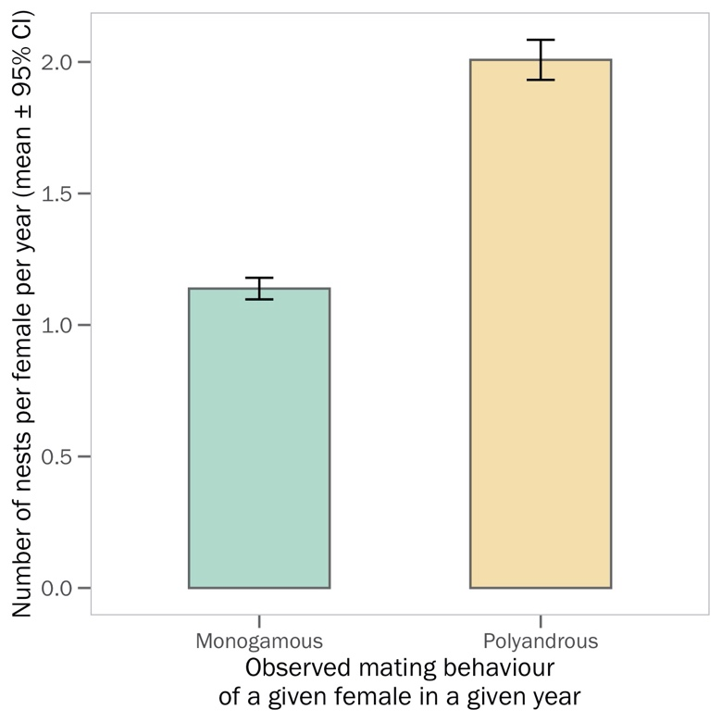**Figure S4.** Differences in nesting frequency between monogamous and polyandrous females.

**Figure 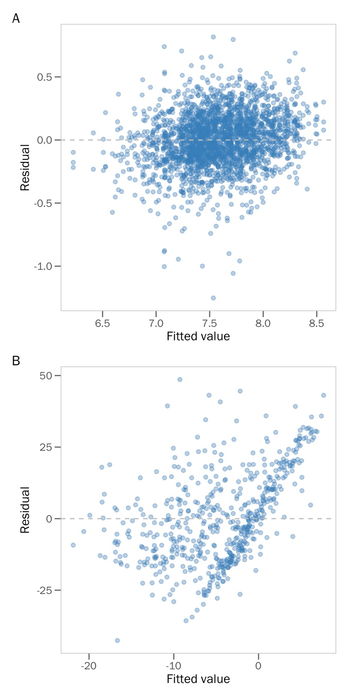S4.** Homoscedastic spread of residuals from the A) ‘egg volume’ and B) ‘lay date’ models.

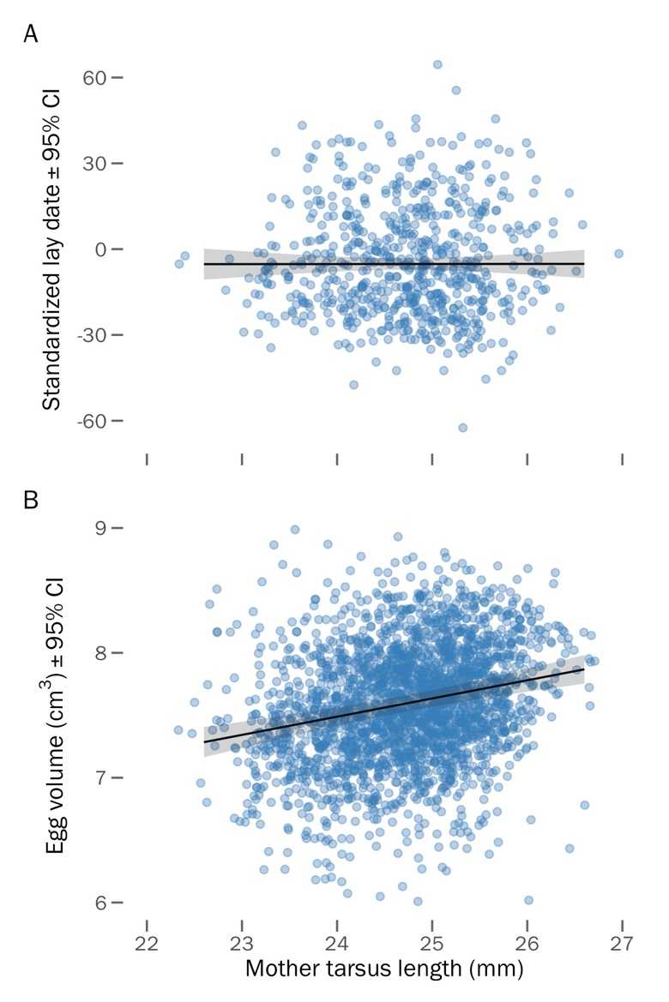**Figure S5.** Relationship between a female’s structural size (i.e., her tarsus length) and A) the lay date of her first nest of the season, and B) the volume of her eggs.

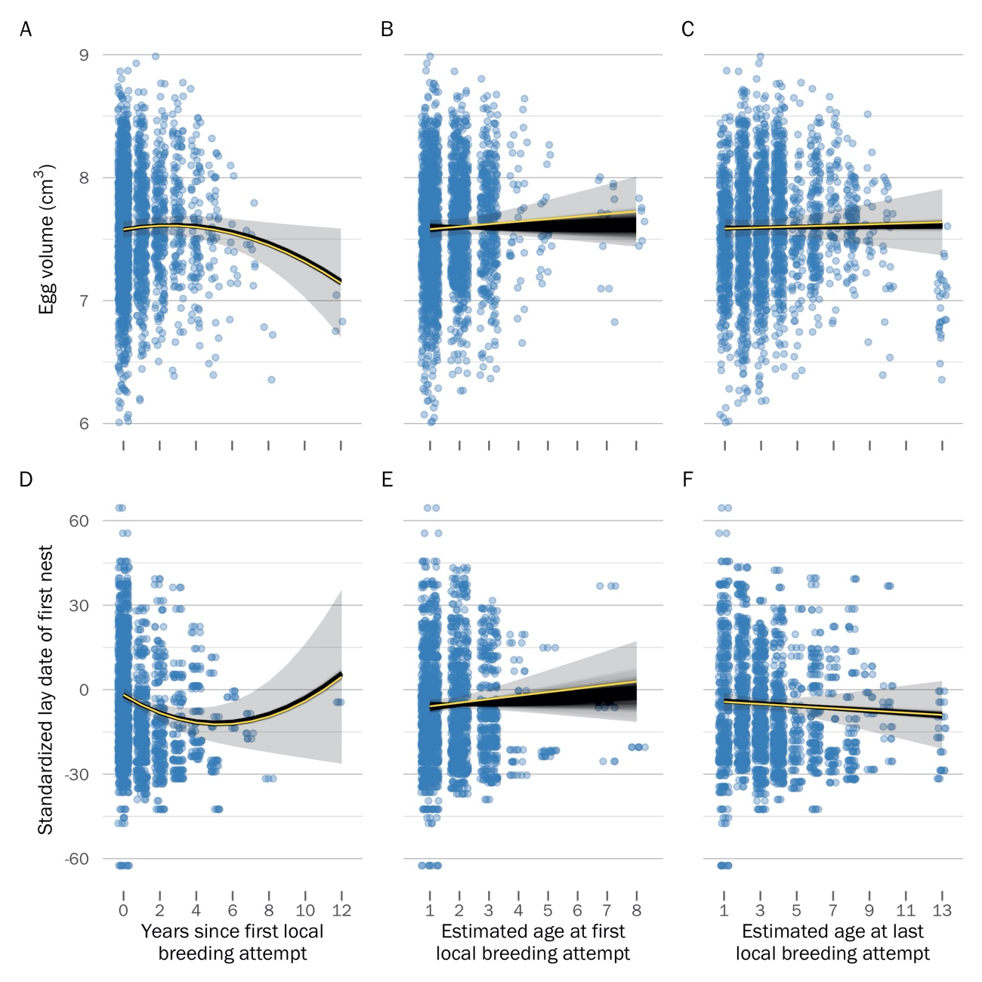**Figure S6.** Visualization of the effect of uncertainty in the age estimate provided by BaSTA on age-dependent trends in egg volume (top row) and lay date (bottom row) dynamics. Black trends show the model predictions for the 1000 bootstraps of the BaSTA age estimate posteriors (see *Methods*).Panels A and D show the within-individual trends of the ‘age-deviation’ score – as expected, these measures are not impacted by uncertainty in the BaSTA age estimate because they are centered for each individual (i.e., the absolute age is irrelevant). Panels B and E show the between-individual trend of the ‘age at first breeding’, and panels C and F show the between-individual trend of the ‘age at last breeding’. Yellow trends and grey ribbons visualize the 95% CI of the model predictions when using the mean age estimate provided by BaSTA (i.e., the effect sizes of the ‘egg volume’ and ‘lay date’ models shown in figs. 6 and 7).

**Appendix S1.**

To explain how mortality risk is associated with age, we compared four commonly used survival functions: exponential, Gompertz, logistic, and Weibull models. The exponential function keeps survival constant across age

(Cox & Oakes, 1984), whereas the other functions allow for age-dependent variation in survival: the Gompertz model is an exponential function in which age-specific mortality is scaled by baseline mortality (Gompertz, 1812; Pletcher, 1999) and the Weibull model is a power function which assumes that baseline and age-specific mortality rates are independent (Pinder *et al.*, 1978). In addition to the stand-alone versions of these functions, we considered two alternative forms of the Gompertz, logistic, and Weibull functions – “Makeham” and “bathtub” shapes. The Makeham shape constrains the survival function to converge to a constant, rather than zero, as age increases(Pletcher, 1999), whereas the bathtub shape enables concavity in the function, such that mortality could decrease at early ages, but increase later in life (Siler, 1979).

We used four parallel simulations to run the Markov chain Monte Carlo (MCMC) optimization procedure in BaSTA with 800,000 iterations, a 100,000 burn-in period, and a thinning interval of 2000 to minimize serial autocorrelation in the chain (see Fig. S1 for simulation diagnostics). We ranked the survival models according to their deviance information criterion (*DIC*) and determined that the logistic model with a bathtub shape fitted our data best (i.e., lowest *DIC*, (Spiegelhalter *et al.*, 2002); Table S1). This logistic model revealed that female mortality rate increased until age 5 years, after which it became constant (Fig. 1b). Using the top model, we extracted the point estimate and 95% credible interval birth year for each individual in the capture-mark-recapture sample.

**File S1.** Commented RMarkdown vignette detailing the analytical steps needed to reproduce all our models and results. Click here to view on your internet browser:

LITERATURE CITED

Amat, J.A., Fraga, R.M. & Arroyo, G.M. (1999) Brood desertion and polygamous breeding in the Kentish plover *Charadrius alexandrinus*. *Ibis*, **141**, 596–607.

Andersson, M. (2004) Social polyandry, parental investment, sexual selection, and evolution of reduced female gamete size. *Evolution*, **58**, 24–34.

Andersson, M. (2005) Evolution of Classical Polyandry: Three Steps to Female Emancipation. *Ethology*, **111**, 1–23.

Argüelles-Tico, A., Küpper, C., Kelsh, R.N., Kosztolányi, A., Székely, T. & van Dijk, R.E. (2015) Geographic variation in breeding system and environment predicts melanin-based plumage ornamentation of male and female Kentish plovers. *Behavioral Ecology and Sociobiology*, **70**, 49–60.

Beamonte-Barrientos, R., Velando, A., Drummond, H. & Torres, R. (2010) Senescence of Maternal Effects: Aging Influences Egg Quality and Rearing Capacities of a Long‐Lived Bird. *The American Naturalist*, **175**, 469–480.

Blomqvist, D., Johansson, O.C. & Götmark, F. (1997) Parental quality and egg size affect chick survival in a precocial bird, the lapwing Vanellus vanellus. *Oecologia*, **110**, 18–24.

Boonekamp, J.J., Salomons, M., Bouwhuis, S., Dijkstra, C. & Verhulst, S. (2014) Reproductive effort accelerates actuarial senescence in wild birds: an experimental study. *Ecology Letters*, **17**, 599–605.

Borgmann, K.L., Conway, C.J. & Morrison, M.L. (2013) Breeding phenology of birds: mechanisms underlying seasonal declines in the risk of nest predation. *PLoS ONE*, **8**, e65909.

Bouwhuis, S., Charmantier, A., Verhulst, S. & Sheldon, B.C. (2010) Trans-generational effects on ageing in a wild bird population. *Journal of Evolutionary Biology*, **23**, 636–642.

Bouwhuis, S., Sheldon, B.C., Verhulst, S. & Charmantier, A. (2009) Great tits growing old: selective disappearance and the partitioning of senescence to stages within the breeding cycle. *Proceedings of the Royal Society B: Biological Sciences*, **276**, 2769–2777.

Byrkjedal, I. & Kalas, J.A. (1985) Seasonal variation in egg size in golden plover Pluvialis apricaria and dotterel Charadrius morinellus populations. *Ornis Scandinavica*, **16**, 108–112.

Carmona-Isunza, M.C., Ancona, S., Székely, T., Ramallo-González, A.P., Cruz-López, M., Serrano-Meneses, M.A., *et al.* (2017) Adult sex ratio and operational sex ratio exhibit different temporal dynamics in the wild. *Behavioral Ecology*, **28**, 523–532.

Christians, J.K. (2002) Avian egg size: Variation within species and inflexibility within individuals. *Biological Reviews of the Cambridge Philosophical Society*, **77**, 1–26.

Colchero, F., Jones, O.R. & Rebke, M. (2012) BaSTA: An R package for Bayesian estimation of age-specific survival from incomplete mark-recapture/recovery data with covariates. *Methods in Ecology and Evolution*, **3**, 466–470.

Colwell, D.M.A. (2010) *Shorebird Ecology, Conservation, and Management*. University of California Press.

Colwell, M.A. & Oring, L.W. (1988) Breeding biology of Wilson's Phalarope in southcentral Saskatchewan. *The Wilson Bulletin*, 567–582.

Colwell, M.A., Feucht, E.J., McAllister, S.E. & Transou, A.N. (2017) Lessons learned from the oldest Snowy Plover. *Wader Study*, **124**, 157–159.

Cooch, E.G., Lank, D.B., Rockwell, R.F. & Cooke, F. (1992) Is There a Positive Relationship between Body Size and Fecundity in Lesser Snow Geese? *The Auk*, **109**, 667–673.

Cox, D.R. & Oakes, D. (1984) *Analysis of Survival Data*. Chapman and Hall, London.

Cruz-López, M., Eberhart-Phillips, L.J., Fernández, G., Beamonte-Barrientos, R., Székely, T., Serrano-Meneses, M.A., *et al.* (2017a) The plight of a plover: Viability of an important snowy plover population with flexible brood care in Mexico. *Biological Conservation*, **209**, 440–448.

Cruz-López, M., Eberhart-Phillips, L.J., Fernández, G., Beamonte-Barrientos, R., Székely, T., Serrano-Meneses, M.A., *et al.* (2017b) The plight of a plover: Viability of an important snowy plover population with flexible brood care in Mexico. *Biological Conservation*, **209**, 440–448.

Curio, E. (1983) Why de young birds reproduce less well? *Ibis*, **125**, 400–404.

D'Urban Jackson, J., Bruford, M.W., Székely, T., DaCosta, J.M., Sorenson, M.D., Russo, I.-R.M., *et al.* (2020) Population differentiation and historical demography of the threatened snowy plover Charadrius nivosus (Cassin, 1858). *Conservation Genetics*, **21**, 387–404.

Deeming, D.C. & Reynolds, S.J. (2015) Nests, Eggs, and Incubation New Ideas about Avian Reproduction. *Avian Biology Research*, **8**, 193.

Dingemanse, N.J., Moiron, M., Araya-Ajoy, Y.G., Mouchet, A. & Abbey-Lee, R.N. (2020) Individual variation in age-dependent reproduction: Fast explorers live fast but senesce young? *Journal of Animal Ecology*, **89**, 601–613.

Drenos, F. & Kirkwood, T.B.L. (2005) Modelling the disposable soma theory of ageing. *Mechanisms of Ageing and Development*, **126**, 99–103.

Eberhart-Phillips, L.J. (2019) Plover breeding systems: diversity and evolutionary origins. In *The population ecology and conservation of Charadrius plovers* (ed. by Colwell, M.A. & Haig, S.M.). pp. 63–88.

Eberhart-Phillips, L.J., Cruz-López, M., Lozano-Angulo, L., Gómez del Ángel, S., Rojas-Abreu, W., Bucio-Pacheco, M., *et al.* (2020a) CeutaOPEN, individual-based field observations of breeding snowy plovers Charadrius nivosus. *Scientific Data*, **7**, 149.

Eberhart-Phillips, L.J., Cruz-López, M., Lozano-Angulo, L., Gómez del Ángel, S., Rojas-Abreu, W., Bucio-Pacheco, M., *et al.* (2020b) CeutaOPEN v1.5. Open Science Framework.

Eberhart-Phillips, L.J., Küpper, C., Carmona-Isunza, M.C., Vincze, O., Zefania, S., Cruz-López, M., *et al.* (2018) Demographic causes of adult sex ratio variation and their consequences for parental cooperation. *Nature Communications*, **9**, 1–8.

Eberhart-Phillips, L.J., Küpper, C., Miller, T.E.X., Cruz-López, M., Maher, K.H., Remedios, dos, N., *et al.* (2017) Sex-specific early survival drives adult sex ratio bias in snowy plovers and impacts mating system and population growth. *Proceedings of the National Academy of Sciences of the United States of America*, **114**, e5474–e5481.

Emlen, S.T. & Oring, L.W. (1977) Ecology, sexual selection, and the evolution of mating systems. *Science*, **197**, 215–223.

Flint, P.L. & Sedinger, J.S. (1992) Reproductive Implications of Egg-Size Variation in the Black Brant. *The Auk*, **109**, 896–903.

Forslund, P. & Pärt, T. (1995) Age and reproduction in birds - hypotheses and tests. *Trends in Ecology & Evolution*, **10**, 374–378.

Fox, C.W. (1994) The Influence of Egg Size on Offspring Performance in the Seed Beetle, Callosobruchus maculatus. *Oikos*, **71**, 321–325.

Gompertz, B. (1812) On the nature of the function expressive of the law of human mortality, and on a new mode of determining the value of life contingencies. *Philosophical Transactions of the Royal Society of London B: Biological Sciences*, **115**, 513–583.

Goymann, W., Makomba, M., Urasa, F. & Schwabl, I. (2015) Social monogamy vs. polyandry: ecological factors associated with sex roles in two closely related birds within the same habitat. *Journal of Evolutionary Biology*, **28**, 1335–1353.

Graham, J.L., Bauer, C.M., Heidinger, B.J., Ketterson, E.D. & Greives, T.J. (2019) Early-breeding females experience greater telomere loss. *Molecular Ecology*, **28**, 114–126.

Griffiths, R., Double, M.C., Orr, K. & Dawson, R.J.G. (1998) A DNA test to sex most birds. *Molecular Ecology*, **7**, 1071–1075.

Grunst, M.L., Grunst, A.S., Formica, V.A., Korody, M.L., Betuel, A.M., Barcelo-Serra, M., *et al.* (2018) Actuarial senescence in a dimorphic bird: different rates of ageing in morphs with discrete reproductive strategies. *Proceedings. Biological sciences*, **285**, 20182053.

Halimubieke, N., Kupán, K., Valdebenito, J.O., Kubelka, V., Carmona-Isunza, M.C., Burgas, D., *et al.* (2020) Successful breeding predicts divorce in plovers. *Scientific Reports*, **10**, 15576–13.

Halimubieke, N., Valdebenito, J.O., Harding, P., López, M.C., Meneses, M.A.S., James, R., *et al.* (2019) Mate fidelity in a polygamous shorebird, the snowy plover (Charadrius nivosus). *Ecology and Evolution*, **28**, 523.

Hall, L.K. & Cavitt, J.F. (2012) Comparative Study of Trapping Methods for Ground-Nesting Shorebirds. *Waterbirds*, **35**, 342–346.

Hammers, M., Richardson, D.S., Burke, T. & Komdeur, J. (2012) Age-dependent terminal declines in reproductive output in a wild bird. *PLoS ONE*, **7**, e40413.

Hanson, H.C. (1954) Apparatus for the Study of Incubated Bird Eggs. *The Journal of Wildlife Management*, **18**, 191–198.

Herborn, K.A., Daunt, F., Heidinger, B.J., Granroth-Wilding, V.H.M., Burthe, S.J., Newell, M.A., *et al.* (2016) Age, oxidative stress exposure and fitness in a long-lived seabird. *Functional Ecology*, **30**, 913–921.

Hoyt, D.F. (1979) Practical Methods of Estimating Volume and Fresh Weight of Bird Eggs. *The Auk*, **96**, 73–77.

Ito, K. (1997) Egg-size and -number variations related to maternal size and age, and the relationship between egg size and larval characteristics in an annual marine gastropod, Haloa japonica (Opisthobranchia; Cephalaspidea). *Marine Ecology Progress Series*, **152**, 187–195.

Jankowiak, Ł., Zyskowski, D. & Wysocki, D. (2018) Age-specific reproduction and disposable soma in an urban population of Common Blackbirds Turdus merula. *Ibis*, **160**, 130–144.

Kaplan, R.H. (1980) The Implications of Ovum Size Variability for Offspring Fitness and Clutch Size within Several Populations of Salamanders (Ambystoma). *Evolution*, **34**, 51–64.

Kirkwood, T.B.L. (1977) Evolution of ageing. *Nature*, **270**, 301–304.

Kirkwood, T.B.L. & Austad, S.N. (2000) Why do we age? *Nature*, **408**, 233–238.

Kirkwood, T.B.L. & Rose, M.R. (1991) Evolution of senescence: late survival sacrificed for reproduction. *Philosophical Transactions of the Royal Society B-Biological Sciences*, **332**, 15–24.

Kubelka, V., Sládeček, M., Zámečník, V., Vozabulová, E. & Šálek, M. (2020) Seasonality Predicts Egg Size Better Than Nesting Habitat in a Precocial Shorebird. *Ardea*, **107**, 239.

Kupán, K., Székely, T., Cruz-López, M., Seymour, K. & Küpper, C. (2021) Offspring desertion with care? Chick mortality and plastic female desertion in Snowy Plovers. *Behavioral Ecology*.

Küpper, C., Augustin, J., Kosztolányi, A., Burke, T., Flguerola, J. & Székely, T. (2009) Kentish versus snowy plover: phenotypic and genetic analyses of *Charadrius alexandrinus* reveal divergence of Eurasian and American subspecies. *The Auk*, **126**, 839–852.

Küpper, C., Horsburgh, G.J., Dawson, D.A., ffrench-Constant, R., Székely, T. & Burke, T. (2007) Characterization of 36 polymorphic microsatellite loci in the Kentish plover (*Charadrius alexandrinus*) including two sex-linked loci and their amplification in four other Charadrius species. *Molecular Ecology Notes*, **7**, 35–39.

Kwon, E., English, W.B., Weiser, E.L., Franks, S.E., Hodkinson, D.J., Lank, D.B., *et al.* (2018) Delayed egg-laying and shortened incubation duration of Arctic-breeding shorebirds coincide with climate cooling. *Ecology and Evolution*, **8**, 1339–1351.

Lack, D.L. (1968) *Ecological adaptations for breeding in birds*.

Lemaître, J.-F., Berger, V., Bonenfant, C., Douhard, M., Gamelon, M., Plard, F., *et al.* (2015) Early-late life trade-offs and the evolution of ageing in the wild. *Proceedings of the Royal Society B: Biological Sciences*, **282**, 20150209.

Liker, A., Reynolds, J.D. & Székely, T. (2001) The evolution of egg size in socially polyandrous shorebirds. *Oikos*, **95**, 3–14.

Medawar, P.B.P. (1952) *An Unsolved Problem of Biology*. University College London, London.

Moran, A.L. & Emlet, R.B. (2001) Offspring size and performance in variable environments: field studies on a marine snail. *Ecology*, **82**, 1597–1612.

Nakagawa, S. & Schielzeth, H. (2010) Repeatability for Gaussian and non‐Gaussian data: a practical guide for biologists. *Biological Reviews*, **85**, 935–956.

Nosály, G. & Székely, T. (1993) Clutch and egg-size variation in the Kentish Plover (*Charadrius alexandrinus*) during the breeding season. *Aquila*, **100**, 161–179.

Nussey, D.H., Coulson, T., Festa-Bianchet, M. & Gaillard, J.M. (2008) Measuring senescence in wild animal populations: Towards a longitudinal approach. *Functional Ecology*, **22**, 393–406.

Ockendon, N., Leech, D. & Pearce-Higgins, J.W. (2013) Climatic effects on breeding grounds are more important drivers of breeding phenology in migrant birds than carry-over effects from wintering grounds. *Biology Letters*, **9**, 20130669.

Oring, L.W. (1986) Avian Polyandry. In *Current Ornithology, vol 3*, Current Ornithology, vol 3 (ed. by Johnston, R.F.). pp. 309–351.

Page, G.W., Stenzel, L.E., Warriner, J.S., Warriner, J.C. & Paton, P.W. (2009) Snowy Plover (Charadrius nivosus). *The Birds of North America Online*, 71935–72002.

Pinder, J.E., Wiener, J.G. & Smith, M.H. (1978) The Weibull Distribution: A New Method of Summarizing Survivorship Data. *Ecology*, **59**, 175–179.

Plaschke, S., Bulla, M., Cruz-López, M., Gómez del Ángel, S. & Küpper, C. (2019) Nest initiation and flooding in response to season and semi-lunar spring tides in a ground-nesting shorebird. *Frontiers in Zoology*, **16**, 15–11.

Pletcher, S. (1999) Model fitting and hypothesis testing for age-specific mortality data. *Journal of Evolutionary Biology*, **12**, 430–439.

Potti, J. (1993) Environmental, ontogenetic, and genetic variation in egg size of Pied Flycatchers. *Canadian Journal of Zoology-revue Canadienne De Zoologie - CAN J ZOOL*, **71**, 1534–1542.

Rahn, H., Paganelli, V.C. & Ar, A. (1975) Relation of Avian Egg Weight to Body Weight. *The Auk*, **92**, 750–765.

Reid, V.W. (1988) Age-Specific Patterns of Reproduction in the Glaucous-Winged Gull: Increased Effort with Age. *Ecology*, **69**, 1454–1465.

Remedios, dos, N., Lee, P.L., Székely, T., Dawson, D.A. & Küpper, C. (2010) Molecular sex-typing in shorebirds: a review of an essential method for research in evolution, ecology and conservation. *Wader Study Group Bulletin*, **117**, 109–118.

Robertson, G.J., Cooch, E.G., Lank, D.B., Rockwell, R.F. & Cooke, F. (1994) Female Age and Egg Size in the Lesser Snow Goose. *Journal of Avian Biology*, **25**, 149.

Salguero-Gómez, R., Jones, O.R., Jongejans, E., Blomberg, S.P., Hodgson, D.J., Mbeau-Ache, C., *et al.* (2016) Fast-slow continuum and reproductive strategies structure plant life-history variation worldwide. *Proceedings of the National Academy of Sciences of the United States of America*, **113**, 230–235.

Sandercock, B.K., Lank, D.B. & Cooke, F. (1999) Seasonal Declines in the Fecundity of Arctic-Breeding Sandpipers: Different Tactics in Two Species with an Invariant Clutch Size. *Journal of Avian Biology*, **30**, 460.

Schamel, D., Tracy, D.M. & Lank, D.B. (2004) Male mate choice, male availability and egg production as limitations on polyandry in the red-necked phalarope. *Animal Behaviour*, **67**, 847–853.

Schroeder, J., Burke, T., Mannarelli, M.E., Dawson, D.A. & Nakagawa, S. (2012) Maternal effects and heritability of annual productivity. *Journal of Evolutionary Biology*, **25**, 149–156.

Siler, W. (1979) A Competing‐Risk Model for Animal Mortality. *Ecology*, **60**, 750–757.

Skrade, P. & Dinsmore, S.J. (2013) Egg-size investment in a bird with uniparental incubation by both sexes. *The Condor*, **115**, 508–514.

Slotow, R. (1996) Black coucal Centropus grillii egg volume predicts their polyandrous mating system. *Journal of Avian Biology*, 171–173.

Snijders, T. & Bosker, R.J. (2011) *Multilevel analysis: An introduction to basic and advanced multilevel modeling*. 2nd edn. Sage.

Spiegelhalter, D.J., Best, N.G., Carlin, B.P. & Van Der Linde, A. (2002) Bayesian measures of model complexity and fit. *Journal of the Royal Statistical Society: Series B (Statistical Methodology)*, **64**, 583–639.

Starck, J.M. & Ricklefs, R.E. (1998) *Avian growth and development. Evolution within the altricial-precocial spectrum*. New York.

Stenzel, L.E., Warriner, J.C., Warriner, J.S., Wilson, K.S., Bidstrup, F.C. & Page, G.W. (1994) Long-distance breeding dispersal of snowy plovers in western North America. *Journal of Animal Ecology*, **63**, 887–902.

Stoffel, M.A., Nakagawa, S. & Schielzeth, H. (2017) rptR: repeatability estimation and variance decomposition by generalized linear mixed‐effects models. *Methods in Ecology and Evolution*, **8**, 1639–1644.

Stoffel, M.A., Nakagawa, S. & Schielzeth, H. (2020) partR2: Partitioning R2 in generalized linear mixed models. *bioRxiv*, 2020.07.26.221168.

Székely, T. & Kosztolányi, A. (2006) Practical guide for investigating breeding ecology of Kentish plover *Charadrius alexandrinus*. *University of Bath*.

Székely, T., Argüelles-Tico, A., Kosztolányi, A. & Küpper, C. (2011) Practical guide for investigating breeding ecology of Kentish plover, 1–16.

Székely, T., Cuthill, I.C. & Kis, J. (1999) Brood desertion in Kentish plover sex differences in remating opportunities. *Behavioral Ecology*, **10**, 185–190.

Székely, T., Kozma, J. & Piti, A. (1994) The Volume of Snowy Plover Eggs (El Volumen de los Huevos de Charadrius alexandrinus). *Journal of Field Ornithology*, **65**, 60–64.

van de Pol, M. & Verhulst, S. (2006) Age‐Dependent Traits: A New Statistical Model to Separate Within‐ and Between‐Individual Effects. *The American Naturalist*, **167**, 766–773.

Verhoeven, M.A., Loonstra, A.H.J., McBride, A.D., Tinbergen, J.M., Kentie, R., Hooijmeijer, J.C.E.W., *et al.* (2020) Variation in Egg Size of Black-Tailed Godwits. *Ardea*, **107**, 291.

Vincze, O., Kosztolányi, A., Barta, Z., Küpper, C., Alrashidi, M., Amat, J.A., *et al.* (2017) Parental cooperation in a changing climate: fluctuating environments predict shifts in care division. *Global Ecology and Biogeography*, **26**, 347–358.

Warner, D.A., Miller, D.A.W., Bronikowski, A.M. & Janzen, F.J. (2016) Decades of field data reveal that turtles senesce in the wild. *Proceedings of the National Academy of Sciences of the United States of America*, **113**, 6502–6507.

Warriner, J.S., Warriner, J.C., Page, G.W. & Stenzel, L.E. (1986) Mating system and reproductive success of a small population of polygamous snowy plovers. *The Wilson Bulletin*, **98**, 15–37.

Weiser, E.L., Brown, S.C., Lanctot, R.B., Gates, H.R., Abraham, K.F., Bentzen, R.L., *et al.* (2018) Life-history tradeoffs revealed by seasonal declines in reproductive traits of Arctic-breeding shorebirds. *Journal of Avian Biology*, **49**, jav–01531.

Williams, G.C. (1957) Pleiotropy, Natural Selection, and the Evolution of Senescence. *Evolution*, **11**, 398.

Williams, T.D. (1994) Intraespecific Variation in Egg Size and Egg Composition in Birds: Effects on Offspring Fitness. *Biological Reviews of the Cambridge Philosophical Society*, **69**, 35–59.

Williams, T.D. (2012) *Physiological adaptations for breeding in birds*. Princenton.

Xu, F., Yang, W. & Li, Y. (2019) Enlarged Egg Size Increases Offspring Fitness of a Frog Species on the Zhoushan Archipelago of China. *Scientific Reports*, **9**, 11653.

Zhang, H., Vedder, O., Becker, P.H. & Bouwhuis, S. (2015) Age-dependent trait variation: the relative contribution of within-individual change, selective appearance and disappearance in a long-lived seabird. *Journal of Animal Ecology*, **84**, 797–807.