HANDWRITING FORGERY DETECTION USING DEEP LEARNING: PAGE-LEVEL, MULTI-REFERENCE VERIFICATION
SDG : SDG 16 – Peace, Justice and Strong Institutions

PROJECT REQUIREMENT SPECIFICATION REPORT
(23AI2014)

Submitted by

LINCY JENITA J
(URK23CS5079)

in partial fulfillment for the award of the degree of

BACHELOR OF TECHNOLOGY
in
COMPUTER SCIENCE AND ENGINEERING
(AI/AIML)

Academic Year 2026-2027
ODD SEMESTER

DIVISION OF ARTIFICIAL INTELLIGENCE AND MACHINE LEARNING
SCHOOL OF COMPUTER SCIENCE AND TECHNOLOGY


November 2026

BONAFIDE CERTIFICATE

This is to certify that the project requirement specification report entitled “HANDWRITING FORGERY DETECTION USING DEEP LEARNING: PAGE-LEVEL, MULTI-REFERENCE VERIFICATION” is a bonafide work done during the odd semester of the academic year 2026-2027 by
Lincy Jenita J (URK23CS5079)
in partial fulfillment of the requirements for the award of the degree of Bachelor of Technology in Computer Science and Engineering (AI /AIML) of Karunya Institute of Technology and Sciences.

Signature of the Supervisor

S. D. Lalitha
Associate Professor
Division of Artificial Intelligence and Machine Learning

Submitted for the Viva Voce held on ___________________

DECLARATION

We, hereby affirm our commitment to the development and implementation of the project described in this report. We are responsible for the creation and development of the project outlined in this Project Requirement Specification (PRS) report, hereby declare the following:

- We have thoroughly reviewed and analyzed the requirements and have ensured that they are accurately represented in this report to the best of our knowledge.
- We commit to adhering to the specifications, functionalities, and features outlined in this PRS during the development phase of the project.
- We will strive to implement industry best practices, coding standards, and security measures to develop a high-quality, reliable, and secure software solution.
- We affirm our commitment to delivering the solution within the agreed-upon timelines, while prioritizing quality.
- We jointly undertake to work towards achieving the selected project outcome (Patent / Startup / Consultancy / Journal Publication) committed to under this project.

Signature of student Signature of the Supervisor

TABLE OF CONTENTS

S.No | Title of the exercise | Page No.
 | Introduction | 5
 | Problem Definition, Scope and Objectives | 6
 | Literature Survey | 7
 | Requirement Analysis | 9
 | Proposed Methodology and System Design | 11
 | Implementation | 13
 | Results and Discussion | 17
 | Conclusion | 22
 | References | 23
 | Annexure - I: Outcome-Specific Supporting Evidence | 25

1. INTRODUCTION

1.1 Background
Handwritten examination scripts, wills, contracts and notes are routinely disputed. A typical case is an answer sheet whose ownership is questioned because another person is suspected of copying the answers in an imitation of the owner's handwriting. The owner can then offer earlier genuine scripts as references, and an examiner must decide whether the questioned script is consistent with them.
This is a page-level, multi-reference verification problem. The evidence is a complete script, not a single word, sentence or signature, and several known pages of the claimed writer are available. The system described in this report takes the previous handwriting samples as reference images and the questioned handwriting as input, compares letter shapes, strokes, spacing and other writing characteristics with a deep neural network, and reports whether the questioned page is consistent with the claimed writer or potentially forged.

1.2 Motivation
Most deep-learning work on handwriting is organised differently. Writer identification and retrieval systems assign a page to one of many known writers or rank a collection by similarity [1]–[5]. Verification work compares a pair of samples, usually words, text patches or signatures [6]–[9]. Little of it combines a whole questioned page with several reference pages, reports a calibrated degree of support, or allows the system to answer “inconclusive”.
A second difficulty is the threat model. Public datasets contain genuine pages by many writers, but almost none contain a person deliberately imitating another. At the same time, generative models can now imitate a given writing style [10]–[13]. A useful system must therefore be honest about what it can and cannot show.

1.3 Overview of the work
- A page-level verifier: a ResNet-18 trained from scratch embeds a full script as an attention-pooled bag of ink patches; one or several reference pages are fused into a calibrated three-way verdict (consistent, inconclusive, likely forged).
- A data pipeline over three English corpora (IAM, CVL, Firemaker) with writer-disjoint splits, leakage checks and a test protocol in which test sets are used once.
- An evaluation of seven baselines and ablations, multi-reference fusion, cross-corpus transfer, disguised writing, calibration and synthetic pages.
- A working demonstration service (CPU) and a live training dashboard, and a journal-style paper draft generated from the result files.

1.4 Organisation of the report
Chapter 2 defines the problem, scope and objectives. Chapter 3 surveys the literature. Chapter 4 analyses the requirements. Chapter 5 presents the methodology and system design, and Chapter 6 the implementation. Chapter 7 reports and discusses the results, Chapter 8 concludes, and Chapter 9 lists the references. Annexure I gives the outcome-specific supporting evidence.

2. PROBLEM DEFINITION, SCOPE AND OBJECTIVES

2.1 Problem statement
Given a claimed writer with N ≥ 1 reference pages R = {r1, …, rN} and one questioned page q, the system must return a similarity score s(q, R) and a verdict: consistent, inconclusive or likely forged. The unit of evidence is a full page. All pages are embedded by one network f into unit vectors, so that s is a function of cosine similarities.

2.2 Scope
In scope | Out of scope for this report (first paper)
English full pages from IAM, CVL and Firemaker | The four Indian languages planned as a second phase (data collection paused by decision)
One to five reference pages per claimed writer | Real impersonation data (none is public)
Writer-disjoint testing and a cross-corpus test | Generators of learned imitation (DiffusionPen and similar)
Calibrated three-way verdict; CPU demonstration | Word-level and signature verification

2.3 Objectives and research questions
- O1. Build and evaluate a page-level, multi-reference handwriting verifier trained from scratch.
- O2. Measure how reliable the verdict is, including its abstention (inconclusive) behaviour and calibration.
- O3. Test transfer to a corpus never used for training or tuning, and the effect of disguised writing.
- O4. Deliver a reproducible pipeline, a working demonstration and a journal-style paper.
The objectives are studied through four research questions. RQ1: how well does a page-level model separate writers, and does it beat untrained and frozen-feature baselines? RQ2: does adding reference pages help, and which fusion rule is best? RQ3: does the model transfer to a corpus recorded with a different scanner and protocol (Firemaker), including pages written in a disguised style? RQ4: which training ingredients matter: distillation, attention pooling, content-matched batches, writer mining, patch count and augmentation?

2.4 Expected outcome and sustainable development goals
The outcome selected for this project is a journal publication (Annexure I). The work supports SDG 16 – Peace, Justice and Strong Institutions, because reliable document verification helps courts, examination bodies and institutions settle disputes about authorship, and, secondarily, SDG 4 (quality education) through the integrity of handwritten examinations.

3. LITERATURE SURVEY
Only the abstracts of the cited arXiv papers and the dataset papers were read for this survey; no performance numbers from other papers are quoted.

3.1 Writer identification and retrieval
Text-independent writer identification with CNNs was established by DeepWriter [1], and later work introduced fragment-based and attention-based models [2], [16]. Unsupervised and self-supervised representations have become competitive for retrieval on historical and modern pages [3]–[5], [17]. A recent study analyses which pipeline factors matter for historical writer identification [18]. These systems answer “which writer” or “which pages are similar”; they do not output a verification decision for a claimed writer.

3.2 Handwriting verification
Adak et al. study writer identification and verification from intra-writer variation [6], [19]. Shaikh et al. propose an attention-based writer-independent verifier [7], and self-supervised pre-training has been applied to the same task [9], [20]. These compare one pair of samples; our setting differs in using complete pages and several references.

3.3 Signature verification
Signature verification uses twin networks and metric learning [8], [21], [22]. The methods are designed for signatures, not for whole pages, but they motivate the use of distance learning and of the cross-dataset generalisation check that we apply to Firemaker.

3.4 Generated handwriting as a threat
Diffusion and transformer generators produce handwriting in a target style from short style samples [10]–[12], including paragraphs [13]. Synthetic data has also been used to pre-train handwriting models [23]. Such generators are the foreseeable forgery tool, but they were not run in this work (Chapter 7, Limitations).

3.5 Distillation, fusion and calibration
Knowledge distillation [24] has been used in offline signature verification [14]. Self-supervised ViTs such as DINOv2 [25] provide strong frozen features. Forensic work argues that the strength of evidence should be expressed as a likelihood ratio [15], and modern networks are often poorly calibrated [26]. We adopt these ideas for page-level handwriting verification.

3.6 Summary and research gap
Table 1: Representative related work and the gap for a page-level, multi-reference task.
Work | Level | What it does | Gap for this task
DeepWriter [1] | text patches | CNN for text-independent writer identification | identifies; does not verify a claim
FragNet [2] | fragments | fragment network for writer identification | closed-set identification
Self-supervised ViT [4] | pages | unsupervised writer retrieval | ranks pages; no verdict
Attention verifier [7] | pairs | writer-independent verification | one pair, not many references
Self-supervised verification [9] | pairs | pre-training for verification | pairs; no calibration
SigNet [8] | signatures | Siamese signature verification | signatures, not full pages

To our knowledge, no prior writer-verification work combines a whole questioned page, several reference pages, content-matched hard negatives, a calibrated verdict that may abstain, a never-tuned cross-corpus test and explicit reporting of what the data cannot show. We do not claim that any single component is new: distillation and likelihood-ratio reporting each have precedent [14], [15].

3.7 Datasets
IAM [27] provides forms by many writers; CVL [28] provides pages by writers who copy the same texts; Firemaker [29] provides four pages for each of 250 writers, with page 3 written in a deliberately changed style.

4. REQUIREMENT ANALYSIS

4.1 Functional requirements
Table 2: Functional requirements.
ID | Requirement | Where met
FR1 | Accept one questioned page and one to five reference pages as images | Demo API /api/verify; train/src/eval.py
FR2 | Normalise pages (crop printed parts, remove background, width 1600) | train/src/prep_cache.py; demo engine
FR3 | Return a similarity score from a page embedding | train/src/model.py
FR4 | Fuse several references (mean, max, top-2, centroid) | train/src/eval.py, multiref.py
FR5 | Return consistent / inconclusive / likely forged with thresholds fixed on validation data | train/src/verdict.py; demo calibration
FR6 | Show where the model looked (attention heatmaps) | train/src/explain.py; demo
FR7 | Reproduce every table and figure from stored run files | train/src/report.py

4.2 Non-functional requirements
- Correctness and leakage control: writer-disjoint splits with assertions; test sets used once; Firemaker never used for tuning; a label-shuffle test to detect leaks.
- Reproducibility: seeded runs, Docker image, configuration saved with each run, no hand-typed numbers in the paper.
- Performance: the demonstration answers in about 2 to 3 seconds on CPU; a 120-epoch training run takes about 50 minutes on the laptop GPU.
- Honest reporting: results are not described as forgery detection rates; limits are printed in the demo and the paper.
- Privacy and security: all data and models stay on the local machine; secrets are kept in a git-ignored environment file.

4.3 Data requirements
Three English corpora are used (Table 7 in Chapter 6). IAM and CVL require registration; the IAM copy used here is a third-party Kaggle copy, so official registration is needed before IAM is cited in a submitted paper. Firemaker is test-only. A Kaggle real-versus-generated set of font-rendered pages is used only for a synthetic-page false-accept test.

4.4 Software requirements
Table 3: Software environment.
Component | Version / choice
Operating system | Linux (CachyOS), Docker with NVIDIA container runtime
Base image | handwriting-train:0.1 built on a local PyTorch image (torch 2.6.0, CUDA 12.4)
Python packages | timm 1.0.11, opencv-python-headless 4.10.0.84, scikit-learn 1.6.1, pandas 2.2.3, pytest 8.3.3, matplotlib 3.9.2
Teacher model | DINOv2-small (frozen, Apache-2.0), used during training only
Demo service | FastAPI, uvicorn, python-multipart (CPU only)
Paper | TeX Live 2026, IEEEtran, biblatex with biber

4.5 Hardware requirements
Table 4: Hardware used and measured resource use.
Item | Value
GPU | NVIDIA RTX 4050 Laptop, 6 GB (about 3.5 GB used in training)
CPU / memory | Intel i7-13650HX (20 threads), 15 GB RAM
Training speed | about 25 to 28 s per epoch (70 steps) with distillation
Demo | CPU only, 3 cores; about 2 to 3 s per comparison

4.6 Constraints, assumptions and risks
Table 5: Main risks and how they are handled.
Risk | Handling
Writer or text leakage between splits | writer-disjoint splits; assertions in manifests.py; unit test; label-shuffle test
Scanner or pen cues inflate IAM results | report CVL and Firemaker as the main evidence; state IAM is optimistic
No real impersonation data | other-writer impostors, Firemaker disguise as a separate stress test; no forgery-rate claim
Disguised writing breaks the model | reported as a limitation; inconclusive outcome retained
Third-party IAM copy | official registration pending (BLOCKERS.md)
Single laptop GPU, 10-hour budget | small student model, early stopping, one GPU job at a time

4.7 Feasibility
Technically the work is feasible: a ResNet-18 student trains in under an hour on a 6 GB GPU, the teacher is open-weight, and the demonstration runs on CPU. Economically it uses only free, open-source software and public or registered datasets. Operationally the pipeline is a set of scripted stages that rebuild every number from stored files.

5. PROPOSED METHODOLOGY AND SYSTEM DESIGN

5.1 Overall design
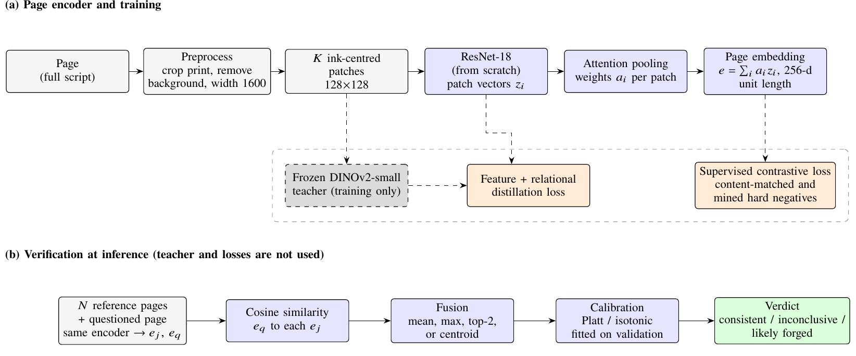
Figure 1: System overview. (a) Training: ink-centred patches are encoded by a ResNet-18 trained from scratch and pooled by attention into a page embedding; a frozen DINOv2 teacher is used only during training. (b) Inference: the questioned page is compared with N reference pages, the scores are fused and calibrated, and a verdict is returned.

5.2 Preprocessing
Each page is converted to gray scale and the printed parts of the forms are removed: for IAM the printed header and footer are cropped using long horizontal separator lines, and for CVL the printed source text above the first separator is cropped. The paper tone and scanner shading are removed by dividing by a smoothed morphological-closing background estimate. Pages are resized to a width of 1600 px, which keeps stroke scale comparable across 300 dpi scans. Pages with an ink fraction below 0.25% are discarded as blank, and duplicate pages are removed by hash.

5.3 Patch sampling and page encoder
A page is treated as a bag of K patches of 128 × 128 pixels. Patches are centred on randomly chosen ink pixels and kept only if their ink fraction passes a threshold that is lowered progressively (5%, 3%, 1.5%, 0.8%) when a page has too few dense windows; a page with no usable ink is rejected instead of being padded. A ResNet-18 [30] with a one-channel stem, randomly initialised, maps each patch to a 256-dimensional vector z_i. Attention pooling [31] computes weights a_i = softmax(wᵀ tanh(V z_i)) and the page embedding e = normalise(Σ a_i z_i). Training uses K = 16 random patches per page with augmentation (rotation ±3°, scale ±10%, contrast and brightness, blur, noise and JPEG artefacts); evaluation uses K = 64 deterministic patches per page.

5.4 Training objective
The main loss is the supervised contrastive loss [32] with temperature 0.1 on page embeddings. Each batch contains 12 writers with two different pages each. IAM batches use random writers; content-matched CVL batches (40% of steps) choose two texts and use only writers who wrote both, so that all negatives share text with the positives' texts and the network must separate writers by style instead of text. Every 10 epochs the writer centroids are computed with the EMA model and, with probability 0.5, a batch is built from a writer and its nearest neighbours (hard-writer mining).

5.5 Distillation from a frozen teacher
A frozen DINOv2-small teacher [25] embeds the same augmented patches. A feature term, 1 − cos(g(z_i), t_i), and a relational term, the KL divergence between the patch-to-patch similarity matrices of teacher and student, are added with weights 0.5 each to the contrastive loss. The teacher is not used at inference; the deployed model is the student alone.

5.6 Multi-reference scoring, calibration and verdict
For N references we compare four fusion rules: the mean cosine, the maximum cosine, the mean of the two largest cosines, and the cosine to the renormalised centroid of the reference embeddings. Scores are calibrated by Platt and isotonic regression fitted on validation trials only. A page is consistent if the score is at or above the 99th percentile of validation impostor scores, likely forged if it is at or below the 1st percentile of validation genuine scores, and inconclusive otherwise. When the two thresholds would overlap because a corpus is separable on validation (IAM), one midpoint threshold is used and there is no inconclusive band.

5.7 Evaluation protocol and metrics
For single-reference evaluation every pair of pages from the same dataset and split is scored; same-writer pairs are genuine and different-writer pairs are impostors, so impostor pairs on CVL include pairs that copy the same text. For multi-reference evaluation every N is tested on one fixed set of writers with nested reference sets and the same impostor queries for every N. We report the equal error rate (EER), the area under the ROC curve (AUC), the false accept rate at 1% and 10% false reject rate, and 95% bootstrap intervals over writers. Thresholds and calibrators are fitted on validation data and applied unchanged to the test sets. Main results are the mean and standard deviation over three seeds.

5.8 Baselines
We compare with (i) a randomly initialised encoder, (ii) the same encoder with batch-normalisation statistics adapted to the data but no label training (validation only), (iii) frozen DINOv2-small features averaged over patches, and (iv) HOG features averaged over patches.

5.9 Demonstration service
The demonstration is a FastAPI service with three endpoints: /api/health, /api/info (model, calibration and sample pairs) and /api/verify (one to five reference images and one questioned image). It repeats the preprocessing, patch sampling and centroid fusion of the evaluation code, so its scores match the evaluation pipeline, and its thresholds are fitted on validation pages only. It runs on CPU so that it never competes with training for the GPU.

6. IMPLEMENTATION

6.1 Code organisation
Table 6: Main modules (train/src/).
Module | Role
prep_cache.py | page cache builder: crops, background normalisation, blank and duplicate filtering
manifests.py | writer-disjoint splits and leakage assertions; writes master.csv
data.py | ink-centred patch sampler, augmentation, content-matched batch sampler with writer mining
model.py | page encoder, supervised contrastive loss, distillation losses
train.py | training loop: mixed precision, EMA, resume, OOM and NaN handling, JSONL log
eval.py, multiref.py, verdict.py | single and multi-reference evaluation, calibration, verdicts, Firemaker, synthetic pages
baselines.py, explain.py | baselines; attention heatmaps and deletion test
report.py | all tables, figures and the abstract, generated from the run files

6.2 Environment
Everything runs in the Docker image handwriting-train:0.1 (PyTorch 2.6, CUDA 12.4), with source and tests bind-mounted so code changes need no rebuild. Training jobs are launched through run_train.sh, which serialises GPU jobs with a lock, lowers priority and records GPU temperature and memory. Exact commands for GPU and CPU use are in docs/HOW_TO_RUN.md.

6.3 Data preparation
Table 7: Writers and pages after preprocessing.
Corpus | Train (writers / pages) | Validation | Test
IAM | 507 / 1262 | 50 / 190 | 99 / 392
CVL (English) | 217 / 909 | 31 / 127 | 62 / 254
Firemaker | – | – | 250 / 1000

IAM writers with a single page contribute two half-page views to training only. A leakage check asserts that no writer appears in two splits, that Firemaker is test-only and that every evaluation writer has at least two pages. A label-shuffle test, which shuffles writer labels inside each batch, keeps the loss at chance (ln 24 = 3.135) and nothing is learned, which confirms that the training signal is the writer identity.

6.4 Training
Table 8: Training and evaluation settings.
Setting | Value
Patch size / patches per page (train, eval) | 128 × 128 / 16, 64
Embedding size, backbone | 256, ResNet-18 (1 channel, random initialisation)
Batch | 12 writers × 2 pages; 40% CVL content-matched
Mining | probability 0.5, centroids refreshed every 10 epochs
Optimiser and schedule | AdamW, lr 3e-4, weight decay 1e-4, 5 warm-up epochs, cosine, 120 epochs, patience 30
Loss | supervised contrastive (τ = 0.1) + 0.5 feature + 0.5 relational distillation
Stabilisation | mixed precision, gradient clip 1.0, EMA 0.999

The main model was trained with three seeds; each run took about 50 minutes (about 26 s per epoch) and stopped at epoch 109, 116 and 119, with the best validation epoch at 79, 93 and 105. Seven further 40-epoch runs form the ablation study.
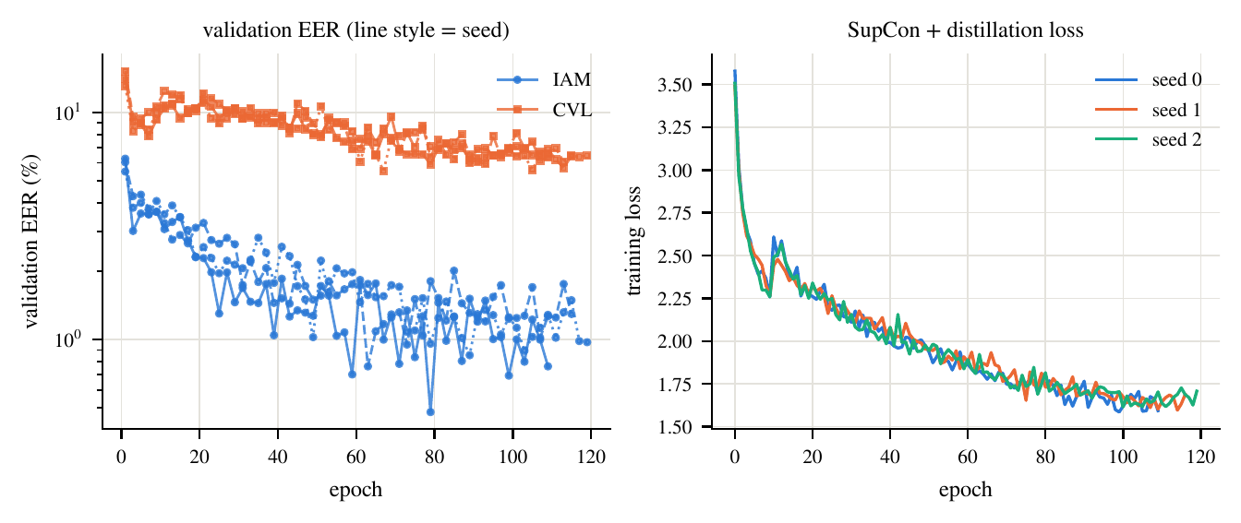
Figure 2: Validation EER (left, log scale; line style = seed) and training loss (right) of the three main runs.

6.5 Final evaluation
Test and Firemaker data were evaluated once per seed after all training had finished (final_eval.sh). Two analysis errors were found afterwards and corrected without touching the model: the IAM verdict thresholds overlapped, and the multi-reference curve let the writer set shrink with the number of references. Both are recorded in FIXES.md and DECISIONS.md, and the corrected analyses (verdict.py and multiref.py) are the ones used in this report.

6.6 Demonstration and dashboard
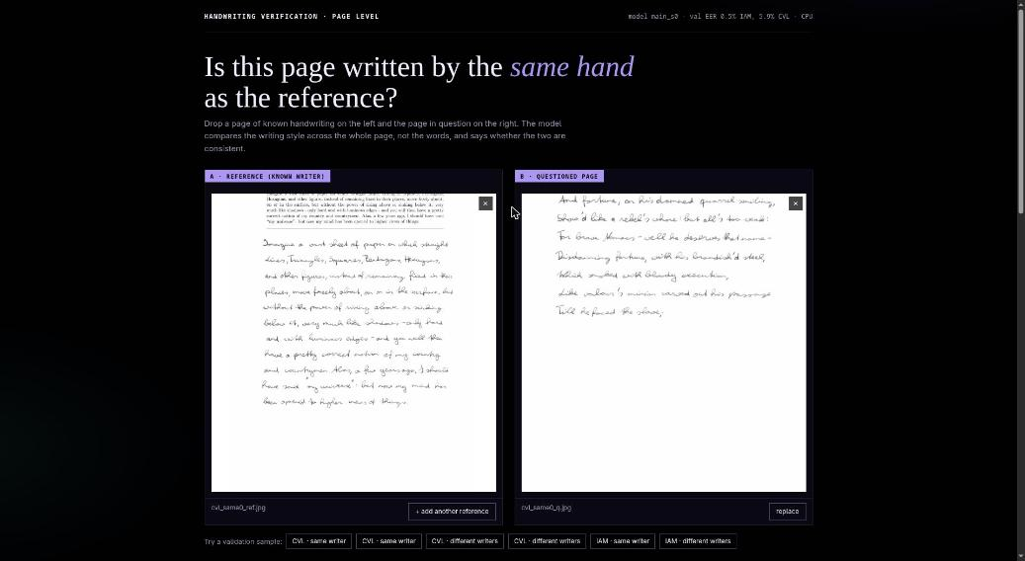
Figure 3: Demonstration: a reference page and a questioned page are uploaded or chosen from validation samples.
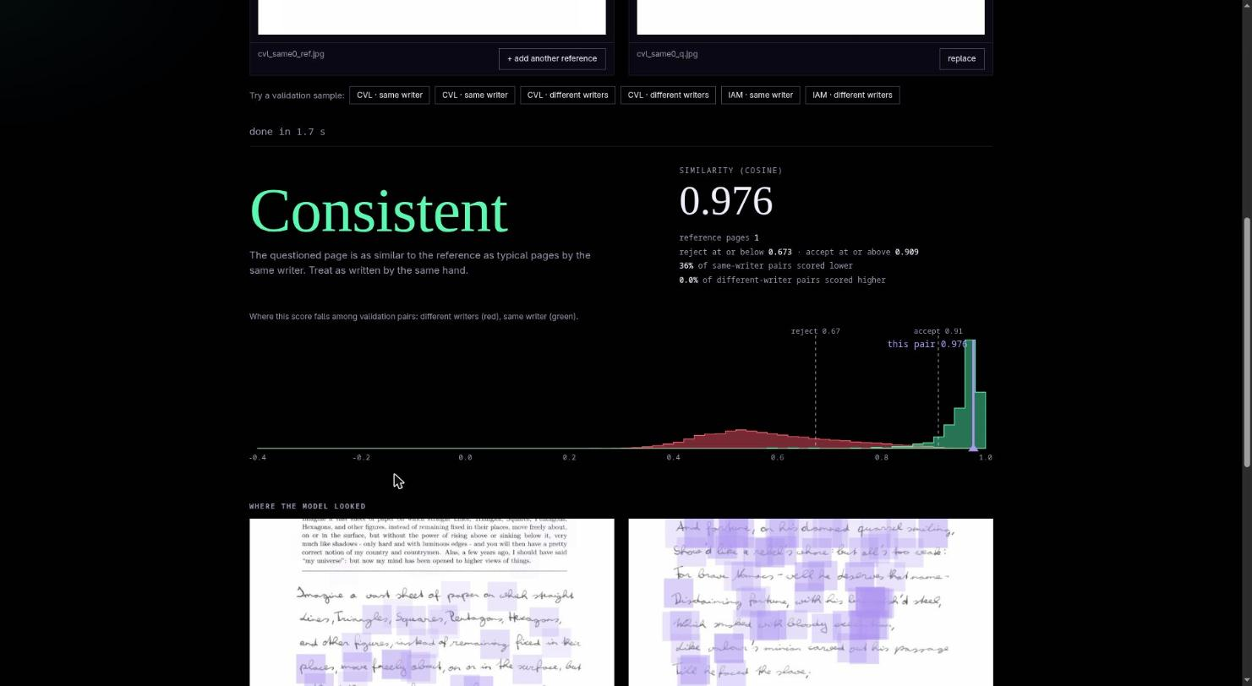
Figure 4: Demonstration result: verdict, similarity score, where the score falls among validation pairs, and attention heatmaps.
A separate local web dashboard shows the progress, estimated remaining time, GPU status and live loss and validation curves of the training queue. Both tools are stdlib or FastAPI services that only read run files or run inference.

6.7 Testing
Six unit tests run in the container: leak-free manifests, patch sampling on real pages, deterministic evaluation patches, varying training patches, EER on extreme inputs, and a decreasing contrastive loss. No linter is configured. The demonstration was also checked end to end by calling its API with sample pairs and with a corrupt file.

6.8 Problems met and how they were fixed
- Resume bug. a second --set argument silently overwrote the first, so a seed-1 run resumed the seed-0 checkpoint; fixed with an extending argument and a seed check on resume.
- Invalid leak test. the first label-shuffle test kept the pairing between pages and writers and was replaced by per-batch shuffling.
- Overlapping verdict thresholds. on separable corpora the accept threshold fell below the reject threshold; fixed with a single midpoint threshold.
- Confounded multi-reference curve. the writer set shrank as N grew; replaced by a controlled study on one writer set.

7. RESULTS AND DISCUSSION
All numbers are test results, in percent, as mean ± standard deviation over three seeds, unless stated. The three seeds share the same writer-disjoint splits.

7.1 RQ1: separating writers
Table 9: Single-reference test results over all page pairs.
Model | IAM EER | IAM AUC | CVL EER | CVL AUC
Random CNN | 23.20 | 0.866 | 30.65 | 0.758
HOG | 11.14 | 0.958 | 23.06 | 0.819
DINOv2-small (frozen) | 5.44 | 0.983 | 15.02 | 0.890
Ours (3 seeds) | 2.35 ± 0.12 | 0.996 ± 0.000 | 7.30 ± 0.29 | 0.968 ± 0.001

On held-out writers the student reaches an EER of 2.35 ± 0.12 on IAM and 7.30 ± 0.29 on CVL. Frozen DINOv2-small features, the teacher without any training on handwriting, give 5.44 and 15.02, so the student roughly halves the error of the teacher on both corpora; HOG and an untrained CNN are far behind. The 95% bootstrap intervals over writers are wide (1.7 to 4.2 on IAM, 4.7 to 12.0 on CVL, per seed) because only 99 and 62 writers are available. Test error is higher than validation error (IAM 0.90 ± 0.31, CVL 5.81 ± 0.15), which shows how optimistic the validation numbers were.
At a strict operating point the picture is weaker: with the false reject rate fixed at 1%, the false accept rate is 10.1 ± 1.2% on IAM and 80.2 ± 12.4% on CVL, and at 10% it is 0.0 and 3.5 ± 0.4%. The content-matched CVL pairs are therefore the hard case, and a single page pair is not enough evidence for a high-stakes decision. On validation, an untrained encoder with batch-normalisation statistics adapted to the data already reaches 8.5% on IAM and 21.3% on CVL, which suggests that corpus-level cues such as scanner and paper carry part of the IAM signal.
Table 10: Per-seed test results (EER, %) and the share of inconclusive CVL verdicts.
Seed | IAM EER | CVL EER | Firemaker p4 | Firemaker p3 | CVL inconclusive
0 | 2.20 | 7.16 | 3.00 | 31.40 | 7.8
1 | 2.50 | 7.71 | 3.40 | 31.80 | 8.8
2 | 2.36 | 7.04 | 3.60 | 32.80 | 8.9

7.2 RQ2: more reference pages and fusion rules
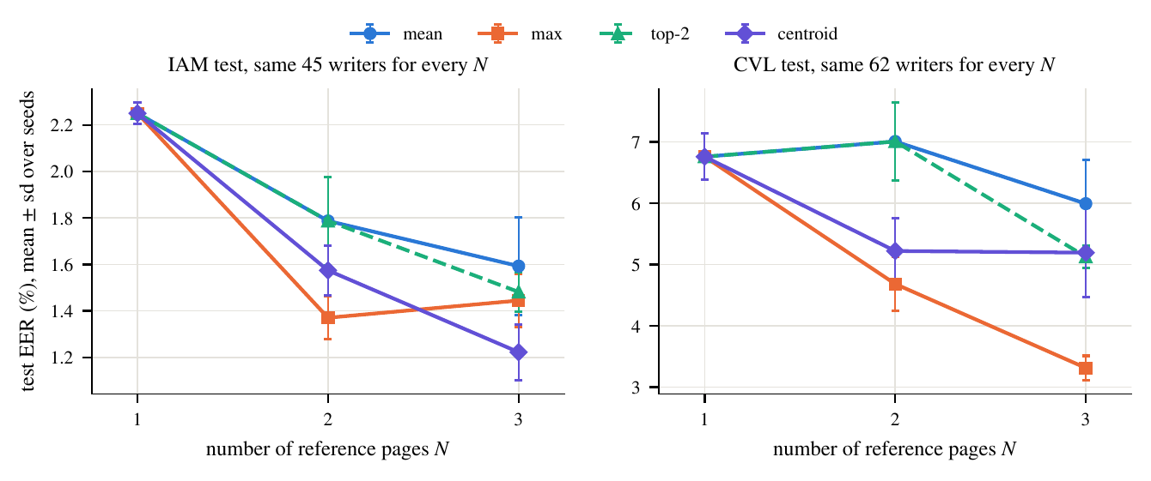
Figure 5: Test EER against the number of reference pages for the four fusion rules, on one fixed set of writers for every N (mean ± sd over three seeds).
Figure 5 evaluates N = 1, 2, 3 references on one fixed set of writers (45 on IAM, 62 on CVL). With the centroid rule, EER falls from 2.25 to 1.57 and 1.22 on IAM, and from 6.76 to 5.22 and 5.19 on CVL. On the 17 IAM writers with at least six pages, five references give 0.81 against 1.96 for one; CVL has too few such writers for N = 5. The fusion rule matters: on CVL the maximum is best at N = 3 (3.31, against 5.99 for the mean and 5.13 for the two largest), while on IAM the centroid is best at three references. The centroid was fixed on validation, where it was best; that the maximum is better on test CVL is a post-hoc observation that has not been confirmed on separate data. The seed-0 bootstrap intervals for N = 1 and N = 3 overlap, so the gain from extra references is consistent in direction but not established for the population of writers.

7.3 RQ3: cross-corpus transfer and disguise
Table 11: Firemaker (250 writers): page 1 against pages 4, 2 and 3 of the same writers.
Pair (same writer) | EER | Same-writer cosine | Other-writer cosine
p1 vs p4 (natural) | 3.33 ± 0.25 | 0.978 | 0.790
p1 vs p2 (upper case) | 23.87 ± 0.47 | 0.906 | 0.791
p1 vs p3 (disguised) | 32.00 ± 0.59 | 0.874 | 0.791

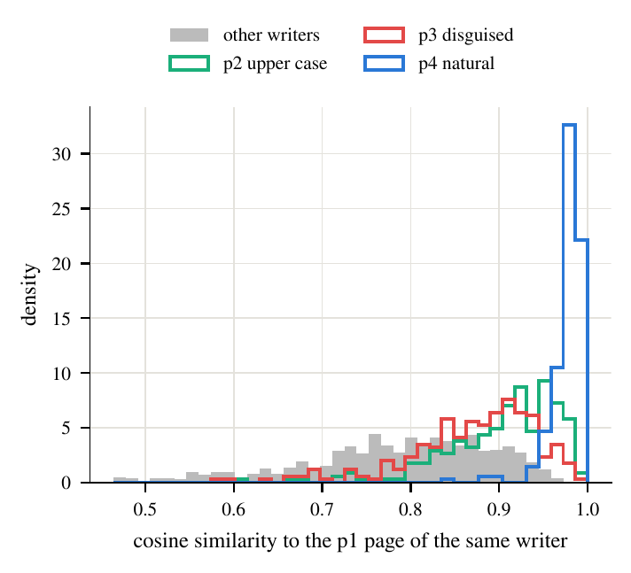
Figure 6: Cosine similarity to page 1 of the same writer on Firemaker (seed 0).
Firemaker differs in scanner and protocol and was never used for training, validation or thresholds. For ordinary writing the EER is 3.33 ± 0.25 (AUC 0.994), close to IAM, so the representation transfers. It does not survive a deliberate change of writing: upper-case copying raises the EER to 23.87 ± 0.47 and the disguised page to 32.00 ± 0.59. The mean same-writer cosine falls from 0.978 to 0.906 and 0.874 while the mean other-writer cosine stays at about 0.79: disguise moves genuine pairs towards impostors. A writer who simply changes style can therefore be rejected by the system, and the same effect would help a forger who copies a style.

7.4 RQ4: training ingredients
Table 12: Ablations on validation (EER, %; 40 epochs, one seed).
Variant | IAM | CVL | Mean
Full model (40 epochs) | 1.72 | 8.98 | 5.35
No distillation | 1.22 | 7.53 | 4.38
Mean pooling | 2.47 | 8.10 | 5.29
No content-matched batches | 1.71 | 7.42 | 4.57
No writer mining | 2.05 | 8.45 | 5.25
8 patches per page | 2.53 | 7.77 | 5.15
No augmentation | 1.74 | 8.02 | 4.88

No ingredient shows a clear benefit. Removing distillation (4.38 against 5.35 mean EER), content-matched batches (4.57) or augmentation (4.88) gives a lower error than the full model, and mean pooling, no mining and eight patches (5.29, 5.25, 5.15) are within 0.2 of it. The seed-to-seed spread of the main runs is about 0.2 in mean validation EER (3.19, 3.57, 3.31), so only larger differences deserve attention, and with one seed per variant we cannot tell whether the lower values of the three variants are real. The 120-epoch main model is better than every 40-epoch variant, which suggests that training length matters more than any single ingredient, although the two schedules also differ in warm-up and patience.

7.5 Calibrated verdicts
Table 13: Three-way verdict on test trials with three references (centroid rule), thresholds from validation only.
Corpus | Consistent | Likely forged | Inconclusive | Error (decided) | ECE raw / Platt / isotonic
IAM | 49.7 | 50.3 | 0.0 | 0.7 | 0.22 / 0.070 / 0.009
CVL | 47.8 | 43.7 | 8.5 | 2.8 | 0.22 / 0.076 / 0.020

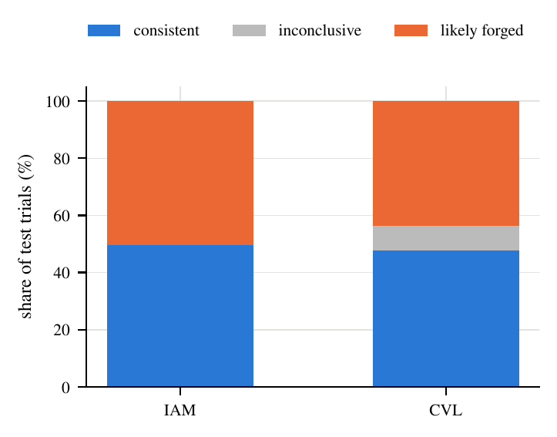
Figure 7: Share of test trials judged consistent, inconclusive and likely forged (mean over three seeds, three references).
Raw cosine scores are not probabilities: their expected calibration error is about 0.22. Platt scaling reduces it to 0.070 and 0.076, and isotonic regression to 0.009 and 0.020, all fitted on validation only (Figure 8). On CVL, 8.5% of trials are inconclusive and of the 91.5% that are decided, 2.8% are wrong. IAM is separable on validation, so one threshold and no inconclusive band is used (error 0.7%), and the IAM verdict should not be read as evidence that the problem is easy.
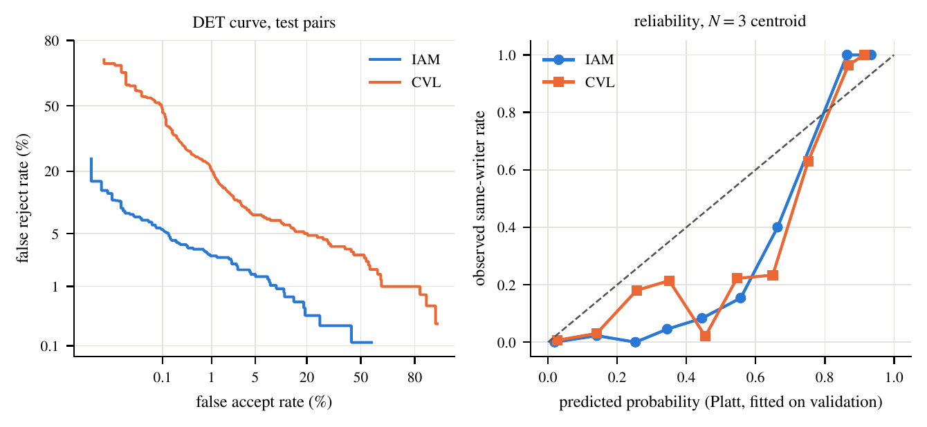
Figure 8: Left: DET curves on test page pairs. Right: reliability of the Platt-calibrated probability for three references; the sigmoid is over-confident in the middle range and under-confident at the top.

7.6 Synthetic pages
The 1362 font-rendered pages of the Kaggle set (and 990 real pages by unknown writers as a control) were scored against every real test page at the validation threshold. Font renderings are accepted for 0.03% of page pairs on IAM and for none on CVL, but unrelated real pages are accepted at a similar rate (0.14% and 0.003%), and all score far below same-writer pairs. The test shows that fonts are not mistaken for real writers in this scan domain; it says nothing about learned imitation.

7.7 Where the model looks
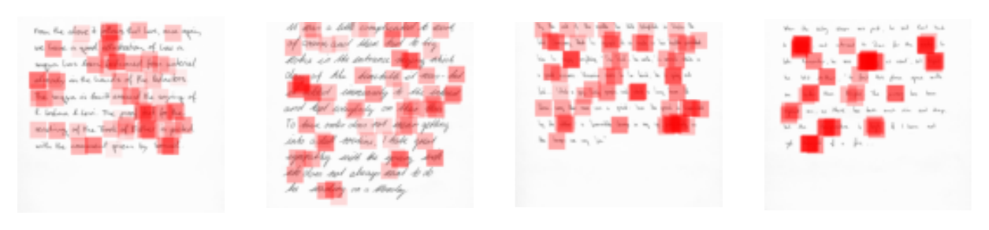
Figure 9: Attention weights (red, opacity proportional to weight) on four IAM validation pages.
Removing the 25% most attended patches lowers the cosine to a same-writer reference by 0.0043 on average, against 0.0022 for random patches (60 validation pairs, pair-to-pair standard deviation about 0.04). The difference is too small to call attention an explanation, so the maps are shown only as a description of where the pooling puts weight.

7.8 Discussion and threats to validity
- What the evidence supports. A small student trained from scratch separates writers better than the foundation model it was distilled from. IAM errors are low and optimistic; CVL (content-matched) and Firemaker (new scanner) are the better guides.
- Disguise is the weak point. A verdict of likely forged means “unlike this writer's ordinary pages”, which a forger and a disguising writer can both produce; this is why the inconclusive outcome is kept.
- No impersonation data. Impostors are other writers, an easier case than a skilled forger; the reported error rates are not forgery detection rates.
- Statistical limits. three seeds, one-seed ablations, wide intervals because few writers are available.
- Data limits. English only, third-party IAM copy, adults writing under instruction rather than under exam pressure.

8. CONCLUSION
We built a page-level handwriting verifier that compares a questioned page with one or several reference pages and returns a calibrated score and a three-way verdict. Trained from scratch on about 2,200 pages, it halves the error of frozen DINOv2 features (2.35% EER on IAM, 7.30% on CVL), transfers to a new corpus for ordinary writing (3.33% on Firemaker), and gains from extra reference pages, but it is fooled by deliberate style change (24 to 32% EER), and none of the training ingredients we ablated is demonstrated to help in a short schedule. Because no public data show one person imitating another, our error rates are not forgery detection rates.

Future work
- Collect a real impersonation set with volunteers copying each other's handwriting, per language.
- Use a handwriting generator to test robustness to learned imitation.
- Repeat the ablations with several seeds at the full schedule.
- Use a larger validation set to choose the fusion rule.
- Extend to the four Indian languages for which data collection was paused.

9. REFERENCES
[1] L. Xing and Y. Qiao, “DeepWriter: A Multi-Stream Deep CNN for Text-independent Writer Identification,” arXiv:1606.06472, 2016.
[2] S. He and L. Schomaker, “FragNet: Writer Identification using Deep Fragment Networks,” arXiv:2003.07212, 2020.
[3] V. Christlein et al., “Unsupervised Feature Learning for Writer Identification and Writer Retrieval,” arXiv:1705.09369, 2017.
[4] T. Raven, A. Matei, and G. A. Fink, “Self-Supervised Vision Transformers for Writer Retrieval,” arXiv:2409.00751, 2024.
[5] M. Peer, F. Kleber, and R. Sablatnig, “Towards Writer Retrieval for Historical Datasets,” arXiv:2305.05358, 2023.
[6] C. Adak et al., “Intra-Variable Handwriting Inspection Reinforced with Idiosyncrasy Analysis,” arXiv:1912.12168, 2019.
[7] M. A. Shaikh et al., “Attention based Writer Independent Handwriting Verification,” arXiv:2009.04532, 2020.
[8] S. Dey et al., “SigNet: Convolutional Siamese Network for Writer Independent Offline Signature Verification,” arXiv:1707.02131, 2017.
[9] M. Chauhan et al., “Self-Supervised Learning Based Handwriting Verification,” arXiv:2405.18320, 2024.
[10] K. Nikolaidou et al., “WordStylist: Styled Verbatim Handwritten Text Generation with Latent Diffusion Models,” arXiv:2303.16576, 2023.
[11] K. Nikolaidou et al., “DiffusionPen: Towards Controlling the Style of Handwritten Text Generation,” arXiv:2409.06065, 2024.
[12] B. Vanherle et al., “VATr++: Choose Your Words Wisely for Handwritten Text Generation,” arXiv:2402.10798, 2024.
[13] M. Mayr et al., “Zero-Shot Paragraph-level Handwriting Imitation with Latent Diffusion Models,” arXiv:2409.00786, 2024.
[14] D. Tsourounis et al., “Leveraging Expert Models for Training Deep Neural Networks in Scarce Data Domains: Application to Offline Handwritten Signature Verification,” arXiv:2308.01136, 2023.
[15] R. J. Ypma, “Evidential strength of categorical expert witness statements,” arXiv:2401.01809, 2024.
[16] V. Kumar and S. Sundaram, “Attention based End to end network for Offline Writer Identification on Word level data,” arXiv:2404.07602, 2024.
[17] A. Maitra et al., “Decorrelation-based Self-Supervised Visual Representation Learning for Writer Identification,” arXiv:2410.01441, 2024.
[18] H. Rasyidi and M. Farazi, “Beyond the Pipeline: Analyzing Key Factors in End-to-End Deep Learning for Historical Writer Identification,” arXiv:2510.18671, 2025.
[19] C. Adak, B. B. Chaudhuri, and M. Blumenstein, “An Empirical Study on Writer Identification & Verification from Intra-variable Individual Handwriting,” arXiv:1708.03361, 2017.
[20] J. Wang et al., “CSSL-RHA: Contrastive Self-Supervised Learning for Robust Handwriting Authentication,” arXiv:2307.11100, 2023.
[21] F.-H. Huang and H.-M. Lu, “Multiscale Feature Learning Using Co-Tuplet Loss for Offline Handwritten Signature Verification,” arXiv:2308.00428, 2023.
[22] M. R. Parracho, “Signature Forgery Detection: Improving Cross-Dataset Generalization,” arXiv:2510.17724, 2025.
[23] V. Pippi et al., “Evaluating Synthetic Pre-Training for Handwriting Processing Tasks,” arXiv:2304.01842, 2023.
[24] G. Hinton, O. Vinyals, and J. Dean, “Distilling the Knowledge in a Neural Network,” arXiv:1503.02531, 2015.
[25] M. Oquab et al., “DINOv2: Learning Robust Visual Features without Supervision,” arXiv:2304.07193, 2023.
[26] C. Guo et al., “On Calibration of Modern Neural Networks,” arXiv:1706.04599, 2017.
[27] U.-V. Marti and H. Bunke, “The IAM-database: An English sentence database for offline handwriting recognition,” International Journal on Document Analysis and Recognition, vol. 5, no. 1, pp. 39–46, 2002.
[28] F. Kleber et al., “CVL-database: An off-line database for writer retrieval, writer identification and word spotting,” in Proc. 12th Int. Conf. on Document Analysis and Recognition (ICDAR), 2013, pp. 560–564.
[29] M. Bulacu, L. R. B. Schomaker, and L. Vuurpijl, “Writer identification using edge-based directional features,” in Proc. 7th Int. Conf. on Document Analysis and Recognition (ICDAR), 2003, pp. 937–941.
[30] K. He et al., “Deep Residual Learning for Image Recognition,” arXiv:1512.03385, 2015.
[31] M. Ilse, J. M. Tomczak, and M. Welling, “Attention-based Deep Multiple Instance Learning,” arXiv:1802.04712, 2018.
[32] P. Khosla et al., “Supervised Contrastive Learning,” arXiv:2004.11362, 2020.

ANNEXURE - I: OUTCOME-SPECIFIC SUPPORTING EVIDENCE
Selected outcome: Journal publication.
Table 14: Evidence for the selected outcome.
Evidence | Details | Status
Paper draft | Page-Level Handwriting Forgery Detection: Multi-Reference Verification with Calibrated Verdicts. IEEEtran, 8 pages including references, 270-word abstract, six result figures, eight tables (paper/main.pdf; LaTeX archive supplied) | Draft complete
Results traceability | docs/paper-claims-map.md maps every number to its evidence file; all tables and figures are generated by report.py | Done
Code and tests | train/ (modules, six unit tests, run logs, Docker setup) | Done; no remote repository yet
Working demonstration | demo/ FastAPI service (CPU) and train/dashboard/ training dashboard | Done
Venue and submission | Journal not yet chosen | Pending
Citation check and AI-use disclosure | Planned with the ARS citation-check and disclosure commands | Pending
Author block and IAM registration | Confirm the guide's title and co-authorship; register officially for IAM | Pending (BLOCKERS.md)

Abstract of the paper draft
Disputed handwritten scripts, such as an exam answer sheet suspected of being copied in another person's hand, require deciding whether a questioned page is consistent with a writer's earlier pages, yet most deep verifiers compare single words or signatures. We study page-level, multi-reference verification: a full page is embedded as an attention-pooled bag of ink patches by a ResNet-18 trained from scratch with content-matched hard negatives and distillation from a frozen DINOv2 teacher, and one or several reference pages are fused into a calibrated three-way verdict (consistent, inconclusive, likely forged). We train three seeds on IAM and CVL with writer-disjoint splits and test exactly once on held-out writers and on Firemaker, a separate corpus never used for training or tuning. The model reaches 2.35% EER on IAM and 7.30% on CVL, against 5.44% and 15.02% for frozen DINOv2 features, 11.1% and 23.1% for HOG, and 23.2% and 30.6% for an untrained network. On Firemaker, ordinary writing transfers across corpora (3.3% EER), but upper-case copying (23.9%) and deliberately disguised writing (32.0%) break it. On one fixed set of writers, three reference pages lower the centroid-fusion EER from 2.25% to 1.22% on IAM and from 6.76% to 5.19% on CVL, and the maximum rule alone reaches 3.31% on CVL, a post-hoc observation. A verdict calibrated on validation data leaves 8.5% of CVL trials inconclusive and is wrong on 2.8% of the rest. No ablated training ingredient shows a clear benefit in a short, single-seed, 40-epoch comparison. No public data show one person imitating another, so these are not forgery detection rates, and the font-rendered pages we tested say nothing about learned imitation.

AI-assistance disclosure
Claude (Anthropic) assisted with code, analysis scripts and drafting. The authors are responsible for the content. The frozen DINOv2-small teacher is used during training only.

