
The Market
The target market of the product are:
• Students
• Teachers and school staff
• Office workers
• Travelers and outdoor enthusiasts
Who are the people capable of doing it?
• Product designers
• Engineers
• Skilled manufacturers
When does it sell best?
The product can be sold throughout the year because people
regularly need drinking water. It may be especially popular
during school days, travel, and outdoor activities.
What are the materials needed?
• Food-grade stainless steel
• Heat-resistant and BPA-free plastic
• Insulation materials
• Leak-proof lids and silicone seals
• Divider for the two chambers
• Handles and other tumbler accessories
Costs
The estimated production cost is ₱250–₱400 per
unit, depending on the materials and design.
The estimated selling price is ₱450–₱650 per unit.
Value Added Features
• Two separate chambers for hot and cold drinks.
• Insulated walls to maintain drink temperatures.
• Leak-proof lids to prevent spills.
• Portable, reusable, and space-saving design.
• Durable and heat-safe materials for everyday use.
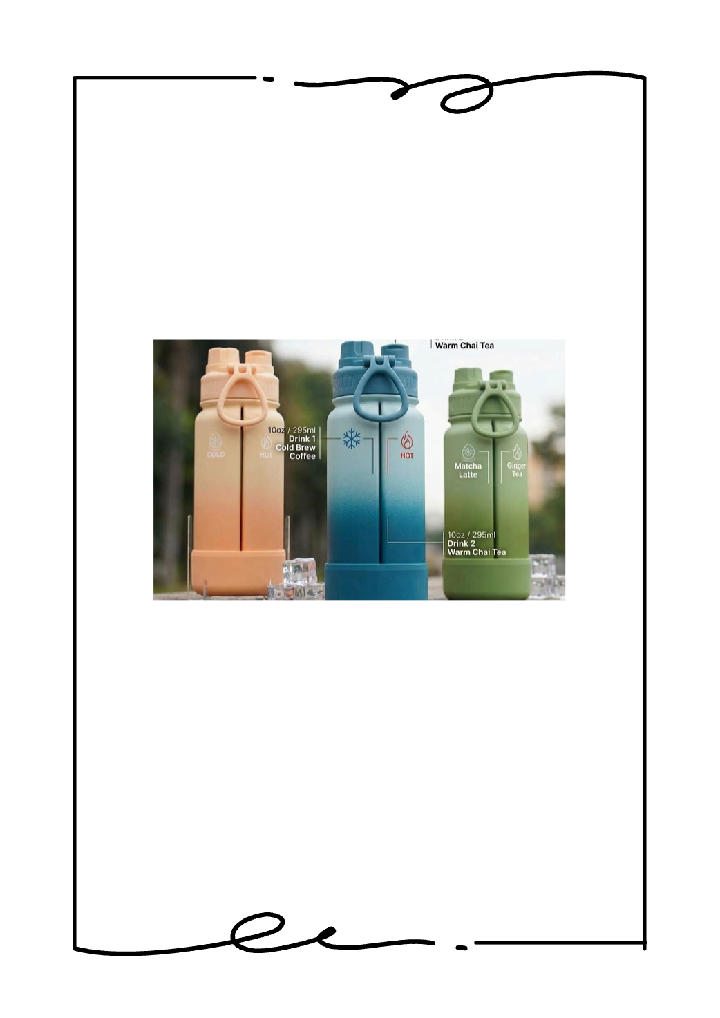
Group 3
PRODUCT CONCEPT
2-IN-1 DUAL
CHAMBER TUMBLER
Product Description:
The 2-in-1 Dual Chamber Tumbler is a specially designed
tumbler divided into two separate chambers. One side is
for cold water, while the other side is for hot water. It
allows users to carry two types of drinks in one container
without mixing them.

