Name: Adding a new product into the system

Steps:

|  |  |
| --- | --- |
| Actor | System |
| 1. Choose command “Add Product” | 2. Displays “Add Product” screen  “Add Product screen” |
| 1. Input data then click “Add” button   “Add Product” screen with data | 1. Hide “Add Product” screen and display “Add product successfully” screen   “Add product successfully” screen: |
| 5. Click on “OK” button and display “Go back to the main menu” screen  “Go back to the main menu” screen: | 1. Click on “OK” button and display “Main” screen   “Main” screen: |

Name: Adding a new customer into the system

Steps:

|  |  |
| --- | --- |
| Actor | System |
| 1.Chooose command “Add Customer” | 2.Displays “Add Customer” screen  “Add Customer Screen”  C:\Users\jing\AppData\Local\Temp\WeChat Files\5788aa95e19f19e92975f639c30800e.png |
| 3. Input data then click “Add” button  “Add Customer” screen with data.  C:\Users\jing\AppData\Local\Temp\WeChat Files\b88c464d02054576e5adf4d51047b81.png | 4.Hide “Add Customer” screen and display “Add product successfully” screen  “Add customer successfully” screen:  C:\Users\jing\AppData\Local\Temp\1568513153.png |
| 5. Click on “OK” button and display “Go back to the main menu” screen  “Go back to the main menu” screen: | 6.Click on “OK” button and display “Main” screen  “Main” screen: |

|  |  |
| --- | --- |
| Actor | System |
| 1. Choose command “Add Product” | 2. Displays “Add Purchase” screen  “Add Purchase screen”  C:\Users\jing\AppData\Local\Temp\WeChat Files\e08bbaaf5b410deae3c4ab1d0fb1b6f.png |
| 3. Input data then click “Add” button  “Add Purchase” screen with data.  C:\Users\jing\AppData\Local\Temp\WeChat Files\a7e0f189e0d89194e17b9e18583fe88.png | 4.Hide “Add Purchase” screen and display “Add Purchase successfully” screen  “Add Purchase successfully” screen:  C:\Users\jing\AppData\Local\Temp\WeChat Files\1a477d236dda7fa071b2cfd5949bf37.png |
| 5. Click on “OK” button and display “Go back to the main menu” screen  “Go back to the main menu” screen: | 6.Click on “OK” button and display “Main” screen  “Main” screen: |

**Products** (productid, name, expiration date, price, tax rate, quantity, manufactured date)

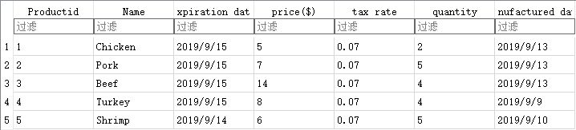

CREATE TABLE IF NOT EXISTS "Products" (

"Productid" INTEGER NOT NULL,

"Name" TEXT,

"expiration date" TEXT,

"price($)" INTEGER,

"tax rate" REAL,

"quantity" INTEGER,

"manufactured date" TEXT,

PRIMARY KEY("Productid")

);

INSERT INTO "Products" ("Productid","Name","expiration date","price($)","tax rate","quantity","manufactured date") VALUES

(1,'Chicken','2019/9/15',5,0.07,2,'2019/9/13'),

(2,'Pork','2019/9/15',7,0.07,5,'2019/9/13'),

(3,'Beef','2019/9/15',14,0.07,4,'2019/9/13'),

(4,"Turkey","2019/9/15",8,0.07,4,"2019/9/9"),

(5,"Shrimp","2019/9/14",6,0.07,5,"2019/9/10")

**Customers** (customerid, name, address, phone, payment info)

; 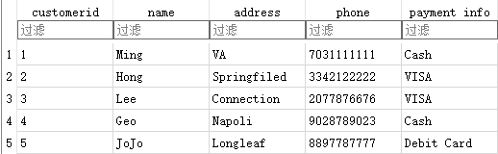

CREATE TABLE "Customers" (

"customerid" INTEGER NOT NULL,

"name" TEXT,

"address" TEXT,

"phone" INTEGER,

"payment info" INTEGER,

PRIMARY KEY("customerid")

);

INSERT INTO "Customers" ("customerid","name","address","phone","payment info") VALUES (1,'Ming','VA',7031111111,'Cash'),

(2,'Hong','Springfiled',3342122222,'VISA'),

(3,'Lee','Connection',2077876676,'VISA'),

(4,'Geo','Napoli',9028789023,'Cash'),

(5,'JoJo','Longleaf',8897787777,'Debit Card');

**Purchase** (purchaseid, customerid, productid, date time, quantity, total cost)

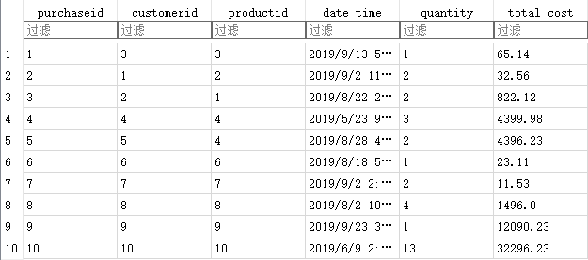

CREATE TABLE IF NOT EXISTS "Products" (

"Productid" INTEGER NOT NULL,

"Name" TEXT,

"expiration date" TEXT,

"price($)" INTEGER,

"tax rate" REAL,

"quantity" INTEGER,

"manufactured date" TEXT,

PRIMARY KEY("Productid")

);

INSERT INTO "Purchase" ("purchaseid","customerid","productid","date time","quantity","total cost") VALUES (1,3,3,'2019/9/13 5:29 P.M.',1,65.14),

(2,1,2,'2019/9/2 11:21 A.M.',2,32.56),

(3,2,1,'2019/8/22 2:23 P.M.',2,822.12),

(4,4,4,'2019/5/23 9:00 A.M.',3,4399.98),

(5,5,4,'2019/8/28 4:23 P.M.',2,4396.23),

(6,6,6,'2019/8/18 5:13 P.M.',1,23.11),

(7,7,7,'2019/9/2 2:23 P.M.',2,11.53),

(8,8,8,'2019/8/2 10:23 A.M.',4,1496.0),

(9,9,9,'2019/9/23 3:53 P.M.',1,12090.23),

(10,10,10,'2019/6/9 2:19 P.M.',13,32296.23);

