Module ICT3715

INFORMATION AND COMMUNICATION TECHNOLOGY PROJECT

|  |  |  |  |  |  |  |  |  |  |
| --- | --- | --- | --- | --- | --- | --- | --- | --- | --- |
| STUDENT NUMBER (Student completes) | | | | | | | | | |
| 4 | 9 | 7 | 4 |  | 0 | 5 | 9 |  | 8 |

|  |  |  |  |  |  |  |  |  |  |  |  |  |
| --- | --- | --- | --- | --- | --- | --- | --- | --- | --- | --- | --- | --- |
| IDENTITY NUMBER (Student completes) | | | | | | | | | | | | |
| 9  1 | 1 | 0 | 1 | 1 | 3 | 5 | 8 | 0 | 7 | 0 | 8 | 6 |

No handwritten assignments will be accepted.

**INSTRUCTIONS:**

Complete this Front Page (page 1)

Complete the Plagiarism Pledge (page 2). Your Assessment (assignment) will not be assessed without this.

After you have completed the front page with your information, the plagiarism pledge, and Assessment (Assignment) 2 with Section A and B, save the document as a PDF document.

You must save your Assessment (Assignment) 2 as a PDF document, or it will not be assessed.

Keep a copy of the original should there be problem with the upload.

PLAGIARISM PLEDGE BY THE STUDENT

1. I have read Unisa’s plagiarism policy.
2. I understand Unisa’s plagiarism policy.
3. I agree to abide by Unisa’s plagiarism policy.
4. I have read the direct copying, plagiarism, and “patch-writing” document.
5. I understand what direct copying, plagiarism, and “patch-writing” is.
6. I undertake to avoid copying directly, plagiarism and patch writing.
7. All academic work, written or otherwise, that I submit is expected to be the result of my own skill and labour.
8. I understand that, if I am guilty of the infringement of breach of copyright/plagiarism or unethical practice, I will be subject to the applicable disciplinary code as determined by Unisa.
9. The marker has the right to refuse to assess the assignment and the system if plagiarism is detected.
10. [Here you can add your references that you have used e.g., information taken from the Internet]

Student name and Surname: _______________________________________

Student number: ______________________________

___________________________ ___________

Student signature: Date:

**Assessment (Assignment) 2**

**Notes:**

This is a compulsory assessment. The assessment contributes to 30% of your year mark.

**System | Online Bus Registration system for a Community**

Due to excessive administrative actions, the Strive High Secondary School preferred to move from a paper base bus registration system to an online bus registration system. The purpose of this Module is to examine the paper base bus registration system and to **design, develop, implement, test, and demonstrate the new system for your final examination.**

**Note:** You are not allowed to develop any other system or use any other data that was not prescribed or provided to you.

The system must be designed and developed as an online system, that is both web-based and mobile-friendly. *For demonstration purposes, the system and database must be hosted locally.*

The outcome of this assessment will form part of the design, development, and implementation

of the database and the system. Your implementation effort will be greatly reduced if you take care with the preparation phases of the system.

**Instructions:**

* Make sure that you did complete the instructions on page 1 of this document (template)
* Complete the header and footer with your own information
* Add your practical system content to the document
* Remove everything that is in brackets []
* Make sure that your Table of Content is updated
* Save the document as PDF, e.g., 12345678_ICT3715_02.pdf, (replace 1234568 with your student number)
* When you are done submit via myModules 2024 on the Module Site under Assessment 2

Table of Contents

1 Assessment 2 7

1.1 Section A = Database [20] 7

1.1.1 Create the database for your system (20) 7

1.2 Section B = Backup and Recovery for the Database and Programming code [10] 8

1.2.1 Database (5) 9

1.2.2 Programming code & Portfolio (assessments -assignments) (5) 9

2 Assessment 1 10

2.1 Section A [4] 10

2.1.1 Programming Languages (3) 10

2.1.2 Database (1) 10

2.2 Section B [28] 10

2.2.1 Activity Diagram (16) 10

2.2.2 ERD Diagram (12) 10

2.3 Section C (Backup and Recovery for the Database and Programming code) [4] 10

2.3.1 Backup and Recovery Software for the Database (2) 10

2.3.2 Backup and Recovery process for the Programming code and your Portfolio (assessments) (2) 11

# Assessment 2

## Section A = Database [20]

### Create the database for your system (20)

**[Now you must create the database**, keep in mind the structure of the tables, columns, PK’s and FK’s, etc. …

**Now you must import the data into your database** and **describe the process(es) that you followed, problems that you've experienced**, etc. Be very specific; the more information you provide, the better.

**For example:**

* If you have created programming scripts and procedures to complete this task, describe it to the marker OR
* If you have followed prompts and buttons in the database of your choice, describe it to the marker.

**Furthermore, describe the problems you have experienced during the import process, and more important describe how you have solved it.**]

**I have the followed the following steps for creating a Database and importing data into the database:**

1. Since I am going to be using MySQL, I accessed <http://localhost/phpmyadmin/> using Google Chrome.
2. I created a database called bus_system_db with 9 tables.
3. After successfully creating the database (bus_system_db), I imported the data using phpMyAdmin in the following tables – bus_tbl, dropoff_btl, pickup_tbl, routes_tbl.
4. Clicked on the table name and then click on the insert tab to enter data manually on each table.

**Screen dumps:**

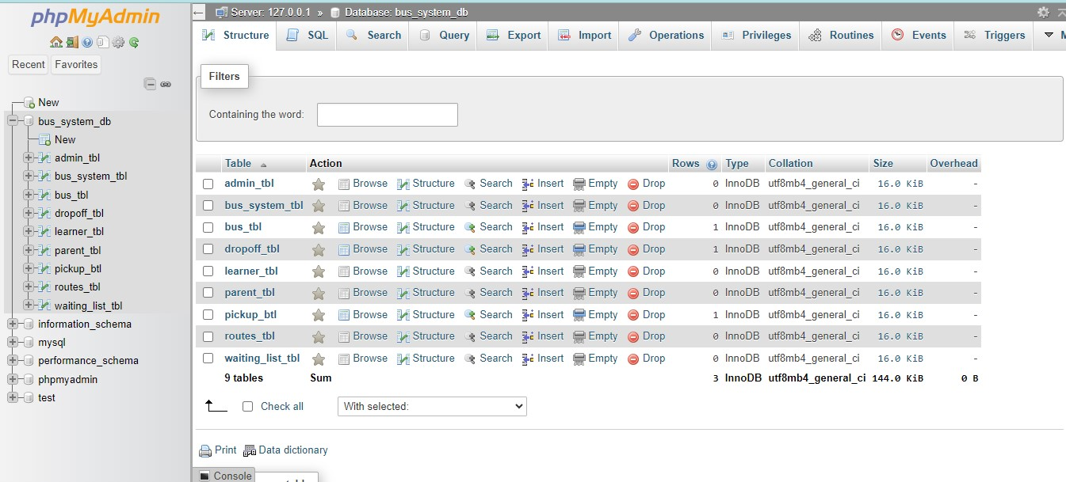

**Imported data on each table:**

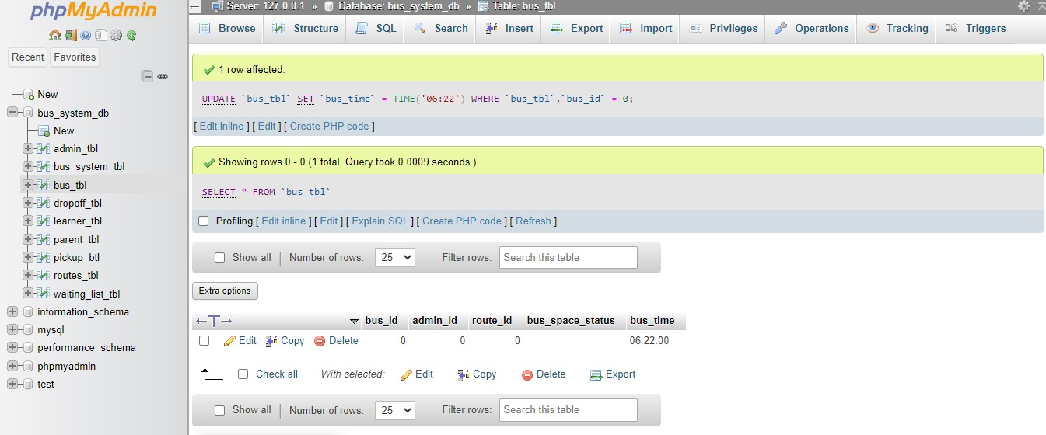

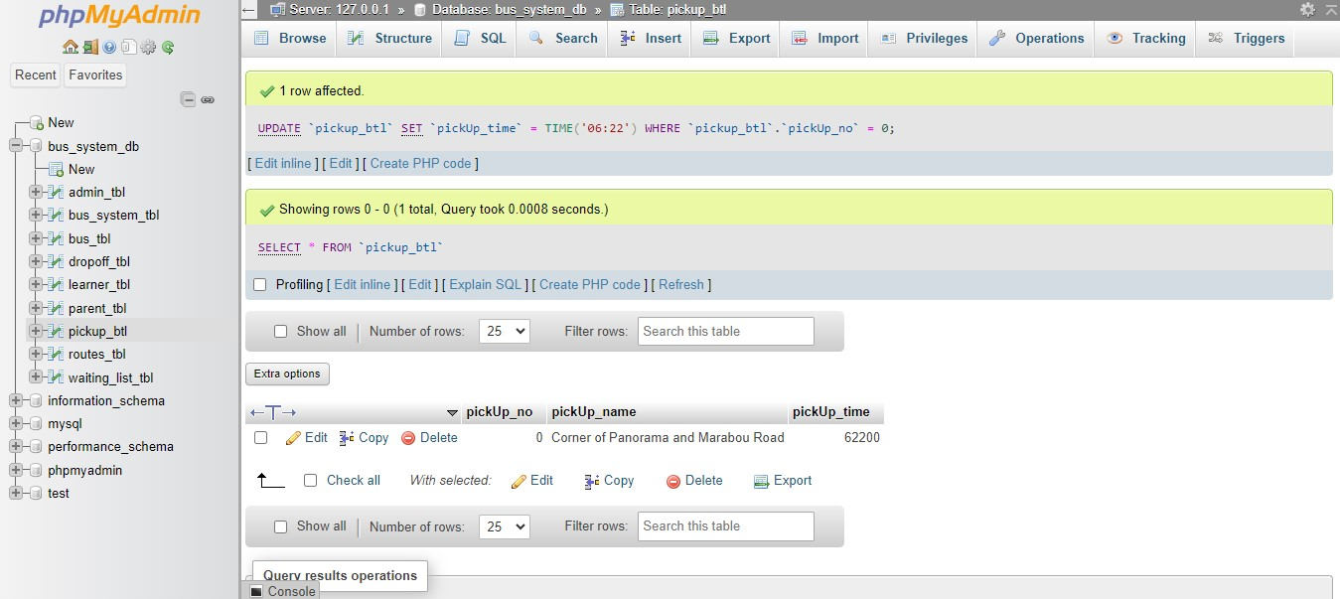

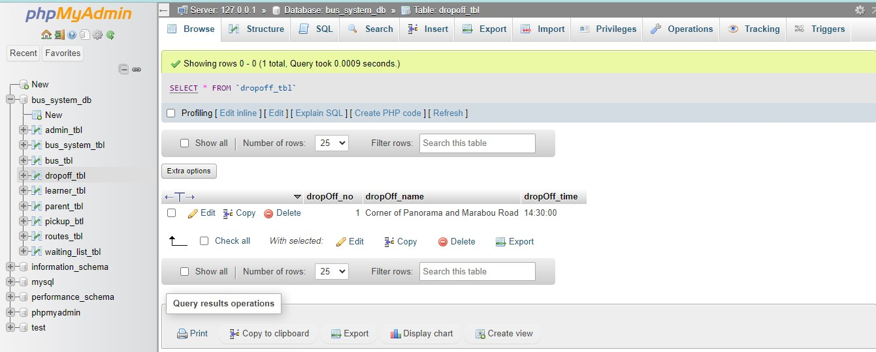

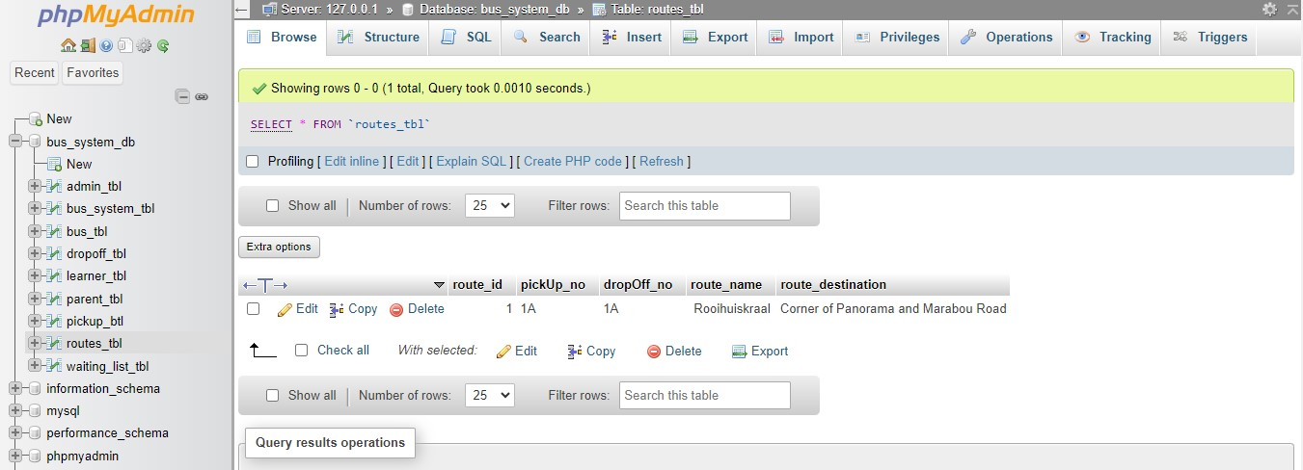

## Section B = Backup and Recovery for the Database and Programming code [10]

[Remember software must be free and not have a trail period, that can expire before your examination of your system at the end of the year.]

[You will not be able to use as an excuse at the end of the year that your system has crashed or that you have changed something at the last minute and now the system is not working anymore.

Thus...

Having a **data backup and recovery plan** is important to the overall success of your system.

Without one, YOU and then the School may suffer from permanent data loss, massive downtime, and unnecessary time wasted and expenses.

It is important that you have a backup and recovery process in place. Just indicating that you backup to a "CD" or the "Cloud" or even a "Memory stick" is not sufficient at all.

*The purpose of the backup is to create a copy of data that can be recovered in the event of a primary data failure.*

Primary data failures can be the result of hardware or software failure, data corruption, or a human-caused event, such as a malicious attack (virus or malware), or accidental deletion of data.

**In this section you have the opportunity to describe the backup and recovery processes that you have put into place**. The processes and methods for both backup and recovery (restoring) of the data will depend on the database that you have chosen. Thus, you will describe it in terms of the database environment of your choice. **Again, be specific, add screenshots as evidence**. Convince the marker that you have backup and recovery in place and that you know how to implement and use it. *(Do not copy and paste "theory" from the Internet or some or other textbook - you need to describe how you have implemented backup and also how you will recover data)*.]

### Database (5)

[Add your answer here for the backup and recovery plan for your database …]

**Backing Up Database:**

1. Login into phpMyAdmin using my database credentials.
2. Select the database (bus_system_db) to back up.
3. Export the database, choose the “Quick” option.
4. Choose the export method “SQL”.
5. Click on the export button to successfully export the database to the backup folder.

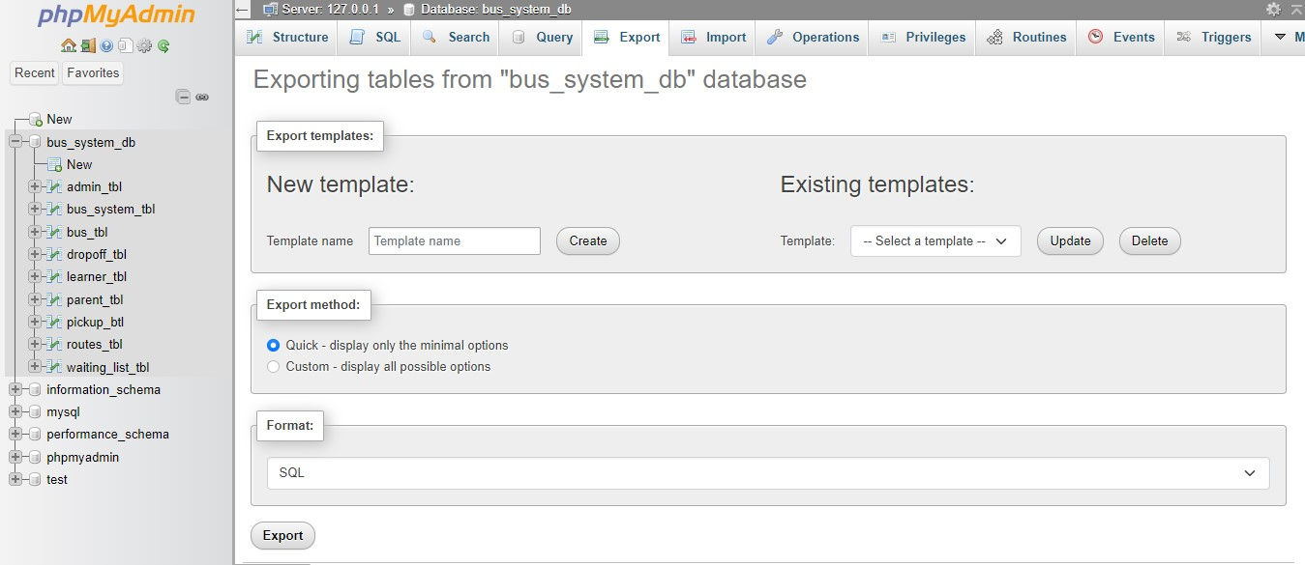

### Programming code & Portfolio (assessments -assignments) (5)

[Add your answer here for the backup and recovery plan for your programming code and your Portfolio (assessments - assignments) …]

**Database Backup and Recovery: Using Git and GitHub**

**Backup Database:**

1. **Export Database via phpMyAdmin**:

* I followed the steps previously mentioned to export my database.

1. **Commit and push changes to GitHub:**

* Opened an integrated terminal on VS Code and then navigated to the backups folder where my .sql file is saved: ***cd backup***
* I initialised a Git repository using the command: ***git init***
* Added the .sql file to the repository using the command: ***git add backups/bus_system_db.sql***
* Commit the backup file using the command: ***git commit -m "Add database backup"***
* Created a repository on Github called backup.
* Push the backup to your GitHub repository using the command:
* ***git remote add origin https://github.com/lebogang26/backup.git***

***git push -u origin master***

Screen Dump of backup on GitHub:

Total of Assessment 2 = 30 marks

# Assessment 1

## Section A [4]

### Programming Languages (3)

[Identified the programming languages that you will use to develop your system]

**HTML5, Bootstrap 5, PHP.**

### Database (1)

[Identified the database software that you will use to develop your database]

**MySQL with PhpMyAdmin.**

## Section B [28]

### Activity Diagram (16)

[Add your Activity Diagram here …]

### ERD Diagram (12)

[Add your ERD Diagram here …]

## Section C (Backup and Recovery for the Database and Programming code) [4]

### Backup and Recovery Software for the Database (2)

[Identified two types of software that you can use for the backup and recovery of your database. Remember software must be free and not have a trail period, that can expire before your examination of your system at the end of the year]

**Git and GitHub and PhpMyAdmin.**

### Backup and Recovery process for the Programming code and your Portfolio (assessments) (2)

[Identified what process / software you can use for the backup and recovery of your programming code and your Portfolio (assessments). Remember software must be free and not have a trail period, that can expire before your examination of your system at the end of the year]

**Git and GitHub.**

Total of Assessment 1 = 36 marks