Group 4

Noel Miranda, Christopher Reaney, Kevin Ramirez, Korbyn Mock

September 23, 2024

Module 10

Assignment: Milestone #2

**Revised ERD:**

**URL**: [Revised_ERD_Link](https://online.visual-paradigm.com/share.jsp?id=333533353838392d34)

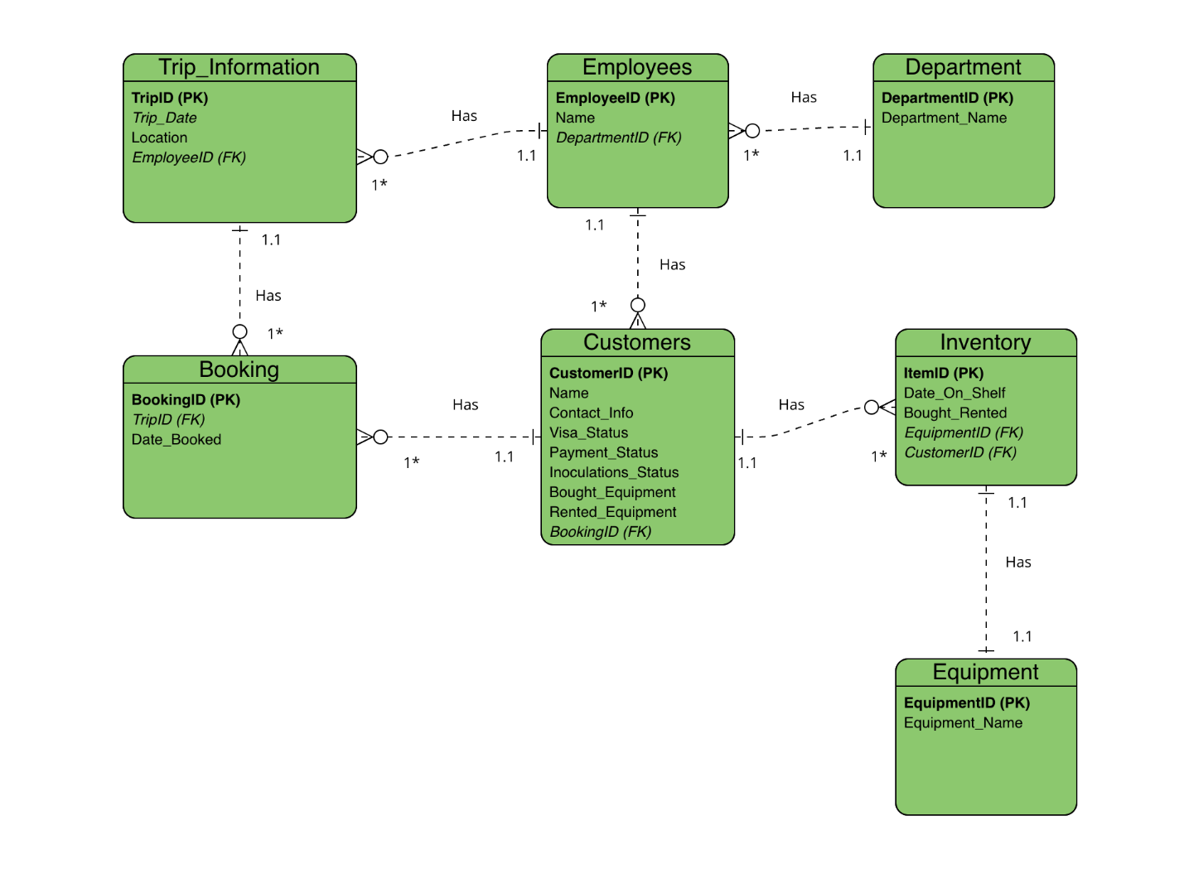

**Relationships**

* Customer to Inventory
  + One customer can have many items.
* Customer to Booking
  + One customer can have many bookings.
* Trip to Booking
  + One trip can have many bookings.
* Employee to Trip
  + One employee (guide) can have many trips.
* Inventory to Equipment
  + One item can have one equipment name.
* Department to Employee
  + One department can have many employees

**Screenshot(s) of the data displayed from your tables:**

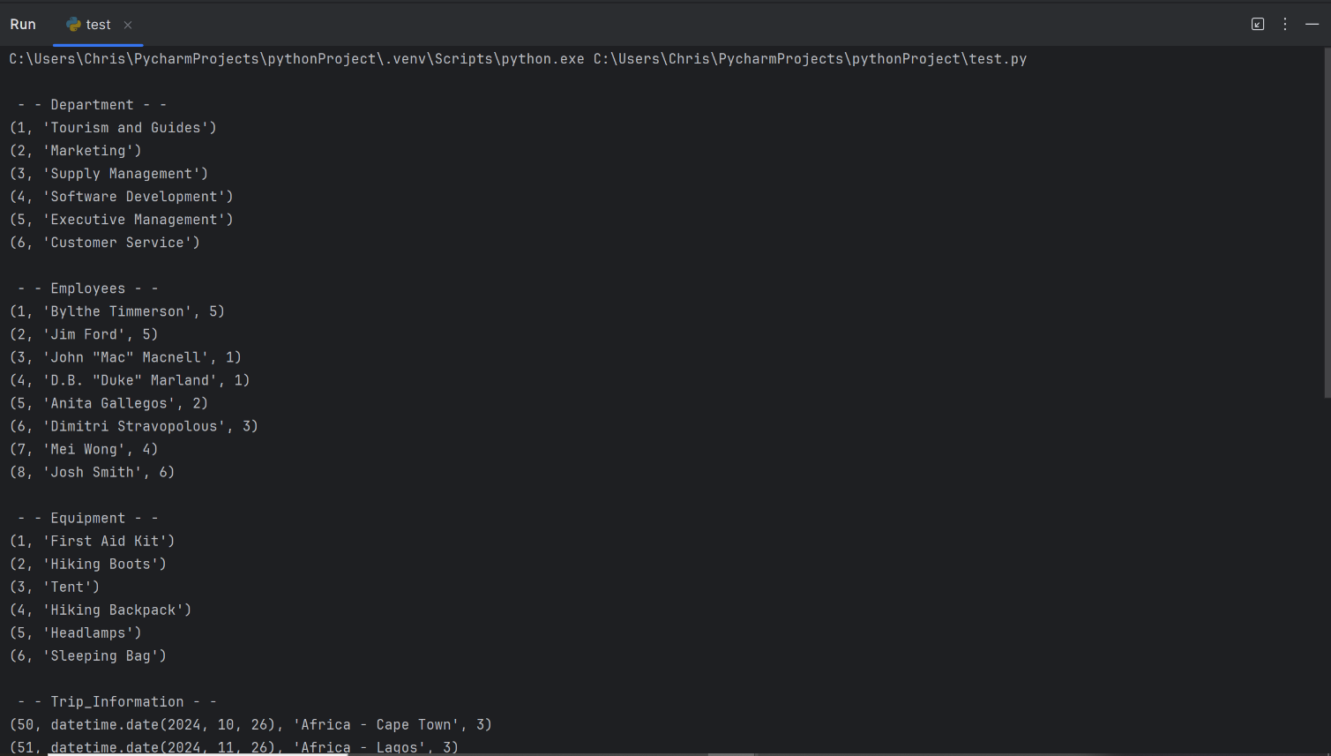

**Continued screenshots on next page**

