Group 4

Korbyn Mock, Noel Miranda, Kevin Ramirez, Christopher Reaney

9/23/2024

Module 9

THE RULES:

They need to create a way to be able to track their inventory better. I would suggest using a computer system that could keep track of their inventory in real time. They could also keep track of who’s buying the equipment and what sells more than the other so that they are able to buy what they need and not what they think that they need. They could also see when the product was bought and be able to determine if it is still up to code with proper equipment. This would keep them from trying to sell stuff that is too old to use. They could then possibly sell the old inventory off on a website like Facebook Marketplace or eBay to try and get back some of their lost profit. They could also use the database to be able to tell who went where and which place is the most popular so that they can advertise it more and possibly bring more attraction to it.

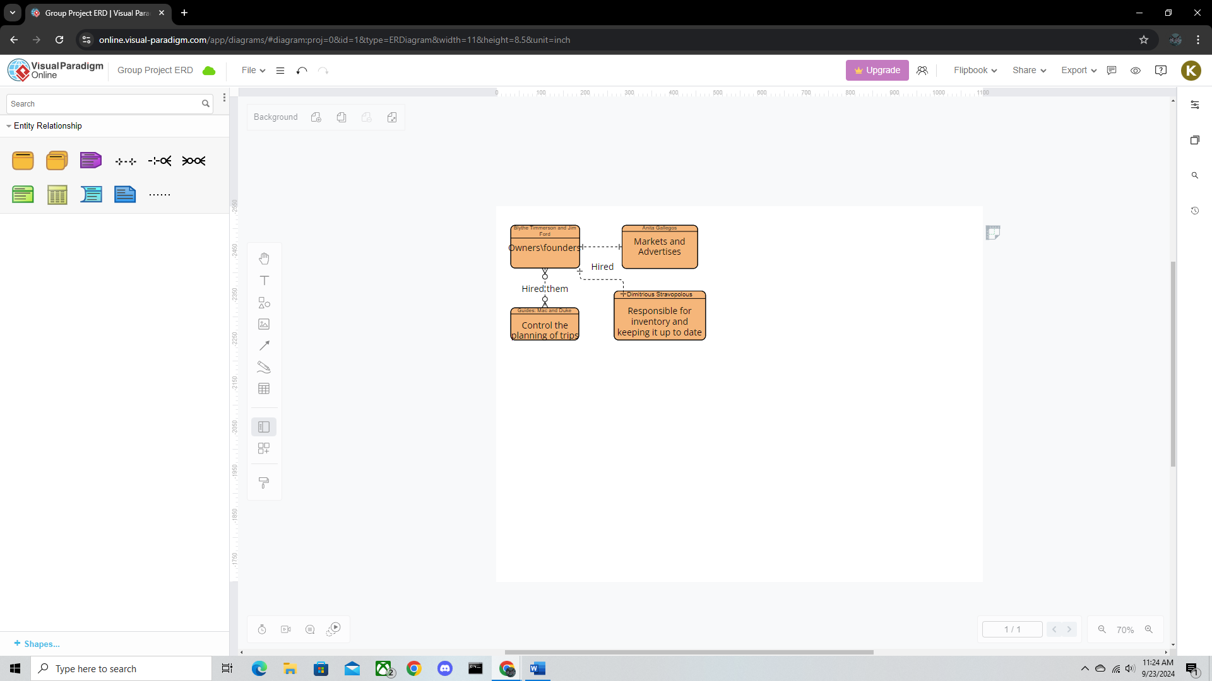

https://online.visual-paradigm.com/app/diagrams/?lightbox=1&highlight=0000ff&edit=https%3A%2F%2Fonline.visual-paradigm.com%2Fapp%2Fdiagrams%2F%23diagram%3Aproj%3D0%26id%3D1%26type%3DERDiagram%26width%3D11%26height%3D8.5%26unit%3Dinch&editBlankUrl=https%3A%2F%2Fonline.visual-paradigm.com%2Fapp%2Fdiagrams%2F%23diagram%3Aproj%3D0%26vpov%3D16.3%26vpob%3D20220410%26client%3D1%26edit%3D_blank&layers=1&nav=1&title=Group%20Project%20ERD&vpov=16.3&vpob=20220410#R3cU2FsdOGVkX1y%2BO8j80fy5kIxpybqHJa1P5nSpqtIqFpSF3eFbUA%3Dt8vUuuP5fCtbSq64QPym1geG%2FlGkEKq25zdHQs0KmcN7TSfIt1jy4ve%2BgxUqCi%2B16UB%2F4jwhuvj9eyKdXw5GVd6IjtBNie2WRw%2FNsaPrWbrSQBiVD7PfAK5ZhrkXp1O2bV97lZGEKbvTgnkZkK%2FyhsVAVp4g2XjBX3lOKW5c%2BImApxTtMU8lsVLmKMUp%2F9JIaQ623rrXlD2hNHi0lUOrJyh88p2yitJsWDrgByQEqVBlMc4GyalopaLiRBjBG6BFWoZIA4kemz%2FPl3Eq0GjrdN4g%2FqZbYvC6zNWcz0sYl2Su1wL3U%2FJ7U91seEHo%2FX5NFBGXMN61Q%2FcQr5j7iJGD%2BgeYvXzvxuXGoS4DFvsAgWNmqpcIROopzUCljuNPL21M32lKcYsJLog10y0n0ANdgc18cbijFzj0psrNju9Ytqr3Uh0JNslH2clAnimKGJXIk%2F5nmz3QhhjeodkbLiEYfrpfH%2FWMMc7j1Sl94RoisjCpGFMUmiPY7BUnbbEUZjGmUQl0Lh6Weuf9eWN%2F6sUtmg%2F5bCPMUcfzJicKVcRpOKywAP4CUILJWuceWBGldu4fOAGyIdL84qxQlAu9o7p9V2xWSAwl77ZsOuVFTGHp8AyAOa8EHH%2B90BAey8XjPlDraHddSZ2cceTYByoTSOxIZvGxpoZeH3t%2Bn0hj4azySViBRcTb95nY4ERMhyWyQT%2BLy1W00EqhkV38T37pG74rRGJGrVGBHZ2%2B%2Bd06%2BnTXKdD7fOZuVIc%2BjOsk9b13JKLsOlVkxHyRW2%2B%2BCx87H66%2F%2FBBamX0jOn4Q8Ty%2BVuwacn7PRU4yyhUy82eQl8R6Bko%2BgOAZM8niD8161TCg1%2BVjsXfU7KpBM06VtIk7Ab1JLXi2D4wA0jUd2LJrWApMV2v0GEz%2FUbfiQ8VdRP7NGs6PcfEksf3KU7EEKNfm6U51EJFN2zcUgxAIHI94PqVYg9VdPAJcxy%2FsBaoI%2FuEGiqRbe3%2FMswM1Xzq9FSRlx9s38olBwif3ZESsaAECcuwyk%2FxMKvojDOhYyn1CUhVhN4pxxKXvJgCjXgLwE7I%2FeJJu9VxOaaMUXBgjoz3Q%2BQeSjmLm8uJTNLP35Ze1upHZ0aaRgF7aqa3FbCSAuPIwuB00mxWBp4sl9aOZwLNyDqEVSdGL6vSeNeOfSTfgZ8k0DM8q8VP5YE5Sxi2Lf8tdj%2B8n2hmEd%2F5y%2FygC3kNuer0rG4hguW%2Bh2qrSJHP%2F4KnWb0l1q0ZDOnKX4HFx0rmpuG4W5swlt0HljJL3vtIoX3EzYdy4PpsAWSbXKCfEJ2H9n7sDWJiXHMreThdoFMdTfJ6MWLHWq0P5rM3n7soJn%2BtDyyMPPvi%2BzRZV2V9E7%2FlLYAcAtpi4L64EyjHagivpKS%2FGV41O68%2Fr2mx9QvOknMWH1hzvsnanx9ygfrVOaFtj6QWt3K86CDy9kkxb0BxKklcxQ4QIw94C6LhTO7NL29vsRwZJ7IoOSvTXZcCovHgQcYrIgtm4HIUQWn%2BcTED5%2BW2jstq6B3VGJPDREV3Tgakj41tuYTxuX1IgsPgkK8JryIAmBd2cp%2BYRCzS41q1N%2BAc7j7yG%2F6IuJT7MQuQqcbWwxM%2FD95d2tZCigyGMsUzlCZ587TuIvm1uIiLkqKG8%2BFhD68y5yEPPpMOCEbcmZhOrViFfS9OmVpaPayXGvNotPD9Bg%2F6lPCKId%2FSGeY4uQ1%2B4qwiBnvWuB9aepAeuTBP1YomPLiRhuX%2BnYXhA0wLVXxKxwtv8IOcuK5CIhvHYJWd4wqYnvWehSbNMwrBvI1LjbH0FvfqGi%2BYa5aolniIRaTyg29uqhwCTdAHXHlHXvoLU875kxbrfbIa%2BC3ilXshPpSGHNmq7xWkG2ROjnM3KaidnqDW5wN%2Byj2R5PXWe6DK6kKQSn%2FZc4zT2mZOqgDmxqmw%2FJFlXfz4XFgFC%2B9jQ6TRUYM4v1WqYqUQ36F9r7L6akRn%2BrI9oBUqVp3kIsVmxKc%2F0AtC3exwCNDIb4y5oxauEAgOhbjDV676%2BAGZMlg1iad8KxS7ggjynUSrB%2Bq8IKz%2BljxXUWbSv7gDMNok6C3mGMhdkWSmNo1aZsL5HNcQSIgyeASoXdXvwIfY3hWtLDSnZLhLFIJOfwuCBtO5LNe4ouIOAqRXZDvcO%2FDsa3f5bzxjghr6ZwdNQwMOtAd7jc791oPn0aCpfCXMYc4cir0hOGDSG1RwCF%2B%2BUHh2UfULnGTVVKGYqA3lR7CRbJsHw2vlY2IAMAsCZaVfMFk8%2FPdWOCyw%2BmQTy8ExsoAdOXy%2F%2B8JDQDRnlBF1btz3TeywaKvWhcHWPYBkCh8vtsYWi5y5CwOo1DmMrczUlt6YJQrk78%2B20Y9viHiwvPXNS45gTZwHtme%2FOWrVIQ%2Bx%2FmE8TX1Lq09f8x8oEs03E%2FhIdtiHB99DxJJhJCQPKYb%2BI5591Ser2IxUhbPNAwE9Z4c7JcI4VGLv9MLi9yEkAsnm4NFif1Un%2F0Ixv1av2VKtYwmOAfxAbVooK3RObdpYcZ9rTea9XZSAOEN6h2EaTwwvDFmkZBPzLrWMjV4v%2Bjj32nnQ1dJ3dz6n%2Bx2PUk831EZIdqGJDhzweJfrNEqWovy1WeuMnNClErbkSQ5bANGbvgC3F0tm0VPt5eMoGLZH5APZeWlRqG1Dh1e%2F6MSgVxmJTcp%2FZmi3h123k5mUasHaECtx0W6h84XyH4wEAqiIypntVgiOmbekW%2FU7cHjKquqzdMMvIs%2B8W1guJjTGgHU%2FjlFCNdPXO6ETCCf7PXj7JXO5SE4tPUk36KDxkbzWc0Ti%2B72JJANy3wpUIKWEll3ALZ2N86J7Tk4KVahn5MarR3rv%2F%2BGNBgUNRsJP0E5TDM9l01EwlYaA4OTSaGFy9UZcoNowHtX55MZ0oeRZBNRkaRhm%2Bl%2FHOt%2BHc%2BEvgFv8KwLN2075H14wgeNXt0OI%2F%2BiuZAl5qyC0h9YwBVyg0kpwvEX65UYF51pl6hpmBAvqmaX7oC2JfLxU%2BwJhfsfHlCsQ3oaD9Sjm6t2UlXuuP%2BQz8wjw7nBUjWk4qGczH3bIosVf4jVeiy4IlqgHGqTT0KU0cy0eTdnEDyUzYzj5JZhnB%2FJ30Cg1SCrJNU%2FN5LrfM3V3s%2Bc7G%2B82ViejK46oJu77Yu07bzm2eMzETe%2Bs0gANgWq%2FJC%2FC2tJyhgrlWMsUwSkexX4lq9NF29CwwMtGOMQxtsYQTvPCN%2BM5dQgFoF1jQbPDLnDMm87%2BVjMQUXv3AHnT2j0Ugb74GitN1f2SYrE7psGaLDmrol2sMjHEYMyMY3qp1DCsw8eA4U6dWiiROzbuBgo6czS%2FP6Q4MUrRsIUzOAt9A5VcSObiGXKbzEK05nTzm3HJRB1lEuiQm7xnTSdMcTtKUNfrapMA7%2BRsa7e72W5IPuVKsQyUDABM%2B%2FUs%2Fj%2FqwL0IVZIwHZO9%2BXf3pYzz4qodcBYQr1ZaAsX5ZIsPDbyIkCS23kH66fUH%2BTjTNeSYjPjNtaIxtOD3xeNrpBRio8AM%2BKRZtbTecbxB214i3BKwdHbdDKDkaFgzlJyMSmLdY4%2BZ%2BjY0GV1cQTyuI%2FE%2FGRJUR2Lg930YqHqGZw1hKaFflA4hzVNKiUZbz3Xq2RyjOTtcEgCDZ75QnQ%2FDVfv4eRrU7AwHrmJRAfMMKYfiry1TIluxBv3Uz4Z3nvsRm%2FjvR43JCqk0ySCQAG4Zk1sHyjfdYPH0I%2BZk1MCR9RrRi7Sz3Q7I7uhekIjBSN%2F2q5y5mUPuyJNWcScj6GDg23ZKyMjo3MXRmZDAp7%2BORP7i0x3kCQoCn2vnHygGzKyI9q8ooWEpwmix6dVAQ6dNEzF8cLWglil8Vc6snkaNIm38nbG7FbYS%2Fz6VI0fZumGxs%2BF6QQvbVgCSJwX8sOSEwLl6iPXXTN%2Bo9yGVKcZweFf9klLqet7Wau7gW8a28nP64wjuXuQNqAjOsHkvlh0BPxeUBzOrQRH%2F%2BZIOlVgTYuwCvDpeJ%2FxRa%2F9UQapfdw8lcxX12PofioDPu5rYYTWCYQjvAsiJ%2B8gey6rSlRFErlJFoKzi6Eg4IFyuh4VQakKjyiSy9wCKExvpz%2FuJATDWxeOtH0R3ry67NP0q0qivcwrSbyNbz7pT%2ByP%2Frah2pefOVCrmKpMO9e8N%2FSCRFbmuZat1YOpgWTobZi3g0OIBj4qTS9%2FXrpJK0ZWJIA1LrGHQXiOwxXl9OxDRNI%2FiI5AGunxRLEK%2FUZiN09DEhB%2BH9OaOIfoGA%3D%3D1eyOnG8b