**Violet Chang || chan1300 || 5197617**

**STAT 3022 Homework 4**

*Problem 1. In R, which diagnostic plot do we use to check for outliers and how do you tell if a point is an outlier? What statistic do we use to check for influential points and how do you tell if a point is an influential point?*

* We use residual diagnostic plots, especially Residual vs. Leverage plot to find outliers. Because in the simple linear model setting, an outlier is a point where the magnitude of the residual is unusually large, if a point does not fit the general pattern in the scatterplot of residual diagnostic plot, then it is an outlier. In other word, if the absolute value of standard residual is greater than standard, then this point is a outlier.
* Cook’s distance can be used to check influential points. To check if a point is influential point or not, fit the model with and without that point to see if the coefficients change very much. If an  Cook's distance is greater than 1, then this point has large influence.

*Problem 2. What factors can help to predict how long a Major League Baseball game will last? The datafile BaseballTimes (in the Stat2Data library) contains a sample of 15 games played on August 26, 2008. The variables are: The goal of the study is to predict Time by finding an appropriate set of quantitative predictors.*

> library(Stat2Data)

> library(leaps)

> library(car)

> data(BaseballTimes)

> pairs(~Time+Runs+Margin+Pitchers+Attendance, data = BaseballTimes)

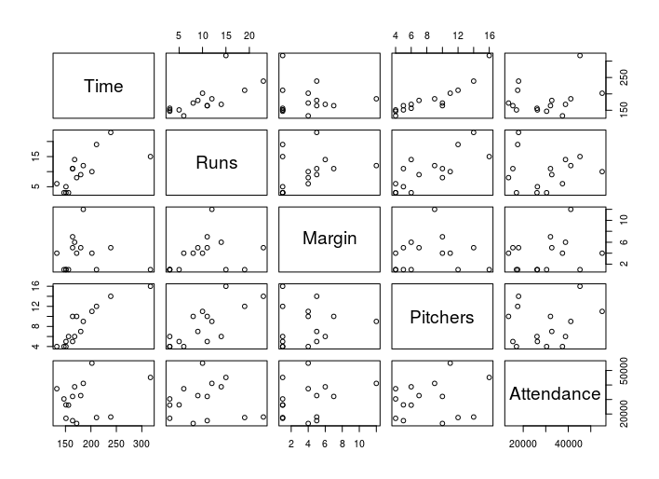#2 (a): From the plot we know that the relationship between Runs and the Pitchers with Time is more like positive linear, while Margin and Attendance shows non-linear relationship with Time. There seems exists a linear like relationship between Runs and Pitchers.

> lm3=lm(Time~Runs+Margin+Pitchers+Attendance, data=BaseballTimes)

> lm4=lm(Time~Runs+Pitchers, data=BaseballTimes)

> summary(lm3)

Call:

lm(formula = Time ~ Runs + Margin + Pitchers + Attendance, data = BaseballTimes)

Residuals:

Min 1Q Median 3Q Max

-25.755 -11.163 -1.571 13.090 36.716

Coefficients:

Estimate Std. Error t value Pr(>|t|)

(Intercept) 88.0151955 17.7733306 4.952 0.000577 ***

Runs 1.5613428 1.6764324 0.931 0.373612

Margin -3.7278867 2.0794572 -1.793 0.103269

Pitchers 8.7322001 2.4849861 3.514 0.005594 **

Attendance 0.0007269 0.0005105 1.424 0.184889

---

Signif. codes: 0 ‘***’ 0.001 ‘**’ 0.01 ‘*’ 0.05 ‘.’ 0.1 ‘ ’ 1

Residual standard error: 20.77 on 10 degrees of freedom

Multiple R-squared: 0.8557, Adjusted R-squared: 0.798

F-statistic: 14.83 on 4 and 10 DF, p-value: 0.0003299

> summary(lm4)

Call:

lm(formula = Time ~ Runs + Pitchers, data = BaseballTimes)

Residuals:

Min 1Q Median 3Q Max

-38.025 -8.525 -3.397 9.757 50.518

Coefficients:

Estimate Std. Error t value Pr(>|t|)

(Intercept) 94.87600 13.95551 6.798 1.91e-05 ***

Runs -0.06436 1.56861 -0.041 0.967948

Pitchers 10.78571 2.40462 4.485 0.000745 ***

---

Signif. codes: 0 ‘***’ 0.001 ‘**’ 0.01 ‘*’ 0.05 ‘.’ 0.1 ‘ ’ 1

Residual standard error: 22.33 on 12 degrees of freedom

Multiple R-squared: 0.7998, Adjusted R-squared: 0.7665

F-statistic: 23.97 on 2 and 12 DF, p-value: 6.436e-05

> anova(lm4, lm3)

Analysis of Variance Table

Model 1: Time ~ Runs + Pitchers

Model 2: Time ~ Runs + Margin + Pitchers + Attendance

Res.Df RSS Df Sum of Sq F Pr(>F)

1 12 5983.4

2 10 4312.2 2 1671.2 1.9377 0.1944

#2 (b): From the nested anova table, we find that the p-value is 0.19 which is larger than 0.05, so we can’t reject hypothesis H0 that the coefficients for Margin and Attendance are zero (Beta1 = Beta2 = 0). In other words, we don’t have enough evidence to say we can remove the Margin and Attendance simultaneously.

> forwardModel = regsubsets(Time~Runs+Margin+Pitchers+Attendance,

+ data=BaseballTimes, nbest=2,method="forward")

> par(mfrow=c(1,1))

> subsets(forwardModel, statistic="cp", names=c("R","M","P","A"),

+ main="Baseball Times Model, Cp")

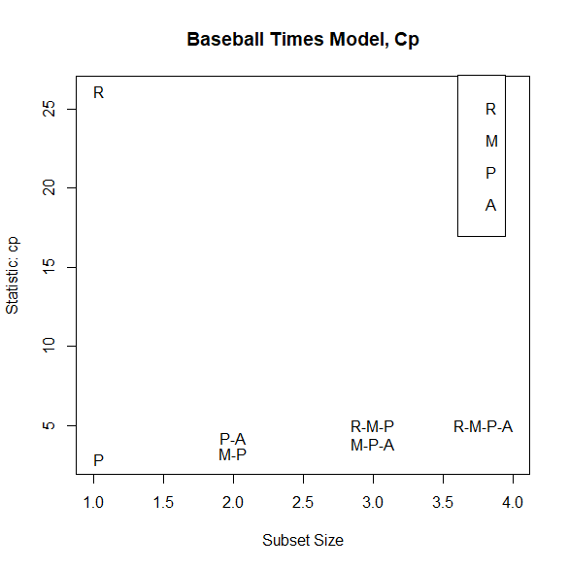> summary(forwardModel)$cp

[1] 2.877398 26.138773 3.222566 4.237234 3.867410 5.027822 5.000000

#2 (c): From the cp value and the plot we say that only Pitchers is selected by the forward selection technique, for it has the smallest cp value.

> seleModel=lm(Time~Pitchers, data=BaseballTimes)

> summary(seleModel)

Call:

lm(formula = Time ~ Pitchers, data = BaseballTimes)

Residuals:

Min 1Q Median 3Q Max

-37.945 -8.445 -3.104 9.751 50.794

Coefficients:

Estimate Std. Error t value Pr(>|t|)

(Intercept) 94.843 13.387 7.085 8.24e-06 ***

Pitchers 10.710 1.486 7.206 6.88e-06 ***

---

Signif. codes: 0 ‘***’ 0.001 ‘**’ 0.01 ‘*’ 0.05 ‘.’ 0.1 ‘ ’ 1

Residual standard error: 21.46 on 13 degrees of freedom

Multiple R-squared: 0.7998, Adjusted R-squared: 0.7844

F-statistic: 51.93 on 1 and 13 DF, p-value: 6.884e-06

> par(mfrow=c(2,2))

> plot(seleModel)  
#2 (d): In part a, we find out the there is a linear relationship between Pitchers and Time. From the plots, the zero-mean assumption is possibly violated, and the normal q-q plot is not that linearly for some points are outside the diagonal line. The constant variance seems hold. Based on these, I think there is no enough evidence to say that this is violated or not for this is just a small sample.

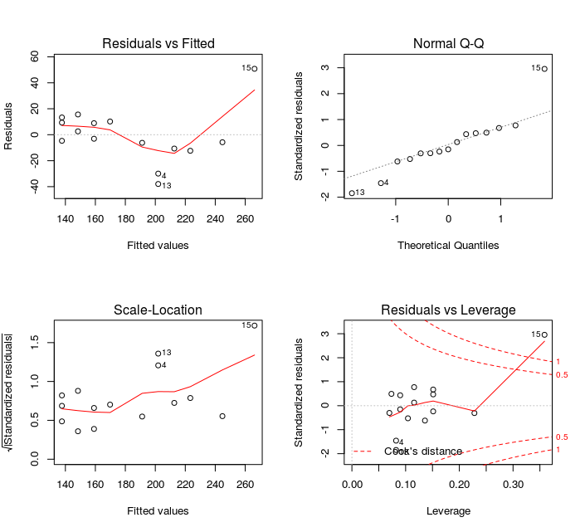

*Problem 4.10*

> data(ReligionGDP)

> ReligionGDP$logGDP=log(ReligionGDP$GDP)

> plot(logGDP~Religiosity, data=ReligionGDP, main="logGDP vs Religiosity")

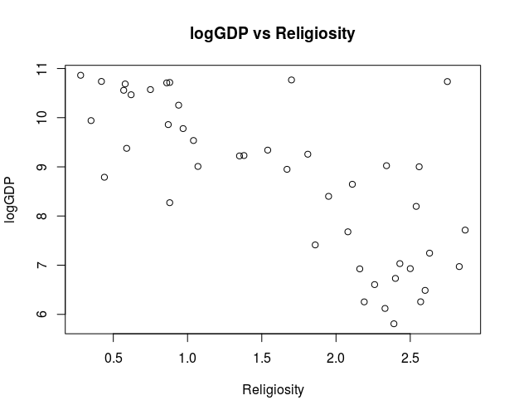

#4.10 (a): From the plot we can find a negative relationship between logGDP and Religiosity. In other words, when Religiosity goes higher, the logGDP will possibly get lower.

> lm1=lm(logGDP~Religiosity, data=ReligionGDP)

> summary(lm1)

Call:

lm(formula = logGDP ~ Religiosity, data = ReligionGDP)

Residuals:

Min 1Q Median 3Q Max

-1.8387 -0.8108 0.1272 0.5833 3.5923

Coefficients:

Estimate Std. Error t value Pr(>|t|)

(Intercept) 10.9961 0.3656 30.079 < 2e-16 ***

Religiosity -1.4013 0.2001 -7.005 1.43e-08 ***

---

Signif. codes: 0 ‘***’ 0.001 ‘**’ 0.01 ‘*’ 0.05 ‘.’ 0.1 ‘ ’ 1

Residual standard error: 1.085 on 42 degrees of freedom

Multiple R-squared: 0.5388, Adjusted R-squared: 0.5278

F-statistic: 49.06 on 1 and 42 DF, p-value: 1.432e-08

#4.10 (b): The summary of this linear model shows that the percentage of the variability is 53.88% based on the R-squared value., which means there is 53.88% of logGDP data can be explained by this model.

#4.10 (c): While religiosity increases 1, the logGDP will decrease 1.4 on the average.

> ReligionGDP$EastEurope=as.factor(ReligionGDP$EastEurope)

> ReligionGDP$MiddleEast=as.factor(ReligionGDP$MiddleEast)

> ReligionGDP$Asia=as.factor(ReligionGDP$Asia)

> ReligionGDP$WestEurope=as.factor(ReligionGDP$WestEurope)

> ReligionGDP$Americas=as.factor(ReligionGDP$Americas)

> lm2=lm(logGDP~Religiosity+EastEurope+MiddleEast+Asia+WestEurope+Americas, data=ReligionGDP)

> summary(lm2)

Call:

lm(formula = logGDP ~ Religiosity + EastEurope + MiddleEast +

Asia + WestEurope + Americas, data = ReligionGDP)

Residuals:

Min 1Q Median 3Q Max

-1.5274 -0.5720 -0.0760 0.5457 2.3395

Coefficients:

Estimate Std. Error t value Pr(>|t|)

(Intercept) 9.2019 0.7452 12.348 1.09e-14 ***

Religiosity -0.9979 0.2852 -3.498 0.00124 **

EastEurope1 0.7901 0.6709 1.178 0.24639

MiddleEast1 1.9374 0.4797 4.039 0.00026 ***

Asia1 0.9856 0.4556 2.163 0.03706 *

WestEurope1 2.0538 0.6975 2.944 0.00556 **

Americas1 1.5937 0.4778 3.336 0.00195 **

---

Signif. codes: 0 ‘***’ 0.001 ‘**’ 0.01 ‘*’ 0.05 ‘.’ 0.1 ‘ ’ 1

Residual standard error: 0.8947 on 37 degrees of freedom

Multiple R-squared: 0.7235, Adjusted R-squared: 0.6787

F-statistic: 16.14 on 6 and 37 DF, p-value: 5.095e-09

#4.10 (e): The summary of this linear model shows that the percentage of the variability is 72.35% based on the R-squared value., which means there is 72.35% of logGDP data can be explained by this model.

#4.10 (f): While religiosity increases 1, the logGDP will decrease 0.9979 on the average.

> anova (lm2, lm1)

Analysis of Variance Table

Model 1: logGDP ~ Religiosity + EastEurope + MiddleEast + Asia + WestEurope +

Americas

Model 2: logGDP ~ Religiosity

Res.Df RSS Df Sum of Sq F Pr(>F)

1 37 29.615

2 42 49.405 -5 -19.79 4.9449 0.001448 **

---

Signif. codes: 0 ‘***’ 0.001 ‘**’ 0.01 ‘*’ 0.05 ‘.’ 0.1 ‘ ’ 1

#4.10 (g): The nested F-test statistic value is 4.94 and the p-value is 0.0014 < 0.05. So we have the strong evidence to say that we reject the hypothesis H0 that Beta2 = Beta3 = Beta4 = Beta5 = Beta6 = 0. We can conclude that the five religions are important factor for predicting logGDP and the new model is better than before.

*Problem 5.12:*

a) Because an explanatory variable is one that explains changes in that variable, for here, the response variable here is the final score, and the explanatory variable here are the four different fonts.

b) This is a randomized experiment as we assign 40 students to 4 fonts groups randomly.

c)The one-way analysis of variance (ANOVA) is used to determine whether there are any statistically significant differences between the means of three or more independent groups. Because there are four different fonts here, we will use ANOVA to compare and analysis the data.

*Problem 5.20:*

a)

|  |  |  |  |  |
| --- | --- | --- | --- | --- |
| Source | DF | SS | MS | F |
| Type | K-1=2 | 37.51 | 37.51/2=18.76 | 18.76/3.68=5.10 |
| Error | N-K=9 | 33.09 | 33.09/9=3.68 |  |
| Total | N-1=11 | 70.60 |  |  |

b) The MS for county type tells me the variability of the mean types, so I can compare the MS with the variability of error to find out if there is more variability.

c)   
> 1-pf(5.1,2,9)

[1] 0.03305489  
So, the p value 0.033

d)H0: Beta1 = Beta2 = Beta3 = 0; H1: Beta1 != Beta2 != Beta3 != 0, I.e, at least one of county’s size is different from others.   
Since the p value is 0.033 < 0.05, we say that we reject H0, which means there is at least one county’s sizes is different from others.

*Problem 5.24:*

> data(FantasyBaseball)

> boxplot(FantasyBaseball[,2:9], main="Boxplot of FantasyBaseball")

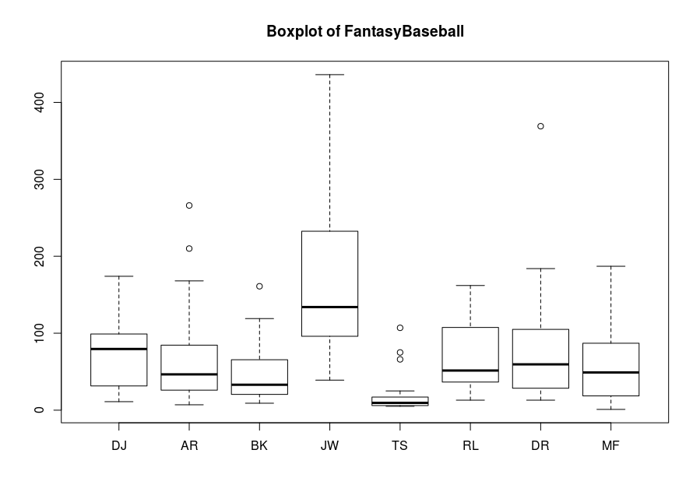#5.24 (a): This boxplot shows that the most of the distribution is skewed to the right. IT is easy to find out that there are some decisions are harder to make which will cost more time. Generally, the time participants take are same while JW is the slowest and TS is the fastest in making decisions.

> dim(FantasyBaseball)

[1] 24 9

> times=with(FantasyBaseball, c(DJ,AR,BK,JW,TS,RL,DR,MF))

> players=rep(colnames(FantasyBaseball)[2:9], each=24)

> newData=data.frame("players"=as.factor(players), "times"=times)

> lm5=lm(times~players, data=newData)

> summary(lm5)

Call:

lm(formula = times ~ players, data = newData)

Residuals:

Min 1Q Median 3Q Max

-124.88 -36.91 -13.33 24.47 288.88

Coefficients:

Estimate Std. Error t value Pr(>|t|)

(Intercept) 68.292 12.528 5.451 1.59e-07 ***

playersBK -20.333 17.718 -1.148 0.2526

playersDJ 1.333 17.718 0.075 0.9401

playersDR 11.833 17.718 0.668 0.5050

playersJW 95.583 17.718 5.395 2.09e-07 ***

playersMF -4.458 17.718 -0.252 0.8016

playersRL -1.167 17.718 -0.066 0.9476

playersTS -48.958 17.718 -2.763 0.0063 **

---

Signif. codes: 0 ‘***’ 0.001 ‘**’ 0.01 ‘*’ 0.05 ‘.’ 0.1 ‘ ’ 1

Residual standard error: 61.38 on 184 degrees of freedom

Multiple R-squared: 0.293, Adjusted R-squared: 0.2661

F-statistic: 10.89 on 7 and 184 DF, p-value: 1.788e-11

> anova(lm5)

Analysis of Variance Table

Response: times

Df Sum Sq Mean Sq F value Pr(>F)

players 7 287196 41028 10.891 1.788e-11 ***

Residuals 184 693126 3767

---

Signif. Codes: 0 ‘***’ 0.001 ‘**’ 0.01 ‘*’ 0.05 ‘.’ 0.1 ‘ ’ 1

> an1=aov(times~players)

> summary(an1)

Df Sum Sq Mean Sq F value Pr(>F)

players 7 287196 41028 10.89 1.79e-11 ***

Residuals 184 693126 3767

---

Signif. codes: 0 ‘***’ 0.001 ‘**’ 0.01 ‘*’ 0.05 ‘.’ 0.1 ‘ ’ 1

> an1=aov(times~players, data=newData)

> par(mfrow=c(2,2))

> plot(an1)

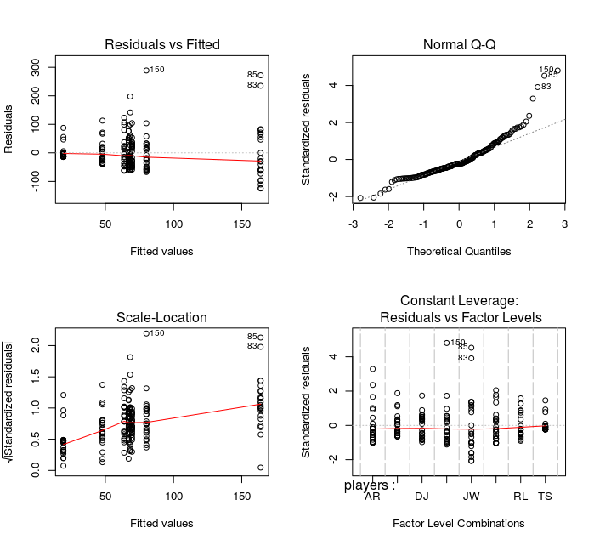#5.24 (b): The plots shows that this model is not that acceptable for from normal q-q plot we see a obvious curve pattern and the zero mean assumption doesn’t not hold according to the residuals vs fitted value plot. So we need to correct the model and can’t reject any hypothesis because the anova and summary table can’t be trusted.

> newData$log=log(newData$times)

> lm6=lm(log~players, data=newData)

> summary(lm6)

Call:

lm(formula = log ~ players, data = newData)

Residuals:

Min 1Q Median 3Q Max

-3.5026 -0.5643 0.0110 0.5941 2.2040

Coefficients:

Estimate Std. Error t value Pr(>|t|)

(Intercept) 3.7798 0.1900 19.896 < 2e-16 ***

playersBK -0.2254 0.2687 -0.839 0.403

playersDJ 0.2427 0.2687 0.904 0.367

playersDR 0.2672 0.2687 0.995 0.321

playersJW 1.1233 0.2687 4.181 4.48e-05 ***

playersMF -0.2772 0.2687 -1.032 0.304

playersRL 0.2078 0.2687 0.773 0.440

playersTS -1.3109 0.2687 -4.879 2.30e-06 ***

---

Signif. codes: 0 ‘***’ 0.001 ‘**’ 0.01 ‘*’ 0.05 ‘.’ 0.1 ‘ ’ 1

Residual standard error: 0.9307 on 184 degrees of freedom

Multiple R-squared: 0.3307, Adjusted R-squared: 0.3053

F-statistic: 12.99 on 7 and 184 DF, p-value: 1.538e-13

> anova(lm6)

Analysis of Variance Table

Response: log

Df Sum Sq Mean Sq F value Pr(>F)

players 7 78.75 11.2500 12.989 1.538e-13 ***

Residuals 184 159.37 0.8661

---

Signif. Codes: 0 ‘***’ 0.001 ‘**’ 0.01 ‘*’ 0.05 ‘.’ 0.1 ‘ ’ 1

> an2=aov(log~players, data=newData)

> summary(an2)

Df Sum Sq Mean Sq F value Pr(>F)

players 7 78.75 11.250 12.99 1.54e-13 ***

Residuals 184 159.37 0.866

---

Signif. codes: 0 ‘***’ 0.001 ‘**’ 0.01 ‘*’ 0.05 ‘.’ 0.1 ‘ ’ 1

> par(mfrow=c(2,2))

> plot(an2)

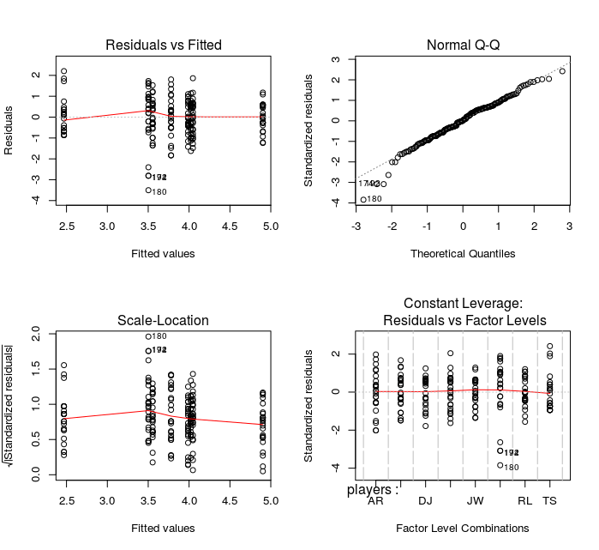

#5.24 (c): The plots shows that this model is better than before because the normal q-q plot shows a more similar linear pattern than previous one and the other three plots also shows better pattern. This time, the assumption can stand and the anova table is more believeable.

#5.24 (d): The F-statistic value is 12.99, p-value is approximately 0, which indicate that we reject the hypothesis H0 that all coefficient values (beta) are equal to zero. In other words, we have the strong evidence to show that there is at least one participant’s mean selection time is different from others.

> source("LSDtest.R")

> lsd=LSDtest(newData$log, newData$players, alpha=0.05)

> lsd

pair est lwr upr

1 AR~BK 0.22537843 -0.30467454 0.75543139

2 AR~DJ -0.24274982 -0.77280279 0.28730315

3 AR~DR -0.26720058 -0.79725355 0.26285239

4 AR~JW -1.12326875 -1.65332172 -0.59321578

5 AR~MF 0.27720147 -0.25285150 0.80725443

6 AR~RL -0.20778389 -0.73783686 0.32226908

7 AR~TS 1.31090586 0.78085289 1.84095883

8 BK~DJ -0.46812824 -0.99818121 0.06192473

9 BK~DR -0.49257901 -1.02263198 0.03747396

10 BK~JW -1.34864717 -1.87870014 -0.81859420

11 BK~MF 0.05182304 -0.47822993 0.58187601

12 BK~RL -0.43316231 -0.96321528 0.09689066

13 BK~TS 1.08552744 0.55547447 1.61558041

14 DJ~DR -0.02445076 -0.55450373 0.50560221

15 DJ~JW -0.88051893 -1.41057190 -0.35046596

16 DJ~MF 0.51995128 -0.01010169 1.05000425

17 DJ~RL 0.03496593 -0.49508704 0.56501890

18 DJ~TS 1.55365568 1.02360271 2.08370865

19 DR~JW -0.85606817 -1.38612114 -0.32601520

20 DR~MF 0.54440205 0.01434908 1.07445502

21 DR~RL 0.05941669 -0.47063627 0.58946966

22 DR~TS 1.57810645 1.04805348 2.10815942

23 JW~MF 1.40047021 0.87041724 1.93052318

24 JW~RL 0.91548486 0.38543189 1.44553783

25 JW~TS 2.43417461 1.90412164 2.96422758

26 MF~RL -0.48498535 -1.01503832 0.04506762

27 MF~TS 1.03370440 0.50365143 1.56375737

28 RL~TS 1.51868975 0.98863678 2.04874272

#5.24 (e): From the Fisher’s LSD procedure, we know that:

JW’s and TS’s average selection times is significantly different from any of other player,

DR’s is different from MF.