**Violet Chang || chan1300 || 5197617**

**STAT 3022 Homework 5**

*Problem 6.22.*

|  |  |  |  |  |  |
| --- | --- | --- | --- | --- | --- |
| **Source** | **DF** | **SS** | **MS** | **F** | **p-value** |
| **Face(Yes/No)** | 1 | 12915 | 12915 | 129.15 | 0 |
| **Gender(M/F)** | 1 | 2500 | 2500 | 25.0 | 2.580991e-16 |
| **Interaction** | 1 | 400 | 400 | 4.0 | 0.04832569 |
| **Residuals** | 96 | 9600 | 100 |  |  |
| **Total** | 99 | 25415 |  |  |  |

> 1-pf(129.15, 1, 96)

[1] 0

> 1-pf(25.0, 1, 96)

[1] 2.580991e-06

> 1-pf(4.0, 1, 96)

[1] 0.04832569

*Problem 6.25.*> library(Stat2Data)  
> data(Alfalfa)  
> aggregate(Ht4~Row, data = Alfalfa,FUN= "mean" )

Row Ht4

1 a 1.16

2 b 1.57

3 c 1.25

4 d 2.26

5 e 2.46

## 6.25 (a): means of each row of cups

> aggregate(Ht4~Acid, data = Alfalfa,FUN= "mean" )

Acid Ht4

1 1.5HCl 1.466

2 3.0HCl 1.084

3 water 2.670

## 6.25 (a): means of each row of treatment

> mean(Alfalfa$Ht4)

[1] 1.74

> sd(Alfalfa$Ht4)

[1] 1.105396

## 6.25 (a): mean and standard deviation for the growth in all cups

> lm1 = aov(Ht4~Acid+Row, data=Alfalfa)

> summary(lm1)

Df Sum Sq Mean Sq F value Pr(>F)

Acid 2 6.852 3.426 4.513 0.0487 *

Row 4 4.183 1.046 1.378 0.3235

Residuals 8 6.072 0.759

---

Signif. Codes: 0 ‘***’ 0.001 ‘**’ 0.01 ‘*’ 0.05 ‘.’ 0.1 ‘ ’ 1

## 6.25 (b): two-way ANOVA table for differences in average growth due to acid using rows as a blocking variable.

> par(mfrow = c(2, 2))

> plot(lm1)

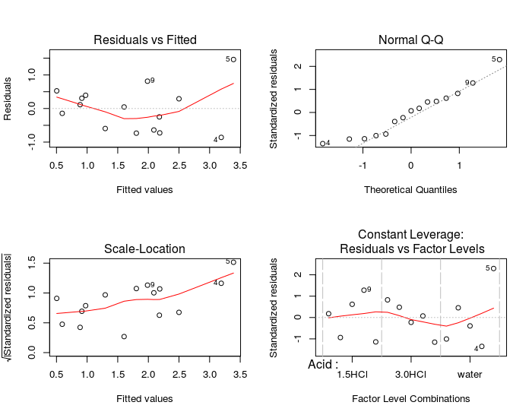## 6.25 (c): From the normal q-q plot, the normality is not very good for it shows a general linear pattern while there exists a curve. The residuals vs fitted value plot shows that the zero mean assumption (equal variances) holds. So generally, this model is acceptable.

## 6.25 (d): Yes. Because the p-value of acid is 0.0487 < 0.05 which indicates that Acid effect is significant, and the observed variability is because of the treatment.

## 6.25 (e): No. Because the p-value of Row is 0.3235 > 0.05 which indicates that distance effect is not significant, and the observed variability is not because of the distance.

*Problem 6.28*

> data(Swahili)

> par(mfrow = c(1, 1))

> interaction.plot(Swahili$Sex, Swahili$Province, Swahili$Attitude.Score)

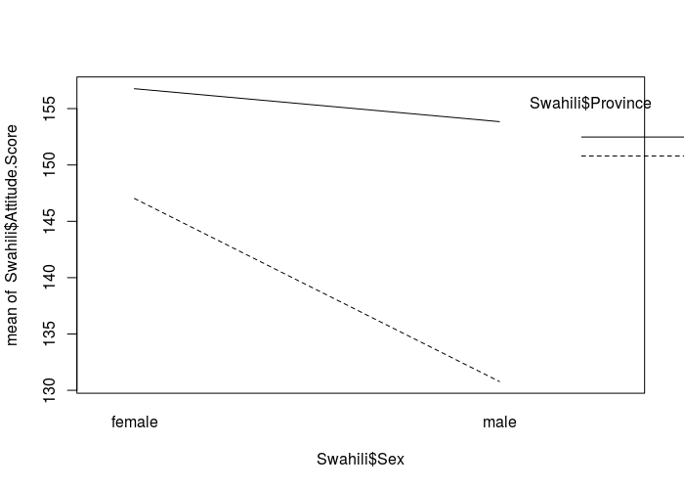> lm2=aov(Attitude.Score~as.factor(Province) * as.factor(Sex), data = Swahili)

> summary(lm2)

Df Sum Sq Mean Sq F value Pr(>F)

as.factor(Province) 1 32275 32275 349.82 < 2e-16 ***

as.factor(Sex) 1 11021 11021 119.45 < 2e-16 ***

as.factor(Province):as.factor(Sex) 1 5320 5320 57.66 1.66e-13 ***

Residuals 476 43917 92

---

Signif. Codes: 0 ‘***’ 0.001 ‘**’ 0.01 ‘*’ 0.05 ‘.’ 0.1 ‘ ’ 1

## 6.28 (a): The plot shows that the average of Nairobi is lower than the average of Pwani. Male has lower average than female. The difference between male and female is larger in Nairobi than in Pwani. The table shows that both p-value of province factor and sex factor are very smaller than 0.05, which indicates that both these two factor are very important to this model.

> par(mfrow = c(2, 2))

> plot(lm2)

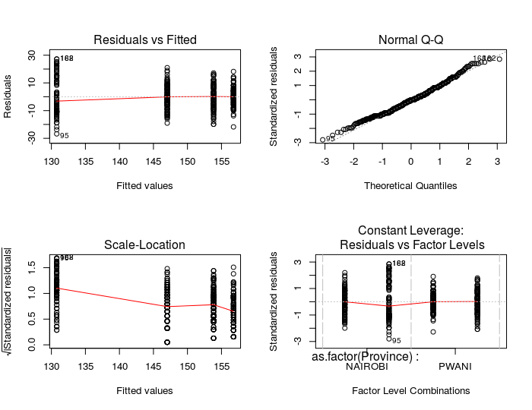

## 6.28 (b): The normal q-q plot shows a general linear pattern which indicates that the normality is met. The residuals vs fitted value plots shows that the zero mean assumption (equal variance) holds. So both normality and equal variance conditions are satisfied.

## 6.28 (c): The balanced design needs equal number of observations from two factors’ each combinations of levels. In this problem, there is only one school from each province, which means if we have students from the school of one province as our observations, we will have no other observations (students) from both this school and the school in another province at same time. So this can’t be a balanced complete factorial design.

*Problem 7.12:*

> data(Blood1)

> Blood1$Overwt = as.factor(Blood1$Overwt)

> Blood1$Smoke = as.factor(Blood1$Smoke)

> interaction.plot(Blood1$Overwt, Blood1$Smoke, Blood1$SystolicBP)

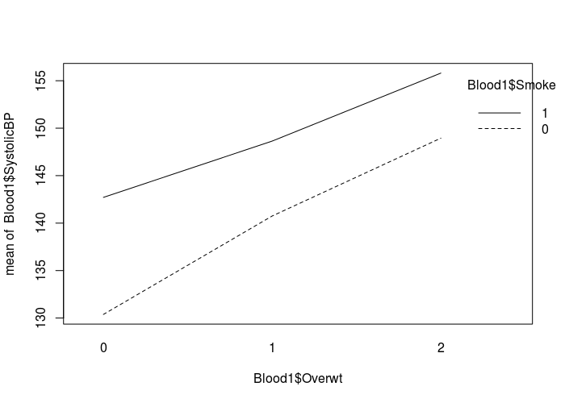

> lm3 = lm(SystolicBP ~ Smoke * Overwt, data = Blood1)

> anova(lm3)

Analysis of Variance Table

Response: SystolicBP

Df Sum Sq Mean Sq F value Pr(>F)

Smoke 1 14635 14634.9 20.5255 7.387e-06 ***

Overwt 2 23443 11721.6 16.4396 1.224e-07 ***

Smoke:Overwt 2 769 384.4 0.5391 0.5836

Residuals 494 352228 713.0

---

Signif. codes: 0 ‘***’ 0.001 ‘**’ 0.01 ‘*’ 0.05 ‘.’ 0.1 ‘ ’ 1

> source("LSDtest.R")

> lout = LSDtest(Blood1$SystolicBP, Blood1$Overwt, alpha = 0.05)

> lout

pair est lwr upr

1 0~1 -8.051464 -14.45261 -1.650318

2 0~2 -16.865865 -22.24359 -11.488141

3 1~2 -8.814400 -15.11657 -2.512235

> subset(lout, sign(lwr)==sign(upr))

pair est lwr upr

1 0~1 -8.051464 -14.45261 -1.650318

2 0~2 -16.865865 -22.24359 -11.488141

3 1~2 -8.814400 -15.11657 -2.512235

> ncomp = choose(nlevels(Blood1$Overwt), 2)

> bout = LSDtest(Blood1$SystolicBP, Blood1$Overwt, alpha = 0.05/ncomp)

> bout

pair est lwr upr

1 0~1 -8.051464 -15.87754 -0.2253901

2 0~2 -16.865865 -23.44070 -10.2910325

3 1~2 -8.814400 -16.51946 -1.1093404

> subset(bout, sign(lwr)==sign(upr))

pair est lwr upr

1 0~1 -8.051464 -15.87754 -0.2253901

2 0~2 -16.865865 -23.44070 -10.2910325

3 1~2 -8.814400 -16.51946 -1.1093404

## 7.12 (a): The Bonferroni intervals shows that there is not interval cover 0, so all intervals are significant and that all weight groups are different from each other.

> lm4 = aov(SystolicBP ~ Overwt, data = Blood1)

> summary(lm4)

Df Sum Sq Mean Sq F value Pr(>F)

Overwt 2 27801 13900 19.02 1.1e-08 ***

Residuals 497 363274 731

---

Signif. codes: 0 ‘***’ 0.001 ‘**’ 0.01 ‘*’ 0.05 ‘.’ 0.1 ‘ ’ 1

> TukeyHSD(lm4, "Overwt", data = Blood1)

Tukey multiple comparisons of means

95% family-wise confidence level

Fit: aov(formula = SystolicBP ~ Overwt, data = Blood1)

$Overwt

diff lwr upr p adj

1-0 8.051464 0.3927115 15.71022 0.0366867

2-0 16.865865 10.4316024 23.30013 0.0000000

2-1 8.814400 1.2740746 16.35473 0.0170703

## 7.12 (b): The TukeyHSD shows that all weight groups are different from each other. And they are all significant.

## 7.12 (c): From the two table we knows that there is no significant difference between these two test.