Violet Chang || chan1300 || 5197617
Stat 3022 HW1
## Question 1
# Question 1: (a)
> x = rnorm(50)
> x
[1] -1.588757874 -0.173113730 1.048441196 -2.638396690 0.176449139 2.108430792 1.357605774 -1.657939534 -0.750492198 -0.675130223 -0.454274591
[12] -0.648333712 -0.661346920 -1.446911931 2.068834049 0.004292554 0.109610191 0.340529607 1.306971919 0.666155648 1.273373534 -0.288888988
[23] -0.837211404 -0.594396485 -1.108104163 -0.327771359 -0.346929680 -0.420436175 0.857092254 0.699800475 0.526496189 0.869972042 -0.189712483
[34] -1.202659202 -1.462067757 1.134754340 -1.511790929 0.385456465 0.132545234 -0.054181594 1.704146151 -0.321814218 -0.914158701 -1.026541178
[45] -0.379825986 -1.698538632 1.087109573 0.729764847 1.174018079 0.762350212
> mean(x)
[1] -0.05711052
> sd(x)
[1] 1.067795
> median(x)
[1] -0.1814131
# Question 1: (b)
> e = rnorm(50, sd = 0.05)
> e
[1] -0.148193689 0.038111008 -0.047617104 -0.001259398 -0.075550753 0.067966293 0.001059469 -0.066459491 0.079747868 0.082503245 -0.072191737
[12] -0.047727119 0.059258508 -0.050258971 0.015277697 -0.019408997 -0.015220947 0.027064631 0.065036213 0.027882416 0.007674216 -0.041812038
[23] 0.074910373 -0.021075638 -0.012408847 -0.008822217 0.093759345 0.008498428 0.061242041 -0.073037320 -0.045320520 0.016626681 -0.034637146
[34] -0.132891752 -0.002704490 0.053505821 0.056058806 -0.014682544 0.066437408 -0.035757009 -0.077900525 -0.037623419 -0.063056974 0.080865581
[45] -0.061978333 0.040481689 0.027223989 -0.040068363 -0.050138423 0.085646688
# Question 1: (c)
> y = 10 * x + e
> y
[1] -16.03577243 -1.69302630 10.43679486 -26.38522630 1.68894064 21.15227421 13.57711721 -16.64585483 -7.42517411 -6.66879898 -4.61493765
[12] -6.53106424 -6.55421069 -14.51937829 20.70361818 0.02351655 1.08088097 3.43236070 13.13475540 6.68943890 12.74140956 -2.93070192
[23] -8.29720366 -5.96504049 -11.09345048 -3.28653580 -3.37553746 -4.19586332 8.63216458 6.92496743 5.21964137 8.71634710 -1.93176198
[34] -12.15948377 -14.62338206 11.40104922 -15.06185048 3.83988211 1.39188975 -0.57757294 16.96356099 -3.25576560 -9.20464398 -10.18454620
[45] -3.86023819 -16.94490464 10.89831972 7.25758011 11.69004237 7.70914880
# Question 1: (d)
> plot(x, y, main = "scatter plot for x, y", xlab = "x", ylab = "y")
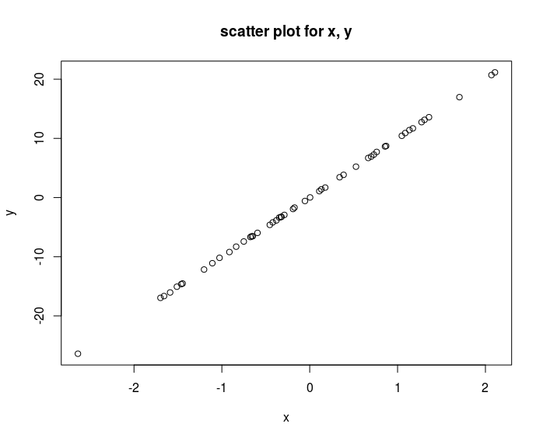
# Question 1: (e)
> hist(y, main = "histogram of y")
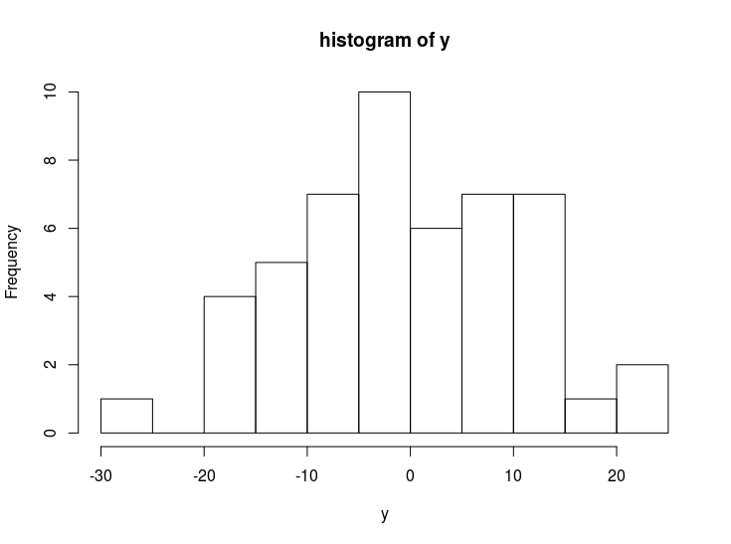
> boxplot(y, main = "boxplot of y")
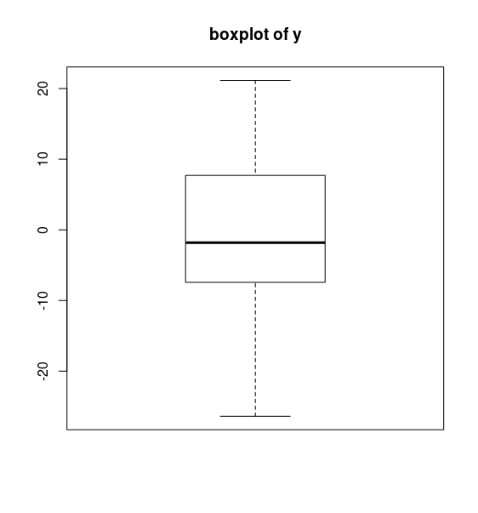
## Question 2
# Question 2: (a)
> library(Stat2Data)
> data(Backpack)
> backpack=data.frame(Backpack)
# Question 2: (b)
> max(backpack$BackpackWeight)
[1] 35
> min(backpack$BackpackWeight)
[1] 2
# Question 2: (c)
> Backpack_p = subset(backpack, Backpack$BackProblems == '1')
> View(Backpack_p)
> Backpack_p
BackpackWeight BodyWeight Ratio BackProblems Major Year Sex Status Units
1 9 125 0.0720000 1 Bio 3 Female U 13
3 10 120 0.0833333 1 GRC 4 Female U 14
8 4 185 0.0216216 1 ARCE 5 Female U 18
14 11 170 0.0647059 1 CPE 4 Male U 16
15 12 125 0.0960000 1 CS 3 Female U 12
17 13 145 0.0896552 1 Bio 4 Female U 16
19 10 125 0.0800000 1 LS 3 Female U 17
22 14 117 0.1196580 1 EE 2 Female U 12
26 18 160 0.1125000 1 Mate 1 Male U 13
30 6 165 0.0363636 1 Soc. Sci. 1 Female U 15
31 10 145 0.0689655 1 GRC 1 Female U 14
32 15 120 0.1250000 1 MLL 3 Female U 16
35 14 165 0.0848485 1 Math 5 Female U 12
41 8 145 0.0551724 1 AGB 4 Female U 16
42 13 135 0.0962963 1 SOCS 3 Female U 16
44 15 165 0.0909091 1 Math 4 Female U 12
56 17 144 0.1180560 1 Bio 2 Female U 13
58 5 185 0.0270270 1 Psych 4 Male U 15
63 11 180 0.0611111 1 Kine 4 Male U 18
64 8 140 0.0571429 1 Poli Sci 3 Female U 12
67 12 127 0.0944882 1 Phys 5 Female U 16
70 5 125 0.0400000 1 ARCE 2 Female U 16
72 20 180 0.1111110 1 CPE 1 Male U 13
78 8 125 0.0640000 1 Pols 5 Female U 16
79 15 130 0.1153850 1 Bus 3 Female U 16
81 25 175 0.1428570 1 CE 4 Female U 15
82 24 145 0.1655170 1 Bus 3 Female U 16
83 5 115 0.0434783 1 ME 3 Female U 14
85 19 130 0.1461540 1 LS 5 Female U 16
89 20 170 0.1176470 1 Bus 3 Male U 18
92 18 160 0.1125000 1 MFGE 3 Male U 13
93 11 168 0.0654762 1 Bus 3 Male U 16
# Question 2: (d)
> mean(Backpack_p$Ratio)
[1] 0.08684313
# Question 2: (e)
> backpack_f = subset(backpack, Sex == 'Female')
> backpack_f
BackpackWeight BodyWeight Ratio BackProblems Major Year Sex Status Units
1 9 125 0.0720000 1 Bio 3 Female U 13
3 10 120 0.0833333 1 GRC 4 Female U 14
5 8 180 0.0444444 0 EE 2 Female U 14
8 4 185 0.0216216 1 ARCE 5 Female U 18
9 5 130 0.0384615 0 Bio 4 Female U 14
10 2 120 0.0166667 0 Bio 5 Female U 8
11 8 135 0.0592593 0 Bus 3 Female U 15
15 12 125 0.0960000 1 CS 3 Female U 12
17 13 145 0.0896552 1 Bio 4 Female U 16
18 6 105 0.0571429 0 LS 3 Female U 16
19 10 125 0.0800000 1 LS 3 Female U 17
22 14 117 0.1196580 1 EE 2 Female U 12
24 15 205 0.0731707 0 Bio 5 Female U 12
28 5 140 0.0357143 0 Poli Sci 2 Female U 16
30 6 165 0.0363636 1 Soc. Sci. 1 Female U 15
31 10 145 0.0689655 1 GRC 1 Female U 14
32 15 120 0.1250000 1 MLL 3 Female U 16
33 9 135 0.0666667 0 LS 6 Female G 14
35 14 165 0.0848485 1 Math 5 Female U 12
36 17 145 0.1172410 0 Psych 4 Female U 13
37 14 140 0.1000000 0 ARCE 2 Female U 15
40 8 143 0.0559441 0 Psy 2 Female U 17
41 8 145 0.0551724 1 AGB 4 Female U 16
42 13 135 0.0962963 1 SOCS 3 Female U 16
43 10 130 0.0769231 0 Nut. 3 Female U 16
44 15 165 0.0909091 1 Math 4 Female U 12
45 10 140 0.0714286 0 LS 1 Female U 14
46 5 115 0.0434783 0 Soc. Sci. 1 Female U 13
47 6 128 0.0468750 0 Bus 1 Female U 14
48 5 150 0.0333333 0 SPC 2 Female U 14
50 10 150 0.0666667 0 CD 3 Female U 16
53 21 116 0.1810340 0 Vocal Music 4 Female U 16
55 13 145 0.0896552 0 Bio 4 Female U 16
56 17 144 0.1180560 1 Bio 2 Female U 13
57 10 130 0.0769231 0 Kine 2 Female U 15
59 9 140 0.0642857 0 Kine 3 Female U 16
60 13 125 0.1040000 0 Math 2 Female U 17
62 10 150 0.0666667 0 Nutrition 4 Female U 12
64 8 140 0.0571429 1 Poli Sci 3 Female U 12
67 12 127 0.0944882 1 Phys 5 Female U 16
68 14 150 0.0933333 0 Kine 3 Female U 16
70 5 125 0.0400000 1 ARCE 2 Female U 16
74 14 125 0.1120000 0 Pols 2 Female U 17
76 25 144 0.1736110 0 LS 3 Female U 17
77 2 105 0.0190476 0 IE 6 Female U 15
78 8 125 0.0640000 1 Pols 5 Female U 16
79 15 130 0.1153850 1 Bus 3 Female U 16
80 10 120 0.0833333 0 AGB 4 Female U 16
81 25 175 0.1428570 1 CE 4 Female U 15
82 24 145 0.1655170 1 Bus 3 Female U 16
83 5 115 0.0434783 1 ME 3 Female U 14
84 10 110 0.0909091 0 CE 2 Female U 16
85 19 130 0.1461540 1 LS 5 Female U 16
86 13 135 0.0962963 0 LS 4 Female U 16
87 9 128 0.0703125 0 Aero 1 Female U 16
> backpack_m = subset(backpack, Sex == 'Male')
> backpack_m
BackpackWeight BodyWeight Ratio BackProblems Major Year Sex Status Units
2 8 195 0.0410256 0 Philosophy 5 Male U 12
4 6 155 0.0387097 0 CSC 6 Male G 0
6 5 240 0.0208333 0 History 0 Male G 0
7 8 170 0.0470588 0 CM 3 Male U 15
12 21 160 0.1312500 0 ME 5 Male U 12
13 11 170 0.0647059 0 CPE 4 Male U 16
14 11 170 0.0647059 1 CPE 4 Male U 16
16 11 175 0.0628571 0 CPE 4 Male U 16
20 5 165 0.0303030 0 Bio 3 Male U 14
21 20 170 0.1176470 0 CSC 2 Male U 16
23 11 145 0.0758621 0 CE 5 Male U 14
25 10 270 0.0370370 0 AGB 3 Male U 12
26 18 160 0.1125000 1 Mate 1 Male U 13
27 8 150 0.0533333 0 AGB 4 Male U 16
29 25 190 0.1315790 0 Aero Eng. 2 Male U 14
34 7 145 0.0482759 0 CPE 6 Male U 11
38 11 160 0.0687500 0 EE 4 Male U 15
39 4 155 0.0258065 0 IT 3 Male U 16
49 13 220 0.0590909 0 CE 2 Male U 13
51 19 170 0.1117650 0 ME 5 Male U 12
52 8 155 0.0516129 0 Econ 2 Male U 12
54 16 190 0.0842105 0 Bus 2 Male U 14
58 5 185 0.0270270 1 Psych 4 Male U 15
61 10 175 0.0571429 0 Act. 2 Male U 19
63 11 180 0.0611111 1 Kine 4 Male U 18
65 12 220 0.0545455 0 EE 1 Male U 14
66 35 195 0.1794870 0 Aero 5 Male U 12
69 2 125 0.0160000 0 IT 5 Male U 15
71 6 180 0.0333333 0 ME 4 Male U 15
72 20 180 0.1111110 1 CPE 1 Male U 13
73 14 150 0.0933333 0 Aero 2 Male U 14
75 8 160 0.0500000 0 ME 2 Male U 13
88 14 135 0.1037040 0 ARCE 4 Male U 13
89 20 170 0.1176470 1 Bus 3 Male U 18
90 16 175 0.0914286 0 Bio 3 Male U 12
91 18 150 0.1200000 0 IT 6 Male U 17
92 18 160 0.1125000 1 MFGE 3 Male U 13
93 11 168 0.0654762 1 Bus 3 Male U 16
94 13 155 0.0838710 0 Psy 4 Male U 14
95 15 210 0.0714286 0 Arch 3 Male U 17
96 14 165 0.0848485 0 ME 3 Male U 11
97 6 195 0.0307692 0 APIO 1 Male U 16
98 11 130 0.0846154 0 Bus 1 Male U 12
99 9 140 0.0642857 0 AERO 3 Male U 12
100 15 170 0.0882353 0 History 5 Male U 14
# Four steps of statistical modeling
# Step 1: Choose a model
> par(mfrow = c(1,1))
> boxplot(backpack_f$BackpackWeight, backpack_m$BackpackWeight, main = "Backpack weight", names = c("females", "males"))
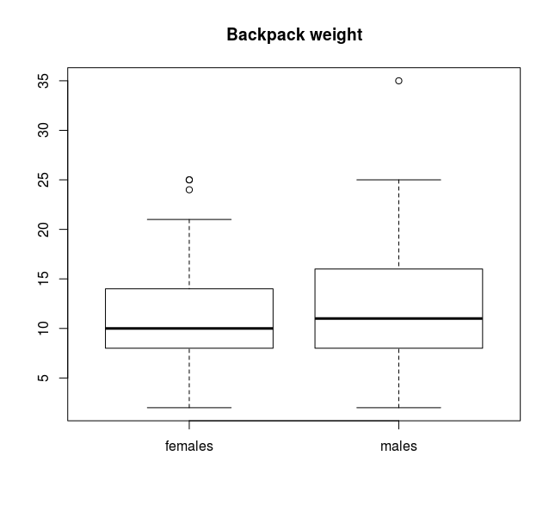
# Step 2: Fit the model
# First find if the variances of these two dataset are same or not, then using two sample t test to fit the model. For there the variances are different, thus, the var.equal should be set up to false, which is default.
> var(backpack_f$BackpackWeight)
[1] 27.96162
> var(backpack_m$BackpackWeight)
[1] 39.38586
> t.test(backpack_f$BackpackWeight, backpack_m$BackpackWeight)

Welch Two Sample t-test

data: backpack_f$BackpackWeight and backpack_m$BackpackWeight
t = -1.1782, df = 86.25, p-value = 0.242
alternative hypothesis: true difference in means is not equal to 0
95 percent confidence interval:
-3.7241290 0.9524118
sample estimates:
mean of x mean of y
11.03636 12.42222

# Step 3: Assess the model
> length(backpack_m$BackpackWeight)
[1] 45
> length(backpack_f$BackpackWeight)
[1] 55
> par(mfrow = c(1,2))
> qqnorm(backpack_f$BackpackWeight, ylab = "female's weight")
> qqline(backpack_f$BackpackWeight, ylab = "female's weight")
> qqnorm(backpack_m$BackpackWeight, ylab = "male's weight")
> qqline(backpack_m$BackpackWeight, ylab = "male's weight")
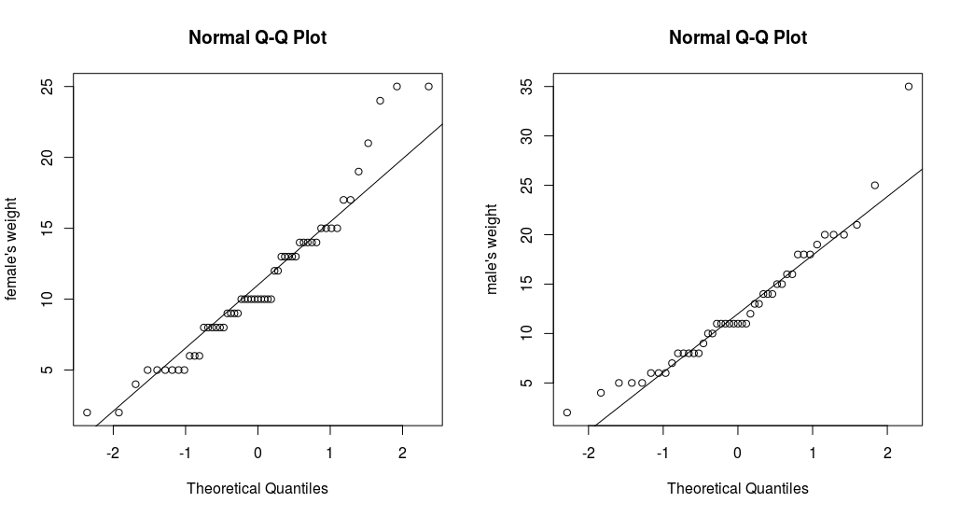
# Step 4: Use the model
The two subsets of this model are not very large. Since the p_value is 0.242 which is very larger than 0.05, the assumption is not correct and then sample is not that unusual. Thus, there is difference of backpack weight between male and female students.

> par(mfrow = c(1,1))

## Question 3
# Question 3: (a)
> data(Volts)
> plot(Volts$Time, Volts$Voltage, main = "Voltage vs Time", xlab = "Time", ylab = "Voltage")
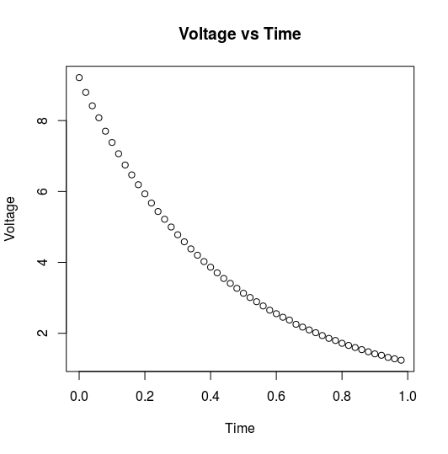
# Comment for (a): the plot shows that as the time increasing, the voltage will get lower and lower, and the pattern is non-linear.
##############################################
# Question 3: (b)
> Volts = transform(Volts, logvolt = log(Voltage))
> plot(Volts$Time, Volts$logvolt, main = "log(Voltage) vs Time", xlab = "Time", ylab = "log(Voltage)")
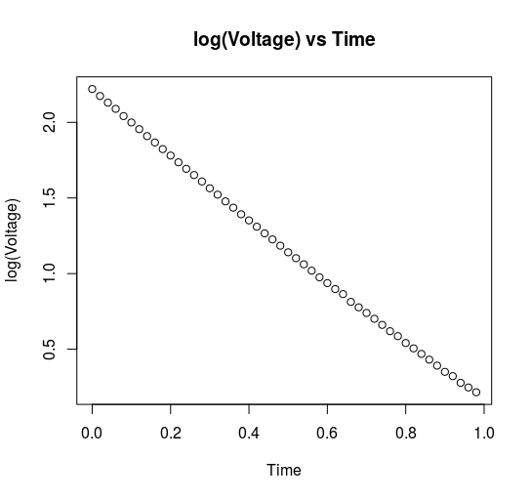
# Comment for (b): the plot shows that after transform the voltage into log(voltage), the plot attern is more like linear.
##############################################
# Question 3: (c)
> lm1 = lm(Volts$logvolt ~ Volts$Time)
> summary(lm1)

Call:
lm(formula = Volts$logvolt ~ Volts$Time)

Residuals:
Min 1Q Median 3Q Max
-0.020448 -0.015084 -0.003621 0.012190 0.043212

Coefficients:
Estimate Std. Error t value Pr(>|t|)
(Intercept) 2.189945 0.004637 472.3 <2e-16 ***
Volts$Time -2.059065 0.008154 -252.5 <2e-16 ***
---
Signif. codes: 0 ‘***’ 0.001 ‘**’ 0.01 ‘*’ 0.05 ‘.’ 0.1 ‘ ’ 1

Residual standard error: 0.01664 on 48 degrees of freedom
Multiple R-squared: 0.9992, Adjusted R-squared: 0.9992
F-statistic: 6.377e+04 on 1 and 48 DF, p-value: < 2.2e-16

# Comment for (c): the prediction equation is hat(logVoltage) = 2.189 – 2.059*Time.
##############################################
# Question 3: (d)
> plot(lm1)
Hit <Return> to see next plot:
Hit <Return> to see next plot: plot(lm1)
Hit <Return> to see next plot:
Hit <Return> to see next plot:
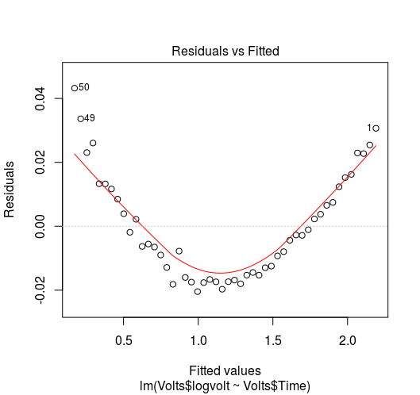
> plot(fitted(lm1), residuals(lm1))

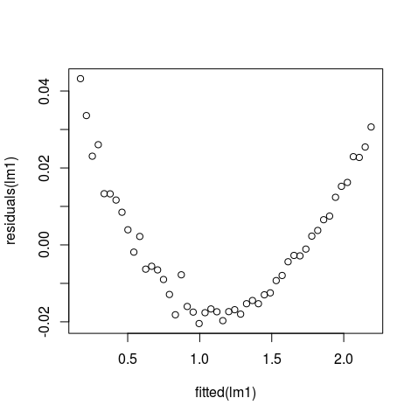
# Comment for (d): the plot shows that it is a curved pattern. Since the logVoltage plot shows the linear pattern, this means that using this model will make the prediction that might be higher than real in the middle and lower at the boundaries of time.

