Supplementary Materials

- Method Details of LDAP
S1.1 computing similarity of lncRNA
We use two methods to measure similarity between lncRNAs: lncRNA sequence similarity and lncRNA interaction profile similarity. The Smith-Waterman alignment algorithm (Emboss-Needle tool) is used to calculate sequence similarity between two lncRNAs. The parameters of Emboss-Needle are specified as default values (Matrix = EDNAfull, Gap open = 10, Gap extend = 0.5). The pairwise similarity between lncRNAs can be defined as:
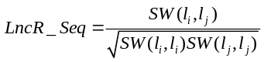 (1)
where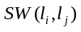denotes the score between lncRNA and lncRNA .
Based on assumption that similar diseases exhibit a similar interaction profile with lncRNAs (Van Laarhoven et al., 2013), the lncRNA interaction profile similarity can be calculated from known lncRNA-disease interactions. It is defined as:
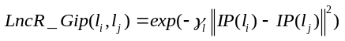 (2)
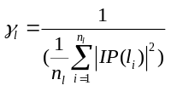 (3)
where 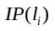 denotes the binary vector encoding the presence or absence of interaction between and all diseases, i.e., the i-th row of lncRNA-disease association adjacency matrix. denotes the number of lncRNAs.

S1.2 computing similarity of disease
We employ five methods (Dis_Gf, Dis_Gip, Dis_GO, Dis_Top and Dis_Icod) for measuring disease similarity.

It is well known that the phenotypes of a disease have close association with genes (Cheng et al., 2014). Therefore, gene function similarity can be used to measure disease similarity. Given two diseases D_{a} and D_{b}, Dis_Gf(D_{a},, D_{b}) is defined as:

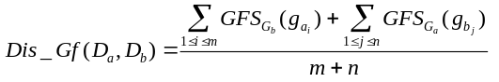 (4)

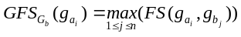 (5)

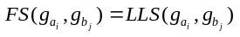 (6)

where 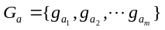and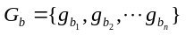 are two gene sets which associated with disease D_{a} and disease D_{b}, respectively. 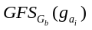represents the gene function similarity between a gene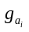 and a gene set 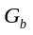. 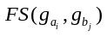represents the gene function similarity between geneand gene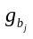. In the same way, the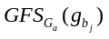 can be computed. 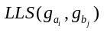 is the similarity score, obtained from HumanNet (Lee et al., 2011), between gene and gene .
The disease interaction profile similarity can be calculated from known lncRNA-disease interactions (Van Laarhoven et al., 2013) and is defined as:
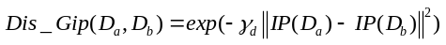 (7)
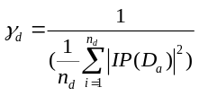 (8)

where 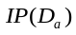 denotes the binary vector encoding the presence or absence of interaction between disease 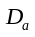 and all lncRNAs, i.e., the a-th column of lncRNA-disease association adjacency matrix. 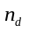denotes the number of diseases.
It is well known that gene ontology is a kind of useful annotation information for disease genes. Therefore, the gene ontology and disease-gene association can be used to measure disease similarity. We obtain the disease gene related GO terms by propagating the GO annotations upwards through the GO hierarchy, i.e., when a gene was annotated with a GO term (Sun et al., 2014). The similarity for pairwise diseases D_{a} and D_{b} is defined as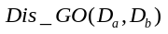, by using the Jaccard index as:
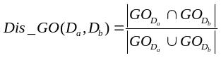 (9)
where 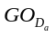 represents the GO set related with disease.
Several researches have shown that diseases have close relationship with protein-protein interaction (PPI) networks. Thus, we use the topology information of the human PPI network and disease-gene association data to measure disease similarity. The graphlet-based method is used to evaluate the topological similarity of genes in the human PPI network (Sun et al., 2014). The topology similarity between D_{a} and D_{b}, Dis_top(D_{a}, D_{b}), is defined as:
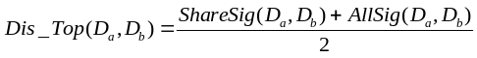 (10)
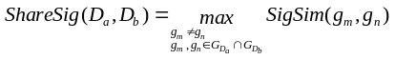 (11)
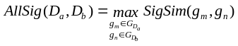 (12)
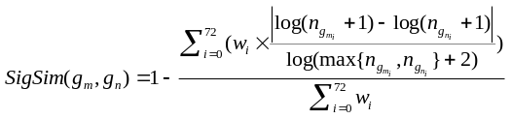 (13)

where 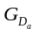 and 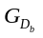 denote the gene set related with D_{a} and D_{b}, respectively. 73 orbits were defined in PPI network (Milenkoviae et al., 2008). 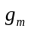and 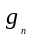 are two nodes in the PPI network. 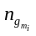 denotes the number of times of node 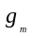 appearing in orbit i. denotes the weight of the i-th orbit.
The disease–disease similarity is measured by calculating the distance between each pair of disease-related genes based on the shortest path in the human PPI network (Paik et al., 2014). The disease similarity between D_{a} and D_{b}, Dis_Icod(D_{a}, D_{b}), is defined as:
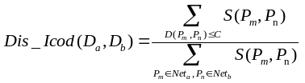 (14)
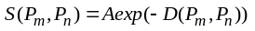 (15)

where D(P_{n}, P_{m}) is the length of the shortest path between proteins P_{n} and P_{m}. 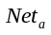is the subnet of PPI network related with disease D_{a} which is obtained based on neighboring nodes of disease gene. A and C denote two free parameters.

S1.3 fusing similarity (kernel) matrix based on Karcher mean
The weighted arithmetic average method is a traditional approach for multiple kernel matrixes fusion (Jeuris et al., 2012). It often reduces to a convex optimization problem. However, there are some limitations: 1) it is suitable for few kernels and small number of data; 2) it is sensitive for noisy data; and 3) it could easily cause useful information loss.
In this study, Karcher mean of matrices is employed to fuse similarity matrices of lncRNA and disease, respectively (Zakeri et al., 2014). For a set of similarity matrices: 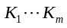 , their Karcher mean (K) is defined as:
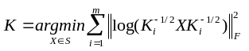 (16)
where S denotes the set of all semi-positive matrices, F denotes the Frobenius norm. The manifold optimization is used to solve the optimization problem. The steepest descent algorithm is used to determine the search direction.

S1.4 bagging SVM for lncRNA-disease association prediction
Several methods have been proposed for positive-unlabled (PU) learning. The goal of these methods is to discriminate positive samples (P) from unlabled samples (U). Bootstrap aggregating or “bagging” is an interesting candidate. The idea of bagging is to estimate a series of classifiers on datasets obtained by perturbing the original training set through bootstrap resampling, and to combine these classifiers by some aggregation technique. The method is conceptually simple, can be applied in many settings and works very well in practice (Mordelet et al., 2014). Bagging generally improves the performance of individual classifiers when they are not too correlated to each other, which happens in particular when the classifier is highly sensitive to small perturbations of the training set.
Algorithm 1. Bagging PU learning
INPUT: P, U, N, M
OUTPUT: s(x)
- Initialize 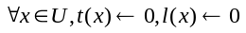
- For i=1 to M
- Obtain a subsample U_{i} of size N from U.
- Train a classifier l_{i} to discriminate P against U_{i}.
- For any i∈U\U_{i}, update:
- 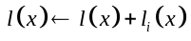
- 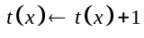
- end
- Return s(x)=l(x)/t(x) for x∈U

The bagging PU learning is described in Algorithm 1. P and U denote positive samples and unlabeled samples, respectively. N denotes the size of a subsample. M denotes times of sampling. t(x) is the number of times of unlabeled sample x predicted by a classifier. The random unlabeled subsample U_{i} is obtained by resampling method in each time. The weighted SVM is trained to discriminate a positive sample P from the unlabeled random subsample U_{i}. The aim of resampling method is to induce the variability in the classifiers. In the last, the score of an unlabeled example x, s(x), is obtained by aggregating the predictions of the classifiers trained on subsamples without x.

Reference
Chen G. et al. (2013) LncRNADisease: a database for long-non-coding RNA-associated diseases. Nucleic acids research, 41, D983-D986.
Cheng, L. et al. (2014) SemFunSim: a new method for measuring disease similarity by integrating semantic and gene functional association. PLoS One, 9, e99415.
Friedenson, B. et al. ( 2007). "The BRCA1/2 pathway prevents hematologic cancers in addition to breast and ovarian cancers". BMC Cancer., 7, 152–162.
Huang, J. et al. (2014) Long non-coding RNA UCA1 promotes breast tumor growth by suppression of p27 (Kip1). Cell Death Dis., 5, e1008.
Jeuris, B. et al. (2012) A survey and comparison of contemporary algorithms for computing the matrix geometric mean. Electronic Transactions on Numerical Analysis, 39, 379–402.
Lee, I. et al. (2011) Prioritizing candidate disease genes by network-based boosting of genome-wide association data. Genome research, 21, 1109-1121.
Milenkoviae, T. et al. (2008) Uncovering Biological Network Function via Graphlet Degree Signatures. Cancer Inform., 6, 257–273.
Mordelet, F. et al. (2014) A bagging svm to learn from positive and unlabeled examples. Pattern Recognition Lett., 37, 201–209.
Paik, H. et al. (2014) Unraveling human protein interaction networks underlying co-occurrences of diseases and pathological conditions. J Transl Med., 12, 99.
Pearson, W.R. et al. (1991) Searching protein sequence libraries: comparison of the sensitivity and selectivity of the Smith-Waterman and FASTA algorithms. Genomics, 11, 635-650.
Sun, K. et al. (2014) Predicting disease associations via biological network analysis. BMC Bioinformatics, 15, 304.
Van Laarhoven, T. et al. (2013) Predicting Drug-Target Interactions for New Drug Compounds Using a Weighted Nearest Neighbor Profile. PLoS One, 8, e66952.

