React Native - Modal

Advertisements

Previous Page
Next Page

In this chapter, we will show you how to use the modal component in React Native.
Let us now create a new file: ModalExample.js
We will put logic inside ModalExample. We can update the initial state by running the toggleModal.
After updating the initial state by running the toggleModal, we will set the visible property to our modal. This prop will be updated when the state changes.
The onRequestClose is required for Android devices.

App.js
import React, { Component } from 'react'
import WebViewExample from './modal_example.js'

const Home = () => {
return (
<WebViewExample/>
)
}
export default Home;

modal_example.js
import React, { Component } from 'react';
import { Modal, Text, TouchableHighlight, View, StyleSheet}

from 'react-native'
class ModalExample extends Component {
state = {
modalVisible: false,
}
toggleModal(visible) {
this.setState({ modalVisible: visible });
}
render() {
return (
<View style = {styles.container}>
<Modal animationType = {"slide"} transparent = {false}
visible = {this.state.modalVisible}
onRequestClose = {() => { console.log("Modal has been closed.") } }>

<View style = {styles.modal}>
<Text style = {styles.text}>Modal is open!</Text>

<TouchableHighlight onPress = {() => {
this.toggleModal(!this.state.modalVisible)}}>

<Text style = {styles.text}>Close Modal</Text>
</TouchableHighlight>
</View>
</Modal>

<TouchableHighlight onPress = {() => {this.toggleModal(true)}}>
<Text style = {styles.text}>Open Modal</Text>
</TouchableHighlight>
</View>
)
}
}
export default ModalExample

const styles = StyleSheet.create ({
container: {
alignItems: 'center',
backgroundColor: '#ede3f2',
padding: 100
},
modal: {
flex: 1,
alignItems: 'center',
backgroundColor: '#f7021a',
padding: 100
},
text: {
color: '#3f2949',
marginTop: 10
}
})
Our starting screen will look like this −
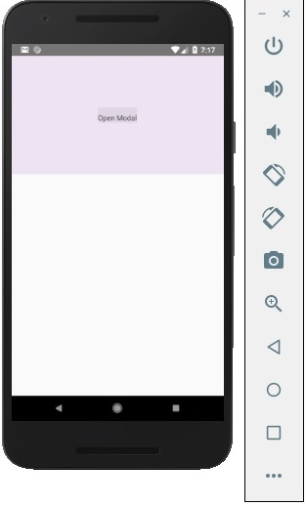
If we click the button, the modal will open.
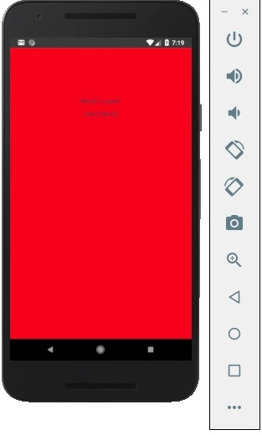

In this chapter we will show you how to use the activity indicator in React Native.

Step 1: App
App component will be used to import and show our ActivityIndicator.

App.js
import React from 'react'
import ActivityIndicatorExample from './activity_indicator_example.js'

const Home = () => {
return (
<ActivityIndicatorExample />
)
}
export default Home

Step 2: ActivityIndicatorExample
Animating property is a Boolean which is used for showing the activity indicator. The latter closes six seconds after the component is mounted. This is done using the closeActivityIndicator() function.

activity_indicator_example.js
import React, { Component } from 'react';
import { ActivityIndicator, View, Text, TouchableOpacity, StyleSheet } from 'react-native';

class ActivityIndicatorExample extends Component {
state = { animating: true }

closeActivityIndicator = () => setTimeout(() => this.setState({
animating: false }), 60000)

componentDidMount = () => this.closeActivityIndicator()
render() {
const animating = this.state.animating
return (
<View style = {styles.container}>
<ActivityIndicator
animating = {animating}
color = '#bc2b78'
size = "large"
style = {styles.activityIndicator}/>
</View>
)
}
}
export default ActivityIndicatorExample

const styles = StyleSheet.create ({
container: {
flex: 1,
justifyContent: 'center',
alignItems: 'center',
marginTop: 70
},
activityIndicator: {
flex: 1,
justifyContent: 'center',
alignItems: 'center',
height: 80
}
})
When we run the app, we will see the loader on screen. It will disappear after six seconds.
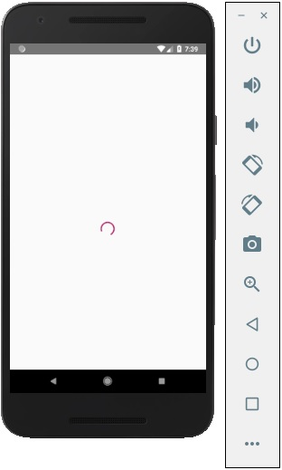
In this chapter, we will create simple Picker with two available options.

Step 1: Create File
Here, the App.js folder will be used as a presentational component.

App.js
import React from 'react'
import PickerExample from './PickerExample.js'

const App = () => {
return (
<PickerExample />
)
}
export default App

Step 2: Logic
this.state.user is used for picker control.
The updateUser function will be triggered when a user is picked.

PickerExample.js
import React, { Component } from 'react';
import { View, Text, Picker, StyleSheet } from 'react-native'

class PickerExample extends Component {
state = {user: ''}
updateUser = (user) => {
this.setState({ user: user })
}
render() {
return (
<View>
<Picker selectedValue = {this.state.user} onValueChange = {this.updateUser}>
<Picker.Item label = "Steve" value = "steve" />
<Picker.Item label = "Ellen" value = "ellen" />
<Picker.Item label = "Maria" value = "maria" />
</Picker>
<Text style = {styles.text}>{this.state.user}</Text>
</View>
)
}
}
export default PickerExample

const styles = StyleSheet.create({
text: {
fontSize: 30,
alignSelf: 'center',
color: 'red'
}
})

Output
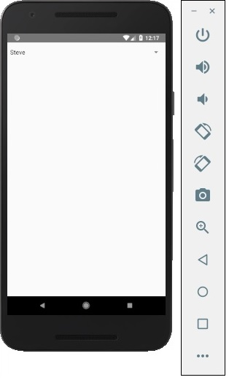
If you click on the name it prompts you all three options as −
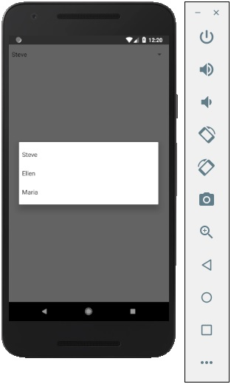
And you can pick one of them and the output will be like.
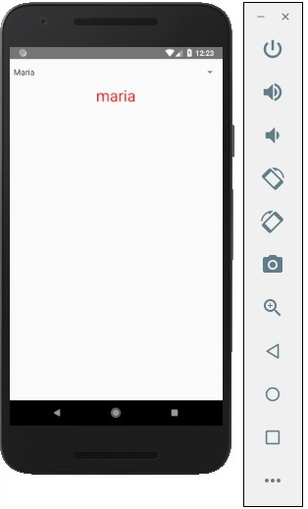
In this chapter, we will create simple Picker with two available options.

Step 1: Create File
Here, the App.js folder will be used as a presentational component.

App.js
import React from 'react'
import PickerExample from './PickerExample.js'

const App = () => {
return (
<PickerExample />
)
}
export default App

Step 2: Logic
this.state.user is used for picker control.
The updateUser function will be triggered when a user is picked.

PickerExample.js
import React, { Component } from 'react';
import { View, Text, Picker, StyleSheet } from 'react-native'

class PickerExample extends Component {
state = {user: ''}
updateUser = (user) => {
this.setState({ user: user })
}
render() {
return (
<View>
<Picker selectedValue = {this.state.user} onValueChange = {this.updateUser}>
<Picker.Item label = "Steve" value = "steve" />
<Picker.Item label = "Ellen" value = "ellen" />
<Picker.Item label = "Maria" value = "maria" />
</Picker>
<Text style = {styles.text}>{this.state.user}</Text>
</View>
)
}
}
export default PickerExample

const styles = StyleSheet.create({
text: {
fontSize: 30,
alignSelf: 'center',
color: 'red'
}
})

Output
If you click on the name it prompts you all three options as −
And you can pick one of them and the output will be like.

