15일 15:00~19:00

16일 팀뷰어로 계속 봐주심 10:00~18:00

***chrony, haproxy, selinux, firewall 확인***

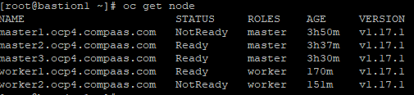

모두 ready 였는데 한 두개 정도가 번갈아가며 not ready로 바뀜

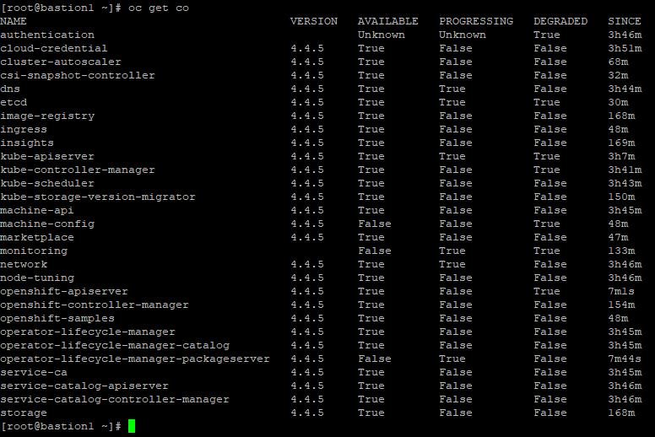

아주 조금씩...뭔가가 바뀌고 있긴 한데 큰 변화는 없음…

**[root@bastion1 ~]# openshift-install wait-for install-complete --log-level debug --dir=/var/www/html/ocp**

DEBUG OpenShift Installer 4.4.5

DEBUG Built from commit 15eac3785998a5bc250c9f72101a4a9cb767e494

DEBUG Fetching Install Config...

DEBUG Loading Install Config...

DEBUG Loading SSH Key...

DEBUG Loading Base Domain...

DEBUG Loading Platform...

DEBUG Loading Cluster Name...

DEBUG Loading Base Domain...

DEBUG Loading Platform...

DEBUG Loading Pull Secret...

DEBUG Loading Platform...

DEBUG Loading Install Config from both state file and target directory

DEBUG On-disk Install Config matches asset in state file

DEBUG Using Install Config loaded from state file

DEBUG Reusing previously-fetched Install Config

INFO Waiting up to 30m0s for the cluster at https://api.ocp4.compaas.com:6443 to initialize...

DEBUG Still waiting for the cluster to initialize: Working towards 4.4.5: 90% complete

DEBUG Still waiting for the cluster to initialize: Working towards 4.4.5: 90% complete

DEBUG Still waiting for the cluster to initialize: Working towards 4.4.5

DEBUG Still waiting for the cluster to initialize: Working towards 4.4.5: downloading update

DEBUG Still waiting for the cluster to initialize: Working towards 4.4.5

DEBUG Still waiting for the cluster to initialize: Working towards 4.4.5: 0% complete

DEBUG Still waiting for the cluster to initialize: Working towards 4.4.5: 10% complete

DEBUG Still waiting for the cluster to initialize: Working towards 4.4.5: 13% complete

DEBUG Still waiting for the cluster to initialize: Working towards 4.4.5: 14% complete

DEBUG Still waiting for the cluster to initialize: Working towards 4.4.5: 45% complete

DEBUG Still waiting for the cluster to initialize: Working towards 4.4.5: 46% complete

DEBUG Still waiting for the cluster to initialize: Working towards 4.4.5: 64% complete

DEBUG Still waiting for the cluster to initialize: Working towards 4.4.5: 80% complete

DEBUG Still waiting for the cluster to initialize: Multiple errors are preventing progress:

* Cluster operator machine-config is reporting a failure: Failed to resync 4.4.5 because: rpc error: code = Unavailable desc = transport is closing

* Could not update imagestream "openshift/cli" (298 of 573): the server does not recognize this resource, check extension API servers

* Could not update oauthclient "console" (342 of 573): the server does not recognize this resource, check extension API servers

DEBUG Still waiting for the cluster to initialize: Multiple errors are preventing progress:

* Cluster operator machine-config is reporting a failure: Failed to resync 4.4.5 because: rpc error: code = Unavailable desc = transport is closing

* Could not update imagestream "openshift/cli" (298 of 573): the server does not recognize this resource, check extension API servers

* Could not update oauthclient "console" (342 of 573): the server does not recognize this resource, check extension API servers

DEBUG Still waiting for the cluster to initialize: Multiple errors are preventing progress:

* Cluster operator machine-config is reporting a failure: Failed to resync 4.4.5 because: rpc error: code = Unavailable desc = transport is closing

* Could not update imagestream "openshift/cli" (298 of 573): the server does not recognize this resource, check extension API servers

* Could not update oauthclient "console" (342 of 573): the server does not recognize this resource, check extension API servers

ERROR Attempted to gather ClusterOperator status after wait failure: listing ClusterOperator objects: Get https://api.ocp4.compaas.com:6443/apis/config.openshift.io/v1/clusteroperators: EOF

FATAL failed to initialize the cluster: Multiple errors are preventing progress:

* Cluster operator machine-config is reporting a failure: Failed to resync 4.4.5 because: rpc error: code = Unavailable desc = transport is closing

* Could not update imagestream "openshift/cli" (298 of 573): the server does not recognize this resource, check extension API servers

* Could not update oauthclient "console" (342 of 573): the server does not recognize this resource, check extension API servers

**[root@bastion1 ~]# openshift-install wait-for bootstrap-complete --log-level debug --dir=/var/www/html/ocp**

DEBUG OpenShift Installer 4.4.5

DEBUG Built from commit 15eac3785998a5bc250c9f72101a4a9cb767e494

INFO Waiting up to 20m0s for the Kubernetes API at https://api.ocp4.compaas.com:6443...

INFO API v1.17.1 up

INFO Waiting up to 40m0s for bootstrapping to complete...

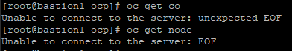

되다 안되다 함….

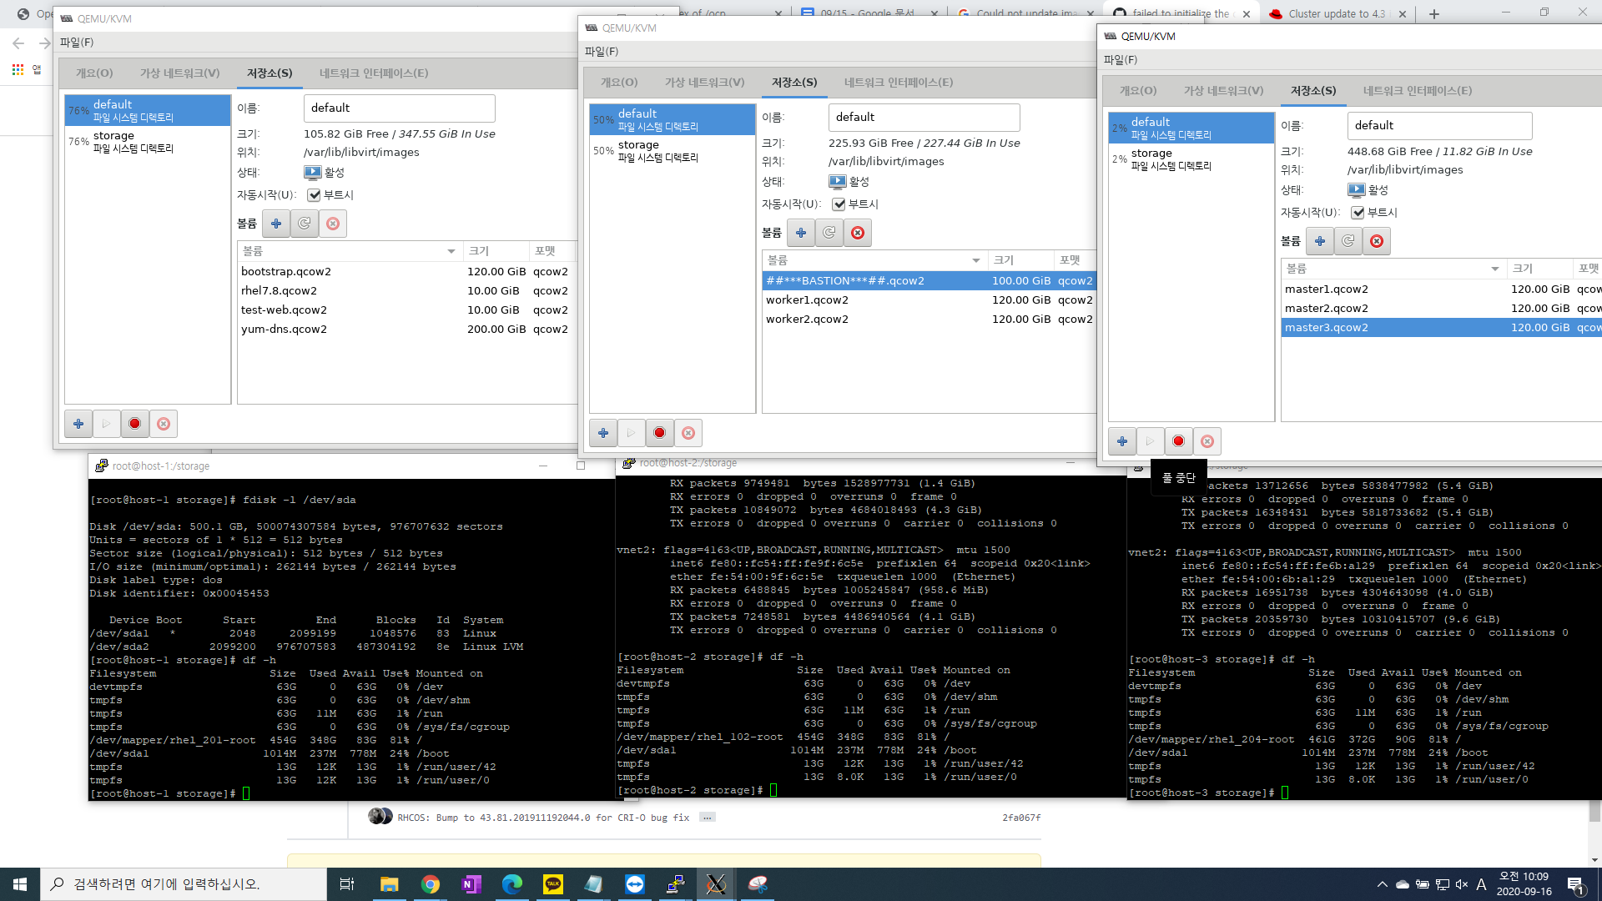

[core@bootstrap ~]$ journalctl -b -f -u bootkube.service

-- Logs begin at Tue 2020-09-15 05:48:01 UTC. --

Sep 16 02:48:56 bootstrap.ocp4.compaas.com bootkube.sh[73389]: I0916 02:48:56.993172 1 waitforceo.go:67] waiting on condition EtcdRunningInCluster in etcd CR /cluster to be True.

Sep 16 02:48:57 bootstrap.ocp4.compaas.com bootkube.sh[73389]: I0916 02:48:57.026520 1 waitforceo.go:67] waiting on condition EtcdRunningInCluster in etcd CR /cluster to be True.

FATAL bootstrap host address and at least one control plane host address must be provided

[root@bastion1 ~]# openshift-install gather bootstrap --dir=/var/www/html/ocp \

> --bootstrap 192.168.0.112\

> master 192.168.0.121\

> master 192.168.0.122\

> master 192.168.0.123

FATA[0000] Error executing openshift-install: accepts 0 arg(s), received 3

[root@bastion1 ~]# oc get pods -n openshift-etcd

NAME READY STATUS RESTARTS AGE

etcd-master1.ocp4.compaas.com 3/3 Running 1 20h

etcd-master2.ocp4.compaas.com 3/3 Running 0 15h

etcd-master3.ocp4.compaas.com 2/3 CrashLoopBackOff 81 14h

installer-2-master1.ocp4.compaas.com 0/1 Completed 0 20h

installer-2-master2.ocp4.compaas.com 0/1 Completed 0 20h

installer-2-master3.ocp4.compaas.com 0/1 Completed 0 20h

installer-3-master2.ocp4.compaas.com 0/1 Completed 0 15h

installer-3-master3.ocp4.compaas.com 0/1 Completed 0 14h

installer-4-master3.ocp4.compaas.com 0/1 Pending 0 6h46m

revision-pruner-2-master1.ocp4.compaas.com 0/1 Completed 0 15h

revision-pruner-2-master2.ocp4.compaas.com 0/1 Completed 0 15h

revision-pruner-2-master3.ocp4.compaas.com 0/1 Completed 0 15h

revision-pruner-3-master2.ocp4.compaas.com 0/1 Completed 0 14h

revision-pruner-3-master3.ocp4.compaas.com 0/1 Pending 0 6h46m

[root@bastion1 ~]# oc logs pod/etcd-master1.ocp4.compaas.com -c etcd -n openshift-etcd

Error from server: etcdserver: request timed out

[root@bastion1 ~]# oc logs pod/etcd-master1.ocp4.compaas.com -c etcd -n openshift-etcd

Error from server: Get https://192.168.0.121:10250/containerLogs/openshift-etcd/etcd-master1.ocp4.compaas.com/etcd: remote error: tls: internal error

echo | openssl s_client -connect api.ocp4.compaas.com:6443 | openssl x509 -noout -text

openssl x509 -in /opt/registry/certs/domain.crt -noout -dates

16일 저녁에 키 새로 생성했는데

[core@bootstrap ~]$ echo | openssl s_client -connect api.ocp4.compaas.com:6443 | openssl x509 -noout -text

depth=1 OU = openshift, CN = kube-apiserver-lb-signer

verify error:num=19:self signed certificate in certificate chain

verify return:1

depth=1 OU = openshift, CN = kube-apiserver-lb-signer

verify return:1

depth=0 O = kube-master, CN = system:kube-apiserver

verify error:num=10:certificate has expired

notAfter=Sep 16 02:39:59 2020 GMT

verify return:1

depth=0 O = kube-master, CN = system:kube-apiserver

notAfter=Sep 16 02:39:59 2020 GMT

verify return:1

DONE

Certificate:

Data:

Version: 3 (0x2)

Serial Number: 7677641153930775537 (0x6a8c75f39cf6cbf1)

Signature Algorithm: sha256WithRSAEncryption

Issuer: OU = openshift, CN = kube-apiserver-lb-signer

Validity

**Not Before: Sep 15 02:39:56 2020 GMT**

**Not After : Sep 16 02:39:59 2020 GMT**

Subject: O = kube-master, CN = system:kube-apiserver

Subject Public Key Info:

Public Key Algorithm: rsaEncryption

RSA Public-Key: (2048 bit)

Modulus:

00:bd:7b:40:74:eb:25:bc:99:da:e6:7d:6d:f9:96:

a8:21:5d:15:51:75:a3:f7:99:3a:eb:d6:12:89:8e:

(생략)

echo | openssl s_client -servername api.ocp4.compaas.com -connect api.ocp4.compaas.com:6443 2>/dev/null | openssl x509 -noout -dates

notBefore=Sep 15 02:39:56 2020 GMT

notAfter=Sep 16 02:39:59 2020 GMT

[root@bastion ~]# openshift-install wait-for bootstrap-complete --dir=/var/www/html/ocp --log-level debug

DEBUG OpenShift Installer 4.4.5

DEBUG Built from commit 15eac3785998a5bc250c9f72101a4a9cb767e494

INFO Waiting up to 20m0s for the Kubernetes API at https://api.ocp4.compaas.com:6443...

DEBUG Still waiting for the Kubernetes API: Get https://api.ocp4.compaas.com:6443/version?timeout=32s: net/http: request canceled (Client.Timeout exceeded while awaiting headers)

INFO API v1.17.1 up

INFO Waiting up to 40m0s for bootstrapping to complete...

ERROR Cluster operator authentication Degraded is True with IngressStateEndpoints_MissingSubsets::RouterCerts_NoRouterCertSecret: RouterCertsDegraded: secret/v4-0-config-system-router-certs -n openshift-authentication: could not be retrieved: secret "v4-0-config-system-router-certs" not found

IngressStateEndpointsDegraded: No subsets found for the endpoints of oauth-server

INFO Cluster operator authentication Progressing is Unknown with NoData:

INFO Cluster operator authentication Available is Unknown with NoData:

ERROR Cluster operator etcd Degraded is True with EtcdMembers_UnhealthyMembers::NodeController_MasterNodesReady::StaticPods_Error: NodeControllerDegraded: The master nodes not ready: node "master2.ocp4.compaas.com" not ready since 2020-09-21 11:09:28 +0000 UTC because NodeStatusUnknown (Kubelet stopped posting node status.)

StaticPodsDegraded: nodes/master2.ocp4.compaas.com pods/etcd-master2.ocp4.compaas.com container="etcd" is not ready

StaticPodsDegraded: nodes/master2.ocp4.compaas.com pods/etcd-master2.ocp4.compaas.com container="etcd" is waiting: "CrashLoopBackOff" - "back-off 20s restarting failed container=etcd pod=etcd-master2.ocp4.compaas.com_openshift-etcd(9c59c1436b9b0a94f904ddb7e19ed59d)"

StaticPodsDegraded: pods "etcd-master3.ocp4.compaas.com" not found

EtcdMembersDegraded: 1 of 3 members are available, etcd-bootstrap is unhealthy, NAME-PENDING-192.168.122.152 has not started

INFO Cluster operator etcd Progressing is True with EtcdMembers_MembersNotStarted::NodeInstaller: NodeInstallerProgressing: 2 nodes are at revision 0; 1 nodes are at revision 2

EtcdMembersProgressing: 1 of 3 members are available, etcd-bootstrap is unhealthy, NAME-PENDING-192.168.122.152 has not started

INFO Cluster operator etcd Available is False with EtcdMembers_No quorum: EtcdMembersAvailable: 1 of 3 members are available, etcd-bootstrap is unhealthy, NAME-PENDING-192.168.122.152 has not started

ERROR Cluster operator kube-apiserver Degraded is True with NodeController_MasterNodesReady::NodeInstaller_InstallerPodFailed: NodeControllerDegraded: The master nodes not ready: node "master2.ocp4.compaas.com" not ready since 2020-09-21 11:09:28 +0000 UTC because NodeStatusUnknown (Kubelet stopped posting node status.)

NodeInstallerDegraded: 1 nodes are failing on revision 4:

NodeInstallerDegraded: ; 1 nodes are failing on revision 5:

NodeInstallerDegraded: static pod of revision 5 has been installed, but is not ready while new revision 6 is pending; 1 nodes are failing on revision 6:

NodeInstallerDegraded: static pod of revision 6 has been installed, but is not ready while new revision 7 is pending

INFO Cluster operator kube-apiserver Progressing is True with NodeInstaller: NodeInstallerProgressing: 3 nodes are at revision 0; 0 nodes have achieved new revision 9

INFO Cluster operator kube-apiserver Available is False with StaticPods_ZeroNodesActive: StaticPodsAvailable: 0 nodes are active; 3 nodes are at revision 0; 0 nodes have achieved new revision 9

ERROR Cluster operator kube-controller-manager Degraded is True with NodeController_MasterNodesReady::NodeInstaller_InstallerPodFailed: NodeControllerDegraded: The master nodes not ready: node "master2.ocp4.compaas.com" not ready since 2020-09-21 11:09:28 +0000 UTC because NodeStatusUnknown (Kubelet stopped posting node status.)

NodeInstallerDegraded: 1 nodes are failing on revision 3:

NodeInstallerDegraded: ; 1 nodes are failing on revision 4:

NodeInstallerDegraded: static pod of revision 4 has been installed, but is not ready while new revision 5 is pending

INFO Cluster operator kube-controller-manager Progressing is True with NodeInstaller: NodeInstallerProgressing: 1 nodes are at revision 0; 1 nodes are at revision 3; 1 nodes are at revision 4; 0 nodes have achieved new revision 5

ERROR Cluster operator kube-scheduler Degraded is True with NodeController_MasterNodesReady: NodeControllerDegraded: The master nodes not ready: node "master2.ocp4.compaas.com" not ready since 2020-09-21 11:09:28 +0000 UTC because NodeStatusUnknown (Kubelet stopped posting node status.)

INFO Cluster operator kube-scheduler Progressing is True with NodeInstaller: NodeInstallerProgressing: 3 nodes are at revision 4; 0 nodes have achieved new revision 5

INFO Cluster operator kube-storage-version-migrator Available is False with _NoMigratorPod: Available: deployment/migrator.openshift-kube-storage-version-migrator: no replicas are available

ERROR Cluster operator network Degraded is True with ApplyOperatorConfig: Error while updating operator configuration: could not apply (/v1, Kind=ConfigMap) openshift-network-operator/applied-cluster: could not retrieve existing (/v1, Kind=ConfigMap) openshift-network-operator/applied-cluster: Get https://api-int.ocp4.compaas.com:6443/api/v1/namespaces/openshift-network-operator/configmaps/applied-cluster: EOF

INFO Cluster operator network Progressing is True with Deploying: DaemonSet "openshift-multus/multus" is not available (awaiting 1 nodes)

DaemonSet "openshift-multus/multus-admission-controller" is not available (awaiting 1 nodes)

DaemonSet "openshift-sdn/ovs" is not available (awaiting 1 nodes)

DaemonSet "openshift-sdn/sdn" is not available (awaiting 1 nodes)

INFO Cluster operator openshift-apiserver Available is False with APIServices_PreconditionNotReady: APIServicesAvailable: PreconditionNotReady

INFO Cluster operator openshift-controller-manager Progressing is True with :

INFO Cluster operator openshift-controller-manager Available is False with :

INFO Use the following commands to gather logs from the cluster

INFO openshift-install gather bootstrap --help

FATAL failed to wait for bootstrapping to complete: timed out waiting for the condition