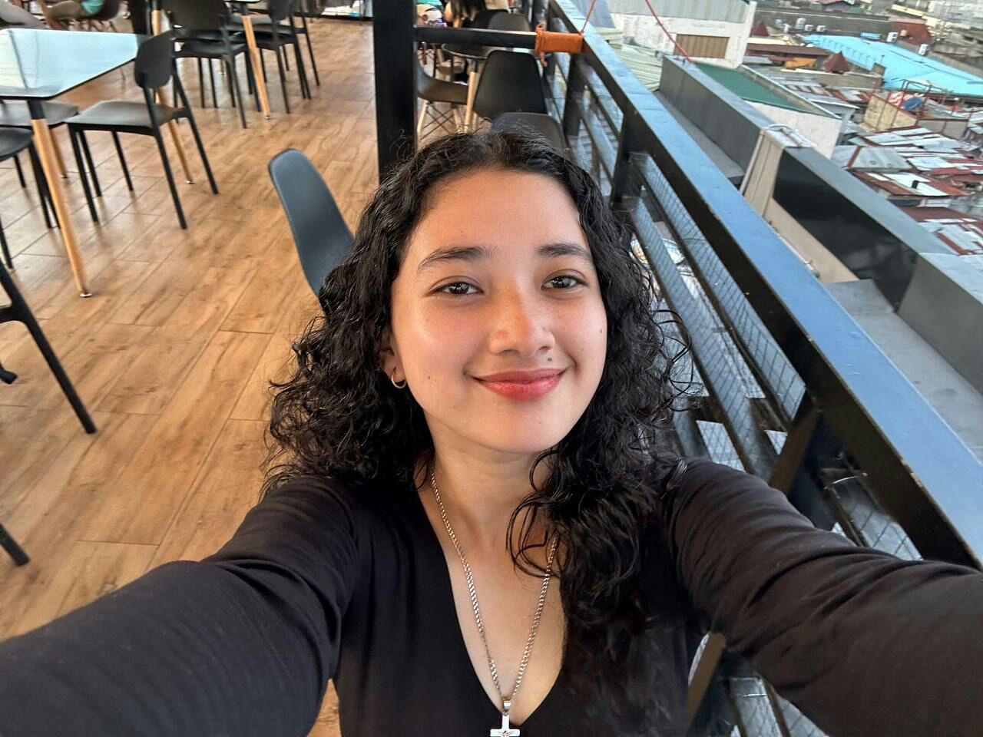

Contact

**Address:**

Talisay St., Buhangin, Davao City

**Phone:**

09951034329

**Email:**

[jdogtheplayer@gmail.com](mailto:jdogtheplayer@gmail.com)

**LinkedIn:**

<https://linkedin.com/in/jdog-the-player-0458a8249>

Languages

Filipino – C2

English – A1

Japanese – A2

Hobbies

* Writing
* Sketching
* Photography
* Design
* Gaming

Summary

Junior Web Developer specializing in front end development. Experienced with all stages of the development cycle for dynamic web projects. Well-versed in numerous programming languages including HTML5, PHP OOP, JavaScript, CSS, MySQL. Strong background in project management and customer relations.

Skill Highlights

|  |  |
| --- | --- |
| * Project management * Strong decision maker * Complex problem solver | * Creative design * Innovative * Service-focused * Keeps on grinding |

Experience

**Web Developer** - 09/2020 to 08/2022

**Freelance:** Philippines

* Cooperate with designers to create clean interfaces and simple, intuitive interactions and experiences.
* Develop project concepts and maintain optimal workflow.
* Work with senior developer to manage large, complex design projects for corporate clients.
* Complete detailed programming and development tasks for front end public and internal websites as well as challenging back-end server code.
* Carry out quality assurance tests to discover errors and optimize usability.

Education

Bachelor of Science in Information Technology: **Major in Healthcare Technologies** - 2022

**University of the Immaculate Conception**, PH

Certifications

PHP Framework (certificate): **Zend, Codeigniter, Symfony**.

Programming Languages: **JavaScript, HTML5, PHP OOP, CSS, SQL, MySQL**.

Lech Nicole

SALAZAR