Document
Overall:
What I did is a personal todolist with a login/register panel, so users can see their own data instead of everyone’s.

MVC Structure:
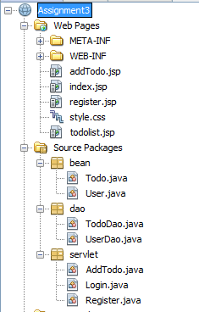

Two main tables:
- Users (id, username, password)
- Todolist (id, userid, todo[the detail of the todo event], complete[“TRUE” or “FALSE”])
Index.jsp – login page (Other pages’ functionalities show directly by their names)

Some screenshots:
