Disk Detection Documentation Updated:
exocode package - current to v.1.2.0 11 August 2015

1 | File Directory

CHANGES.txt
LICENSE.txt
MANIFEST.in
README.rst
setup.py
src/
Catalogs/
random_catalog_sample+1000.csv
random_catalog_sample+2000.csv
tam_cat_sample.csv
tycho_2mass_wise_XMATCH-POS.csv
FITS/
TAM/
index-0/
...
RandSample+1000/
RandSample+2000/
Full_Cat/
Results/
TAM/
RandSample+1000/
RandSample+2000/
Full_Cat/
analysis_script.py
array_processing.py
dataAcq.py
dataGen.py
diffraction.py
display.py
final_blob_identification.py
good_candidates.py
GUI.py
GUI.sh
img_check.py
pixel_regions.py
random_catalog_gen.py
thresholding.py

2 | Data Descriptions

Each stellar target contained in a loaded catalog is represented by a folder in the
FITS/<catalog identifier/ directory. These folders are named in accordance with the line on which the coordinates of the target are located in the given catalog, i.e. index-0 and index-5 for lines 0 and 5.

The directories contain the following files:

FITS/<catalog>/index-#/2MASS--H
FITS/<catalog>/index-#/2MASS--J
FITS/<catalog>/index-#/2MASS--K
FITS/<catalog>/index-#/DSS--DSS1+Blue
FITS/<catalog>/index-#/DSS--DSS1+Red
FITS/<catalog>/index-#/DSS--DSS2+Blue
FITS/<catalog>/index-#/DSS--DSS2+IR
FITS/<catalog>/index-#/DSS--DSS2+Red
FITS/<catalog>/index-#/WISE+(AllWISE)--w1
FITS/<catalog>/index-#/WISE+(AllWISE)--w2
FITS/<catalog>/index-#/WISE+(AllWISE)--w3
FITS/<catalog>/index-#/WISE+(AllWISE)--w4
FITS/<catalog>/index-#/stellar_coordinates.txt
FITS/<catalog>/index-#/file_directory.txt

Some target directories may be missing some of these files, either because images were not available or because img_check.py was not run to create the file_directory.txt notices.

3 | Program Descriptions

analysis_script.py
target_analysis(target, data_container, verify=False)
Processes the image data associated with a single stellar target. Returns a list of lists, where each sublist is the data calculated for one of the target’s images. Each list has the format:
['Image Address', 'Target Index', 'Target Right Ascension', 'Target Declination', 'Survey', 'Band', 'Number of Central Blobs', 'Main Blob Center', 'Main Blob Radius', 'Main Blob Displacement', 'Percent Outside Diffraction', 'Threshold Value', 'Percent of Image White', 'Validation', 'Error']

target: an integer in the range of the catalog representing the index of the target
(to analyze index-22, target = 22)
data_container: file path to directory containing all of the stellar target image folders
(‘FITS/<catalog identifier>/’)
verify: show images to allow for visual confirmation
Warning: takes an extremely long time to visually verify an entire catalog of data

array_processing.py
lingray(x, survey=’’, a=None, b=None):
linear processing of FITS images for later use

x: numpy image array, grayscale
survey: must be changed to ‘DSS’ to generate 8bit output, otherwise image type is Float
a, b: optional cutoffs for min and max values, respectively
(autocalculated from image if not supplied)

loggray(x, survey=’’, a=None, b=None):
logarithmic processing of FITS images for later use

x: numpy image array, grayscale
survey: must be changed to ‘DSS’ to generate 8bit output, otherwise image type is Float
a, b: optional cutoffs for min and max values, respectively
(autocalculated from image if not supplied)

dataAcq.py
Constants
download_catalog: relative file path to csv catalog with coordinates
format: ra,dec pairs on a new line for each target, no header row
max_indices: upper bound of range of targets to download
(eg. 1000 for full download of catalog with 1000 targets, 50 for a subset of 50)
data_container: relative file path to containing directory to create target image
directories - (‘FITS/<catalog>/’ would download images to
FITS/<catalog>/index-#/ directory)

To use:
Change constants as relevant, then run
Prints index numbers as download starts for that line to keep you updated
Takes a while to download the full image set from each target

Customization:
For different purposes, you may want to choose which types of images you get. These parameters are clearly labeled under #FinderChart url generation. To change the angular size of the images, alter the “size” variable (represent as float > .1 in arcmin)

dataGen.py
Constants:
data_container: relative file path to containing directory to create target image
directories - (‘FITS/<catalog>/’ would grab images images
FITS/<catalog>/index-#/ directory)
min_index: minimum index in range to analyze
max_index: maximum range to analyze
NOTE: will be used as range(min_index, max_index), so max_index
itself will not be analyzed
output_file: file name to download resulting data to
eg. ‘Results/<catalog>/ANALYSIS.csv’
Warning: make sure the file path exists! Otherwise, the program will terminate
without returning any data

To use:
Change constants as relevant, then run
Takes a while to run depending on number of targets in catalog
~90 sec for 55 targets, up to 25 minutes for 2000 targets
Ouptut notes:
csv file with header row as seen in analysis_scripy.py documentation
cells without calculated data contain ‘NULL’

diffraction.py
diffract(image, out_file = ‘‘, display = False)
applies a diffraction limited circle corresponding to WISE w4 angular resolution (12’’)
drawn as dark pink circle with crosshairs to mark the center

image: numpy image array
out_file: string representing relative file path to save image with diffraction circle to
eg. ‘Results/<catalog>/<filename-diffract>.png’
display:
opens processed image for viewing
enter to close image window and continue program

display.py
display(target)
Displays all images associated with that target in a grid, with diffraction circles on each image
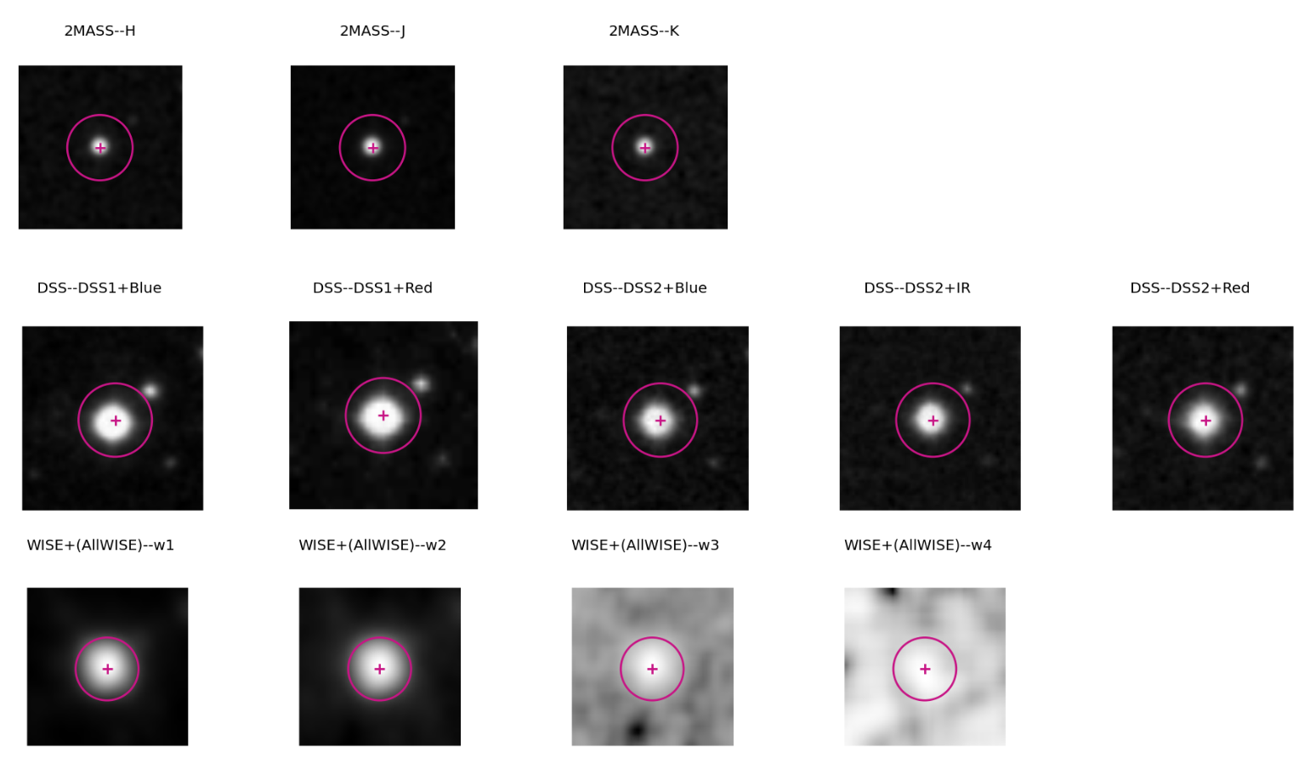

target: stellar target index of interest
ie. # part of index-#/

final_blob_identification.py
blobl(image, survey)
LaPlacian of Gaussian implementation of skikit-image (skimage) blob detection profram for use with WISE and DSS survey images
WISE characteristics: few large blobs
DSS characteristics: few large blobs plus many small blobs

image: numpy grayscale image array
survey: string, ‘WISE’ or ‘DSS’ to indicate processing parameters

Returns a dict of detected blobs: {(row,column): radius}
e.g. {(29,29): 7, (18,17): 2}

blobdoh_2MASS(image)
Determinant of Hessian implementation of scikit-image (skimage) blob detection program for use with 2MASS survey images
2MASS characteristics: few small blobs

image: numpy grayscale image array

Returns a dict of detected blobs: {(row,column): radius}
e.g. {(29,29): 7, (18,17): 2}

good_candidates.py
Shows w4 band images of targets that are good in w3 bands for visual validation, target indices of images marked good (input: 1) are saved for download to file

To use: change filenames to open as desired, then run. Program will prompt you for a response indicating the quality of each image (‘Good? ‘), input 0 for bad candidates and 1 for good candidates

Output: text file with target numbers on individual lines:
Good Candidate Index Numbers
2
23
34
87
104
...

GUI.py
Python GUI made using tkinter

Features:
Catalog Selection - display data from targets in any catalog in Catalogs/ directory
Data Download - if a catalog’s images are not fully downloaded, dataAcq.py protocols are implemented with a push of a button to complete the download
Data Display for Individual Targets - flip through the different indices with the ‘Display Next Index’ button, or jump straight to a desired target with the input box
NOTE: if you enter an index outside of the range of the catalog, nothing will happen
Image Display for Individual Targets - ‘Show Target Images’ button brings up a new window with the images associated with that target in clean rows according to survey: 2MASS on top, then DSS, then WISE

To use GUI with your own catalogs:
- make sure that the catalog is of the format:
ra1,dec1
ra2,dec2
ra3,dec3
...,...
raN,decN
No headers or spaces, and each target should have its own line
Processing does support additional information after declination, so long as it is still csv
and comes after the coordinate identifiers
- save the catalog to the Catalogs/ directory
- create subdirectories in FITS/ and Results/ to handle the data for your catalog
- in GUI.py, in the initialization for the Data class (lines 19-26), add these subdirectories to the appropriate locations like so:
self.image_data[‘new_catalog.csv’] = ‘FITS/new_catalog_images/’
self.num_data[‘new_catalog.csv’] = ‘Results/new_catalog_data/’
This will properly integrate the new catalog for use with the GUI
**If changes are made to the GUI, it is your responsibility to update GUI.sh accordingly.**

GUI.sh

Executable wrapper for GUI.py
$ ./GUI.sh
to run in src directory

img_check.py
Checks each index folder in a catalog directory for proper image download

To use: change directory variable to appropriate catalog subdirectory in FITS/, then run

Outputs:
Writes additional file (file_directory.txt) to each target’s index folder with information on the status of images contained within

eg:
Available files:

2MASS--H: True
2MASS--J: True
2MASS--K: True
DSS--DSS1+Blue: True
DSS--DSS1+Red: True
DSS--DSS2+Blue: True
DSS--DSS2+IR: True
DSS--DSS2+Red: True
WISE+(AllWISE)--w1: True
WISE+(AllWISE)--w2: True
WISE+(AllWISE)--w3: True
WISE+(AllWISE)--w4: True

pixel_regions.py
circle_points(radius,(row,col))

Finds the pixels in a circular region of a given radius around a central pixel at position (row,col)

radius: integer in pixels, max distance from center pixel to be included in the region
(row,col): position of pixel to center region around

Returns two lists:
border region with perimeter pixels only:
Accessed via circle_points(rad(r,c))[0]
Each element in the list is a (row, column) tuple
eg [(1,0),(0,1),(0,0),(1,2),(2,1),(2,2),...]

whole region with all enclosed pixels and perimeter pixels:
Accessed via circle_points(rad,(r,c))[1]
Each element in the list is a (row, column) tuple
eg [(1,1),(1,0),(0,1),(0,0),(1,2),(2,1),(2,2),...]

middle_box(dimensions)
Returns the pixels in the middle 9th of a rectangular field

dimensions: (number of rows, number of columns) tuple
list format also supported

Returns a list of (row,col) tuples for pixels in this range
eg [(1,1),(1,2),(2,1),(2,2)]

random_catalog_gen.py
Creates a random sampling of a desired number of targets from the full tycho_2mass_XMATCH-POS.csv catalog

To use:
Change desired_rows to reflect the number of targets you’d like, then run
Alteration of output_name is possible but unnecessary to keep in RandSample+### format

Output:
A new catalog will be created in the Catalogs/ directory with the desired number of rows
Each row has the csv format ra,dec -- there is no header
eg: Catalogs/RandSample+5.csv
15.2393,-30.2543
123.2943,54.3924
124.2328,-18.9021
290.7584,-25.2901
16.2641,31.4829

thresholding.py
threshold(img)
Implementation of Global Otsu Thresholding method to remove background noise and create binary images

img: numpy grayscale image array

Returns:
numpy array representing image after threshold processing
Accessed via threshold(img)[0]
calculated threshold value
Pixels with values under this threshold are False in the returned array, pixels with values equal to or exceeding this threshold are True in the returned array
Integer or Float depending on numerical type of pixel values in input array
Accessed via threshold(img)[1]

4 | Dependencies

- matplotlib
- astropy (as of v1.2)
- skimage
- numpy
- PIL

5 | Future Development

Future versions of this package will include:
- more accurate and precise blob detection
- a refined good candidate detector based on a wider range of criteria

Future versions of the GUI will include:
- guided process to add in new, user-defined catalogs within the application

6 | License

This software is offered in accordance with the MIT license:

Permission is hereby granted, free of charge, to any person obtaining a copy
of this software and associated documentation files (the "Software"), to deal
in the Software without restriction, including without limitation the rights
to use, copy, modify, merge, publish, distribute, sublicense, and/or sell
copies of the Software, and to permit persons to whom the Software is
furnished to do so, subject to the following conditions:

THE SOFTWARE IS PROVIDED "AS IS", WITHOUT WARRANTY OF ANY KIND, EXPRESS OR IMPLIED, INCLUDING BUT NOT LIMITED TO THE WARRANTIES OF MERCHANTABILITY, FITNESS FOR A PARTICULAR PURPOSE AND NONINFRINGEMENT. IN NO EVENT SHALL THE AUTHORS OR COPYRIGHT HOLDERS BE LIABLE FOR ANY CLAIM, DAMAGES OR OTHER LIABILITY, WHETHER IN AN ACTION OF CONTRACT, TORT OR OTHERWISE, ARISING FROM, OUT OF OR IN CONNECTION WITH THE SOFTWARE OR THE USE OR OTHER DEALINGS IN THE SOFTWARE.

