Business Exchange Services (BES)
bes-sales-support@dxc.com

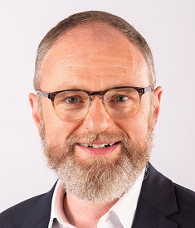 | Contact Me for:  All BES Non-Healthcare Solutions  Primary contact for EMEA/AP | Stefan Ceulemans  Business Exchange Services  EMEA Delivery Manager  stefan.ceulemans@dxc.com  

 | Contact Me for:  All BES Non-Healthcare Solutions  Primary contact for AMS | Mats Jansson  Business Exchange Services  B2B Solutions Architect (Delivery)  mats.jansson2@dxc.com  

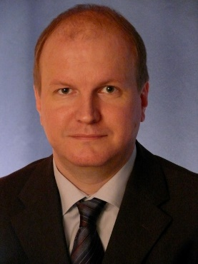 | Contact Me for:  BES SEEBURGER Solutions | Kai Haberzettl  Project Manager  Seeburger COE  kai.haberzettl@dxc.com  

 | Contact Me for:  BES Healthcare Solutions | Laura Dahlberg  Business Exchange Services  Healthcare Delivery Consultant  laura.dahlberg@dxc.com  

 | Contact Me for:  All BES Solutions | Michael V. Bassett  Business Exchange Services  B2B Solutions Consultant (Delivery)  michael.bassett@dxc.com  

DXC Technology
123 Street Address
City, ST 12345
dxc.com

