Asus S530

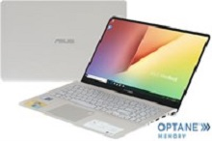

Price: $752.9

\*\*\*Specification:

-Screen:15.6", Full HD (1920x1080).

-CPU:Intel Core i5, 1.6GHz.

-RAM: 4GB, Hard drive HDD:1TB.

-VGA:Intel HD Graphics 620.

-OS: Windows 10.

-Instant battery, DVD: None.

\*\*\*Salient feature:

-Own fashion design.

-Big sound with dual speakers.

-Thin, anti-glare screen.

-Soft keyboard.