Asus TP410

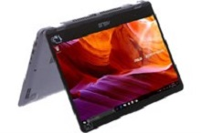

Price: $516.3

\*\*\*Specification:

-Screen:14", Full HD(1920x1080).

-CPU:Intel Core i3, 2.4GHz.

-RAM: 4GB, Hard drive HDD:1TB.

-VGA:Intel UHD Graphics 620.

-OS: Window 10.

-Instant battery, DVD: None.

\*\*\*Salient feature:

-Own fashion design.

-Big sound with dual speakers.

-Thin, anti-glare screen.

-Soft keyboard.