Asus VivoBook X507

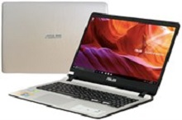

Price: $627.7

\*\*\*Specification:

-Screen:15.6", Full HD(1920x1080)

-CPU:Intel Core i5, 1.6GHz

-RAM: 4GB, Hard drive HDD:1TB

-VGA: NVIDIA Geforce MX130, 2GB

-OS:Windows 10

-Instant battery, DVD: None

\*\*\*Salient feature:

-Own fashion design

-Big sound with dual speakers

-Thin, anti-glare screen

-Soft keyboard