Dell Inspirion 3576

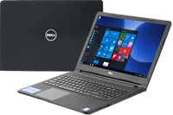

Price: $615.7

\*\*\*Specification:

-Screen:15.6", Full HD(1920x1080).

-CPU:Intel Core i5, 1.6GHz.

-RAM: 4GB, Hard drive HDD:1TB.

-VGA:Intel UHD Graphics 620.

-OS:Windows 10.

-Removable battery, DVD: None.

\*\*\*Salient feature:

-Simple, sturdy design

-Strong configuration

-Big screen, clear picture

-Smart touchpad